Name: V.Siri Chandana
Roll No:2520030609
Section:2
Subject:OS
Skill Problem no. 5
5.
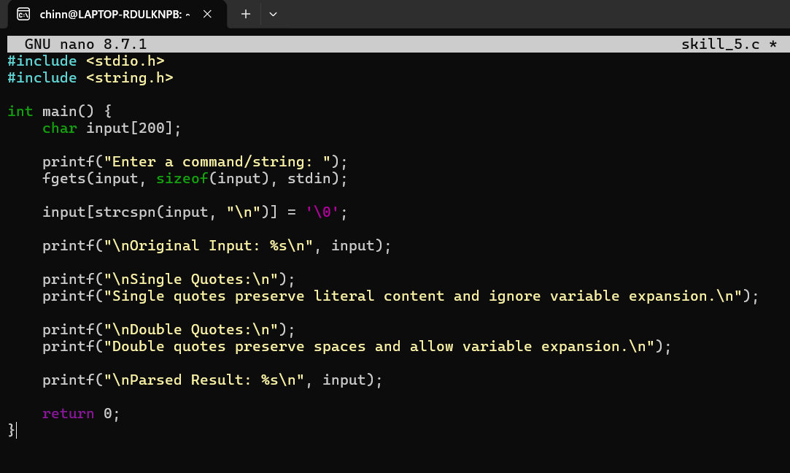

Output:
