Software Architecture and Design Specification
Project: Secure Online Code Execution Platform (CodeBox)
Version: 1.1
Authors: SE Mini Project Team
Date: 29-10-2026
Status: Baselined - reflects the implemented system

Revision History
Version | Date | Author | Change Summary
1.0 | 13-10-2026 | Project Team | Initial architecture and design
1.1 | 29-10-2026 | Project Team | Aligned with the implementation: sandbox details, policy lists, measured values, additional ADRs, residual risks found in testing

Approvals
Role | Name | Signature/Date
Project Guide
Team Lead
QA Lead

1. Introduction

1.1 Purpose
This document specifies the architecture and design of the Secure Online Code Execution Platform: a web application that lets users write Python programs and run them in an isolated environment with enforced time and resource limits, while protecting the host server from unsafe code.

1.2 Scope
Covers the React front end, the FastAPI back end, the sandbox execution subsystem, the SQLite data store and the security architecture. Excludes container/VM isolation, other programming languages and multi-server deployment (listed under future work).

1.3 Audience
Developers, QA engineers, security reviewers, project guides and maintenance teams.

1.4 Definitions
API, ADR (architecture decision record), JWT, ORM, Job Object, audit hook, STRIDE, RBAC, SPA, SRS, STP, RTM. See Appendix 5.1 for the glossary.

2. Document Overview

2.1 How to use this document
Section 3 explains the architecture (components, pattern, technology, risks, security). Section 4 gives the detailed design: data model, sandbox algorithm, sequence diagrams, API definitions, error handling and UX. Requirement IDs (CEP-F-###, CEP-NF-###, CEP-SR-###) refer to the SRS; design-spec IDs (DS-xxx-##) are defined in section 3.8.

2.2 Related Documents
SRS (docs/SRS.docx), Software Test Plan with results (docs/Test_Plan.docx), PROJECT_DETAILS.md, HOW_TO_RUN.md.

3. Architecture

3.1 Goals & Constraints
- Goals: (1) never let user code harm the host; (2) deterministic enforcement of time, memory, process and output limits; (3) responsive, simple user experience; (4) easy to install and run on a student's Windows machine; (5) every security-relevant event is auditable.
- Constraints: no Docker/VM; Windows host; Python only; single-machine deployment; SQLite storage; limited project time, so mature libraries are preferred over custom components.

3.2 Stakeholders & Concerns
Stakeholder | Concerns
Learners | Fast feedback, clear errors, privacy of their code and history
Administrators / operators | Host safety, observability, easy configuration, no orphan processes
Security reviewers | Isolation strength, defence in depth, honest statement of residual risk
Developers / maintainers | Modularity, testability, small and understandable code base
Evaluators | Traceability from requirements to design to tests, demonstrable attack resistance

3.3 Component (UML) Diagram
The system is organised in four tiers. The sandbox tier is isolated from the application tier by an operating-system process boundary.
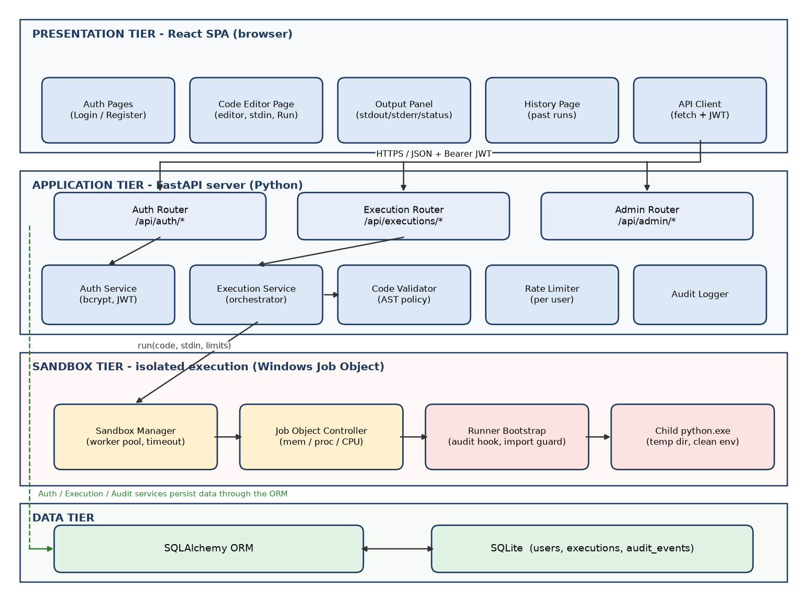
Figure 3.1 - Component diagram

3.4 Component Descriptions
Component | Responsibility | Key interfaces
React SPA | Login/registration, code editor (CodeMirror), output panel, history and admin pages; keeps the JWT in sessionStorage | REST API client (fetch)
Auth Router / Auth Service | Register, login, token issue and verification, login throttling, admin seeding | POST /api/auth/register, /login, GET /me
Execution Router | Receives submissions, returns results, serves history | POST/GET/DELETE /api/executions
Execution Service | Orchestrates one run: size check -> rate limit -> validate -> sandbox -> persist -> audit | execute(db, user, code, stdin, ip)
Code Validator | AST-based static policy check; returns Allowed or Blocked(reason) | validate(source) -> Verdict
Rate Limiter | In-memory sliding-window counters per user and per username/IP | check / peek_blocked / record
Sandbox Manager | Bounded worker pool; creates work dir; launches child; enforces wall-clock timeout; collects output; cleans up | run(source, stdin, limits) -> RunResult
Job Object Controller | Creates a Windows Job Object with memory, process-count, CPU-time, UI-restriction and kill-on-close limits and assigns the child to it | JobObject(...).assign / terminate / peak_memory_kb
Runner Bootstrap | Script executed inside the child before user code: pre-loads standard modules, installs audit hook and import guard, then runs the user program in a fresh __main__ module | python -I -S -B -u -X utf8 runner_bootstrap.py main.py
Audit Logger | Writes security events to audit_events and purges events older than the retention window | log(db, type, user, detail, ip)
Admin Router | Audit events and statistics for administrators | GET /api/admin/*
SQLAlchemy ORM + SQLite | Persistence of users, executions and audit events with parameterised queries | Session, models

3.5 Chosen Architecture Pattern and Rationale
A layered monolith (presentation, application, sandbox, data) with a REST boundary between the SPA and the server was chosen. The server is a single deployable unit, which keeps installation trivial for the project environment, while the sandbox is a separate OS process so that a failure or attack in user code cannot corrupt the server. Microservices and message queues were rejected as unnecessary for a single-machine scale and the project's time budget.
Architecture decision records:
ADR | Decision | Alternatives considered | Rationale
ADR-1 | Isolate by child process + Windows Job Object + hardened interpreter | Docker; WSL2; RestrictedPython; in-process exec() | Docker is unavailable by project decision. exec() or RestrictedPython run inside the server and are known to be bypassable. A Job Object gives kernel-enforced limits and tree-kill.
ADR-2 | Add a CPython audit hook plus import guard inside the child | AST blocklist only | Static checks are easy to evade (getattr, string tricks). The audit hook sees the real events (open, socket.connect, subprocess.Popen, ctypes.dlopen...) and cannot be removed by user code. Confirmed by the 40-program attack corpus.
ADR-3 | Synchronous request/response with a bounded worker pool (4 slots, queue 20) | Celery/Redis queue; WebSockets | Runs are at most 5 s so a blocking response is adequate and far simpler; the semaphore gives back-pressure.
ADR-4 | SQLite via SQLAlchemy | PostgreSQL, MySQL | Zero-install, file based; ORM keeps the switch to another DB a configuration change.
ADR-5 | Stateless JWT bearer tokens | Server sessions + cookies | Simple SPA integration, no session store; short expiry limits exposure. Token kept in sessionStorage.
ADR-6 | React + Vite SPA with CodeMirror 6 | Monaco editor; server-rendered templates | Required by project decision; CodeMirror is small and fast to load.
ADR-7 | Deny all file writes and non-sandbox reads in user code | Allow writes inside temp dir | A 5-second program can write gigabytes; denying writes removes the disk-exhaustion risk entirely.
ADR-8 | Start the child with the BASE interpreter, not the virtual-environment launcher | venv python.exe | The venv launcher spawns the real interpreter as a second process, which violates ActiveProcessLimit = 1 (found during smoke testing).
ADR-9 | Pre-load a small set of standard modules before installing the hook | Allow every transitive import | dataclasses -> inspect -> importlib would otherwise hit the import guard; pre-loading keeps common programs working while user imports of blocked modules still fail.

3.6 Technology Stack & Data Stores
Layer | Technology | Notes
Front end | React 18, Vite 5, CodeMirror 6 (@uiw/react-codemirror), React Router 6, fetch API | Plain CSS; no UI framework
Back end | Python 3.11+, FastAPI, Uvicorn, Pydantic v2 | Automatic OpenAPI docs at /docs
Security libs | bcrypt, PyJWT | bcrypt cost 12 (4 in tests); HS256 tokens
Persistence | SQLAlchemy 2.x ORM, SQLite (WAL mode) | File: backend/data/codebox.db
Sandbox | subprocess, ctypes (kernel32 Job Object API, ntdll NtResumeProcess), sys.addaudithook | No third-party dependency; Windows only
Testing | pytest + httpx TestClient + live uvicorn; Vitest + React Testing Library | 103 backend and 8 front-end tests
Tooling | Node.js, npm; diagrams drawn with matplotlib; documents generated with docx-js

3.7 Risks & Mitigations
ID | Risk | Likelihood / Impact | Mitigation
R1 | Sandbox escape via a bypass of the audit hook or an allowed native module | Medium / High | Layered defence (3.9); deny ctypes and native-extension events; hook binds all builtins it uses; run server under a low-privilege account; document as residual risk; recommend Docker/VM for production.
R2 | Resource exhaustion (CPU, memory, fork bomb, output flood) | High / Medium | Job Object limits, wall-clock timer, output caps, worker pool and queue limit, per-user rate limit. Verified by TC-SBX-01..04 and TC-REL-01.
R3 | Race between process start and Job assignment | Low / Medium | Create the process suspended, assign to the job, then resume (NtResumeProcess).
R4 | Orphan processes or temp files after a crash | Medium / Medium | KILL_ON_JOB_CLOSE, try/finally cleanup, start-up sweep of the temp root. Verified by TC-SBX-07.
R5 | Credential theft or brute force | Medium / High | bcrypt, throttling, generic errors, short-lived tokens, audit log.
R6 | Cross-user data leakage | Low / High | Owner check on every query; 404 instead of 403 to avoid enumeration.
R7 | Windows-specific code is hard to test on other machines | Medium / Low | All Win32 calls isolated in job_object.py; documented requirement for a Windows host.
R8 | Time overrun of the project | Medium / Medium | Four sequential tasks, requirements prioritised (High items first).

3.8 Traceability to Requirements
Design-spec IDs map the requirements to the design elements below. The full requirement-to-design-to-test mapping is the RTM in SRS section 8.
Design spec | Design element | Section | Requirements realised
DS-AUTH-01 | Auth Service: registration, bcrypt, JWT issue/verify | 4.3 | CEP-F-001,002,003,005; CEP-SR-002,003
DS-AUTH-02 | Login throttling and rate limiter | 4.1 | CEP-F-004; CEP-SR-010
DS-EXE-01 | Execution Service orchestration and status mapping | 4.1, 4.2 | CEP-F-010,012,018
DS-EXE-02 | Worker pool and queue | 4.1 | CEP-F-016; CEP-NF-008
DS-VAL-01 | AST code validator and policy lists | 4.1 | CEP-F-024
DS-SBX-01 | Process launch, Job Object limits, temp dir, cleanup | 4.1 | CEP-F-011,017,020,021,026; CEP-NF-001,002,004; CEP-SR-001,006
DS-SBX-02 | Runner bootstrap, audit hook, import guard | 4.1 | CEP-F-023,025; CEP-NF-003; CEP-SR-007
DS-SBX-03 | Output capture, caps, stats, stdin | 4.1 | CEP-F-013,014,015,022
DS-HIS-01 | Execution persistence and owner-scoped queries | 4.1, 4.3 | CEP-F-030..033; CEP-SR-004
DS-UI-01 / 02 | Editor, output, auth and history pages | 4.5 | CEP-F-040..043; CEP-NF-005
DS-ADM-01 | Admin router (audit events, statistics, RBAC) | 4.3 | CEP-F-050,051,052
DS-SEC-01 | Validation, CORS, headers | 3.9, 4.4 | CEP-SR-005,008
DS-AUD-01 | Audit logger | 4.1 | CEP-NF-007; CEP-SR-009
DS-DATA-01 | Data model (users, executions, audit_events) | 4.1 | CEP-F-030; CEP-NF-007
DS-OPS-01 | Configuration through environment variables | 4.1 | CEP-NF-006

3.9 Security Architecture
Trust boundaries
- Boundary A: Internet/browser -> API. Everything arriving is untrusted; validated and authenticated.
- Boundary B: server process -> sandbox child process. User code and everything it prints is untrusted.
- Boundary C: sandbox child -> host OS. Crossed only through the limited operations the audit hook and Job Object allow.
Defence in depth
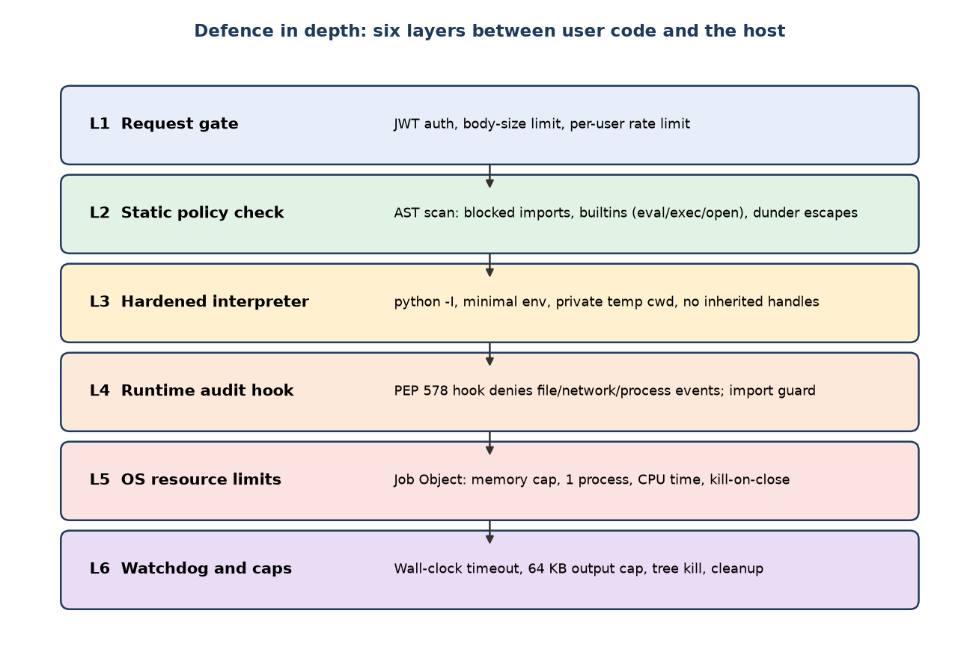
Figure 3.2 - Six defence layers
Threat modelling (STRIDE)
Threat | Example in this system | Mitigation
Spoofing | Forged or stolen token; credential stuffing | HS256 signed short-lived JWT, bcrypt, login throttling, generic error messages
Tampering | Code modifies server files or other users' data; altered request bodies | No file writes or out-of-sandbox reads in the child; schema validation; ORM parameterised queries; owner checks
Repudiation | User denies submitting malicious code | audit_events with user, IP, type, time; executions store the exact code
Information disclosure | Program reads server secrets, env vars, DB file, other users' code; verbose errors leak paths | Clean child environment, audit-hook read restriction, owner-scoped queries, sanitised tracebacks and error bodies
Denial of service | while True, memory bomb, fork bomb, output flood, request flood | Wall-clock + CPU limit, Job memory limit, ActiveProcessLimit 1, 64 KB output caps, worker pool + queue limit, per-user rate limit
Elevation of privilege | Sandbox escape; normal user calls admin API | Layered sandbox; runs under non-admin account; is_admin RBAC check against the database (token claim not trusted) returning 403; no shell or ctypes in child
Residual risks (stated honestly)
- A subprocess sandbox shares the host kernel. A vulnerability in CPython, an allowed standard-library C extension, or the Windows kernel could allow escape; containers or VMs are stronger and are the recommended production upgrade.
- Audit hooks are a policy mechanism inside the interpreter, not a kernel boundary; the combination with the Job Object and static checks is what provides defence in depth. The hook binds every builtin it needs as a local, and the gc and importlib modules are blocked, to prevent user code from reaching or patching it.
- Console devices: open('CON') uses CPython's console I/O class, which raises no audit event, so the hook cannot veto it. It only reaches the child's own hidden console (CREATE_NO_WINDOW), never the server's, and a blocked read ends at the time limit. Discovered by the attack corpus (STP defect 6).
- Reads of the Python installation directory are required for imports and are therefore permitted (read-only).
- Compatibility cost of the policy: modules that need blocked capabilities do not work inside the sandbox (unittest, zipfile, tarfile, timeit, getpass, asyncio, shutil, tempfile, sqlite3, pickle, socket-based modules). Setting environment variables (os.environ[...] = ...) is denied.
- The platform must not be run under an administrator account; this is documented in HOW_TO_RUN.md. No independent penetration test has been performed.

4. Design

4.1 Design Overview

4.1.1 Module / package structure
backend/
run.py start the server (uvicorn, app factory)
app/
main.py FastAPI app factory, CORS, error handlers, SPA hosting
config.py Settings from environment (limits, secrets)
database.py Engine (SQLite WAL), session factory
models.py User, Execution, AuditEvent (SQLAlchemy)
schemas.py Pydantic request/response models and validation rules
security.py bcrypt hashing, JWT encode/decode
deps.py get_db, get_current_user, require_admin
errors.py AppError + uniform error body
create_admin.py CLI to create/promote an administrator
routers/ auth.py executions.py admin.py meta.py
services/ auth_service.py execution_service.py
validator.py rate_limiter.py audit.py
sandbox/ manager.py job_object.py runner_bootstrap.py
tests/ pytest suite (103 tests) incl. live-server tests
frontend/
src/ api.js AuthContext.jsx App.jsx
pages/ (Auth, Editor, History, Admin) components/ test/
docs/ SRS, SAD, Test Plan, diagrams, tools (document generators)

4.1.2 Data model
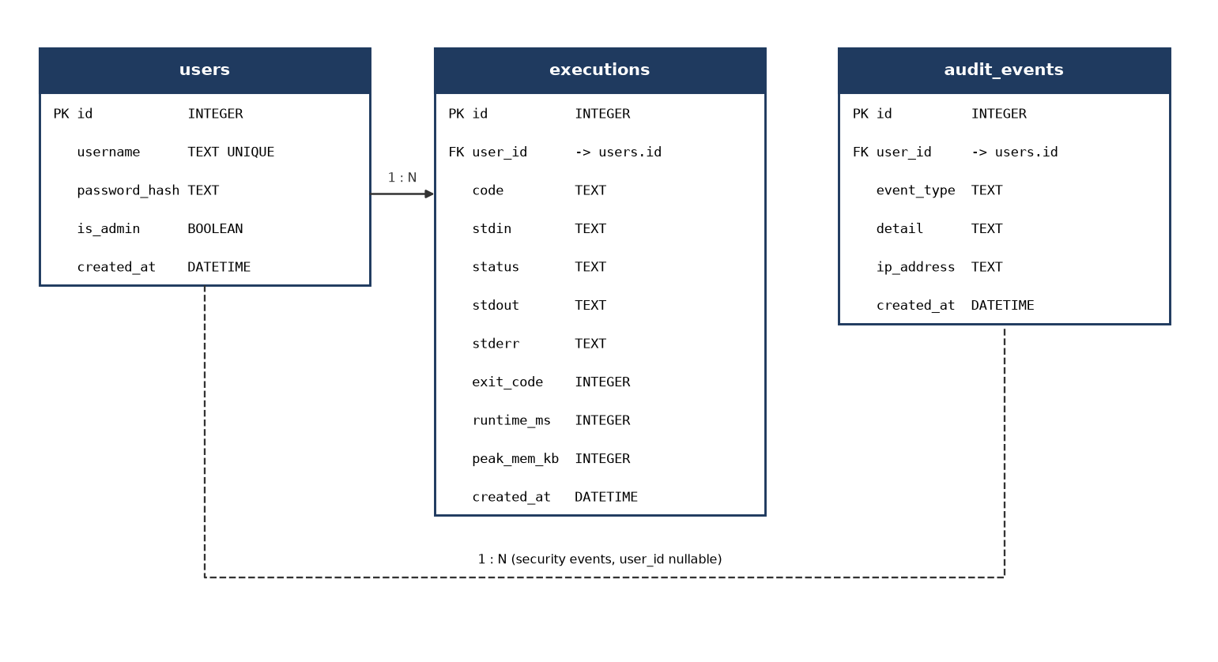
Figure 4.1 - Entity-relationship diagram
Table | Notes
users | username unique, stored lower-case (case-insensitive), password_hash (bcrypt), is_admin flag, created_at
executions | Owner user_id (FK, cascade delete), code, stdin, status, stdout, stderr (each at most 64 KB), exit_code, runtime_ms, peak_mem_kb, blocked_reason, created_at; index on (user_id, created_at)
audit_events | event_type (LOGIN_FAILED, LOGIN_THROTTLED, BLOCKED_CODE, TIMEOUT, MEMORY_LIMIT, OUTPUT_LIMIT, RATE_LIMITED, ADMIN_ACCESS), nullable user_id, detail, ip_address, created_at

4.1.3 Execution status model
Status | Meaning | Determined by
COMPLETED | Exit code 0 within all limits | Exit code, no limit flag
RUNTIME_ERROR | Non-zero exit code or uncaught exception (including syntax error and PermissionError from the hook) | Exit code != 0 and not killed by a limit
TIMEOUT | Exceeded 5 s wall-clock or CPU time | Watchdog timer (wait timeout) or Job CPU-limit backstop (limit + 1 s)
MEMORY_LIMIT | Exceeded 128 MB | Allocation fails under the Job memory limit -> MemoryError (or peak >= 90% of limit)
OUTPUT_LIMIT | stdout or stderr exceeded 64 KB | Reader thread counter; process tree killed
BLOCKED | Rejected by static policy; never started | Code Validator verdict
INTERNAL_ERROR | Platform failure (could not start child, etc.) | Exception in Sandbox Manager; details logged, generic message returned

4.1.4 Configuration (environment variables, defaults)
Variable | Default | Purpose
EXEC_TIMEOUT_SECONDS | 5 | Wall-clock limit per run (CPU backstop = +1 s)
EXEC_MEMORY_LIMIT_MB | 128 | Job Object process memory limit
EXEC_OUTPUT_LIMIT_BYTES | 65536 | Per-stream output cap
MAX_CODE_BYTES / MAX_STDIN_BYTES | 51200 / 16384 | Input size caps
MAX_CONCURRENT_RUNS / MAX_QUEUE_LENGTH | 4 / 20 | Worker pool and queue
RATE_LIMIT_RUNS_PER_MIN | 10 | Per-user execution rate
LOGIN_MAX_FAILURES / LOGIN_LOCK_MINUTES | 5 / 5 | Brute-force throttling
JWT_SECRET, JWT_EXPIRE_MINUTES | (random if unset) / 60 | Token signing and lifetime
BCRYPT_ROUNDS | 12 | Password hash cost
ADMIN_USERNAME / ADMIN_PASSWORD | (unset) | Seeds or promotes an administrator at start-up
FRONTEND_ORIGIN, DATABASE_URL, SANDBOX_ROOT, AUDIT_RETENTION_DAYS | http://localhost:5173, sqlite file, backend/data/sandbox_tmp, 90 | CORS, storage, work area, audit retention

4.1.5 Sandbox design (core of the system)
Algorithm for one execution, performed by the Sandbox Manager after the Code Validator has accepted the source:
- Acquire a worker slot from a bounded semaphore (4); if 20 requests are already waiting (or the wait exceeds 60 s), fail fast with 503.
- Create a private temporary directory; write main.py (user code). Nothing else is copied in; stdin is streamed through a pipe.
- Build a minimal environment: SystemRoot, TEMP and TMP set to the work dir, PYTHONDONTWRITEBYTECODE; no server variables.
- Create a Job Object with: ProcessMemoryLimit = 128 MB, ActiveProcessLimit = 1, PerProcessUserTimeLimit = timeout + 1 s (backstop), KILL_ON_JOB_CLOSE, DIE_ON_UNHANDLED_EXCEPTION, and all UI restrictions (clipboard, desktop, handles...).
- Start the base python.exe with -I -S -B -u -X utf8 runner_bootstrap.py <main.py>, cwd = work dir, piped stdin/stdout/stderr, no inherited handles, flags CREATE_SUSPENDED | CREATE_NO_WINDOW; assign it to the Job Object, then resume it (NtResumeProcess).
- Inside the child, the bootstrap (a) reads and compiles the program, (b) pre-loads a few standard modules, (c) pops blocked modules from sys.modules, (d) installs the audit hook / import guard, (e) executes the program in a fresh __main__ module and prints sanitised tracebacks.
- Two reader threads drain stdout and stderr, counting bytes; when a stream passes 64 KB the process tree is killed and the status becomes OUTPUT_LIMIT. The main thread waits at most 5 s and then terminates the job (TIMEOUT).
- On exit, read the job accounting (peak memory) and map exit code and flags to a status (4.1.3); output is normalised to LF and server paths are scrubbed from stderr.
- In a finally block: terminate the job, close pipes and handles, delete the temp directory, release the worker slot. Return RunResult.

Static policy (Code Validator, DS-VAL-01)
Rule class | Blocked items (default policy)
Imports | subprocess, socket, ssl, http, urllib, ftplib, smtplib, poplib, imaplib, telnetlib, xmlrpc, socketserver, requests, ctypes, cffi, multiprocessing, signal, shutil, tempfile, glob, sqlite3, pickle, marshal, shelve, dbm, importlib, runpy, code, codeop, pty, fcntl, mmap, resource, webbrowser, builtins, gc, _winapi, msvcrt, winreg, winsound, pdb, bdb, trace, cProfile, profile, asyncio, ensurepip, venv; relative imports
Built-in names | eval, exec, compile, open, __import__, breakpoint, globals, vars, __builtins__, __loader__, __spec__
Attribute access | __subclasses__, __globals__, __builtins__, __code__, __bases__, __mro__, __closure__, __loader__, f_globals, f_locals, f_builtins, f_back, gi_frame, gi_code, cr_frame, cr_code, ag_frame, tb_frame; getattr/setattr/delattr/hasattr with a constant string beginning '__'
Unanalysable source | ast.parse failing with RecursionError / MemoryError / ValueError is BLOCKED; plain SyntaxError is passed through so Python reports it normally

Runtime policy (audit hook and import guard, DS-SBX-02)
Audit event / action | Decision
open (read) of the work dir or the Python installation directories | Allow (read-only)
open of any other path; any write / append / create / exclusive mode or flag; Windows device names (CON, NUL, COMn...) and alternate data streams in paths that do raise an event | Deny - PermissionError
socket.*, ssl, http, urllib and similar prefixes | Deny
subprocess.Popen, os.system, os.exec*, os.spawn*, os.posix_spawn, os.fork, os.startfile, _winapi.* | Deny
ctypes.* (dlopen, dlsym, cdata, string_at...), msvcrt.*, winreg.*, mmap.*, multiprocessing.* | Deny
os.remove, rename, replace, mkdir, rmdir, chmod, chown, link, symlink, truncate, utime, putenv, unsetenv, kill, chdir, add_dll_directory | Deny
os.listdir / os.scandir outside the allowed roots | Deny
import of a blocked module (guard on the 'import' event), code.__new__, sys.settrace, sys.setprofile | Deny
Everything else (math, string, list, dict, time, random, collections, itertools, json, re, datetime, dataclasses, threading, queue, ...) | Allow

4.2 UML Sequence Diagrams
Three flows specific to the platform are shown: authentication, code execution (the core flow including policy and limit handling) and history management.
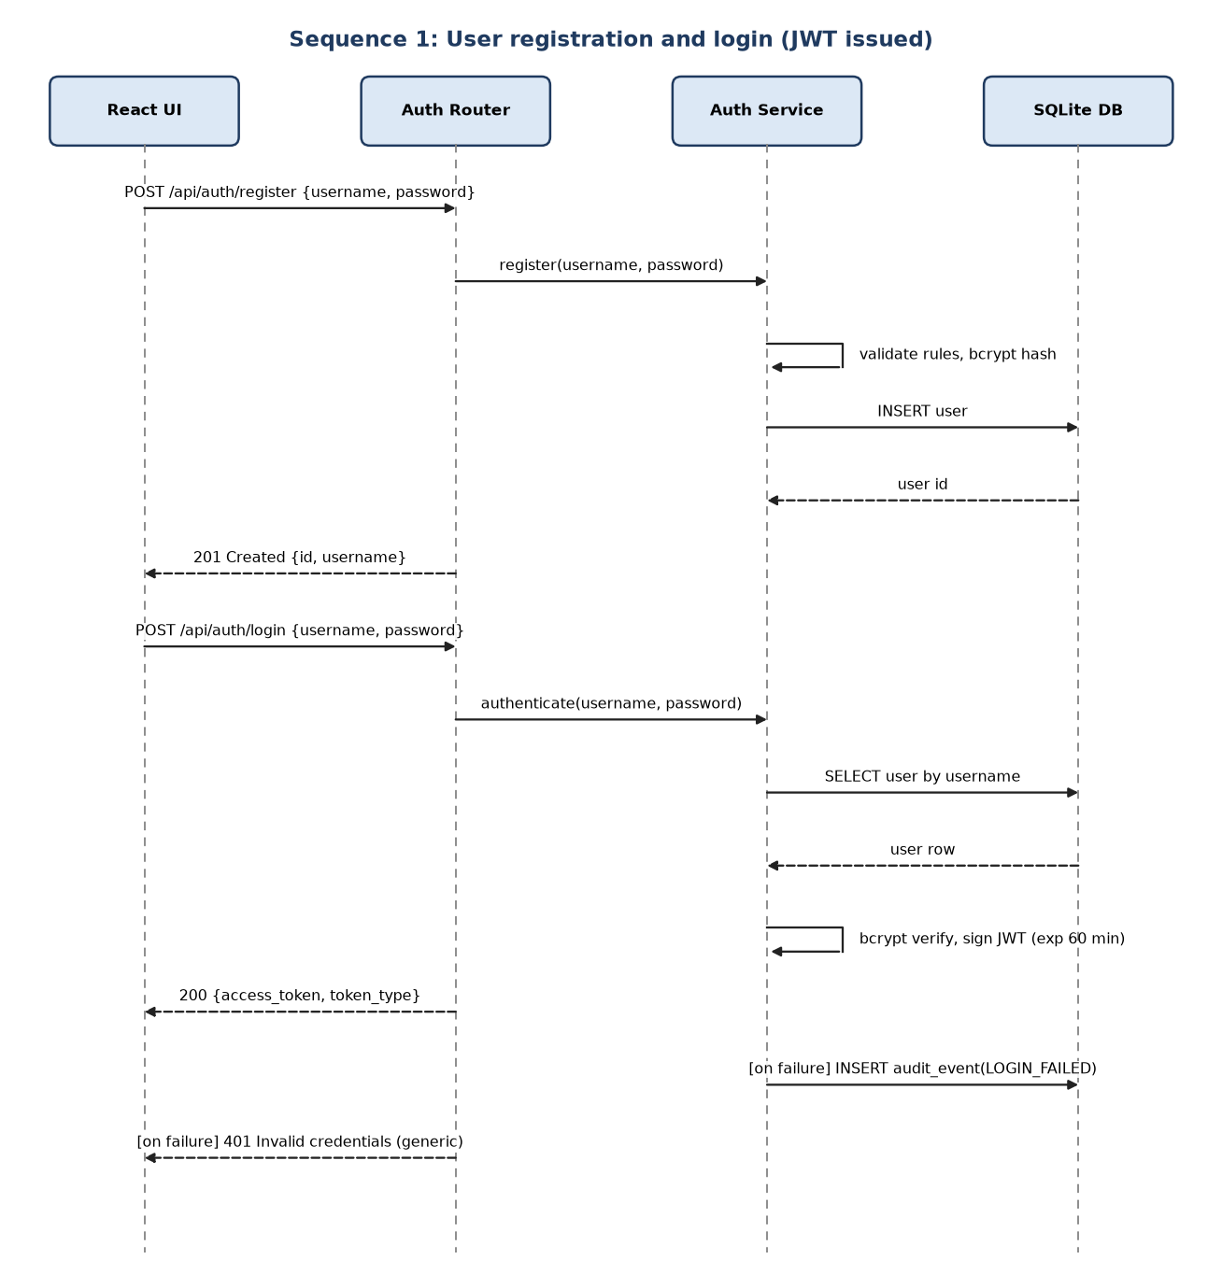
Figure 4.2 - Sequence: registration and login
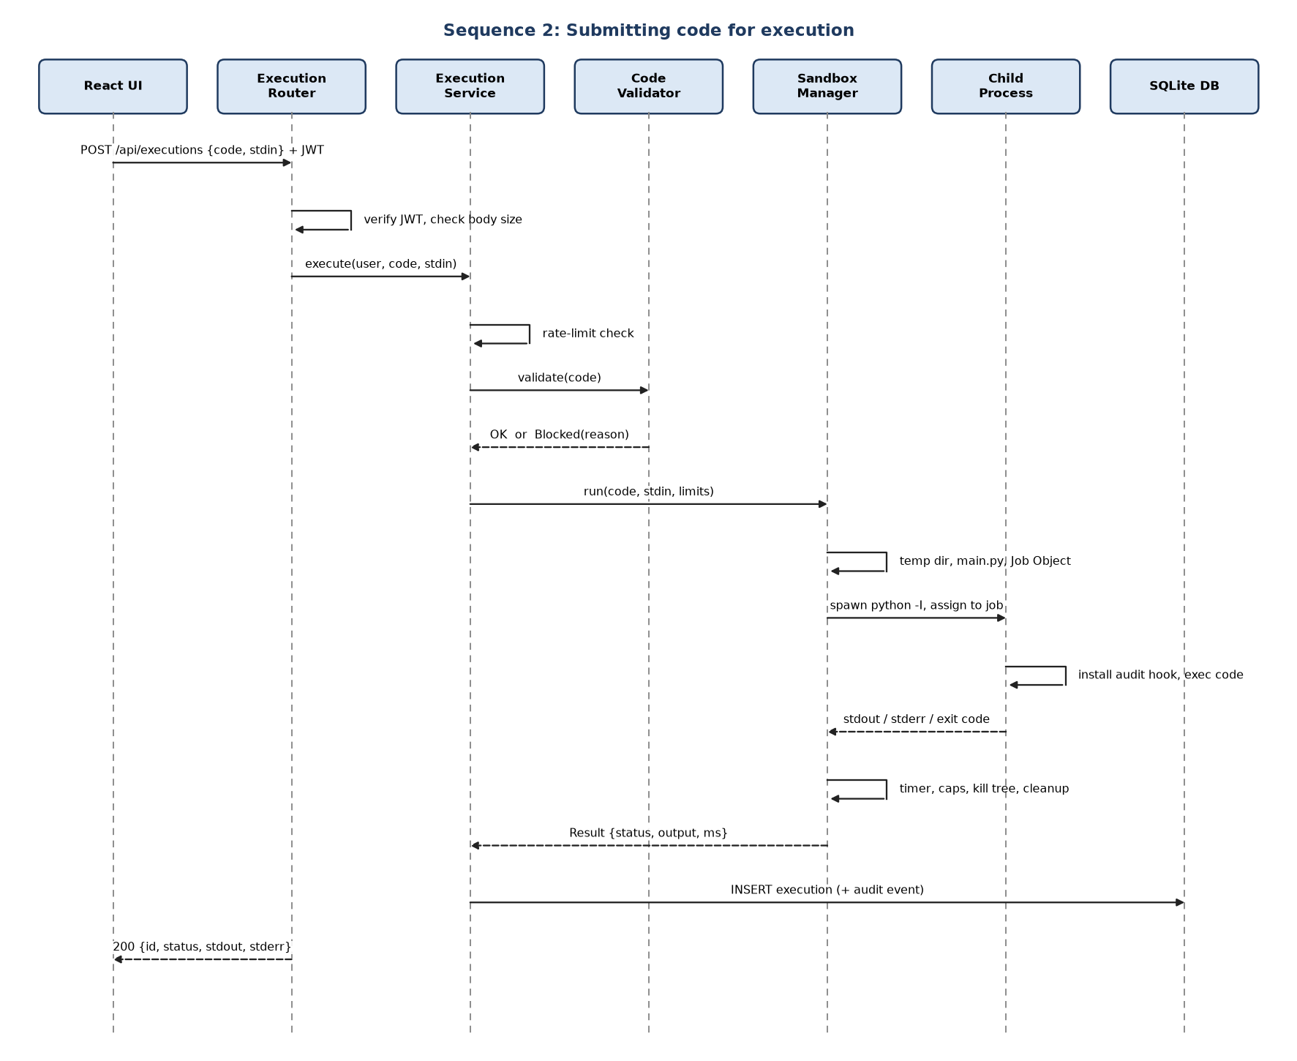
Figure 4.3 - Sequence: code execution
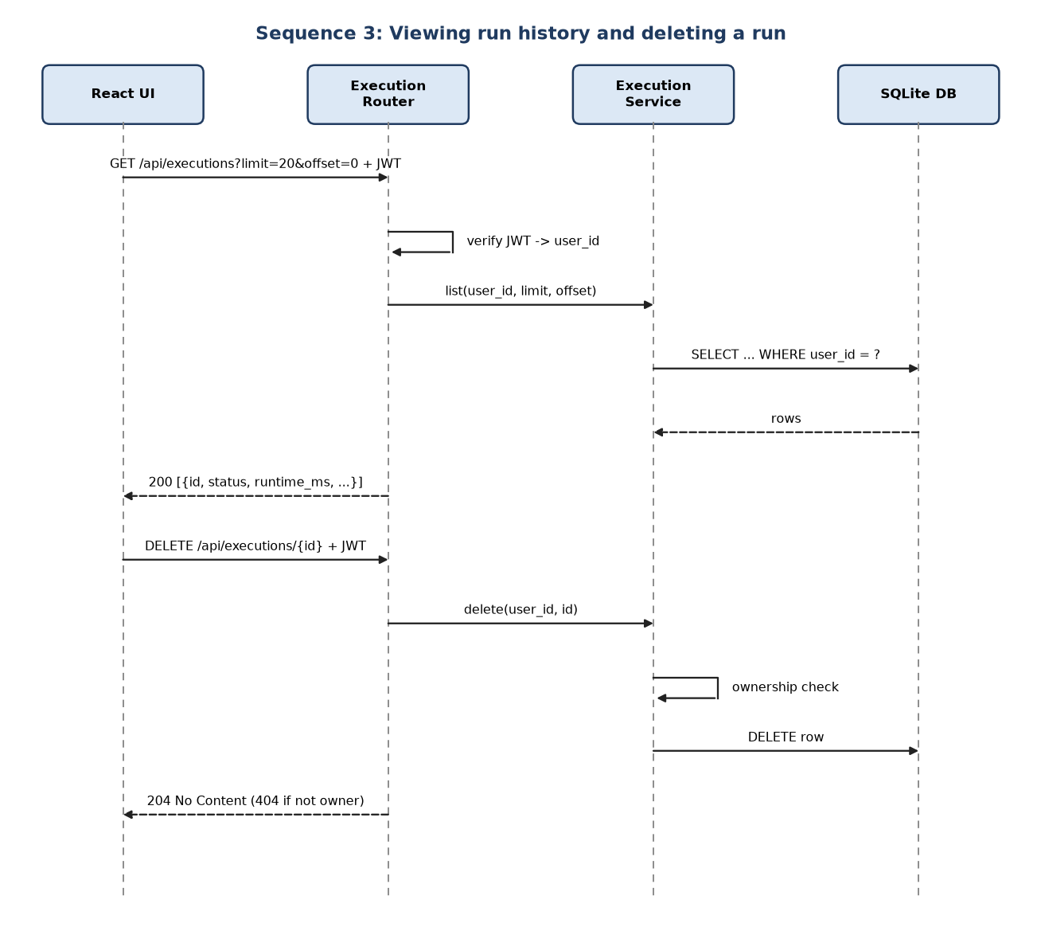
Figure 4.4 - Sequence: history list and delete

4.3 API Design
All endpoints are under /api, exchange JSON and are documented by OpenAPI at /docs. Authenticated endpoints expect the header Authorization: Bearer <token>.
Method | Path | Auth | Purpose | Success
POST | /api/auth/register | None | Create account | 201
POST | /api/auth/login | None | Obtain JWT | 200
GET | /api/auth/me | User | Current user profile | 200
POST | /api/executions | User | Run code | 200
GET | /api/executions | User | List own runs (limit, offset) | 200
GET | /api/executions/{id} | User | Run detail (owner only) | 200
DELETE | /api/executions/{id} | User | Delete run (owner only) | 204
GET | /api/limits | None | Published limits for the UI | 200
GET | /api/health | None | Liveness probe | 200
GET | /api/admin/audit-events | Admin | Audit events (type, from, to, limit, offset) | 200
GET | /api/admin/stats | Admin | Totals per status, users, active users, queue | 200

Component interface 1: Auth Router
POST /api/auth/register
Request : { "username": "alice", "password": "Passw0rd!" }
Response: 201 { "id": 7, "username": "alice", "is_admin": false }
Errors : 409 Username already taken
422 Validation error (length / strength rules)

POST /api/auth/login
Request : { "username": "alice", "password": "Passw0rd!" }
Response: 200 { "access_token": "<jwt>", "token_type": "bearer", "expires_in": 3600 }
Errors : 401 Invalid credentials (generic, no user enumeration)
429 Too many failed attempts (Retry-After header)

Component interface 2: Execution Router
POST /api/executions (Authorization: Bearer <jwt>)
Request : { "code": "print(input())", "stdin": "hello\n" }
Response: 200 {
"id": 128, "status": "COMPLETED",
"stdout": "hello\n", "stderr": "", "exit_code": 0,
"runtime_ms": 156, "peak_mem_kb": 9120,
"blocked_reason": null, "created_at": "2026-10-29T10:15:02Z"
}
Errors : 401 Missing/invalid token
413 Code or stdin too large
422 Validation error
429 Rate limit exceeded (Retry-After header)
503 Server busy, queue full

Note: a program that times out, is blocked or errors is still a 200
response; the outcome is carried in "status".

GET /api/executions?limit=20&offset=0
Response: 200 { "items": [ { "id", "status", "runtime_ms", "created_at", "code_preview" } ], "total": 57 }

Component interface 3: Sandbox Manager (internal Python interface)
class SandboxManager:
def run(self, source: str, stdin: str, limits: Limits) -> RunResult: ... # raises SandboxBusy when the queue is full

@dataclass
class Limits: timeout_s: float; memory_mb: int; output_bytes: int

@dataclass
class RunResult:
status: str # COMPLETED | RUNTIME_ERROR | TIMEOUT | MEMORY_LIMIT | OUTPUT_LIMIT | BLOCKED | INTERNAL_ERROR
stdout: str; stderr: str; exit_code: int | None
runtime_ms: int; peak_mem_kb: int | None; blocked_reason: str | None

4.4 Error Handling, Logging & Monitoring
- Uniform error body: { "error": { "code": "RATE_LIMITED", "message": "Too many runs, retry in 12 s" } } with the proper HTTP status; stack traces are never returned.
- Status code policy: 422 validation, 401 authentication, 403 authorisation, 404 not found or not owner, 409 conflict, 413 too large, 429 throttled, 503 busy, 500 unexpected (generic message, details in server log).
- Sanitised tracebacks: the runner filters its own frames and the manager scrubs the work-directory and runner paths from stderr; server paths never appear (TC-EXE-06).
- Logging: application log via the standard logging module; no passwords, tokens or full source code in logs. Security events go to audit_events.
- Monitoring: /api/health; /api/admin/stats gives total runs, per-status counts, average runtime, active users and queue length; the admin audit view lists bursts of BLOCKED_CODE or LOGIN_FAILED.
- Start-up sweep: on boot the server deletes stale sandbox temp directories, seeds the administrator and purges audit events older than the retention window.

4.5 UX Design
Primary screen (Editor page):
+----------------------------------------------------------------------+
| CodeBox [Editor] [History] [Admin*] alice [Logout] |
+----------------------------------------------------------------------+
| main.py Limits: 5 s | 128 MB | 64 KB output |
| +------------------------------------------+ +---------------------+ |
| | 1 name = input("Name? ") | | Standard input | |
| | 2 print("Hello,", name) | | Ada | |
| | | +---------------------+ |
| +------------------------------------------+ |
| [ Run ] Ctrl+Enter (spinner while running) |
+----------------------------------------------------------------------+
| [Completed] Runtime: 156 ms Memory: 9.1 MB Exit code: 0 |
| Output |
| Name? Hello, Ada |
| Errors (red, only if present) |
+----------------------------------------------------------------------+

- Status shown as a coloured badge with text (green completed, amber limit exceeded, red error/blocked) so colour is never the only signal.
- Inline validation on forms; the Run button is disabled while a run is in progress.
- Blocked code shows the rule and line that was violated.
- Ctrl+Enter runs the code; all controls are reachable by keyboard; ARIA labels on editor, stdin and output; results are announced through an aria-live region.
- History page: table (time, status, runtime, preview) with View, Delete and 'Load into editor'.

4.6 Open Issues & Next Steps
- Resolved: the memory limit was measured; a bare Python process commits about 10-13 MB, so the 128 MB limit leaves ample room.
- Resolved: reading the Python installation directory remains allowed (read-only) because imports need it; documented as residual risk.
- Open: usability walkthrough with three human participants (TC-UX-01) has not been performed.
- Open: independent penetration test before exposing the service to untrusted users.
- Future work: Docker/gVisor or Windows Sandbox backend behind the same SandboxManager interface; more languages; asynchronous queue with streaming output; per-user quotas; CAPTCHA on registration; make rate-limiter state shared across multiple server processes.

5. Appendices

5.1 Glossary
ADR architecture decision record; ORM object-relational mapper; JWT JSON Web Token; Job Object Windows kernel object enforcing limits on a group of processes; Audit hook CPython callback for sensitive runtime events (PEP 578); STRIDE threat categories; RBAC role-based access control; SPA single-page application; Fork bomb program that spawns processes exponentially.

5.2 References
- IEEE 42010 (architecture description)
- OWASP Top 10 and OWASP ASVS
- NIST SP 800-160 (systems security engineering)
- PEP 578 - Python Runtime Audit Hooks
- Microsoft Docs - Job Objects, JOBOBJECT_EXTENDED_LIMIT_INFORMATION
- FastAPI, SQLAlchemy, React, Vite documentation

5.3 Tools
Python, FastAPI/Uvicorn, pytest, Node.js/Vite/Vitest, SQLite, Swagger UI (built into FastAPI), matplotlib for the diagrams, docx-js for generating these documents (docs/tools).

