Software Requirements Specification (SRS)
Project: Secure Online Code Execution Platform (CodeBox)
Version: 1.1
Authors: SE Mini Project Team
Date: 29-10-2026
Status: Baselined; verification status recorded in the RTM (section 8)

Revision history
Version | Date | Author | Change summary | Approval
1.0 | 13-10-2026 | Project Team | Initial SRS with use-case diagrams and RTM
1.1 | 29-10-2026 | Project Team | Updated after implementation and testing: measured values in acceptance criteria, RTM status from executed tests

Approvals
Role | Name | Signature / Email | Date
Course Coordinator
Project Guide
Team Lead

Table of Contents
1. Introduction
2. Overall description
3. External interface requirements
4. System features (detailed)
5. Non-functional requirements (detailed) and 5.1 Security
6. Quality attributes & Acceptance tests
7. System models and diagrams
8. Requirements Traceability Matrix (RTM)

1. Introduction

1.1 Purpose
This document is the Software Requirements Specification (SRS) for the Secure Online Code Execution Platform. It defines the functional, non-functional and security requirements, the external interfaces and the verification criteria of a web platform that lets registered users write Python programs and execute them in an isolated environment on the server. It is the reference for the design (SAD), the implementation and the test plan (STP).

1.2 Scope
In scope: user registration and login; submission of Python 3 source code with optional standard input; execution of the code in an isolated child process with enforced time, memory, process and output limits; capture and display of stdout, stderr, exit code and statistics; storage and review of execution history; static and runtime protection of the host from unsafe code; an administrator view of audit events and statistics; a React web interface.
Out of scope: languages other than Python; interactive (streaming) terminals; code collaboration; installation of third-party packages by users; container/VM-level isolation (documented as future work); payment or quota billing; mobile applications.

1.3 Audience
Developers, QA engineers, project guides and assessment evaluators, and system administrators who deploy the platform.

1.4 Definitions
Term | Meaning
API | Application Programming Interface (REST over HTTP/JSON)
Sandbox | The isolated environment (child process + Job Object + runtime hook) in which user code runs
Job Object | A Windows kernel object that groups processes and enforces limits (memory, process count, CPU time) on them
Audit hook | A CPython (PEP 578) callback that observes and can veto sensitive runtime events such as file opens and socket connects
JWT | JSON Web Token, a signed token carrying the identity of an authenticated user
bcrypt | Adaptive password hashing function with per-password salt
SPA | Single Page Application (the React front end)
RBAC | Role-Based Access Control (user / administrator)
RTM | Requirements Traceability Matrix
STRIDE | Threat model: Spoofing, Tampering, Repudiation, Information disclosure, Denial of service, Elevation of privilege

2. Overall description

2.1 Product perspective
The platform is a self-contained three-tier web application: a React SPA in the user's browser, a FastAPI (Python) server that exposes a REST API and orchestrates executions, and an SQLite database. The server launches each submission as a separate, resource-limited child process (the sandbox). The platform does not depend on Docker or any external execution service. Figure 3.1 in the SAD shows the component structure.

2.2 Major product functions (detailed)
- Register and authenticate users (JWT)
- Submit Python code and standard input
- Validate code against a security policy before running
- Execute code in an isolated process with time / memory / process / output limits
- Capture and return stdout, stderr, exit code, runtime and memory
- Classify the outcome (completed, runtime error, timeout, memory limit, output limit, blocked)
- Store and browse the personal execution history
- Rate-limit and queue executions to protect the server
- Record security events and give administrators an audit and statistics view

2.3 User roles and characteristics (expanded)
- Learner (registered user): students or developers with basic Python knowledge who want to try code quickly; expects results in seconds and clear error messages.
- Administrator: operates the platform; reviews audit events and statistics; has no ability to see other users' passwords.
- Anonymous visitor: may only see the login and registration pages.
- Malicious actor (threat actor): a registered user who deliberately submits hostile code; treated as a design assumption for the security requirements.

2.4 Operating environment
Server: Windows 10/11 (64-bit), Python 3.11+, single machine (reference: 4 cores, 8 GB RAM). Client: current Chrome, Edge or Firefox. Build tooling: Node.js 20+ for the React front end. Database: SQLite file on the server.

2.5 Constraints
- No Docker or virtual machine is available; isolation must rely on OS process features (Job Objects), a hardened interpreter and CPython audit hooks.
- Only Python 3 is supported as the user language.
- Windows-specific APIs (Job Objects) are used; Linux support is out of scope for version 1.0.
- Default limits: 5 s execution time, 128 MB memory, 64 KB output per stream, 50 KB source, 16 KB stdin.
- A subprocess sandbox without hardware or container isolation cannot offer the guarantees of a VM; residual risks are documented in the SAD.

2.6 Assumptions and dependencies
- The host runs the platform under a non-administrator Windows account.
- Third-party libraries: FastAPI, SQLAlchemy, PyJWT, bcrypt, React, Vite, CodeMirror.
- System time is correct (needed for token expiry and rate limiting).

3. External interface requirements

3.1 User interfaces
A responsive React single-page application with pages: Login/Register, Editor (code editor, stdin box, Run button, output panel), History (table of previous runs with detail view) and Admin (audit events and statistics, administrators only). Accessibility: keyboard operable controls, labelled form fields, sufficient colour contrast, status conveyed by text as well as colour.

3.2 Hardware interfaces
None specific. The server uses the machine's CPU, memory and disk; the Job Object API of the Windows kernel is used to constrain child processes.

3.3 Software interfaces
- REST API (JSON over HTTP, Bearer JWT) between the SPA and the FastAPI server; documented via OpenAPI/Swagger at /docs.
- Database interface: SQLAlchemy ORM to SQLite (users, executions, audit_events).
- Operating-system interface: Win32 Job Object API (kernel32) via ctypes, and process creation for python.exe.
- Python interpreter: the base python.exe of the installation that runs the server, launched with isolated mode (-I) for user code.

3.4 Communications
- HTTP/1.1 with JSON bodies; CORS restricted to the configured front-end origin.
- TLS 1.2+ is required whenever the service is exposed beyond localhost (terminated by a reverse proxy); development runs on localhost without TLS.
- User code has no network access of any kind.
Coverage check against the template: this SRS contains 32 functional requirements (minimum 15), 8 non-functional requirements (minimum 5), 3 security objectives (2-4) and 10 security requirements (minimum 5).

4. System features (detailed)
Each requirement below includes acceptance criteria and a reference test case. IDs follow CEP-F-###.

4.1 User Registration and Authentication
Description: Create accounts and authenticate users so that execution and history are tied to an identity.
Req ID | Requirement (shall...) | Type | Priority | Source / Stakeholder | Acceptance criteria / Test case ref | Comments / Dependencies
CEP-F-001 | The system shall allow a visitor to register an account with a unique username (3-30 characters) and a password of at least 8 characters containing a letter and a digit. | Functional | High | Business | AC-F-001: Valid details create the account (201); duplicate or invalid details are rejected (409/422). Test: TC-AUTH-01, TC-AUTH-06 | Username compared case-insensitively
CEP-F-002 | The system shall store passwords only as salted bcrypt hashes and shall never return or log a password. | Functional | High | Security | AC-F-002: Database inspection shows only hashes; API responses and logs contain no password. Test: TC-AUTH-02 | See CEP-SR-002
CEP-F-003 | The system shall authenticate a user by username and password and issue a signed JWT access token valid for 60 minutes. | Functional | High | Business | AC-F-003: Correct credentials return 200 and a token; the token is rejected after expiry. Test: TC-AUTH-03 | Expiry configurable
CEP-F-004 | The system shall reject invalid credentials with a generic message and temporarily block a username/IP after 5 consecutive failures within 5 minutes. | Functional | High | Security | AC-F-004: The 6th attempt within the window returns 429 even with the correct password; a LOGIN_FAILED audit event is recorded. Test: TC-AUTH-04 | Prevents brute force and user enumeration
CEP-F-005 | The system shall require a valid token for all execution, history and admin endpoints and respond 401 otherwise. | Functional | High | Security | AC-F-005: Requests with missing, malformed, expired or tampered tokens return 401. Test: TC-AUTH-05

4.2 Code Submission and Execution
Description: Accept source code and stdin, run it in the sandbox and return the classified result.
Req ID | Requirement (shall...) | Type | Priority | Source / Stakeholder | Acceptance criteria / Test case ref | Comments / Dependencies
CEP-F-010 | The system shall accept Python 3 source code of at most 50 KB and optional standard input of at most 16 KB for execution. | Functional | High | Business | AC-F-010: Inputs within limits are accepted; larger inputs return 413 with a clear message. Test: TC-EXE-01, TC-EXE-10 | Limits configurable
CEP-F-011 | The system shall execute submitted code in a separate, isolated operating-system process and return its standard output, standard error and exit code. | Functional | High | Business | AC-F-011: print('hi') returns stdout 'hi', stderr empty, exit code 0. Test: TC-EXE-02 | Never in the server process
CEP-F-012 | The system shall classify every run with exactly one status: COMPLETED, RUNTIME_ERROR, TIMEOUT, MEMORY_LIMIT, OUTPUT_LIMIT, BLOCKED or INTERNAL_ERROR. | Functional | High | Business | AC-F-012: Each reference program in the test suite maps to the expected status. Test: TC-EXE-03 | Status table in SAD 4.1
CEP-F-013 | The system shall report the wall-clock runtime (ms) and peak memory (KB) of each run. | Functional | Medium | Business | AC-F-013: Response contains runtime_ms and peak_mem_kb greater than 0 for completed runs. Test: TC-EXE-04
CEP-F-014 | The system shall supply the submitted stdin to the program and deliver end-of-file once it is consumed. | Functional | Medium | Business | AC-F-014: A program using input() echoes the supplied lines; reading past the end raises EOFError. Test: TC-EXE-05
CEP-F-015 | The system shall capture syntax errors and uncaught exceptions and return the Python traceback in stderr with status RUNTIME_ERROR. | Functional | High | Business | AC-F-015: A program raising ZeroDivisionError returns non-zero exit code and the traceback text. Test: TC-EXE-06 | Tracebacks must not reveal server paths
CEP-F-016 | The system shall run at most 4 executions concurrently and queue up to 20 further requests, returning 503 when the queue is full. | Functional | Medium | Operations | AC-F-016: With 4 long jobs running, 20 requests are queued and the 25th receives 503. Test: TC-EXE-07 | Protects host CPU/RAM
CEP-F-017 | The system shall give every run a fresh private working directory that is deleted after the run, so that no state persists between runs. | Functional | High | Security | AC-F-017: A file name written or listed in run N is absent in run N+1; the directory no longer exists after the run. Test: TC-EXE-08
CEP-F-018 | The system shall limit each user to 10 executions per minute and respond 429 when exceeded. | Functional | Medium | Operations | AC-F-018: The 11th request within 60 s returns 429 with a Retry-After header. Test: TC-EXE-09 | Sliding window

4.3 Resource Limits and Safety Enforcement
Description: Protect the host from unsafe or abusive programs using static checks, OS limits and runtime hooks.
Req ID | Requirement (shall...) | Type | Priority | Source / Stakeholder | Acceptance criteria / Test case ref | Comments / Dependencies
CEP-F-020 | The system shall terminate a program that exceeds 5 seconds of execution time and report status TIMEOUT. | Functional | High | Security | AC-F-020: while True: pass is killed within 5.5 s and reported as TIMEOUT. Test: TC-SBX-01 | Both wall-clock and CPU limit
CEP-F-021 | The system shall terminate a program whose memory use exceeds 128 MB and report status MEMORY_LIMIT. | Functional | High | Security | AC-F-021: Allocating a 500 MB list is killed and reported as MEMORY_LIMIT; the server stays healthy. Test: TC-SBX-02 | Job Object memory limit
CEP-F-022 | The system shall cap captured stdout and stderr at 64 KB each, terminate the program when the cap is exceeded and report status OUTPUT_LIMIT. | Functional | High | Security | AC-F-022: An infinite print loop is stopped; the response is at most 64 KB per stream. Test: TC-SBX-03
CEP-F-023 | The system shall prevent user code from creating additional processes (fork bombs, subprocess, os.system). | Functional | High | Security | AC-F-023: Attempts to spawn processes fail or are blocked; the process count of the job never exceeds 1. Test: TC-SBX-04 | ActiveProcessLimit = 1 plus audit hook
CEP-F-024 | The system shall statically analyse submitted code before execution and reject code that imports or uses blocked modules or built-ins, returning status BLOCKED with the reason. | Functional | High | Security | AC-F-024: 'import socket' and 'eval(...)' return BLOCKED naming the rule; the code is never started. Test: TC-SBX-05 | Policy list in SAD 4.1
CEP-F-025 | The system shall deny user code any network access and any file access outside its working directory, and any file write. | Functional | High | Security | AC-F-025: Opening C:\Windows\win.ini, any file for writing, or a socket fails with PermissionError. Test: TC-SBX-06 | Runtime audit hook
CEP-F-026 | The system shall terminate the whole process tree and release all resources of a run, including when the platform itself raises an error. | Functional | High | Reliability | AC-F-026: After 100 mixed runs no python.exe child and no temp directory remains. Test: TC-SBX-07 | KILL_ON_JOB_CLOSE + finally block

4.4 Execution History
Description: Persist and review past executions, visible only to their owner.
Req ID | Requirement (shall...) | Type | Priority | Source / Stakeholder | Acceptance criteria / Test case ref | Comments / Dependencies
CEP-F-030 | The system shall persist every execution (code, stdin, status, output, runtime, timestamp) linked to the submitting user. | Functional | High | Business | AC-F-030: After a run, the record is retrievable by its id. Test: TC-HIS-01
CEP-F-031 | The system shall list a user's own executions newest first with pagination. | Functional | Medium | Business | AC-F-031: GET /api/executions?limit=5&offset=5 returns the second page in descending time order. Test: TC-HIS-02
CEP-F-032 | The system shall return the full detail of an execution only to its owner and respond 404 to any other user. | Functional | High | Security | AC-F-032: User B requesting user A's execution id receives 404. Test: TC-HIS-03 | Object-level authorisation
CEP-F-033 | The system shall allow a user to delete their own execution records. | Functional | Low | Business | AC-F-033: DELETE returns 204 and subsequent GET returns 404. Test: TC-HIS-04

4.5 Web Interface
Description: Provide the browser front end for the above functions.
Req ID | Requirement (shall...) | Type | Priority | Source / Stakeholder | Acceptance criteria / Test case ref | Comments / Dependencies
CEP-F-040 | The web interface shall provide a code editor with Python syntax highlighting, a standard-input box and a Run button. | Functional | High | Business | AC-F-040: The three controls are visible on the editor page and Run submits the code. Test: TC-UI-01
CEP-F-041 | The web interface shall display stdout, stderr, status badge, runtime and memory for each run, distinguishing errors visually. | Functional | High | Business | AC-F-041: After each run the output panel shows all fields; stderr is rendered in an error colour. Test: TC-UI-02
CEP-F-042 | The web interface shall show a progress state while a run is in progress and prevent duplicate submission. | Functional | Medium | Usability | AC-F-042: The Run button is disabled and a spinner is shown until the response arrives. Test: TC-UI-03
CEP-F-043 | The web interface shall provide registration and login forms with inline validation messages and a history page listing past runs. | Functional | Medium | Usability | AC-F-043: Invalid input shows a message next to the field; the history page lists runs and opens their detail. Test: TC-UI-04

4.6 Administration and Monitoring
Description: Give administrators visibility of security events and platform usage.
Req ID | Requirement (shall...) | Type | Priority | Source / Stakeholder | Acceptance criteria / Test case ref | Comments / Dependencies
CEP-F-050 | The system shall let an administrator view security audit events, filterable by type and date. | Functional | Medium | Operations | AC-F-050: GET /api/admin/audit-events?type=BLOCKED_CODE returns only matching events. Test: TC-ADM-01
CEP-F-051 | The system shall let an administrator view platform statistics: total runs, runs per status and number of active users. | Functional | Low | Operations | AC-F-051: The statistics endpoint returns counts consistent with the database. Test: TC-ADM-02
CEP-F-052 | The system shall respond 403 to any non-administrator calling an admin endpoint. | Functional | High | Security | AC-F-052: A normal user's token on /api/admin/* returns 403. Test: TC-ADM-03

5. Non-functional requirements (detailed)
NFRs below are measurable and tied to test plans. IDs CEP-NF-###.
Req ID | Requirement | Category | Priority | Acceptance criteria / Measurement
CEP-NF-001 | A trivial program (e.g. print('hi')) shall return its result within 2 seconds for 90% of requests on the reference machine, excluding queue wait. | Performance | High | 90th percentile of 30 runs <= 2 s. Test: TC-PERF-01
CEP-NF-002 | Sandbox start-up overhead (process creation, job setup, cleanup) shall not exceed 500 ms. | Performance | Medium | Mean time of empty-program runs <= 500 ms. Test: TC-PERF-02
CEP-NF-003 | No program in the attack test-suite (file read/write, network, process spawn, fork bomb, memory bomb, output flood, import tricks) shall compromise the host or the server process. | Security | High | 100% of attack cases end in a controlled status and the server remains healthy. Test: TC-SEC-01..TC-SEC-10, TC-SBX-*
CEP-NF-004 | The server shall remain responsive (health endpoint answers within 1 s) while hostile programs are running, and shall leave no orphan processes after 100 mixed runs. | Reliability | High | Health probe latency <= 1 s during load; process count returns to baseline. Test: TC-REL-01
CEP-NF-005 | A first-time user shall be able to register, log in and run a program within 2 minutes without documentation; the UI shall work in current Chrome, Edge and Firefox at 1280x720 or larger. | Usability | Medium | Usability walkthrough with 3 users succeeds. Test: TC-UX-01
CEP-NF-006 | The platform shall run on Windows 10/11 with Python 3.11+ and Node.js 20+, install with documented commands only, and expose all limits as environment variables. | Portability / Maintainability | Medium | A clean machine follows HOW_TO_RUN.md and reaches a working app. Test: TC-MNT-01
CEP-NF-007 | All security-relevant events shall be stored with timestamp, user, IP and type, and retained for at least 90 days (configurable). | Auditability | Medium | Events for failed login, blocked code and limit breaches are queryable. Test: TC-OPS-01
CEP-NF-008 | A single reference machine (4 cores, 8 GB RAM) shall support 20 concurrent users with 4 simultaneous executions without request failures other than 429/503. | Scalability | Medium | Load test of 20 virtual users. Test: TC-PERF-03

5.1. Security

5.1.1 Security Objectives
ID | Objective | Description
SO-1 | Host integrity and availability | Untrusted code must never be able to read, modify or destroy the host system, nor exhaust its CPU, memory, disk or process table so that the platform becomes unavailable.
SO-2 | Confidentiality and isolation of data | Credentials, tokens, server secrets and one user's code and results must never be disclosed to another user or to the executing program.
SO-3 | Accountability and abuse detection | Security-relevant actions must be attributable to a user and recorded so that abuse (brute force, repeated malicious submissions, flooding) can be detected and investigated.

5.1.2 Security Requirements
Req ID | Requirement (shall...) | Type | Priority | Acceptance criteria / Test case ref
CEP-SR-001 | All user code shall run in a separate OS process, assigned to a Windows Job Object, and never inside the server process. | Security | High | Process inspection shows execution in a child python.exe inside a job. Test: TC-SEC-01
CEP-SR-002 | Passwords shall be hashed with bcrypt (cost >= 12 in production) and never logged or returned by any API. | Security | High | DB dump and logs contain no plaintext password. Test: TC-SEC-02
CEP-SR-003 | Tokens shall be signed (HS256) with a secret supplied via environment, expire after 60 minutes, and be required on every endpoint except register, login, health and limits. | Security | High | Tampered/expired tokens rejected with 401. Test: TC-SEC-03
CEP-SR-004 | Access to executions shall be restricted to the owning user (object-level authorisation). | Security | High | Cross-user access returns 404. Test: TC-SEC-04
CEP-SR-005 | All inputs shall be validated by schema and size; database access shall use the ORM with parameterised queries only. | Security | High | SQL-injection strings and oversize bodies are rejected or stored inertly. Test: TC-SEC-05
CEP-SR-006 | The child process environment shall contain only an allow-listed minimal set of variables and no server secrets. | Security | High | A program printing its environment shows no JWT secret or DB path. Test: TC-SEC-06
CEP-SR-007 | A runtime audit hook inside the child shall deny network, process-creation, ctypes and out-of-sandbox file events, and any file write. | Security | High | Each denied event class raises PermissionError. Test: TC-SEC-07
CEP-SR-008 | CORS shall be restricted to the configured front-end origin, and standard security headers shall be sent; production deployments shall terminate TLS 1.2+. | Security | Medium | Cross-origin call from another origin is blocked. Test: TC-SEC-08
CEP-SR-009 | Security events (login failure, blocked code, limit breach, admin access) shall be written to the audit log without storing passwords or tokens. | Security | Medium | Audit rows exist for each event class and contain no secrets. Test: TC-SEC-09
CEP-SR-010 | Login and execution endpoints shall be rate limited per user/IP to slow brute force and flooding. | Security | Medium | Excess requests return 429. Test: TC-SEC-10

The threat analysis (STRIDE), trust boundaries and the layered defence that realise these requirements are in the SAD, section 3.9.

6. Quality attributes & Acceptance tests
- Exit criteria for acceptance: all High-priority functional and security requirements implemented and verified, no critical NFR failure, every attack test ends in a controlled status, and the RTM shows all test cases passed.
- Acceptance test suites: Authentication (TC-AUTH), Execution (TC-EXE), Sandbox (TC-SBX), History (TC-HIS), User interface (TC-UI), Administration (TC-ADM), Security (TC-SEC), Performance/Reliability (TC-PERF, TC-REL), Usability and maintainability (TC-UX, TC-MNT, TC-OPS).
- Quality attributes: security (primary), reliability, performance, usability, maintainability, portability.

7. System models and diagrams

7.1 UML Use-Case diagrams
Use-case diagram 1 - Learner use cases. The learner registers, logs in, writes code, supplies input, runs it in the sandbox, views output and manages history. Running code includes policy validation and resource-limit enforcement and may extend to recording an audit event.
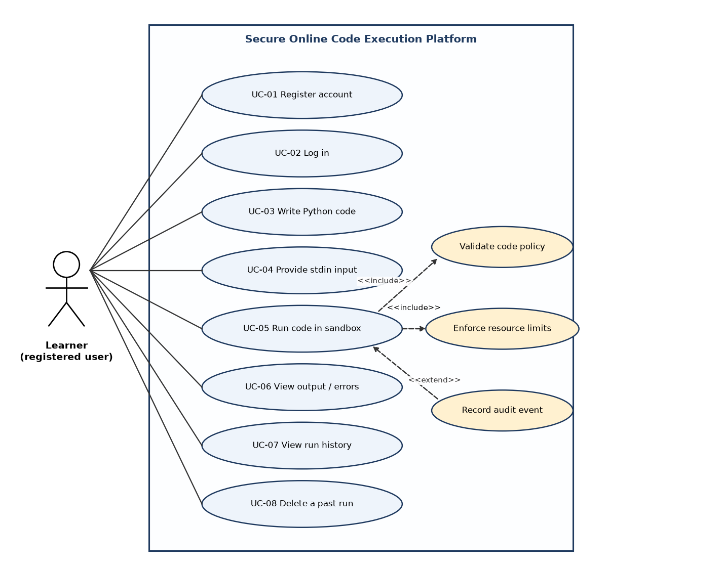
Figure 7.1 - Use-case diagram: learner interactions
Use-case diagram 2 - Administration and sandbox subsystem. The administrator monitors audit events and statistics and configures limits; the sandbox runtime (system actor) terminates runaway processes and cleans temporary files.
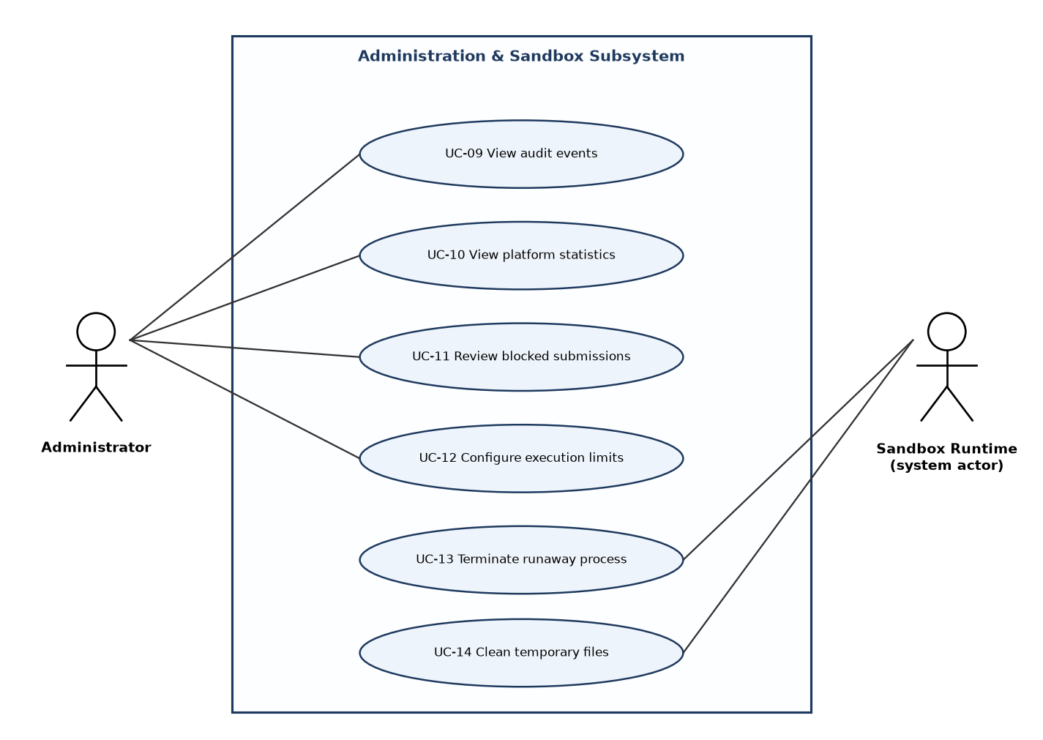
Figure 7.2 - Use-case diagram: administration and sandbox runtime

7.2 Use-case descriptions (key use cases)
Use case | Actor | Main flow | Alternate / exception flows
UC-01 Register account | Learner | 1. Open registration page. 2. Enter username and password. 3. System validates and stores bcrypt hash. 4. System confirms. | Username exists -> 409. Weak password -> 422 with rules.
UC-02 Log in | Learner | 1. Enter credentials. 2. System verifies. 3. System returns JWT. 4. UI opens editor. | Wrong credentials -> 401 generic. 5 failures -> 429 and audit event.
UC-05 Run code in sandbox | Learner | 1. Click Run. 2. System authenticates and rate-checks. 3. Code validator accepts. 4. Sandbox runs code under limits. 5. Result is stored and returned. 6. UI shows output. | Policy violation -> BLOCKED. Limit exceeded -> TIMEOUT / MEMORY_LIMIT / OUTPUT_LIMIT. Queue full -> 503. Rate exceeded -> 429.
UC-07 View run history | Learner | 1. Open History. 2. System lists own runs newest first. 3. Learner opens a run to see code and output. | Foreign id -> 404.
UC-09 View audit events | Administrator | 1. Open Admin page. 2. Filter by type/date. 3. Review events. | Non-admin -> 403.

8. Requirements Traceability Matrix (RTM)
Status legend: N = not started, P = partially verified, A = achieved / verified by passing tests. Status is derived from the executed test run of 29-10-2026 (see the Test Plan, section 14).
Req ID | Requirement short | Section ref / Design Spec | Module | Test case(s) | Status (N/P/A) | Comments
CEP-F-001 | Register account | 4.1 / DS-AUTH-01 | AuthModule | TC-AUTH-01, TC-AUTH-06 | A
CEP-F-002 | Hash passwords | 4.1 / DS-AUTH-01 | AuthModule | TC-AUTH-02 | A
CEP-F-003 | Login / issue JWT | 4.1 / DS-AUTH-01 | AuthModule | TC-AUTH-03 | A
CEP-F-004 | Login throttling | 4.1 / DS-AUTH-02 | AuthModule | TC-AUTH-04 | A
CEP-F-005 | Token required | 4.1 / DS-AUTH-01 | AuthModule | TC-AUTH-05 | A
CEP-F-010 | Accept code + stdin | 4.2 / DS-EXE-01 | ExecutionModule | TC-EXE-01, TC-EXE-10 | A
CEP-F-011 | Isolated execution | 4.2 / DS-SBX-01 | SandboxModule | TC-EXE-02 | A
CEP-F-012 | Status classification | 4.2 / DS-EXE-01 | ExecutionModule | TC-EXE-03 | A
CEP-F-013 | Runtime / memory stats | 4.2 / DS-SBX-03 | SandboxModule | TC-EXE-04 | A
CEP-F-014 | stdin support | 4.2 / DS-SBX-03 | SandboxModule | TC-EXE-05 | A
CEP-F-015 | Capture errors | 4.2 / DS-SBX-03 | SandboxModule | TC-EXE-06 | A
CEP-F-016 | Concurrency + queue | 4.2 / DS-EXE-02 | ExecutionModule | TC-EXE-07 | A
CEP-F-017 | Fresh workdir per run | 4.2 / DS-SBX-01 | SandboxModule | TC-EXE-08 | A
CEP-F-018 | Rate limit runs | 4.2 / DS-EXE-01 | RateLimiter | TC-EXE-09 | A
CEP-F-020 | Time limit | 4.3 / DS-SBX-01 | SandboxModule | TC-SBX-01 | A
CEP-F-021 | Memory limit | 4.3 / DS-SBX-01 | SandboxModule | TC-SBX-02 | A
CEP-F-022 | Output cap | 4.3 / DS-SBX-03 | SandboxModule | TC-SBX-03 | A
CEP-F-023 | No child processes | 4.3 / DS-SBX-02 | SandboxModule | TC-SBX-04 | A
CEP-F-024 | Static policy check | 4.3 / DS-VAL-01 | ValidatorModule | TC-SBX-05 | A
CEP-F-025 | File / network denial | 4.3 / DS-SBX-02 | SandboxModule | TC-SBX-06 | A
CEP-F-026 | Cleanup | 4.3 / DS-SBX-01 | SandboxModule | TC-SBX-07 | A
CEP-F-030 | Persist runs | 4.4 / DS-HIS-01 | HistoryModule | TC-HIS-01 | A
CEP-F-031 | List history | 4.4 / DS-HIS-01 | HistoryModule | TC-HIS-02 | A
CEP-F-032 | Owner-only detail | 4.4 / DS-HIS-01 | HistoryModule | TC-HIS-03 | A
CEP-F-033 | Delete run | 4.4 / DS-HIS-01 | HistoryModule | TC-HIS-04 | A
CEP-F-040 | Editor + Run | 4.5 / DS-UI-01 | FrontendUI | TC-UI-01 | A
CEP-F-041 | Output panel | 4.5 / DS-UI-01 | FrontendUI | TC-UI-02 | A
CEP-F-042 | Progress state | 4.5 / DS-UI-01 | FrontendUI | TC-UI-03 | A
CEP-F-043 | Auth + history UI | 4.5 / DS-UI-02 | FrontendUI | TC-UI-04 | A
CEP-F-050 | View audit events | 4.6 / DS-ADM-01 | AdminModule | TC-ADM-01 | A
CEP-F-051 | Platform statistics | 4.6 / DS-ADM-01 | AdminModule | TC-ADM-02 | A
CEP-F-052 | Admin RBAC | 4.6 / DS-ADM-01 | AdminModule | TC-ADM-03 | A
CEP-NF-001 | Response time | 5 / DS-SBX-01 | SandboxModule | TC-PERF-01 | A
CEP-NF-002 | Sandbox overhead | 5 / DS-SBX-01 | SandboxModule | TC-PERF-02 | A
CEP-NF-003 | Attack resistance | 5 / DS-SBX-02 | SandboxModule | TC-SBX-01, TC-SBX-04, TC-SBX-06, TC-SEC-01 | A
CEP-NF-004 | Resilience | 5 / DS-SBX-01 | SandboxModule | TC-REL-01, TC-SBX-07 | A
CEP-NF-005 | Usability | 5 / DS-UI-01 | FrontendUI | TC-UX-01 | N | TC-UX-01 pending
CEP-NF-006 | Portability | 5 / DS-OPS-01 | Config | TC-MNT-01 | A
CEP-NF-007 | Audit retention | 5 / DS-AUD-01 | AuditModule | TC-OPS-01 | A
CEP-NF-008 | Capacity | 5 / DS-EXE-02 | ExecutionModule | TC-PERF-03 | A
CEP-SR-001 | Process isolation | 5.1.2 / DS-SBX-01 | SandboxModule | TC-SEC-01 | A
CEP-SR-002 | Password hashing | 5.1.2 / DS-AUTH-01 | AuthModule | TC-SEC-02, TC-AUTH-02 | A
CEP-SR-003 | Token security | 5.1.2 / DS-AUTH-01 | AuthModule | TC-SEC-03, TC-AUTH-05 | A
CEP-SR-004 | Object-level auth | 5.1.2 / DS-HIS-01 | HistoryModule | TC-SEC-04, TC-HIS-03 | A
CEP-SR-005 | Input validation | 5.1.2 / DS-SEC-01 | All | TC-SEC-05 | A
CEP-SR-006 | Clean environment | 5.1.2 / DS-SBX-01 | SandboxModule | TC-SEC-06 | A
CEP-SR-007 | Runtime hook | 5.1.2 / DS-SBX-02 | SandboxModule | TC-SEC-07, TC-SBX-06 | A
CEP-SR-008 | CORS / headers | 5.1.2 / DS-SEC-01 | FastAPI app | TC-SEC-08 | A
CEP-SR-009 | Audit logging | 5.1.2 / DS-AUD-01 | AuditModule | TC-SEC-09, TC-OPS-01 | A
CEP-SR-010 | Rate limiting | 5.1.2 / DS-AUTH-02 | RateLimiter | TC-SEC-10, TC-AUTH-04, TC-EXE-09 | A

RTM summary: 49 of 50 requirements achieved (A), 0 partially verified (P), 1 not verified (N).

