Vasavi College of Engineering
Department of Electronics and Communication Engineering

Microprocessors and Microcontrollers
Course Based Project Report (2025-26)
Semester V

Password Protected Door Lock System using 8051

By: -
Pagidoju Siddhartha Chary 1602-23-735-109 ECE B
Yenamandra Siri Satyamurthy 1602-23-735-111 ECE B
Yashwanth Chakravarthy 1602-23-735-128 ECE B

INDEX
S. No. |  | Content | Page No.
1 | Abstract |  | 1
2 | Objectives |  | 1
3 | Introduction |  | 2
4 | Block Diagram |  | 3
5 | Circuit Diagram |  | 3
6 | Explanation |  | 4
7 | List of Components |  | 5
8 | Program |  | 6
9 | Code Explanation |  | 11
10 | Results |  | 13
11 | Applications |  | 14
12 | Advantages |  | 14
13 | Limitations |  | 15
14 | Future Scope |  | 15
15 | Conclusion |  | 16

ABSTRACT

The project “Password Protected Door Lock System using 8051 Microcontroller” aims to design a secure and automated access control mechanism that allows only authorized users to operate a door through a password entered via a keypad. The system uses the AT89C51 microcontroller as the main controller, interfaced with a 4x3 matrix keypad for user input, a 16x2 LCD for display messages, and a DC motor with a driver circuit to perform the physical locking and unlocking actions. When a correct 4-digit password is entered, the system unlocks the door by rotating the motor in one direction, waits for a few seconds, and then locks it again by reversing the motor. If an incorrect password is entered three consecutive times, the system activates a 10-second lockout to prevent unauthorized access. The project also includes a feature to change the password using a predefined key sequence through the keypad itself. The entire design is implemented in Embedded C using Keil µVision and simulated in Proteus Design Suite. This project effectively demonstrates the use of microcontrollers in automation and security systems, combining both hardware and software concepts to achieve a reliable, flexible, and user-friendly digital door lock system.

OBJECTIVES

- To design and implement a secure password-based access control system using the AT89C51 microcontroller.
- To interface a keypad, LCD display, and DC motor driver with the microcontroller for real-time operation.
- To develop an algorithm for password verification, allowing access only when the entered password matches the stored one.
- To implement a security feature that locks the system for 10 seconds after three consecutive incorrect password attempts.
- To provide an option for changing the password directly through the keypad using a special key sequence.
- To simulate and test the complete system using Keil µVision for coding and Proteus Design Suite for circuit verification.
- To demonstrate the use of embedded system concepts in real-world automation and security applications.

INTRODUCTION

Security plays an important role in modern life, especially in homes, offices, and laboratories where controlled access is essential. Traditional mechanical locks are often limited in functionality and prone to unauthorized use. To overcome these drawbacks, electronic password-based systems provide a more reliable and flexible approach to access control.
The Password Protected Door Lock System using 8051 Microcontroller is designed to improve security by using a digital password mechanism instead of physical keys. The system uses a 4x3 matrix keypad for password input, a 16x2 LCD for displaying system messages, and a DC motor (controlled through a driver circuit) to simulate door movement. The AT89C51 microcontroller serves as the main control unit, handling input from the keypad, comparing it with the stored password, and controlling the motor accordingly.
When the correct password is entered, the motor rotates to unlock the door, waits for a few seconds, and then locks it again automatically. If the password is entered incorrectly three times, the system activates a 10-second lockout for added security. Additionally, a special keypad command allows users to change the password without reprogramming the microcontroller.
This project demonstrates how embedded systems can be used to build efficient, low-cost, and user-friendly security solutions, integrating both hardware and software for real-time control and automation.

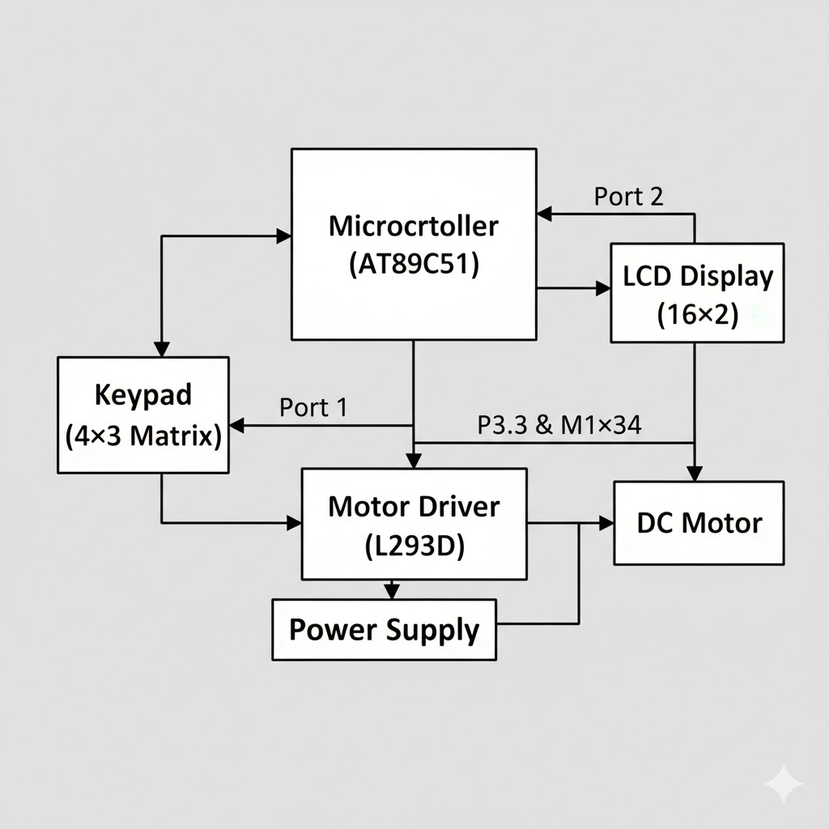

BLOCK DIAGRAM EXPLANATION
The block diagram of the Password Protected Door Lock System mainly consists of the AT89C51 microcontroller, a 4×3 keypad, a 16×2 LCD display, a motor driver (L293D), a DC motor, and a power supply. Each of these components performs a specific function and works together to achieve the desired password-controlled locking mechanism.
The AT89C51 microcontroller serves as the central processing unit of the system. It receives input from the keypad, processes the entered password, and sends control signals to the motor driver and LCD display. The 4×3 keypad, connected to Port 1 of the microcontroller, allows the user to enter numeric passwords and special command sequences. The microcontroller continuously scans the keypad to detect key presses and stores the entered digits temporarily for comparison.
The 16×2 LCD display, connected to Port 2 of the microcontroller, provides real-time feedback to the user. It displays prompts like “ENTER PASSWORD,” “PASSWORD MATCH,” and “ACCESS DENIED,” allowing easy interaction and understanding of the system’s current state.
The motor driver (L293D) acts as an interface between the low-power microcontroller and the high-current DC motor. It receives control signals from pins P3.3 and P3.4 of the AT89C51 and drives the motor in the desired direction. The DC motor, connected to the motor driver outputs, performs the physical action of locking and unlocking the mechanism depending on the password verification result.
The power supply provides the necessary voltage and current to the motor driver and indirectly powers the motor and microcontroller. This ensures stable and reliable operation of the entire system. Together, these blocks form an efficient and secure password-based door lock system capable of providing controlled access.

CIRCUIT DIAGRAM

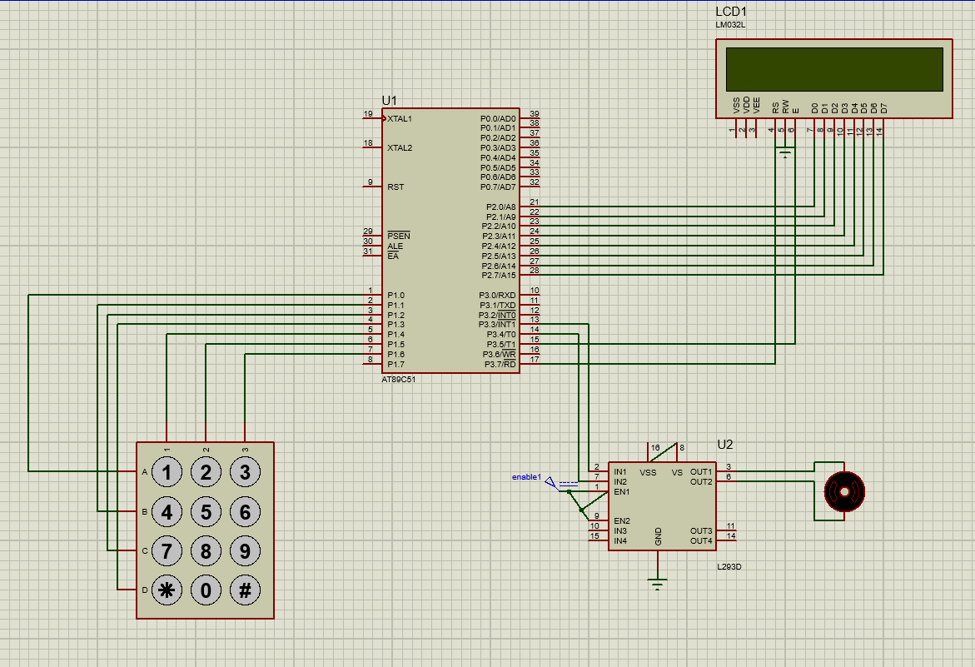

WORKING OF THE CIRCUIT
1. Power Initialization
- The power supply provides +5 V to the L293D motor driver.
- Once power is ON, the microcontroller begins program execution.
2. System Initialization
- The AT89C51 initializes the LCD (connected to Port 2) using lcd_init() and clears the display.
- The motor control pins (P3.3 and P3.4) connected to the L293D are set low to keep the motor OFF.
- The LCD displays the startup message:
“PASSWORD PROTECT SYSTEM”.
3. Password Entry Stage
- The system then prompts the user:
“ENTER PASSWORD:”
- The keypad (connected to Port 1) is continuously scanned using keyscan().
- Each numeric key pressed by the user is stored in an array and displayed as * on the LCD for confidentiality.
- The * key clears the input, and the # key confirms the entry.
4. Password Verification
- When the user presses #, the entered digits are compared with the stored password.
- If all four digits match → the system proceeds to unlock the door.
- If incorrect → the LCD shows “PASSWORD WRONG” and prompts again.
- After three wrong attempts, the system locks for 10 seconds, displaying a countdown on the LCD.
5. Unlocking Stage
- On a correct password, the LCD shows “PASSWORD MATCH”.
- The AT89C51 sends signals to the L293D motor driver inputs (IN1 & IN2) to rotate the DC motor in one direction.
- The motor turns approximately 90° to simulate unlocking the door.
- After unlocking, the motor is stopped and remains idle for about 4 seconds.
6. Automatic Lock back
- After the delay, the AT89C51 reverses the logic to the motor driver inputs, rotating the motor in the opposite direction to lock the door back.
- Once locking is complete, both control pins are set LOW to stop the motor.
7. Password Change Option
- If the user enters the special code “*440#”, the system enters Password Change Mode.
- The LCD prompts “SET NEW PASSWORD:” and the user enters four new digits.

COMPONENTS
Component Name | Quantity | Specification | Function
AT89C51  Microcontroller | 1 | 8-bit MCU, 4 KB Flash, 128 bytes RAM, 32 I/O pins | Controls the stopwatch operation timing, display, and button handling
4X3 Matrix Keypad | 1 | 12 keys arranged in 4 rows and 3 columns  Keys labeled 0–9, ‘*’, and ‘#’  Interface type: digital input to microcontroller | The keypad serves as the user input interface. It allows users to enter passwords, clear input (‘*’), confirm entries (‘#’), and access password change mode.
16X2 LCD Display | 1 | Display format: 16 characters × 2 lines  Operating voltage: 4.7V to 5.3V  Logic ‘1’ voltage: 2.2V to 5V  Interface: 8-bit or 4-bit parallel data | It provides clear feedback to the user during password entry and system operation.
L293D Motor Driver IC | 1 | Dual H-Bridge motor driver  Supply voltage for logic (VCC1): 5V  Motor supply voltage (VCC2): up to 36V | The L293D acts as an interface between the microcontroller and the DC motor.
DC Motor | 1 | Bidirectional rotation capability via H-Bridge | The DC motor simulates the mechanical locking mechanism.
Power Supply  (DC) | 1 | +5V regulated supply | Provides operating voltage for the dc motor driver
Ground (GND) | 1 | Common ground node | Provides reference for all voltage levels

PROGRAM
#include <reg51.h>
#include "lcdpro.h"
#include "keypadpro.h"
#include "motorpro.h"
void check(void);
void wait(void);
void change_password(void);
unsigned char password[4] = {'1', '2', '3', '4'}; // default password
unsigned char entered[10];
unsigned char count = 0;
unsigned char attempts = 0;
void main(void)
{
unsigned char key;
lcd_init();
motor_init();
lcd_cmd(0x80);
printString("PASSWORD PROTECT");
lcd_cmd(0xC4);
printString("SYSTEM");
delay(800);
lcd_cmd(0x01);
lcd_cmd(0x80);
printString("ENTER PASSWORD:");
lcd_cmd(0xC0);
while (1)
{
key = keyscan();
if (key >= '0' && key <= '9')
{
if (count < 10) // allow multiple digits before #
{
entered[count++] = key;
lcd_data('*');
}
}
else if (key == '*')
{
lcd_cmd(0x01);
lcd_cmd(0x80);
printString("ENTER PASSWORD:");
lcd_cmd(0xC0);
count = 0;
}
else if (key == '#')
{
// If the user entered *440# sequence, trigger password change mode
if (count == 3 && entered[0] == '4' && entered[1] == '4' && entered[2] == '0')
{
change_password();
}
else if (count == 4)
{
check();
}
else
{
lcd_cmd(0x01);
printString("PASSWORD WRONG");
delay(600);
}

// Reset for next input
count = 0;
lcd_cmd(0x01);
lcd_cmd(0x80);
printString("ENTER PASSWORD:");
lcd_cmd(0xC0);
}
}
}
void check(void)
{
if (entered[0] == password[0] && entered[1] == password[1] &&
entered[2] == password[2] && entered[3] == password[3])
{
lcd_cmd(0x01);
printString("PASSWORD MATCH");
motor_unlock(); // rotate motor to unlock
delay(150); // rotate duration (adjust to reach 90°)
// Stop motor
mp = 0;
mn = 0;
delay(1000); // 4 seconds wait while unlocked
delay(1000);
//delay(1000);
//delay(1000);
// Lock again
lockback(); // rotate reverse to lock
//delay(400); // same rotation time for locking

mp = 0;
mn = 0;
attempts = 0;
}
else
{
attempts++;
lcd_cmd(0x01);
printString("PASSWORD WRONG");
lcd_cmd(0xC0);
printString("TRY AGAIN");
delay(800);
if (attempts >= 3)
{
attempts = 0;
wait(); // 10-sec lockout
}
}
}
void wait(void)
{
unsigned char i;
lcd_cmd(0x01);
printString("ACCESS DENIED");
lcd_cmd(0xC0);
printString("WAIT 10 SECONDS");
for (i = 10; i > 0; i--)
{
lcd_cmd(0xC0);
printString("WAIT ");
lcd_data((i / 10) + '0');
lcd_data((i % 10) + '0');
printString(" SECONDS ");
delay(1000);
}
lcd_cmd(0x01);
lcd_cmd(0x80);
printString("ENTER PASSWORD:");
lcd_cmd(0xC0);
}
void change_password(void)
{
unsigned char i, newkey;
lcd_cmd(0x01);
printString("SET NEW PASSWORD:");
lcd_cmd(0xC0);
for (i = 0; i < 4; i++)
{
newkey = keyscan();
while (!(newkey >= '0' && newkey <= '9'))
newkey = keyscan();
password[i] = newkey;
lcd_data('*');
}
lcd_cmd(0x01);
printString("PASSWORD UPDATED");
delay(800);
lcd_cmd(0x01);
lcd_cmd(0x80);
printString("ENTER PASSWORD:");
lcd_cmd(0xC0);
}

CODE EXPLANATION
- The program is written in Embedded C for the AT89C51 microcontroller, which controls the password-based door lock system using a keypad, LCD, and DC motor.
- Header Files:
- #include <reg51.h> includes the special function register (SFR) definitions for the AT89C51 microcontroller.
- "lcdpro.h" contains functions to initialize the LCD and display data or commands.
- "keypadpro.h" includes functions for scanning and detecting key presses from the 4×3 matrix keypad.
- "motorpro.h" provides functions for controlling the DC motor through the motor driver circuit.
- Keypad Configuration:
- A 4×3 matrix keypad is connected to Port 1 of the microcontroller.
- It consists of 4 row lines and 3 column lines, used to detect numeric and control key inputs (‘0’–‘9’, ‘*’, and ‘#’).
- The keypad is used for entering the password and sending control commands.
- LCD Configuration:
- A 16×2 LCD display is connected to Port 2 of the microcontroller.
- It displays user messages such as “PASSWORD PROTECT SYSTEM,” “ENTER PASSWORD,” “PASSWORD MATCH,” and “PASSWORD WRONG.”
- It operates in 8-bit mode with command and data control signals RS, RW, and EN connected to P3.7, P3.6, and P3.5 respectively.
- Motor Driver Interface:
- Two motor control pins, P3.3 and P3.4, are connected to the L293D motor driver inputs.
- The motor driver controls the DC motor rotation direction to perform lock and unlock operations.
- The motor rotates one way to unlock the door and in the opposite direction to lock it back.
- Global Variables:
- Password[] stores the default 4-digit password (“1234”).
- Entered[] temporarily stores the digits entered by the user.
- Count tracks the number of digits entered.
- Attempts counts the number of wrong password tries before the system locks for 10 seconds.

- System Initialization (main()):
- The LCD and motor are initialized using lcd_init() and motor_init().
- A welcome message “PASSWORD PROTECT SYSTEM” is displayed.
- The LCD then prompts the user with “ENTER PASSWORD” to begin input.
- Keypad Input Handling:
- The system continuously scans the keypad for pressed keys.
- When a numeric key is pressed, the digit is stored, and an asterisk () is displayed on the LCD for security.
- Pressing ‘’ clears the LCD and resets the input, allowing re-entry.
- Pressing ‘#’ confirms the input and triggers verification or password change, depending on the sequence entered.
- Password Verification:
- When four digits are entered and ‘#’ is pressed, the system compares them with the stored password.
- If the password matches, “PASSWORD MATCH” is displayed, and the motor rotates to unlock the door, remains unlocked for 4 seconds, and then reverses to lock again.
- If the password is incorrect, “PASSWORD WRONG” and “TRY AGAIN” messages are displayed.
- Password Change Mode:
- If the special sequence “440#” is entered, the system enters password change mode.
- The LCD displays “SET NEW PASSWORD,” prompting the user to enter a new 4-digit code.
- After entering the new password, “PASSWORD UPDATED” is displayed, and the new password replaces the old one in memory.
- Security Lockout:
- After three consecutive incorrect password attempts, the system activates a 10-second lockout timer.
- During this period, the LCD displays “ACCESS DENIED – WAIT 10 SECONDS,” and no input is accepted until the timer expires.
- Motor Control Logic:
- motor_unlock() activates the motor to rotate in one direction for unlocking.
- After a delay (equivalent to a 90° rotation), the motor stops for 4 seconds (door remains open).
- lockback() then reverses the motor direction to lock the system again and stops the motor afterward.
- Overall Working:
- When powered ON, the system displays the welcome message and waits for password input.
- On correct password entry, the door unlocks temporarily, then locks back automatically.
- On incorrect entries, the system warns the user and enforces a timed lockout after repeated failures.
- The password can be conveniently changed from the keypad without modifying the code.

RESULTS

- The Password Protected Door Lock System using the AT89C51 microcontroller was successfully simulated in Proteus.
- The system accurately accepts a 4-digit password from the keypad and displays status messages on the 16×2 LCD.
- On entering the correct password, the LCD shows “PASSWORD MATCH” and the DC motor unlocks, waits for 4 seconds, and then locks again.
- For a wrong password, the system displays “PASSWORD WRONG – TRY AGAIN” and restricts access after three incorrect attempts for 10 seconds.
- The password can be changed directly using the keypad through the special input sequence 440#.
- The system provides a secure, reliable, and cost-effective locking mechanism suitable for basic access control applications.

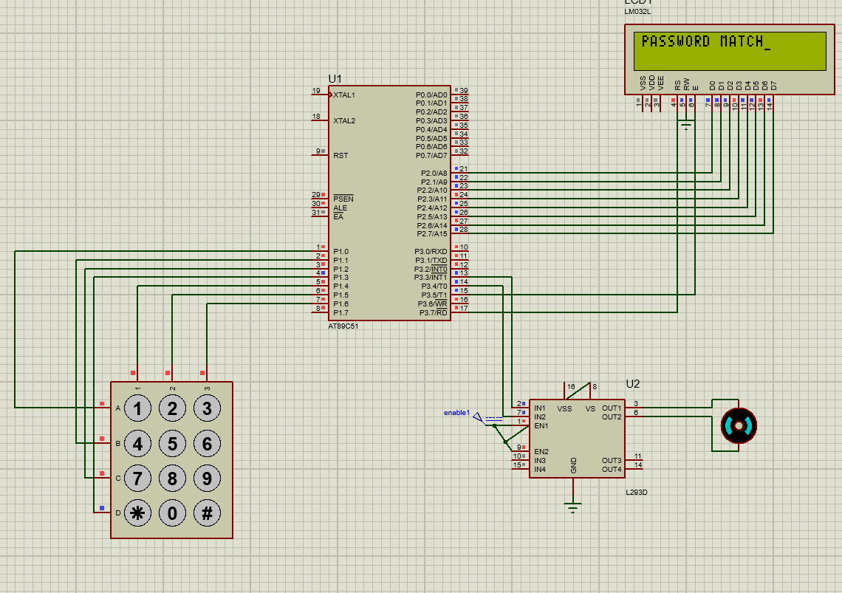
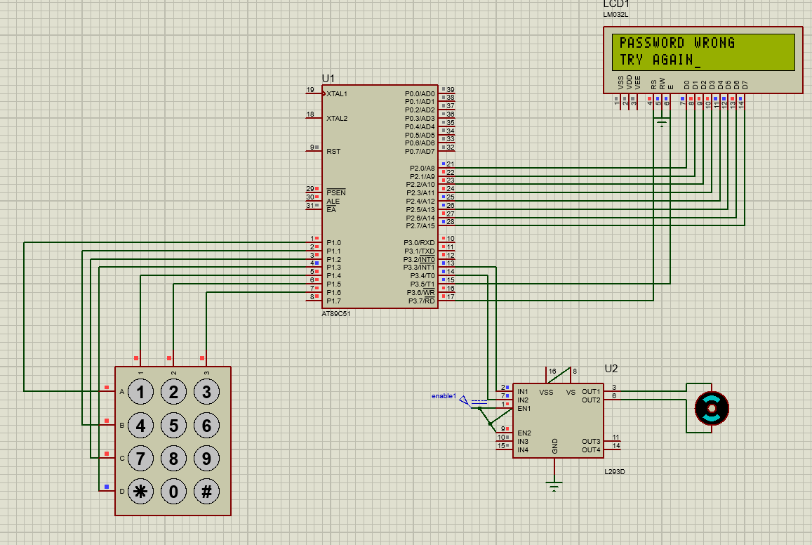

APPLICATIONS

- Used in homes and offices for secure door-locking systems.
- Suitable for laboratories, classrooms, and storage areas where restricted access is required.
- Can be implemented in lockers, safes, and cabinets to protect valuable items.
- Applicable in industrial automation where access to machines or control panels needs to be password-protected.
- Useful in attendance and entry control systems for small-scale security setups.
- Can serve as a training project for understanding embedded systems, keypad interfacing, and motor control.

ADVANTAGES

  - Provides enhanced security by restricting access through password authentication.
  - Low-cost and simple design using easily available components like the AT89C51 and L293D.
  - Allows password change directly from the keypad without reprogramming the microcontroller.
  - Offers bidirectional motor control, enabling automatic lock and unlock actions.
  - Consumes low power and is suitable for battery-operated systems.
  - Can be easily modified or expanded for advanced features like GSM, RFID, or Bluetooth access.

LIMITATIONS

  - The password is stored in volatile memory, so it resets to the default value when the system is powered off (unless EEPROM or non-volatile storage is added).
  - The system can accept only numeric passwords, limiting its flexibility compared to alphanumeric authentication systems.
  - The length of the password is fixed, reducing the overall security level.
  - The project does not include real-time clock functionality or logging features to record access attempts.
  - Unauthorized access detection such as alarm or buzzer indication for repeated wrong attempts is not implemented.
  - The system is designed only for single-user access and cannot differentiate between multiple authorized users.
  - The microcontroller cannot handle very high current loads, hence only small DC motors can be used without external circuitry.

FUTURE SCOPE

  - Integration with RFID, fingerprint, or face recognition modules can provide multi-level security.
  - A GSM or IoT-based alert system can be added to notify the owner via SMS or mobile app on unauthorized access attempts.
  - The design can be expanded to control multiple locks or doors using a single microcontroller.
  - Incorporating a buzzer or alarm can enhance user feedback and improve safety against tampering.
  - Future versions can include a graphical LCD or OLED display for a more intuitive user interface.
  - The system can be redesigned using low-power microcontrollers or wireless modules for smart home automation integration.

CONCLUSION

The Password Protected Door Lock System using the AT89C51 microcontroller has been successfully designed and simulated to provide a secure and reliable access control mechanism. The project demonstrates the integration of hardware components such as the keypad, LCD display, motor driver, and DC motor to form a functional and interactive system.
The microcontroller plays a central role in processing the password input from the keypad, verifying it against the stored password, and controlling the motor driver accordingly. When the correct password is entered, the motor rotates to unlock the system, waits for a few seconds, and then locks it again automatically. In case of a wrong password, the system displays an error message and restricts access after multiple failed attempts to enhance security.
A notable feature of this design is the ability to change the password directly through the keypad without altering the program code. This makes the system user-friendly and flexible for real-time applications. The use of an LCD ensures clear communication between the system and the user, providing feedback at each stage of operation.
Overall, the project successfully achieves its objective of providing a low-cost, practical, and efficient electronic locking mechanism. It can be further enhanced with advanced technologies such as biometric authentication or wireless connectivity, making it suitable for modern smart security systems.

