**Title: Wi-fi Range Extender using Raspberry pi**

**1.Problem Statement**

Wireless networks often suffer from limited coverage areas, especially in large homes, offices, or campuses. Dead zones occur where signals are weak or unavailable, resulting in poor connectivity and reduced performance. Commercial Wi-Fi extenders can be expensive and offer limited customization. This project aims to develop a cost-effective, easy-to-build Wi-Fi range extender using a Raspberry Pi that is compatible with standard Wi-Fi protocols and can overcome dead zones by enhancing signal coverage in a specific area.

**2.Scope of the Solution**

• Extend the range of an existing Wi-Fi network using Raspberry Pi.

• Use affordable and easily available components.

• Ensure compatibility with standard 802.11 Wi-Fi protocols.

• Provide an open-source and customizable solution.

• Applicable in homes, classrooms, labs, and small offices.

**3. Required Components**

Raspberry Pi 3/4 with built-in Wi-Fi

USB Wi-Fi Adapter (for dual Wi-Fi interfaces)

microSD card (16GB or more) with Raspberry Pi OS

Power adapter for Raspberry Pi

Monitor, Keyboard, Mouse (for initial setup)

Router (for connecting to source Wi-Fi)

Ethernet cable (optional for setup)

Heat sinks or cooling fan (optional for performance)

**4.Simmulted ciricuit**

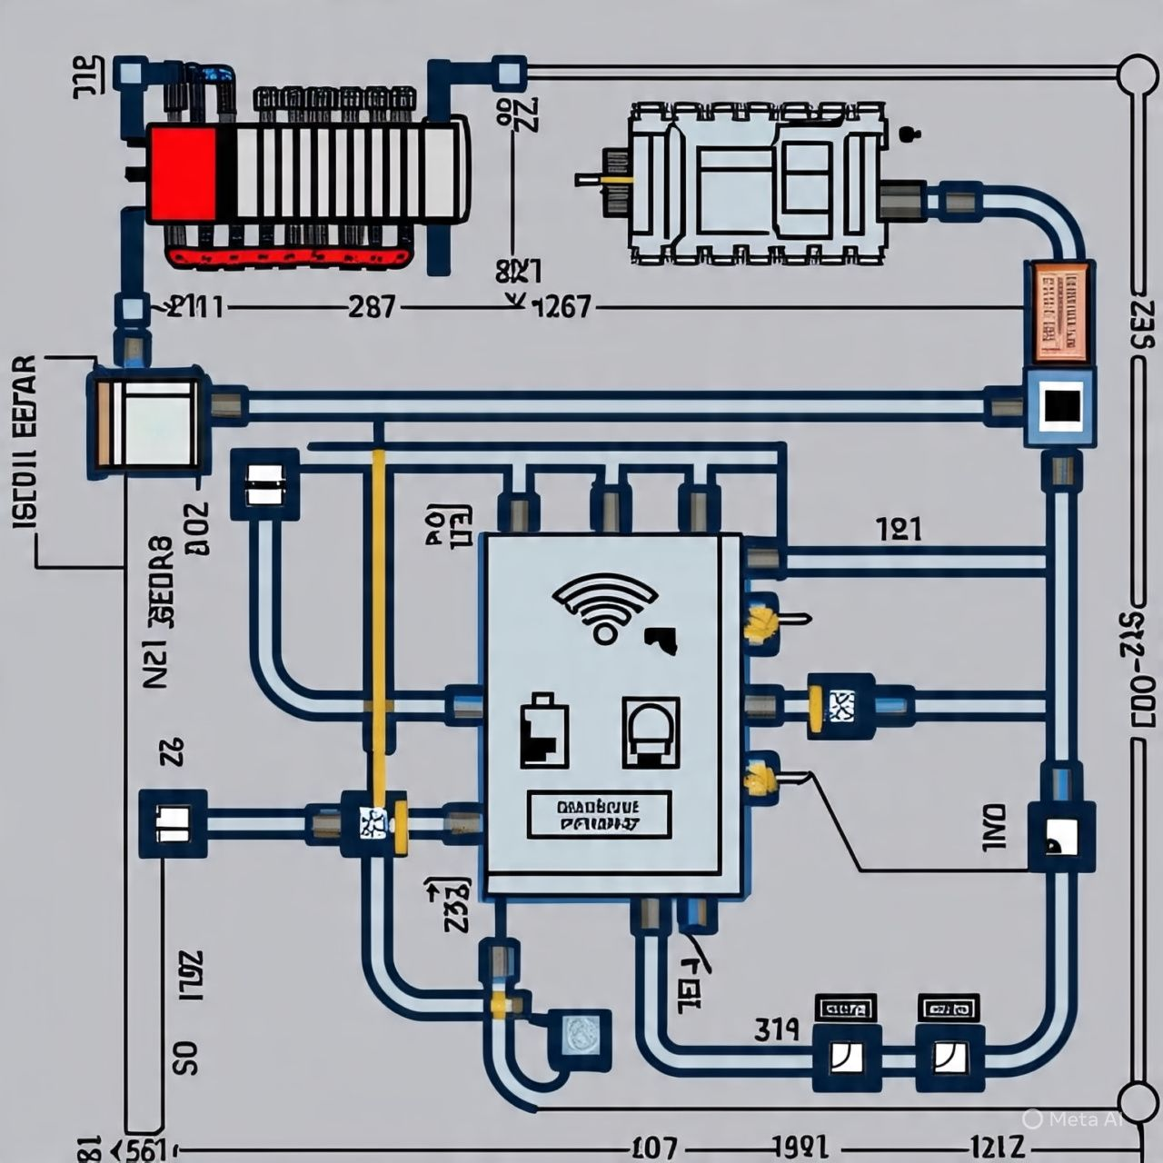

**5.Video Demo:**

Youtube video : <https://youtu.be/BHhHdMHmfSs>

**6. Gerber File**

This project does involve a custom PCB, so Gerber file is needed. If you plan to make a custom board (for example, a dedicated PCB with Wi-Fi modules), I can help design one using KiCad or EasyEDA and generate a Gerber. As it was uploaded in github

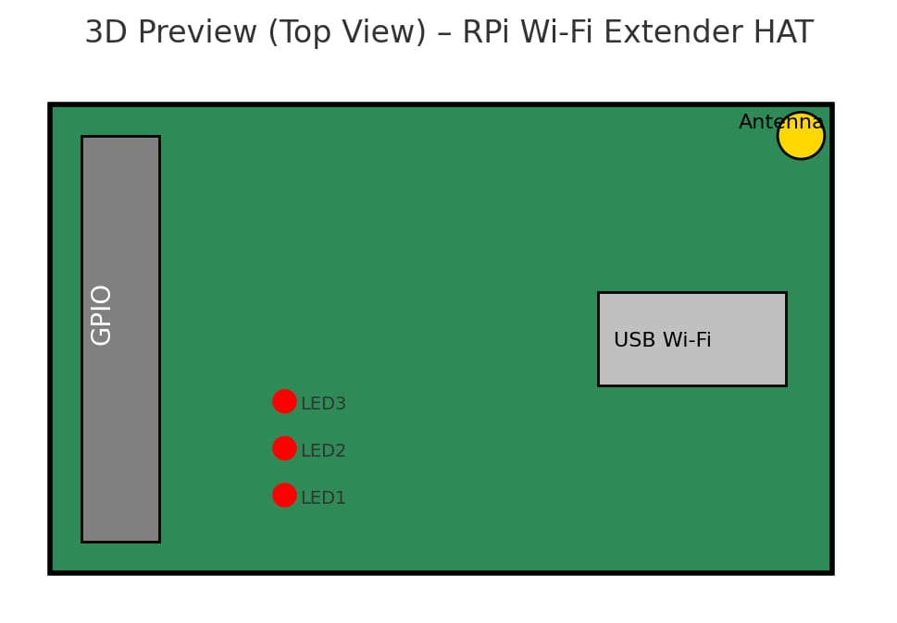

Github profile link: https://github.com/sirisha0217/rpi-wifi-extender

**7. Code for the Solution**

Here’s a basic setup script to configure Raspberry Pi as a Wi-Fi extender:

# Update and install packages

sudo apt update

sudo apt install hostapd dnsmasq iptables-persistent

# Stop services initially

sudo systemctl stop hostapd

sudo systemctl stop dnsmasq

# Configure static IP for wlan1 (USB Wi-Fi adapter)

sudo nano /etc/dhcpcd.conf

# Add:

interface wlan1

static ip_address=192.168.220.1/24

nohook wpa_supplicant

# Configure dnsmasq

sudo mv /etc/dnsmasq.conf /etc/dnsmasq.conf.orig

sudo nano /etc/dnsmasq.conf

# Add:

interface=wlan1

dhcp-range=192.168.220.10,192.168.220.50,255.255.255.0,24h

# Configure hostapd

sudo nano /etc/hostapd/hostapd.conf

# Add:

interface=wlan1

driver=nl80211

ssid=Pi_Extender

hw_mode=g

channel=7

wmm_enabled=0

macaddr_acl=0

auth_algs=1

ignore_broadcast_ssid=0

# Point to the config

sudo nano /etc/default/hostapd

# Add this line:

DAEMON_CONF="/etc/hostapd/hostapd.conf"

# Enable NAT

sudo nano /etc/sysctl.conf

# Uncomment:

net.ipv4.ip_forward=1

# Set up iptables

sudo iptables -t nat -A POSTROUTING -o wlan0 -j MASQUERADE

sudo sh -c "iptables-save > /etc/iptables/rules.v4"

# Start services

sudo systemctl start hostapd

sudo systemctl start dnsmasq