ICP1

Cassandra Queries

Query1:

Cqlsh:cs>select empid,ename,jobtitle,hiredate from employee;

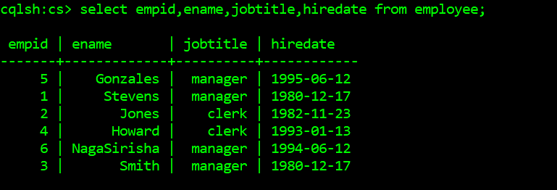

Query2:

cqlsh:cs> select ename,salary from employee where jobtitle = 'clerk' allow filtering;

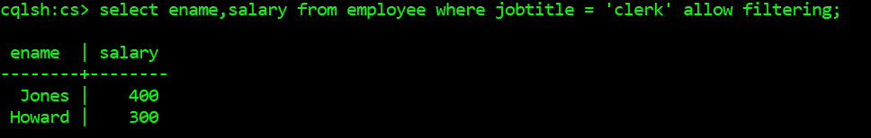

Query3:

cqlsh:cs> select ename,jobtitle,salary from employee where hiredate = '1980-12-17' allow filtering;

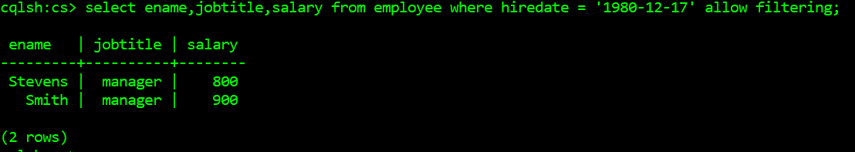

Query4:

cqlsh:cs> select ename,annualsalary from employee;

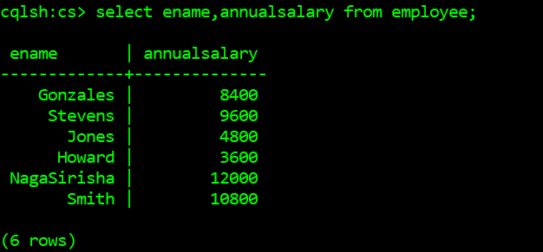

Query5:

cqlsh:cs> select department,deptno from employee where deptno >=20 allow filtering;

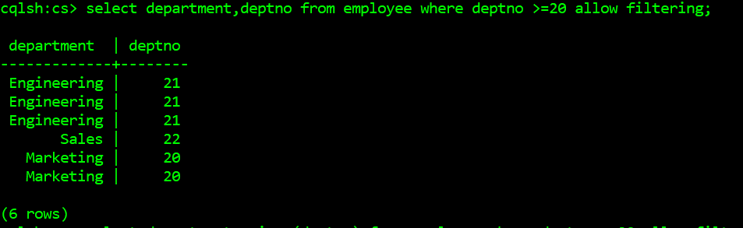

Query6:

cqlsh:cs> select ename,salary from employee where jobtitle = 'manager' and salary = 900 allow filtering;

