**LAB ASSIGNMENT 2**

**Name:Naga Sirisha Sunkara**

**Class ID:21**

**Team ID:5**

**Technical partners details:**

**Name:Vinay Santhosham**

**Class ID:17**

Video Link: <https://youtu.be/b8tOCqfIQWY>

**Objective:**

Task1:Perform Queries on the hive table with the given dataset

Task2:Perform Queries on the solr with the given dataset

To perform the given tasks we have chosen super heroes dataset.

**Task1:**

**Creation of table:**



**Query1:To get the number of super heroes in each category gender**

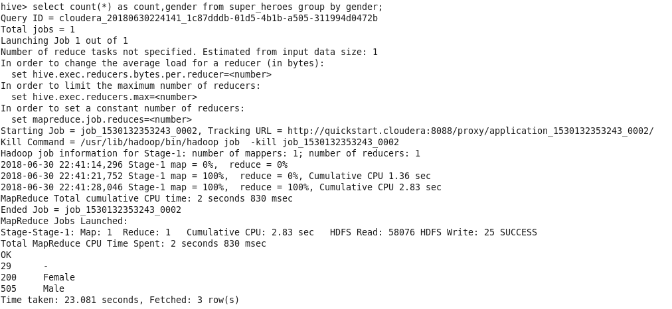

**Query2:To get the average,maximum height and weight in the given dataset**

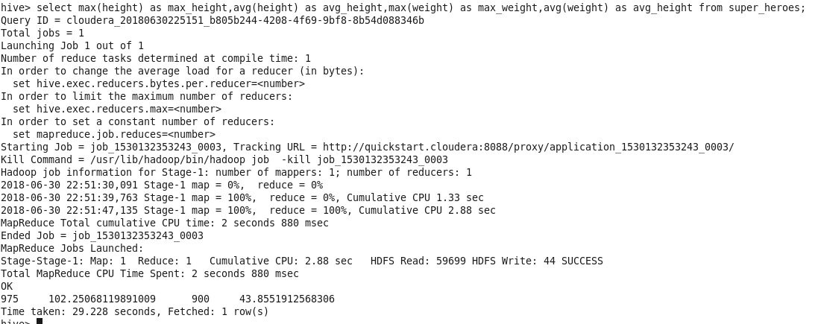

**Query3:To get the number of super heroes with the weight > 90**

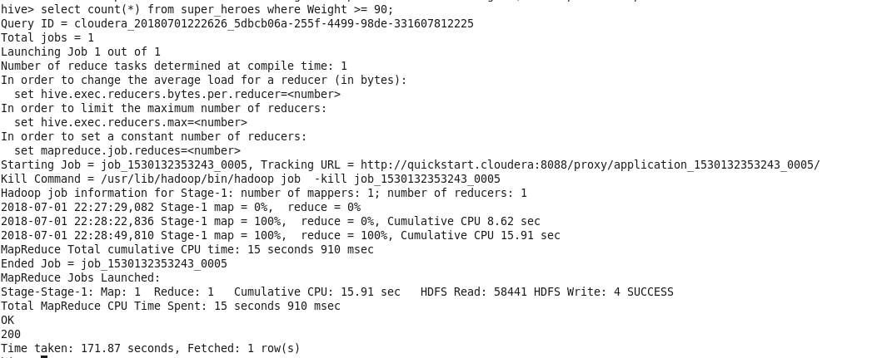

**Query4:To get the name and height of super heroes list in descending order of height**

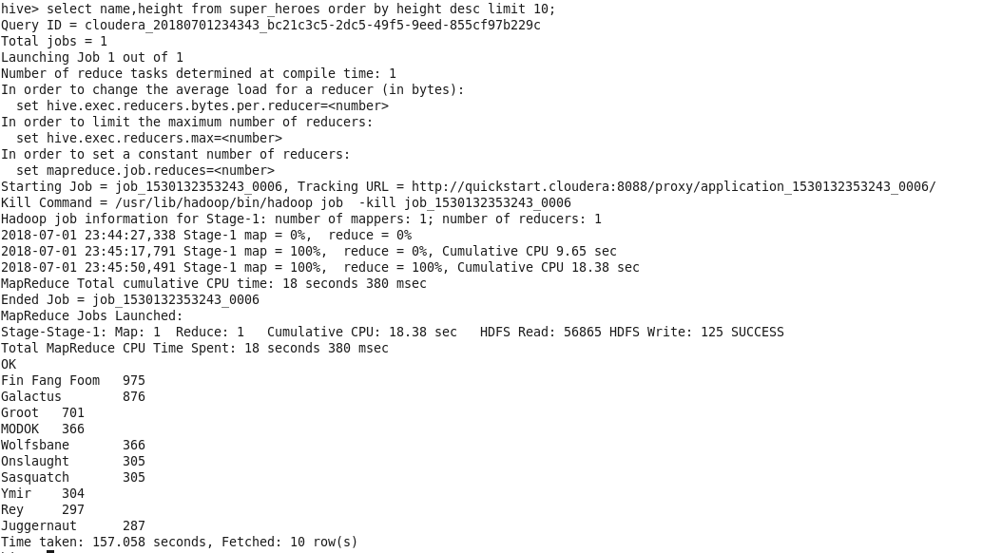

**Query5:To get the distinct publishers in super heroes dataset**

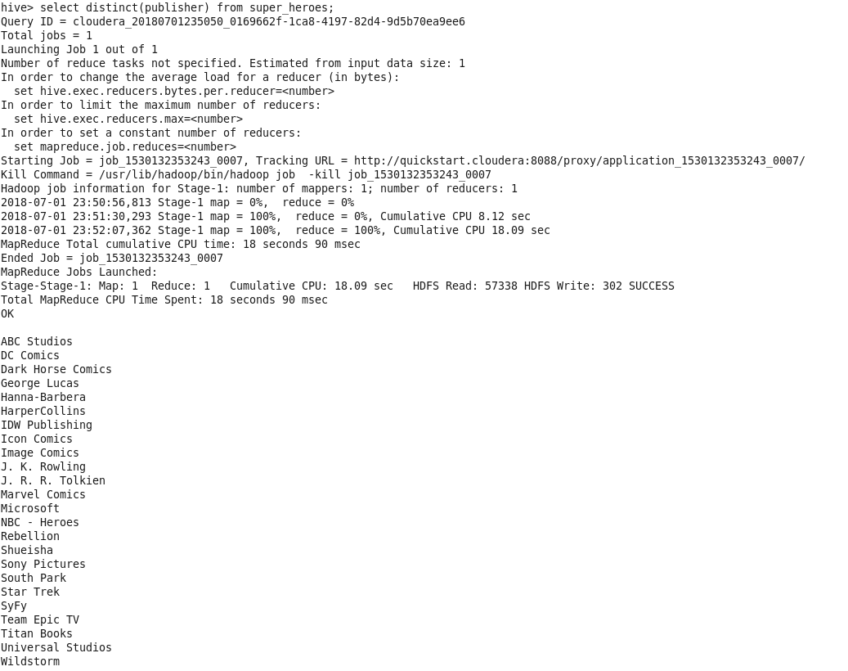

**Query6:To get the name and substring from 1 to 5 characters in publisher dataset**

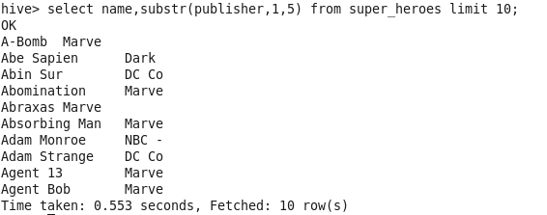

**Query7:To get the id,name,publisher in the order of name**

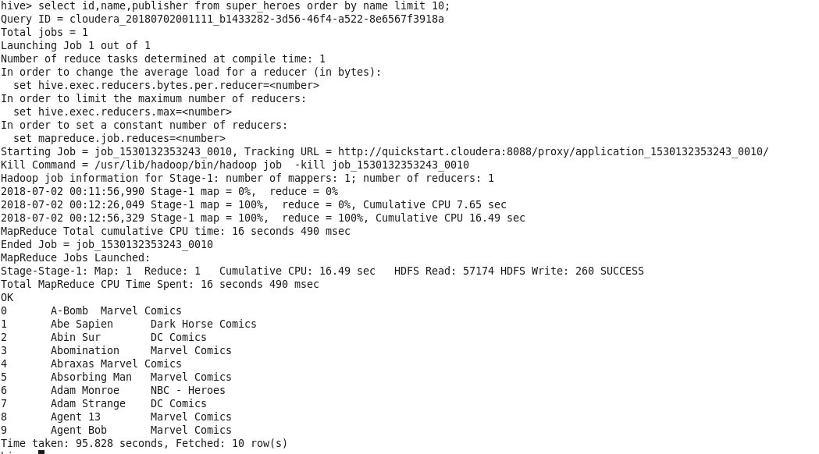

**Query8:To get the list of super heroes with both hair and eye color as brown**

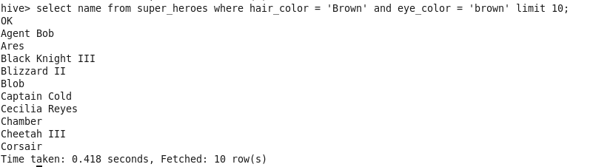

**Query9:To get the sum of weights grouped by the category eye color**

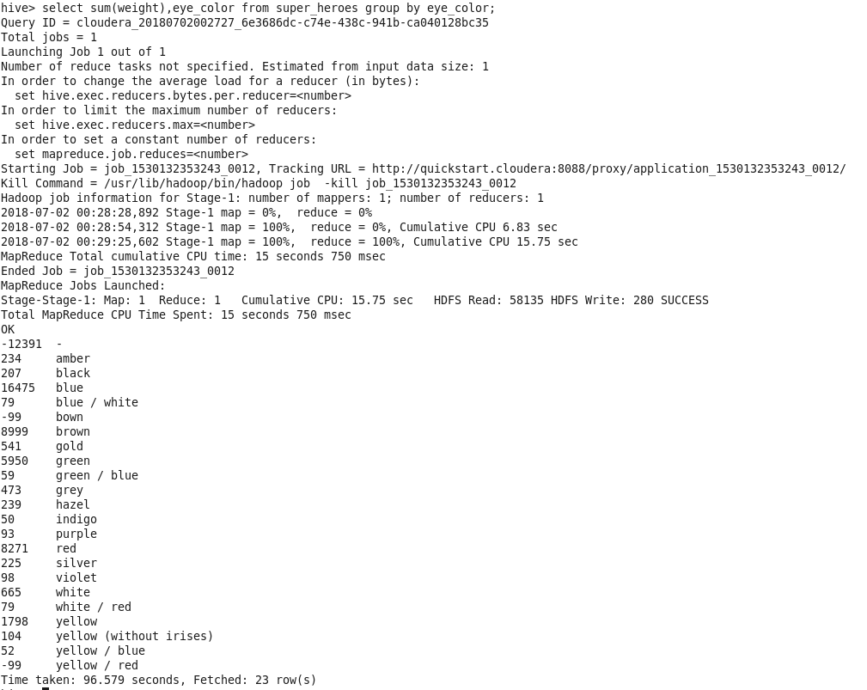

**Query10:To get the name and concatenate the gender and race in the given dataset.**

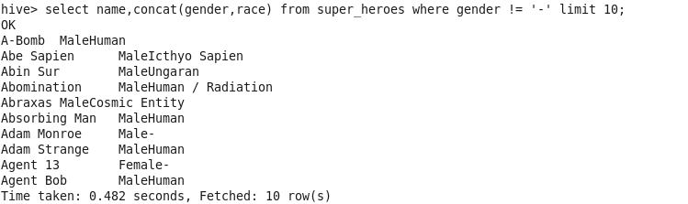

**Task 2:**

Steps to be followed before loading the dataset:

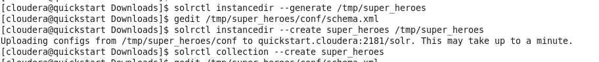

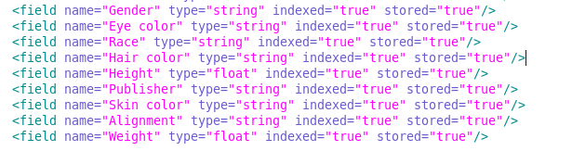

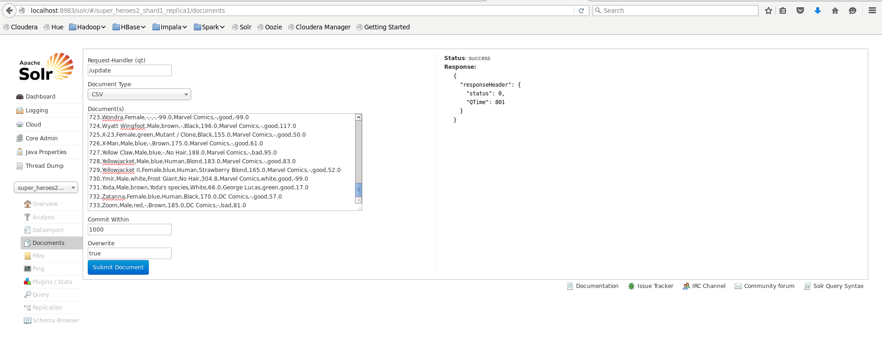

**Query1:To get the details of super heroes with race as human and publisher as wildstorm**

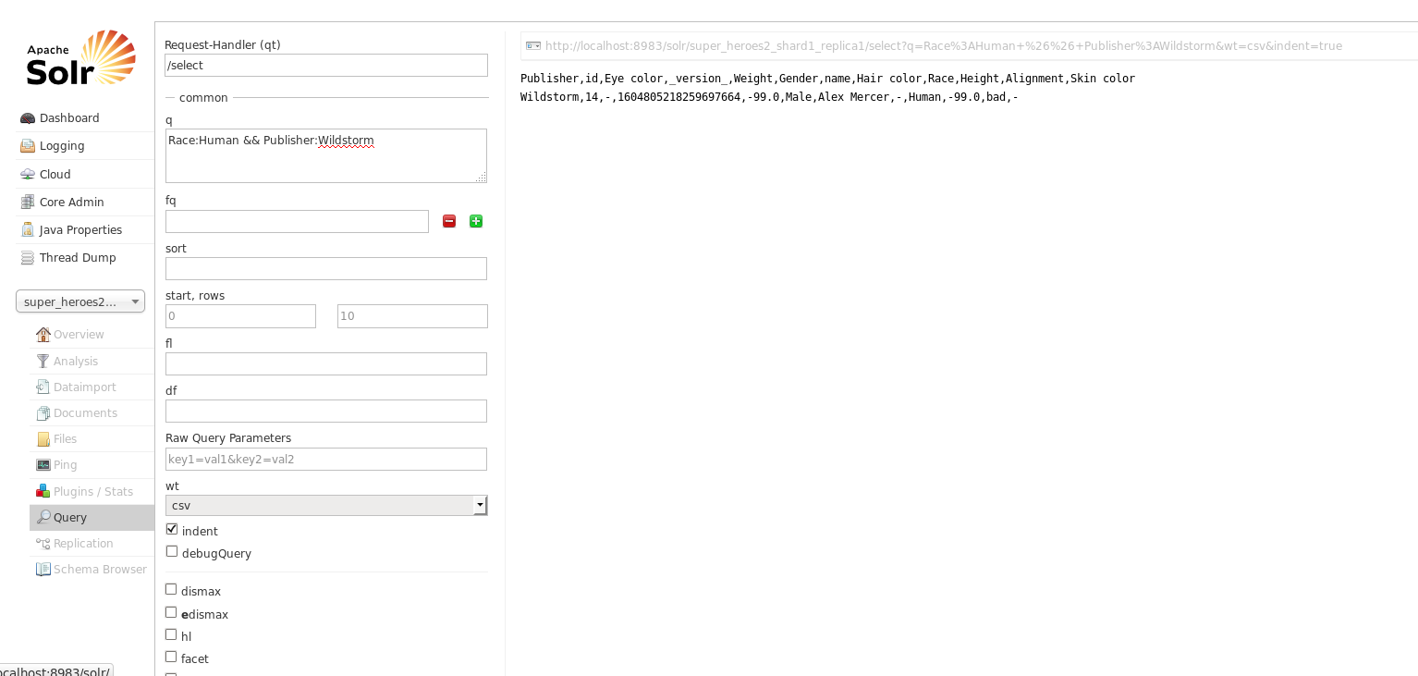

**Query2:To get the details of super heroes with publisher name starting with im and ending with cs**

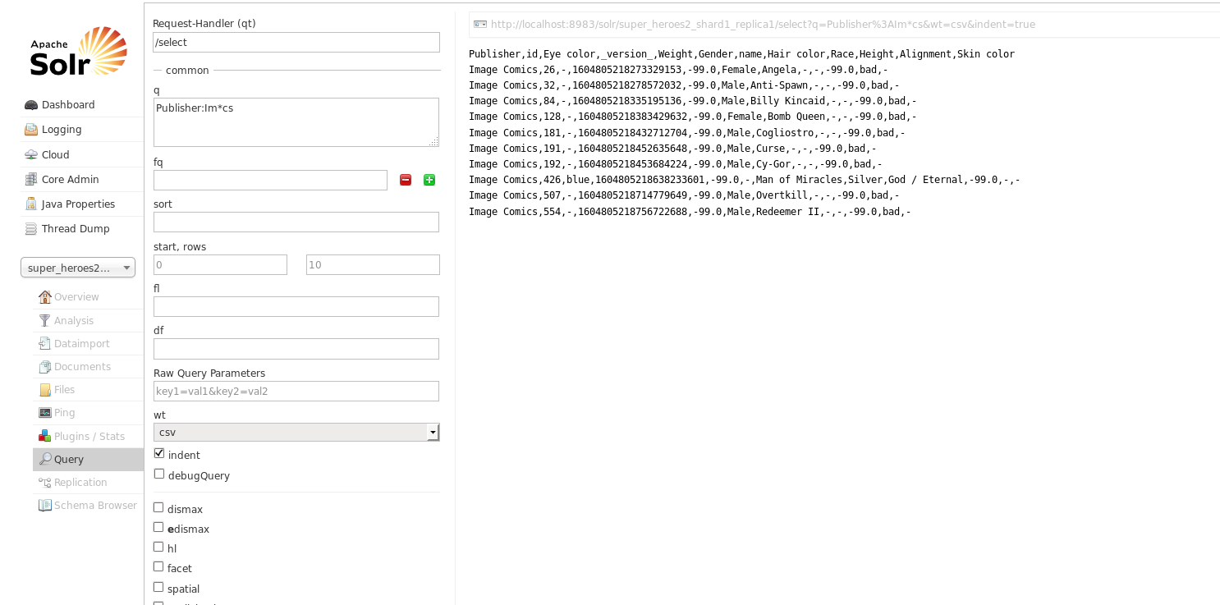

**Query3:Proximity search implementation**

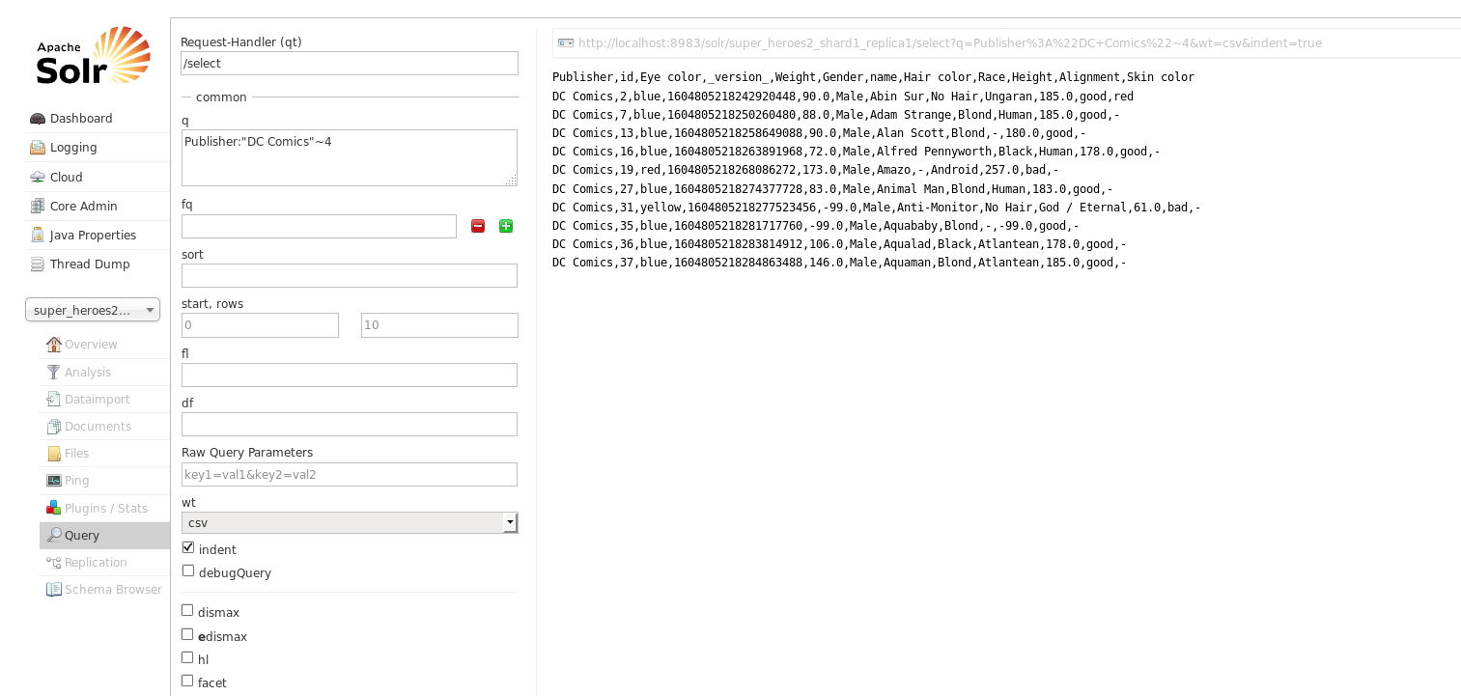

**Query4:To get the list with weight range in between 150 to 300**

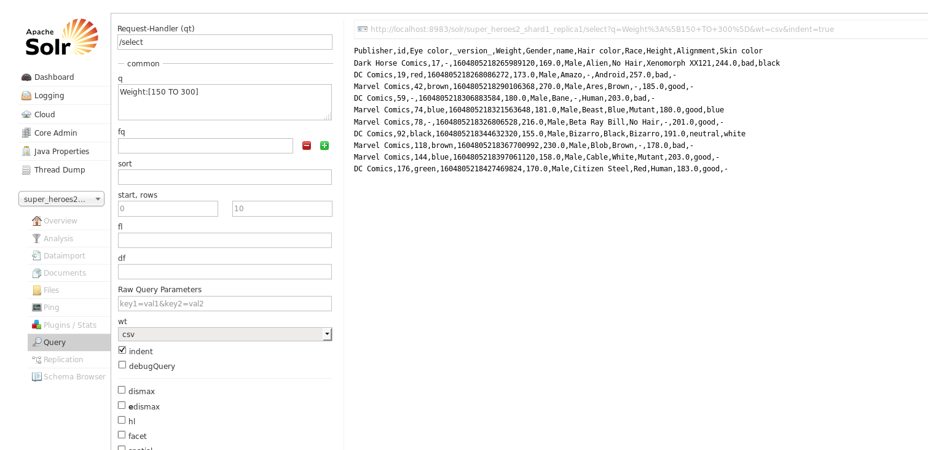

**Query5:To get the list with publisher as Image Comics and not DC comics**

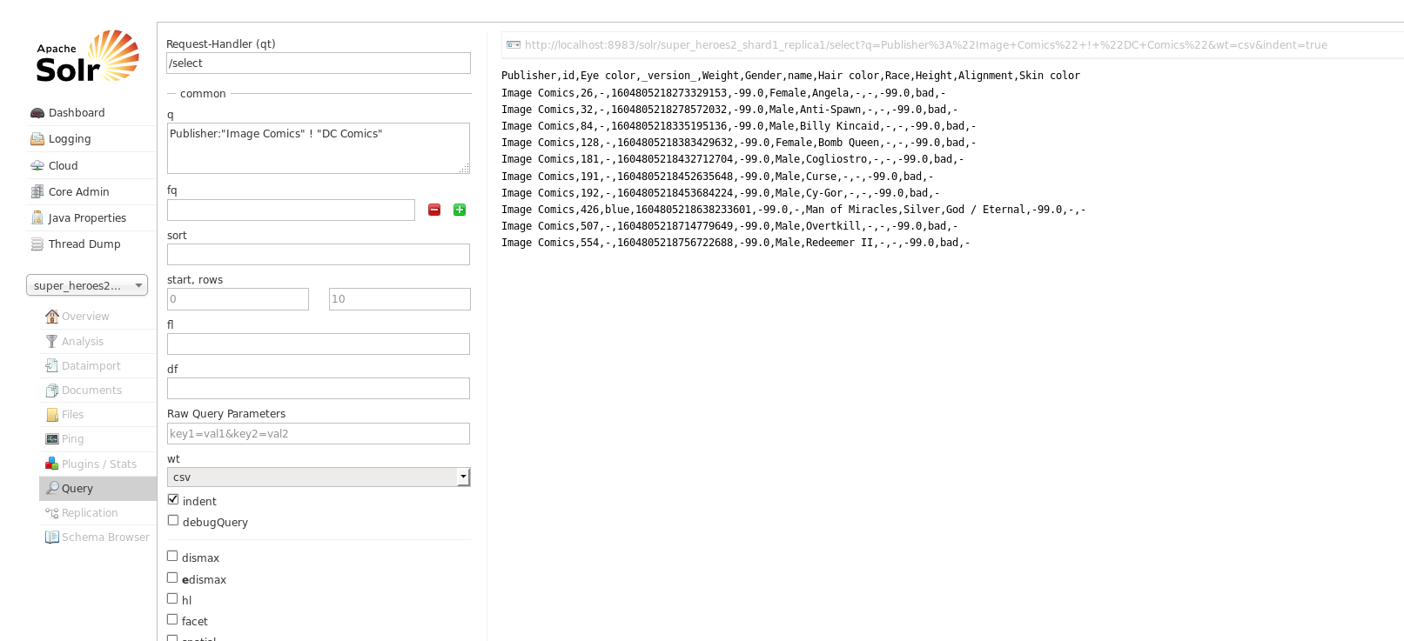

### Query6:To get the list where alignment is bad

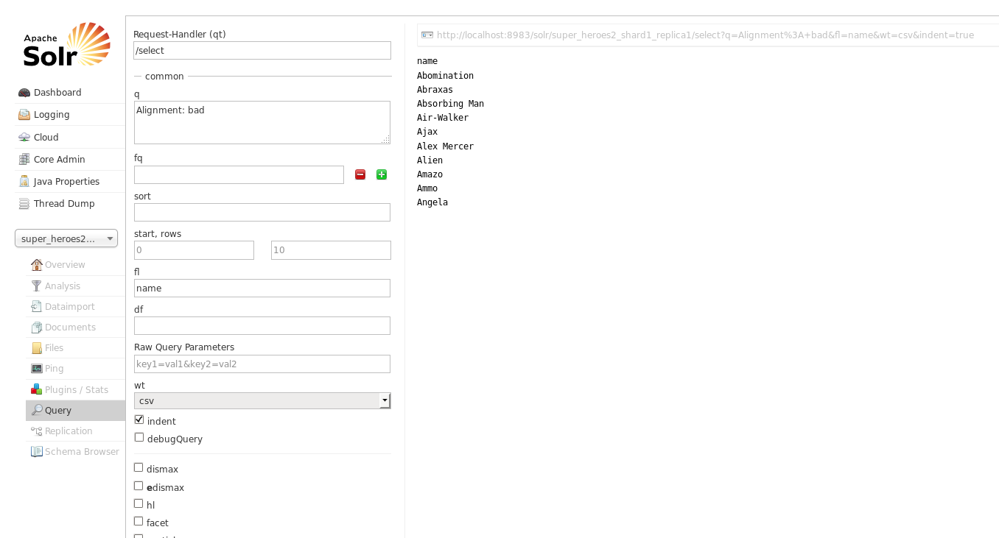

### Query7:Sorting the id in descending order

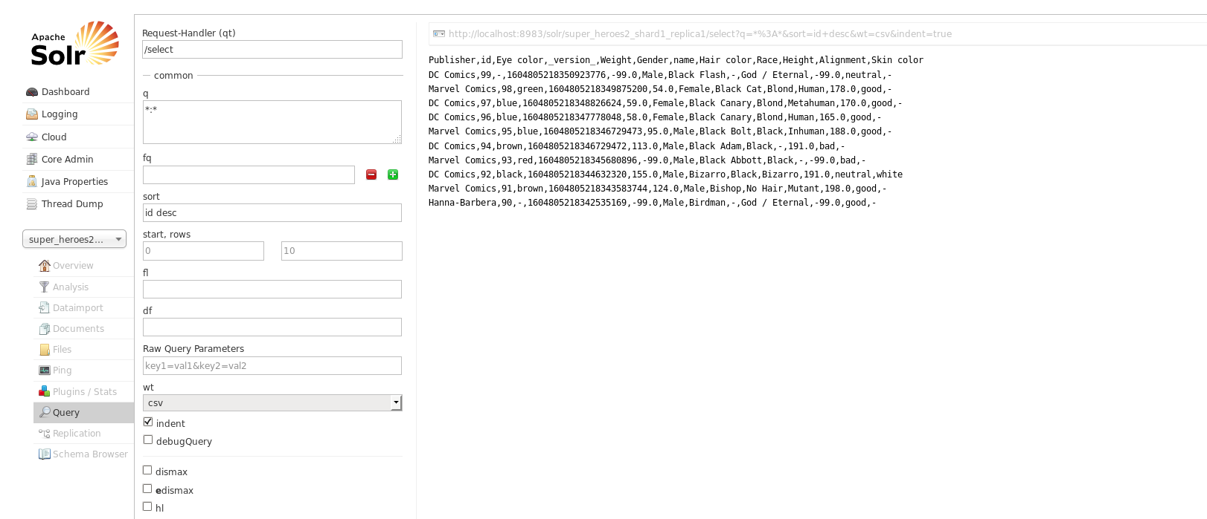

### Query8:To filter the Publisher in first 20 rows

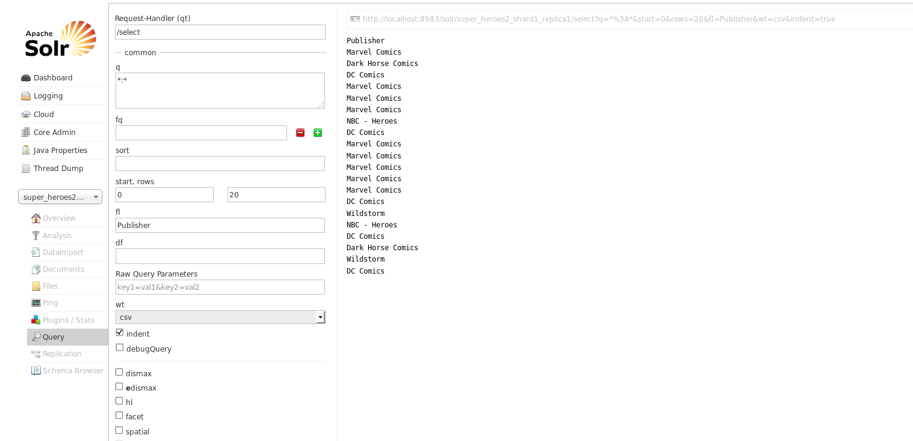

### Query9:List of super heroes with weight from 0-50 or 100-150



### Query10:Boosting with ^

