SIMATS ENGINEERING
ASSESSMENT TOOL 2

COURSE NAME: Artificial Intelligence COURSE CODE: CSA1741

CO1-AT2-Constraint-Based Problem Solving

Register Number | 192325130
Name | - Sirisha

COURSE OUTCOME COVERED
CO1: Apply AI basics such as intelligent agents and uninformed search methods to solve problems effectively.( BL3)
Assessment Tool Weightage: 20%

QUESTIONS:3 Total Marks:30

- A hospital needs to assign 3 doctors (D1, D2, D3) to 3 shifts (Morning, Afternoon, Night) such that:
Constraints:
- D1 cannot work Night shift
- D2 must work before D3 (Morning < Afternoon < Night)
- Only one doctor per shift
- D3 cannot work Morning
- All doctors must be assigned exactly one shift
Apply Backtracking Search to find a valid assignment with all intermediate steps and constraint checks. State the final valid schedule
- A robot operates in a grid environment (5×5). It must move from Start (S) to Goal (G). Obstacles block certain paths.

Constraints:
- Movement allowed: Up, Down, Left, Right
- Cost of each move = 1
- Cannot pass through obstacles
- Use Manhattan Distance heuristic
Using above constraints and BFS Search Algorithm Show step-by-step node expansion and priority queue updates and determine the optimal path and cost.

- An autonomous rescue robot is deployed in a disaster-affected building to locate and rescue survivors. The robot operates in a partially observable environment where some paths are blocked, and it must make decisions with limited information.
The building is represented as a grid of rooms. The robot starts at position S and must reach a survivor located at G.

Constraints:
- The robot can move up, down, left, right
- Some cells are blocked (obstacles) and cannot be traversed
- The robot has limited sensing capability (can only observe adjacent cells)
- Each movement has a cost of 1, but entering risky zones has an additional cost of 2
- The robot must minimize total cost while ensuring safe navigation
- The robot must update its knowledge dynamically (online search scenario)

Tasks:
a) Analyze all the given constraints and explain how they affect the robot’s decision-making process.
b) Develop a solution approach using an appropriate search strategy (e.g., Uniform Cost Search / Online Search Agent). Clearly explain the steps involved.
c) Demonstrate how the robot applies AI concepts such as:
- Intelligent agents
- Rationality
- Environment type
d) Justify why your chosen approach is the most suitable for solving this problem under the given constraints.

Code of Conduct:

I __K.Sirisha ( 192325130)_____ (Name / Reg No) certify that this submission is my original work and that I have adhered to the guidelines specified for this assessment.
I understand that any violation of academic integrity rules will result in disciplinary action.

Signature of the student:

RUBRICS FOR CALCULATION: K. Sirisha

Criterion | Level 4 (Exemplary) | Level 3 (Proficient) | Level 2 (Developing) | Level 1 (Beginning) | Max Marks
Criteria | Level 4 (Exemplary) | Level 3 (Proficient) | Level 2 (Developing) | Level 1 (Beginning) | Max Marks
Problem Understanding | Clearly defines the problem and identifies all relevant constraints accurately | Identifies most constraints with minor gaps | Partial understanding; misses key constraints | Fails to identify constraints correctly | 6
Constraint Analysis | Analyzes constraints effectively and prioritizes them logically | Provides reasonable analysis with some prioritization | Limited analysis; weak prioritization | No meaningful analysis or prioritization | 6
Solution Development | Develops optimal and feasible solutions satisfying all constraints | Develops workable solutions with minor limitations | Solutions partially satisfy constraints | Solutions do not meet constraints | 7.5
Application of Concepts | Effectively applies appropriate concepts, methods, or tools | Applies concepts with minor errors | Limited application; requires guidance | Unable to apply relevant concepts | 6
Justification | Provides strong justification for decisions with logical reasoning | Provides justification with some clarity | Weak or unclear justification | No justification provided | 4.5

Question 1
A hospital needs to assign 3 doctors (D1, D2, D3) to 3 shifts (Morning, Afternoon, Night). Constraints: D1 cannot work Night; D2 must work before D3 (Morning < Afternoon < Night); only one doctor per shift; D3 cannot work Morning; every doctor gets exactly one shift. Apply Backtracking Search to find a valid assignment with all intermediate steps and constraint checks. State the final valid schedule.

Problem Understanding
This is a Constraint Satisfaction Problem (CSP). It has three parts:
- Variables: D1, D2, D3 (the doctors).
- Domain of each variable: {M, A, N}, where M = Morning, A = Afternoon, N = Night.
- Constraints: the five rules given in the question (listed below).
Goal: give every doctor one shift so that all constraints are true at the same time.

Constraint Analysis
No. | Constraint | Type | Written as
C1 | D1 cannot work Night | Unary (one variable) | D1 ≠ N
C2 | D3 cannot work Morning | Unary (one variable) | D3 ≠ M
C3 | D2 must work before D3 | Binary (two variables) | D2 < D3 (M < A < N)
C4 | Only one doctor per shift | All-different | D1, D2, D3 all different
C5 | Each doctor gets exactly one shift | Built into the problem | Each variable has one value
Priority: the unary constraints C1 and C2 are the simplest, so they are checked first. They cut down the domains before the search starts:
Doctor | Domain after C1 and C2 | Reason
D1 | {M, A} | Night is removed by C1
D2 | {M, A, N} | No unary constraint; C3 will remove N later, because D3 cannot be after Night
D3 | {A, N} | Morning is removed by C2
Using C3: D2 must be earlier than D3. If D3 = A then D2 = M. If D3 = N then D2 = M or A.

Solution Development
Backtracking Search assigns one variable at a time, checks every constraint after each assignment, and goes back (backtracks) when a constraint fails. Variable order: D1, D2, D3. Value order: M, A, N.
Step | Assignment tried | Constraint check | Result
1 | D1 = M | C1: M ≠ N, true | Accept
2 | D1 = M, D2 = M | C4: Morning is already used by D1, false | Reject – backtrack to next value
3 | D1 = M, D2 = A | C4: A is free, true. No constraint is broken | Accept
4 | D1 = M, D2 = A, D3 = M | C2: D3 cannot work Morning, false (C4 and C3 also fail) | Reject
5 | D1 = M, D2 = A, D3 = A | C4: Afternoon is already used by D2, false (C3 also fails, as A is not before A) | Reject
6 | D1 = M, D2 = A, D3 = N | C1 true, C2: N ≠ M true, C3: A < N true, C4: M, A, N all different true | Accept – all variables assigned
The search tree (the path followed):
Start (no assignment)
|-- D1 = M (C1 ok)
|-- D2 = M X (C4 fails: Morning used)
|-- D2 = A (ok)
|-- D3 = M X (C2, C4, C3 fail)
|-- D3 = A X (C4, C3 fail)
|-- D3 = N OK (all constraints true) => SOLUTION
Final valid schedule:
Shift | Doctor | Check
Morning | D1 | D1 ≠ N ✓
Afternoon | D2 | D2 before D3 ✓
Night | D3 | D3 ≠ M ✓
Python program (q1_backtracking.py):
The same method written as a Python program. The code is shown in the VS Code editor.
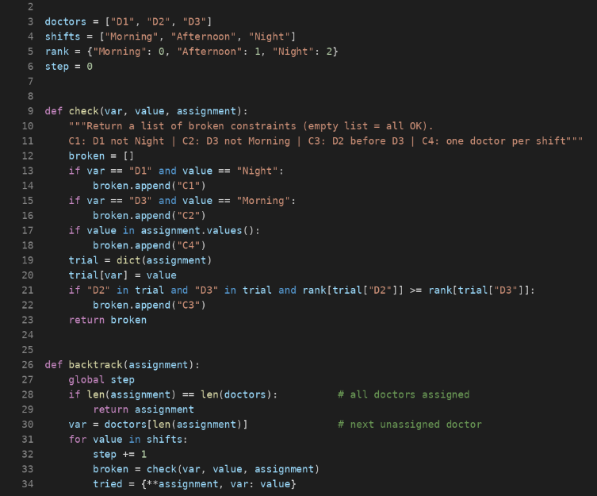
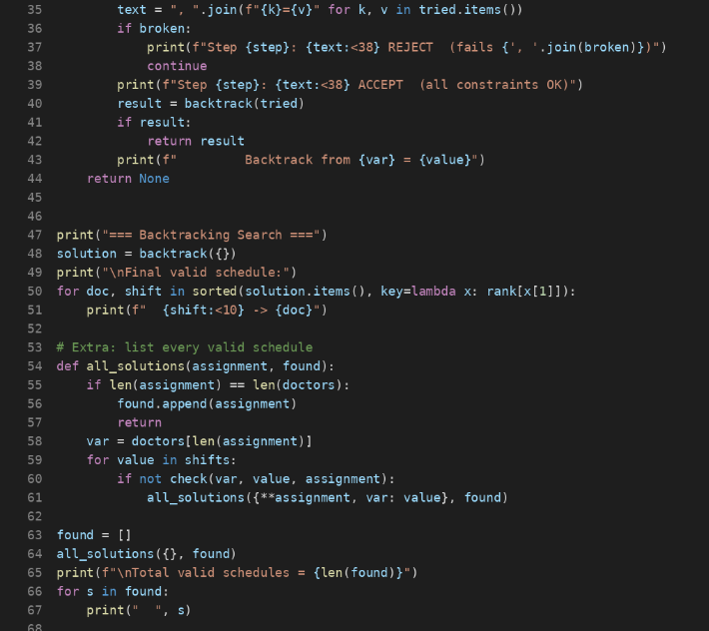
Output of the program (terminal):
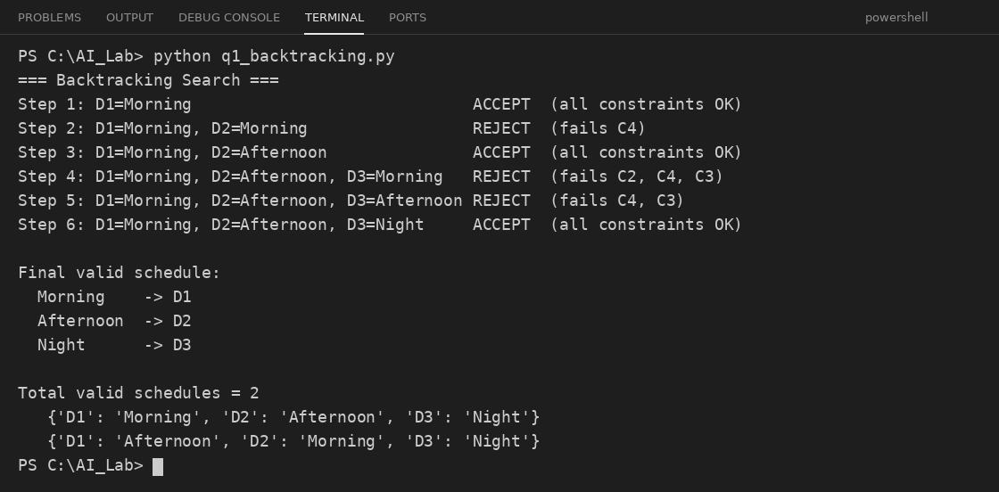

Application of Concepts
- Constraint Satisfaction Problem: variables, domains and constraints were defined clearly.
- Backtracking Search: it is depth-first search that assigns one variable at a time. It checks constraints after every assignment and goes back on failure (steps 2, 4 and 5).
- Constraint propagation (node consistency): the unary constraints reduced the domains before searching.
Full check of the answer: D1 = Morning (not Night ✓); D2 = Afternoon is before D3 = Night ✓; D3 is not Morning ✓; each shift has one doctor ✓; each doctor has one shift ✓. All 5 constraints are satisfied.

Justification
Backtracking is a good choice because it is simple, uses little memory and stops a wrong branch as soon as one constraint fails, so it does not waste time on bad schedules. Note: a second valid schedule also exists – D1 = Afternoon, D2 = Morning, D3 = Night. Backtracking returns the first valid one it finds, and the question asks for a valid assignment, so either is correct.

Question 2

A robot moves in a 5×5 grid from Start (S) to Goal (G). Obstacles block certain paths. Movement: Up, Down, Left, Right; cost of each move = 1; the robot cannot pass through obstacles; use the Manhattan Distance heuristic. Using these constraints and the BFS algorithm, show step-by-step node expansion and priority queue updates and find the optimal path and cost.

Problem Understanding (2 marks)
The question does not include the grid picture, so I assume the following example grid (rows 0–4 from top to bottom, columns 0–4 from left to right; a cell is written as (row, column)). If your grid is different, the same steps can be repeated.
- Start S: (2, 0)
- Goal G: (2, 4)
- Obstacles (X): (1, 2), (2, 2), (3, 2), (4, 2) – a wall with a gap only at the top, (0, 2).

 |  | X
S |  | X |  | G
 |  | X
 |  | X
Assumed 5×5 grid (S = start, G = goal, X = obstacle)

Constraint Analysis (2 marks)
Constraint | How it affects the search
Moves: Up, Down, Left, Right | Each cell has at most 4 neighbours; no diagonal moves.
Cost of each move = 1 | All steps cost the same, so the path cost = number of moves. This is why BFS can find the optimal path.
Cannot pass through obstacles | Cells marked X are never added to the queue.
Manhattan heuristic | h(n) = |row − 2| + |column − 4|. It tells how far a cell is from G if there were no obstacles. It never over-estimates, so it is safe (admissible).
Priority order used in the queue: f(n) = g(n) + h(n), where g(n) = cost from S so far. The lowest f is expanded first. Ties are broken by lower h, then by the order of insertion (first in, first out). Neighbours are checked in the order Up, Down, Left, Right.

Solution Development
Algorithm (BFS with a priority queue):
- Put S in the queue with g = 0 and f = h(S) = 4.
- Remove the node with the lowest f from the queue (this is the node expanded).
- If it is G, stop and trace the path back using parent links.
- Otherwise, add each free, unvisited neighbour with g = g(parent) + 1 and f = g + h.
- Repeat from step 2.
Format used: cell [g, f]. The priority queue is shown in the order in which nodes will be removed.
Step | Node expanded [g, f] | Neighbours added [g, f] | Priority queue after the step
1 | (2,0) [0, 4] | (2,1) [1,4], (1,0) [1,6], (3,0) [1,6] | (2,1)[1,4], (1,0)[1,6], (3,0)[1,6]
2 | (2,1) [1, 4] | (1,1) [2,6], (3,1) [2,6] ((2,2) is an obstacle) | (1,1)[2,6], (3,1)[2,6], (1,0)[1,6], (3,0)[1,6]
3 | (1,1) [2, 6] | (0,1) [3,8] ((1,2) is an obstacle) | (3,1)[2,6], (1,0)[1,6], (3,0)[1,6], (0,1)[3,8]
4 | (3,1) [2, 6] | (4,1) [3,8] ((3,2) is an obstacle) | (1,0)[1,6], (3,0)[1,6], (0,1)[3,8], (4,1)[3,8]
5 | (1,0) [1, 6] | (0,0) [2,8] | (3,0)[1,6], (0,1)[3,8], (4,1)[3,8], (0,0)[2,8]
6 | (3,0) [1, 6] | (4,0) [2,8] | (0,1)[3,8], (4,1)[3,8], (0,0)[2,8], (4,0)[2,8]
7 | (0,1) [3, 8] | (0,2) [4,8] | (0,2)[4,8], (4,1)[3,8], (0,0)[2,8], (4,0)[2,8]
8 | (0,2) [4, 8] | (0,3) [5,8] | (0,3)[5,8], (4,1)[3,8], (0,0)[2,8], (4,0)[2,8]
9 | (0,3) [5, 8] | (1,3) [6,8], (0,4) [6,8] | (1,3)[6,8], (0,4)[6,8], (4,1)[3,8], (0,0)[2,8], (4,0)[2,8]
10 | (1,3) [6, 8] | (2,3) [7,8], (1,4) [7,8] | (2,3)[7,8], (1,4)[7,8], (0,4)[6,8], (4,1)[3,8], (0,0)[2,8], (4,0)[2,8]
11 | (2,3) [7, 8] | (3,3) [8,10], (2,4) [8,8] | (2,4)[8,8], (1,4)[7,8], (0,4)[6,8], (4,1)[3,8], (0,0)[2,8], (4,0)[2,8], (3,3)[8,10]
12 | (2,4) [8, 8] = G | Goal found – stop | –
Tracing back the parents from G: (2,4) ← (2,3) ← (1,3) ← (0,3) ← (0,2) ← (0,1) ← (1,1) ← (2,1) ← (2,0).
Optimal path: (2,0) → (2,1) → (1,1) → (0,1) → (0,2) → (0,3) → (1,3) → (2,3) → (2,4)
Path cost: 8 moves × 1 = 8

 | 3 | 4 | 5
 | 2 | X | 6
S | 1 | X | 7 | G
 |  | X
 |  | X
Optimal path (blue cells; numbers show the move number)
Python program (q2_grid_search.py):
The same method written as a Python program. The code is shown in the VS Code editor.
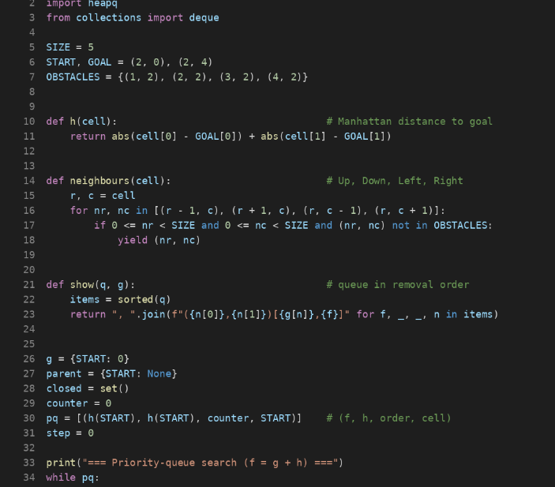
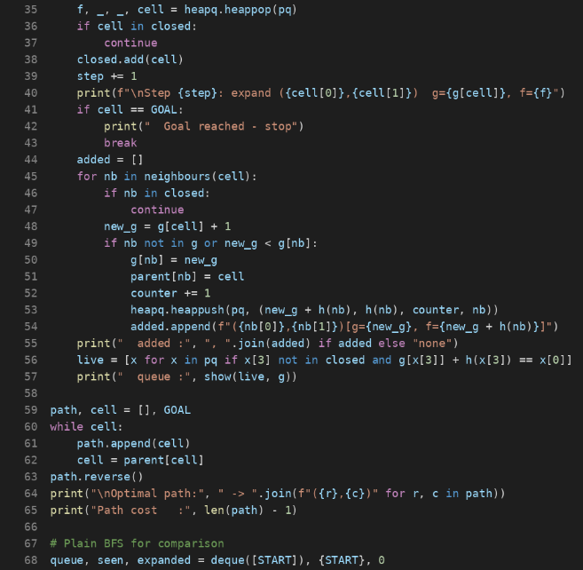
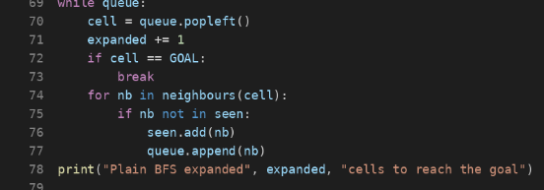
Output of the program (terminal):
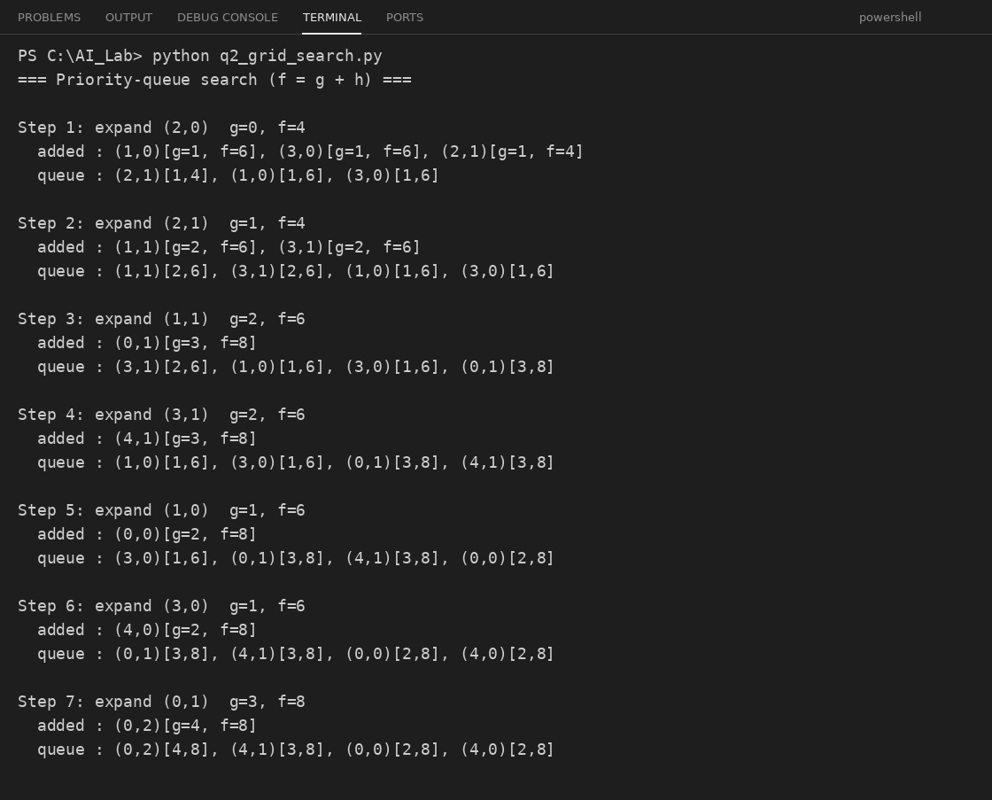
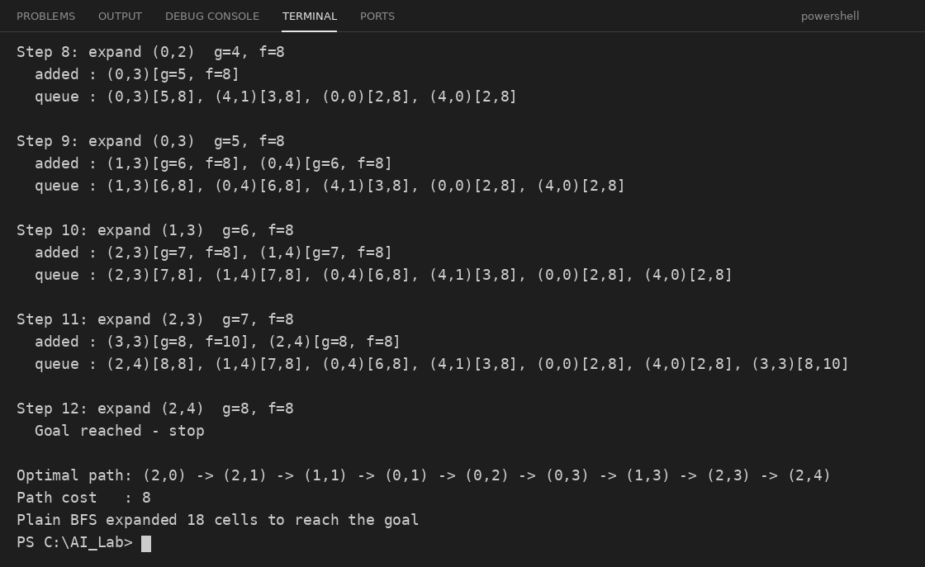

Application of Concepts
- BFS: explores cells layer by layer (all cells 1 move away, then 2 moves, and so on). With equal move costs, the first time it reaches G is by the shortest path. Plain BFS (without the heuristic) also gives cost 8 here, but expands 18 cells.
- Priority queue with f = g + h: the Manhattan distance guides the order of expansion towards G, so the search is more focused than blind BFS.
- Admissible heuristic: h never over-estimates the real cost (the real cost is 8, while h at S is 4). So the answer stays optimal.
- Visited check: a cell is never expanded twice, which stops loops.
Accuracy check: the path has 8 moves, and none of its cells is an obstacle. At step 11, (3,3) got f = 10 because moving down moves away from G, so it was not expanded. The goal was removed from the queue with f = 8, which equals the true cost.

Justification
The robot cannot go straight to G because the wall blocks the way. The Manhattan distance is only 4, but the real cost is 8 because the robot must go up around the wall through (0,2) and come back down. Since every move costs 1 and the heuristic is admissible, the first path that reaches G is the optimal one, with cost 8. No path with fewer moves exists, because the only gap in the wall is at (0,2).

Question 3

An autonomous rescue robot works in a partially observable, disaster-affected building. The building is a grid of rooms; the robot starts at S and must reach a survivor at G. Constraints: moves up/down/left/right; some cells are blocked; it can only observe adjacent cells; each move costs 1 but entering a risky zone costs an extra 2; it must minimise total cost while staying safe; it must update its knowledge dynamically (online search). Tasks: (a) analyse the constraints and how they affect decisions; (b) develop a solution approach using a search strategy and explain the steps; (c) show how the robot applies intelligent agents, rationality and environment type; (d) justify why the approach is most suitable.

Problem Understanding
- Environment: a grid of rooms (assumed 5×5 for the example).
- Start / Goal: S = (0,0), G = (4,4). The robot must reach the survivor at G.
- Unknown to the robot at the start: which cells are blocked and which are risky. It learns this only by looking at neighbouring cells.
- Cost of a move: 1 for a normal cell; 1 + 2 = 3 for entering a risky cell.
- Goal: reach G with the lowest total cost and without entering blocked cells.

Constraint Analysis (Task a)
Constraint | How it affects the robot's decisions | Priority
Blocked cells | Cannot be entered. The robot must plan around them and re-plan when a new one is found. | 1 – highest (a hard rule)
Safe navigation | The robot should avoid risky zones when a reasonable safe route exists. | 2
Limited sensing (adjacent cells only) | The robot cannot see the whole map, so it cannot make one perfect plan in advance. It must decide using what it knows now. | 3
Move cost 1, risky zone +2 | A risky cell costs 3, so a safe detour of up to 2 extra steps is cheaper than one risky cell. | 4
Minimise total cost | Among safe routes, choose the one with the lowest total cost. | 5
Dynamic knowledge update (online search) | After every move the robot adds new information to its map and re-plans. | Works with all of the above
Overall effect: the robot works with incomplete information, so its decisions must be made step by step and corrected when new facts appear. Hard constraints (blocked cells) come first, then safety and cost.

Solution Development (Task b)
Approach: Online Search Agent using Uniform Cost Search (UCS) with re-planning.
UCS always expands the cell with the lowest total cost so far, g(n). It is used inside an online loop:
- Start at S with an empty map. Assume that unknown cells are free and not risky (optimistic assumption).
- Sense: look at the adjacent cells and record which are blocked or risky.
- Plan: run UCS on the known map from the current cell to G. A move into a blocked cell is not allowed; entering a risky cell costs 3; other cells cost 1.
- Act: take only the first step of the best plan.
- Update the total cost and the map, then repeat from step 2 until G is reached.
Worked example (assumed building; the robot does not know it in advance). Blocked cells: (0,3), (1,2), (2,0), (3,3). Risky cells: (1,1), (2,1), (3,2).
S |  |  | X
1 | 2 R | X
X | 3 R
 | 4 | R | X
 | 5 | 6 | 7 | G
X = blocked, R = risky (yellow), blue/yellow numbers = the robot's actual path
Step | Robot at | New facts sensed | UCS plan from here (cost) | Move to | Move cost | Total so far
1 | (0,0) | Nothing new | Down the left column, then along the bottom (8) | (1,0) | 1 | 1
2 | (1,0) | (2,0) blocked; (1,1) risky | Re-plan: (1,1) → (2,1) → (3,1) → (4,1) → bottom row (9) | (1,1) | 3 | 4
3 | (1,1) | (1,2) blocked; (2,1) risky | Same route continues (8 left) | (2,1) | 3 | 7
4 | (2,1) | Nothing new | (3,1) → (4,1) → (4,2) → (4,3) → G (5) | (3,1) | 1 | 8
5 | (3,1) | (3,2) risky | Go down, then right along row 4 (4) | (4,1) | 1 | 9
6 | (4,1) | Nothing new | (4,2) → (4,3) → G (3) | (4,2) | 1 | 10
7 | (4,2) | Nothing new | (4,3) → G (2) | (4,3) | 1 | 11
8 | (4,3) | (3,3) blocked | (4,4) (1) | (4,4) = G | 1 | 12
Result: the robot reaches the survivor with a total cost of 12. In step 2 it found that (2,0) was blocked and re-planned. The top route is closed by the blocked cells (1,2) and (0,3), and the left column is closed by (2,0), so the robot had to pass the two risky cells (1,1) and (2,1) (3 + 3). Even if the robot had known the whole map from the start, the best cost would also be 12, so the online robot lost nothing in this example.
Accuracy check of the cost: 1 + 3 + 3 + 1 + 1 + 1 + 1 + 1 = 12 ✓.
Python program (q3_rescue_robot.py):
The same method written as a Python program. The code is shown in the VS Code editor.
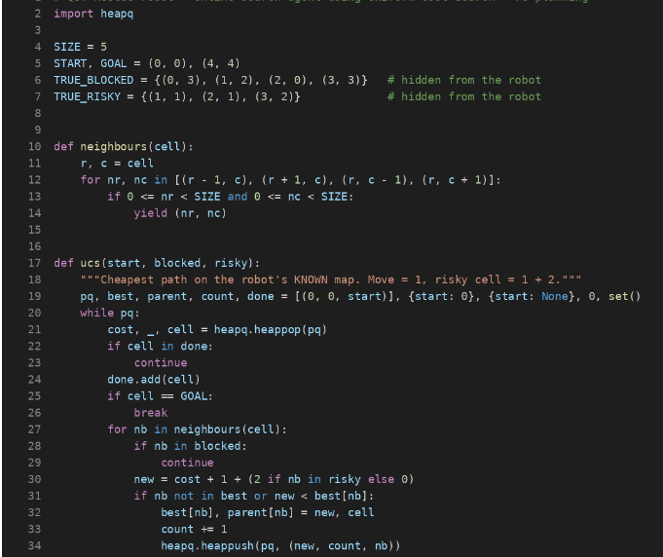
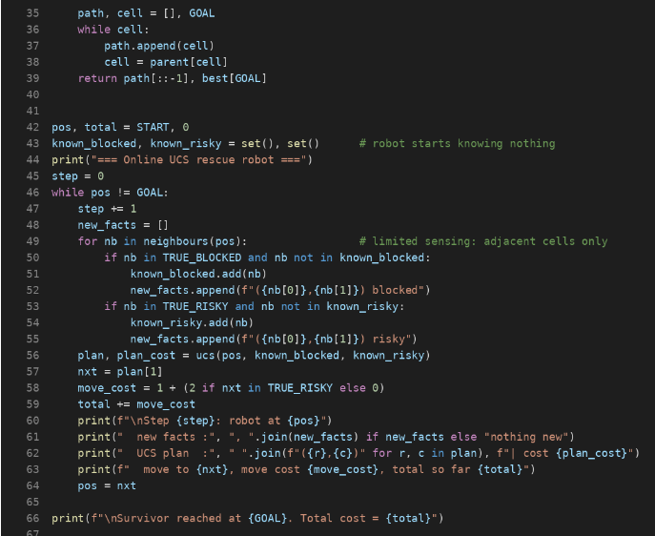
Output of the program (terminal):
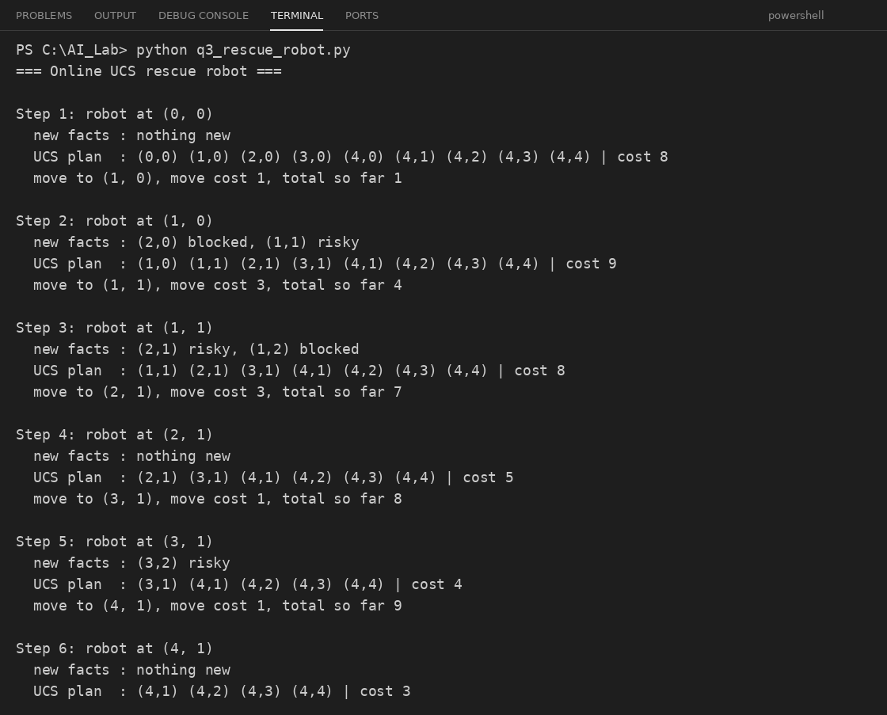
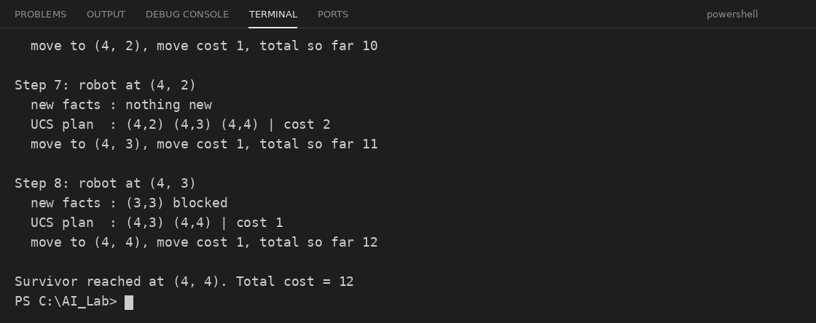

Application of Concepts (Task c)
AI concept | How the robot uses it
Intelligent agent | The robot senses its surroundings (percepts: blocked, risky or free adjacent cells, its position) and acts on them (actions: move up, down, left, right). It is a goal-based and utility-based agent: its goal is to reach G, and it prefers the lowest-cost, safest route. It also keeps an internal map (a model), which it updates after every move.
Rationality | A rational agent does the action that is expected to give the best result with the information it has. At each step the robot picks the move on the lowest-cost known route. When a new blocked cell is found, it changes its plan. This is rational because it does not repeat a plan that has become wrong, and it avoids risky cells unless the detour costs more.
Environment type | Partially observable (only adjacent cells are seen); deterministic (a move goes where intended, in this example); sequential (each move affects later cost); static (the building does not change while the robot thinks); discrete (grid cells); single agent (only the robot acts); unknown (the map is learned while exploring).

Justification (Task d)
- UCS is optimal when costs are positive, and here the costs are uneven (1 or 3), so plain BFS would give a wrong answer; UCS handles uneven costs correctly.
- Online search with re-planning is needed because the map is unknown at the start; an offline plan could lead into a blocked cell.
- Planning only one step at a time and then sensing again keeps the robot safe: it never enters a cell it knows is blocked.
- It uses little memory, since it keeps only the map it has learned so far.
So an Online Search Agent using UCS is the most suitable approach: it satisfies the blocked-cell and risk constraints, works with limited sensing, and finds the minimum-cost route as new information arrives.

