3.a)Develop an android application to demonstrate the Implicit and Explicit

Intent.

1. Implement Android Notifications

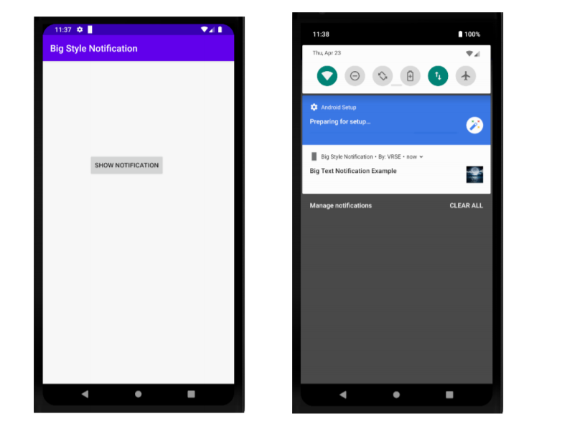

b) Inbox Style

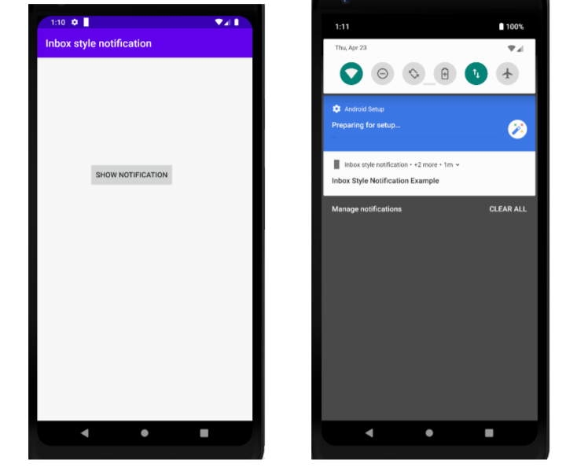

c) BigPicture Style Notification

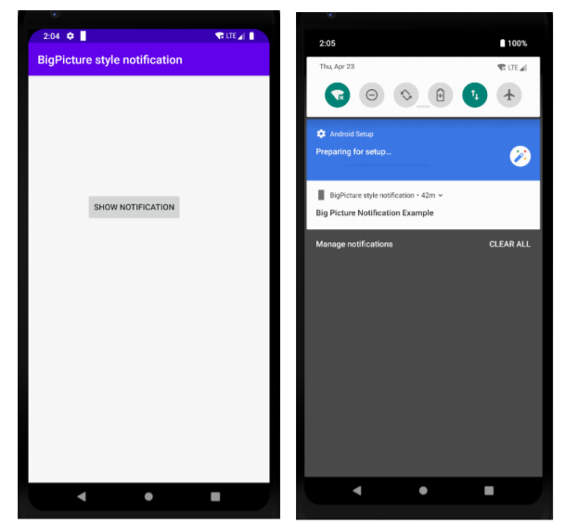

7.b. Implementation of Android Custom Toast

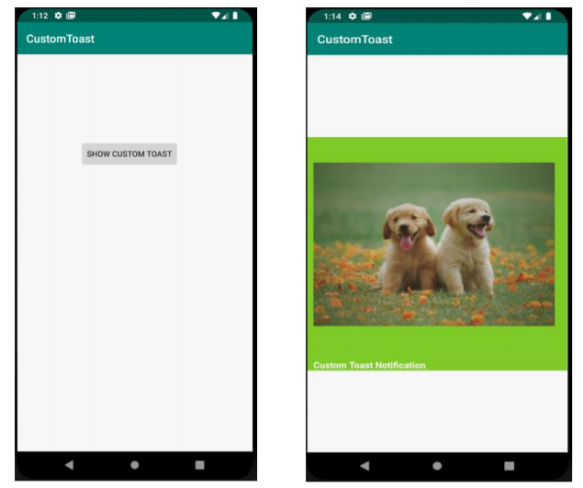

8.a. Implementation of Progress Notifications

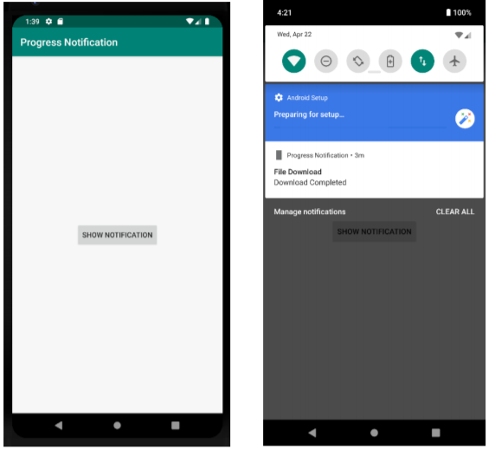

8.b. Implementation of Push Notification

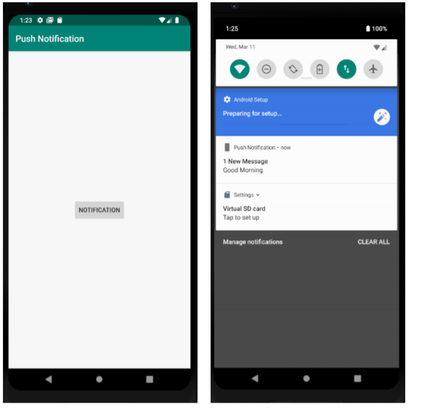

9.a. Implement Android Camera

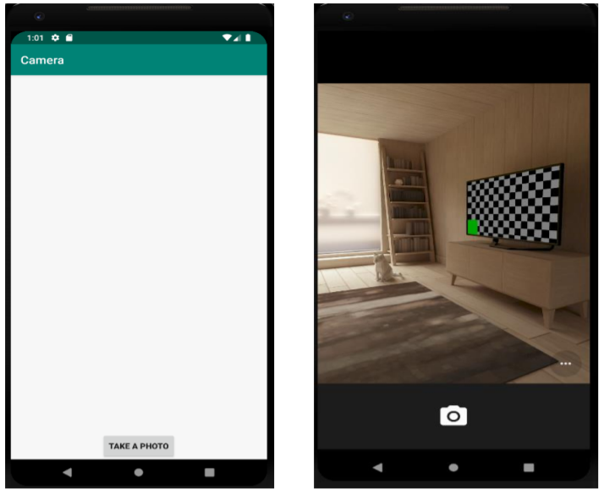

9.b) Implementation of Android Audio Player, Video Player

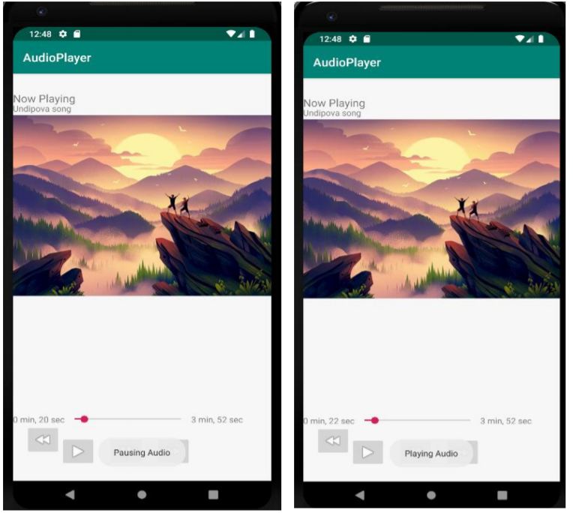

Develop an android application to implement login and registration screens

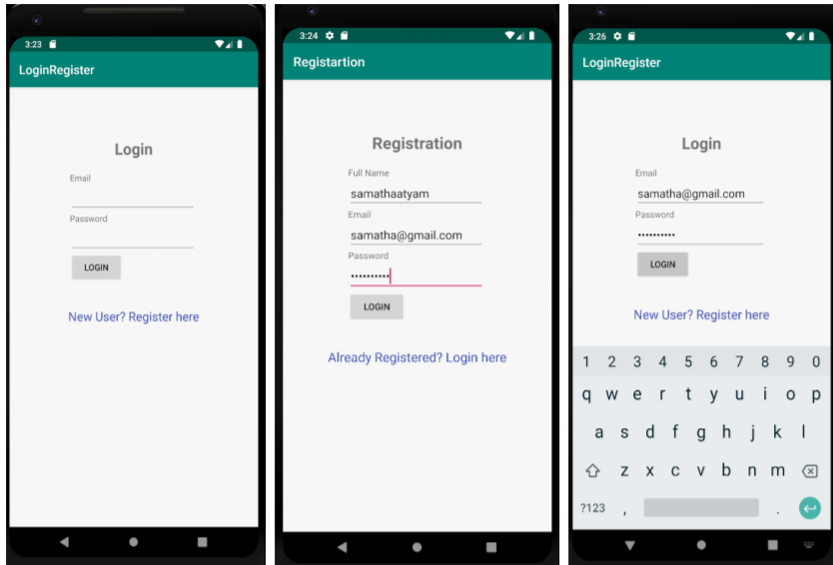

Develop an android application to implement Android Tabs Layout

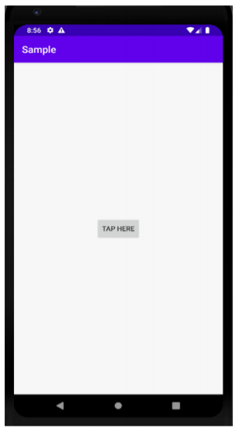

Implement hello world program

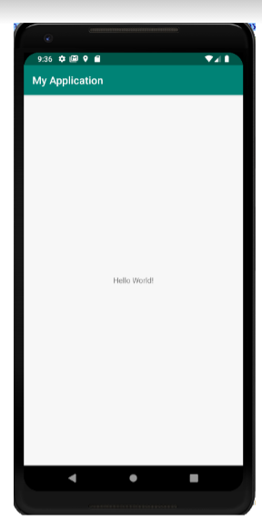

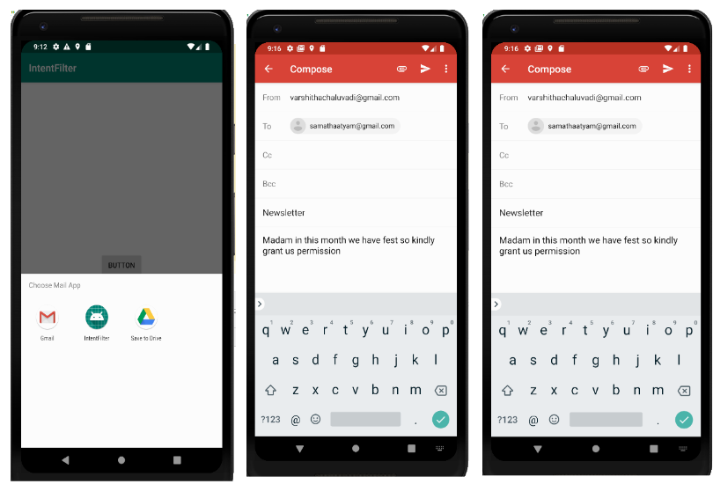

TextView, EditText, Button, Toggle Button, CheckBox, Radiobutton,

Spinner

b) DatePicker, TimePicker, SeekBar, RatingBar, TextClock, Switch

