**DATA ANALYTICS**

**TITLE-GLOBAL ECONOMIC DATA: COMPREHENSIVE ANALYSIS AND INSIGHTS**

**Team Name: Analytics Alliance**

**Team :21471A05H6 M. Yuva Sravani** 21471A05H6@nrtec.in

**21471A05H1 K. Thrylokya** 21471A05H1@nrtec.in

**21471A05J9 S.V. Jhansi Lakshmi** 21471A05J9@nrtec.in

**21471A05J7 B. Sirisha** 21471A05J7@nrtec.in

**INTRODUCTION:**

**Description:**

World Economic Data refers to a collection of data encompassing various economic indicators and factors from countries around the world. It includes information such as GDP growth rates, Corruption, Tourism, Unemployment and Cost of Living etc. To conduct a comprehensive analysis of World Economic Data, we would typically employ statistical techniques, econometric models, and data visualization tools. These methods help in understanding the relationships between different economic variables, conducting scenario analyses, and making data-driven decisions.

**Purpose**:

**Business impact:**

**Informed Decision Making:** Data analytics empowers businesses to make smarter decisions by extracting valuable insights from data, leading to more effective strategies and improved outcomes.

**Customer Personalization:** Analysing customer data allows businesses to personalize their products and services, creating tailored experiences that meet individual needs. Personalization enhances customer satisfaction, loyalty, and increases revenue through targeted marketing efforts.

**Operational Efficiency:** Data analytics identifies inefficiencies in business processes, enabling optimization to reduce costs and enhance productivity.

**Social impact:**

**Education Enhancement:** Data analytics identifies areas where students need support, allowing educators to tailor teaching methods and improve learning outcomes.

**Public Policy and Governance:** Governments use data analytics to make evidence-based decisions, leading to more effective public policies and resource allocation.

**LITERATURE SURVEY:**

**Existing problem:**

Global economic data is crucial for businesses, policymakers, and researchers to make informed decisions and navigate the complex global landscape. We aim to achieve comprehensive analysis and actionable insights from global economic data.

**Proposed Solution:**

We analyse the related data and derive the useful information then we convert the information into visualisation form. We create a web application with the help of IBM Cognos platform, python frame works like flask.

We provide output according to user interests and priority in which the output is in a clear visual form which helps to identify the risk factors and helps to take decisions.

**THEORITICAL ANALYSIS:**

**Diagrammatic overview of the project:**

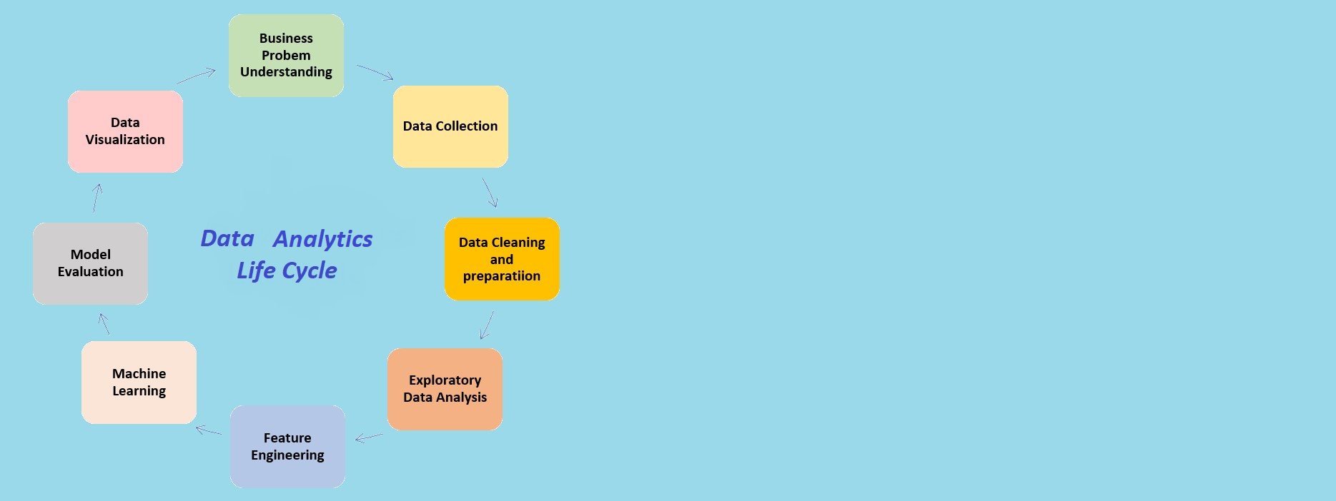

**Hardware/Software designing:**

**IBM Cognos**: Data-driven business intelligence and performance management platform for generating actionable insights and reports.

**Python**: A versatile and powerful programming language widely used for data analytics, statistical analysis, and machine learning applications.

**Flask**: A light weight web framework often used to deploy data analytics APIs and web applications.

**EXPERIMENTAL INVESTIGATIONS:**

**1.Introduction:**

The goal of this project is to conduct a comprehensive analysis of the global economy using data analytics techniques. By harnessing the power of data and applying advanced analytical tools, we aim to gain valuable insights into various economic aspects, identify trends, and make informed predictions. The scope of this project encompasses data collection, cleaning, analysis, and visualization to provide a deeper understanding of the global economy's dynamics.

**2.Data Collection:**

Identifying relevant and reliable sources of economic data, including international organizations, government agencies, financial institutions, and reputable research publications.

Gathering data on key economic indicators such as GDP, inflation rates, unemployment rates, trade balances, exchange rates, interest rates, stock market indices, and commodity prices.

Ensuring data covers a substantial period to capture historical trends and variations.

**3.Data Cleaning and Preparation:**

Cleaning and preprocessing the collected data to ensure consistency, accuracy, and compatibility for analysis.

Handling the missing values, outliers, and data inconsistencies appropriately.

Transforming data into suitable formats and structures for analysis.

**4.Exploratory Data Analysis (EDA):**

Conducting EDA to get a preliminary understanding of the data and uncover patterns, correlations, and insights.

Visualizing the data using charts, graphs, and interactive visualizations to highlight significant economic trends.

**5.Time-Series Analysis:**

Applying time-series analysis techniques to understand the evolution of economic indicators over time.

Identifying seasonal patterns, trends, and cyclical variations that may influence the global economy.

**6.Sentiment Analysis:**

Utilizing sentiment analysis on economic news articles, social media, and other text data to gauge public and investor sentiment's impact on the economy.

Identifying positive and negative sentiments related to economic events and assess their potential influence on economic trends.

**7.Economic Forecasting:**

Developing predictive models using machine learning algorithms to forecast economic indicators in the short and medium term. Validating the accuracy of the models through cross-validation and back testing.

**8.Economic Impact of Events:**

Investigating the impact of significant global events (e.g., pandemics, geopolitical events, policy changes) on the global economy using data-driven methodologies.

Evaluating how these events have historically affected economic indicators and identify potential implications for the future.

**9.Regional and Country-Level Analysis:**

Performing regional and country-level analyses to compare economic performance, identify variations, and assess the interconnectedness of different economies.

Analyse factors contributing to economic growth or decline in specific regions or countries.

**10.Visualization and Reporting:**

Creating informative and visually appealing dashboards and reports to present the findings of the analysis. Based on the analysis, provide actionable recommendations to policymakers, businesses, and investors to make informed decisions related to the global economy.

**Flowchart:**

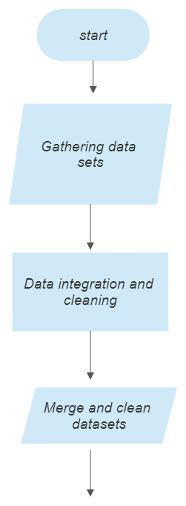

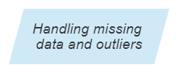

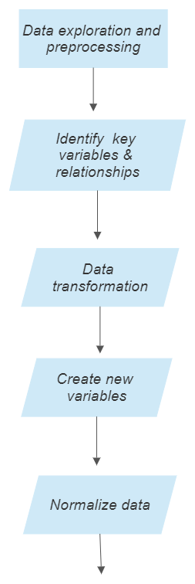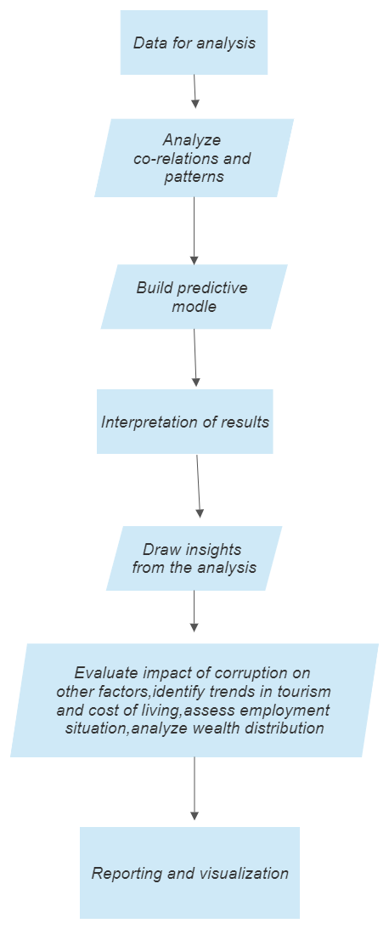

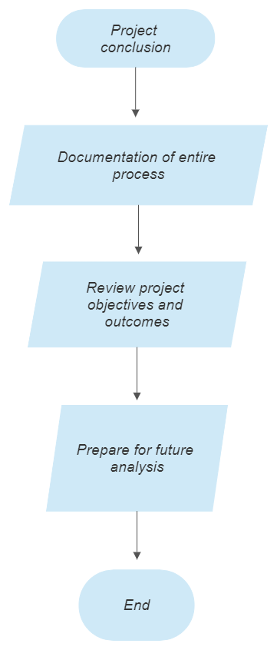

**RESULT:**

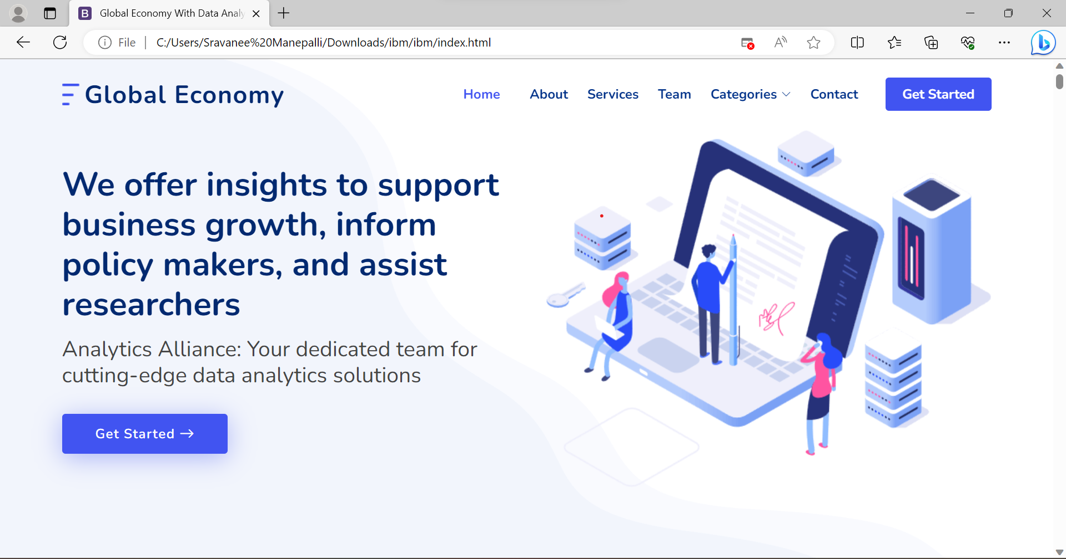

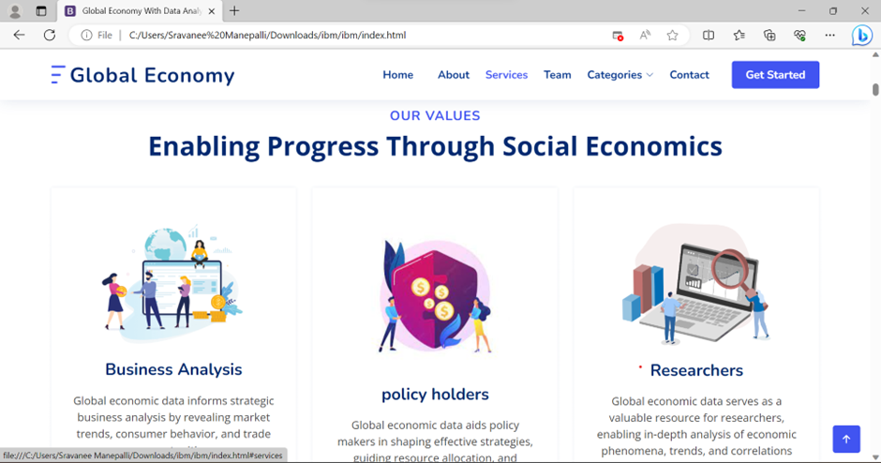

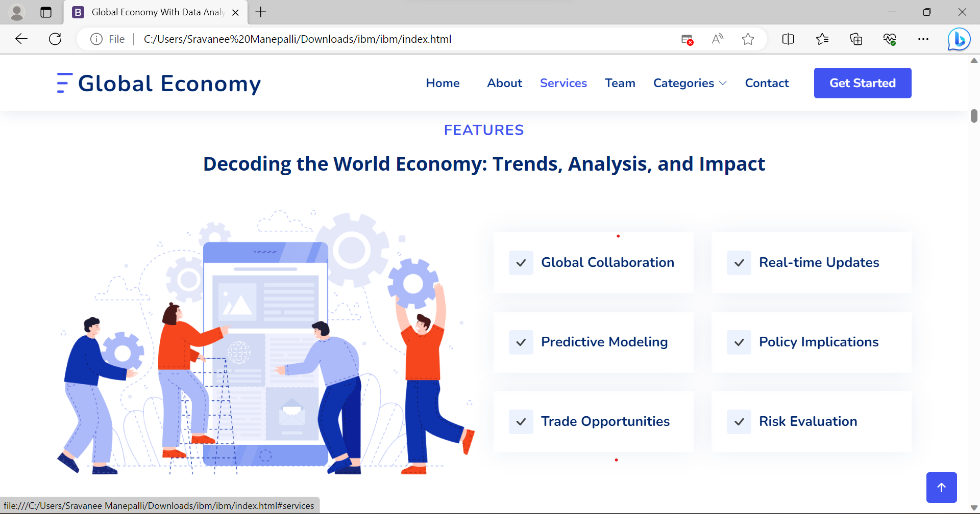

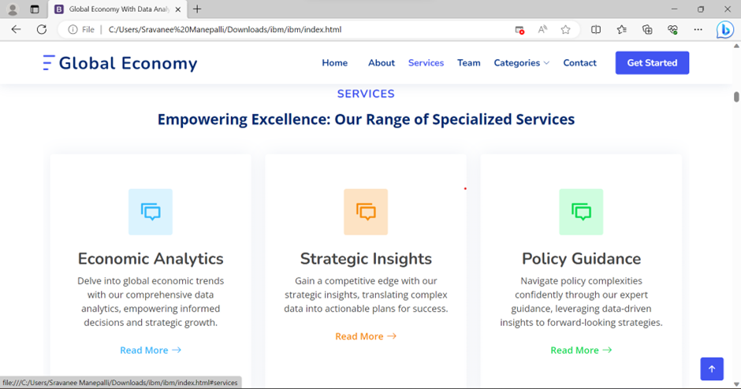

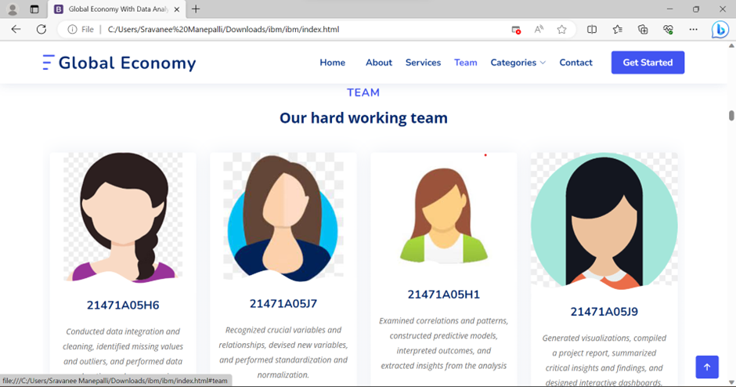

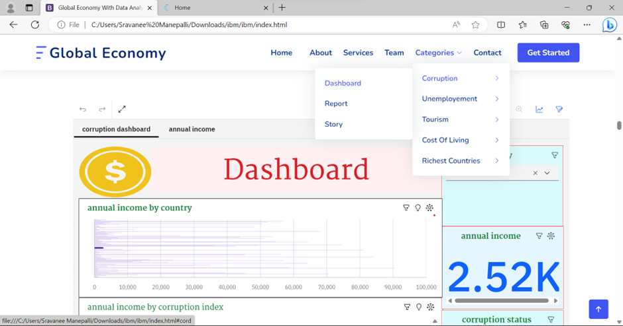

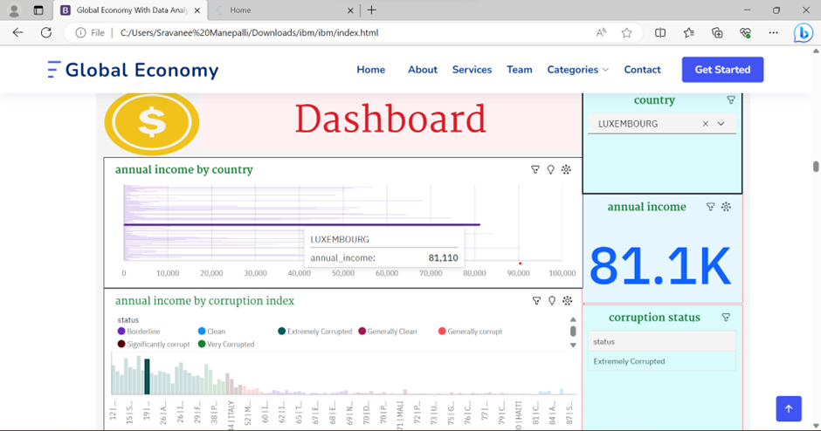

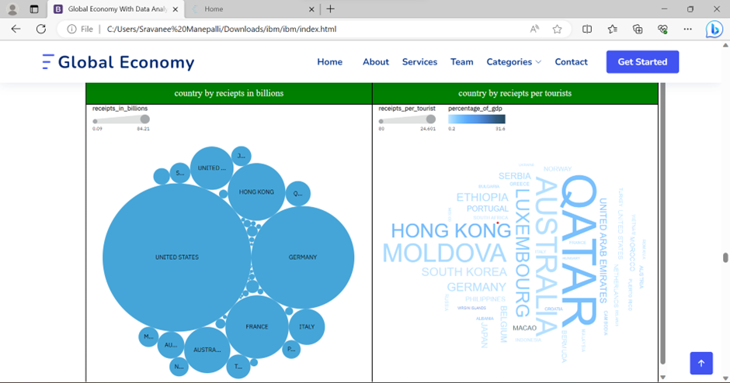

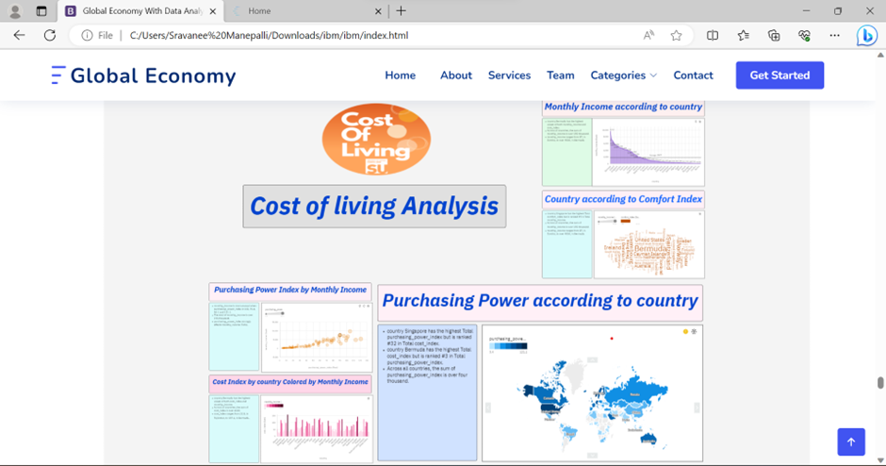

**Advantages:**

**Crisis Management:** During economic crises, visualizations help authorities and organizations better understand the extent of the crisis, its impacts, and potential pathways to recovery.

**Real-Time Monitoring:** Real-time visualizations allow for the monitoring of economic indicators and events as they unfold. This is particularly valuable for financial institutions, traders, and investors who need up-to-date information for timely decisions.

**Comparative Analysis:** Visualizations enable easy comparison of economic indicators across different countries and regions. This can reveal disparities, similarities, and areas of potential collaboration or competition.

**Comprehensive Understanding:** Visualizations provide a holistic view of the global economy, helping people grasp the interconnectedness of various factors such as trade, investment, currency exchange rates, and economic indicators.

**Disadvantages:**

**Data Availability:** Certain economic indicators may not be readily available for all countries or regions, making it difficult to create a comprehensive global picture.

**Data Quality and Reliability:** The quality and consistency of data from different sources might vary, making it necessary to carefully validate and cleanse the data before analysis.

**External Factors:** Economic developments are often influenced by external factors beyond the scope of traditional economic indicators, such as technological advancements, environmental issues, and societal changes. Incorporating such factors into the analysis is challenging

**Applications**:

**Government and Policy Agencies**:

**Economic Policy Formulation:** Visualizations of economic indicators help policymakers understand the current state of the economy and make informed decisions about fiscal and monetary policies.

**Trade Analysis:** Visualizing trade data assists in negotiating trade agreements and understanding trade flows.

**International Organizations:**

**Development Planning:** Visualizations of global economic indicators can guide international development organizations in allocating resources and setting priorities.

**Poverty Analysis:** Visualizations help identify regions and populations most affected by poverty, facilitating targeted interventions.

Think Tanks and Economic Research Organizations:

**Policy Advocacy:** Visualizations of economic data support research-based policy advocacy efforts.

Environmental and Sustainability Organizations:

**Sustainable Development:** Visualizations help illustrate the relationship between economic growth, resource use, and environmental impact

**Conclusion**:

Visualizations enable us to confront challenges head-on, from addressing disparities in wealth distribution and trade imbalances to adapting to technological disruptions and environmental changes. In times of crisis, the real-time insights gleaned from visualizations empower us to respond swiftly and strategically, mitigating the impact of economic upheavals.

**Future scope:**

**Blockchain Integration**: Utilize blockchain technology to ensure data integrity and transparency in economic visualizations, enhancing credibility.

**Artificial Intelligence Integration:** Utilize AI algorithms to enhance visualizations, enabling automatic pattern recognition, anomaly detection, and data-driven recommendations.

**Multi-Dimensional Analysis**: Combine economic data with other relevant datasets, such as environmental, social, and health data, to enable comprehensive analysis.

**Predictive Analytics:** Integrate predictive modelling into visualizations to forecast economic trends and potential scenarios, empowering decision-makers with foresight.

**Long-Term Trends:** Visualize long-term global economic trends, such as demographic shifts, technological progress, and sustainability challenges.

**Policy Impact Assessment:** Develop visualizations that allow policymakers to simulate and assess the potential effects of different policy interventions.

**Bibliography:**

"The World is Flat: A Brief History of the Twenty-first Century" by Thomas L. Friedman

This book explores the impact of globalization and technological advancements on the global economy, discussing how the world has become more interconnected and the implications for individuals, businesses, and governments.

**Appendix:**

Source code:

