Q1: Top 5 Highest Rated Products
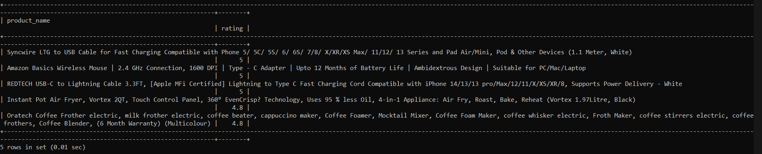

Q2: Top 5 Products With Highest Discounts
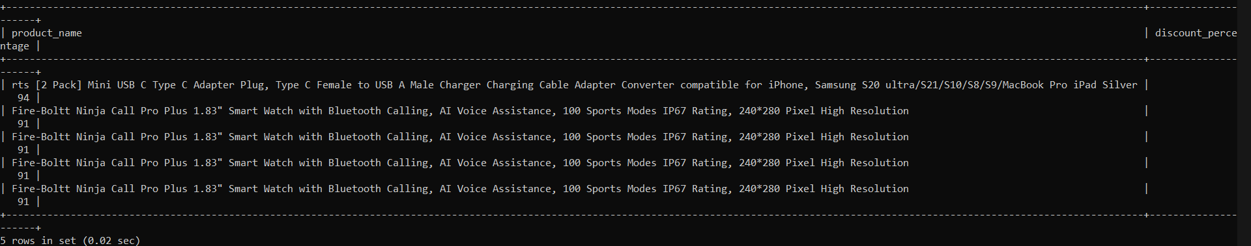

Q3: Top 5 Most Reviewed Products
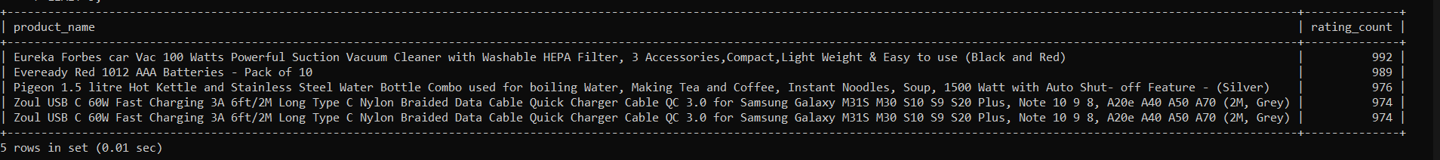
Q4: Average Product Rating by Category
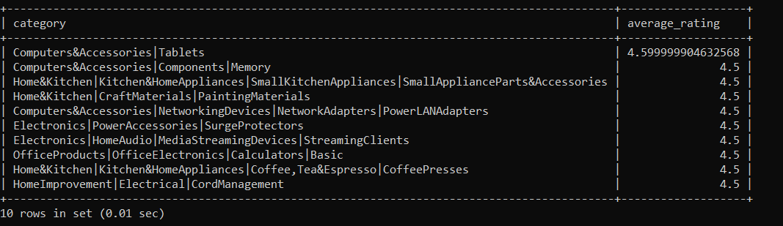

Q5: Top 5 Most Expensive Products
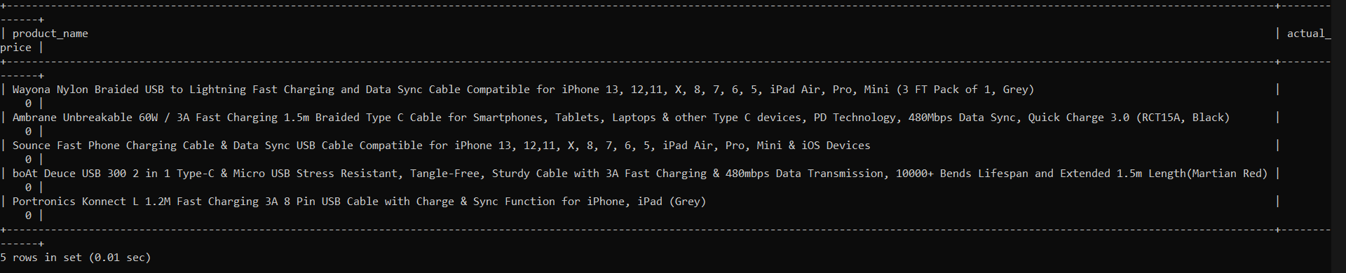

Q6: Low Rated Products With High Discounts
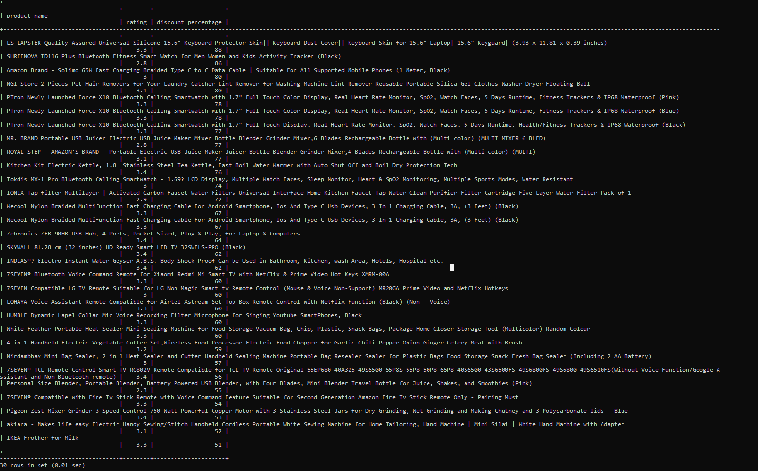
Q7: Number of Products in Each Category
