Screenshot No. : 01 for Step No. 4.1.1

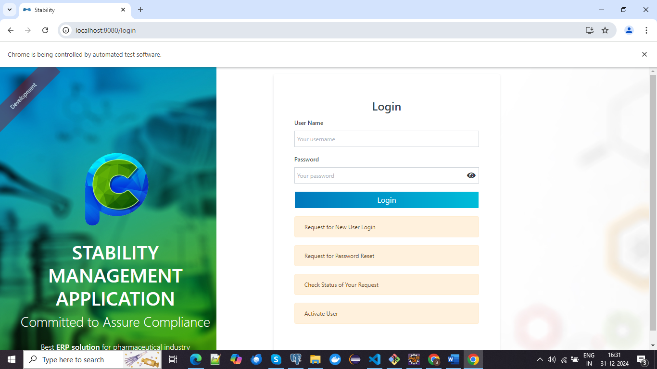

Screenshot No. : 01 for Step No. 4.1.2

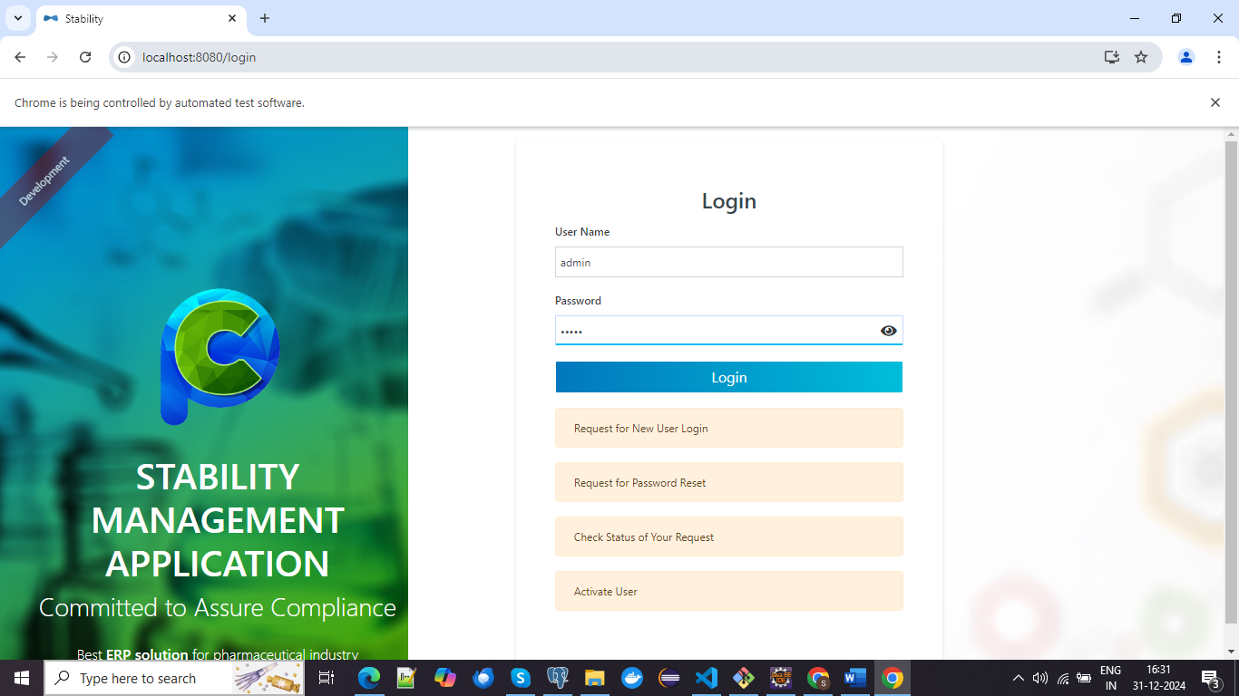

Screenshot No. : 01 for Step No. 4.1.2

