Visvesvaraya Technological University

Belgaum-590014


A DBMS Mini-Project Report
On

“BMTC DATABASE”

A Mini project report submitted in partial fulfillment of the requirements for the 5th semester of Bachelor of Engineering in Computer Science and Engineering
of Visvesvaraya Technological University, Belgaum

Submitted by:

A MANOJ KUMAR 1RN15CS002

AMITH R KORADAKERI 1RN15CS019

Under the Guidance of:

Mrs. S Mamatha Jajur Mr. H R Shashidhar
Asst Professor Asst Professor
Dept. of CSE Dept. of CSE


Department of Computer Science and Engineering
RNS Institute of Technology
Channasandra, Uttarahalli-Kengeri Main Road, Bangalore-560 098
2017-2018

RNS Institute of Technology
Channasandra, Uttarahalli-Kengeri Main Road,
Bangalore-560 061

Department of Computer Science & Engineering

CERTIFICATE
Certified that the mini project work entitled “BMTC DATABASE” has been successfully carried out by A MANOJ KUMAR bearing USN 1RN15CS002 and AMITH R KORADAKERI bearing USN 1RN15CS019, bonafide students of RNS Institute of Technology in partial fulfillment of the requirements for the 5th semester of Bachelor of Engineering in Computer Science and Engineering of Visvesvaraya Technological University, Belgaum, during academic year 2017-2018. It is certified that all corrections/suggestions indicated for Internal Assessment have been incorporated in the report deposited in the departmental library. The project report has been approved as it satisfies the laboratory requirements of 5th semester BE, CSE.

Prof. S Mamatha Jajur Prof. H R Shashidhar Dr. G T Raju
Asst Prof. Asst Prof. Prof. and Head
Dept. of CSE Dept. of CSE Dept of CSE

External Viva:
Name of the Examiners Signature with Date
1.
2.

ACKNOWLEDGEMENT

Any achievement, be it scholastic or otherwise does not depend solely on the individual efforts but on the guidance, encouragement and cooperation of intellectuals, elders and friends. A number of personalities, in their own capacities have helped me in carrying out this project work. We would like to take this opportunity to thank them all.
We would like to thank Dr. H N Shivashankar, Director, RNSIT, Bangalore, for his moral support towards completing my project.
We are grateful to Dr. M K Venkatesha, Principal, RNSIT, Bangalore, for his support towards completing my project.
We would like to thank Dr. G T Raju, Dean of Engg., Prof & Head , Department of Computer Science & Engineering, RNSIT, Bangalore, for his valuable suggestions and expert advice.
We deeply express my sincere gratitude to my guide Prof. Mamatha Jajur and Prof. H R Shashidhar, Asst Prof, Department of CSE, RNSIT, Bangalore, for their able guidance, regular source of encouragement and assistance throughout this project.

We would like to thank all the teaching and non-teaching staff of Department of Computer Science & Engineering RNSIT, Bangalore for their constant support and encouragement.

Date : 20/11/2017 Student names
Place : Bangalore A Manoj Kumar Amith R Koradakeri

ABSTRACT

BMTC DATABASE

Bangalore Metropolitan Transport Corporation(BMTC)

Bangalore Metropolitan Transport Corporation (BMTC) is a government agency that operates the public transport bus service in Bangalore, India. It has the highest number of Volvo buses operated by a public transport company in India.
The BMTC is one of the three Subsidiaries of Karnataka State Road Transport Corporation, in the context of the city's expansion in the year 1997, Bangalore Transport Service(BTS) was formed . Later Bangalore Transport Service(BTS) became Bangalore Metropolitan Transport Corporation. And the colour scheme of BTS was also changed from red to a blue and white combination. For this day BMTC still remains a division of KSRTC. The profits earned by BMTC are used to cover the losses from the NWKRTC and NEKRTC divisions of KSRTC. Indian actor superstar Rajinikanth began acting in plays while working in the Bangalore Transport Service as a bus conductor.

BMTC is considered said to have the best transport facilities in India. BMTC database system deals with details of buses. It also includes of information like route details and depot details of bus.

By using this software,we can find the details of the buses and details of the route as well as depot and staff.User can also check availability of bus and route details.The project provides and checks all sorts of constraints so that user can find details of all the buses.

This project is implemented using two end i.e., front end and back end
Front End : JavaNetBeans
Back End : Oracle Database

CONTENTS
Chapter | Page No
1. Introduction to Database Management System
1.1 Introduction
1.2 History of DBMS
1.3 Characteristics of Database Approach
1.4 Applications of DBMS
2. Schema and ER Diagram
2.1 ER Diagram (…with description related to ur project)
2.2 Schema Diagram(…with description related to ur project)
3. Resource Requirements
3.1 Hardware Requirements
3.2 Software Requirements
4. Description of Tools and Technologies( relevant to ur project)
4.1 JAVA SWINGS
4.2 JAVA
4.3 MySQL
5. PHP/JAVA Database Connectivity
6. Implementation (SQL Commands with output and code(related to each GUI used)- relevant to your project)
7. Snapshots
8. Future enhancement
9.Conclusion
10.Bibliography

CHAPTER 1

INTRODUCTION TO DATABASE MANAGEMENT SYSTEM
  - Introduction

Databases and database technology have a major impact on the growing use of computers. It is fair to say that databases play a critical role in almost all areas where computers are used, including business, electronic commerce, engineering, medicine, genetics, law, education, and library science. The word database is so commonly used that we must begin by defining what a database is. Our initial definition is quite general. A database is a collection of related data. By data, we mean known facts that can be recorded and that have implicit meaning. For example, consider the names, telephone numbers, and addresses of the people you know. You may have recorded this data in an indexed address book or you may have stored it on a hard drive, using a personal computer and software such as Microsoft Access or Excel. This collection of related data with an implicit meaning is a database. The preceding definition of database is quite general; for example, we may consider the collection of words that make up this page of text to be related data and hence to constitute a database. However, the common use of the term database is usually more restricted.

A database has the following implicit properties:
- A database represents some aspect of the real world, sometimes called the miniworld or the universe of discourse (UoD). Changes to the miniworld are reflected in the database.
- A database is a logically coherent collection of data with some inherent meaning. A random assortment of data cannot correctly be referred to as a database.
- A database is designed, built, and populated with data for a specific purpose. It has an intended group of users and some preconceived applications in which these users are interested.

A database management system (DBMS) is a collection of programs that enables users to create and maintain a database. The DBMS is a general-purpose software system that facilitates the processes of defining, constructing, manipulating, and sharing databases among various users and applications. Defining a database involves specifying the data types, structures, and constraints of the data to be stored in the database. The database definition or descriptive information is also stored by the DBMS in the form of a database catalog or dictionary; it is called meta-data. Constructing the database is the process of storing the data on some storage medium that is controlled by the DBMS. Manipulating a database includes functions such as querying the database to retrieve specific data, updating the database to reflect changes in the miniworld, and generating reports from the data. Sharing a database allows multiple users and programs to access the database simultaneously.

1.2 HISTORY OF DBMS
A Database Management System allows a person to organize, store, and retrieve data from a computer. It is a way of communicating with a computer’s “stored memory.” In the very early years of computers, “punch cards” were used for input, output, and data storage. Punch cards offered a fast way to enter data, and to retrieve it. Herman Hollerith is given credit for adapting the punch cards used for weaving looms to act as the memory for a mechanical tabulating machine, in 1890. Much later, databases came along.
Databases (or DBs) have played a very important part in the recent evolution of computers. The first computer programs were developed in the early 1950s, and focused almost completely on coding languages and algorithms. At the time, computers were basically giant calculators and data (names, phone numbers) was considered the leftovers of processing information. Computers were just starting to become commercially available, and when business people started using them for real-world purposes, this leftover data suddenly became important.

Enter the Database Management System (DBMS). A database, as a collection of information, can be organized so a Database Management System can access and pull specific information. In 1960, Charles W. Bachman designed the Integrated Database System, the “first” DBMS. IBM, not wanting to be left out, created a database system of their own, known as IMS. Both database systems are described as the forerunners of navigational database.
By the mid-1960s, as computers developed speed and flexibility, and started becoming popular, many kinds of general use database systems became available. As a result, customers demanded a standard be developed, in turn leading to Bachman forming the Database Task Group. This group took responsibility for the design and standardization of a language called Common Business Oriented Language (COBOL). The Database Task Group presented this standard in 1971, which also came to be known as the “CODASYL approach.”
The CODASYL approach was a very complicated system and required substantial training. It depended on a “manual” navigation technique using a linked data set, which formed a large network. Searching for records could be accomplished by one of three techniques:
- Using the primary key (also known as the CALC key)
- Moving relationships (also called sets) to one record from another
- Scanning all records in sequential order
Eventually, the CODASYL approach lost its popularity as simpler, easier-to-work-with systems came on the market.
Edgar Codd worked for IBM in the development of hard disk systems, and he was not happy with the lack of a search engine in the CODASYL approach, and the IMS model. He wrote a series of papers, in 1970, outlining novel ways to construct databases. His ideas eventually evolved into a paper titled, A Relational Model of Data for Large Shared Data Banks, which described new method for storing data and processing large databases. Records would not be stored in a free-form list of linked records, as in CODASYL navigational model, but instead used a “table with fixed-length records.”
IBM had invested heavily in the IMS model, and wasn’t terribly interested in Codd’s ideas. Fortunately, some people who didn’t work for IBM “were” interested. In 1973, Michael Stonebraker and Eugene Wong (both then at UC Berkeley) made the decision to research relational database systems. The project was called INGRES (Interactive Graphics and Retrieval System), and successfully demonstrated a relational model could be efficient and practical. INGRES worked with a query language known as QUEL, in turn, pressuring IBM to develop SQL in 1974, which was more advanced (SQL became ANSI and OSI standards in 1986 1nd 1987). SQL quickly replaced QUEL as the more functional query language.
RDBM Systems were an efficient way to store and process structured data. Then, processing speeds got faster, and “unstructured” data (art, photographs, music, etc.) became much more common place. Unstructured data is both non-relational and schema-less, and Relational Database Management Systems simply were not designed to handle this kind of data.

1.3 CHARACTERISTIC OF DATABASE APPROACH
A number of characteristics distinguish the database approach from the much older approach of programming with files. In traditional file processing, each user defines and implements the files needed for a specific software application as part of programming the application. For example, one user, the grade reporting office, may keep files on students and their grades. Programs to print a student’s transcript and to enter new grades are implemented as part of the application. A second user, the accounting office, may keep track of students’ fees and their payments. Although both users are interested in data about students, each user maintains separate files— and programs to manipulate these files—because each requires some data not avail able from the other user’s files. This redundancy in defining and storing data results in wasted storage space and in redundant efforts to maintain common up-to-date data. In the database approach, a single repository maintains data that is defined once and then accessed by various users. In file systems, each application is free to name data elements independently. In contrast, in a database, the names or labels of data are defined once, and used repeatedly by queries, transactions, and applications. The main characteristics of the database approach versus the file-processing approach are the following:
■ Self-describing nature of a database system
■ Insulation between programs and data, and data abstraction
■ Support of multiple views of the data
■ Sharing of data and multiuser transaction processing.

1.3.1 Self-Describing Nature of a Database System

A fundamental characteristic of the database approach is that the database system contains not only the database itself but also a complete definition or description of the database structure and constraints. This definition is stored in the DBMS catalog, which contains information such as the structure of each file, the type and storage format of each data item, and various constraints on the data. The information stored in the catalog is called meta-data, and it describes the structure of the primary database. The catalog is used by the DBMS software and also by database users who need information about the database structure. A general-purpose DBMS software package is not written for a specific database application. Therefore, it must refer to the catalog to know the structure of the files in a specific database, such as the type and format of data it will access. The DBMS software must work equally well with any number of database applications—for example, a university database, a banking database, or a company database—as long as the database definition is stored in the catalog. In traditional file processing, data definition is typically part of the application programs themselves. Hence, these programs are constrained to work with only one specific database, whose structure is declared in the application programs. For example, an application program written in C++ may have structure or class declarations, and a COBOL program has data division statements to define its files. Whereas file-processing software can access only specific databases, DBMS software can access diverse databases by extracting the database definitions from the catalog and using these definitions.

1.3.2 Insulation between Programs and Data, and Data Abstraction

In traditional file processing, the structure of data files is embedded in the application programs, so any changes to the structure of a file may require changing all programs that access that file. By contrast, DBMS access programs do not require such changes in most cases. The structure of data files is stored in the DBMS catalog separately from the access programs. We call this property program-data independence. In some types of database systems, such as object-oriented and object-relational systems users can define operations on data as part of the database definitions. An operation (also called a function or method) is specified in two parts. The interface (or signature) of an operation includes the operation name and the data types of its arguments (or parameters).The implementation (or method) of the operation is specified separately and can be changed without affecting the interface. User application programs can operate on the data by invoking these operations through their names and arguments, regardless of how the operations are implemented. This may be termed program-operation independence. The characteristic that allows program-data independence and program-operation independence is called data abstraction. A DBMS provides users with a conceptual representation of data that does not include many of the details of how the data is stored or how the operations are implemented. Informally, a data model is a type of data abstraction that is used to provide this conceptual representation. The data model uses logical concepts, such as objects, their properties, and their interrelationships, that may be easier for most users to understand than computer storage concepts. Hence, the data model hides storage and implementation details that are not of interest to most database users.

1.3.3 Support of Multiple Views of the Data

A database typically has many users, each of whom may require a different perspective or view of the database. A view may be a subset of the database or it may contain virtual data that is derived from the database files but is not explicitly stored. Some users may not need to be aware of whether the data they refer to is stored or derived. A multiuser DBMS whose users have a variety of distinct applications must provide facilities for defining multiple views.

1.3.4 Sharing of Data and Multiuser Transaction Processing

A multiuser DBMS, as its name implies, must allow multiple users to access the database at the same time. This is essential if data for multiple applications is to be integrated and maintained in a single database. The DBMS must include concurrency control software to ensure that several users trying to update the same data do so in a controlled manner so that the result of the updates is correct. For example, when several reservation agents try to assign a seat on an airline flight, the DBMS should ensure that each seat can be accessed by only one agent at a time for assignment to a passenger. These types of applications are generally called online transaction processing (OLTP) applications. A fundamental role of multiuser DBMS software is to ensure that concurrent transactions operate correctly and efficiently. The concept of a transaction has become central to many database applications. A transaction is an executing program or process that includes one or more database accesses, such as reading or updating of database records. Each transaction is supposed to execute a logically correct database access if executed in its entirety without interference from other transactions. The DBMS must enforce several transaction properties. The isolation property ensures that each transaction appears to execute in isolation from other transactions, even though hundreds of transactions may be executing concurrently. The atomicity property ensures that either all the database operations in a transaction are executed or none are.

APPLICATIONS OF DBMS
Applications where we use Database Management Systems are:
- Telecom: There is a database to keeps track of the information regarding calls made, network usage, customer details etc. Without the database systems it is hard to maintain that huge amount of data that keeps updating every millisecond.
- Industry: Where it is a manufacturing unit, warehouse or distribution center, each one needs a database to keep the records of ins and outs. For example distribution center should keep a track of the product units that supplied into the center as well as the products that got delivered out from the distribution center on each day; this is where DBMS comes into picture.
- Banking System: For storing customer info, tracking day to day credit and debit transactions, generating bank statements etc. All this work has been done with the help of Database management systems.
- Education sector: Database systems are frequently used in schools and colleges to store and retrieve the data regarding student details, staff details, course details, exam details, payroll data, attendance details, fees details etc. There is a hell lot amount of inter-related data that needs to be stored and retrieved in an efficient manner.
- Online shopping: You must be aware of the online shopping websites such as Amazon, Flipkart etc. These sites store the product information, your addresses and preferences, credit details and provide you the relevant list of products based on your query. All this involves a Database management system.

CHAPTER 2

SCHEMA AND ER DIAGRAM

2.1 SCHEMA DIAGRAM

BUS
BUS_NO | BUS_TYPE | MANUFACTURING_COMPANY

BUS_NO | ROUTE_ID | SOURCE | DESTINATION | VIA | DISTANCE | JOURNEY_TIME | Timings
ROUTE

STAFF_ID | BUS_NO | STAFF_NAME | DESIGNITION | SALARY | EXPERIENCE | ROUTE_ID
STAFF

DEPOT
BUS_NO | DEPOT NO | DEPOT_NAME | STAFF_ID

FACILITIES
BUS_NO | ROUTE_ID | ADULTFARE | CHILD_FARE | DAILY_PASS

2.2 ER DIAGRAM

Source
Destination
Via
Time
Distance
Depot_no
Depot_name
belongs
ROUTE
DEPOT
Route ID

goes

Bus no
reports
Bus Type
BUS
Child Fare
Adult Fare
Daily Pass
FACILITIES
has
Manufacturing Company
has
Experience
STAFF ID
Qualifications
STAFF

STAFF Name

CHAPTER 3

SYSTEM REQUIREMENTS

3.1HARDWARE REQUIREMENTS
The Hardware requirements are very minimal and the program can be run on most of the machines.
Processor | : | Pentium4 processor
Processor Speed | : | 2.4 GHz
RAM | : | 1 GB
Storage Space | : | 40 GB
Monitor Resolution | : | 1024*768 or 1336*768 or 1280*1024

3.2SOFTWARE REQUIREMENTS
Operating System : Windows XP
IDE : Microsoft Visual Studio with C++ (version 6)
OpenGL libraries, Header Files which includes GL/glut.h, Object File Libraries, glu32.lib,opengl32.lib,glut32.lib,DLLfiles,glu32.dll,glut32.dll,opengl32.dll.

CHAPTER 4

DESCRIPTION OF TOOLS AND TEHNOLOGIES

4.1JAVA SWINGS AND APPLETS
A Java applet is a small application that is written in the Java programming language, or another programming language that compiles to Java bytecode, and delivered to users in the form of Java bytecode. The user launches the Java applet from a web page, and the applet is then executed within a Java virtual machine (JVM) in a process separate from the web browser itself. A Java applet can appear in a frame of the web page, a new application window, Sun's AppletViewer, or a stand-alone tool for testing applets. Java applets were introduced in the first version of the Java language, which was released in 1995.Java applets are usually written in Java, but other languages such as Jython, JRuby, Pascal, Scala, or Eiffel (via SmartEiffel)may be used as well.
Java applets run at very fast speeds and, until 2011, they were many times faster than JavaScript.^{[11]} Unlike JavaScript, Java applets had access to 3D hardware acceleration, making them well-suited for non-trivial, computation-intensive visualizations. As browsers have gained support for hardware-accelerated graphics thanks to the canvas technology (or specifically WebGL in the case of 3D graphics), as well as just-in-time compiled JavaScript, the speed difference has become less noticeable.Since Java bytecode is cross-platform (or platform independent), Java applets can be executed by browsers (or other clients) for many platforms, including Microsoft Windows, FreeBSD, Unix, macOS and Linux.Java applet technology has been marked for deprecation.
he Applets are used to provide interactive features to web applications that cannot be provided by HTML alone.They can capture mouse input and also have controls like buttons or check boxes. In response to user actions, an applet can change the provided graphic content. This makes applets well-suited for demonstration, visualization, and teaching. There are online applet collections for studying various subjects, from physics to heart physiology.An applet can also be a text area only; providing, for instance, a cross-platform command-line interface to some remote system. If needed, an applet can leave the dedicated area and run as a separate window. However, applets have very little control over web page content outside the applet's dedicated area, so they are less useful for improving the site appearance in general, unlike other types of browser extensions Applets can also play media in formats that are not natively supported by the browser.
Pages coded in HTML may embed parameters within them that are passed to the applet. Because of this, the same applet may have a different appearance depending on the parameters that were passed.
As applets were available before CSS and DHTML were standard, they were also widely used for trivial effects such as rollover navigation buttons. Heavily criticized, this usage is now declining.
Java applets are executed in a sandbox by most web browsers, preventing them from accessing local data like the clipboard or file system. The code of the applet is downloaded from a web server, after which the browser either embeds the applet into a web page or opens a new window showing the applet's user interface.
A Java applet extends the class java.applet.Applet, or in the case of a Swing applet, javax.swing.JApplet. The class which must override methods from the applet class to set up a user interface inside itself (Applet) is a descendant of Panel which is a descendant of Container. As applet inherits from container, it has largely the same user interface possibilities as an ordinary Java application, including regions with user specific visualization.
The first implementations involved downloading an applet class by class. While classes are small files, there are often many of them, so applets got a reputation as slow-loading components. However, since .jars were introduced, an applet is usually delivered as a single file that has a size similar to an image file (hundreds of kilobytes to several megabytes).The domain from where the applet executable has been downloaded is the only domain to which the usual (unsigned) applet is allowed to communicate. This domain can be different from the domain where the surrounding HTML document is hosted.Java system libraries and runtimes are backwards-compatible, allowing one to write code that runs both on current and on future versions of the Java virtual machine.
Swing is a GUI widget toolkit for Java. It is part of Oracle's Java Foundation Classes (JFC) – an API for providing a graphical user interface (GUI) for Java programs.
Swing was developed to provide a more sophisticated set of GUI components than the earlier Abstract Window Toolkit (AWT). Swing provides a native look and feel that emulates the look and feel of several platforms, and also supports a pluggable look and feel that allows applications to have a look and feel unrelated to the underlying platform. It has more powerful and flexible components than AWT. In addition to familiar components such as buttons, check boxes and labels, Swing provides several advanced components such as tabbed panel, scroll panes, trees, tables, and lists.
Unlike AWT components, Swing components are not implemented by platform-specific code. Instead, they are written entirely in Java and therefore are platform-independent. The term "lightweight" is used to describe such an element.
Swing is a highly modular-based architecture, which allows for the "plugging" of various custom implementations of specified framework interfaces: Users can provide their own custom implementation(s) of these components to override the default implementations using Java's inheritance mechanism.
Swing is a component-based framework, whose components are all ultimately derived from the javax.swing.JComponent class. Swing objects asynchronously fire events, have bound properties, and respond to a documented set of methods specific to the component. Swing components are Java Beans components, compliant with the Java Beans Component Architecture specifications.
Since early versions of Java, a portion of the Abstract Window Toolkit (AWT) has provided platform-independent APIs for user interface components. In AWT, each component is rendered and controlled by a native peer component specific to the underlying windowing system.
By contrast, Swing components are often described as lightweight because they do not require allocation of native resources in the operating system's windowing toolkit. The AWT components are referred to as heavyweight components.
Much of the Swing API is generally a complementary extension of the AWT rather than a direct replacement. In fact, every Swing lightweight interface ultimately exists within an AWT heavyweight component because all of the top-level components in Swing (JApplet, JDialog, JFrame, and JWindow) extend an AWT top-level container.
Swing's high level of flexibility is reflected in its inherent ability to override the native host operating system (OS)'s GUI controls for displaying itself. Swing "paints" its controls using the Java 2D APIs, rather than calling a native user interface toolkit. Thus, a Swing component does not have a corresponding native OS GUI component, and is free to render itself in any way that is possible with the underlying graphics GUIs.
However, at its core, every Swing component relies on an AWT container, since (Swing's) JComponent extends (AWT's) Container. This allows Swing to plug into the host OS's GUI management framework, including the crucial device/screen mappings and user interactions, such as key presses or mouse movements. Swing simply "transposes" its own (OS-agnostic) semantics over the underlying (OS-specific) components. So, for example, every Swing component paints its rendition on the graphic device in response to a call to component.paint(), which is defined in (AWT) Container. But unlike AWT components, which delegated the painting to their OS-native "heavyweight" widget, Swing components are responsible for their own rendering.
This transposition and decoupling is not merely visual, and extends to Swing's management and application of its own OS-independent semantics for events fired within its component containment hierarchies. Generally speaking, the Swing architecture delegates the task of mapping the various flavors of OS GUI semantics onto a simple, but generalized, pattern to the AWT container. Building on that generalized platform, it establishes its own rich and complex GUI semantics in the form of the JComponent model.

4.2JAVA

Java is a general-purpose computer programming language that is concurrent, class-based, object-oriented,and specifically designed to have as few implementation dependencies as possible. It is intended to let application developers "write once, run anywhere" (WORA), meaning that compiled Java code can run on all platforms that support Java without the need for recompilation. Java applications are typically compiled to bytecode that can run on any Java virtual machine (JVM) regardless of computer architecture. As of 2016, Java is one of the most popular programming languages in use,particularly for client-server web applications, with a reported 9 million developers. Java was originally developed by James Gosling at Sun Microsystems (which has since been acquired by Oracle Corporation) and released in 1995 as a core component of Sun Microsystems' Java platform. The language derives much of its syntax from C and C++, but it has fewer low-level facilities than either of them.
One design goal of Java is portability, which means that programs written for the Java platform must run similarly on any combination of hardware and operating system with adequate runtime support. This is achieved by compiling the Java language code to an intermediate representation called Java bytecode, instead of directly to architecture-specific machine code. Java bytecode instructions are analogous to machine code, but they are intended to be executed by a virtual machine (VM) written specifically for the host hardware. End users commonly use a Java Runtime Environment (JRE) installed on their own machine for standalone Java applications, or in a web browser for Java applets.

4.3MYSQL

MySQL is a Relational Database Management System (RDBMS). MySQL server
can manage many databases at the same time. In fact, many people might have different
databases managed by a single MySQL server. Each database consists of a structure to hold
the data and the data itself. A data-base can exist without data, only a structure, be totally
empty, twiddling its thumbs and waiting for data to be stored in it.
Data in a database is stored in one or more tables. You must create the data-base and
the tables before you can add any data to the database. First you create the empty database.
Then you add empty tables to the database. Database tables are organized like other tables
that you’re used in rows and columns. Each row represents an entity in the database, such as
a customer, a book, or a project. Each column contains an item of information about the
entity, such as a customer name, a book name, or a project start date. The place where a
particular row and column intersect, the individual cell of the table, is called a field. Tables
in databases can be related. Often a row in one table is related to several rows in another
table. For instance, you might have a database containing data about books you own. You
would have a book table and an author table. One row in the author table might contain
information about the author of several books in the book table. When tables are related.
you include a column in one table to hold data that matches data in the column of another
table.

MySQL, the most popular Open Source SQL database management system, is
developed, distributed, and supported by MySQL AB. MySQL AB is a commercial company,
founded by the MySQL developers. It is a second generation Open Source company that
unites Open Source values and methodology with a successful business model.
- MySQL is a database management system.
A database is a structured collection of data. It may be anything from a simple
shopping list to a picture gallery or the vast amounts of information in a corporate
network. To add, access, and process data stored in a computer database, you need a
database management system such as MySQL Server. Since computers are very good
at handling large amounts of data, database management systems play a central role in
computing, as standalone utilities, or as parts of other applications.
- MySQL is a relational database management system.
A relational database stores data in separate tables rather than putting all the data in
one big storeroom. This adds speed and flexibility. The SQL part of “MySQL” stands
for “Structured Query Language.” SQL is the most common standardized language
used to access databases and is defined by the ANSI/ISO SQL Standard. The SQL
standard has been evolving since 1986 and several versions exist. “SQL-92” refers to
the standard released in 1992, “SQL:1999” refers to the standard released in 1999, and
“SQL:2003” refers to the current version of the standard. We use the phrase “the SQL
standard” to mean the current version of the SQL Standard at any time.

- MySQL software is Open Source.
Open Source means that it is possible for anyone to use and modify the software.
Anybody can download the MySQL software from the Internet and use it without
paying anything. If you wish, you may study the source code and change it to suit
your needs. The MySQL software uses the GPL (GNU General Public License), to
define what you may and may not do with the software in different situations. The
MySQL Database Server is very fast, reliable, and easy to use.

MySQL Server was originally developed to handle large databases much faster than
existing solutions and has been successfully used in highly demanding production
environments for several years. Although under constant development, MySQL
Server today offers a rich and useful set of functions. Its connectivity, speed, and
security make MySQL Server highly suited for accessing databases on the Internet.
- MySQL Server works in client/server or embedded systems.
The MySQL Database Software is a client/server system that consists of a multi-
threaded SQL server that supports different back ends, several different client
programs and libraries, administrative tools, and a wide range of application
programming interfaces (APIs).

CHAPTER 5

JAVA DATABASE CONNECTIVITY

Java Database Connectivity (JDBC) is an application programming interface (API) for the programming language Java, which defines how a client may access a database. It is Java based data access technology and used for Java database connectivity. It is part of the Java Standard Edition platform, from Oracle Corporation. It provides methods to query and update data in a database, and is oriented towards relational databases. A JDBC-to-ODBC bridge enables connections to any ODBC-accessible data source in the Java virtual machine (JVM) host environment.
FUNCTIONALITY
JDBC allows multiple implementations to exist and be used by the same application. The API provides a mechanism for dynamically loading the correct Java packages and registering them with the JDBC Driver Manager. The Driver Manager is used as a connection factory for creating JDBC connections.
JDBC connections support creating and executing statements. These may be update statements such as SQL's CREATE, INSERT, UPDATE and DELETE, or they may be query statements such as SELECT. Additionally, stored procedures may be invoked through a JDBC connection. JDBC represents statements using one of the following classes:
- Statement – the statement is sent to the database server each and every time.
- PreparedStatement – the statement is cached and then the execution path is pre-determined on the database server allowing it to be executed multiple times in an efficient manner.
- CallableStatement – used for executing stored procedures on the database.
Update statements such as INSERT, UPDATE and DELETE return an update count that indicates how many rows were affected in the database. These statements do not return any other information.
Query statements return a JDBC row result set. The row result set is used to walk over the result set. Individual columns in a row are retrieved either by name or by column number. There may be any number of rows in the result set. The row result set has metadata that describes the names of the columns and their types.
There is an extension to the basic JDBC API in the javax.sql.
JDBC connections are often managed via a connection pool rather than obtained directly from the driver.

JDBC DRIVERS
JDBC drivers are client-side adapters (installed on the client machine, not on the server) that convert requests from Java programs to a protocol that the DBMS can understand.
Types:
Commercial and free drivers provide connectivity to most relational-database servers. These drivers fall into one of the following types:
a. Type 1 that calls native code of the locally available ODBC driver.
b. Type 2 that calls database vendor native library on a client side. This code then talks to database over the network.
c. Type 3, the pure-java driver that talks with the server-side middleware that then talks to the database.
d. Type 4, the pure-java driver that uses database native protocol.
Note also a type called an internal JDBC driver - a driver embedded with JRE in Java-enabled SQL databases. It is used for Java stored procedures.

5 Steps to connect to the database in java
There are 5 steps to connect any java application with the database in java using JDBC. They are as follows:
- Register the driver class
- Creating connection
- Creating statement
- Executing queries
- Closing connection

1) Register the driver class
The forName() method of Class class is used to register the driver class. This method is used to dynamically load the driver class.
Syntax of forName() method: public static void forName(String className throws ClassNotFoundException

2) Create the connection object
The getConnection() method of DriverManager class is used to establish connection with the database.
Syntax of getConnection() method:
- public static Connection getConnection(String url)throws SQLException
- public static Connection getConnection(String url,String name,String password) throws SQLException

3) Create the Statement object
The createStatement() method of Connection interface is used to create statement. The object of statement is responsible to execute queries with the database.
Syntax of createStatement() method:
public Statement createStatement()throws SQLException

4) Execute the query

The executeQuery() method of Statement interface is used to execute queries to the database. This method returns the object of ResultSet that can be used to get all the records of a table.
Syntax of executeQuery() method:
public ResultSet executeQuery(String sql)throws SQLException

5) Close the connection object
By closing connection object statement and ResultSet will be closed automatically. The close() method of Connection interface is used to close the connection.
Syntax of close() method:
public void close()throws SQLException

CHAPTER 6

IMPLEMENTATION

Source Code

Program for JDBC connectivity

import java.sql.*;

public class jap {

Statement st;

ResultSet rs;

Connection con;

public jap()

{

try

{

Class.forName("oracle.jdbc.driver.OracleDriver");

} catch (ClassNotFoundException ex)

{

System.out.println("error"+ex);

}

try

{

con=DriverManager.getConnection("jdbc:oracle:thin:@//localhost:1521/orcl","manoj","manoj");

st=con.createStatement();

System.out.println("success");

}

catch(SQLException e)

{

System.out.println("error"+e);

}

}

Creation of tables

CREATE table Bus

(

Bus_No varchar(30) primary key,

Bus_Type char(30),

Company char(30)

);

CREATE table Route

(

Bus_no varchar(30) references Bus(Bus_No),

RID int primary key,

source varchar(50),

destination varchar(50),

via varchar(50),

distance varchar(30),

time varchar(30)

);

CREATE table Staff

(

SID int primary key,

Bus_No varchar(30) references Bus(Bus_no)on delete cascade,

S_Name char(30),

Designation char(30),

Salary int,

Years_Exp int,

RID int references Route(RID)on delete cascade

);

create table Depot

(

Bus_no varchar(30) references Bus(Bus_no)on delete cascade,

Depot_no int,

Depot_name varchar(30),

SID int references Staff(SID)

);

Create table Facilities

(

Bus_No varchar(30) references Bus(Bus_No) on delete cascade,

RID int references Route(RID) on delete cascade,

adult_fare int,

child_fare int,

passes int

);

Description of the table

SQL> desc bus;
Name Null? Type
---------------- ---------------- -----------------------
BUS_NO NOT NULL VARCHAR2(30)
BUS_TYPE CHAR(30)
COMPANY CHAR(30)

SQL> desc route
Name Null? Type
------------------------ ------------- ------------------------
BUS_NO VARCHAR2(30)
RID NOT NULL NUMBER(38)
SOURCE VARCHAR2(50)
DESTINATION VARCHAR2(50)
VIA VARCHAR2(50)
DISTANCE VARCHAR2(30)
TIME VARCHAR2(30)

SQL> desc staff
Name Null? Type
-------------------------- ---------------- ------------------------
SID NOT NULL NUMBER(38)
BUS_NO VARCHAR2(30)
S_NAME CHAR(30)
DESIGNATION CHAR(30)
SALARY NUMBER(38)
YEARS_EXP NUMBER(38)
RID NUMBER(38)

SQL> desc depot;
Name Null? Type
----------------------------- --------- ------------------------
BUS_NO VARCHAR2(30)
DEPOT_NO NUMBER(38)
DEPOT_NAME VARCHAR2(30)
SID NUMBER(38)

CHAPTER 7

SNAPSHOTS

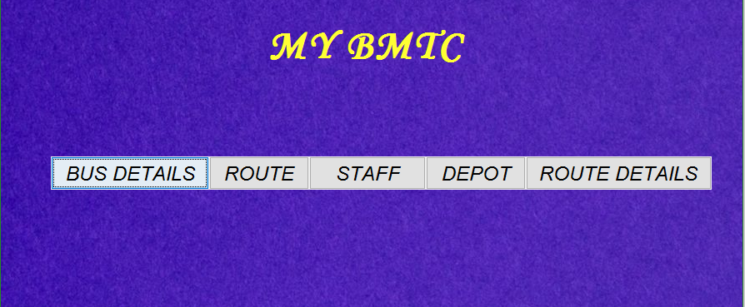

Source Code :

private void jButton1ActionPerformed(java.awt.event.ActionEvent evt) {

BUS B=new BUS();

B.setVisible(true);

close();

}

private void jButton2ActionPerformed(java.awt.event.ActionEvent evt) {

DETAILS D=new DETAILS();

D.setVisible(true);

close(); // TODO add your handling code here:

}

private void jButton3ActionPerformed(java.awt.event.ActionEvent evt) {

DEPOT D=new DEPOT();

D.setVisible(true);

close(); // TODO add your handling code here:

}

private void jButton4ActionPerformed(java.awt.event.ActionEvent evt) {

ROUTE R=new ROUTE();

R.setVisible(true);

close(); // TODO add your handling code here:

}

private void jButton5ActionPerformed(java.awt.event.ActionEvent evt) {

LOGIN L=new LOGIN();

L.setVisible(true);

close(); // TODO add your handling code here:

}

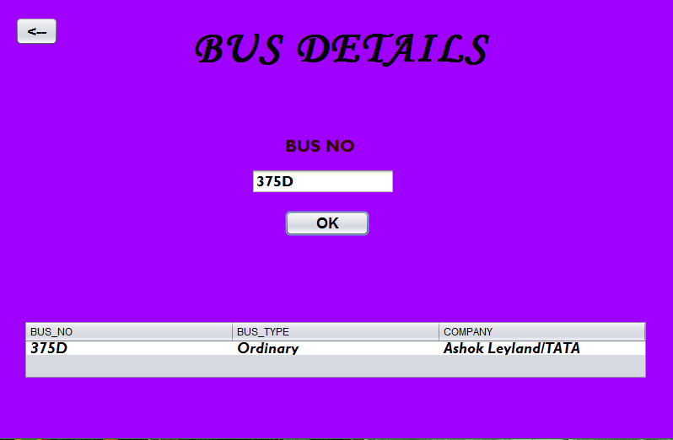

Source Code:

private void jButton1ActionPerformed(java.awt.event.ActionEvent evt) {

BUS B=new BUS();

B.setVisible(true);

close();

}

private void jButton2ActionPerformed(java.awt.event.ActionEvent evt) {

DETAILS D=new DETAILS();

D.setVisible(true);

close(); // TODO add your handling code here:

}

private void jButton3ActionPerformed(java.awt.event.ActionEvent evt) {

DEPOT D=new DEPOT();

D.setVisible(true);

close(); // TODO add your handling code here:

}

private void jButton4ActionPerformed(java.awt.event.ActionEvent evt) {

ROUTE R=new ROUTE();

R.setVisible(true);

close(); // TODO add your handling code here:

}

private void jButton5ActionPerformed(java.awt.event.ActionEvent evt) {

LOGIN L=new LOGIN();

L.setVisible(true);

close(); // TODO add your handling code here:

}

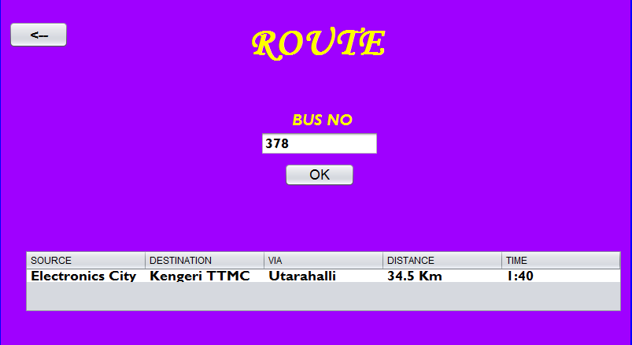

private void jButton1ActionPerformed(java.awt.event.ActionEvent evt) {

int s=Integer.parseInt(jTextField1.getText());

jap j=new jap();

try

{

ps=(j.con).prepareStatement("delete from Staff where SID=?");

ps.setInt(1,s);

rs=ps.executeQuery();

while(rs.next())

{

String s1="Deleted Sussessfully";

jTextField2.setText(s1);

}

}

catch(SQLException e)

{

System.out.println("Exception"+e);

}

// TODO add your handling code here:

}

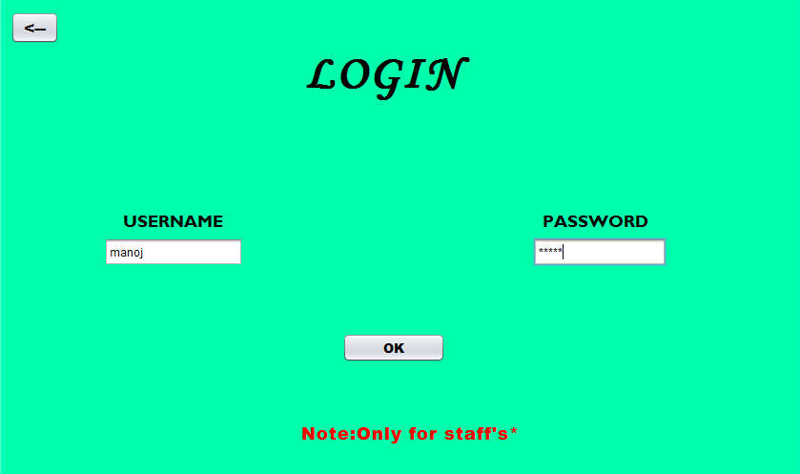

private void jButton1ActionPerformed(java.awt.event.ActionEvent evt) {

String s=(String)jTextField1.getText();

String s1=(String)jPasswordField1.getText();

String s2="manoj";

String s3="manoj";

if((s.contains("manoj")&&(s1.contains("manoj"))))

{

STAFF S=new STAFF();

S.setVisible(true);

close();

}

else

{

System.out.println("error");

}

// TODO add your handling code here:

}

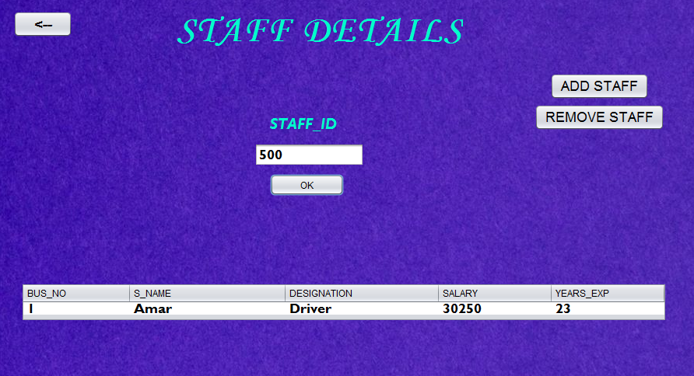

private void jButton1ActionPerformed(java.awt.event.ActionEvent evt) {

int s=Integer.parseInt(jTextField1.getText());

jap j=new jap();

try

{

ps=(j.con).prepareStatement("Select Bus_No,S_Name,Designation,Salary,Years_Exp from Staff where SID=?");

ps.setInt(1,s);

rs=ps.executeQuery();

jTable1.setModel(DbUtils.resultSetToTableModel(rs));

}

catch(SQLException e)

{

System.out.println("Exception"+e);

}

// TODO add your handling code here:

}

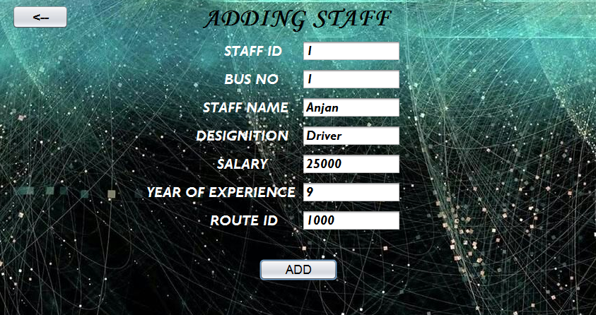

private void jButton1ActionPerformed(java.awt.event.ActionEvent evt) {

int s2=Integer.parseInt(jTextField2.getText());

String s1=(String)jTextField1.getText();

String s3=(String)jTextField3.getText();

String s4=(String)jTextField4.getText();

String s5=(String)jTextField5.getText();

String s6=(String)jTextField6.getText();

String s7=(String)jTextField7.getText();

jap j=new jap();

try{

ps=(j.con).prepareStatement("Insert into Staff(SID,Bus_No,S_Name,Designation,Salary,Years_Exp,RID) values (?,?,?,?,?,?,?)");

ps.setInt(1,s2);

ps.setString(2,s1);

ps.setString(3,s3);

ps.setString(4,s4);

ps.setString(5,s5);

ps.setString(6,s6);

ps.setString(7,s7);

ps.execute();

}

catch(SQLException e)

{

System.out.println("Exception"+e);// TODO add your handling code here:

}

}

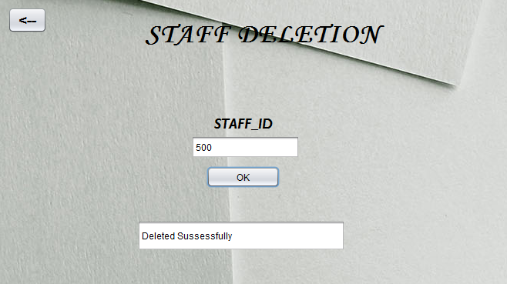

private void jButton1ActionPerformed(java.awt.event.ActionEvent evt) {

int s=Integer.parseInt(jTextField1.getText());

jap j=new jap();

try

{

ps=(j.con).prepareStatement("delete from Staff where SID=?");

ps.setInt(1,s);

rs=ps.executeQuery();

while(rs.next())

{

String s1="Deleted Sussessfully";

jTextField2.setText(s1);

}

}

catch(SQLException e)

{

System.out.println("Exception"+e);

}

// TODO add your handling code here:

}

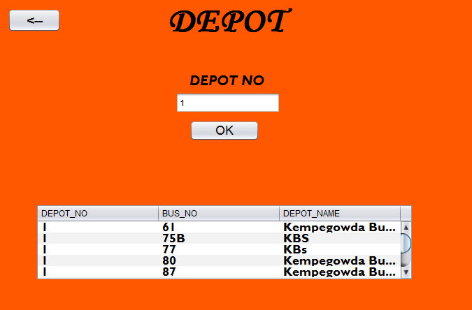

private void jButton1ActionPerformed(java.awt.event.ActionEvent evt) {

String s=(String)jTextField3.getText();

jap j=new jap();

try

{

ps=(j.con).prepareStatement("Select Depot_No,Bus_No,Depot_Name from Depot where Depot_No=?");

ps.setString(1,s);

rs=ps.executeQuery();

jTable1.setModel(DbUtils.resultSetToTableModel(rs));

}

catch(SQLException e)

{

System.out.println("Exception"+e);

} // TODO add your handling code here:

}

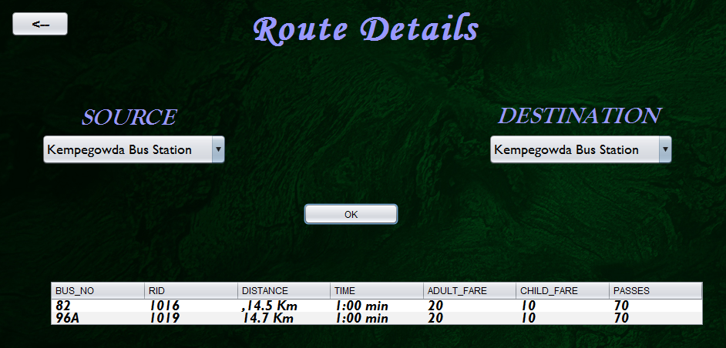

private void jButton1ActionPerformed(java.awt.event.ActionEvent evt) {

String s=(String)jTextField1.getText();

jap j=new jap();

try

{

ps=(j.con).prepareStatement("Select source,destination,via,distance,time from Route where Bus_no=?");

ps.setString(1,s);

rs=ps.executeQuery();

jTable1.setModel(DbUtils.resultSetToTableModel(rs));

}

catch(SQLException e)

{

System.out.println("Exception"+e);

} // TODO add your handling code here:

}

CHAPTER 8

FUTURE ENHANCEMENT

Additional changes that can be done to this project is that link can be drawn from the google maps and in order to get the user location and based on that,google analyzes the nearest bus stops and also the nearest bus depot and available of buses in that particular route.

CHAPTER 9
CONCLUSION

The document we have put is a group assignment that was done by 2 individuals.Some of that problems that we faced as a group are that, we couldn’t meet due to clashing schedule,others are busy with obligations.We would like to say that we tried to produce the best group work we could,hopefully learnt from this experience to better ourselves for our future endeavors.

CHAPTER 10

BIBLIOGRAPHY

