DOCKER

why we use it?

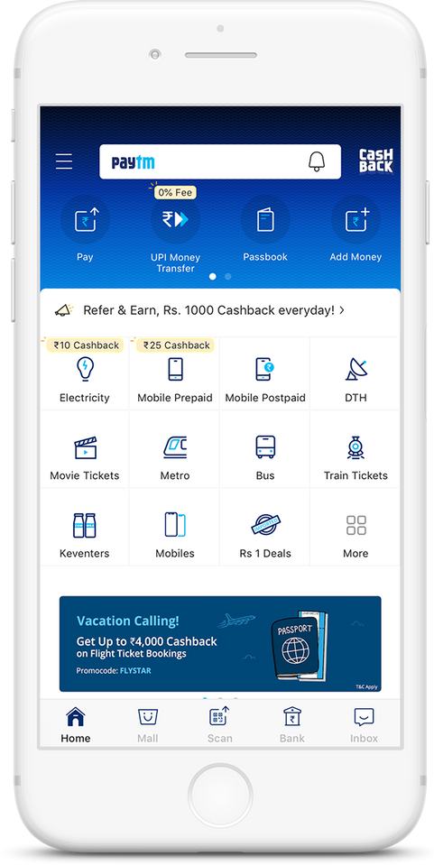MONOLITHIC

If an application contains N number of services (Let's take Paytm has Money Transactions, Movie Tickets, Train tickets, etc..) If all these services are included in one server then it will be called Monolithic Architecture. Every monolithic Architecture has only one database for all the services.

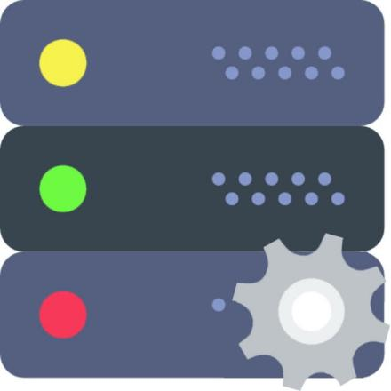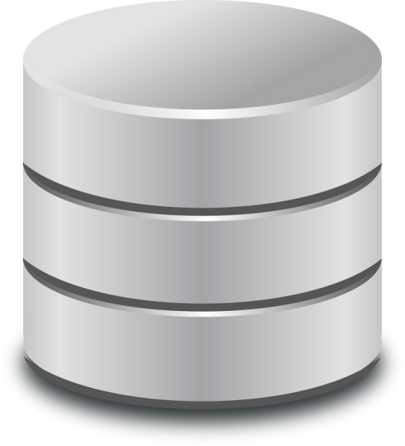

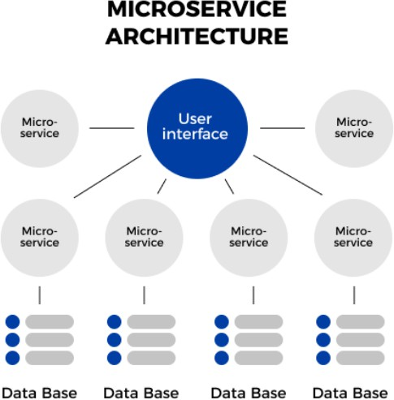MICRO SERVICE

If an application contains N number of services (Let's take Paytm has Money Transactions, Movie Tickets, Train tickets, etc..) if every service has its own individual servers then it is called microservices. Every microservice architecture has its own database for each service.



why docker

let us assume that we are developing an application, and every application has front end, backend and Database.

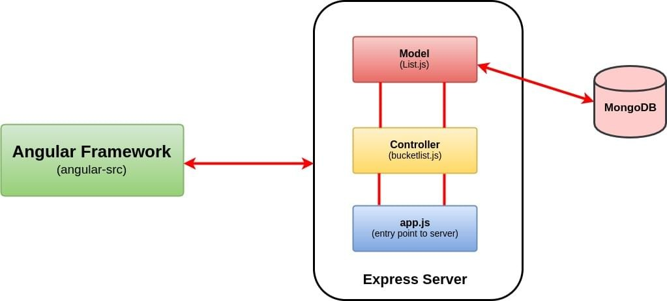database

react

Backend

To develop the application we need install those dependencies to run to the code.

So i installed Java11, ReactJS and MongoDB to run the code. After some time, i need another versions of java, react and mongo DB for my application to run the code.



So its really a hectic situation to maintain multiple versions of same tool in our system.

To overcome this problem we will use virtualization.

virtualization:

It is used to create a virtual machines inside on our machine. in that virtual machines we can hots guest OS in our machine.

by using this Guest OS we can run multiple application on same machine.

Hypervisor is used to create the virtualization.

#### DRAWBACKS:

 It is old method.

 If we use multiple guest OS then the performance of the system is low.

#### CONTAINERIZATION:

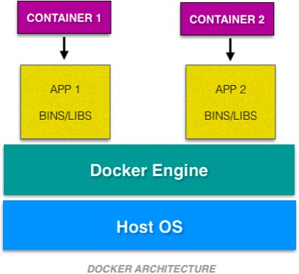 It is used to pack the application along with its dependencies to run the application.

#### CONTAINER:

 Container is nothing but, it is a virtual machine which does not have any OS.

 Docker is used to create these containers.



#### BEFORE DOCKER:



**WAR**

**WAR**

##### WAR

**WAR**

**DEV**

**TEST**

**PROD**

 JAVA

 TOMCAT  MYSQL

 JAVA

 TOMCAT  MYSQL

 JAVA

 TOMCAT  MYSQL

#### AFTER DOCKER:



##### WAR

IMAGE

IMAGE

IMAGE

**DEV**

##### TEST

**PROD**

IMAGE = WAR + JAVA + TOMCAT + MYSQL

# DOCKER

 It is an open source centralized platform designed to create, deploy and run applications.  Docker is written in the Go language.

 Docker utoses containers on host O.S run applications. It allows applications to use the same Linux kernel as a system on the host computer, rather than creating a whole virtual O.S.

 We can install Docker on any O.S but the docker engine runs natively on Linux distribution.

 Docker performs O.S level Virtualization also known as Containerization.

 Before Docker many users face problems that a particular code is running in the developer’s system but not in the user system.

 It was initially released in March 2013, and developed by Solomon Hykes and Sebastian Pahl.

 Docker is a set of platform-as-a-service that use O.S level Virtualization, where as VM ware uses Hardware level Virtualization.

 Container have O.S files but its negligible in size compared to original files of that O.S.

# architecture:

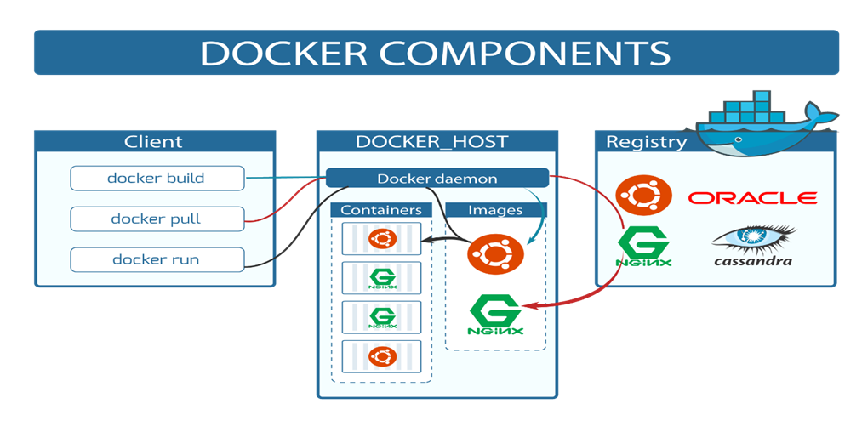

### docker client:

It is the primary way that many Docker users interact with Docker. When you use commands such as docker run, the client sends these commands to docker daemon, which carries them out. The docker command uses the Docker API.

### docker host:

Docker host is the machine where you installed the docker engine.

### docker daemon:

Docker daemon runs on the host operating system. It is responsible for running containers to manage docker services. Docker daemon communicates with other daemons. It offers various Docker objects such as images, containers, networking, and storage.

### docker registry:

A Docker registry is a scalable open-source storage and distribution system for docker images.

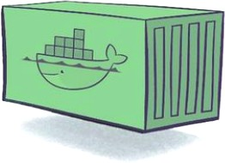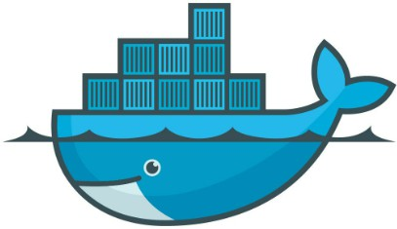IMAGE CONTAINER

OINTS TO BE FOLLOWED:

 You cant use docker directly, you need to start/restart first (observe the docker version before and after restart)

 You need a base image for creating a Container.

 You cant enter directly to Container, you need to start first.  If you run an image, By default one container will create.

### basic docker commands:

To install docker in Linux : yum install docker -y To see the docker version : docker --version

To start the docker service : service docker start

To check service is start or not : service docker status To check the docker information : docker info

To see all images in local machine : docker images

To find images in docker hub : docker search image name

To download image from docker hub to local : docker pull image name

To download and run image at a time : docker run -it image name /bin/bash

To give names of a container : docker run -it --name raham img-name /bin/bash To start container : docker start container name

To go inside the container : docker attach container name To see all the details inside container : cat /etc/os-release To get outside of the container : exit

To see all containers : docker ps -a

To see only running containers : docker ps (ps: process status) To stop the container : docker stop container name

To delete container : docker rm container name

To stop all the containers : docker stop $(docker ps -a -q) To delete all the stopped containers : docker rm $(docker ps -a -q)

To delete all images : docker rmi -f $(docker images -q)

### docker RENAME:

To rename docker container: Docker rename old_container new_container To rename docker port:

stop the container

go to path (var/lib/docker/container/container_id) open hostconfig.json

edit port number

restart docker and start container

### docker EXORT:

It is used to save the docker container to a tar file Create a file which contains will gets stored: touch docker/password/secrets/file1.txt

TO EXPORT: docker export -o docker/password/secrets/file1.txt

container_name

SYNTAX: docker export -o path container

### basic docker commands:

To see list of containers : docker container ls

To see all running containers: docker container ls -a To see latest 2 containers : docker container ls -n 2 To see latest container : docker container ls --latest To see all container id's : docker ls -a -q

To remove all containers : docker container rm -f $(docker container ls -aq) To see containers with sizes : docker container ls -a -s

To stop container after some time: docker stop -t 60 cont_id

### kill vs sto:

KILL: It passes SIGKILL signal to the container and container must be in running state. STOP: It passes SIGTERM signal to the container and container m

## RUNNING A CONTAINER:

 docker run --name cont1 -d nginx  docker inspect cont1

 curl container_private_ip:80

 docker run --name cont2 -d -p 8081(hostport):80(container port) nginx

docker exec:

 syntax - docker exec cont_name command  ex-1: docker exec cont1 ls

 ex-2: docker exec cont mkdir devops

 to enter into container: docker exec -it cont_name /bin/bash

## CREATE IMAGE FROM CONTAINER:

First it should have a base image - docker run nginx

Now create a container from that image - docker run -it --name container_name image_name /bin/bash

Now start and attach the container

 go to tmp folder and create some files (if you want to see the what changes has made in that image - docker diff container_name)

exit from the container

now create a new image from the container - docker commit container_name new_image_name

Now see the images list - docker images Now create a container using the new image start and attach that new container

see the files in tmp folder that you created in first container.

## DOCKER FILE:

 It is basically a text file which contains some set of instructions.  Automation of Docker image creation.

 Always D is capital letters on Docker file.

 And Start Components also be Capital letter.

## HOW IT WORKS:

 First you need to create a Docker file  Build it

 Create a container using the image

why docker hub

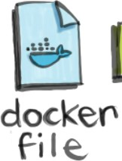



build



**DEV**

IMAGE

IMAGE

**TEST**

IMAGE

**PROD**

### docker file comonents:

FROM: For base image this command must be on top of the file. Ex: ubuntu, Redis, Jenkins LABEL: Labeling like EMAIL, AUTHOR, etc.

RUN: To execute commands and commit the layer.

COPY: Copy files/folders from local system (docker VM) where need to provide Source and Destination. ADD: It can download files from the internet and also, we can extract files at docker image side.

EXPOSE: To expose ports such as 8080 for tomcat and port 80 nginx etc. WORKDIR: To set working directory for the Container.

CMD: Executes commands but during Container creation.

ENTRYPOINT: The command that executes inside of a container. like running the services in a container. ENV: Environment Variables.

ARG argument is not available inside the Docker containers and ENV argument is accessible inside the container

RUN: it is used to execute the commands while we build the images and add a new layer into the image. CMD: it is used to execute the commands when we run the container.

if we have multiple CMD’s only last one will gets executed.

ENTRYPOINT: it overwrites the CMD when you pass additional parameters while running the container.

COPY: Used to copy local files to containers

ADD: Used to copy files form internet and extract them

STOP: attempts to gracefully shutdown container, issues a SIGTERM signal to the main process. KILL: immediately stops/terminates them, while docker kill (by default) issues a SIGKILL signal.

## DOCKER FILE TO CREATE AN IMAGE:

FROM: ubuntu

RUN: touch aws devops linux

FROM: ubuntu

RUN: touch aws devops linux

RUN echo "hello world">/tmp/file1

TO BUILD: docker build -t image_name . (. represents current directory) Now see the image and create a new container using this image.

go to container and see the files that you created.

docker run -it - -name container name image-name /bin/bash

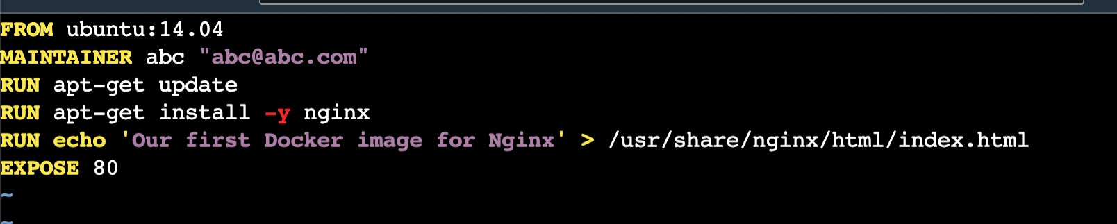

### to build:

docker build -t image1 .

### to run:

docker run -dit --name cont1 -p 8081:80 image1 nginx -g "daemon off;"

## DOCKER VOLUMES:

 When we create a Container then Volume will be created.  Volume is simply a directory inside our container.

 First, we have to declare the directory Volume and then share Volume.  Even if we stop the container still, we can access the volume.

 You can declare directory as a volume only while creating container.  We can’t create volume from existing container.

 You can share one volume across many number of Containers.  Volume will not be included when you update an image.

 If Container-1 volume is shared to Container-2 the changes made by Container-2 will be also available in the Container-1.

 You can map Volume in two ways: 1. Container < ------ > Container

2. Host < ------- > Container

## USES OF VOLUMES:

 Decoupling Container from storage.

 Share Volume among different Containers.  Attach Volume to Containers.

 On deleting Container Volume will not be deleted.

## CREATING VOLUMES FROM DOCKER FILE:

Create a Docker file and write FROM ubuntu VOLUME["/myvolume"]

 build it - docker build -t image_name .

 Run it - docker run -it - -name container1 ubuntu /bin/bash  Now do ls and you will see myvolume-1 add some files there

 Now share volume with another Container - docker run -it - -name container2(new) - -privileged=true - -volumes-from container1 ubuntu  Now after creating container2, my volume1 is visible

 Whatever you do in volume1 in container1 can see in another container  touch /myvolume1/samplefile1 and exit from container2.

 docker start container1

 docker attach container1

 ls/volume1 and you will see your samplefile1

#### CREATING VOLUMES FROM COMMAND:

 docker run -it - -name container3 -v /volume2 ubuntu /bin/bash  now do ls and cd volume2.

 Now create one file and exit.

 Now create one more container, and share Volume2 - docker run-it - -name container4 - - -privileged=true - -volumes-from container3 ubuntu  Now you are inside container and do ls, you can see the Volume2

 Now create one file inside this volume and check in container3, you can see that file

#### VOLUMES (HOST TO CONTAINER):

 Verify files in /home/ec2-use

 docker run -it - -name hostcont -v /home/ec2-user:/raham - -privileged=true ubuntu  cd ram [ram is (container-name)]

 Do ls now you can see all files of host machine.

 Touch file1 and exit. Check in ec2-machine you can see that file.

#### SOME OTHER COMMANDS:

 docker volume ls

 docker volume create <volume-name>  docker volume rm <volume-name>

 docker volume prune (it will remove all unused docker volumes).  docker volume inspect <volume-name>

 docker container inspect <container-name>

#### MOUNT VOLUMES:

 To attach a volume to a container: docker run -it --name=example1 --mount source=vol1,destination=/vol1 ubuntu  To send some files from local to container:

 create some files

 docker run -it --name cont_name -v "$(pwd)":/my-volume ubuntu  To remove the volume: docker volume rm volume_name

 To remove all unused volumes: docker volume prune

#### BASE VOLUMES:

STEPS

 create a volume : docker volume create volume99(volume-name)

 mount it: docker run -it -v volume99:/my-volume --name container1 ubuntu

 now go to my-volume and create some files over there and exit from container  mount it: docker run -it -v volume99:/my-volume-01 --name container2 ubuntu

DOCKER REGISTRY: It is used to store the images. Docker hub is the default registry

Cloud based registry Local registry

 Docker Hub

 GCR - Google Container Registry

 Amazon ECR - Elastic Container Registry

 Nexus  Jfrog

 DTR - Docker Trusted Registry

#### DOCKER USH:

 Select an image that includes docker and S.G SSH and HTTP enable anywhere on it.  docker run -it ubuntu /bin/bash

 Create some files inside the container and create an image from that container by using - docker commit container-name image1  now create a docker hub account

 Go to ec2-user and log in by using docker login.  Enter username and password.

 Now give the tag to your image, without tagging we can’t push our image to docker.  docker tag image1 rahamshaik/new-image-name (ex: project1)

 docker push rahamshaik/project1

 Now you can see this image in the docker hub account.

 Now create one instance in another region and pull the image from the hub.  docker pull rahamshaik/project1

 docker run -it - -name mycontainer rahamshaik/project1 /bin/bash  Now give ls and cd tmp and ls you can see the files you created.

 Now go to docker hub and select your image -- > settings -- > make it private.  Now run docker pull rahamshaik/project1

 If it is denied then login again and run it.

 If you want to delete image settings -- > project1 -- > delete

#### JENKINS SETU USING DOCKER IMAGE:

DESCRIPTION: By using the docker file, we can set up the Jenkins dashboard without installing any dependencies.

Login to docker hub

search for Jenkins then you will get Jenkins official image.

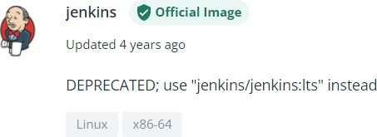

Click on the image

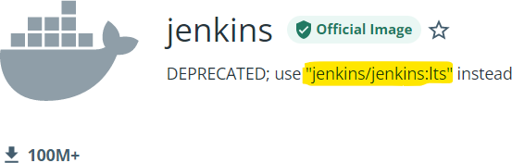

 copy the code : docker pull jenkinsci/jenkins:lts  run this code in docker engine

 now see docker images then you will get jenkins image  create container using that image

 Now exit from the container and start the container again  Inspect the container : docker inspect jenkins

 now go to jenkins image in docker hub and scroll down you will get command

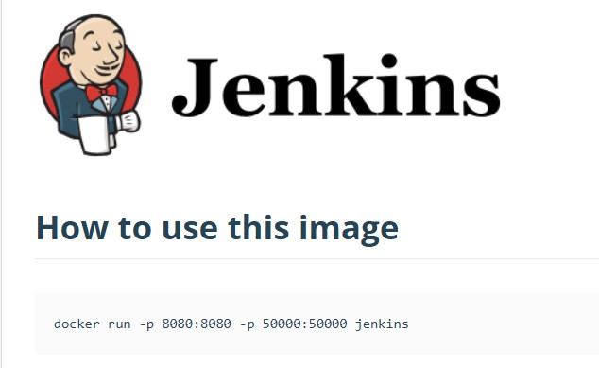

 run this command on docker engine and connect with Jenkins dashboard (public ip:8080)

DOCKER network:

it allows you to attach your container into many networks, it is used to isolate the containers.

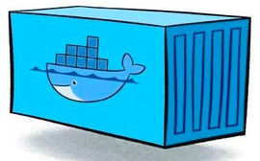172.17.0.1



172.17.0.2

172.17.0.3

BRIDGE

To create a network: docker network create network_name To see the list: docker network ls

To delete a network: docker network rm network_name To inspect: docker network inspect network_name

To connect a container to the network: docker network connect network_name container_id/name

To disconnect from the container: docker network disconnect network_name container_name To prune: docker network prune

#### DOCKER SWARM:

 Docker swarm is an orchestration service within docker that allows us to manage and handle multiple containers at the same time.

 It is a group of servers that runs the docker application.  It is used to manage the containers on multiple servers.  This can be implemented by the cluster.

 The activities of the cluster are controlled by a swarm manager, and machines that have joined the cluster is called swarm worker.

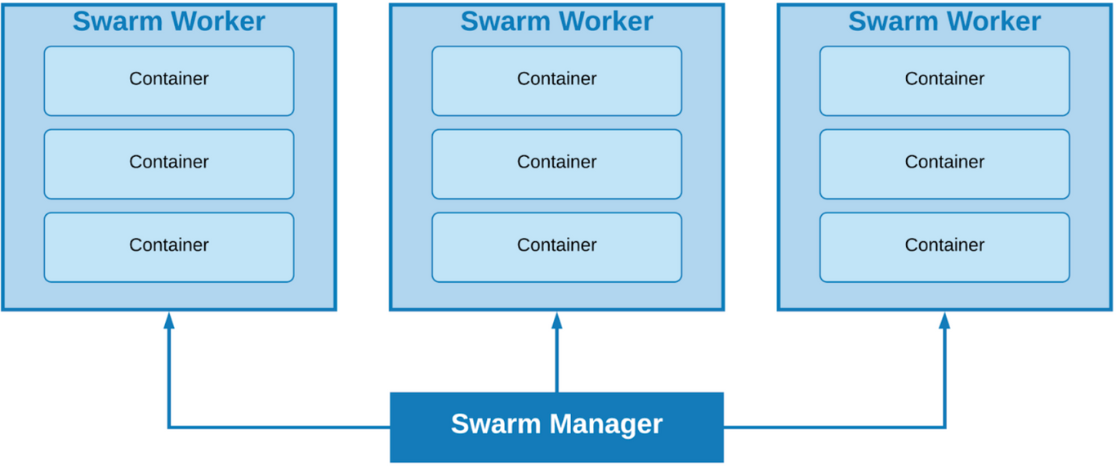

Docker Engine helps to create Docker Swarm.

There are mainly worker nodes and manager nodes.

The worker nodes are connected to the manager nodes.

So any scaling or update needs to be done first it will go to the manager node. From the manager node, all the things will go to the worker node.

Manager nodes are used to divide the work among the worker nodes.

Each worker node will work on an individual service for better performance.

DOCKER SWARM Comonents:

SERVICE: Represents a part of the feature of an application. TASK: A single part of work.

MANAGER: This manages the work among the different nodes. WORKER: Which works for a specific purpose of the service.

#### SETU**:**

Create 3 node one is manager and another two are workers Manager node: docker swarm init --advertise-addr (private ip) Run the below command to join the worker nodes

To check nodes on docker swarm: docker node ls

Here * Indicates the current node like master branch on git Now we created the docker swarm cluster

docker info : To see all the docker info running on our machine. docker swarm leave : To down the docker node (need to wait few sec) docker node rm node-id : To remove the node permenantly

docker swarm leave : To delete the swarm but will get error

docker swarm leave –force : To delete the manager forcefully docker swarm join-token worker. : To get the token of the worker docker swarm join-token manager : To get the token of the worker

#### SWARM SERVICE**:**

Now we want to run a service on the swarm

So we want to run a specific container on all these nodes

To do that we will use a docker service command which will create a service for us That service is nothing but a container.

We have a replicas here when one replica goes down another will work for us. Atleast one of the replica needs to be up among them.

docker service create --name raham --replicas 3 --publish 80:80 httpd

raham : service name replicas : nodes publish : port reference image: apache

docker service ls : To list the services

docker service ps service-name : To see where the services are running docker ps : To see the containers (Check all nodes once)

docker rm -f names : To remove the service (it will come again later) public ip on browser : To check its up and running or not

docker service rm service-name : To remove the service

To create a service: docker service create —name devops —replicas 2 image_name Note: image should be present on all the servers

To update the image service: docker service update —image image_name service_name Note: we can change image,

To rollback the service: docker service rollback service_name To scale: docker service scale service_name=3

To check the history: docker service logs

To check the containers: docker service ps service_name To inspect: docker service inspect service_name

To remove: docker service rm service_name

#### DOCKER COMOSE:

 **It is a tool used to build, run and ship the multiple containers for application. ** **It is used to create multiple containers in a single host.**

 **It used YAML file to manage multi containers as a single service.**

 **The Compose file provides a way to document and configure all of the application’s service dependencies (databases, queues, caches, web service APIs, etc).**

COMMANDS:

**Start all services: Docker Compose up. Stop all services: Docker Compose down.**

**Run Docker Compose file: Docker-compose up -d.**

**List the entire process: Docker ps.**

#### COMOSE FILE:

**The Docker Compose file includes Services, Networks and Volumes. The Default Path is ./docker-compose.yml**

**It contains a service definition which configures each container started for that service.**

#### COMOSE INSTALLATION:

**sudo curl -L "https://github.com/docker/compose/releases/download/1.29.2/docker- compose-$(uname -s)-$(uname -m)" -o /usr/local/bin/docker-compose**

**sudo chmod +x /usr/local/bin/docker-compose**

**sudo ln -s /usr/local/bin/docker-compose /usr/bin/docker-compose docker-compose --version**

COMOSE file:

 **version - specifies the version of the Compose file. ** **services - it the services in your application.**

 **networks - you can define the networking set-up of your application. ** **volumes - you can define the volumes used by your application.**

 **configs - configs lets you add external configuration to your containers. Keeping configurations external will make your containers more generic.**

CREATING DOCKER-COMOSE.YML**:**

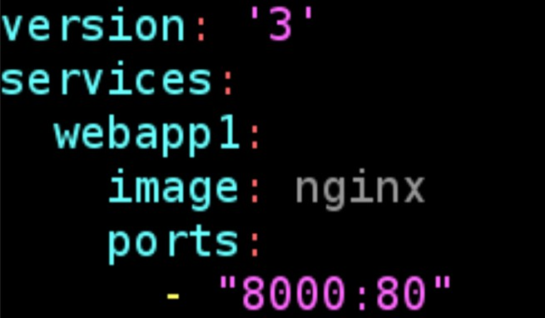

**vim docker-compose.yml**

**Version: It is the compose file format which supports the relavent docker engine Services: The services that we are going to use by this file (Webapp1 is service name) Image: Here we are taking the Ngnix image for the webserver**

**Ports: 8000 port is mapping to container port 80 Docker-compose up -d**

**Public-ip:8000 -- > You can see the Nginx image Docker network ls -- > you can see root_default**

**Docker-compose down -- > It will delete all the Created containers**

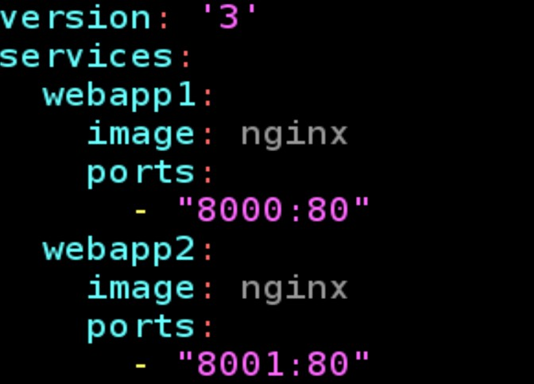

**Docker-compose up -d**

**Public-ip:8000 & public-ip:8001-- > You can see the Nginx image on both ports Docker container ls**

**Docker network ls**

#### CHANGING DEFAULT FILE**:**

**mv docker-compose.yml docker-compose1.yml**

**docker-compose up -d**

**You will get some error because you are changing by default docker-compose.yml Use the below command to overcome this error**

**docker-compose -f docker-compose1.yml up -d docker-compose -f docker-compose1.yml down**

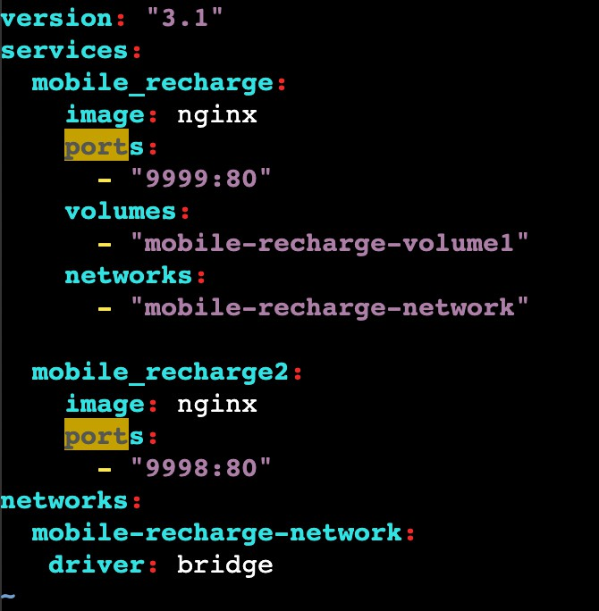

**docker-compose up -d - used to run the docker file docker-compose build - used to build the images docker-compose down - remove the containers**

**docker-compose config - used to show the configurations of the compose file**

**docker-compose images - used to show the images of the file docker-compose stop - stop the containers**

**docker-compose logs - used to show the log details of the file**

**docker-compose pause - to pause the containers docker-compose unpause - to unpause the containers**

**docker-compose ps - to see the containers of the compose file**

#### DOCKER STACK:

**It is used when you want to launch the whole software together. You will write all the services and launch them together.**

**docker stack deploy -c demo.yml demostack**

**demo.yml = name of file & demostack = name of stack**

**now see the services by using docker service ls all of the services are running**

**docker service scale id=no.of_replicas : To scale the services**

**docker service ps stackname : To see the the services running**

DOCKER INTEGRATION with Jenkins

 **Install docker and Jenkins in a server.**

 **vim /lib/systemd/system/docker.service**

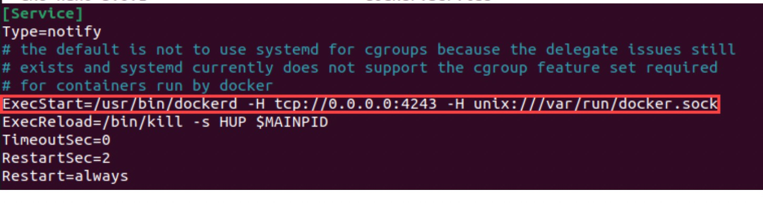

 **Replace the above line with**

 **ExecStart=/usr/bin/dockerd -H tcp://0.0.0.0:4243 -H unix:///var/run/docker.sock ** **systemctl daemon-reload**

 **service docker restart**

 **curl http://localhost:4243/version**

 **Install Docker plugin in Jenkins Dashboard.**

 **Go to manage jenkins>Manage Nodes & Clouds>>Configure Cloud. ** **Add a new cloud >> Docker**

 **Name: Docker**

 **add Docker cloud details.**

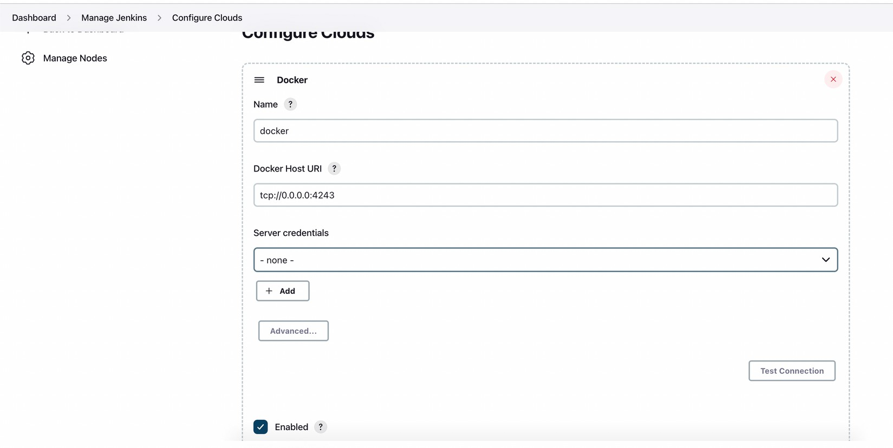

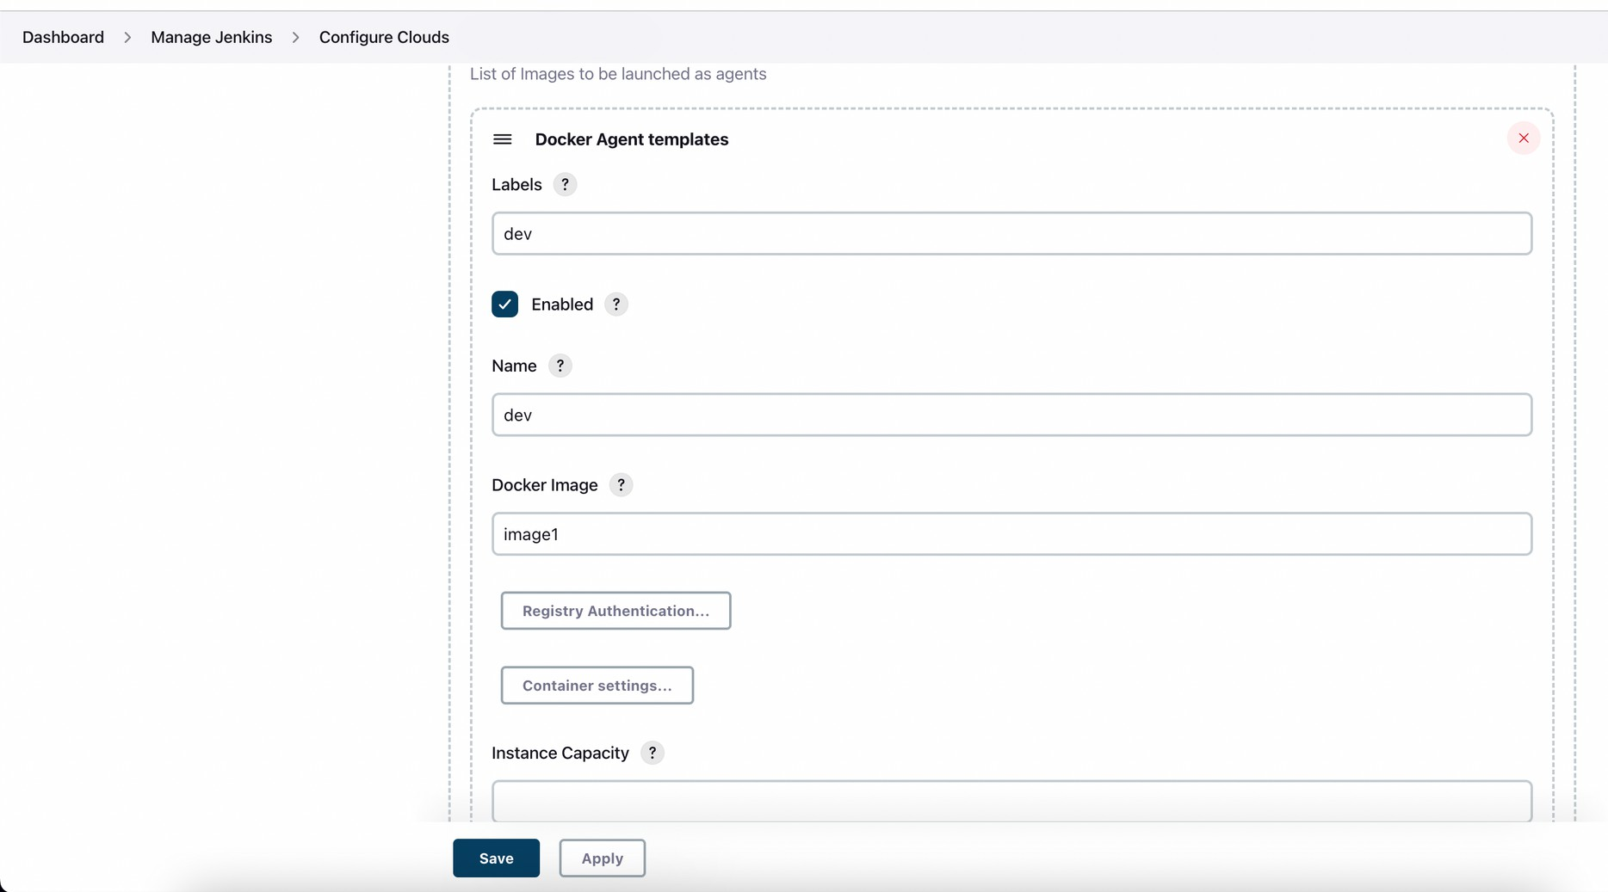 Add Docker Agent Template

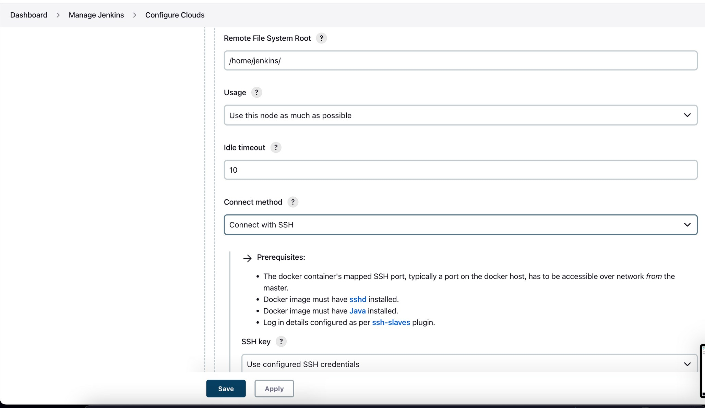

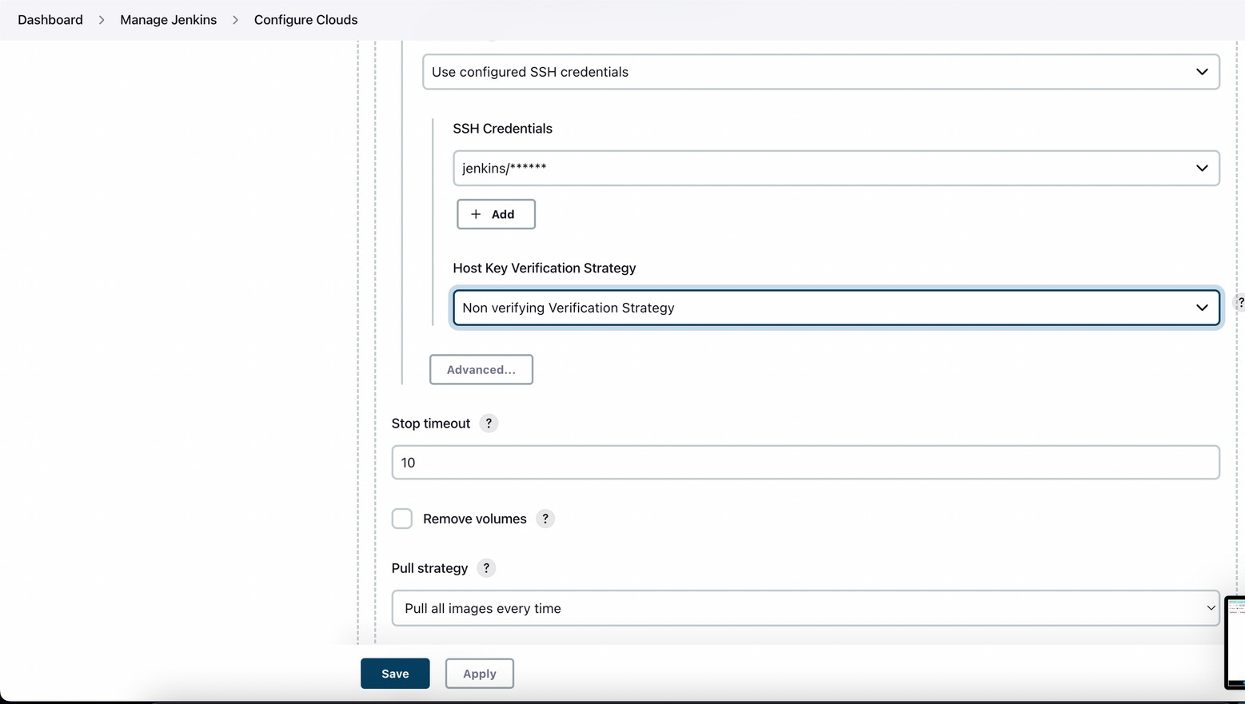

 Save it and do and watch the container in Jenkins dashboard.  Manage Jenkins>>Docker (last option)

Deloyment docker file:

Create 2 files:

1. Dockerfile
2. index.html file

Dockerfile consists of

FROM ubuntu

RUN at-get udate

RUN at-get install aache2 -y COY index.html /var/www/html/

CMD ["/usr/sbin/aachectl", "-D", "FOREGROUND"]

Index.html file consists of

<h1>hi this is my web a</h1>

Add these files into GitHub and Integrate with Jenkins by declarative code pipeline.

pipeline { agent any stages {

stage ("git") { steps {

git branch: 'main', url: 'https://github.com/devops0014/dockabnc.git'

}

}

stage ("build") { steps {

sh 'docker build -t image77 .'

}

}

stage ("container") { steps {

sh 'docker run -dit -p 8077:80 image77'

}

}

}

}

You will get Permission Denied error while building the code. To resolve that error you need to follow these steps:

 usermod -aG docker jenkins  usermod -aG root jenkins

 chmod 777 /var/run/docker.sock

Now you can build the code and it will gets deployed.

DevOps by RAHAM

docker directory data:

We use docker to run the images and create the containers. but what if the memory is full in instance. we have a add a another volume to the instance and mount it to the docker engine. Lets see how we do this.

 Uninstall the docker - yum remove docker -y  remove all the files - rm -rf /var/lib/docker/*

 create a volume in same AZ & attach it to the instance  to check it is attached or not - fdisk -l

 to format it - fdisk /dev/xvdf --> n p 1 enter enter w

 set a path - vi /etc/fstab (/dev/xvsf1 /var/lib/docker/ ext4 defaults 0 0)  mount -a

 install docker - yum install docker -y && systemctl restart docker  now you can see - ls /var/lib/docker

 df -h

ortainer:

 it is a container organizer, designed to make tasks easier, whether they are clustered or not.  abel to connect multiple clusters, access the containers, migrate stacks between clusters

 it is not a testing environment mainly used for production routines in large companies.  Portainer consists of two elements, the Portainer Server and the Portainer Agent.

 Both elements run as lightweight Docker containers on a Docker engine

ortainer:

 Must have swarm mode and all ports enable with docker engine

 curl -L https://downloads.portainer.io/ce2-16/portainer-agent-stack.yml -o portainer-agent- stack.yml

 docker stack deploy -c portainer-agent-stack.yml portainer docker ps

 public-ip of swamr master:9000

#### DOCKER RUN VS CMD VS ENTRYOINT:

RUN: it is used to execute the commands while we build the images and add a new layer into the image.

FROM centos:centos7 RUN yum install git -y or

RUN [“yum”, “install”, “git” “-y”]

CMD: it is used to execute the commands when we run the container.

It is used to set the default command.

if we have multiple CMD’s only last one will gets executed.

FROM centos:centos7 CMD yum install maven -y or

CMD [“yum”, “install”, “maven”, “-y”]

If you want to overwrite the parameters:

docker run image_name httpd (FAILED)

docker run image_name yum install httpd -y (only httpd will gets installed)

ENTRYPOINT: it overwrites the CMD when you pass additional parameters while running the container.

FROM centos:centos7

ENTRYPOINT [“yum”, “install”, “maven”, “-y”]

If you want to overwrite the parameters:

docker run image_name httpd (both maven and httpd will gets installed) docker run image_name yum install httpd -y (both maven and httpd will gets installed)

FROM centos:centos7 ENTRYPOINT [“yum”, “install”, “-y”] CMD [“httpd”]

Bydefault it will executes httpd command, if you specify the command while running the container it will gets executed.

docker run image_name (httpd will install) docker run image_name git (only git will install)

docker run imageS_name git tree(both git & tree will install)