FUNTIONS:

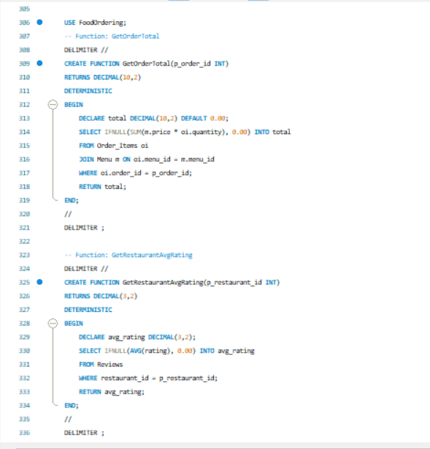

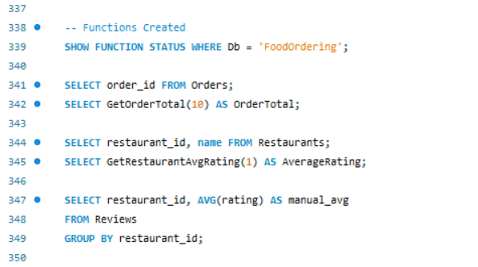

BEFORE:

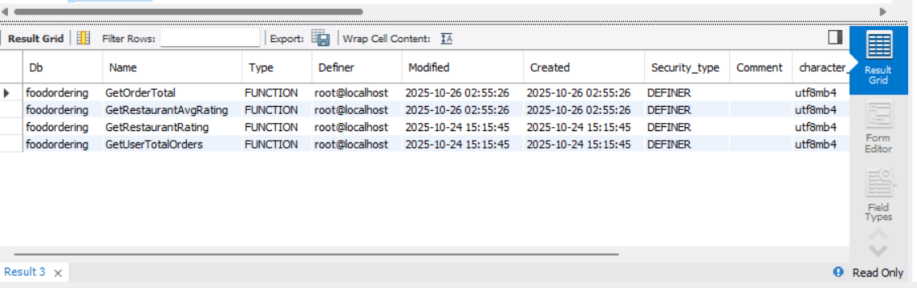

AFTER:

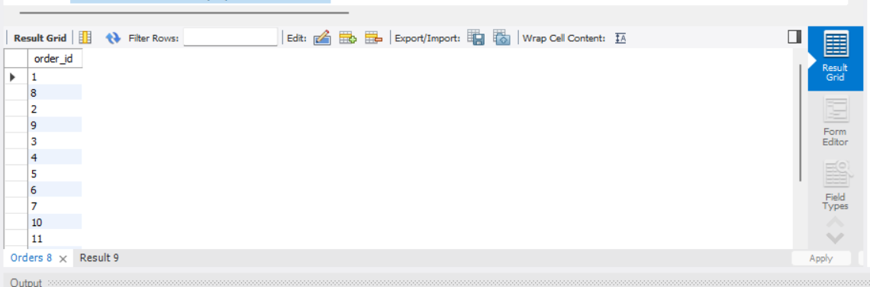

**GET ORDER TOTAL**

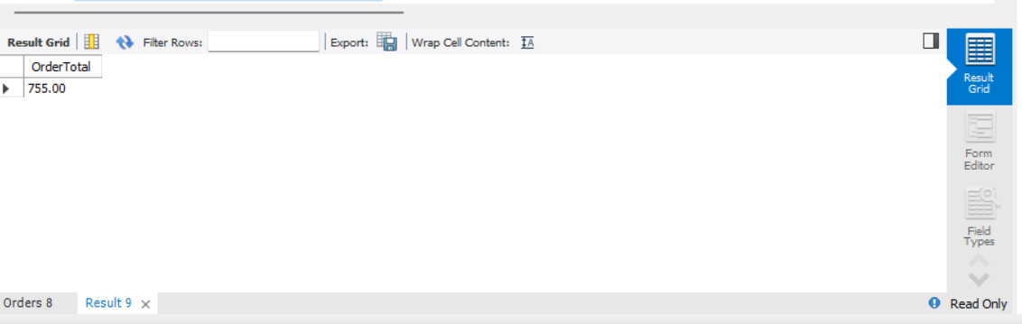

**GET RESTAURENT AVG RATING**

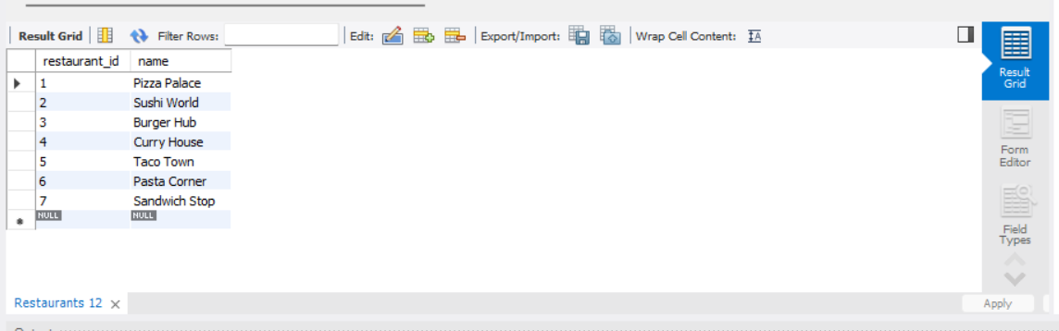

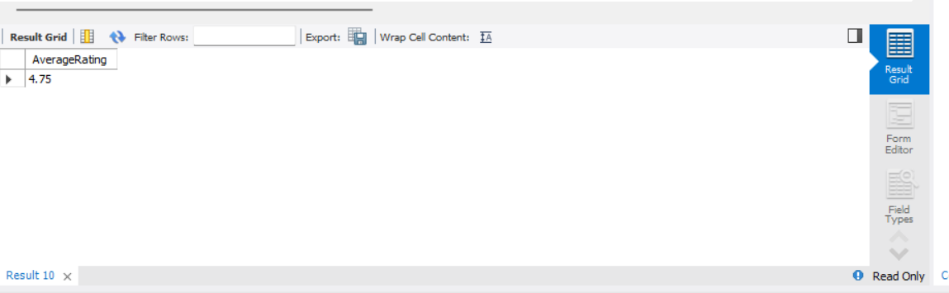

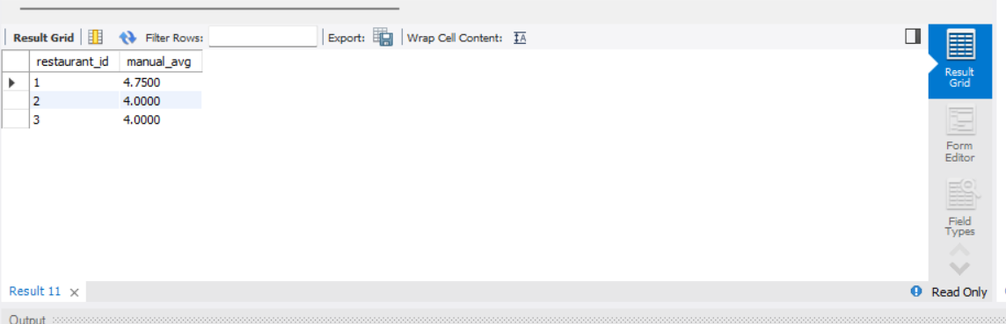

PROCEDURE

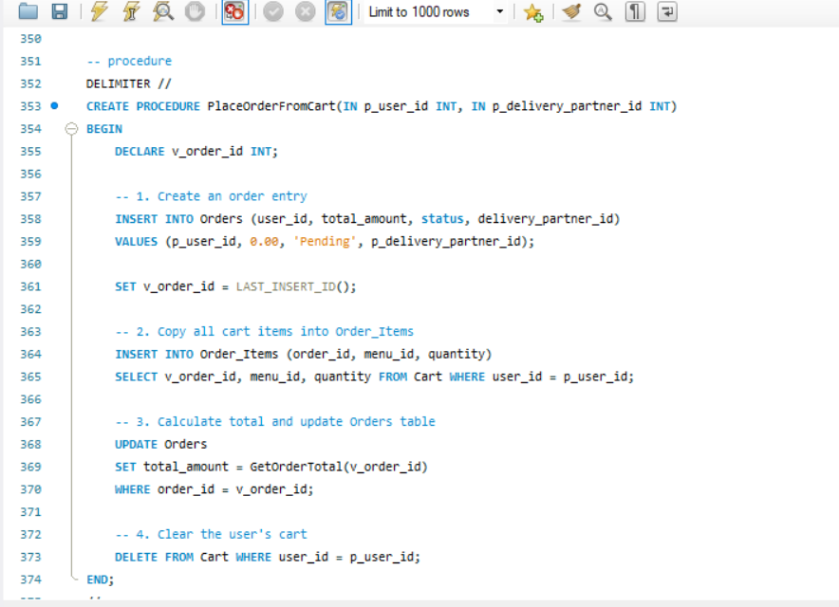

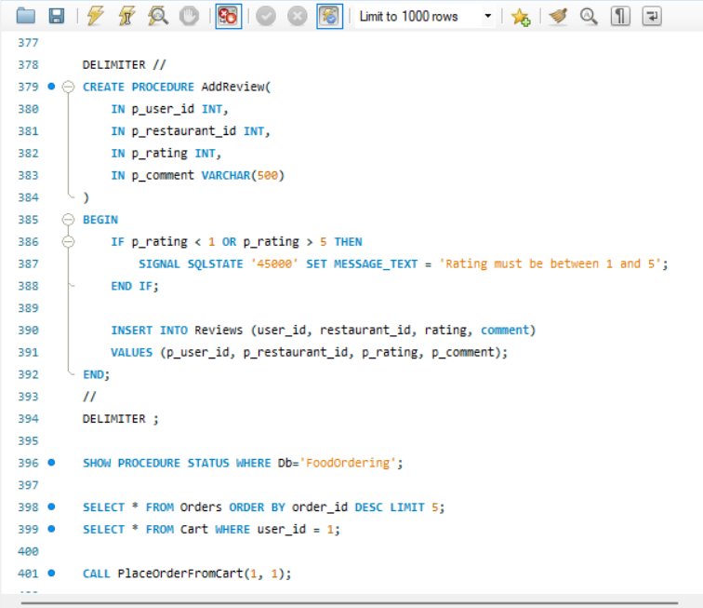

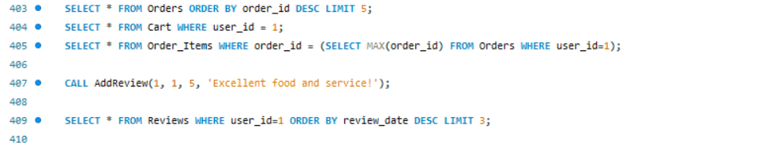

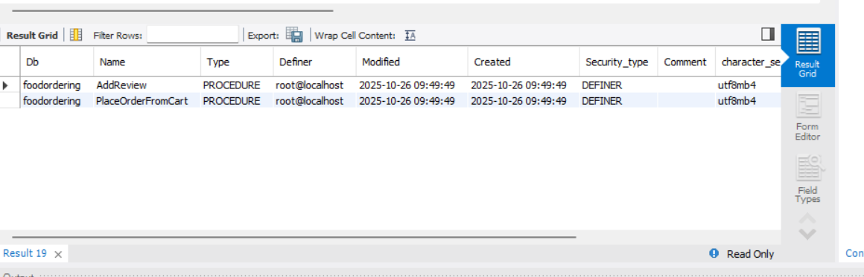

BEFORE

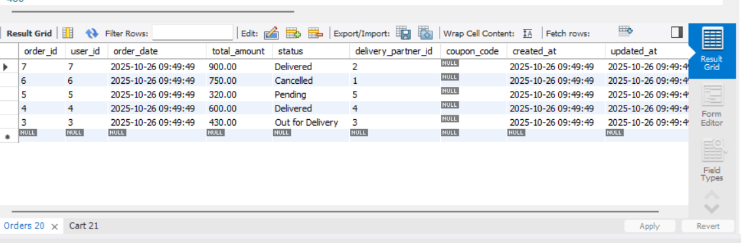

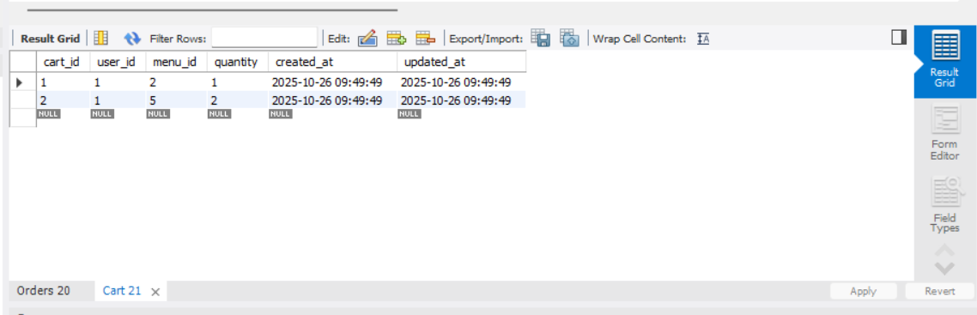

AFTER

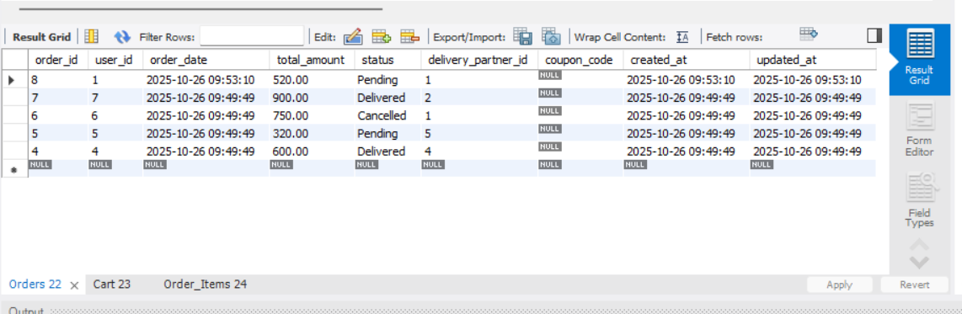

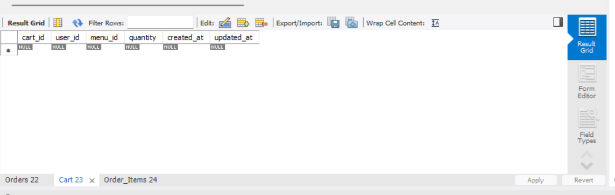

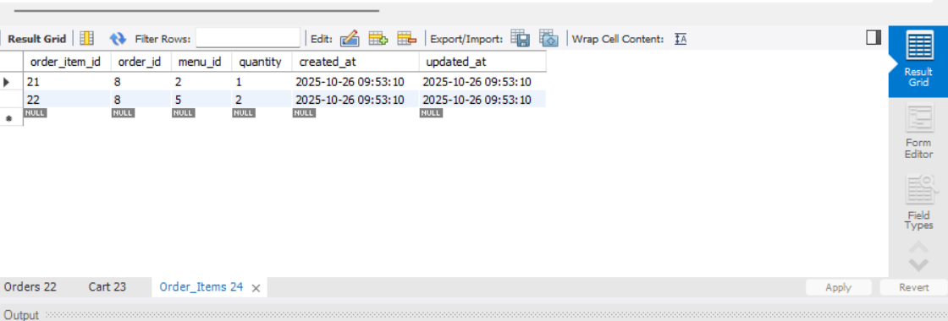

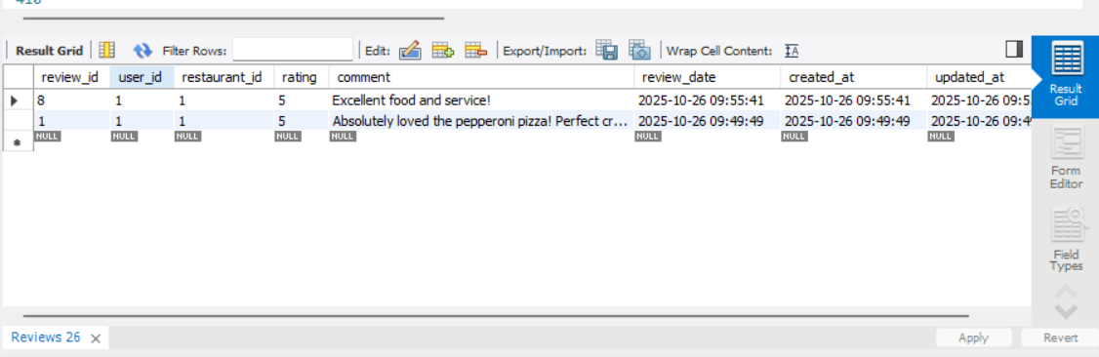

TRIGGERS:

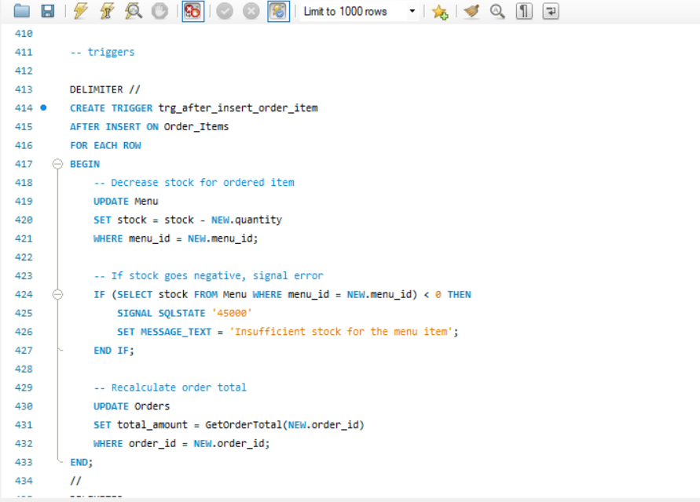

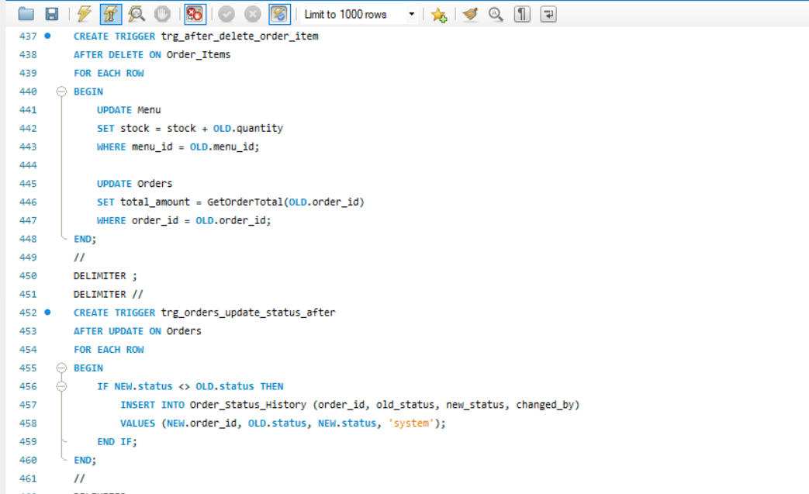

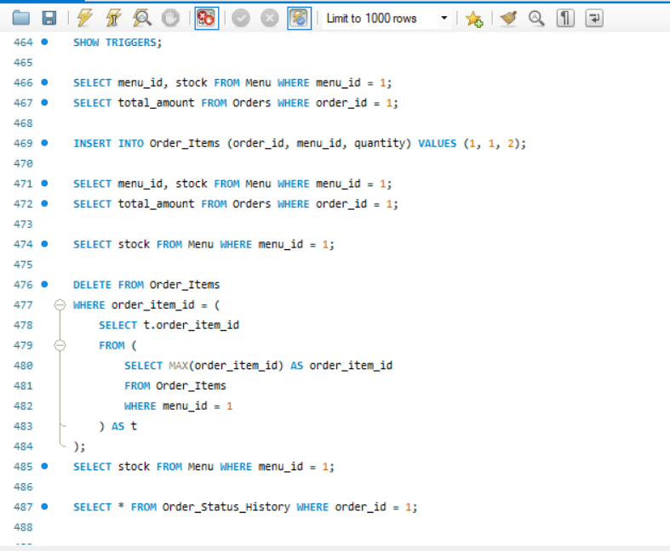

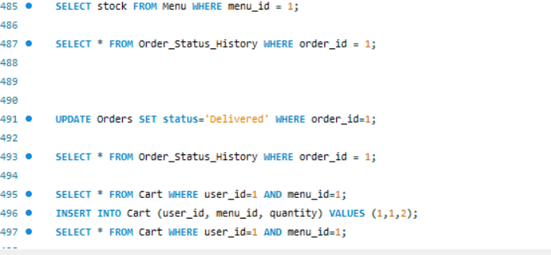

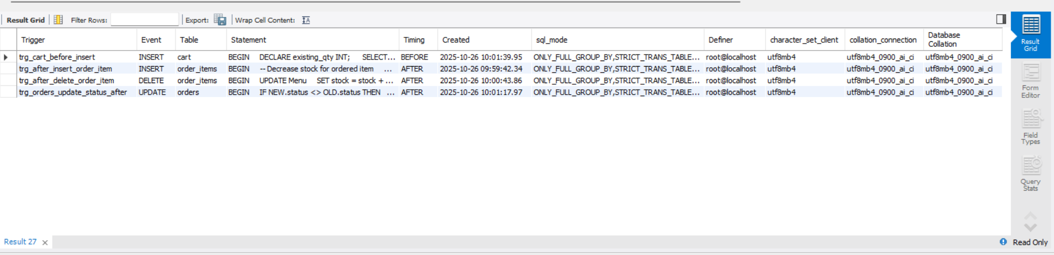

BEFORE

**Stock & Total Update Trigger:**

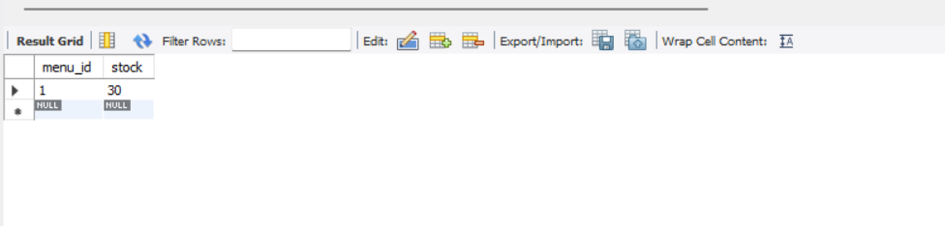

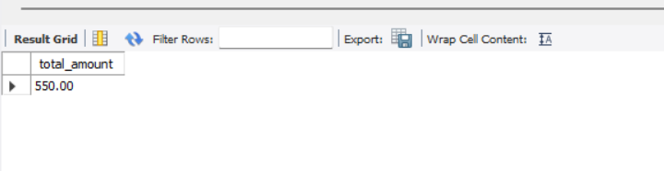

AFTER

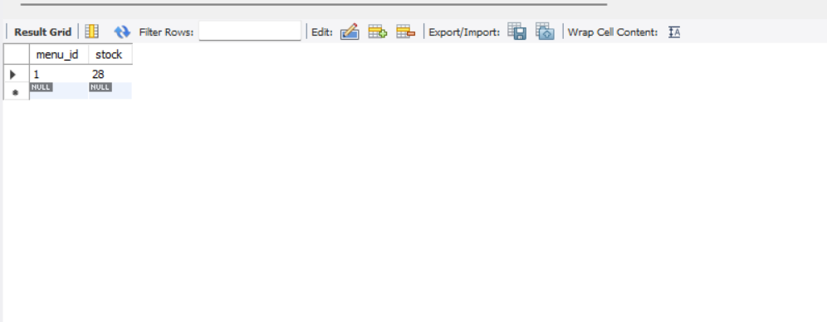

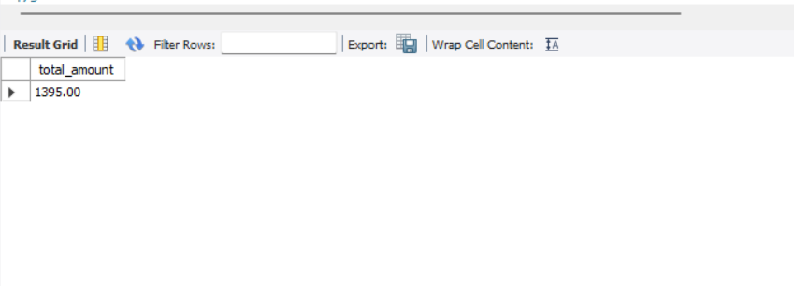

**Delete Trigger**

BEFORE

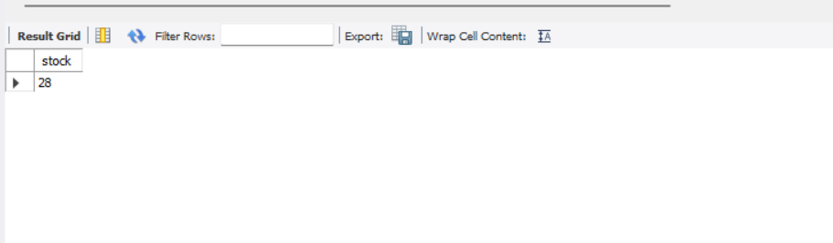

AFTER

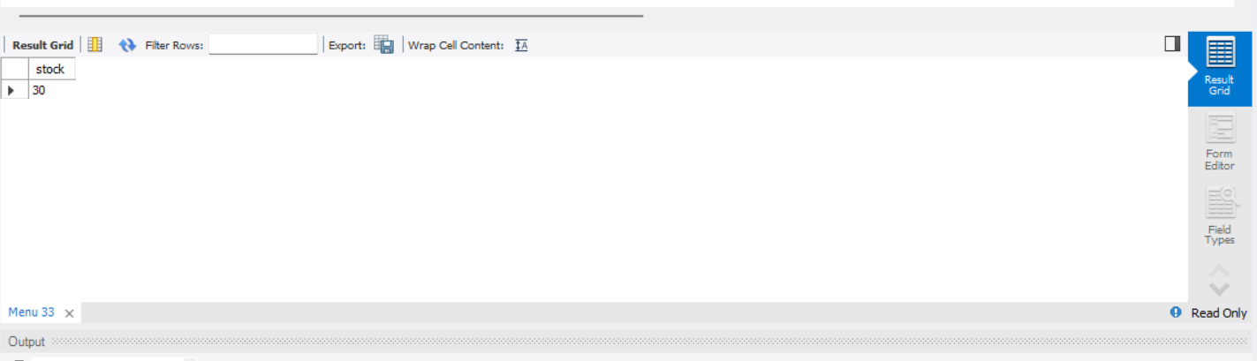

**Order Status History Trigger**

BEFORE:

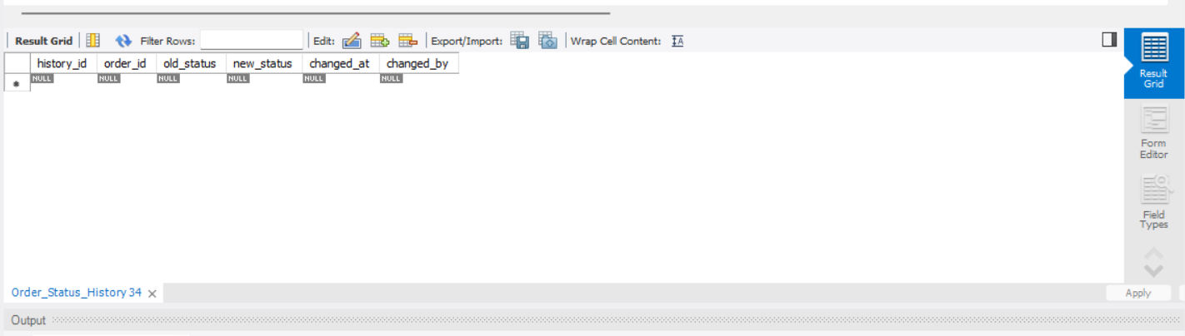

AFTER:

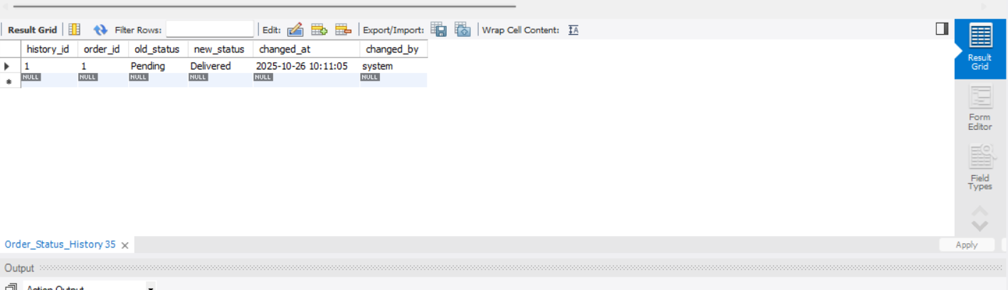

**Cart Quantity Increment Trigger**

BEFORE:

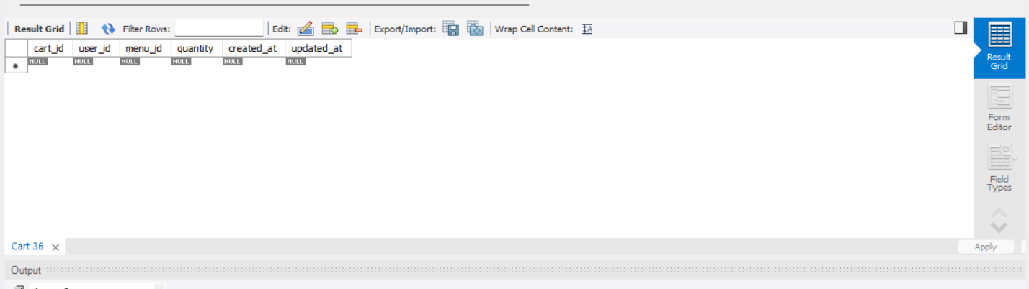

AFTER:

