Hey sirish, the sequence diagram u sent me was gr8 however I was told that we do not need to have the feature of adding the train to the network anymore. We just need to check for collision that’s it …

Hope the below looks good enough … yr input wud be gr88 on this …

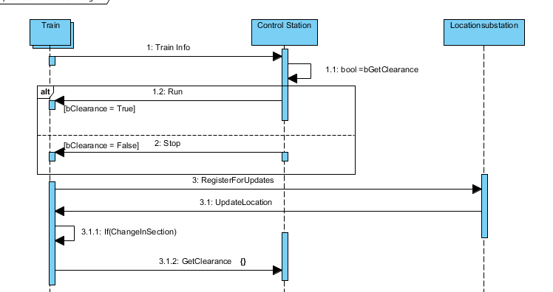

**I went though your class diagram however I made my own because as far as I think this is wat we are suppose to do ..**

**I’ll every feature in detail by tomorrow ..**

