# NEIL GOGTE INSTITUTE OF TECHNOLOGY

**(A Unit of Keshav Memorial Technical Education (KMTES) (Approved by AICTE, New Delhi & Affiliated to Osmania University, Hyderabad).**

**A**

**MINI PROJECT REPORT**

**on**

**Social Networking Site**

**BACHELOR OF ENGINEERING**

**in**

**COMPUTER SCIENCE AND ENGINEERING**

**Submitted by**

|  |  |
| --- | --- |
| **Aadithya** | **- 2453-18-733-061** |
| **Siri Spandana** | **- 2453-18-733-117** |
| **Siddhartha** | **- 2453-18-733-107** |
| **Abhishek Choudhary** | **- 2453-18-733-121** |

**Under the Guidance of**

**Mr. Srinivas**

**DEPARTMENT OF COMPUTER SCIENCE AND ENGINEERING**

**Kachawanisingaram Village, Hyderabad, Telangana 500058.**

**March 2021**

**NEIL GOGTE INSTITUTE OF TECHNOLOGY**

**(A Unit of Keshav Memorial Technical Education (KMTES)**

**(Approved by AICTE, New Delhi & Affiliated to Osmania University, Hyderabad).**

# CERTIFICATE



This is to certify that the project report titled “**Buzzfeed**” is being submitted by **Aadithya**(**2453-18-733-061**),**Spandana(2453-18-733-117)**,**Siddartha(2453-1 8-733-107),Abhishek(2453-18-733-121)** of III year B.E.V Semester **Computer Science and Engineering** is a record of bonafide work carried out by them. The results embodied in this report have not been submitted to any other University for the award of any degree.

**Internal Guide HOD**

**External Examiner**

# NEIL GOGTE INSTITUTE OF TECHNOLOGY

**(A Unit of Keshav Memorial Technical Education (KMTES) (Approved by AICTE, New Delhi & Affiliated to Osmania University, Hyderabad).**

# DECLARATION



We hereby declare that the Mini Project Report entitled, “**Buzzfeed**” submitted for the B.E degree is entirely our work and all ideas and references have been duly acknowledged. It does not contain any work for the award of any other degree.

**Date:**

**Aadithya**

**2453-18-733-061**

**Siri Spandana 2453-18-733-117**

**Siddartha**

**2453-18-733-107**

**Abhishek**

**2453-18-733-121**

# NEIL GOGTE INSTITUTE OF TECHNOLOGY

**(A Unit of Keshav Memorial Technical Education (KMTES) (Approved by AICTE, New Delhi & Affiliated to Osmania University, Hyderabad).**

**ACKNOWLEDGEMENT**

We are happy to express our deep sense of gratitude to the principal of the college **Dr D Jaya Prakash,** Professor, Neil Gogte Institute of Technology, for having provided us with adequate facilities to pursue our project.

We would like to thank **Dr K V Ranga Rao,** Professor and Head, Department of Computer Science and Engineering, Neil Gogte Institute of Technology, for having provided the freedom to use all the facilities available in the department, especially the laboratories and the library.

We are very grateful to our project guide **Mr. Srinivas**, Department of Computer Science and Engineering, Neil Gogte Institute of Technology, for his extensive patience and guidance throughout our project work.

We sincerely thank our seniors and all the teaching and non-teaching staff of the Department of Computer Science & Engineering and Information Technology for their timely suggestions, healthy criticism and motivation during this work.

We would also like to thank classmates for always being there whenever we needed help or moral support. With great respect and obedience, We thank our parents, sisters and brother who were the backbone behind our deeds.

Finally, We express our immense gratitude with pleasure to the other individuals who have either directly or indirectly contributed to our need at the right time for the development and success of this work.

Abstract

Social media is fundamentally changing the way people communicate, consume and collaborate. It provides companies a new platform to interact with their customers. In academia, there is a surge in research efforts on understanding its effects. This paper aims to provide a review of current status of social media research. We discuss the specific domains in which the impacts of social media have been examined. A brief review of applicable research methodologies and approaches is also provided.

The purpose of the project is to build an application program to reduce the manual work for managing the users' posts. It tracks all the details about the friends, type of comments made and posts.

On these types of sites we meet up familiar persons or complete strangers whom we share similar interest with. If the earlier trend was making associations and groups physical, the present generation believes in making online communities and forms to discuss issues related to various and diverse topics.

# NEIL GOGTE INSTITUTE OF TECHNOLOGY

(**A Unit of Keshav Memorial Technical Education (KMTES)**

**(Approved by AICTE, New Delhi & Affiliated to Osmania University, Hyderabad).**

|  |  |  |  |
| --- | --- | --- | --- |
|  | | **CONTENTS** |  |
| **S NO.** |  | **TITLE** | **PAGE No.** |
| **1.** |  | **INTRODUCTION** |  |
|  | **1.1** | Problem Statement | 1 |
|  | **1.2** | Objective | 1 |
| **2.** | **2.1** | **LITERATURE SURVEY**  Survey | 2 |
|  | **2.2** | Existing System | 3 |
|  | **2.3** | Disadvantages of Existing System | 4 |
|  | **2.4** | Proposed System | 4 |
|  | **2.5** | Advantages of Proposed System | 4 |
| **3.** | **3.1** | **ANALYSIS**  Hardware Requirements | 5 |
|  | **3.2** | Software Requirements | 5 |
| **4.** | **4.1** | **DESIGN**  Class Diagram | 6 |
|  | **4.2** | Use Case Diagram | 6 |
|  | **4.3** | Activity Diagram | 8 |
|  | **4.4** | Deployment Diagram | 9 |
|  | **4.5** | Sequence Diagram | 9 |
|  | **4.6** | Database | 11 |
| **5.** |  | **IMPLEMENTATION** |  |
|  | **5.1** | Source code | 12 - 48 |
| **6.** |  | **TESTING AND VALIDATION** |  |
|  | **6.1** | Project Screenshots | 49 - 51 |

### CONCLUSION AND FUTURE ENHANCEMENTS 52

1. **REFERENCES** 53

**LIST OF TABLES AND FIGURES**

|  |  |  |
| --- | --- | --- |
| **TABLE NO.** | **TABLE NAME** | **PAGE NO.** |
| 1. | Level of study | 2 |
| 2. | SNS usefulness | 2 |
| 3. | How often did you use the social media | 3 |

|  |  |  |
| --- | --- | --- |
| **FIGURE NO.** | **FIGURE NAME** | **PAGE NO.** |
| 1. | BuzzFeed class diagram | 6 |
| 2. | Buzzfeed use case diagram | 7 |
| 3. | Login use case diagram | 7 |
| 4. | Buzzfeed Activity diagram | 8 |
| 5. | Login Activity diagram | 8 |
| 6. | Deployment diagram | 9 |
| 7. | login Sequence diagram | 10 |
| 8. | buzzfeed Sequence diagram | 10 |
| 9 | database | 11 |
| 10 | logIn page | 49 |
| 11 | signUp page | 49 |
| 12 | posting an image | 50 |
| 13 | Timeline | 50 |
| 14 | change the password | 51 |

* 1. **INTRODUCTION**

Social media is interactive *digitally-mediated technologies* that facilitate the creation or sharing/exchange of information, ideas, career interests, and other forms of expression via virtual communities and networks among people who, for example, share interests , activities, backgrounds or real-life connections. Scholars from disparate fields have examined SNSs in order to understand the practices, implications, culture and meaning of the sites as well as users' engagement with them.

These sites provide a common platform for people, where they can perform many activities related social responsibilities. Like voice out violations, injustice, inhumanity, corruption happening in their vicinity and provides online debate or discussion on certain topics of broad applicability. The site can provide various measures for fellow citizens to rate, control and monitor the social responsibility of individuals.

There have been several incidents when social media has proved itself a boon; be it dealing with a crisis or emergency and sometimes even saving a life. Amid pandemic we witnessed how they became the primary source of information. There are also various groups and communities formed on different platforms that work as a support system of communities.

Social networking sites are not only for one to communicate or interact but they are also one effective way for business promotion. Today, the world is interconnected through social networks, helping people communicate without any hassles. It’s all thanks to social media.

### PROBLEM STATEMENT

We define social network sites as web-based services that allow individuals to contrast a public or semi-public profile within a bounded system, articulate a list of other users with whom they share a connection, and view and traverse their list of connections and those made by others within the system.

The nature and nomenclature of these connections may vary from site to site. These allow users to share ideas, activities, events and interests within their individual networks.

### OBJECTIVE

social networking is a fun form of entertainment,perfect for meeting people with common interests, and for entrepreneurs , authors , actors, musicians or artists , it can be a very successful business technique. This framework involves getting accounts, contacts, blog posts, etc., and typically something special to that specific social network.

* 1. **LITERATURE SURVEY**

Web-based SNS makes it possible to connect people who share interests and activities across political, economic, and geographical borders. Through e-mail and instant messaging, online communities are created where a gift economy and reciprocal altruism are encouraged through cooperation.

### SURVEY

On conducting online surveys it’s been found that social networking sites offers a new learning environment, and is used for online academic discussions between distance learners;

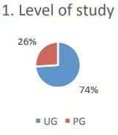

TABLE 1. LEVEL OF STUDY

The students who responded to the survey were a mix of Undergraduate and postgraduate students

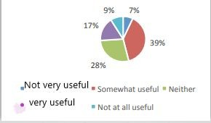

TABLE 2. SNS USEFULNESS

Overall, 56% found social media useful to some degree

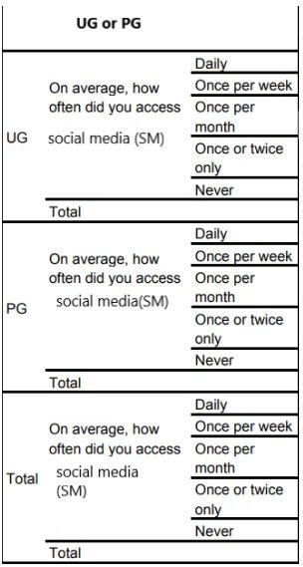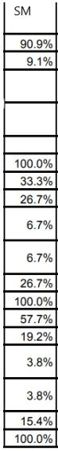

TABLE 3. HOW OFTEN DID YOU USE THE SOCIAL MEDIA

On average, it’s been found that many students use social media(SM) for educational purposes and find it useful.

### EXISTING SYSTEM

The first recognizable social network site launched in 1997. It allowed users to create profiles, list their friends and beginning in 1998, surf the friends lists. From 1997 to 2001, a number of community tools began supporting various combinations of profiles and publicly articulated friends. Asian Avenue, BlackPlanet allowed users to create personal, professional, and dating profiles – users could identify friends on their personal profiles without seeking approval for those connections . likewise, shortly after its launch in 1999. When swedish web community LunarStorm refashioned itself as an SNS in 2000, it contained friends lists, guest books and diary pages.

Before social media existed there were no instant means of communication. when people wanted to stay in touch with each other, they would write letters or send postcards. This was before the invention of the telephone. Now, with social media, people can post pictures and write captions and hashtags. These have become new means of communication through social media. For business publicity, traditional news sources were much more widely used by marketers. Creating a news-worthy press release to send to local and national press was a low-budget way of getting highly valuable space in print publications and sometimes also on radio and television.

### DISADVANTAGES OF EXISTING SYSTEM

* + 1. Business perspective: If consumers like what they’re seeing, and if relationships are built between them and company workers, they’ll want to buy the product of the company. This can result in businesses being able to productively grow at a much faster rate. But that was not easily possible previously.There were no means to relay suggestions or concerns of customers to the companies.
    2. Communication: Aside from businesses, there were less means for people to connect with one another in a much easier, comfortable, and faster

way. Though there were telephones there were coin booths which were

expensive and only available at particular places.

* + 1. Emergency help and information was not relied on quickly in time.
    2. Though there were NGOs , reaching them for help was difficult.

### PROPOSED SYSTEM

The main idea is to develop a web portal through which users can share their information with friends and get in touch with friends daily. In the present trend, social networking sites are popular and mostly used web portals like Facebook plus where they can upload images, videos and post their daily activities and views and share information between their circle. This project is implemented with basic features like profile creation, searching friends ,adding friends, chat with friends, and uploading status. This application can be further developed by adding new features to the existing one. Upgrading to the new version can be easily implemented.

### ADVANTAGES OF PROPOSED SYSTEM

* Social networking gives you a chance to connect with people around the world.
* This technology gives us access to easy, instant communication tools.
* Social networking creates brand exposure for businesses.
* General fun and enjoyment

## ANALYSIS

### HARDWARE REQUIREMENTS

processor : Intel Pentium IV 2.0 GHz and above RAM: 512 MB and above

Hard disk :80GB and above Monitor: CRt or LED monitor Keyboard: Normal or multimedia Mouse: compatible mouse

### SOFTWARE REQUIREMENTS

Language :PHP

BackEnd: PHPMyAdmin , Apache server Frontend: XAMPP

Operation System: windows 10 and above Browser: any latest browser

### CLASS DIAGRAM

* 1. **DESIGN**

Class diagrams describe the static structure of a system,or how it is structured rather than how it behaves.These diagrams contain the following elements:

* + 1. Classes,which represent entities with common characteristics or features.These features include attributes,operations,and associations.
    2. Associations,which represent relationships that relate two or more other classes where the relationships have common characteristics or features.These features include attributes and operations.

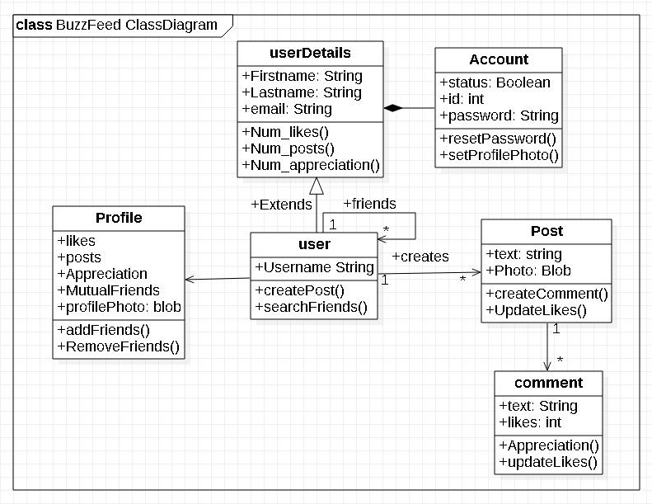

Fig1. BuzzFeed class diagram

### USE CASE DIAGRAM

A use case diagram is a graphic depiction of the interactions among the elements of a system. A use case is a methodology used in system analysis to identify

, clarify, and organize system requirements .In this context, the term “system” refers to something being developed or operated , such as a mail-order product sales and

service website. Use case diagrams are employed in UML, a standard notation for the modeling of real world objects and systems.

* + The actors, usually individuals involved with the system defined according to their roles
  + The use cases, which are the specific roles played by the actors within and around the system, the relationships between and among the actors and the use cases.

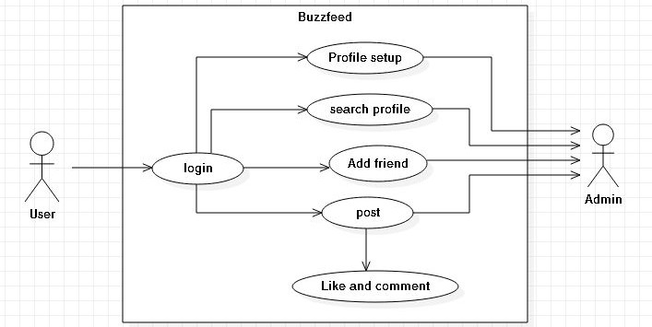

Fig2. BuzzFeed use case diagram

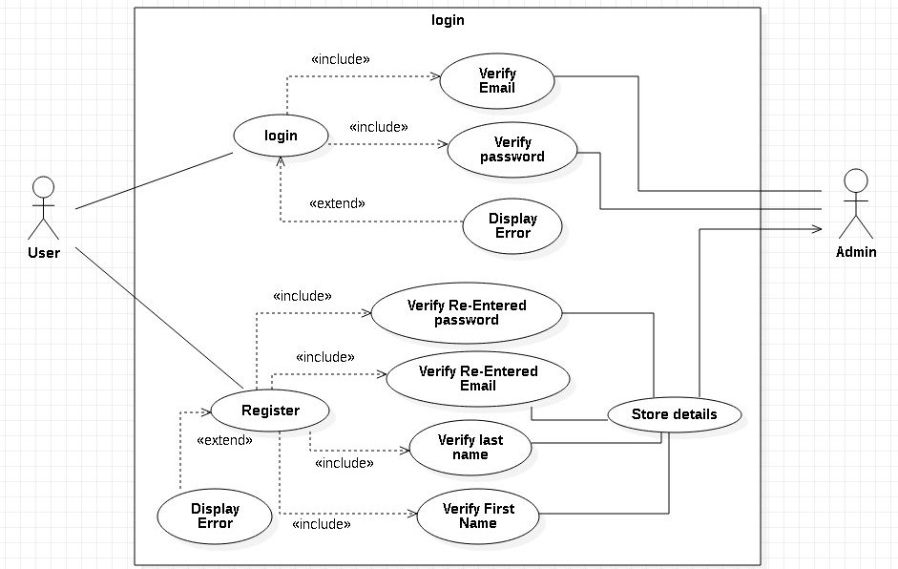

Fig3. login use case diagram

### ACTIVITY DIAGRAM

An activity diagram visually presents a series of actions or flow of control in a system similar to a flowchart or a data flow diagram. Activity diagrams are often used in business process modeling. They can also describe the steps in a use case diagram . Activities modeled can be sequential and concurrent.

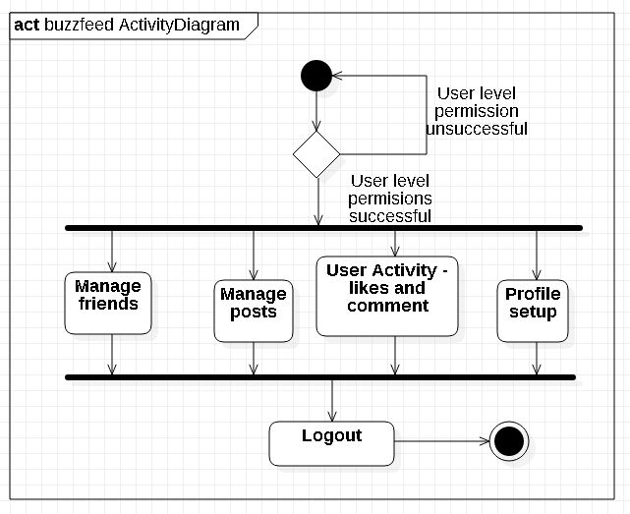

Fig4. BuzzFeed activity diagram

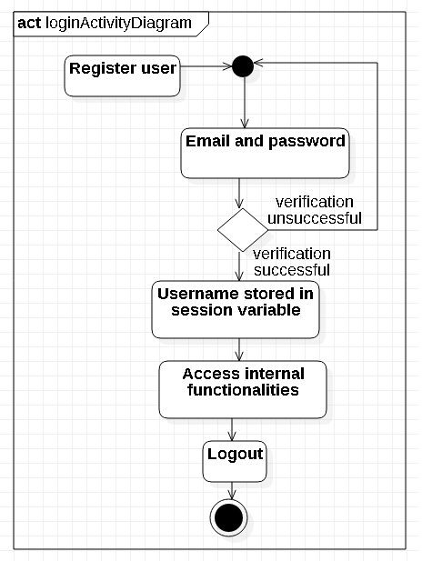

Fig5. login activity diagram

### DEPLOYMENT DIAGRAM

Deployment diagram shows the configuration of run-time processing nodes and the components that live on them.These diagrams address the static deployment view of architecture.Deployment Diagram displays the configuration of run-time processing elements and the software components,processes,and objects that live on them.Software component instances represent run-time manifestations of code.

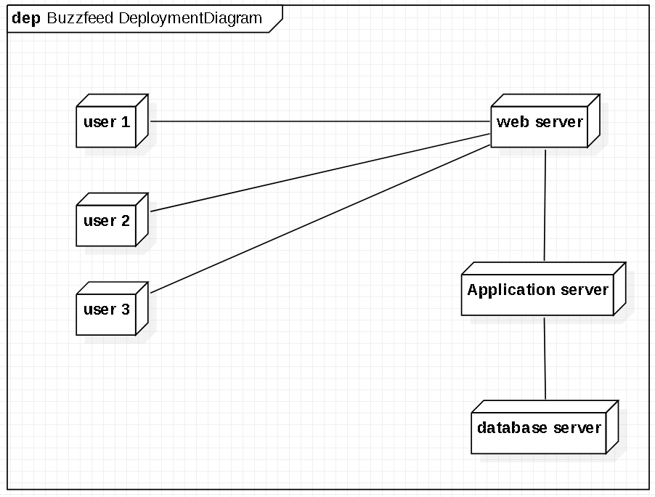

Fig6. Deployment diagram

### SEQUENCE DIAGRAM

UML Sequence Diagrams are interaction diagrams that detail how operations are carried out. They capture the interaction between objects in the context of a collaboration. Sequence Diagrams are time focused and they show the order of the interaction visually by using the vertical axis of the diagram to represent time, what messages are sent and when.

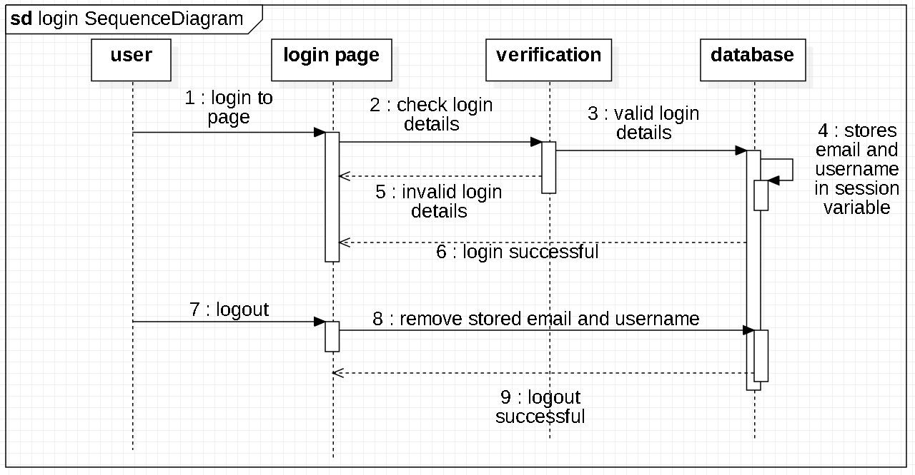

Fig7. login sequence diagram

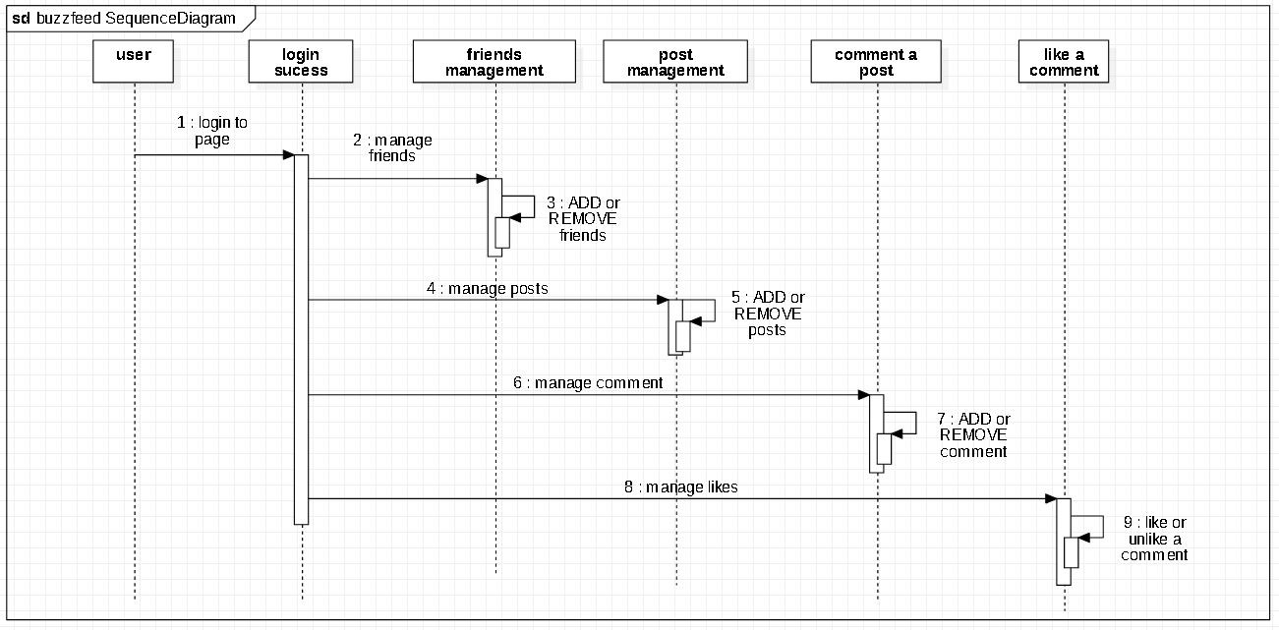

Fig8. buzzfeed sequence diagram

### DATABASE

Database is used to store the relevant information of the individuals. A database is a collection of rows and columns in which rows indicate the tuple and columns indicate the domain of tables.phpMyAdmin is an open-source software tool which is written in PHP. It is a third-party tool to manage the tables and data inside the database. phpMyAdmin supports various types of operations on MariaDB and MySQL. The main purpose of phpMyAdmin is to handle the administration of MySQL over the web.

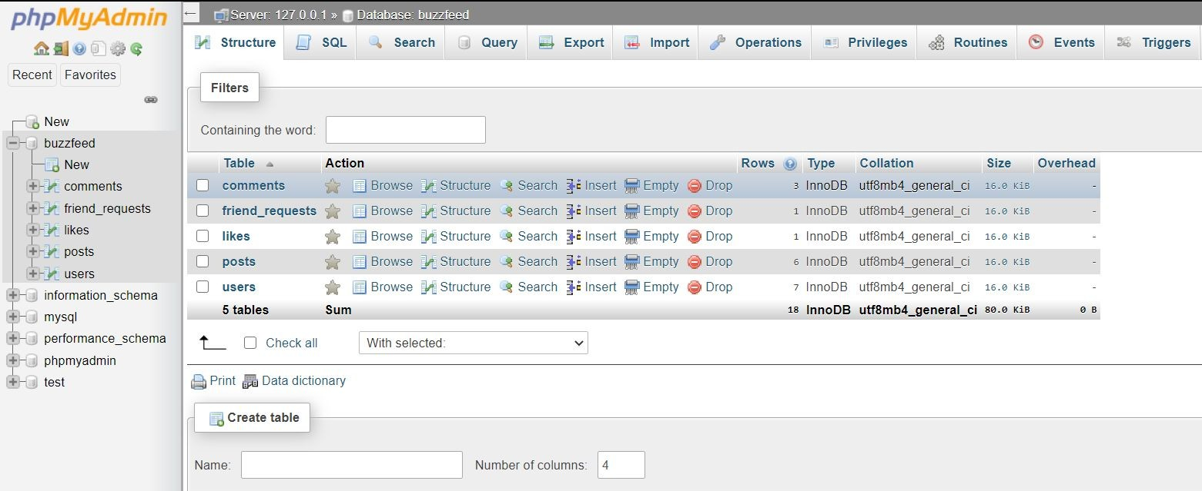

Fig 9 database

<?php

### IMPLEMENTATION

* 1. **source code**
     1. **config/config.php**

//Last name

$lname = strip_tags($_POST['reg_lname']);

$lname = str_replace(' ', '', $lname); //remove spaces

$lname = ucfirst(strtolower($lname));

ob_start(); //Turns on output buffering session_start();

$con = mysqli_connect("localhost", "root", "", "social"); //Connection variable

if(mysqli_connect_errno())

echo "Failed to connect: " . mysqli_connect_errno(); ?>

### register_handler.php

<?php

//Declaring variables to prevent errors

$fname = ""; //First name

$lname = ""; //Last name

$em = ""; //email

$em2 = ""; //email 2

$password = ""; //password

$password2 = ""; //password 2

$date = ""; //Sign up date

$error_array = array(); //Holds error messages if(isset($_POST['register_button'])){

//Registration form values

//First name

$fname = strip_tags($_POST['reg_fname']);

//Remove html tags

$fname = str_replace(' ', '', $fname); //remove spaces

$fname = ucfirst(strtolower($fname));

//Uppercase first letter

$_SESSION['reg_fname'] = $fname; //Stores first name into session variable

$_SESSION['reg_lname'] = $lname;

//email

$em = strip_tags($_POST['reg_email']);

$em = str_replace(' ', '', $em); //remove spaces

$em = ucfirst(strtolower($em));

$_SESSION['reg_email'] = $em;

//email 2

$em2 = strip_tags($_POST['reg_email2']);

$em2 = str_replace(' ', '', $em2); //remove spaces

$em2 = ucfirst(strtolower($em2));

$_SESSION['reg_email2'] = $em2;

//Password

$password = strip_tags($_POST['reg_password']); //Remove html tags

$password2 = strip_tags($_POST['reg_password2']);

//Remove html tags

$date = date("Y-m-d"); //Current date if($em == $em2) {

//Check if email is in valid format

if(filter_var($em, FILTER_VALIDATE_EMAIL)) {

$em = filter_var($em, FILTER_VALIDATE_EMAIL);

//Check if email already exists

$e_check = mysqli_query($con, "SELECT email FROM users WHERE email='$em'");

//Count the number of rows returned

$num_rows = mysqli_num_rows($e_check); if($num_rows > 0)

array_push($error_array, "Email already in use<br>");

}else

array_push($error_array, "Invalid email format<br>");

}else

array_push($error_array, "Emails don't match<br>");

if(strlen($fname) > 25 || strlen($fname) < 2)

array_push($error_array, "Your first name must be between 2 and 25 characters<br>");

if(strlen($lname) > 25 || strlen($lname) < 2)

array_push($error_array, "Your last name must be between 2 and 25 characters<br>");

if($password != $password2)

array_push($error_array, "Your passwords do not match<br>");

else

if(preg_match('/^(?=.[0-9])(?=.[a-z])(?=.[A-Z])(

?=.[*.!@$%^&(){}[]:;<>,.?\+\-\/\|\=).{8,32}$/',

$password))

array_push($error_array, "Check And enter again<br>");

if(strlen($password) > 30 || strlen($password) < 5)

array_push($error_array, "Your password must be betwen 5 and 30 characters<br>");

if(empty($error_array)) {

$password = md5($password); //Encrypt password before sending to database

//Generate username by concatenating first name and last name

$username = strtolower($fname . "_" . $lname);

$check_username_query = mysqli_query($con, "SELECT username FROM users WHERE username='$username'");

$i = 0;//if username exists add number to username

while(mysqli_num_rows($check_username_qu ery) != 0) {

$i++; //Add 1 to i

$username = $username . "_" . $i;

$check_username_query = mysqli_query($con, "SELECT username FROM users WHERE username='$username'");

}//Profile picture assignment

$rand = rand(1, 2); //Random number between 1 and 2

if($rand == 1)

$profile_pic = "assets/images/profile_pics/defaults/head_deep

_blue.png";

else if($rand == 2)

$profile_pic = "assets/images/profile_pics/defaults/head_emer ald.png";

$query = mysqli_query($con, "INSERT INTO users VALUES ('', '$fname', '$lname',

'$username', '$em', '$password', '$date', '$profile_pic', '0', '0', 'no', ',','0')");

array_push($error_array, "<span style='color: #14C800;'>You're all set! Go ahead and login!</span><br>");

//Clear session variables

$_SESSION['reg_fname'] = "";

$_SESSION['reg_lname'] = "";

$_SESSION['reg_email'] = "";

$_SESSION['reg_email2'] = "";

} } ?>

### includes/form_handlers/login_handler.php

<?php if(isset($_POST['login_button'])) {

$email = filter_var($_POST['log_email'], FILTER_SANITIZE_EMAIL); //sanitize email

$_SESSION['log_email'] = $email;

$password = md5($_POST['log_password']);

$check_database_query = mysqli_query($con, "SELECT * FROM users WHERE

email='$email' AND password='$password'");

$check_login_query = mysqli_num_rows($check_database_query);

if($check_login_query == 1) {

//On click signup, hide login and show registration form

$("#signup").click(function() {

$("#first").slideUp("slow", function(){

$("#second").slideDown("slow");

}); });

//On click signup, hide registration and show login form

$("#signin").click(function() {

$("#second").slideUp("slow", function(){

$("#first").slideDown("slow");

}); }); });

### register.php

$row = mysqli_fetch_array($check_database_query);

$username = $row['username'];

$user_closed_query = mysqli_query($con, "SELECT * FROM users WHERE

email='$email' AND user_closed='yes'");

if(mysqli_num_rows($user_closed_query) == 1)

$reopen_account = mysqli_query($con, "UPDATE users SET user_closed='no' WHERE email='$email'");

$_SESSION['username'] = $username; header("Location: index.php");

exit();

}else

array_push($error_array, "Email or password was incorrect<br>");

} ?>

### assets/js/register.js

$(document).ready(function() {

<?php

require 'config/config.php'; require

'includes/form_handlers/register_handler.php';

require 'includes/form_handlers/login_handler.php';

?>

<html>

<head>

<title>Welcome to BuZzfeed!</title>

<link rel="stylesheet" type="text/css" href="assets/css/register_style.css">

<script src="https://ajax.googleapis.com/ajax/libs/jquer y/2.1.3/jquery.min.js"></script>

<script src="assets/js/register.js"></script>

</head>

<body>

<?php if(isset($_POST['register_button'])) {

echo '<script>

$(document).ready(function() {

$("#first").hide();

$("#second").show();

});

</script>';

} ?>

<div class="wrapper">

<div class="login_box">

<div class="login_header">

<h1>BuZzfeed!</h1>

</div>

<br>

<div id="first">

<form action="register.php" method="POST">

<input type="email" name="log_email" placeholder="Email Address" value="<?php

if(isset($_SESSION['log_email'])) echo $_SESSION['log_email'];

?>" required> <br>

<input type="password" name="log_password" placeholder="Password"><br>

<?php if(in_array("Email or password was incorrect<br>", $error_array)) echo "Email or password was incorrect<br>"; ?>

<input type="submit" name="login_button" value="Login"> <br>

<a href="#" id="signup" class="signup">Need an account? Register here!</a>

</form> </div>

<div id="second">

<form action="register.php" method="POST">

<input type="text" name="reg_fname" placeholder="First Name" value="<?php

if(isset($_SESSION['reg_fname'])) echo $_SESSION['reg_fname'];

?>" required> <br>

<?php if(in_array("Your first name must be between 2 and 25 characters<br>",

$error_array)) echo "Your first name must be between 2 and 25 characters<br>"; ?>

<input type="text" name="reg_lname" placeholder="Last Name" value="<?php

if(isset($_SESSION['reg_lname'])) echo $_SESSION['reg_lname'];

?>" required> <br>

<?php if(in_array("Your last name must be between 2 and 25 characters<br>",

$error_array)) echo "Your last name must be

between 2 and 25 characters<br>"; ?>

<input type="email" name="reg_email" placeholder="Email" value="<?php

if(isset($_SESSION['reg_email'])) echo $_SESSION['reg_email'];

?>" required> <br>

<input type="email" name="reg_email2" placeholder="Confirm Email" value="<?php

if(isset($_SESSION['reg_email2'])) echo $_SESSION['reg_email2'];

?>" required> <br>

<?php if(in_array("Email already in use<br>",

$error_array)) echo "Email already in use<br>";

else if(in_array("Invalid email format<br>",

$error_array)) echo "Invalid email format<br>";

else if(in_array("Emails don't match<br>",

$error_array)) echo "Emails don't match<br>";

?>

<input type="password" name="reg_password" placeholder="Password" required>

<br>

<input type="password" name="reg_password2" placeholder="Confirm Password" required> <br>

<?php if(in_array("Your passwords do not match<br>", $error_array)) echo "Your passwords do not match<br>";

else if(in_array("Check And enter again<br>",

$error_array)) echo "please enter english alphabets ,number *.!@$%^&(){}[]:;<>,.?+-/|= only<br>";

else if(in_array("Your password must be betwen 5 and 30 characters<br>",

$error_array)) echo "Your password must be betwen 5 and 30 characters<br>"; ?>

<input type="submit" name="register_button" value="Register">

<br>

<?php if(in_array("<span style='color: #14C800;'>You're all set! Go ahead and login!</span><br>", $error_array)) echo "<span style='color: #14C800;'>You're all set! Go ahead and login!</span><br>"; ?>

<a href="#" id="signin" class="signin">Already have an account? Sign in here!</a>

</form>

</div> </div> </div>

</body>

</html>

### includes/classes/User.php

<?php

class User { private $user; private $con;

public function construct($con, $user){

$this->con = $con;

$user_details_query = mysqli_query($con, "SELECT * FROM users WHERE

username='$user'");

$this->user = mysqli_fetch_array($user_details_query);

}

public function getUsername() { return $this->user['username']; }

public function getNumberOfFriendRequests()

{

$username = $this->user['username'];

$query = mysqli_query($this->con, "SELECT * FROM friend_requests WHERE user_to='$username'");

return mysqli_num_rows($query); } public function getNumPosts() {

$username = $this->user['username'];

$query = mysqli_query($this->con, "SELECT num_posts FROM users WHERE username='$username'");

$row = mysqli_fetch_array($query); return $row['num_posts']; }

public function getFirstAndLastName() {

$username = $this->user['username'];

$query = mysqli_query($this->con, "SELECT first_name, last_name FROM users WHERE username='$username'");

$row = mysqli_fetch_array($query); return $row['first_name'] . " " .

$row['last_name'];}

public function getProfilePic() {

$username = $this->user['username'];

$query = mysqli_query($this->con, "SELECT profile_pic FROM users WHERE username='$username'");

$row = mysqli_fetch_array($query); return $row['profile_pic']; } public function getFriendArray() {

$username = $this->user['username'];

$query = mysqli_query($this->con, "SELECT friend_array FROM users WHERE username='$username'");

$row = mysqli_fetch_array($query); return $row['friend_array']; } public function isClosed() {

$username = $this->user['username'];

$query = mysqli_query($this->con, "SELECT user_closed FROM users WHERE username='$username'");

$row = mysqli_fetch_array($query); if($row['user_closed'] == 'yes') return true;

else

return false;}

public function isFriend($username_to_check)

{

$usernameComma = "," . $username_to_check . ",";

if((strstr($this->user['friend_array'],

$usernameComma) || $username_to_check ==

$this->user['username'])) return true;

else

return false;}

public function didReceiveRequest($user_from)

{

$user_to = $this->user['username'];

$check_request_query =

mysqli_query($this->con, "SELECT * FROM

friend_requests WHERE user_to='$user_to' AND user_from='$user_from'");

if(mysqli_num_rows($check_request_query) > 0)

return true; else

return false;}

public function didSendRequest($user_to) {

$user_from = $this->user['username'];

$check_request_query =

mysqli_query($this->con, "SELECT * FROM friend_requests WHERE user_to='$user_to' AND user_from='$user_from'");

if(mysqli_num_rows($check_request_query) > 0)

return true;

else return false;} public function

removeFriend($user_to_remove) {

$logged_in_user = $this->user['username'];

$query = mysqli_query($this->con, "SELECT friend_array FROM users WHERE username='$user_to_remove'");

$row = mysqli_fetch_array($query);

$friend_array_username = $row['friend_array'];

$new_friend_array = str_replace($user_to_remove . ",", "",

$this->user['friend_array']);

$remove_friend = mysqli_query($this->con, "UPDATE users SET friend_array='$new_friend_array' WHERE username='$logged_in_user'");

$new_friend_array =

str_replace($this->user['username'] . ",", "",

$friend_array_username);

$remove_friend = mysqli_query($this->con, "UPDATE users SET

friend_array='$new_friend_array' WHERE username='$user_to_remove'");}

public function sendRequest($user_to) {

$user_from = $this->user['username'];

$query = mysqli_query($this->con, "INSERT INTO friend_requests VALUES('', '$user_to', '$user_from')");}

public function getMutualFriends($user_to_check) {

$mutualFriends = 0;

$user_array = $this->user['friend_array'];

$user_array_explode = explode(",",

$user_array);

$query = mysqli_query($this->con, "SELECT friend_array FROM users WHERE username='$user_to_check'");

$row = mysqli_fetch_array($query);

$user_to_check_array = $row['friend_array'];

$user_to_check_array_explode = explode(",",

$user_to_check_array); foreach($user_array_explode as $i) { foreach($user_to_check_array_explode as $j) { if($i == $j && $i != "") {

$mutualFriends++;

} }

}

return $mutualFriends;} }

?>

### includes/classes/Post.php

<?php class Post {

private $user_obj; private $con;

public function construct($con, $user){

$this->con = $con;

$this->user_obj = new User($con, $user);} public function submitPost($body, $user_to,

$imageName) {

$body = strip_tags($body); //removes html tags

$body = mysqli_real_escape_string($this->con,

$body);

$body = str_replace('\r\n', "\n", $body);

$body = nl2br($body);

$check_empty = preg_replace('/\s+/', '', $body);

//Deltes all spaces if($check_empty != "") {

$body_array = preg_split("/\s+/", $body);

foreach($body_array as $key => $value) {

if(strpos($value, ["www.youtube.com/watch?v=")](http://www.youtube.com/watch?v) !== false) {

$link = preg_split("!&!", $value);

$value = preg_replace("!watch\?v=!", "embed/", $link[0]);

$value = "<br><iframe width=\'420\' height=\'315\' src=\'" . $value

."\'></iframe><br>";

$body_array[$key] = $value;

} }

$body = implode(" ", $body_array);

//Current date and time

$date_added = date("Y-m-d H:i:s");

//Get username

$added_by = $this->user_obj->getUsername();

//If user is on own profile, user_to is 'none' if($user_to == $added_by)

$user_to = "none";

//insert post

$query = mysqli_query($this->con, "INSERT INTO posts VALUES('', '$body', '$added_by', '$user_to', '$date_added', 'no', 'no', '0', '$imageName')");

$returned_id = mysqli_insert_id($this->con);

//Insert notification if($user_to != 'none') {

$notification = new Notification($this->con,

$added_by);

$notification->insertNotification($returned_id,

$user_to, "like");

}

//Update post count for user

$num_posts = $this->user_obj->getNumPosts();

$num_posts++;

$update_query = mysqli_query($this->con, "UPDATE users SET num_posts='$num_posts' WHERE username='$added_by'");

$stopWords = "a about above across after again against all almost alone along already

also although always among am an and another any anybody anyone anything anywhere are

area areas around as ask asked asking asks at away b back backed backing backs be became

because become becomes been before began behind being beings best better between big

both but by c came can cannot case cases certain certainly clear clearly come could

d did differ different differently do does done down down downed downing downs during

e each early either end ended ending ends enough even evenly ever every everybody

everyone everything everywhere f face faces fact facts far felt few find finds first

for four from full fully further furthered furthering furthers g gave general generally

get gets give given gives go going good goods got great greater greatest group grouped

grouping groups h had has have having he her here herself high high high higher

highest him himself his how however i im if important in interest interested interesting

interests into is it its itself j just k keep keeps kind knew know known knows

large largely last later latest least less let lets like likely long longer

longest m made make making man many may me member members men might more most

mostly mr mrs much must my myself n necessary need needed needing needs never

new new newer newest next no nobody non noone not nothing now nowhere number

numbers o of off often old older oldest on once one only open opened opening

opens or order ordered ordering orders other others our out over p part parted

parting parts per perhaps place places point pointed pointing points possible

present presented presenting presents problem problems put puts q quite r

rather really right right room rooms s said same saw say says second seconds

see seem seemed seeming seems sees several shall she should show showed

showing shows side sides since small smaller smallest so some somebody

someone something somewhere state states still still such sure t take

taken than that the their them then there therefore these they thing

things think thinks this those though thought thoughts three through

thus to today together too took toward turn turned turning turns two

u under until up upon us use used uses v very w want wanted wanting

wants was way ways we well wells went were what when where whether

which while who whole whose why will with within without work

worked working works would x y year years yet you young younger

youngest your yours z lol haha omg hey ill iframe wonder else like

hate sleepy reason for some little yes bye choose";

//Convert stop words into array - split at white space

$stopWords = preg_split("/[\s,]+/",

$stopWords);

//Remove all punctionation

$no_punctuation = preg_replace("/[^a-zA-Z 0-9]+/", "", $body);

//Predict whether user is posting a url. If so, do not check for trending words

if(strpos($no_punctuation, "height") === false && strpos($no_punctuation, "width") === false

&& strpos($no_punctuation, "http") === false && strpos($no_punctuation, "youtube") === false){

//Convert users post (with punctuation removed) into array - split at white space

$keywords = preg_split("/[\s,]+/",

$no_punctuation); foreach($stopWords as $value) {

foreach($keywords as $key => $value2){ if(strtolower($value) == strtolower($value2))

$keywords[$key] = "";

}

}

}

}

}

public function loadPostsFriends($data, $limit)

{

$page = $data['page'];

$userLoggedIn =

$this->user_obj->getUsername(); if($page == 1)

$start = 0; else

$start = ($page - 1) * $limit;

$str = ""; //String to return

$data_query = mysqli_query($this->con, "SELECT * FROM posts WHERE deleted='no' ORDER BY id DESC");

if(mysqli_num_rows($data_query) > 0) {

$num_iterations = 0; //Number of results checked (not necessarily posted)

$count = 1;

while($row = mysqli_fetch_array($data_query)) {

$id = $row['id'];

$body = $row['body'];

$added_by = $row['added_by'];

$date_time = $row['date_added'];

$imagePath = $row['images'];

//Prepare user_to string so it can be included even if not posted to a user

if($row['user_to'] == "none")

$user_to = "";

else {

$user_to_obj = new User($this->con,

$row['user_to']);

$user_to_name =

$user_to_obj->getFirstAndLastName();

$user_to = "to <a href='" . $row['user_to'] ."'>" .

$user_to_name . "</a>";

}

//Check if user who posted, has their account closed

$added_by_obj = new User($this->con,

$added_by);

if($added_by_obj->isClosed()) continue;

$user_logged_obj = new User($this->con,

$userLoggedIn);

if($user_logged_obj->isFriend($added_by)){ if($num_iterations++ < $start)

continue;

//Once 10 posts have been loaded, break if($count > $limit)

break; else

$count++;

if($userLoggedIn == $added_by)

$delete_button = "<button class='delete_button btn-danger' id='post$id'>X</button>";

else

$delete_button = "";

$user_details_query = mysqli_query($this->con, "SELECT

first_name, last_name, profile_pic FROM users WHERE username='$added_by'");

$user_row = mysqli_fetch_array($user_details_query);

$first_name = $user_row['first_name'];

$last_name = $user_row['last_name'];

$profile_pic = $user_row['profile_pic']; ?>

<script>

function toggle<?php echo $id; ?>() { var target = $(event.target);

if (!target.is("a")) {

var element = document.getElementById("toggleComment<? php echo $id; ?>");

if(element.style.display == "block") element.style.display = "none";

else

element.style.display = "block";

}

}

</script> <?php

$comments_check = mysqli_query($this->con, "SELECT * FROM comments WHERE post_id='$id'");

$comments_check_num = mysqli_num_rows($comments_check);

//Timeframe

$date_time_now = date("Y-m-d H:i:s");

$start_date = new DateTime($date_time);

//Time of post

$end_date = new DateTime($date_time_now);

//Current time

$interval = $start_date->diff($end_date);

//Difference between dates if($interval->y >= 1) { if($interval->y == 1)

$time_message = $interval->y . " year ago"; //1 year ago

else

$time_message = $interval->y . " years ago";

//1+ year ago

}

else if ($interval->m >= 1) { if($interval->d == 0)

$days = " ago";

else if($interval->d == 1)

$days = $interval->d . " day ago"; else

$days = $interval->d . " days ago"; if($interval->m == 1)

$time_message = $interval->m . " month ".

$days; else

$time_message = $interval->m . " months ".

$days;

}

else if($interval->d >= 1) { if($interval->d == 1)

$time_message = "Yesterday"; else

$time_message = $interval->d . " days ago";

}

else if($interval->h >= 1) { if($interval->h == 1)

$time_message = $interval->h . " hour ago"; else

$time_message = $interval->h . " hours ago";

}

else if($interval->i >= 1) {

if($interval->i == 1)

$time_message = $interval->i . " minute ago"; else

$time_message = $interval->i . " minutes ago";

}

else {

if($interval->s < 30)

$time_message = "Just now"; else

$time_message = $interval->s . " seconds ago";

}

if($imagePath != "")

$imageDiv = "<div class='postedImage'>

<img src='$imagePath'> </div>"; else

$imageDiv = "";

$str .= "<div class='status_post' onClick='javascript:toggle$id()'>

<div class='post_profile_pic'>

<img src='$profile_pic' width='50'>

</div>

<div class='posted_by' style='color:#ACACAC;'>

<a href='$added_by'> $first_name $last_name

</a> $user_to &nbsp;&nbsp;&nbsp;&nbsp;$time_message

$delete_button

</div>

<div id='post_body'>

$body <br> $imageDiv <br> <br>

</div>

<div class='newsfeedPostOptions'>

Comments($comments_check_num)&nbsp;&n bsp;&nbsp;

<iframe src='like.php?post_id=$id' scrolling='no'></iframe>

</div>

</div>

<div class='post_comment' id='toggleComment$id' style='display:none;'>

<iframe src='comment_frame.php?post_id=$id' id='comment_iframe' frameborder='0'></iframe> </div> <hr>";

}

?>

<script>

$(document).ready(function() {

$('#post<?php echo $id; ?>').on('click', function() {

bootbox.confirm("Are you sure you want to delete this post?", function(result) {

$.post("includes/form_handlers/delete_post.php

?post_id=<?php echo $id; ?>", {result:result}); if(result)

location.reload();

});

});

});

</script>

<?php

} //End while loop if($count > $limit)

$str .= "<input type='hidden' class='nextPage' value='" . ($page + 1) . "'>

<input type='hidden' class='noMorePosts' value='false'>";

else

$str .= "<input type='hidden' class='noMorePosts' value='true'><p style='text-align: centre;' class='noMorePostsText'> No more posts to show! </p>";

} echo $str;

}

public function loadProfilePosts($data, $limit) {

$page = $data['page'];

$profileUser = $data['profileUsername'];

$userLoggedIn =

$this->user_obj->getUsername(); if($page == 1)

$start = 0; else

$start = ($page - 1) * $limit;

$str = ""; //String to return

$data_query = mysqli_query($this->con, "SELECT * FROM posts WHERE deleted='no' AND ((added_by='$profileUser' AND user_to='none') OR user_to='$profileUser') ORDER BY id DESC");

if(mysqli_num_rows($data_query) > 0) {

$num_iterations = 0; //Number of results checked (not necasserily posted)

$count = 1; while($row =

mysqli_fetch_array($data_query)) {

$id = $row['id'];

$body = $row['body'];

$added_by = $row['added_by'];

$date_time = $row['date_added']; if($num_iterations++ < $start)

continue;

//Once 10 posts have been loaded, break if($count > $limit)

break; else

$count++;

if($userLoggedIn == $added_by)

$delete_button = "<button class='delete_button btn-danger' id='post$id'>X</button>";

else

$delete_button = "";

$user_details_query = mysqli_query($this->con, "SELECT

first_name, last_name, profile_pic FROM users WHERE username='$added_by'");

$user_row = mysqli_fetch_array($user_details_query**);**

$first_name = $user_row['first_name'];

$last_name = $user_row['last_name'];

$profile_pic = $user_row['profile_pic'];

?>

<script>

function toggle<?php echo $id; ?>() { var target = $(event.target);

if (!target.is("a")) {

var element = document.getElementById("toggleComment<? php echo $id; ?>");

if(element.style.display == "block") element.style.display = "none";

else

element.style.display = "block";

}

}

</script>

<?php

$comments_check = mysqli_query($this->con, "SELECT * FROM comments WHERE post_id='$id'");

$comments_check_num = mysqli_num_rows($comments_check);

//Timeframe

$date_time_now = date("Y-m-d H:i:s");

$start_date = new DateTime($date_time);

//Time of post

$end_date = new DateTime($date_time_now);

//Current time

$interval = $start_date->diff($end_date);

//Difference between dates if($interval->y >= 1) { if($interval->y == 1)

$time_message = $interval->y . " year ago"; //1 year ago

else

$time_message = $interval->y . " years ago";

//1+ year ago

}

else if ($interval->m >= 1) { if($interval->d == 0)

$days = " ago";

else if($interval->d == 1)

$days = $interval->d . " day ago"; else

$days = $interval->d . " days ago"; if($interval->m == 1)

$time_message = $interval->m . " month".

$days;

else

$time_message = $interval->m . " months".

$days;

}

else if($interval->d >= 1) { if($interval->d == 1)

$time_message = "Yesterday"; else

$time_message = $interval->d . " days ago";

}

else if($interval->h >= 1) { if($interval->h == 1)

$time_message = $interval->h . " hour ago"; else

$time_message = $interval->h . " hours ago";

}

else if($interval->i >= 1) { if($interval->i == 1)

$time_message = $interval->i . " minute ago"; else

$time_message = $interval->i . " minutes ago";

}

else {

if($interval->s < 30)

$time_message = "Just now"; else

$time_message = $interval->s . " seconds ago";

}

$str .= "<div class='status_post' onClick='javascript:toggle$id()'>

<div class='post_profile_pic'>

<img src='$profile_pic' width='50'>

</div>

<div class='posted_by' style='color:#ACACAC;'>

<a href='$added_by'> $first_name $last_name

</a> &nbsp;&nbsp;&nbsp;&nbsp;$time_message

$delete_button

</div>

<div id='post_body'>

$body <br> <br> <br>

</div>

<div class='newsfeedPostOptions'>

Comments($comments_check_num)&nbsp;&n bsp;&nbsp;

<iframe src='like.php?post_id=$id' scrolling='no'></iframe>

</div>

</div>

<div class='post_comment' id='toggleComment$id' style='display:none;'>

<iframe src='comment_frame.php?post_id=$id' id='comment_iframe' frameborder='0'></iframe> </div> <hr>";

?>

<script>

$(document).ready(function() {

$('#post<?php echo $id; ?>').on('click', function() {

bootbox.confirm("Are you sure you want to delete this post?", function(result) {

$.post("includes/form_handlers/delete_post.php

?post_id=<?php echo $id; ?>", {result:result}); if(result)

location.reload();

});

});

});

</script>

<?php

} //End while loop if($count > $limit)

$str .= "<input type='hidden' class='nextPage' value='" . ($page + 1) . "'>

<input type='hidden' class='noMorePosts' value='false'>";

else

$str .= "<input type='hidden' class='noMorePosts' value='true'><p style='text-align: centre;' class='noMorePostsText'> No more posts to show! </p>";

} echo $str;

}

public function getSinglePost($post_id) {

$userLoggedIn =

$this->user_obj->getUsername();

$opened_query = mysqli_query($this->con, "UPDATE notifications SET opened='yes' WHERE user_to='$userLoggedIn' AND link LIKE '%=$post_id'");

$str = ""; //String to return

$data_query = mysqli_query($this->con, "SELECT * FROM posts WHERE deleted='no' AND id='$post_id'");

if(mysqli_num_rows($data_query) > 0) {

$row = mysqli_fetch_array($data_query);

$id = $row['id'];

$body = $row['body'];

$added_by = $row['added_by'];

$date_time = $row['date_added'];

//Prepare user_to string so it can be included even if not posted to a user

if($row['user_to'] == "none") {

$user_to = "";

}

else {

$user_to_obj = new User($this->con,

$row['user_to']);

$user_to_name =

$user_to_obj->getFirstAndLastName();

$user_to = "to <a href='" . $row['user_to'] ."'>" .

$user_to_name . "</a>";

}

//Check if user who posted, has their account closed

$added_by_obj = new User($this->con,

$added_by);

if($added_by_obj->isClosed()) { return;

}

$user_logged_obj = new User($this->con,

$userLoggedIn);

if($user_logged_obj->isFriend($added_by)){ if($userLoggedIn == $added_by)

$delete_button = "<button class='delete_button btn-danger' id='post$id'>X</button>";

else

$delete_button = "";

$user_details_query = mysqli_query($this->con, "SELECT

first_name, last_name, profile_pic FROM users WHERE username='$added_by'");

$user_row = mysqli_fetch_array($user_details_query);

$first_name = $user_row['first_name'];

$last_name = $user_row['last_name'];

$profile_pic = $user_row['profile_pic']; ?>

<script>

function toggle<?php echo $id; ?>(e) { if( !e ) e = window.event;

var target = $(e.target); if (!target.is("a")) {

var element = document.getElementById("toggleComment<? php echo $id; ?>")**;**

if(element.style.display == "block") element.style.display = "none";

else

element.style.display = "block";

}

}

</script>

<?php

$comments_check = mysqli_query($this->con, "SELECT * FROM comments WHERE post_id='$id'");

$comments_check_num = mysqli_num_rows($comments_check);

//Timeframe

$date_time_now = date("Y-m-d H:i:s");

$start_date = new DateTime($date_time);

//Time of post

$end_date = new DateTime($date_time_now);

//Current time

$interval = $start_date->diff($end_date);

//Difference between dates if($interval->y >= 1) { if($interval == 1)

$time_message = $interval->y . " year ago"; //1 year ago

else

$time_message = $interval->y . " years ago";

//1+ year ago

}

else if ($interval->m >= 1) { if($interval->d == 0)

$days = " ago";

else if($interval->d == 1)

$days = $interval->d . " day ago"; else

$days = $interval->d . " days ago"; if($interval->m == 1)

$time_message = $interval->m . " month".

$days; else

$time_message = $interval->m . " months".

$days;

}

else if($interval->d >= 1) { if($interval->d == 1)

$time_message = "Yesterday"; else

$time_message = $interval->d . " days ago";

}

else if($interval->h >= 1) { if($interval->h == 1)

$time_message = $interval->h . " hour ago"; else

$time_message = $interval->h . " hours ago";

}

else if($interval->i >= 1) { if($interval->i == 1) {

$time_message = $interval->i . " minute ago"; else

$time_message = $interval->i . " minutes ago";

}

else {

if($interval->s < 30)

$time_message = "Just now";

else $time_message = $interval->s . " seconds ago";

}

$str .= "<div class='status_post' onClick='javascript:toggle$id()'>

<div class='post_profile_pic'>

<img src='$profile_pic' width='50'>

</div>

<div class='posted_by' style='color:#ACACAC;'>

<a href='$added_by'> $first_name $last_name

</a> $user_to &nbsp;&nbsp;&nbsp;&nbsp;$time_message

$delete_button

</div>

<div id='post_body'>

$body <br><br><br>

</div>

<div class='newsfeedPostOptions'>

Comments($comments_check_num)&nbsp;&n bsp;&nbsp;

<iframe src='like.php?post_id=$id' scrolling='no'></iframe>

</div>

</div>

<div class='post_comment' id='toggleComment$id' style='display:none;'>

<iframe src='comment_frame.php?post_id=$id' id='comment_iframe' frameborder='0'></iframe>

</div>

<hr>";

?>

<script>

$(document).ready(function() {

$('#post<?php echo $id; ?>').on('click', function() {

bootbox.confirm("Are you sure you want to delete this post?", function(result) {

$.post("includes/form_handlers/delete_post.php

?post_id=<?php echo $id; ?>", {result:result}); if(result) location.reload();

});

});

});

</script>

<?php

}

else {

echo "<p>You cannot see this post because you are not friends with this user.</p>";

return;

}

}

else {

echo "<p>No post found. If you clicked a link, it may be broken.</p>";

return;} echo $str;

}

} ?>

### includes/form_handlers/delete_post.php

<?php

require '../../config/config.php'; if(isset($_GET['post_id']))

$post_id = $_GET['post_id']; if(isset($_POST['result'])) { if($_POST['result'] == 'true')

$query = mysqli_query($con, "UPDATE posts SET deleted='yes' WHERE id='$post_id'");

} ?>

### includes/header.php

<?php

require 'config/config.php'; include("includes/classes/User.php"); include("includes/classes/Post.php"); if (isset($_SESSION['username'])) {

$userLoggedIn = $_SESSION['username'];

$user_details_query = mysqli_query($con, "SELECT * FROM users WHERE

username='$userLoggedIn'");

$user = mysqli_fetch_array($user_details_query);

}

else

header("Location: register.php");

?>

<html>

<head>

<title>Welcome to BuZzfeed</title>

<!-- Javascript -->

<script src="https://ajax.googleapis.com/ajax/libs/jquer y/2.1.3/jquery.min.js"></script>

<script src="assets/js/bootstrap.js"></script>

<script src="assets/js/bootbox.min.js"></script>

<script src="assets/js/demo.js"></script>

<script src="assets/js/jquery.jcrop.js"></script>

<script src="assets/js/jcrop_bits.js"></script>

<!-- CSS -->

<link rel="stylesheet" href="//maxcdn.bootstrapcdn.com/font-awesom e/4.3.0/css/font-awesome.min.css">

<link rel="stylesheet" type="text/css" href="assets/css/bootstrap.css">

<link rel="stylesheet" type="text/css" href="assets/css/style.css">

<link rel="stylesheet" href="assets/css/jquery.Jcrop.css" type="text/css" />

</head>

<body>

<div class="top_bar">

<div class="logo">

<a href="index.php">BuZzfeed!</a>

</div>

<div class="search">

<form action="search.php" method="GET" name="search_form">

<input type="text" onkeyup="getLiveSearchUsers(this.value, '<?php echo $userLoggedIn; ?>')" name="q" placeholder="Search..." autocomplete="off" id="search_text_input">

<div class="button_holder">

<img src="assets/images/icons/magnifying_glass.png ">

</div>

</form>

<div class="search_results">

</div>

<div class="search_results_footer_empty">

</div>

</div>

<nav>

<a href="<?php echo $userLoggedIn; ?>">

<?php echo $user['first_name']; ?> </a>

<a href="index.php"> <i class="fa fa-home fa-lg"> </i> </a>

<a href="requests.php"> <i class="fa fa-users fa-lg"> </i> </a>

<a href="settings.php"> <i class="fa fa-cog fa-lg"> </i> </a>

<a href="includes/handlers/logout.php"><i class="fa fa-sign-out fa-lg"></i> </a>

</nav>

<div class="dropdown_data_window" style="height:0px; border:none;"></div>

<input type="hidden" id="dropdown_data_type" value="">

</div>

<script>

var userLoggedIn = '<?php echo

$userLoggedIn; ?>';

$(document).ready(function() {

$('.dropdown_data_window').scroll(function() {

var inner_height =

$('.dropdown_data_window').innerHeight();

//Div containing data

var scroll_top =

$('.dropdown_data_window').scrollTop();

var page =

$('.dropdown_data_window').find('.nextPageDr opdownData').val();

var noMoreData =

$('.dropdown_data_window').find('.noMoreDro pdownData').val();

if ((scroll_top + inner_height >=

$('.dropdown_data_window')[0].scrollHeight) && noMoreData == 'false') {

var pageName; //Holds name of page to send ajax request to

var type = $('#dropdown_data_type').val(); if(type == 'notification')

pageName = "ajax_load_notifications.php"; else if(type == 'message')

pageName = "ajax_load_messages.php" var ajaxReq = $.ajax({

url: "includes/handlers/" + pageName, type: "POST",

data: "page=" + page + "&userLoggedIn=" + userLoggedIn,

cache:false,

success: function(response) {

$('.dropdown_data_window').find('.nextPageDr opdownData').remove(); //Removes current

.nextpage

$('.dropdown_data_window').find('.noMoreDro pdownData').remove(); //Removes current

.nextpag

$('.dropdown_data_window').append(response);

} });

} //End if return false;

}); //End (window).scroll(function())

});

</script>

<div class="wrapper">

### index.php

<?php include("includes/header.php"); if(isset($_POST['post'])){

$uploadOk = 1;

$imageName =

$_FILES['fileToUpload']['name'];

$errorMessage = ""; if($imageName != "") {

$targetDir = "assets/images/posts/";

$imageName = $targetDir . uniqid() . basename($imageName);

$imageFileType = pathinfo($imageName, PATHINFO_EXTENSION);

if($_FILES['fileToUpload']['size'] > 10000000)

{

$errorMessage = "Sorry your file is too large";

$uploadOk = 0;}

if(strtolower($imageFileType) != "jpeg" && strtolower($imageFileType) != "png" && strtolower($imageFileType) != "jpg") {

$errorMessage = "Sorry, only jpeg, jpg and png files are allowed";

$uploadOk = 0;} if($uploadOk) {

if(move_uploaded_file($_FILES['fileToUpload'

]['tmp_name'], $imageName)) $uploadOk = 1;

else $uploadOk = 0; } } if($uploadOk) {

$post = new Post($con, $userLoggedIn);

$post->submitPost($_POST['post_text'], 'none',

$imageName);

}else

echo "<div style='text-align:center;' class='alert alert-danger'> $errorMessage </div>";

} ?>

<div class="user_details column">

<a href="<?php echo $userLoggedIn; ?>">

<img src="<?php echo $user['profile_pic'];

?>"> </a>

<div class="user_details_left_right">

<a href="<?php echo $userLoggedIn; ?>">

<?php echo $user['first_name'] . " " .

$user['last_name'];?> </a><br>

<?php echo "Posts: " . $user['num_posts']. "<br>";

echo "Likes: " . $user['num_likes']."<br>"; echo "appreciation: " . $user['appreciation'] ;?>

</div> </div>

<div class="main_column column">

<form class="post_form" action="index.php" method="POST"

enctype="multipart/form-data">

<input type="file" name="fileToUpload" id="fileToUpload">

<textarea name="post_text" id="post_text" placeholder="Got something to say?"></textarea>

<input type="submit" name="post" id="post_button" value="Post">

<hr> </form>

<div class="posts_area"></div>

<!-- <button id="load_more">Load More Posts</button> -->

<img id="loading" src="assets/images/icons/loading.gif">

</div>

<script>

var userLoggedIn = '<?php echo

$userLoggedIn; ?>';

$(document).ready(function() {

$('#loading').show();

//Original ajax request for loading first posts

$.ajax({

url: "includes/handlers/ajax_load_posts.php", type: "POST",

data: "page=1&userLoggedIn=" + userLoggedIn,

cache:false,

success: function(data) {

$('#loading').hide();

$('.posts_area').html(data);

} });

$(window).scroll(function() {

//$('#load_more').on("click", function() {

var height = $('.posts_area').height(); //Div containing posts

var scroll_top = $(this).scrollTop();

var page =

$('.posts_area').find('.nextPage').val();

var noMorePosts =

$('.posts_area').find('.noMorePosts').val();

if ((document.body.scrollHeight == document.body.scrollTop + window.innerHeight) && noMorePosts == 'false') {

//if (noMorePosts == 'false') {

$('#loading').show(); var ajaxReq = $.ajax({

url: "includes/handlers/ajax_load_posts.php", type: "POST",

data: "page=" + page + "&userLoggedIn=" + userLoggedIn,

cache:false,

success: function(response) {

$('.posts_area').find('.nextPage').remove();

//Removes current .nextpage

$('.posts_area').find('.noMorePosts').remove();

//Removes current .nextpage

$('.posts_area').find('.noMorePostsText').remov e(); //Removes current .nextpage

$('#loading').hide();

$('.posts_area').append(response);

} });

} //End if return false;

}); //End (window).scroll(function())

});

</script>

</div> </body> </html>

### post.php

<?php include("includes/header.php"); if(isset($_GET['id']))

$id = $_GET['id']; else

$id = 0; ?>

<div class="user_details column">

<a href="<?php echo $userLoggedIn; ?>">

<img src="<?php echo $user['profile_pic'];

?>"> </a>

<div class="user_details_left_right">

<a href="<?php echo $userLoggedIn; ?>">

<?php echo $user['first_name'] . " " .

$user['last_name'];

?> /a><br>

<?php echo "Posts: " . $user['num_posts']. "<br>";

echo "Likes: " . $user['num_likes']; ?>

</div> </div>

<div class="main_column column" id="main_column">

<div class="posts_area">

<?php

$post = new Post($con, $userLoggedIn);

$post->getSinglePost($id);

?>

</div> </div>

### comment_frame.php

<html>

<head>

<title></title>

<link rel="stylesheet" type="text/css" href="assets/css/style.css">

</head>

<body>

<style type="text/css">

* {

font-size: 12px;

font-family: Arial, Helvetica, Sans-serif;

}

</style>

<?php

require 'config/config.php'; include("includes/classes/User.php"); include("includes/classes/Post.php"); if (isset($_SESSION['username'])) {

$userLoggedIn = $_SESSION['username'];

$user_details_query = mysqli_query($con, "SELECT * FROM users WHERE

username='$userLoggedIn'");

$user = mysqli_fetch_array($user_details_query);}

else

header("Location: register.php");

?>

<script>

function toggle() { var element =

document.getElementById("comment_section")

;

if(element.style.display == "block") element.style.display = "none";

else

element.style.display = "block";}

</script>

<?php //Get id of post if(isset($_GET['post_id']))

$post_id = $_GET['post_id'];

$user_query = mysqli_query($con, "SELECT added_by, user_to FROM posts WHERE id='$post_id'");

$row = mysqli_fetch_array($user_query);

$posted_to = $row['added_by'];

$user_query1 = mysqli_query($con, "SELECT

* FROM users WHERE username = '$userLoggedIn'");

$row1 = mysqli_fetch_array($user_query1);

$app = $row1['appreciation'];

$user_to = $row['user_to']; if(isset($_POST['postComment' . $post_id])) {

$post_body = $_POST['post_body'];

$post_body = mysqli_escape_string($con,

$post_body);

$date_time_now = date("Y-m-d H:i:s");

$bad = "true";

if(preg_match("/shit/i", $post_body)>0 || preg_match("/bad/i", $post_body)>0 || preg_match("/damn/i", $post_body)>0 || preg_match("/ass/i", $post_body)>0)

$bad = "false";

$insert_post = mysqli_query($con, "INSERT INTO comments VALUES ('', '$post_body', '$userLoggedIn', '$posted_to', '$date_time_now', 'no', '$post_id','$bad')");

echo "<p>Comment Posted! </p>";

if(preg_match("/good/i", $post_body)>0 || preg_match("/well done/i", $post_body)>0 || preg_match("/super/i", $post_body)>0) {

$app++;

$app_var = mysqli_query($con,"UPDATE users SET appreciation='$app' WHERE username = '$userLoggedIn'");

} } ?>

<form action="comment_frame.php?post_id=<?php echo $post_id; ?>" id="comment_form" name="postComment<?php echo $post_id; ?>" method="POST">

<textarea name="post_body"></textarea>

<input type="submit" name="postComment<?php echo $post_id; ?>" value="Post">

</form>

<!-- Load comments -->

<?php

$get_comments = mysqli_query($con, "SELECT * FROM comments WHERE post_id='$post_id' ORDER BY id ASC");

$count = mysqli_num_rows($get_comments); if($count != 0) {

while($comment = mysqli_fetch_array($get_comments)) {

$comment_body = $comment['post_body'];

$posted_to = $comment['posted_to'];

$posted_by = $comment['posted_by'];

$date_added = $comment['date_added'];

$removed = $comment['removed'];

$bad_f = $comment['bad'];

//Timeframe

$date_time_now = date("Y-m-d H:i:s");

$start_date = new DateTime($date_added);

//Time of post

$end_date = new DateTime($date_time_now);

//Current time

$interval = $start_date->diff($end_date);

//Difference between dates if($interval->y >= 1) { if($interval == 1)

$time_message = $interval->y . " year ago"; //1 year ago

else

$time_message = $interval->y . " years ago";

//1+ year ago}

else if ($interval->m >= 1) { if($interval->d == 0)

$days = " ago";

else if($interval->d == 1)

$days = $interval->d . " day ago"; else

$days = $interval->d . " days ago"; if($interval->m == 1) {

$time_message = $interval->m . " month".

$days; else

$time_message = $interval->m . " months".

$days;}

else if($interval->d >= 1) { if($interval->d == 1)

$time_message = "Yesterday"; else

$time_message = $interval->d . " days ago";

}else if($interval->h >= 1) { if($interval->h == 1)

$time_message = $interval->h . " hour ago"; else

$time_message = $interval->h . " hours ago";

}else if($interval->i >= 1) { if($interval->i == 1)

$time_message = $interval->i . " minute ago"; else

$time_message = $interval->i . " minutes ago";

}else {

if($interval->s < 30)

$time_message = "Just now";

else

$time_message = $interval->s . " seconds ago";}

$user_obj = new User($con, $posted_by);

?>

<?php if ($bad_f=="false") { ?>

<div class="comment_section_bad" style="color: red";>

<a href="<?php echo $posted_by?>" target="_parent"><img src="<?php echo

$user_obj->getProfilePic();?>" title="<?php

echo $posted_by; ?>" style="float:left;" height="30"></a>

<a href="<?php echo $posted_by?>" target="_parent"> <b> <?php echo

$user_obj->getFirstAndLastName(); ?>

</b></a>

&nbsp;&nbsp;&nbsp;&nbsp; <?php echo

$time_message . "<br>" . $comment_body; ?>

<hr>

</div>

<?php } else { ?>

<div class="comment_section">

<a href="<?php echo $posted_by?>" target="_parent"><img src="<?php echo

$user_obj->getProfilePic();?>" title="<?php echo $posted_by; ?>" style="float:left;" height="30"></a>

<a href="<?php echo $posted_by?>" target="_parent"> <b> <?php echo

$user_obj->getFirstAndLastName(); ?>

</b></a>

&nbsp;&nbsp;&nbsp;&nbsp; <?php echo

$time_message . "<br>" . $comment_body; ?>

<hr> </div>

<?php } ?>

<?php} } else {

echo "<center><br><br>No Comments to Show!</center>"; } ?>

</body>

</html>

### like.php

<html>

<head>

<title></title>

<link rel="stylesheet" type="text/css" href="assets/css/style.css">

</head>

<body>

<style type="text/css">

* {

font-family: Arial, Helvetica, Sans-serif;} body {

background-color: #fff;} form {

position: absolute; top: 0;

} </style>

<?php

require 'config/config.php'; include("includes/classes/User.php"); include("includes/classes/Post.php"); if (isset($_SESSION['username'])) {

$userLoggedIn = $_SESSION['username'];

$user_details_query = mysqli_query($con, "SELECT * FROM users WHERE

username='$userLoggedIn'");

$user = mysqli_fetch_array($user_details_query);}

else

header("Location: register.php");

//Get id of post if(isset($_GET['post_id']))

$post_id = $_GET['post_id'];

$get_likes = mysqli_query($con, "SELECT likes, added_by FROM posts WHERE id='$post_id'");

$row = mysqli_fetch_array($get_likes);

$total_likes = $row['likes'];

$user_liked = $row['added_by'];

$user_details_query = mysqli_query($con, "SELECT * FROM users WHERE

username='$user_liked'");

$row = mysqli_fetch_array($user_details_query);

$total_user_likes = $row['num_likes'];

//Like button if(isset($_POST['like_button'])) {

$total_likes++;

$query = mysqli_query($con, "UPDATE posts SET likes='$total_likes' WHERE id='$post_id'");

$total_user_likes++;

$user_likes = mysqli_query($con, "UPDATE users SET num_likes='$total_user_likes' WHERE username='$user_liked'");

$insert_user = mysqli_query($con, "INSERT INTO likes VALUES('', '$userLoggedIn', '$post_id')");

//Insert Notification

if($user_liked != $userLoggedIn) {

$notification = new Notification($con,

$userLoggedIn);

$notification->insertNotification($post_id,

$user_liked, "like");

} }//Unlike button if(isset($_POST['unlike_button'])) {

$total_likes--;

$query = mysqli_query($con, "UPDATE posts SET likes='$total_likes' WHERE id='$post_id'");

$total_user_likes--;

$user_likes = mysqli_query($con, "UPDATE users SET num_likes='$total_user_likes' WHERE username='$user_liked'");

$insert_user = mysqli_query($con, "DELETE FROM likes WHERE username='$userLoggedIn' AND post_id='$post_id'");

}

//Check for previous likes

$check_query = mysqli_query($con, "SELECT

* FROM likes WHERE username='$userLoggedIn' AND post_id='$post_id'");

$num_rows = mysqli_num_rows($check_query);

if($num_rows > 0) {

echo '<form action="like.php?post_id=' .

$post_id . '" method="POST" class="abc">

<input type="submit" class="comment_like" name="unlike_button" value="Unlike">

<div class="like_value">'. $total_likes .' Likes

</div></form>';} else {

echo '<form action="like.php?post_id=' .

$post_id . '" method="POST" class="abc">

<input type="submit" class="comment_like" name="like_button" value="Like">

<div class="like_value">'. $total_likes .' Likes

</div></form>'; } ?>

</body>

</html>

### search.php

<?php include("includes/header.php"); if(isset($_GET['q']))

$query = $_GET['q']; else

$query = ""; if(isset($_GET['type']))

$type = $_GET['type']; else

$type = "name"; ?>

<div class="main_column column" id="main_column">

<?php if($query == "")

echo "You must enter something in the search box.";

else {

//If query contains an underscore, assume user is searching for usernames

if($type == "username")

$usersReturnedQuery = mysqli_query($con, "SELECT * FROM users WHERE username LIKE '$query%' AND user_closed='no' LIMIT 8");

//If there are two words, assume they are first and last names respectively

else {

$names = explode(" ", $query); if(count($names) == 3)

$usersReturnedQuery = mysqli_query($con, "SELECT * FROM users WHERE (first_name LIKE '$names[0]%' AND last_name LIKE '$names[2]%') AND user_closed='no'");

//If query has one word only, search first names or last names

else if(count($names) == 2)

$usersReturnedQuery = mysqli_query($con, "SELECT * FROM users WHERE (first_name LIKE '$names[0]%' AND last_name LIKE '$names[1]%') AND user_closed='no'");

else

$usersReturnedQuery = mysqli_query($con, "SELECT * FROM users WHERE (first_name LIKE '$names[0]%' OR last_name LIKE '$names[0]%') AND user_closed='no'");

}

//Check if results were found

if(mysqli_num_rows($usersReturnedQuery) == 0)

echo "We can't find anyone with a " . $type . " like: " .$query;

else

echo mysqli_num_rows($usersReturnedQuery)

. " results found: <br> <br>";

echo "<p id='grey'>Try searching for:</p>"; echo "<a href='search.php?q=" . $query

."&type=name'>Names</a>, <a href='search.php?q=" . $query

."&type=username'>Usernames</a><br><br>< hr id='search_hr'>";

while($row = mysqli_fetch_array($usersReturnedQuery)) {

$user_obj = new User($con, $user['username']);

$button = "";

$mutual_friends = "";

if($user['username'] != $row['username']) {

//Generate button depending on friendship status

if($user_obj->isFriend($row['username']))

$button = "<input type='submit' name='" .

$row['username'] . "' class='danger' value='Remove Friend'>";

else

if($user_obj->didReceiveRequest($row['userna me']))

$button = "<input type='submit' name='" .

$row['username'] . "' class='warning' value='Respond to request'>";

else

if($user_obj->didSendRequest($row['username'

]))

$button = "<input type='submit' class='default' value='Request Sent'>";

else

$button = "<input type='submit' name='" .

$row['username'] . "' class='success' value='Add Friend'>";

$mutual_friends =

$user_obj->getMutualFriends($row['username']

) . " friends in common";

//Button forms if(isset($_POST[$row['username']])) { if($user_obj->isFriend($row['username'])) {

$user_obj->removeFriend($row['username']);

header("Location: http://$_SERVER[HTTP_HOST]$_SERVER[R EQUEST_URI]");

}

else

if($user_obj->didReceiveRequest($row['userna me'])) {

header("Location: requests.php");

} else

if($user_obj->didSendRequest($row['username'

])) {

} else {

$user_obj->sendRequest($row['username']);

header("Location: http://$_SERVER[HTTP_HOST]$_SERVER[R EQUEST_URI]");

} } }

echo "<div class='search_result'>

<div class='searchPageFriendButtons'>

<form action='' method='POST'>" . $button . "<br></form>

</div>

<div class='result_profile_pic'>

<a href='" . $row['username'] ."'><img src='".

$row['profile_pic'] ."' style='height: 100px;'></a>

</div>

<a href='" . $row['username'] ."'> " .

$row['first_name'] . " " . $row['last_name'] . "

<p id='grey'> " . $row['username'] ."</p>

</a><br>" . $mutual_friends ."<br>

</div>

<hr id='search_hr'>";

} } ?>

</div>

### profile.php

<?php include("includes/header.php"); if(isset($_GET['profile_username'])) {

$username = $_GET['profile_username'];

$user_details_query = mysqli_query($con, "SELECT * FROM users WHERE

username='$username'");

$user_array = mysqli_fetch_array($user_details_query);

$num_friends = (substr_count($user_array['friend_array'], ",")) - 1;}

if(isset($_POST['remove_friend'])) {

$user = new User($con, $userLoggedIn);

$user->removeFriend($username);} if(isset($_POST['add_friend'])) {

$user = new User($con, $userLoggedIn);

$user->sendRequest($username);} if(isset($_POST['respond_request'])) { header("Location: requests.php");} ?>

<style type="text/css">

.wrapper { margin-left: 0px; padding-left: 0px;

}

</style>

<div class="profile_left">

<img src="<?php echo

$user_array['profile_pic']; ?>">

<div class="profile_info">

<p><?php echo "Posts: " .

$user_array['num_posts']; ?></p>

<p><?php echo "Likes: " .

$user_array['num_likes']; ?></p>

<p><?php echo "Friends: " . $num_friends;

?></p>

<p><?php echo "Appreciation: " .

$user_array['appreciation']; ?></p>

</div>

<form action="<?php echo $username; ?>" method="POST">

<?php

$profile_user_obj = new User($con,

$username);

if($profile_user_obj->isClosed()) header("Location: user_closed.php");

$logged_in_user_obj = new User($con,

$userLoggedIn); if($userLoggedIn != $username) {

if($logged_in_user_obj->isFriend($username))

echo '<input type="submit" name="remove_friend" class="danger" value="Remove Friend"><br>';

else if

($logged_in_user_obj->didReceiveRequest($us ername))

echo '<input type="submit" name="respond_request" class="warning" value="Respond to Request"><br>';

else if

($logged_in_user_obj->didSendRequest($usern ame))

echo '<input type="submit" name="" class="default" value="Request Sent"><br>';

else

echo '<input type="submit" name="add_friend" class="success" value="Add Friend"><br>';

?>

</form>

<?php

if($userLoggedIn != $username) {

echo '<div class="profile_info_bottom">';

echo

$logged_in_user_obj->getMutualFriends($user name) . " Mutual friends";

echo '</div>'; } ?>

</div>

<div class="profile_main_column column">

<div class="posts_area"></div>

<img id="loading" src="assets/images/icons/loading.gif">

</div>

<!-- Modal -->

<div class="modal fade" id="post_form" tabindex="-1" role="dialog"

aria-labelledby="postModalLabel" aria-hidden="true">

<div class="modal-dialog">

<div class="modal-content">

<div class="modal-header">

<button type="button" class="close" data-dismiss="modal"

aria-label="Close"><span

aria-hidden="true">&times;</span></button>

<h4 class="modal-title" id="postModalLabel">Post something!</h4>

</div>

<div class="modal-body">

<p>This will appear on the user's profile page and also their newsfeed for your friends to see!</p>

<form class="profile_post" action="" method="POST">

<div class="form-group">

<textarea class="form-control" name="post_body"></textarea>

<input type="hidden" name="user_from" value="<?php echo $userLoggedIn; ?>">

<input type="hidden" name="user_to" value="<?php echo $username; ?>">

</div>

</form>

</div>

<div class="modal-footer">

<button type="button" class="btn btn-default" data-dismiss="modal">Close</button>

<button type="button" class="btn btn-primary" name="post_button" id="submit_profile_post">Post</button>

</div>

</div>

</div>

</div>

<script>

var userLoggedIn = '<?php echo

$userLoggedIn; ?>';

var profileUsername = '<?php echo $username;

?>';

$(document).ready(function() {

$('#loading').show();

//Original ajax request for loading first posts

$.ajax({ url:

"includes/handlers/ajax_load_profile_posts.php ",

type: "POST",

data: "page=1&userLoggedIn=" + userLoggedIn + "&profileUsername=" + profileUsername,

cache:false,

success: function(data) {

$('#loading').hide();

$('.posts_area').html(data);

}

});

$(window).scroll(function() {

var height = $('.posts_area').height(); //Div containing posts

var scroll_top = $(this).scrollTop();

var page =

$('.posts_area').find('.nextPage').val();

var noMorePosts =

$('.posts_area').find('.noMorePosts').val();

if ((document.body.scrollHeight == document.body.scrollTop + window.innerHeight) && noMorePosts == 'false') {

$('#loading').show(); var ajaxReq = $.ajax({

url: "includes/handlers/ajax_load_profile_posts.php ",

type: "POST",

data: "page=" + page + "&userLoggedIn=" + userLoggedIn + "&profileUsername=" + profileUsername,

cache:false,

success: function(response) {

$('.posts_area').find('.nextPage').remove();

//Removes current .nextpage

$('.posts_area').find('.noMorePosts').remove();

//Removes current .nextpage

$('#loading').hide();

$('.posts_area').append(response);

}

});

} //End if

return false;

}); //End (window).scroll(function())

});

</script>

</div>

</body>

</html>

### request.php

<?php

include("includes/header.php"); //Header

?>

<div class="main_column column" id="main_column">

<h4>Friend Requests</h4>

<?php

$query = mysqli_query($con, "SELECT * FROM friend_requests WHERE user_to='$userLoggedIn'");

if(mysqli_num_rows($query) == 0)

echo "You have no friend requests at this time!";

else {

while($row = mysqli_fetch_array($query)) {

$user_from = $row['user_from'];

$user_from_obj = new User($con, $user_from); echo $user_from_obj->getFirstAndLastName()

. " sent you a friend request!";

$user_from_friend_array =

$user_from_obj->getFriendArray();

if(isset($_POST['accept_request' . $user_from

])) {

$add_friend_query = mysqli_query($con, "UPDATE users SET friend_array=CONCAT(friend_array,

'$user_from,') WHERE username='$userLoggedIn'");

$add_friend_query = mysqli_query($con, "UPDATE users SET friend_array=CONCAT(friend_array, '$userLoggedIn,') WHERE username='$user_from'");

$delete_query = mysqli_query($con, "DELETE FROM friend_requests WHERE user_to='$userLoggedIn' AND user_from='$user_from'");

echo "You are now friends!"; header("Location: requests.php");

}

if(isset($_POST['ignore_request' . $user_from

])) {

$delete_query = mysqli_query($con, "DELETE FROM friend_requests WHERE user_to='$userLoggedIn' AND user_from='$user_from'");

echo "Request ignored!"; header("Location: requests.php"); }

?>

<form action="requests.php" method="POST" class="request_form">

<input type="submit" name="accept_request<?php echo $user_from;

?>" id="accept_button" value="Accept">

<input type="submit" name="ignore_request<?php echo $user_from;

?>" id="ignore_button" value="Ignore">

</form>

<?php

} } ?>

</div>

### upload.php

<?php

include("includes/header.php");

$profile_id = $user['username'];

$imgSrc = "";

$result_path = "";

$msg = "";

//0 - Remove The Temp image if it exists if (!isset($_POST['x']) &&

!isset($_FILES['image']['name']) ){

//Delete users temp image

$temppath = 'assets/images/profile_pics/'.$profile_id.'_temp.j peg';

if (file_exists ($temppath)){ @unlink($temppath); }

}

if(isset($_FILES['image']['name'])){

//1 - Upload Original Image To Server

//Get Name | Size | Temp Location

$ImageName = $_FILES['image']['name'];

$ImageSize = $_FILES['image']['size'];

$ImageTempName =

$_FILES['image']['tmp_name'];

//Get File Ext

$ImageType = @explode('/',

$_FILES['image']['type']);

$type = $ImageType[1]; //file type

//Set Upload directory

$uploaddir =

$_SERVER['DOCUMENT_ROOT'].'/Demo/as

sets/images/profile_pics';

//Set File name

$file_temp_name =

$profile_id.'_original.'.md5(time()).'n'.$type;

//the temp file name

$fullpath = $uploaddir."/".$file_temp_name; // the temp file path

$file_name = $profile_id.'_temp.jpeg';

//$profile_id.'_temp.'.$type; // for the final resized image

$fullpath_2 = $uploaddir."/".$file_name; //for the final resized image

//Move the file to correct location

$move = move_uploaded_file($ImageTempName

,$fullpath) ; chmod($fullpath, 0777);

//Check for valid uplaod if (!$move) {

die ('File didnt upload');

} else {

$imgSrc= "assets/images/profile_pics/".$file_name; // the image to display in crop area

$msg= "Upload Complete!"; //message to page

$src = $file_name; //the file name to post from cropping form to the resize

}

//2 - Resize The Image To Fit In Cropping Area

//get the uploaded image size clearstatcache();

$original_size = getimagesize($fullpath);

$original_width = $original_size[0];

$original_height = $original_size[1];

// Specify The new size

$main_width = 500; // set the width of the image

$main_height = $original_height / ($original_width / $main_width); // this sets the height in ratio

//create new image using correct php func

if($_FILES["image"]["type"] == "image/gif")

$src2 = imagecreatefromgif($fullpath);

elseif($_FILES["image"]["type"] == "image/jpeg" || $_FILES["image"]["type"] == "image/pjpeg")

$src2 = imagecreatefromjpeg($fullpath);

elseif($_FILES["image"]["type"] == "image/png")

$src2 = imagecreatefrompng($fullpath); else

$msg .= "There was an error uploading the file. Please upload a .jpg, .gif or .png file. <br />";

//create the new resized image

$main = imagecreatetruecolor($main_width,$main_heig ht);

imagecopyresampled($main,$src2,0, 0, 0, 0,$main_width,$main_height,$original_width,$ original_height);

//upload new version

$main_temp = $fullpath_2; imagejpeg($main, $main_temp, 90); chmod($main_temp,0777);

//free up memory imagedestroy($src2); imagedestroy($main);

//imagedestroy($fullpath);

@ unlink($fullpath); // delete the original upload

}//ADD Image

//3- Cropping & Converting The Image To Jpg if (isset($_POST['x'])){

//the file type posted

$type = $_POST['type'];

//the image src

$src = 'assets/images/profile_pics/'.$_POST['src'];

$finalname = $profile_id.md5(time());

if($type == 'jpg' || $type == 'jpeg' || $type == 'JPG' || $type == 'JPEG'){

//the target dimensions 150x150

$targ_w = $targ_h = 150;

//quality of the output

$jpeg_quality = 90;

//create a cropped copy of the image

$img_r = imagecreatefromjpeg($src);

$dst_r = imagecreatetruecolor( $targ_w,

$targ_h );

imagecopyresampled($dst_r,$img_r,0,0,$_POS T['x'],$_POST['y'],

$targ_w,$targ_h,$_POST['w'],$_POST['h']);

//save the new cropped version

imagejpeg($dst_r, "assets/images/profile_pics/".$finalname."n.jpe g", 90);

}else if($type == 'png' || $type == 'PNG'){

//the target dimensions 150x150

$targ_w = $targ_h = 150;

//quality of the output

$jpeg_quality = 90;

//create a cropped copy of the image

$img_r = imagecreatefrompng($src);

$dst_r = imagecreatetruecolor( $targ_w,

$targ_h );

imagecopyresampled($dst_r,$img_r,0,0,$_POS T['x'],$_POST['y'],

$targ_w,$targ_h,$_POST['w'],$_POST['h']);

//save the new cropped version

imagejpeg($dst_r, "assets/images/profile_pics/".$finalname."n.jpe g", 90);

}else if($type == 'gif' || $type == 'GIF'){

//the target dimensions 150x150

$targ_w = $targ_h = 150;

//quality of the output

$jpeg_quality = 90;

//create a cropped copy of the image

$img_r = imagecreatefromgif($src);

$dst_r = imagecreatetruecolor( $targ_w,

$targ_h );

imagecopyresampled($dst_r,$img_r,0,0,$_POS T['x'],$_POST['y'],

$targ_w,$targ_h,$_POST['w'],$_POST['h']);

//save the new cropped version

imagejpeg($dst_r, "assets/images/profile_pics/".$finalname."n.jpe g", 90);

}

//free up memory

imagedestroy($img_r); // free up memory imagedestroy($dst_r); //free up memory

@ unlink($src); // delete the original upload

//return cropped image to page

$result_path

="assets/images/profile_pics/".$finalname."n.jp

eg";

//Insert image into database

$insert_pic_query = mysqli_query($con, "UPDATE users SET profile_pic='$result_path' WHERE username='$userLoggedIn'");

header("Location: ".$userLoggedIn);

}// post x ?>

<div id="Overlay" style=" width:100%; height:100%; border:0px #990000 solid; position:absolute; top:0px; left:0px;

z-index:2000; display:none;"></div>

<div class="main_column column">

<div id="formExample">

<p><b> <?=$msg?> </b></p>

<form action="upload.php" method="post" enctype="multipart/form-data">

Upload something<br /><br />

<input type="file" id="image" name="image" style="width:200px; height:30px; " /><br /><br

/>

<input type="submit" value="Submit" style="width:85px; height:25px;" />

</form><br /><br />

</div> <!-- Form-->

<?php

if($imgSrc){ //if an image has been uploaded display cropping area?>

<script>

$('#Overlay').show();

$('#formExample').hide();

</script>

<div id="CroppingContainer" style="width:800px; max-height:600px; background-color:#FFF; margin-left: -200px; position:relative; overflow:hidden; border:2px

#666 solid; z-index:2001; padding-bottom:0px;">

<div id="CroppingArea" style="width:500px; max-height:400px; position:relative; overflow:hidden; margin:40px 0px 40px 40px; border:2px #666 solid; float:left;">

<img src="<?=$imgSrc?>" border="0" id="jcrop_target" style="border:0px #990000 solid; position:relative; margin:0px 0px 0px 0px; padding:0px; " />

</div>

<div id="InfoArea" style="width:180px; height:150px; position:relative; overflow:hidden; margin:40px 0px 0px 40px; border:0px #666 solid; float:left;">

<p style="margin:0px; padding:0px; color:#444; font-size:18px;">

<b>Crop Profile Image</b><br /><br />

<span style="font-size:14px;">

Crop / resize your uploaded profile image.

<br/>

Once you are happy with your profile image then please click save.

</span> </p> </div> <br />

<div id="CropImageForm" style="width:100px; height:30px; float:left; margin:10px 0px 0px 40px;" >

<form action="upload.php" method="post" onsubmit="return checkCoords();">

<input type="hidden" id="x" name="x" />

<input type="hidden" id="y" name="y" />

<input type="hidden" id="w" name="w" />

<input type="hidden" id="h" name="h" />

<input type="hidden" value="jpeg" name="type" /> <?php // $type ?>

<input type="hidden" value="<?=$src?>" name="src" />

<input type="submit" value="Save" style="width:100px; height:30px;" />

</form>

</div>

<div id="CropImageForm2" style="width:100px; height:30px; float:left; margin:10px 0px 0px 40px;" >

<form action="upload.php" method="post" onsubmit="return cancelCrop();">

<input type="submit" value="Cancel Crop" style="width:100px; height:30px;" />

</form> </div>

</div><!-- CroppingContainer -->

<?php}?> </div>

<?php if($result_path) { ?>

<img src="<?=$result_path?>" style="position:relative; margin:10px auto; width:150px; height:150px;" />

<?php } ?> <br /><br />

### includes/form_handlers/settings_handler.php

<?php if(isset($_POST['update_details'])) {

$first_name = $_POST['first_name'];

$last_name = $_POST['last_name'];

$email = $_POST['email'];

$email_check = mysqli_query($con, "SELECT

* FROM users WHERE email='$email'");

$row = mysqli_fetch_array($email_check);

$matched_user = $row['username']; if($matched_user == "" || $matched_user ==

$userLoggedIn) {

$message = "Details updated!<br><br>";

$query = mysqli_query($con, "UPDATE users SET first_name='$first_name',

last_name='$last_name', email='$email' WHERE username='$userLoggedIn'");

}else

$message = "That email is already in use!<br><br>";

}else

$message = ""; if(isset($_POST['update_password'])) {

$old_password = strip_tags($_POST['old_password']);

$new_password_1 = strip_tags($_POST['new_password_1']);

$new_password_2 = strip_tags($_POST['new_password_2']);

$password_query = mysqli_query($con, "SELECT password FROM users WHERE username='$userLoggedIn'");

$row = mysqli_fetch_array($password_query);

$db_password = $row['password']; if(md5($old_password) == $db_password) { if($new_password_1 == $new_password_2) { if(strlen($new_password_1) <= 4)

$password_message = "Sorry, your password must be greater than 4 characters<br><br>";

else {

$new_password_md5 = md5($new_password_1);

$password_query = mysqli_query($con, "UPDATE users SET password='$new_password_md5' WHERE username='$userLoggedIn'");

$password_message = "Password has been changed!<br><br>";

}}else

$password_message = "Your two new passwords need to match!<br><br>";

}else

$password_message = "The old password is incorrect! <br><br>";}

else{ $password_message = "";} if(isset($_POST['close_account'])){ header("Location: close_account.php");}?>

### settings.php

<?php include("includes/header.php");

include("includes/form_handlers/settings_handl er.php"); ?>

<div class="main_column column">

<h4>Account Settings</h4>

<?php echo "<img src='" . $user['profile_pic']

."' class='small_profile_pic'>"; ?> <br>

<a href="upload.php">Upload new profile picture</a> <br><br><br>

Modify the values and click 'Update Details'

<?php

$user_data_query = mysqli_query($con, "SELECT first_name, last_name, email FROM users WHERE username='$userLoggedIn'");

$row = mysqli_fetch_array($user_data_query);

$first_name = $row['first_name'];

$last_name = $row['last_name'];

$email = $row['email'];?>

<form action="settings.php" method="POST">

First Name: <input type="text" name="first_name" value="<?php echo

$first_name; ?>" id="settings_input"><br>

Last Name: <input type="text" name="last_name" value="<?php echo

$last_name; ?>" id="settings_input"><br>

Email: <input type="text" name="email" value="<?php echo $email; ?>" id="settings_input"><br>

<?php echo $message; ?>

<input type="submit" name="update_details" id="save_details" value="Update Details" class="info settings_submit"><br>

</form>

<h4>Change Password</h4>

<form action="settings.php" method="POST">

Old Password: <input type="password" name="old_password" id="settings_input"><br>

New Password: <input type="password" name="new_password_1" id="settings_input"><br>

New Password Again: <input type="password" name="new_password_2" id="settings_input"><br>

<?php echo $password_message; ?>

<input type="submit" name="update_password" id="save_details" value="Update Password" class="info settings_submit"><br>

</form>

<h4>Close Account</h4>

<form action="settings.php" method="POST">

<input type="submit" name="close_account" id="close_account" value="Close Account" class="danger settings_submit">

</form>

</div>

### user_closed.php

<?php include("includes/header.php");?>

<div class="main_column column" id="main_column">

<h4>User Closed</h4> This account is closed.

<a href="index.php"> Click here to go back.</a>

</div>

### close_account.php

<?php include("includes/header.php"); if(isset($_POST['cancel'])) { header("Location: settings.php");} if(isset($_POST['close_account'])) {

$close_query = mysqli_query($con, "UPDATE users SET user_closed='yes' WHERE username='$userLoggedIn'");

session_destroy(); header("Location: register.php");}?>

<div class="main_column column">

<h4>Close Account</h4>

Are you sure you want to close your account?<br><br>

Closing your account will hide your profile and all your activity from other users.<br><br>

You can re-open your account at any time by simply logging in.<br><br>

<form action="close_account.php" method="POST">

<input type="submit" name="close_account" id="close_account" value="Yes! Close it!" class="danger settings_submit">

<input type="submit" name="cancel" id="update_details" value="No way!" class="info settings_submit">

</form>

</div>

## TESTING AND VALIDATION

### 6.1. PROJECT SCREENSHOTS

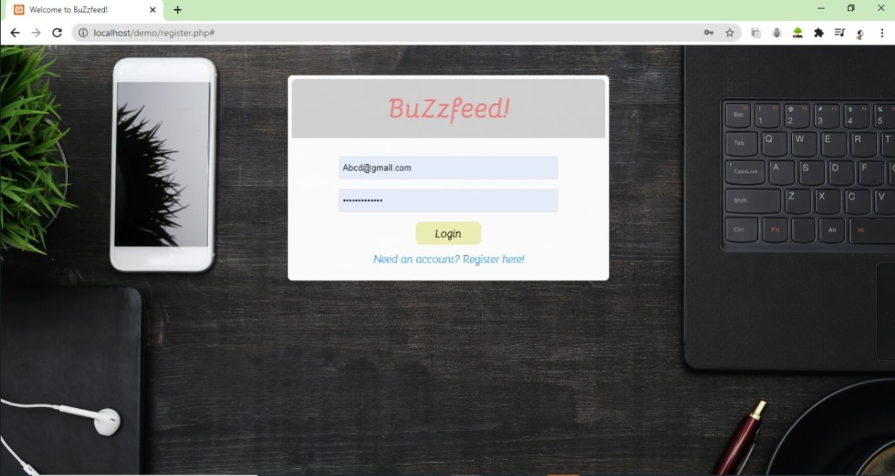

fig10 login page

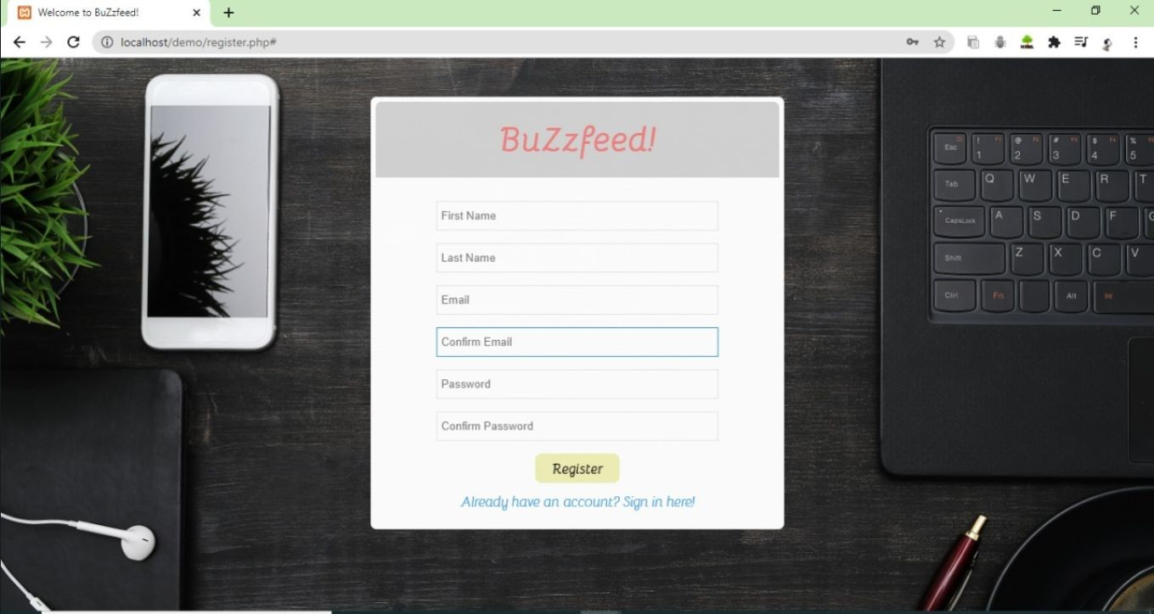

fig11. SignUp page

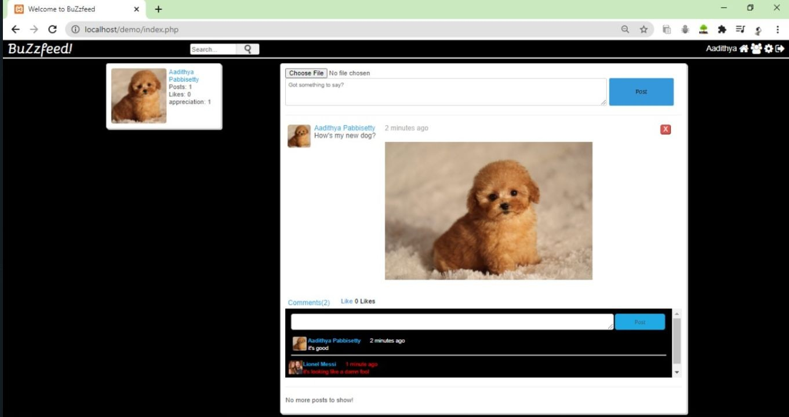

fig12. Posting an Image

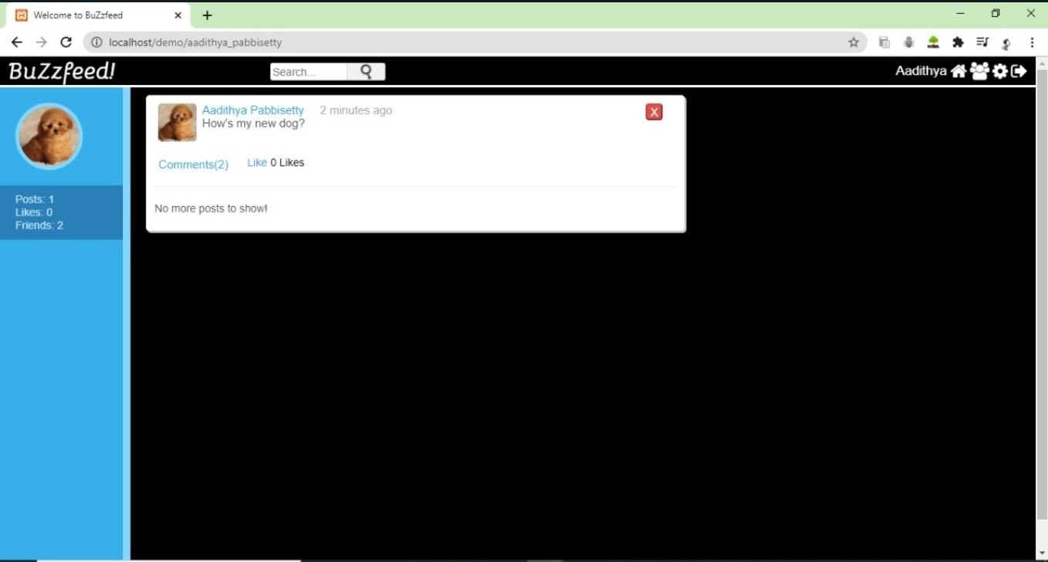

fig13. Timeline

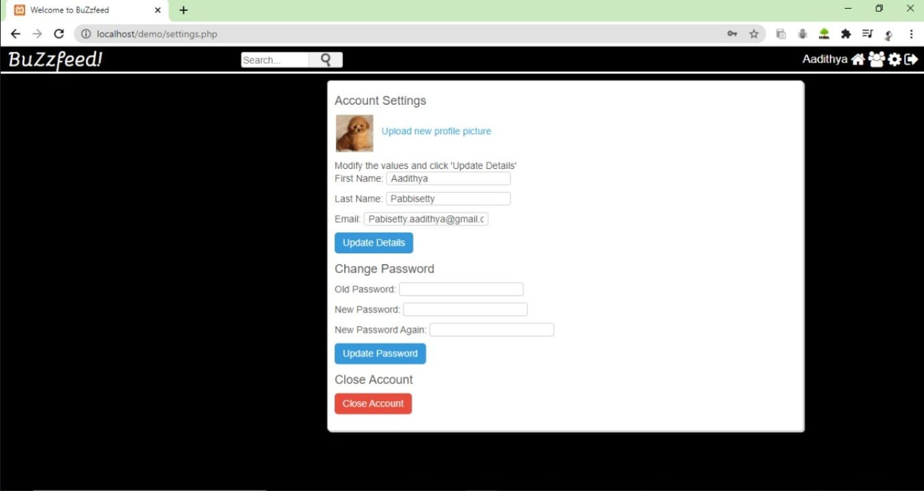

fig14 Changing the Password

## CONCLUSION AND FUTURE ENHANCEMENTS

We developed a system with conscious effort, making use of available tools, techniques and resources -that would generate a proper system for BUZZFEED.

The system has been developed keeping an eye on user-friendliness.So that system is acceptable to any user and adequately meets his/her needs. All the features have been tested properly and the results were positive.Thus system has fulfilled all the objectives identified and is able to replace the existing system.

Social media changed our life so much. Our life became more convenient because social media is a very useful tool for us in the 21st century, it could help us to improve our life. However, we have to be aware of how we use them. If we could use social media smartly, having social media will become a good change for us.As in case of any system development our project too has some shortcomings. As of now we haven’t implemented the messaging feature yet due to time constraint.This feature can be enhanced in future.

## 8.REFERENCES

Create a Social Networking Website course by Marvic Grima [https://www.youtube.com/watch?v=JrTQWgj5b0g&list=PLgZrwJPaR_XLaf_oERoj4gZCIAqzx8bf-&inde](https://www.youtube.com/watch?v=JrTQWgj5b0g&list=PLgZrwJPaR_XLaf_oERoj4gZCIAqzx8bf-&index=1) [x=1](https://www.youtube.com/watch?v=JrTQWgj5b0g&list=PLgZrwJPaR_XLaf_oERoj4gZCIAqzx8bf-&index=1)

PHP MySQL connection :

[PHP MySQL Connect to database (w3schools.com)](https://www.w3schools.com/php/php_mysql_connect.asp)

[PHP Tutorial (w3schools.com)](https://www.w3schools.com/php/default.asp)

[CSS Tutorial (w3schools.com)](https://www.w3schools.com/Css/)

[Coursera | Online Courses & Credentials From Top Educators. Join for Free | Coursera](https://www.coursera.org/account/accomplishments/verify/ERLQU5STSMKV)