Here’s a quick update on my progress:

Backend: The Django REST API has been implemented to process event data from the provided files.

Search Functionality: The API supports searching based on a query string, earliest time, and latest time, and returns the filename where the event was found along with the search time taken.

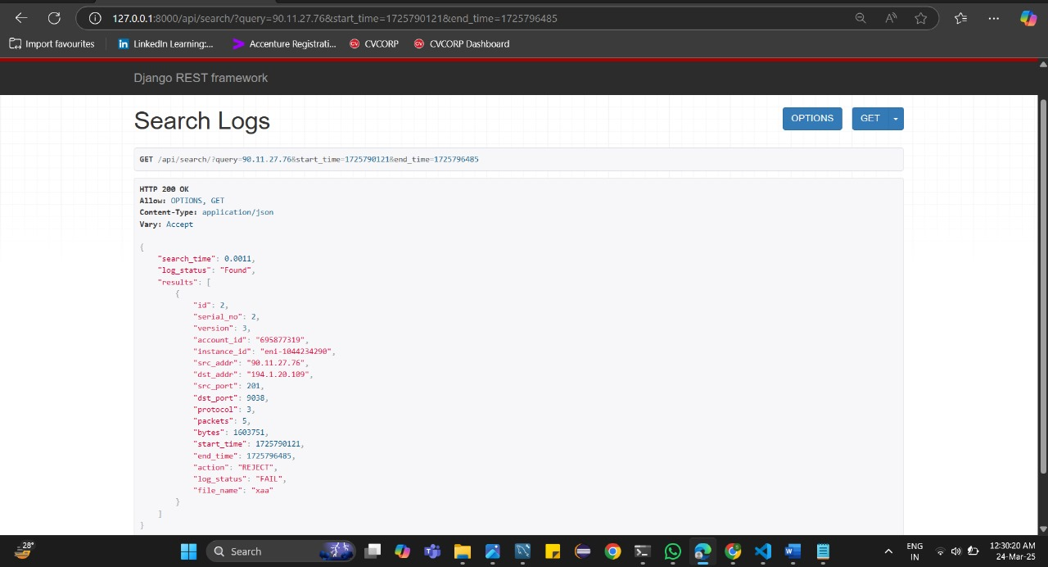

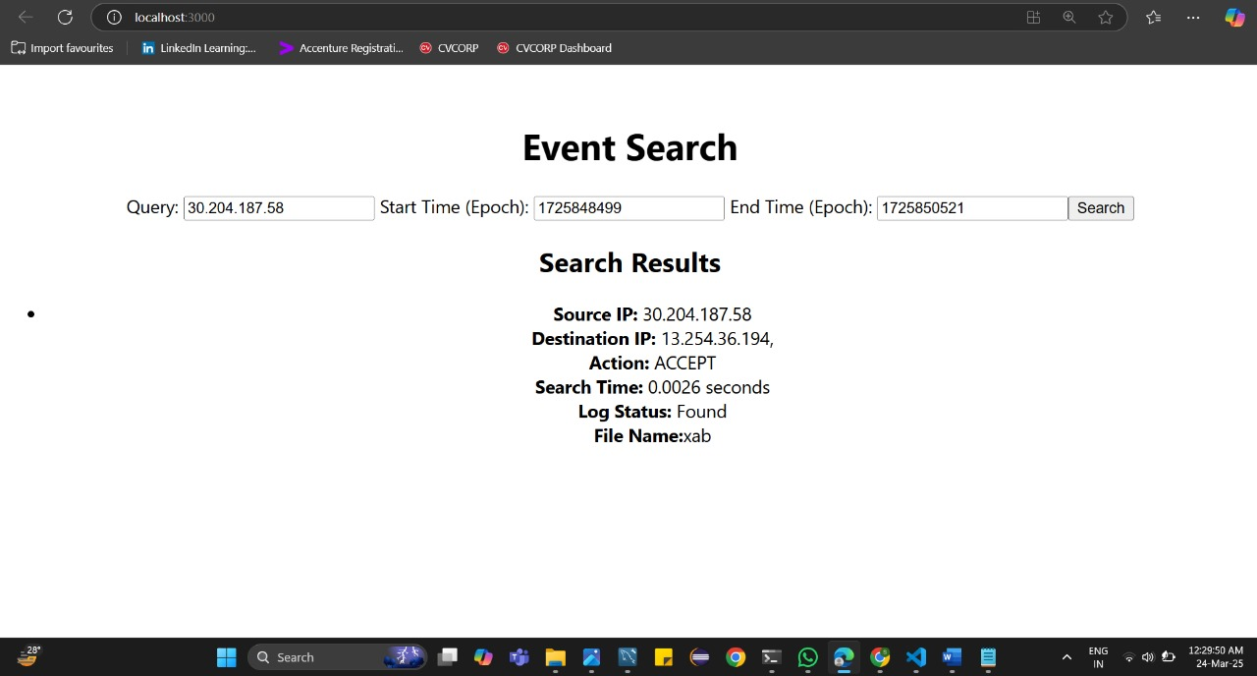

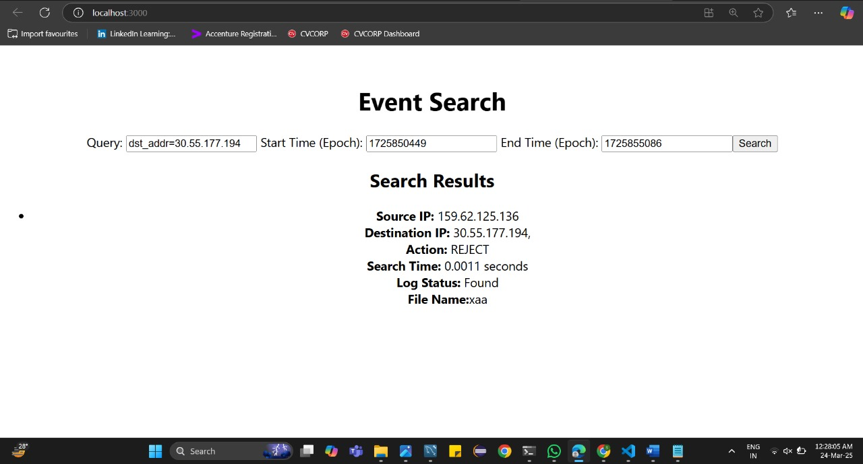

Performance: The backend has been tested and can handle at least 10 simultaneous API calls successfully.

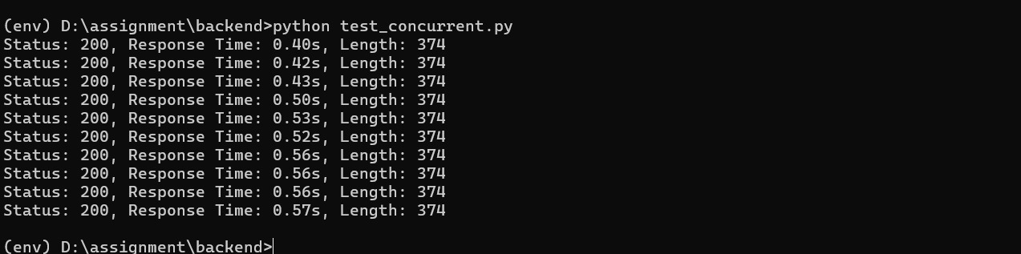

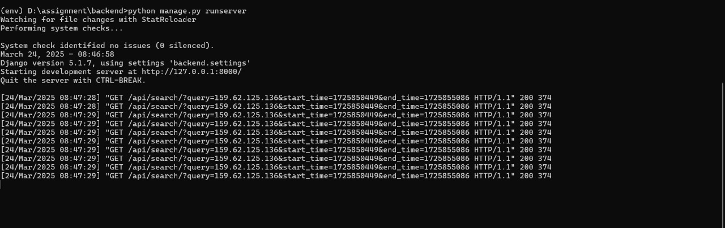

Frontend: The React.js UI development is completed, focusing on integrating the search functionality and displaying results as required.

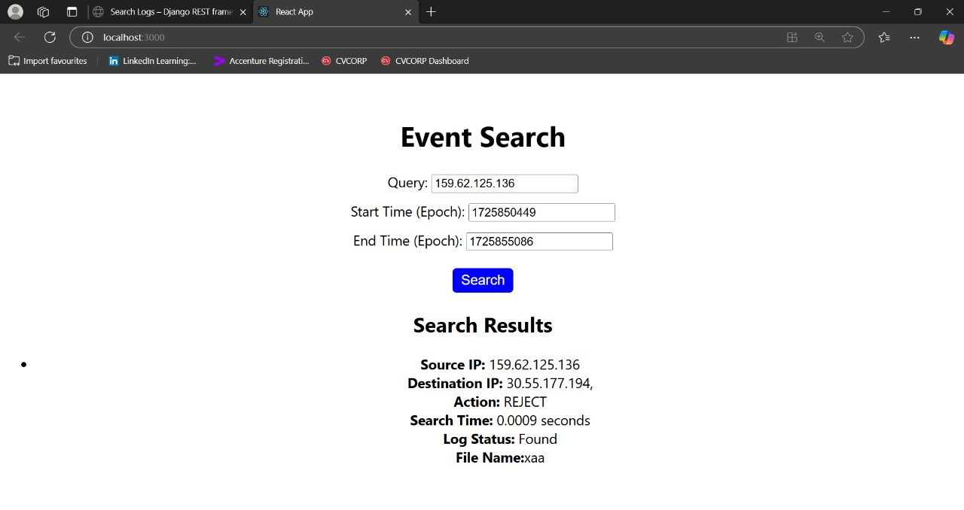

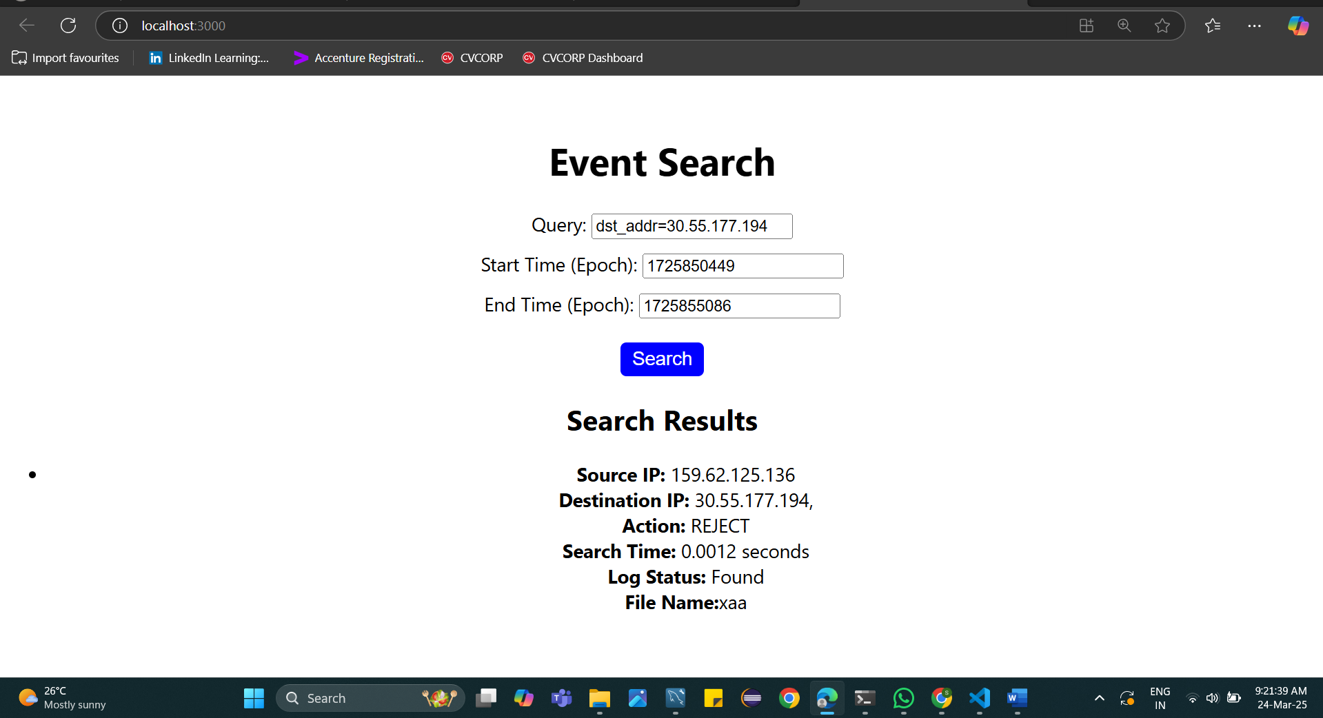

I have completed the assignment as per the given requirements. Please let me know if any further details or clarifications are needed.