# Overview

Thanks again for applying with us! We want to get to know you a little better and find out more about your background and experience. Please provide well-formed answers that provide real insight into your professional experience and approach to delivering working software. After we get a chance to read through your answers, we will contact you in two to three business days and set up your virtual interview with our team. Thanks again, and we’re looking forward to talking with you more soon!

# General Questions

1. What are the first things you do when reviewing someone else’s code?
2. How do you determine if the code is “good” or “bad”?
3. What are your guiding principles and practices for software development and team management? How did you learn them? How do you share them with your team?
4. Tell us about a challenging bug you had to troubleshoot and resolve in a production environment. How did you find it, reproduce it, resolve it, and deploy it?
5. Tell us about a time you had to effectively manage your time between team member needs, your own development commitments, and client relationships.
6. Tell us about a time you had to organize a team to meet an aggressive deadline. What steps did you take to ensure everyone could effectively meet the deadline?

# Code Review

For the following questions, please review the code sample below. Imagine a developer on the team submitted this code in a pull request:

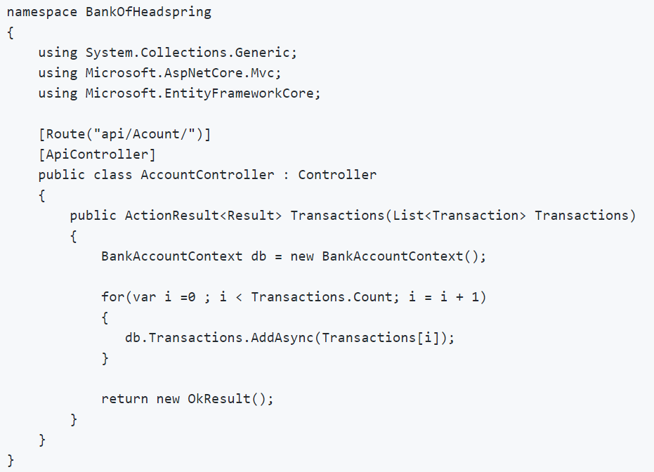

1. Please provide a comprehensive list of any issues you see with the code.
2. What feedback would you give to the developer and how would you message it to them?

# Coding Exercise

Tell us about your solution to the Coding Exercise.

1. What design tradeoffs did you make?
2. How did you decide what testing framework to use?
3. What parts of the requirements were ambiguous? What assumptions did you make when the requirements were not clear?
4. What errors did you run into and how did you resolve them?
5. Is there anything you’d especially like to highlight about your solution that you felt demonstrated your design and development skills particularly well?
6. What would you differently if you had to do this over again?