拓扑页面

参考下图显示，显示交换机、主机和链路，这些主机以及交换的下面的名称就放名称+其编号就可，鼠标放到交换机、主机以及链路上的时候，会显示其信息，信息就是传上来的信息，例如交换机，传上数据为

{"switchId":"00:00:00:00:00:00:00:04","ip":"/192.168.50.246:47214","openFlowVersion":"OF_13","connectedSince":1545038042595}，那就显示这些

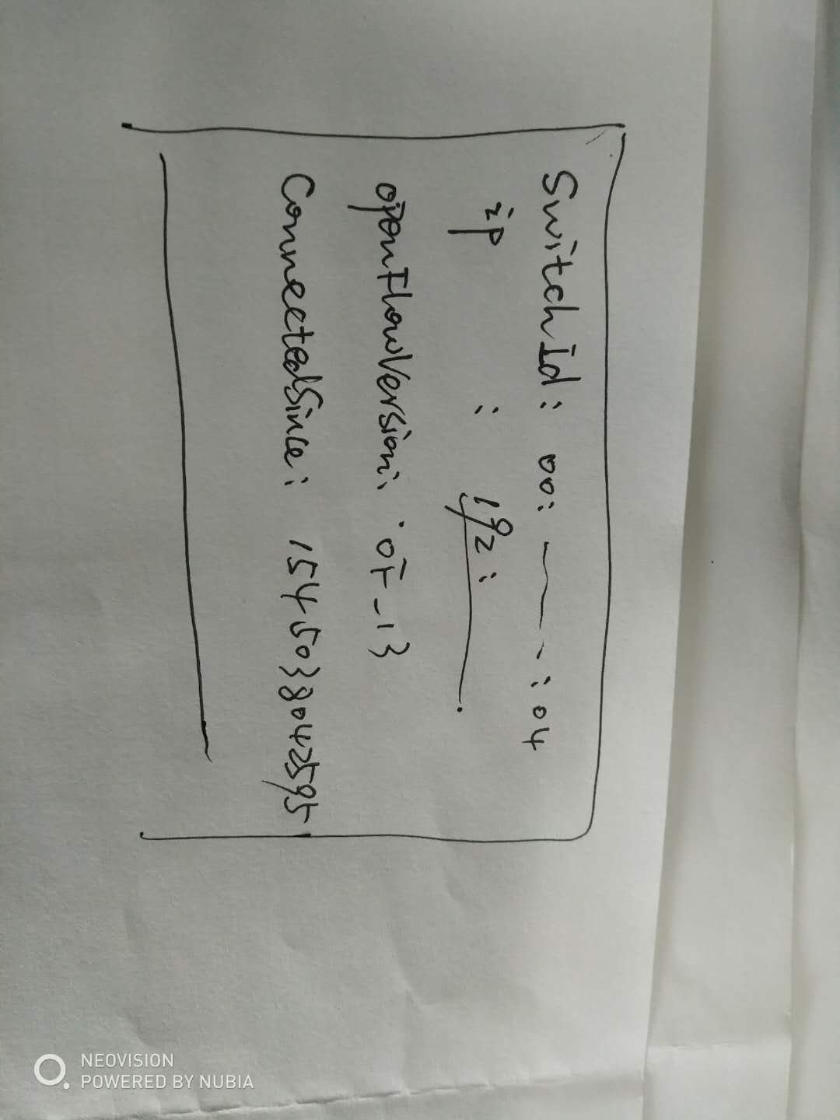

下图为编号样例图

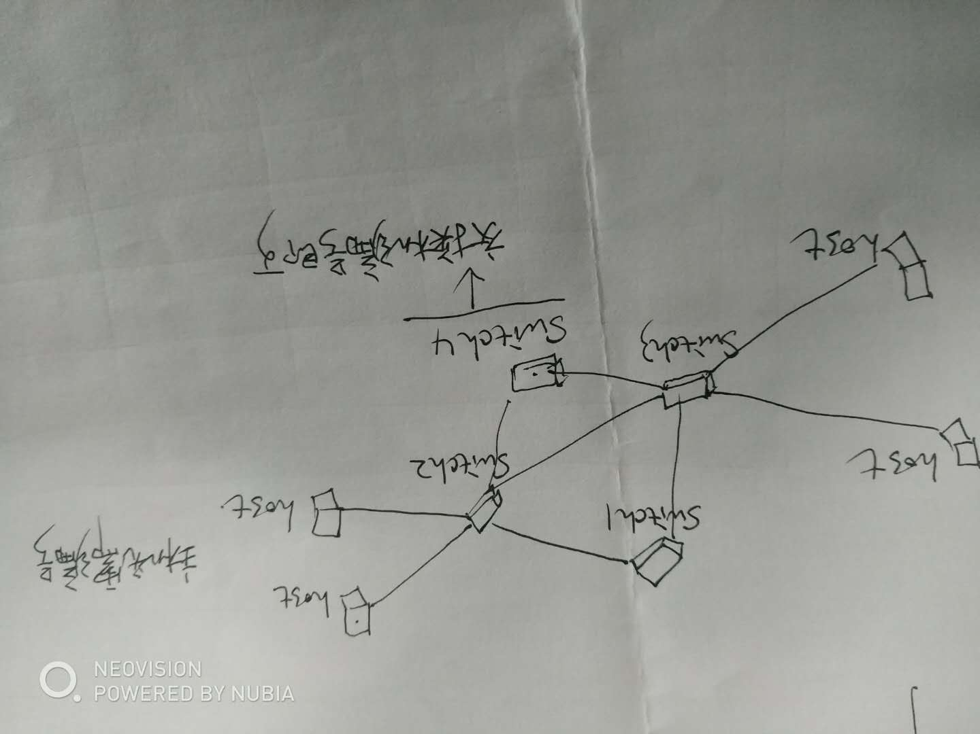

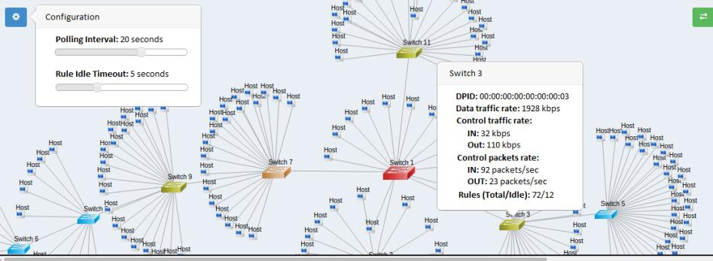

数据信息：

主机信息 url为<http://localhost:8080/semSDN/host>

返回信息：这个信息包含连接到了哪个交换机的哪个端口上，以及ip,mac

[{"ip":"10.0.0.6","mac":"e2:eb:15:1a:f3:71","sId":"00:00:00:00:00:00:00:03","spid":6,"lastSeen":1545038436002},{"ip":"10.0.0.5","mac":"2e:5d:1b:13:05:85","sId":"00:00:00:00:00:00:00:03","spid":5,"lastSeen":1545038436003},{"ip":"10.0.0.4","mac":"c2:0f:e4:2c:71:4e","sId":"00:00:00:00:00:00:00:03","spid":4,"lastSeen":1545038436088},{"ip":"10.0.0.3","mac":"26:e8:64:cd:5c:09","sId":"00:00:00:00:00:00:00:01","spid":6,"lastSeen":1545038435951},{"ip":"10.0.0.2","mac":"d2:f1:a4:28:ee:22","sId":"00:00:00:00:00:00:00:01","spid":5,"lastSeen":1545038435949},{"ip":"10.0.0.1","mac":"16:0f:09:bf:16:1a","sId":"00:00:00:00:00:00:00:01","spid":4,"lastSeen":1545038435950}]

交换机信息 url为：http://localhost:8080/semSDN/switches

返回信息：这个包含交换机信息

[{"switchId":"00:00:00:00:00:00:00:04","ip":"/192.168.50.246:47214","openFlowVersion":"OF_13","connectedSince":1545038042595},{"switchId":"00:00:00:00:00:00:00:03","ip":"/192.168.50.246:47227","openFlowVersion":"OF_13","connectedSince":1545038217960},{"switchId":"00:00:00:00:00:00:00:02","ip":"/192.168.50.246:47216","openFlowVersion":"OF_13","connectedSince":1545038042595},{"switchId":"00:00:00:00:00:00:00:01","ip":"/192.168.50.246:47217","openFlowVersion":"OF_13","connectedSince":1545038042595}]

链路信息 url : http://localhost:8080/semSDN/links

返回信息：这个是交换机之间的链路信息

[{"src_sid":"00:00:00:00:00:00:00:03","src_pid":3,"dst_sid":"00:00:00:00:00:00:00:04","dst_pid":2,"type":"internal","direction":"bidirectional","latency":324},{"src_sid":"00:00:00:00:00:00:00:01","src_pid":2,"dst_sid":"00:00:00:00:00:00:00:04","dst_pid":1,"type":"internal","direction":"bidirectional","latency":142},{"src_sid":"00:00:00:00:00:00:00:01","src_pid":1,"dst_sid":"00:00:00:00:00:00:00:02","dst_pid":1,"type":"internal","direction":"bidirectional","latency":89},{"src_sid":"00:00:00:00:00:00:00:02","src_pid":2,"dst_sid":"00:00:00:00:00:00:00:03","dst_pid":1,"type":"internal","direction":"bidirectional","latency":194},{"src_sid":"00:00:00:00:00:00:00:01","src_pid":3,"dst_sid":"00:00:00:00:00:00:00:03","dst_pid":2,"type":"internal","direction":"bidirectional","latency":337}]

主机、交换机、链路三个页面

下面的表格，标题处加个底色蓝色，可以参考这个样式

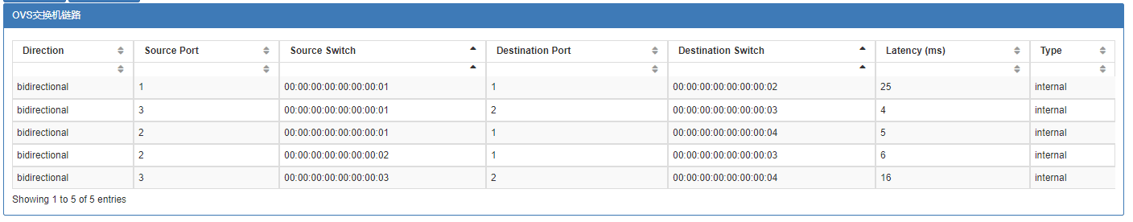

交换机页面是显示一个表格，表格的上方是标题**已连接的交换机，**下方是每一列的显示内容

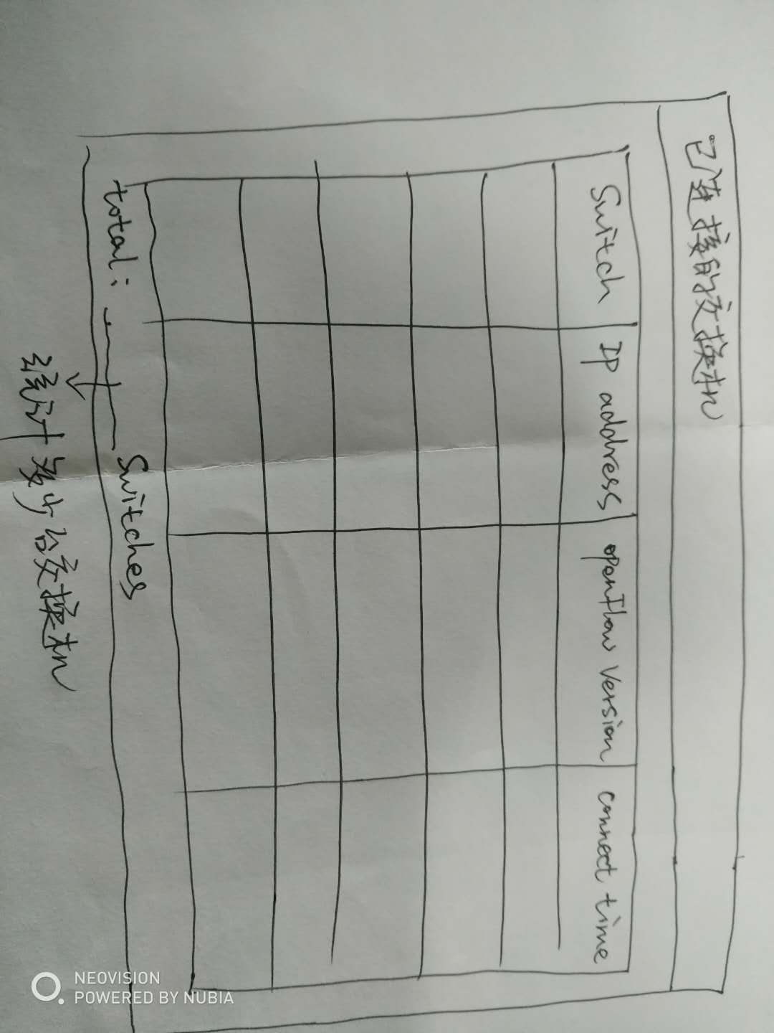

交换机信息 url为：http://localhost:8080/semSDN/switches

返回信息：这个包含交换机信息

[{"switchId":"00:00:00:00:00:00:00:04","ip":"/192.168.50.246:47214","openFlowVersion":"OF_13","connectedSince":1545038042595},{"switchId":"00:00:00:00:00:00:00:03","ip":"/192.168.50.246:47227","openFlowVersion":"OF_13","connectedSince":1545038217960},{"switchId":"00:00:00:00:00:00:00:02","ip":"/192.168.50.246:47216","openFlowVersion":"OF_13","connectedSince":1545038042595},{"switchId":"00:00:00:00:00:00:00:01","ip":"/192.168.50.246:47217","openFlowVersion":"OF_13","connectedSince":1545038042595}]

主机页面，显示一个表格，表格上方是**连接的主机，**下面是每一栏的显示内容，列名如图

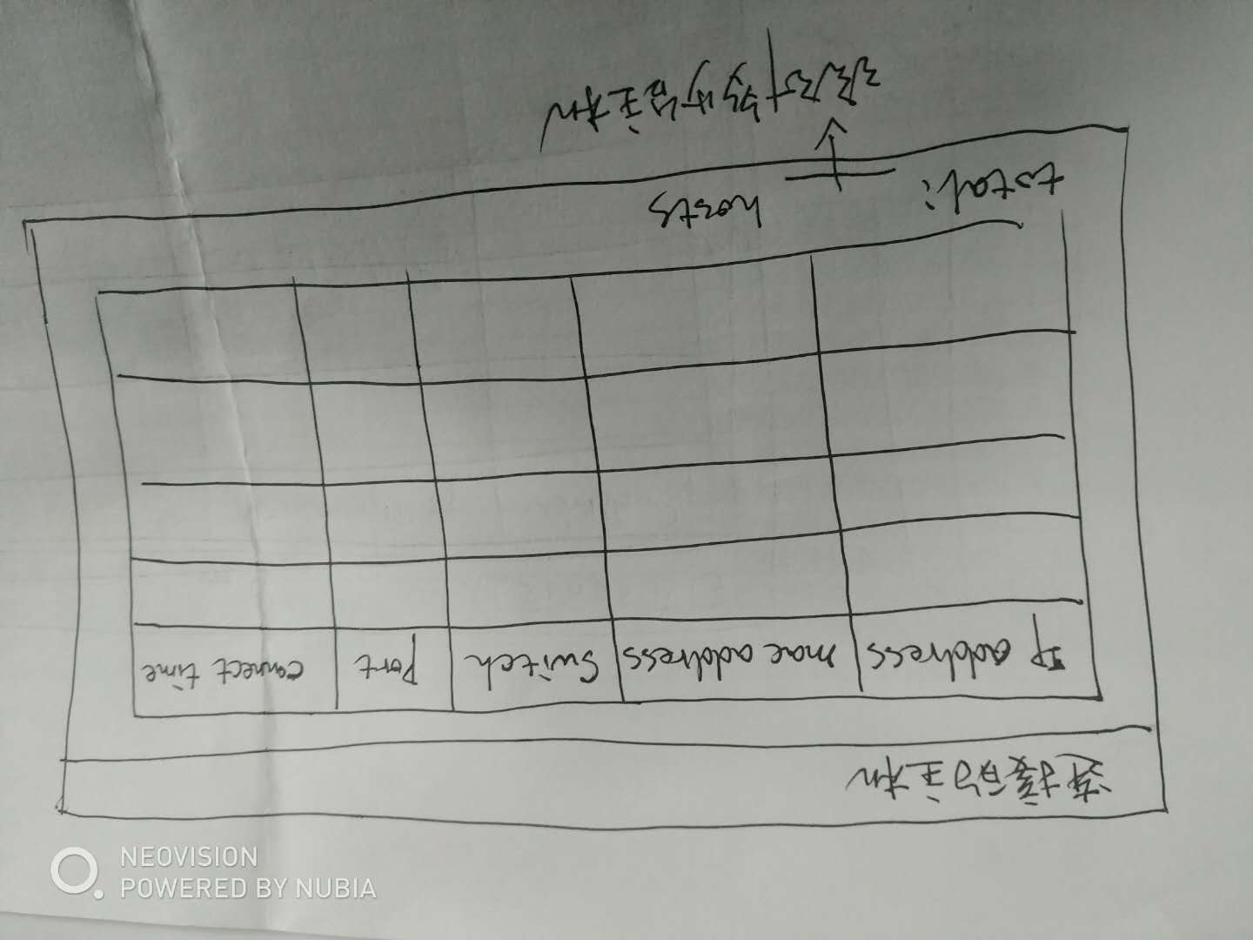

主机信息 url为<http://localhost:8080/semSDN/host>

返回信息：

[{"ip":"10.0.0.6","mac":"e2:eb:15:1a:f3:71","sId":"00:00:00:00:00:00:00:03","spid":6,"lastSeen":1545038436002},{"ip":"10.0.0.5","mac":"2e:5d:1b:13:05:85","sId":"00:00:00:00:00:00:00:03","spid":5,"lastSeen":1545038436003},{"ip":"10.0.0.4","mac":"c2:0f:e4:2c:71:4e","sId":"00:00:00:00:00:00:00:03","spid":4,"lastSeen":1545038436088},{"ip":"10.0.0.3","mac":"26:e8:64:cd:5c:09","sId":"00:00:00:00:00:00:00:01","spid":6,"lastSeen":1545038435951},{"ip":"10.0.0.2","mac":"d2:f1:a4:28:ee:22","sId":"00:00:00:00:00:00:00:01","spid":5,"lastSeen":1545038435949},{"ip":"10.0.0.1","mac":"16:0f:09:bf:16:1a","sId":"00:00:00:00:00:00:00:01","spid":4,"lastSeen":1545038435950}]

点击链路，显示如下左上方写**交换机链路，**列如图，然后显示每一行的数据就行了，数据格式在后面附图了

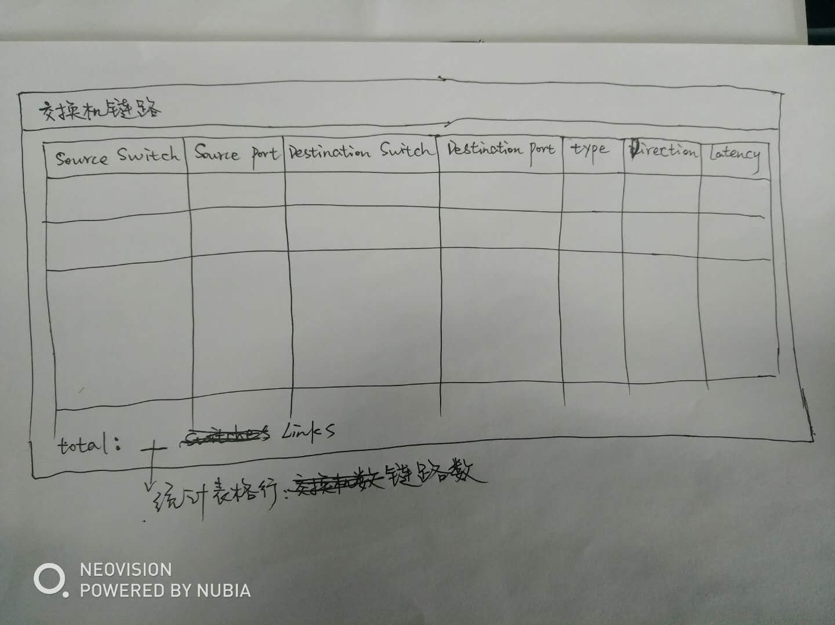

链路信息 url : http://localhost:8080/semSDN/links

返回信息：这个是交换机之间的链路信息

[{"src_sid":"00:00:00:00:00:00:00:03","src_pid":3,"dst_sid":"00:00:00:00:00:00:00:04","dst_pid":2,"type":"internal","direction":"bidirectional","latency":324},{"src_sid":"00:00:00:00:00:00:00:01","src_pid":2,"dst_sid":"00:00:00:00:00:00:00:04","dst_pid":1,"type":"internal","direction":"bidirectional","latency":142},{"src_sid":"00:00:00:00:00:00:00:01","src_pid":1,"dst_sid":"00:00:00:00:00:00:00:02","dst_pid":1,"type":"internal","direction":"bidirectional","latency":89},{"src_sid":"00:00:00:00:00:00:00:02","src_pid":2,"dst_sid":"00:00:00:00:00:00:00:03","dst_pid":1,"type":"internal","direction":"bidirectional","latency":194},{"src_sid":"00:00:00:00:00:00:00:01","src_pid":3,"dst_sid":"00:00:00:00:00:00:00:03","dst_pid":2,"type":"internal","direction":"bidirectional","latency":337}]