端口性能页面的详细情况：参考如下

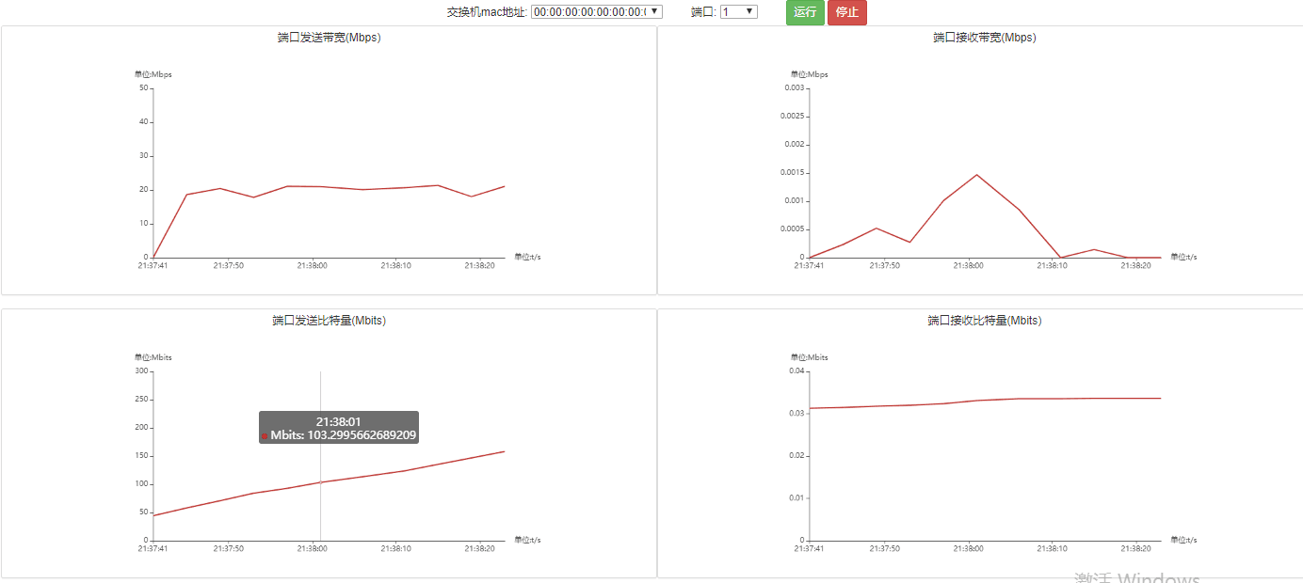

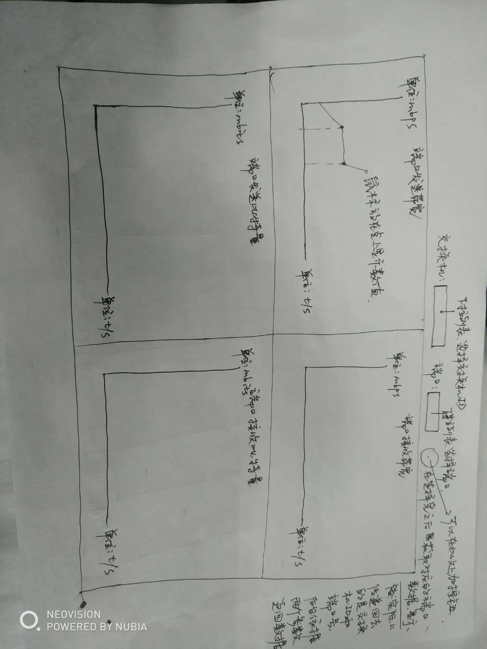

对页面上方选择交换机以及端口的信息

url: http://localhost:8080/semSDN/switch/portlist

返回json字符串：

[{"swid":"00:00:00:00:00:00:00:04","spid":[2,1]},{"swid":"00:00:00:00:00:00:00:02","spid":[2,1]},{"swid":"00:00:00:00:00:00:00:03","spid":[3,2,1]},{"swid":"00:00:00:00:00:00:00:01","spid":[3,2,1]}]

swid：交换机id

spid：对应的一台交换机的端口列表

上述信息用作页面上方选择交换机和端口用，

在选择了交换机和端口以后，返回性能信息：

url: http://localhost:8080/semSDN/portPerformance/{选择的交换机ID}/{选择的交换机的端口}

返回的json数据：

{"bitsPerSecondRx":0.0,"rxBytes":39.53751468658447,"txBytes":39.19035625457764,"time":"2019-01-03 20:33:40","bitsPerSecondTx":0.0}

Time:时间

bitsPerSecondRx：端口接收带宽

bitsPerSecondTx：端口发送带宽

rxBytes：端口接收比特量

txBytes：端口发送比特量

分别对应的是四幅折线图

链路性能页面，这个和上个图除了显示不同，基本布局是一样的

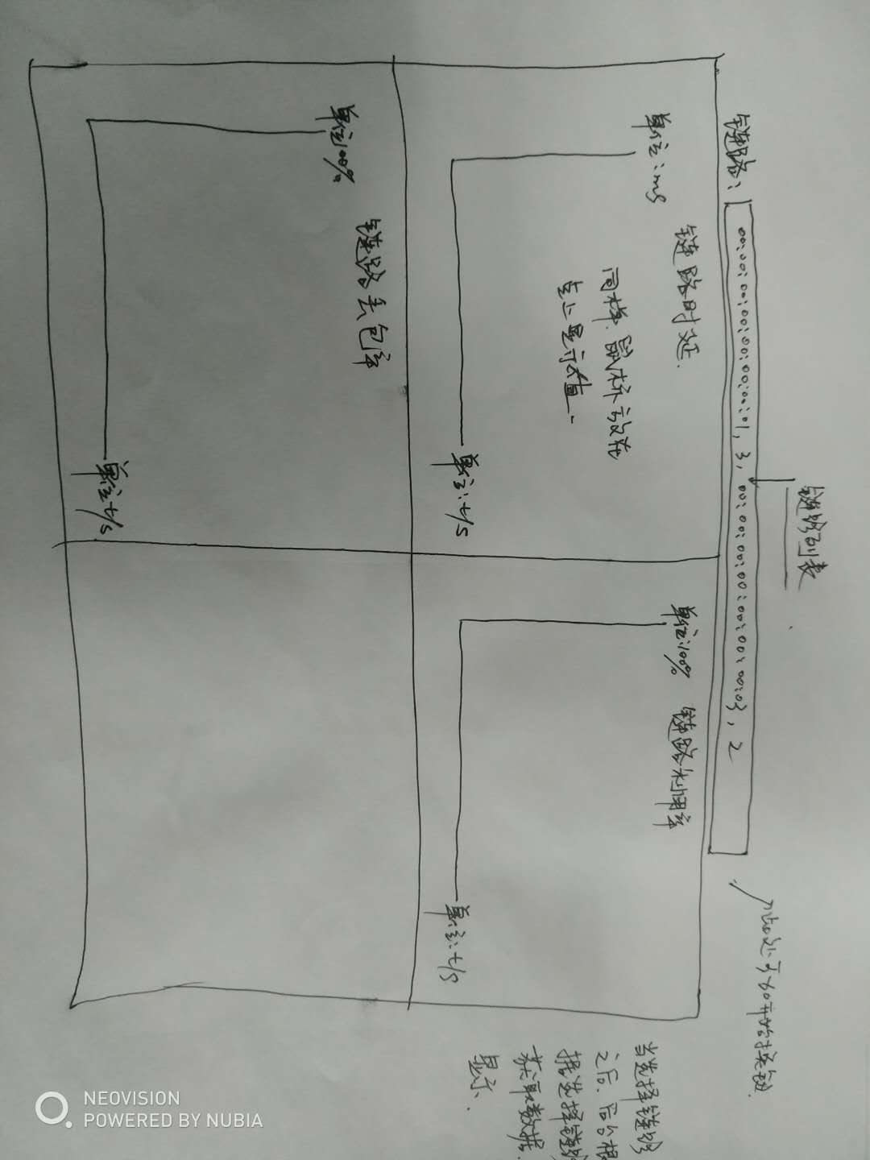

对页面上方的链路列表，

url: <http://127.0.0.1:8080/semSDN/linkList>

返回数据，将其显示列表可选择，点击下拉为一条一条的链路，00:00:00:00:00:00:00:03,3,00:00:00:00:00:00:00:04,2，显示就以这样字符串的形式显示

源交换机id，源端口，目的交换机，目的端口

["00:00:00:00:00:00:00:03,3,00:00:00:00:00:00:00:04,2","00:00:00:00:00:00:00:01,2,00:00:00:00:00:00:00:04,1","00:00:00:00:00:00:00:01,1,00:00:00:00:00:00:00:02,1","00:00:00:00:00:00:00:02,2,00:00:00:00:00:00:00:03,1","00:00:00:00:00:00:00:01,3,00:00:00:00:00:00:00:03,2"]

对于折线图的数据

url: http://127.0.0.1:8080/semSDN/linkPerformance/{选择的链路字符串}

数据的样式

{"latency":63.0,"dropRate":0.0,"time":"2019-01-03 20:33:37","bandwidthUtil":0.0}

Latency：时延

dropRate：丢包率

time：时间

bandwidthUtil：带宽利用率

三个曲线图分别对应Latency、dropRate、bandwidthUtil