点击网络拓扑的页面：后台传递链路信息、交换机信息、主机信息，显示拓扑，如下效果

需要把图中的节点换成交换机和主机的图标即可，至于图标下的字就显示switch1,switch2,switch3，Host1,host2标号就行了，当鼠标放到链路上或者交换机上，显示一些信息，

以下是详细信息：

主机信息 url为<http://localhost:8080/semSDN/host>

返回信息：这个信息包含连接到了哪个交换机的哪个端口上，以及ip,mac

[{"ip":"10.0.0.6","mac":"e2:eb:15:1a:f3:71","sId":"00:00:00:00:00:00:00:03","spid":6,"lastSeen":1545038436002},{"ip":"10.0.0.5","mac":"2e:5d:1b:13:05:85","sId":"00:00:00:00:00:00:00:03","spid":5,"lastSeen":1545038436003},{"ip":"10.0.0.4","mac":"c2:0f:e4:2c:71:4e","sId":"00:00:00:00:00:00:00:03","spid":4,"lastSeen":1545038436088},{"ip":"10.0.0.3","mac":"26:e8:64:cd:5c:09","sId":"00:00:00:00:00:00:00:01","spid":6,"lastSeen":1545038435951},{"ip":"10.0.0.2","mac":"d2:f1:a4:28:ee:22","sId":"00:00:00:00:00:00:00:01","spid":5,"lastSeen":1545038435949},{"ip":"10.0.0.1","mac":"16:0f:09:bf:16:1a","sId":"00:00:00:00:00:00:00:01","spid":4,"lastSeen":1545038435950}]

交换机信息 url为：http://localhost:8080/semSDN/switches

返回信息：这个包含交换机信息

[{"switchId":"00:00:00:00:00:00:00:04","ip":"/192.168.50.246:47214","openFlowVersion":"OF_13","connectedSince":1545038042595},{"switchId":"00:00:00:00:00:00:00:03","ip":"/192.168.50.246:47227","openFlowVersion":"OF_13","connectedSince":1545038217960},{"switchId":"00:00:00:00:00:00:00:02","ip":"/192.168.50.246:47216","openFlowVersion":"OF_13","connectedSince":1545038042595},{"switchId":"00:00:00:00:00:00:00:01","ip":"/192.168.50.246:47217","openFlowVersion":"OF_13","connectedSince":1545038042595}]

链路信息 url : http://localhost:8080/semSDN/links

返回信息：这个是交换机之间的链路信息

[{"src_sid":"00:00:00:00:00:00:00:03","src_pid":3,"dst_sid":"00:00:00:00:00:00:00:04","dst_pid":2,"type":"internal","direction":"bidirectional","latency":324},{"src_sid":"00:00:00:00:00:00:00:01","src_pid":2,"dst_sid":"00:00:00:00:00:00:00:04","dst_pid":1,"type":"internal","direction":"bidirectional","latency":142},{"src_sid":"00:00:00:00:00:00:00:01","src_pid":1,"dst_sid":"00:00:00:00:00:00:00:02","dst_pid":1,"type":"internal","direction":"bidirectional","latency":89},{"src_sid":"00:00:00:00:00:00:00:02","src_pid":2,"dst_sid":"00:00:00:00:00:00:00:03","dst_pid":1,"type":"internal","direction":"bidirectional","latency":194},{"src_sid":"00:00:00:00:00:00:00:01","src_pid":3,"dst_sid":"00:00:00:00:00:00:00:03","dst_pid":2,"type":"internal","direction":"bidirectional","latency":337}]

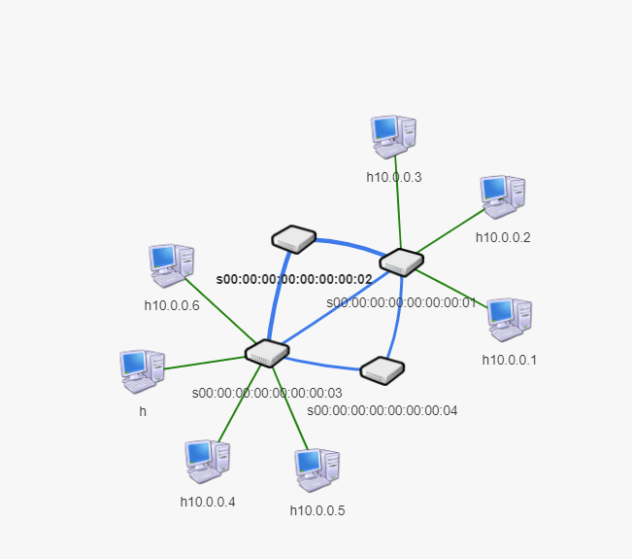

上面的数据显示完后，是这样的一个拓扑图

拓扑的显示效果可以参考以下两幅图

