<Project Title e.g., Fire Fighting Robots>
Project Report
Team Function Munchkins
Deliverable 1 team members: <Names of those who participated, e.g., Nicole Ang-Wanek, Michael Machas, Anoop Grewal>
Deliverable 2 team members: <Names of those who participated, e.g., Nicole Ang-Wanek, Michael Machas, Anoop Grewal>
Deliverable 3 team members: <Names of those who participated, e.g., Nicole Ang-Wanek, Michael Machas, Anoop Grewal>
Deliverable 4 team members: <Names of those who participated, e.g., Nicole Ang-Wanek, Michael Machas, Anoop Grewal>
Deliverable 5 team members: <Names of those who participated, e.g., Nicole Ang-Wanek, Michael Machas, Anoop Grewal>
<Now start a new page>

1. Introduction
< In this paragraph, introduce the application area where your intended collection of robots can be deployed. Also mention the current issues faced in that area as per your research. Relevant sources should be provided in the References section but cited here by their number. >
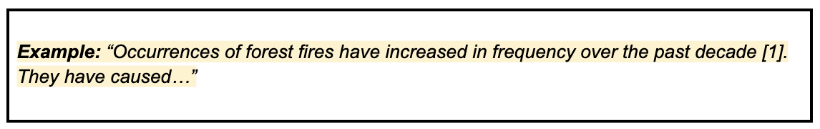
< In this paragraph, mention in a sentence, that you are proposing a robotic solution for the above issues. Then provide a list of customers (i.e., the end-users and the payers) who will use your system. Provide their relevant background / demographic information that is relevant to the project (e.g., age group, location, job category, etc. as relevant to the project). Also provide a list other stakeholders who are not the end-users or payers, but are impacted by or will impact your design (e.g. investors, government policy makers, public, etc.)>
< In this paragraph, as per your research, mention how the customers are handling/solving the issues currently. Mention 2-3 current products/solutions available. Explain how they function/work. Relevant sources should be provided in the References section but cited here by their number. >
< In this paragraph, as per your research, mention what is lacking in the current solutions. Mention that your robotic system hopes to handle some (if not all) of these inadequacies and add value. Relevant sources should be provided in the References section but cited here. >

2. Formal Problem Definition

2.1 Problem Statement
< In this section, include a 1-2 sentence problem statement that explains the goal for the design project. >
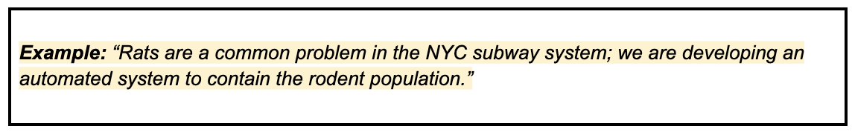

2.2 Robot Types
< In this section, include the list of the robots you are thinking about. Provide each robot's name and its function/description in a sentence or two. Your robotic system should have (at least) as many robots as there are team members in your group (ideally, you should have more robots in mind than your number of teammates to serve as backups). These robots will work together to complete the overall task. Focus on WHAT the robots will do, not HOW. >
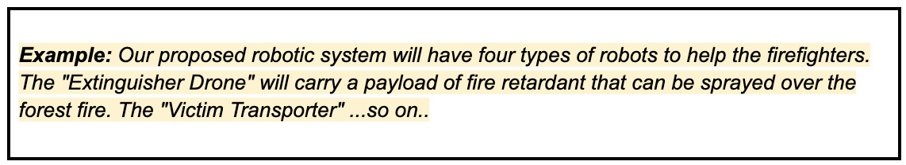

2.3 Design Requirements
< In this section, write a numbered list of at least 6 design requirements of your robotic system based on customer research and needs (with citations at the end, if needed). Be quantitative (i.e. use numbers to be specific where possible). >
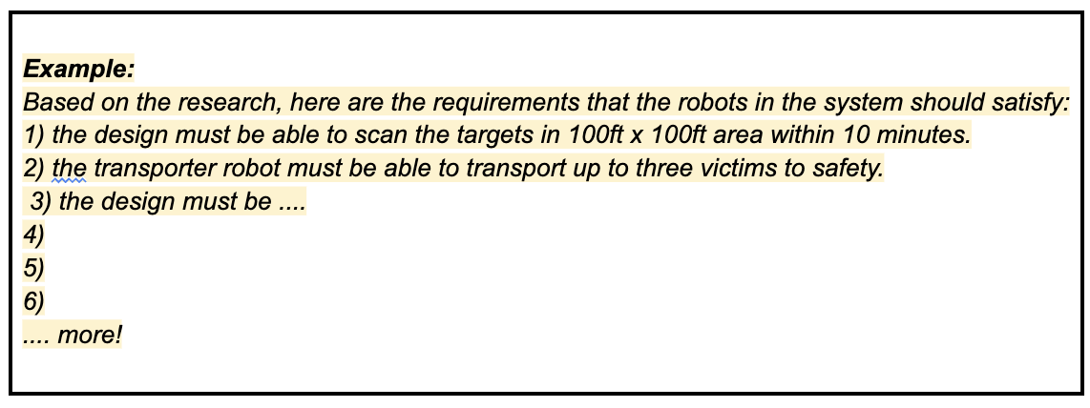
< Note - The requirements in the list may be organized into separate categories (e.g., for each individual robot, for collective activity, etc.), if you feel it is appropriate. Requirements should be relevant to the customers, don't include the ones artificially imposed though course project description (e.g., "The design shall have at least X sensors/actuators" or "design shall have four robots" are not customer-based requirements). >

2.4 Project Schedule
< In this paragraph, briefly mention what are the important tasks and milestones for this project (milestones are the deliverables and the tasks that must be accomplished by your team to reach those milestones). Then add a line to refer to the Appendix where your Gantt chart is included. >
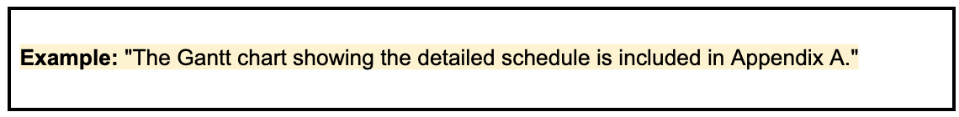

3. Individual Ideation
< In this section, each team member presents one (1) idea for each of the proposed robots in section 2.2. >
3.1 Robot Ideas by <Insert Team first member's name>
< In this subsection, the first team member provides one idea for each of the robots described in section 2.2, as separate paragraphs.>
< Please include a rough sketch for the first robot from section 2.2. A hand-drawn sketch is fine, CAD is not necessary. Please label various parts in the sketch for understandability. Include a few sentences describing the first robot's components (sensors and actuators) and unique features relevant to the requirements in the section 2.3. Here, focus on HOW your robots will accomplish their task - you have previously determined WHAT the robots will accomplish. >
< Repeat similar paragraphs and sketches for second, third, and fourth robots from section 2.2. Thus, if your team has 4 team members (and 4 robots), your INDIVIDUAL section will have 4 paragraphs and 4 sketches. Your team would have 16 paragraphs and 16 sketches in total. >
3.2 Robot Ideas by < Insert Team second member's name >
< Provide similar content as 3.1 by the second team member. >

3.3 Robot Ideas by < Insert Team third member's name >
< Provide similar content as 3.1 by the third team member. >

3.4 Robot Ideas by < Insert Team fourth member's name, if any >
< Provide similar content as 3.1 by the fourth team member (if any). >

4. Robot Selection
< In this section, the team will collectively make decision matrices to rate the different designs for each robot from section 3. >
4.1 Decision Matrix for < Insert 1st Robot's Name >
The criteria to judge this robot and their corresponding weights were selected by the team based on the requirements in section 2.3. The ratings were collectively decided by the team informed by research. All this information is shown as the decision matrix in Table <number> below.
Table <number>. Decision Matrix to rate various designs of <Insert 1st Robot's Name>.
Criteria | Weights | <1st Team Member>'s design |  | <2nd Team Member>'s design |  | <3rd Team Member>'s design |  | <4th Team Member (if any)>'s design
 |  | Rating | Score | Rating | Score | Rating | Score | Rating | Score
<Crit1>
<Crit2>
<Crit3>
<Crit4>
Total
<Fill the unshaded cells with Team selected numbers>
<You can include more criteria if needed but at least 3 are required. The criteria for each robot can be different.>
<If you want, you can include an AHP table to decide criteria weights in the second column of the decision matrix.>
4.2 Decision Matrix for < Insert 2nd Robot's Name >
< Provide similar content to 4.1 for the second robot. >
4.3 Decision Matrix for < Insert 3rd Robot's Name >
< Provide similar content to 4.1 for the third robot. >
4.4 Decision Matrix for < Insert 4th Robot's Name, if any >
< Provide similar content to 4.1 for the fourth robot, if any. >

5. Proposed Designs
Based on the scores in section 4, the team decided to proceed with the following designs for each of the robots. Each robot was assigned to a specific team member as can be seen in the sub-sections below.
5.1 < Insert 1st Robot's Name > by < Insert Team Member's name handling this robot >
5.1.1 Description
< In this paragraph (or paragraphs), provide a description of your final proposed design for the individual robot. This may be the best among the designs from the decision matrix in the previous section or a combination of those designs, pulling their strengths. Very clearly mention all the sensors and all the actuators you will use in your robot. Make sure the sensors are either available in TinkerCAD (or to purchase) or can be proxied by similar available sensors. Describe how various parts of your robot (sensors, actuators, etc.) are connected and function together. Mention the key features and functionalities of your robot. When describing your robot, you can refer to the figure(s) you include below. >
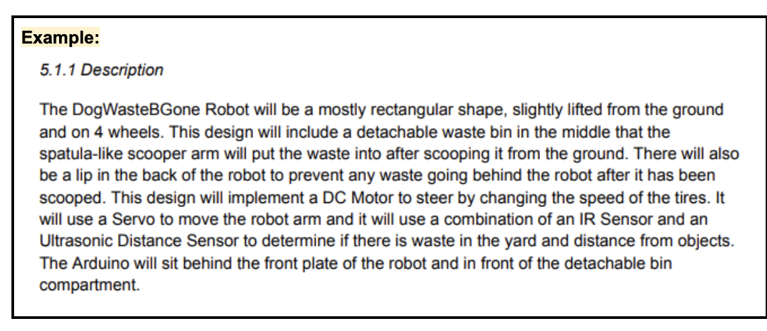
< Provide a snapshot of the CAD model of the robot and include the snapshot here as a figure. Make sure to include some dimensions and labels. You can include a key instead of labels, if desired. Most of your CAD design may simply be a combination of boxes and cylinders with slots/holes in them. For example, a motor can just be a cylinder with a shaft (another smaller cylinder) coming from it, an Arduino can just be a box (give it a different color though). Show all important components needed (e.g. shafts and bearings, pulleys, wheels, gearbox, sensors, actuators, etc). You don't need to show any electrical wires, or pulley cables. There should be enough detail in your design but don't go way overboard. You hopefully will only need 10-30 parts in your model. It should be at the right zoom level and viewpoint to see clearly. Feel free to include multiple snapshots from different viewpoints, (e.g., you can make a component invisible to show what's inside/below it). If you are doing a physical build, you do not need to create a CAD model! You can just include labeled screenshots of your physical robot >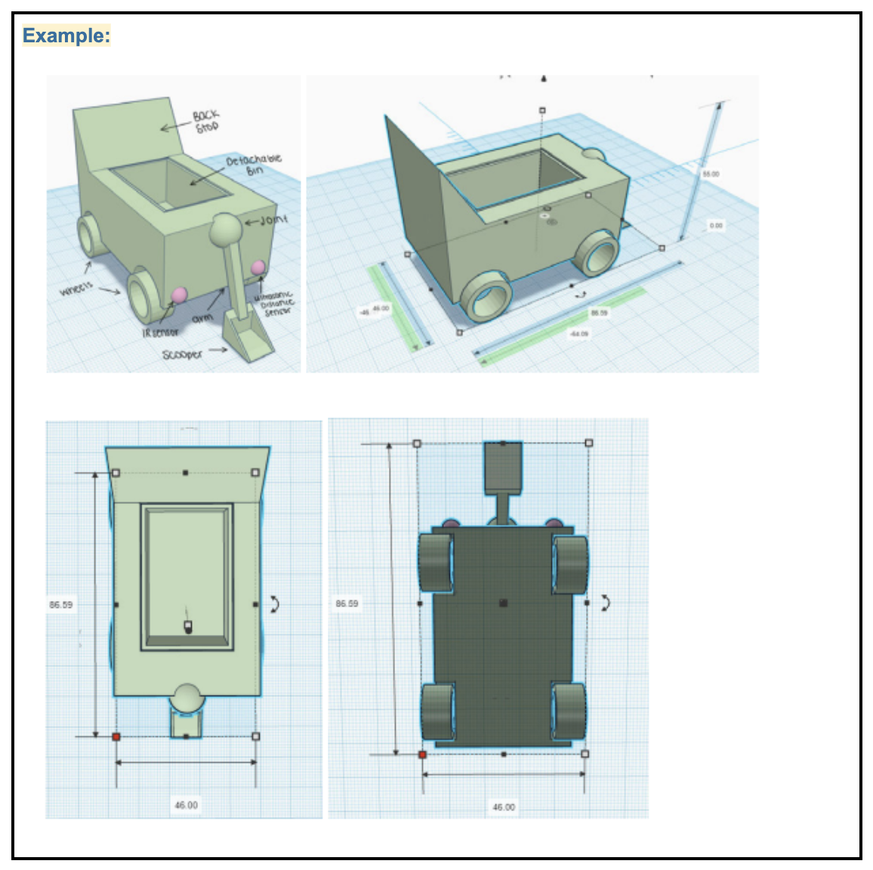
5.1.2 Algorithm
< In this paragraph, referring to the flowchart figure below by its number, briefly explain the algorithm of your robot. Mention all actions/processes that this robot will do based on all combinations of sensor inputs and the commands received from the operator/other robots. Mention what information will be sent to other robots and when. You are welcome to present various parts of this algorithm, as a bulleted list for readability. >
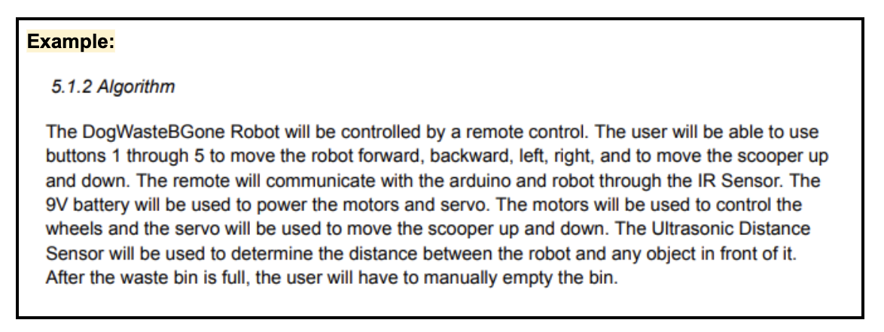
< Provide a snapshot of the flowchart (activity) diagram of the actions/processes of your robot based on various sensor inputs and information sent/received from other robots or the operator. This flowchart is a graphical representation of your algorithm. Include the snapshot here as a figure. Make sure the zoom level of the snapshot is sufficient to read clearly. >
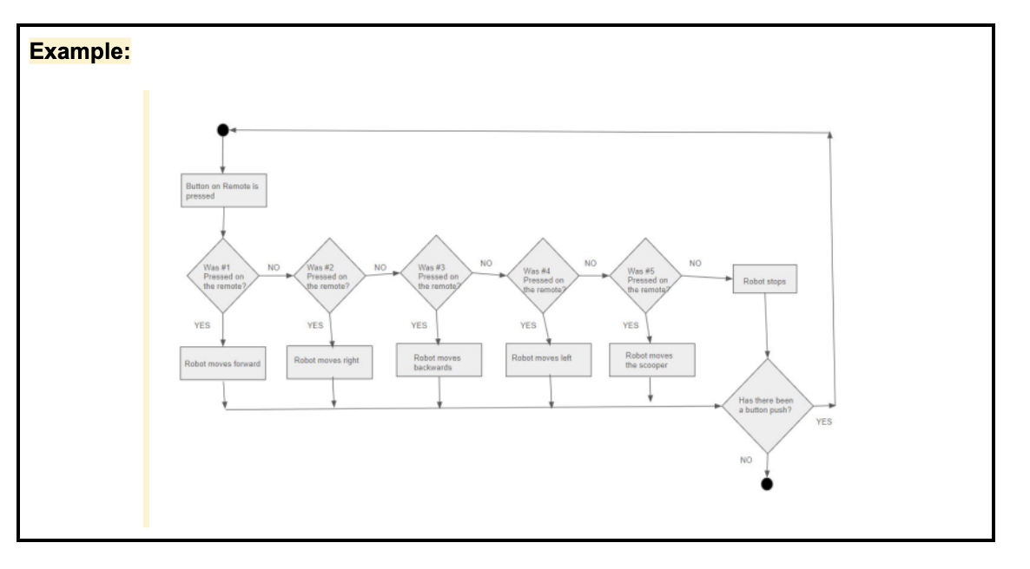
5.1.3 TinkerCAD Simulation
A TinkerCAD circuit was made for this robot to simulate the algorithm described in the previous subsection. The circuit's snapshot is shown in the Figure < number > below and the TinkerCAD link for that circuit can be accessed at < insert your shareable TinkerCAD link >. A short video demonstrating the working circuit and the algorithm can be viewed at this link: < Insert YouTube Link >.
< NOTE: Don't just paste the TinkerCAD link from the browser window. It won't open for us. To create a shareable link, go to https://www.tinkercad.com/dashboard, then click on your circuit, then click 'Copy Link'. Note, you'll have to 'change visibility' so that the design is either public, or 'viewable to anyone with the link'. >
<The above YouTube link should lead to a 3-5 minute video (penalty if the video is longer!) produced by the individual team member for their robot. Make sure the video is not marked private on YouTube. In this video, the team members will show a screen recording of their working TinkerCAD circuit and code while verbally explaining and demonstrating. In the recording, the teammate should demonstrate how various actions are taken (e.g., how actuators move or messages are printed, etc.) when sensor values are manually changed or the inputs are received from the operator/other robots. The inputs received from the operator/other robots can be implemented in the simulation as words or characters manually sent through the Serial monitor, which are then received in the code using Serial.readString() command. Alternatively, these inputs can be sent using an IR remote available in the TinkerCAD. The information to be sent by your robot to the operator/other robots can be simply printed on the monitor using Serial.println(). Thus, this video is a demonstrated proof that all your actuators and sensors are working based on the algorithm from the previous section. Make sure to briefly and quickly scroll through all of your code in this video, so that if the viewer wants to read your code they can pause and read. If a team member made a physical robot, then instead of TinkerCAD simulation they can show and explain a similar recording of their actual working robot. >
< Provide a snapshot of your tinkerCAD circuit here as a figure. Make sure all the sensors, actuators, Arduino connections, etc. are easily visible in the snapshot. >
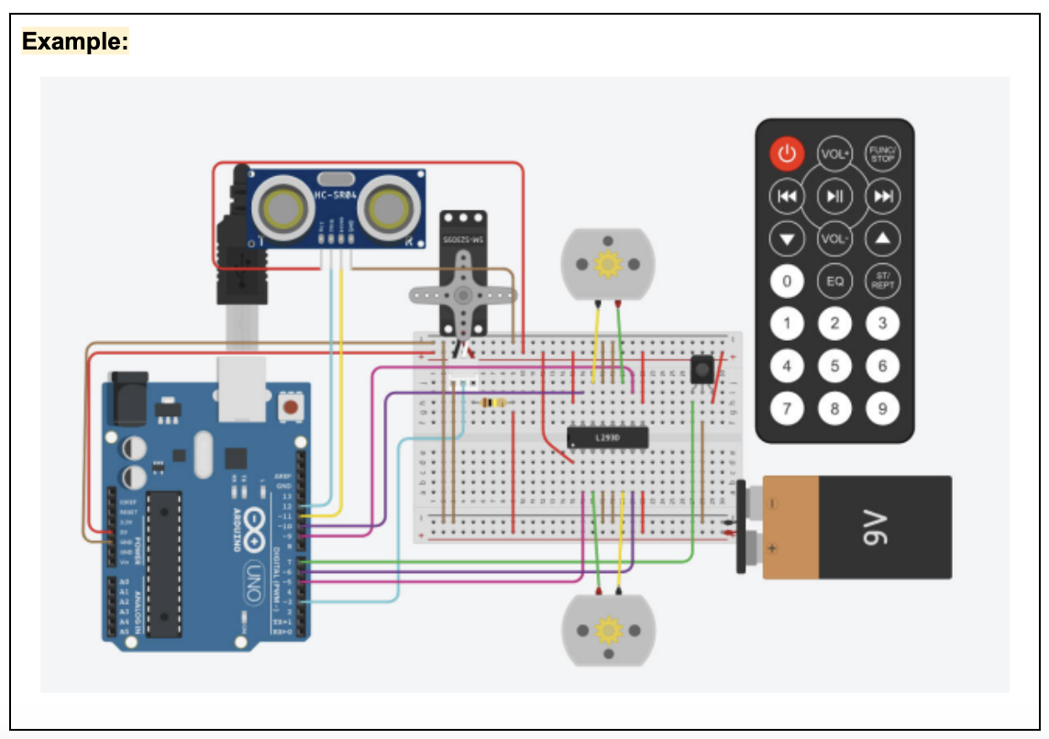
5.2 <Insert 2nd Robot's Name> by <Insert Team Member's name handling this robot>
5.2.1 Description
< Provide similar content to 5.1.1 >
5.2.2 Algorithm
< Provide similar content to 5.1.2 >
5.2.3 TinkerCAD Simulation
< Provide similar content to 5.1.3 >

5.3 <Insert 3rd Robot's Name> by <Insert Team Member's name handling this robot>
5.3.1 Description
< Provide similar content to 5.1.1 >
5.3.2 Algorithm
< Provide similar content to 5.1.2 >
5.3.3 TinkerCAD Simulation
< Provide similar content to 5.13 >

5.4 <Insert 4th Robot's Name, if any> by <Insert Team Member's name handling this robot>
5.4.1 Description
< Provide similar content to 5.1.1 >
5.4.2 Algorithm
< Provide similar content to 5.1.2 >
5.4.3 TinkerCAD Simulation
< Provide similar content to 5.13 >

6. Robot Collaboration
This section describes how the individual robots work together to accomplish the team tasks of < provide brief summary of overall tasks. >

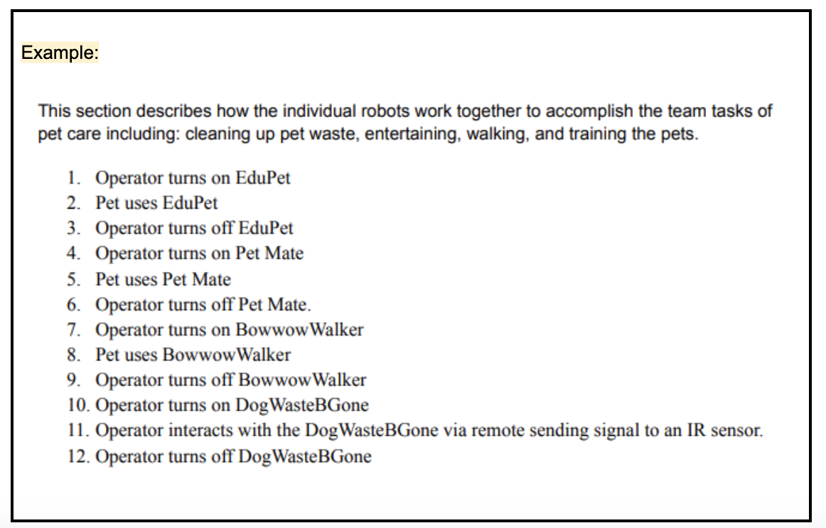

< In this paragraph, referring to the scene figure(s) below by their number(s), explain the algorithm of your overall robot system/collection. Mention the sequence in which the various robots will perform their tasks. Mention what signals/information will the operator provide/receive from robots or their sensors to make those decisions. You are heavily encouraged to present this as a bulleted list for readability. If there is no operator and the robots are just autonomously communicating with each other, then explain how and in what order they inter-communicate to accomplish all the team goals. >
<Include a figure showing the snapshot of the scene/area/arena where the robots are deployed. This could be a screenshot of a 3D CAD model or a simple 2D top-view drawing that visually shows the layout of "scene elements". For fire-fighting robots, these "scene elements" are ground, forest/trees, fire fighters, victims/survivors, and your robots, etc. Thus, this figure gives, to the reader, a simple visual of the setting in which your robot system is deployed. In the presentation video that accompanies this report, you will manually move the robots (or any other 'scene elements') by click-and-drag/mouse keys/animations, as you visually explain how the whole system functions. This can be easily done if the scene figure was made in a cad software (3D) or using vector graphics (2D, top view) like in PowerPoint / Google Drawing, etc. Do not spend too much time on graphics design of scene elements, as long as the viewer can roughly make out what they are, it should be OK. Include labels or a key in the figure to identify various elements. >
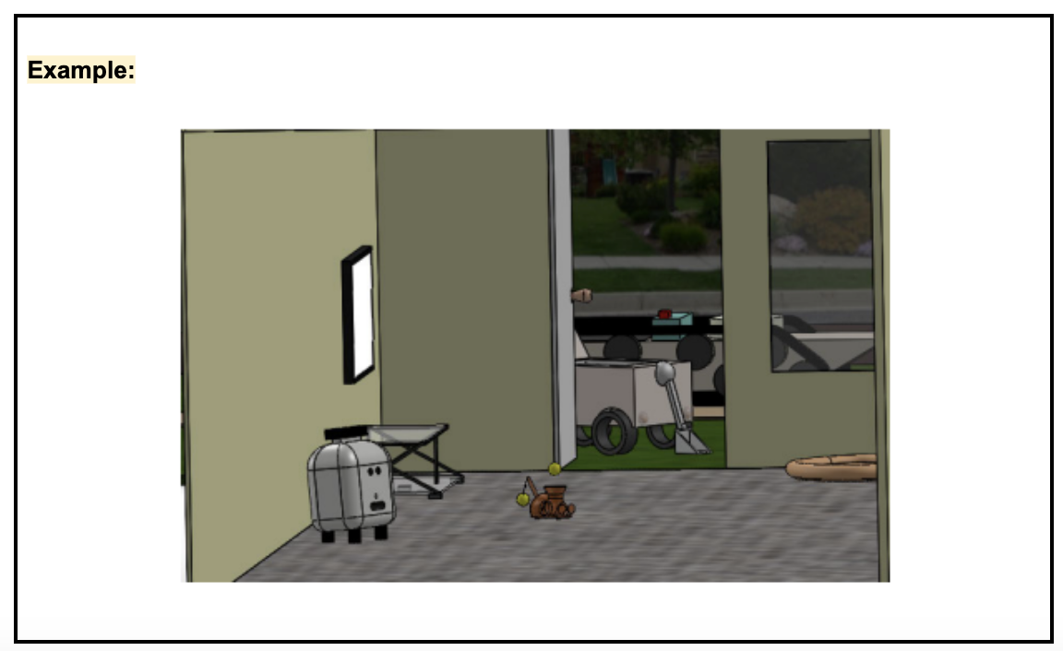

7. Conclusions
< In this paragraph, mention the value added by your whole robot system. How does your robot system satisfy the requirements from section 2.3 and market deficiencies mentioned in section 1. >
< In this paragraph, mention how your system compares to current solutions in the market as researched and mentioned in section 1. Why should anyone invest in your design? Mention the quantitative economical advantages, if any, based on your research compared to current solutions. References will go below, but should be cited here by their number. >
< In this paragraph, in a few sentences, briefly summarize the whole report and the content of all its sections/subsections. Explain what was the problem and what you eventually proposed to solve it. Then add a line to refer to the Appendix: "A video summarizing this project as a pitch to the customers is in Appendix B." >
< In this paragraph, briefly reflect on the project. Mention any lessons learned from the setbacks, and mention how would you do things differently, if given another chance. >

References
[1] Include all references used as a numbered list. Any professional reference format works here.
[2] Reference numbers should also be cited in the text of the report above, in order, as mentioned in the lecture videos and in the IEEE Style Guide.
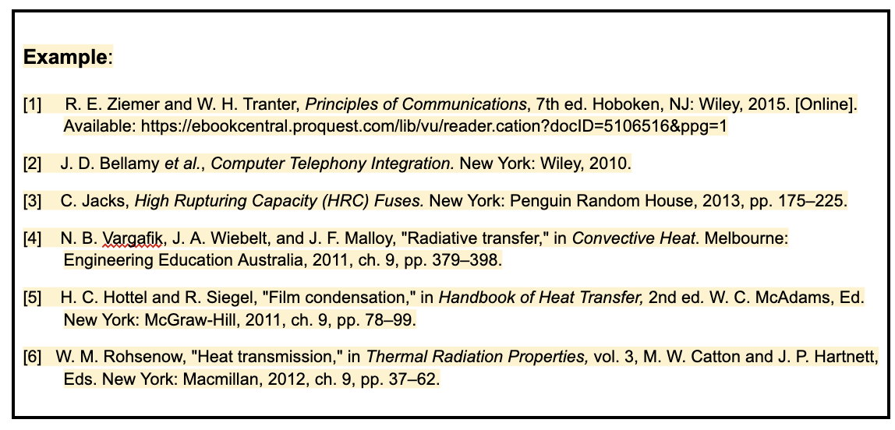

Appendix A: Gantt Chart
< Include a snapshot of Gantt Chart here that shows the detailed project schedule. You may use MS Excel, Google Spreadsheet, or any other software to create your Gantt chart. Please include a legible snapshot with enough Zoom level to be able to read the letters. You can include a link, but sometimes they don’t work properly. A Gantt chart has the following 5 elements:
- all the tasks listed in the first column,
- a timeline in the top row in appropriate units (e.g., weeks or days),
- task-boxes for each task, in the row for that task, appropriately placed on the timeline,
- milestones (triangle/diamond shaped) to show special events/goals,
- arrows connecting task-boxes which are dependent on each other (if B cannot start until A finishes, draw an arrow connecting A to B).
Your Gantt Chart should include specific tasks that you have identified as necessary to complete your project. These tasks are not a list of your upcoming deliverables! You just need to be aware of them and plan accordingly. Be realistic about the time it will take to complete these tasks and leave some room for delays, testing, and setbacks. Consider the time taken in ordering and receiving of the materials if you are making a robot with physical parts. Give time for troubleshooting, because nothing ever works for the first time. People usually spend about as much time fixing/debugging the project as much time they spent building it. >

Appendix B: Pitch Video
Here is a video summarizing this project as a pitch to the customers <insert YouTube link of your final presentation video>.
< Note: The above YouTube link should lead to a 4-5 minute video (penalty if the video is longer!) produced by the team for their robot system. Make sure the video is not marked private on YouTube. Team will create the presentation slides (e.g., MS PowerPoint or Google slides) and the video will show a screen recording of those slides along with the speakers (on camera) as they go through the slides. All the team members should speak.
Everybody should take an equitable part in preparing slides and presenting them on camera. If you are not on camera, you'll lose points.
Camera presence is needed for academic integrity reasons.
You are welcome to use Zoom or any other software to edit/record screen and camera. Please follow the guidelines for oral technical communication from the lecture videos. Include the following slides in the video. The slide content is based on the information already in this report.
Note: If any slide is getting heavy with information, you can split it into multiple slides, but please keep the order of slides as below.
- Title Slide
Containing: Project title, Team number, and Team member names (only those who participated in making the slides and the video)
All team members should briefly introduce themselves.
- Introduction Slide
Containing: Problem statement, Customer list, Issues faced by the customers in the application area, and how your robot system may solve them.
- Proposed Robots Slide
Containing: The names of all the robots that are part of the system.
- Robot 1 Slide(s)
Include Robot 1's CAD screenshot, a TinkerCAD circuit screenshot, and flowchart screenshot.
Very briefly (10-20 s) explain what the robot 1 does using its sensors/actuators. Choose your words wisely to concisely convey all the important information, even though you don't have time to explain the CAD/circuit/flowchart etc. in all their details.
- Robot 2, 3, 4 Slide(s)
In the same spirit as above.
- Robot Collaboration Slide
Using the scene figure (a 3D CAD model or the 2D top-view picture of the scene/area where the robots are deployed) demonstrate and explain how the robots will all move around to accomplish the tasks. You must manually move the robots (or any other 'scene elements') by click-and-drag or mouse keys as you explain. This demonstration is the centerpiece of the video, spend enough time on this.
- Benchmarking and Value Added Slide
Show pics of other competing solutions, and how your solution is better in solving the customer needs/requirements.
- Conclusion Slide
Give some summary/closing thoughts on the project, in a few seconds.
Include any references involved.
There is intentionally a lot of information to be presented in the few minutes. To accomplish this the team needs proper preparation, practice and usually it involves writing a script for the video. Presenting a lot of information in a clear, concise, and complete way without losing any detail is the real technical communication skill. Review the FSE100 Final Presentation Guidelines.>

