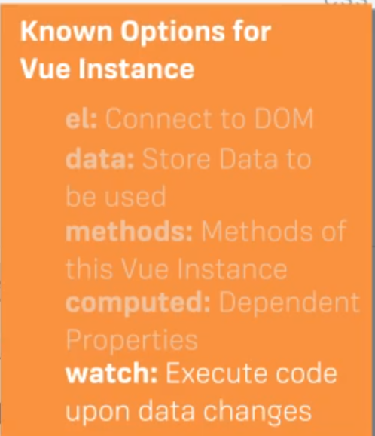

**DOM INTERACTIONS**

**v-on or @**

v-on or @: is an event listener that can be placed on any element example:

<button @click="increase">Increase</button>

@click here performs a function called increase when the button is clicked

<input type="text" @input=changeTitle>

@input here listens to a change in the input element and runs the changeTitle function

**v-bind or :**

v-bind or : is used to bind a link to an element

<p> {{ title }} - <a :href="link">Google</a></p>

:href here goes to the link when title is clicked

**CONDITIONALS AND LISTS**

**v-if, v-else**

<section class="row controls" v-if="!gameRunning">

<div class="small-12 columns">

<button id="start-game" @click="gameStart">START NEW GAME</button>

</div>

</section>

<section class="row controls" v-else>

<div class="small-12 columns">

<button id="attack" @click="attack">ATTACK</button>

<button id="special-attack" @click="specialAttack">SPECIAL ATTACK</button>

<button id="heal" @click="heal">HEAL</button>

<button id="give-up" @click="giveUp">GIVE UP</button>

</div>

</section>

**v-for**

<section class="row log" v-if="turns.length > 0">

<div class="small-12 columns">

<ul>

<li v-for="turn in turns"

:class="{'player-turn': turn.isPlayer, 'monster-turn': !turn.isPlayer }">

{{ turn.text }}

</li>

</ul>

</div>

</section>

**VUE INSTANCE LIFECYCLE**

