# Learning Design Standard

Content Design

 

Contents

Revision history 4

Using the Learning Design Standards 5

Intellectual property and moral rights 5

The opportunity 6

Guidance for providers 7

Good learning design 7

Learning environment 7

Standards of compliance 8

Learning outcome assessment 8

Guidance for agencies 9

Customising content 9

Setting the context 10

Building the digital capability of the Australian Public Service 10

The Digital Service Standard 10

The multidisciplinary digital delivery team 11

Jobs, roles and skills 12

Overview of content design 13

Target audience 14

Primary 14

Secondary 14

Pathways to content design 15

Qualifications and certifications 16

Capabilities needed for content design 17

Relevant SFIA skills 18

References 19

Key content areas 20

Unit 1: Introduction to content design 20

Unit 2: Content design process 22

## Revision history

| Date | Version | Contact | Content |
| --- | --- | --- | --- |
| 04/05/2018 | 0.4 | Ross McGuire | First exposure draft |
| 18/05/2018 | 0.4 | Ross McGuire | Review and added DTA feedback (where appropriate) |
| 13/06/2018 | 1 | Ross McGuire | Exposure Draft feedback added – Phrasal changes |
| 18/06/2018 | 1 | Ross McGuire | Added – Intellectual property and moral rights |
| 18/06/2018 | 1 | Ross McGuire | Created DTA version |

## Using the Learning Design Standards

The Australian Public Service Commission (APSC) has developed Learning Design Standards (LDS) to describe a capability needed by the Australian Public Service (APS) to help with the digital transformation of government services.

The LDS describes the context, business need, target audience, underpinning capabilities and curriculum for these capabilities. It does not prescribe or mandate a specific learning solution or format to build the capability described. That is left open for providers and sellers to design solutions that meet the specific needs of individual agencies.

This document is for:

* **Providers and sellers** seeking to work with APS agencies to understand the needs of the APS when developing and marketing products.
* **APS agencies** seeking to build capability, to inform their learning & development planning, program development and approaches to market for learning solutions.

All queries relating to this standard should be directed to [capability@apsc.gov.au](mailto:capability@apsc.gov.au).

### Intellectual property and moral rights

Intellectual property in parts of these materials may be owned by the Skills Framework for the Information Age (SFIA) Foundation.

The Australian Public Service Commission (APSC) holds an extended public sector licence on behalf of all Australian Public Service (APS) agencies covered by the Public Service Act 1999 (PS Act) for the use of SFIA materials. This licence permits certain uses of SFIA materials including the creation and internal distribution of products and services derived from or using significant extracts of SFIA materials. The licence does not extend to commercial use of the materials and does not cover Commonwealth bodies other than agencies under the PS Act.

These materials may only be used by APS agencies in accordance with the terms of the extended public sector licence granted to the APSC. No other uses of these materials are permitted. For more information on the APSC SFIA licence contact [capability@apsc.gov.au](mailto:capability@apsc.gov.au).

Third-parties, including commercial entities and non-APS Commonwealth entities wishing to use these materials should contact SFIA via [www.sfia-online.org](http://www.sfia-online.org)

## The opportunity

The Australian Government is modernising the way it delivers services to citizens. ‘Digital by default’ is the guiding principle. This means many APS agencies will need to engage multidisciplinary teams in the design, development and implementation of digital services as defined in the [Digital Service Standard](https://www.dta.gov.au/standard/). Content design has been identified as a key skill that will be in high demand for the APS workforce to transform service delivery.

## Guidance for providers

### Good learning design

When proposing or developing a solution, it is important to be consistent with contemporary instructional design practices. Adult learning is a continuous process that is not limited to the classroom or formal training activities. Good learning design leverages the ways adults learn all the time through a range of experiences.

The diagram below shows some elements that you could include in a learning program.

Figure 1 - Pathways to learning

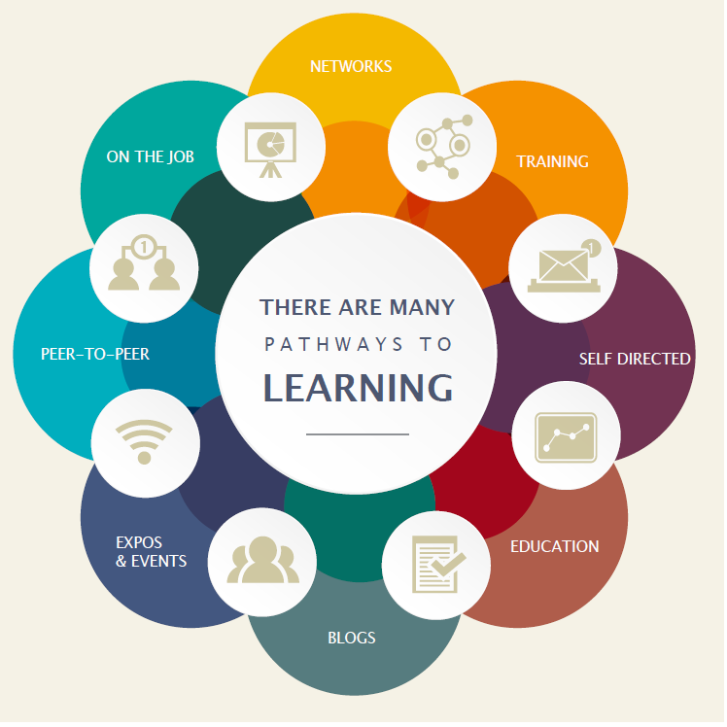

### Learning environment

The APS is made up of many different departments and agencies. Each may have their own:

* culture
* business needs
* technical platforms
* geographic dispersion
* existing level of digital capability and maturity

If your learning solution is intended for broad use across the APS you need to consider how it would apply in different contexts. Any digital solutions you develop need to be able to be deployed on a wide range of platforms.

### Standards of compliance

The APS will require all digital learning solutions to be compatible with the following standards:

* Web content accessibility guidelines version 2.0 AA compliance level
* Australian Signals Directorate (ASD) Information Security Manual Standards

The APS recommend that digital learning solutions consider the following standards:

* Digital Transformation Agency (DTA) [Digital Service Standard](https://www.dta.gov.au/standard/)
* [Learning Design Specification standard](https://www.imsglobal.org/learningdesign/index.html)

### Learning outcome assessment

Agency requirements for assessment may vary. Formative and/or summative assessment may be offered by the provider and should be specified by the agency when engaging providers.

**Formative assessment** - ***monitors learning*** and gives ongoing feedback. It is used by facilitators to improve their teaching, and by learners to improve their learning. The purpose is assessment **FOR** learning. Examples of formative assessments are

* observations, conferences, questioning
* drawing concept maps, reflections
* self-evaluations and self-assessments

**Summative assessment** - evaluates the level of success or capability at the end of a learning activity, comparing it against some standard or benchmark. The purpose is assessment **OF** learning. Examples of summative assessments are:

* a midterm assessment or end-of-course test
* a final project
* a presentation or report

## Guidance for agencies

### Customising content

Agencies may extend, reduce or change the content of this LDS.

Agencies should highlight these changes so that providers can readily adapt their learning solutions to meet your agency needs.

## Setting the context

### Building the digital capability of the Australian Public Service

*The Australian Government is progressing a digital transformation agenda to revolutionise the way it delivers services.* Australians are more mobile, more connected and more reliant on technology than ever before**.** [The Digital Transformation Agency (DTA)](https://www.dta.gov.au/what-we-do/) is leading this transformation in order to improve how the Australian Government delivers services online.

*As part of the digital transformation agenda, the APSC and the DTA are jointly delivering the Building Digital Capability Program. One of the main activities of this program is the identification of digital capability shortfalls and the definition of learning programs to build capability in those areas.*

### The Digital Service Standard

The Digital Transformation Agency guides government service modernisation through the [Digital Service Standard](https://www.dta.gov.au/what-we-do/) (‘the Standard’). The Standard helps digital teams to build services that are simple, clear and fast.

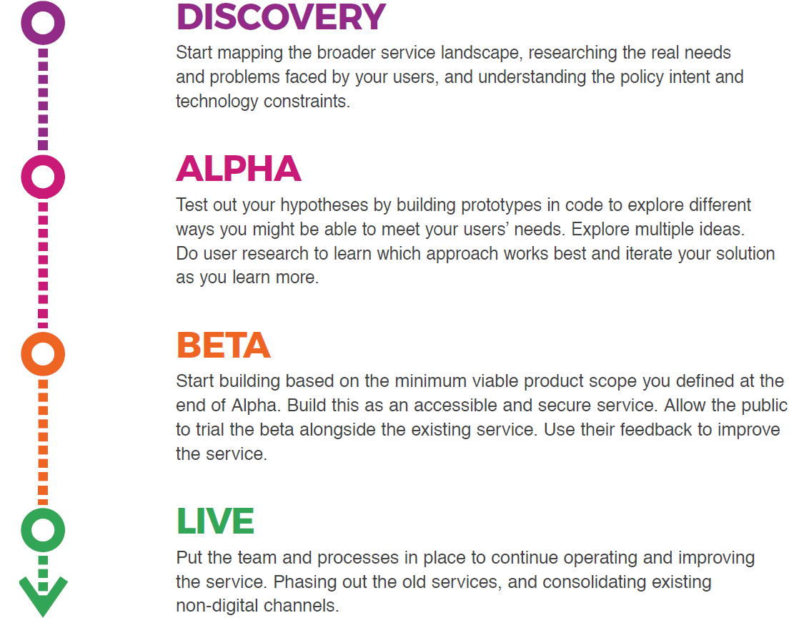

### The multidisciplinary digital delivery team

The Digital Service Standard suggests the ideal multidisciplinary team to design, build, operate and iterate a digital service. This team includes core (permanent) roles as well as extended roles that you can bring into the team when needed. People may perform one or many roles, depending on their capability and the workload.

Figure 2 - The digital delivery team

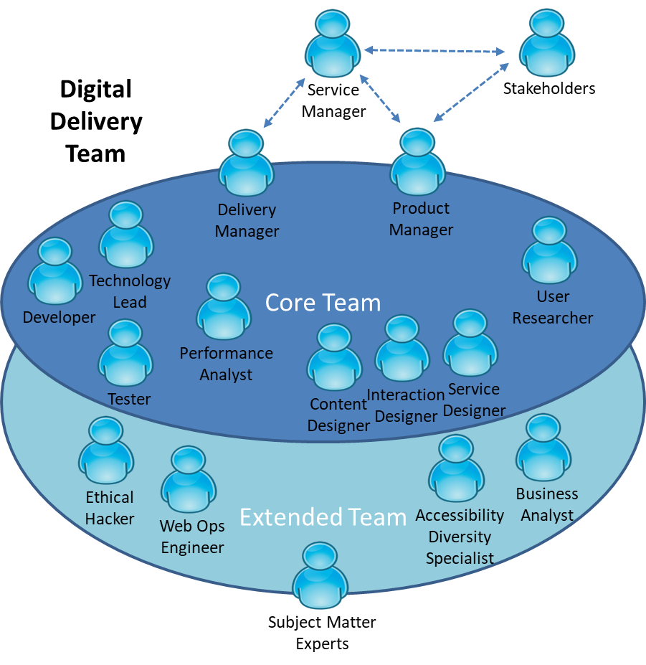

The capabilities defined by the Learning Design Standards relate to the roles in a digital delivery team. An agency will be able to use the LDS to define an effective team that meets their specific agency requirements for digital transformation.

## Jobs, roles and skills

Members of multidisciplinary teams may perform many roles in their jobs. Each role has expectations of skill, behaviours and knowledge. You can verify these through relevant qualifications and certifications.

Figure 3 - Role composition

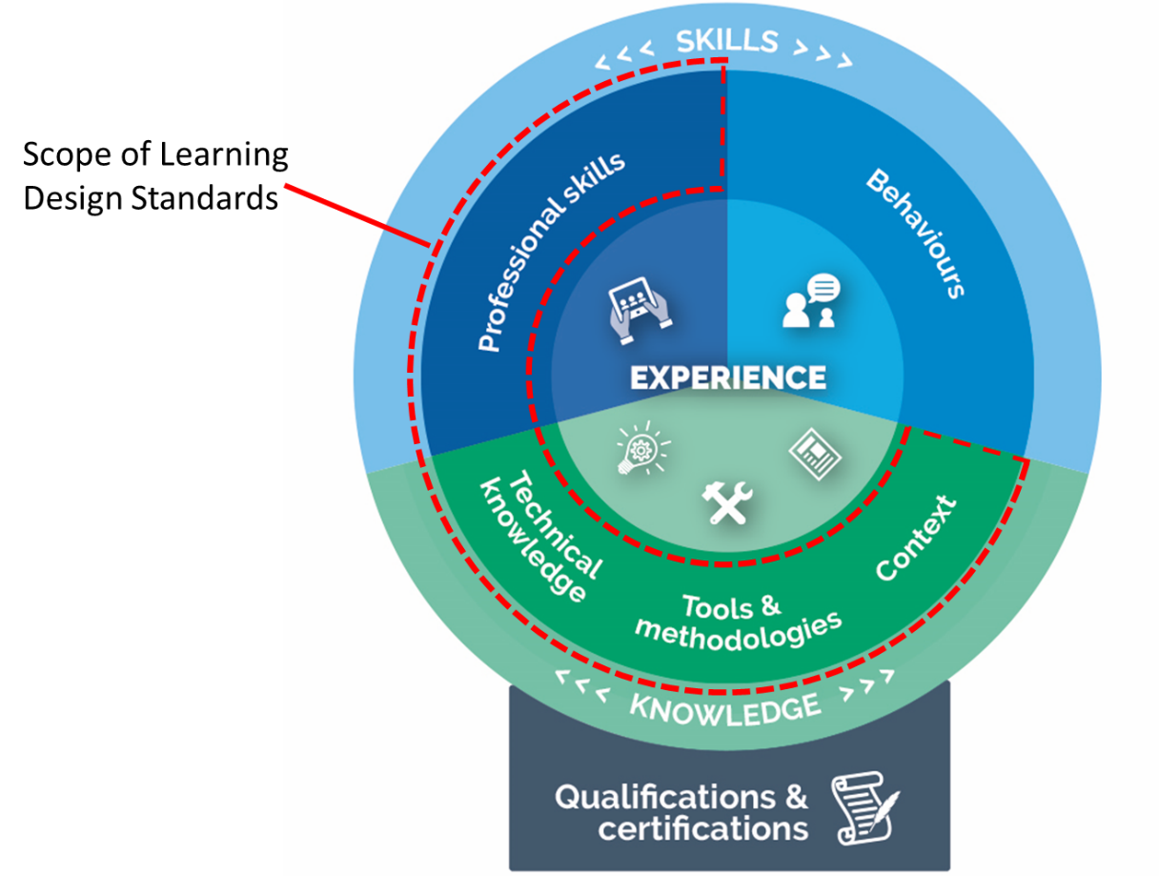

This Learning Design Standard only addresses learning outcomes for professional skills and knowledge. A person who has done training also needs to put it into practice. This allows them to gain experience and become effective. Individual agencies will determine how they manage experience.

Providers may wish to provide certifications that verify the learning outcomes specified in this LDS, but these are not mandated. It is up to individual agencies to decide if they want certification.

Individual agencies will define jobs according to their needs. Jobs may involve one role only, though it is becoming more common for multidisciplinary teams to have job fluidity. Members may perform many roles according to their capabilities and the needs of the team.

## Overview of content design

For the purposes of this learning design standard, the primary function of ‘content design’ refers to the design and creation of information for a digital service. It is user-centred, part of the service design and delivery process, and is done in an agile way.[1]

Content designers:

* decipher and translate complicated information into a more easily understandable form by a user, for example, this may be plain English or a diagram
* make evidence-based decisions about content that will best meet user needs
* design thinking - to build, test, and learn
* work as part of a multidisciplinary team
* advocate for what the user needs rather than what the organisation wants.

Content designers are responsible for the creation, curation, organisation, layout, evaluation, review and continuous improvement of content that’s designed around user needs. They work with user researchers, stakeholders, subject experts and multidisciplinary teams to meet user needs.

**Why this role is important**

Government online information and services are often essential for citizens to access and use e.g. obtain a licence, complete a tax return, etc. Government often publishes content on websites that it thinks citizens ‘must have’ rather than what people ‘need’ to know based on the tasks required. This information can be vast and unclear and can frustrates citizens who end up confused and failing to complete what they need to do. Content designers can collaborate with user researchers and/or do their own research to identify user needs. They help to create digital services that are easy to use. Effective content:

* meets a user need
* is structured to reflect how users read online and on different devices
* is expressed in plain language
* is accessible and inclusive
* is searchable and findable.

APS content designers work in multidisciplinary teams as part of the service design and delivery process. This process aligns with the DTA’s Digital Service Standard (the Standard).

## Target audience

### Primary

APS employees in multidisciplinary teams who create content for their agency for use on digital platforms.

Therethere is no set pre-requisite academic pathway for entry into this capability, but there are qualkifications that may be of benefit. However, there are some academic pathways in relevant disciplines that may be beneficial in a government digital service delivery team.

### Secondary

Other multidisciplinary (service delivery) team members performing related activities to develop and improve user-centred digital services, for example;

* service designer
* user researcher
* product manager

## Pathways to content design

Everybody has a different work history and career path. The following are some of the more common fields people may have come from before coming to the current role:

* Journalism
* Communications
* Editing
* Web development and design
* Education
* Learning and development
* English
* Linguistics
* Marketing
* Information technology
* Language
* Arts
* Website production

## Qualifications and certifications

The following qualifications are relevant to the capability described in this LDS.

## Capabilities needed for content design

The skills, knowledge and attributes listed below are the minimum needed for someone to be effective in this role. A person undertaking the learning defined by this LDS should have the knowledge and skills described below after finishing the learning. They may need experience of these in a workplace to embed the learning and become effective.

| Knowledge: | Skills: | Attributes: |
| --- | --- | --- |
| **Organisational context**   * Government frameworks and processes * Digital Service Standard   **Methodologies, procedures and standards**   * Service design and delivery process * Accessibility and inclusivity * Project management   **Tools**   * Relevant technology and digital platforms * The Content Guide * Content management systems   **Theory/theoretical**   * Cognitive information processing (how people read and consume content principles * Agile Manifesto * Agile practices & principles * User-centred design principles   **Concepts**   * Concepts of continuous delivery | **Technological**   * Using publishing systems   **Analytical**   * Interpreting user research for content design * Synthesising information from a range of sources * Translate complicate information into plain language * Referencing * Summarising information * Structuring content * Analytics and statistics * Users’ digital process   **Communication**   * Plain English writing * Editing and proofreading * Accessible content creation principles and practices * Advanced language skills * Develop key messages and themes * Reporting and presenting * Key messages/themes   **Planning and organising**   * Ideation techniques * Testing content * Iterating content * Capturing feedback - knowing how to edit from that feedback * Quality assurance and continuous improvement * Time management * Delivering at pace * Adapting to change   **Relationships**   * Stakeholder engagement/ consultation * Ability to advocate for user needs * Negotiation | **Professionalism**   * Analytical mindset * Strategic mindset * Objectivity * Attention to detail * Team mindset * Unconscious bias awareness   **Personal**   * Creativity * Curiosity * Empathy * Ethical approach * Observant * Resilient * Self-motivated * Values driven * Flexible * Self-aware |

## Relevant SFIA skills

The *Skills Framework for the Information Age* (SFIA) is a global standard that defines Digital and other ICT related skills. A person possessing the following SFIA skills at the levels indicated would be capable of performing the role described by this standard.

| Code | Skill | Applicable Levels | Caveats* |
| --- | --- | --- | --- |
| [INCA](https://www.sfia-online.org/en/sfia-6/skills/solution-development-and-implementation/systems-development/information-content-authoring) | Information content authoring | 3 | - |

*Caveats are identified components of a SFIA skill that are not explicitly required for the current role. For the purpose of this Learning Design Standard the SFIA description should be read as though the caveated components were not included in the SFIA skill description.

## References

The reference list below provides locations for sources referred to in this standard so that readers can easily locate and use them if required.

* [DTA Digital Service Standard](https://www.dta.gov.au/standard/)
* [Content Design Centre (courses)](http://contentdesign.london/)
* [How to plan, write, and manage content at 18F](https://content-guide.18f.gov/)
* [UK GDS Blog: Content design](https://gds.blog.gov.uk/category/content-design/)
* [Nielsen Norman Group (courses)](https://www.nngroup.com/search/?q=content&searchSubmit=Search)
* [Book: Collaborate - Bring people together around digital projects](https://gathercontent.com/books/collaborate)
* [Example job description: Content Designer](https://view.officeapps.live.com/op/view.aspx?src=https%3A%2F%2Fassets.publishing.service.gov.uk%2Fmedia%2F588b2643e5274a7a6800002f%2FContentDesignerJobDescription.doc)
* [Content Design Centre: Copywriter to content designer](http://contentdesign.london/content-design/copywriter-to-content-designer/)
* [UK GDS - Content design: planning, writing and managing content](https://www.gov.uk/guidance/content-design)
* [DTA](https://guides.service.gov.au/content-guide/) Content Guide

## Key content areas

The following table outlines content areas that need to be addressed.

Unit = area of learning.   
Topic = component of area of learning.

### Unit 1: Introduction to content design

**Learning objective:** Explain the principles associated with good content design

| Topic title | Topic learning objectives | Critical content |
| --- | --- | --- |
| 1.1 Definition of content design | **Define** content design | 1. Content design:  * creates content for user-centred services that work for the entire population * creates content that meets accessibility standards * creates content that works on all device formats (responsive design) |
| 1.2 Principles of content design | **Identify** the principles of successful content design | 1. Principles that underlie content design include:  * user-focused to meet needs * inclusive and accessible to meet the needs of all users * designed using data: content is evidence based on evidence such as statistics and analytics * owned by the content designer as part of an end-to-end creation/delivery process * simple and easy to understand using plain language, simple word choices and no jargon * communal: thinking, ideas, and outputs are shared * iterative, flexible and open to feedback: content will change and develop as a result of feedback and testing with relevant users and stakeholders * self-awareness: content designers are aware of their own biases and how these may influence content design and creation |
| 1.3 Role of the capability (content design) as part of the Digital Service Standard, service design and the delivery process | **Explain** how and where content design fits into service design | 1. Recap digital service design:  * Digital Transformation Agenda * Digital Service Standard (the Standard) * The role of the capability, content design, in the service design and delivery process: * identifies user needs and demonstrates how content decisions support these needs * creates content design hypotheses to improve the service * works with product manager, user researcher, interaction designer and performance analyst to run design experiments * delivers content that meets accessibility standards * is confident in explaining content design decisions and rationale * is open to and encourages critique from colleagues * conduct content reviews and content audits of existing services * Working as part of a multidisciplinary team |

### Unit 2: Content design process

**Learning objective:** To apply the processes of content design

| Topic title | Topic learning objectives | Critical content |
| --- | --- | --- |
| 2.1 User needs | **Identify** users and their needs | 1. Profiles of real users: based on pains, gains, and tasks, education, level of digital literacy, socio-economic, cultural background, geographic, user journeys 2. User research: understanding how user research is gathered, for example interviews, surveys 3. Participating in user research: bringing research and design thinking in early, working with the team on synthesis 4. Interpreting user research:  * recognising needs: what does the user need from, or to find out from government? * discovering ways to best communicate with users * understanding the ways users access content |
| 2.2 Government business needs | **Recognise** the user need government is trying to meet through different types of content | 1. The broad types of government content:  * informational (for example, how to apply for a family benefit) * transactional (for example, actually applying for a family benefit) |
| 2.3 Content research | **Identify** examples of content research techniques | 1. Potential examples include:  * source content (for example, legislation, policy, procedure, ministerial announcements) * desktop research, existing content across other domains, online forums, social media) * researching metrics (for example, online data analytics) * stakeholder consultation (for example, policy and business owners, industry and community) * analysis of user research |
| 2.4 Plan content | **Conduct** required content planning | 1. Factors to consider in content planning:  * timeframes * ways of organising content (for example, mind mapping, storyboarding, writing tools) * accessibility and inclusivity requirements * consultation and engagement * stakeholder consultation and engagement * multidisciplinary team composition * multimedia elements * appropriate language and tone * available technology for authoring * digital literacy * content strategy: ensuring content is aligned with the agency’s broader content strategy * evaluation: deciding how success will be measured (for example, performance analysis metrics) |
| 2.5 Content creation | **Apply** content design principles and skills to create content | 1. User-centred: create content with the user in mind based on user research 2. Accessibility e.g. alt text 3. Inclusivity 4. Ideation techniques 5. Structure:  * content elements (for example, text, graphics, layout, hyperlinks, lists, headings, flow and logic) * frontloading (for example, keywords, trigger words) * agency specific requirements (style guides, templates) * pair writing with subject experts * team review  1. Search Engine Optimisation (SEO) 2. Writing for mobile first 3. Readability: plain english/language principles 4. Good writing, editing, spelling and grammar  * appropriate tone/voice/language * punctuation for the screen * reading level |
| 2.6 Content testing and iteration | **Use** the content testing, improvement and iteration cycle | 1. Testing draft content with users, draft content and applying feedback 2. Reporting and /presenting results of testing content with users 3. Fact checking by subject expert and stakeholders 4. Content critiques by the wider team 5. Using the results of content testing with evidence for the approach to content 6. Retesting and re-engaging 7. Iterating as many times as needed. |
| 2.7 Publishing and ongoing service management | **Apply** publishing and ongoing monitoring and evaluation as part of the content lifecycle | 1. Workflow:  * stakeholder engagement and approval * agency content sign-off process  1. Publishing on the most appropriate platform for users (for example, website, digital service pages, eLearning, etc.) 2. Continuous monitoring and evaluation 3. Using metrics and analytics to maintain and improve the product or service. 4. Agile delivery: sprint planning, product backlog, delivering improvements in increments |

1. Government Digital Services. UK