**Getting MySQL to work for VSCode**

1. Install MySQL:

* Ensure to remember your user and passwords
* Download: <https://dev.mysql.com/downloads/windows/installer/>
* Video: <https://www.youtube.com/watch?v=WuBcTJnIuzo>

1. Install JDBC:

* Download: <https://dev.mysql.com/downloads/connector/j/5.1.html>
* Video: <https://www.youtube.com/watch?v=2i4t-SL1VsU>

1. Create a “lib” folder in the Java project directory and paste the “mysql-connector-java-5.1.48-bin.jar” file from the JBDC download into it.

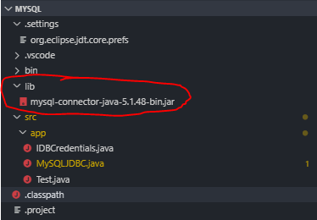

1. Add the “mysql-connector-java-5.1.29-bin.jar” file from the JDBC download into the Java project classpath.

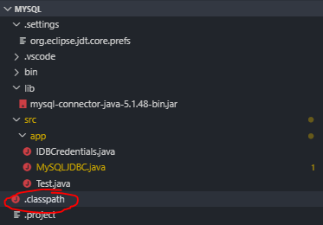

* Paste in “<classpathentry kind="lib" path="lib/mysql-connector-java-5.1.48-bin.jar"/>”
* Note that the "mysql-connector-java-5.1.48-bin.jar" portion should match **YOUR** jar file

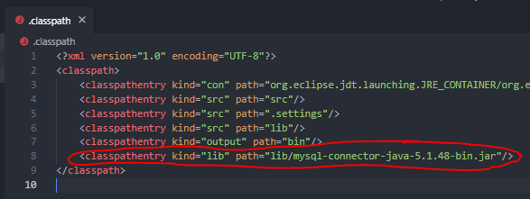

1. Open MySQL workbench and enter the query “ALTER USER 'root'@'localhost' IDENTIFIED WITH mysql_native_password BY 'PASSWORD'”

* Note that “PASSWORD” should be replaced by your personal MySQL password

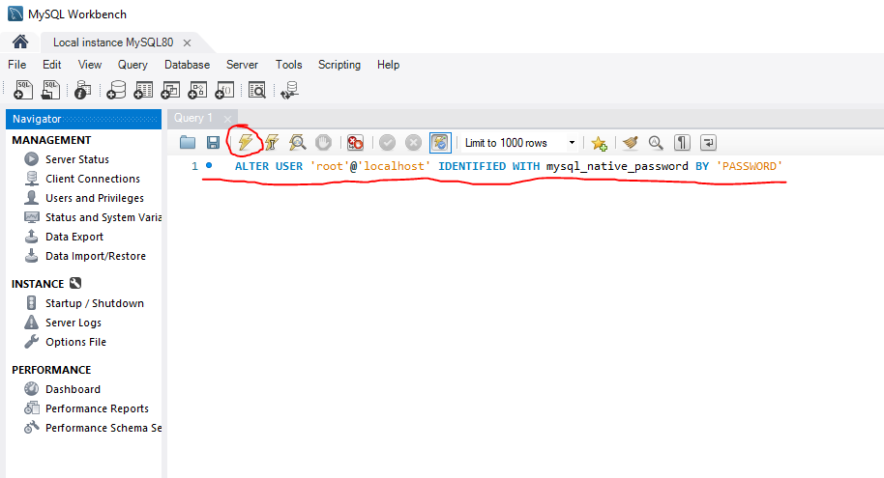

1. OPTIONAL: Test your connection by downloading the SQLTools VSCode extension

* Note: This and the following steps are just for verifying that MySQL is working properly. This extension is not required to use MySQL in VSCode.

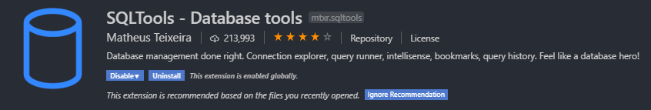

* Add new connection

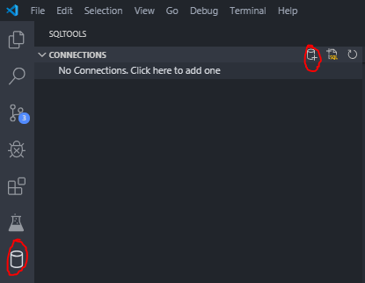

* Select MySQL

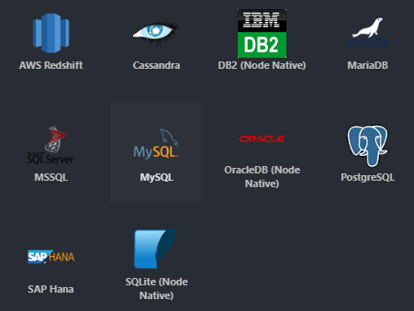

* Input credentials and press “Save Connection”
  + “Connection Name” can be anything
  + Database “world” is one of the pre-set databases that comes after downloading MySQL. You can see it using MySQL Workbench (See Appendix A)
  + Note that “PASSWORD” should be your personal MySQL password

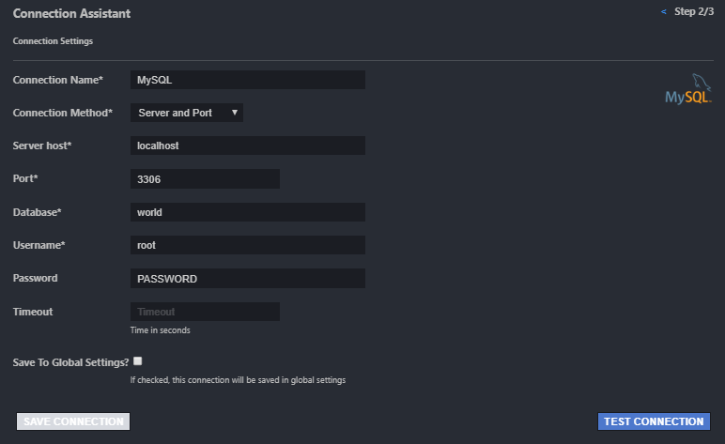

1. If successful, you should see something like the following:

* If the extension detects a connection, you have installed everything correctly and should be able to connect to and manipulate MySQL databases through Java files. (Assuming you have properly placed the jar file in the library folder and added it to the classpath)

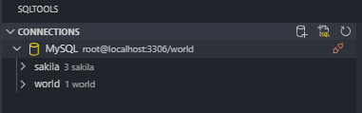

**Appendix A**

