**Trafalgar Travel Ltd**

Guinep CMS

**Quick Reference**

The Guinep CMS is for adding and removing content that the mobile APP will display to users.

# Access the CMS

To access the Guinep CMS you can use the url below:

<http://208.163.52.249/guinep-cms/>

You will be present will the login screen where you can enter the login information that was provided.

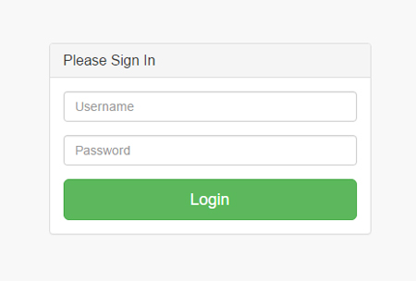

# The Home Page

The Home page or dashboard will display large icons that will give you quick access to the various sections where you can add your their content.

# Notification Form

The form titled "**Send** **notification to device**" will allow you send notification to mobile devices with Guinep app installed, Try not to spam the users.

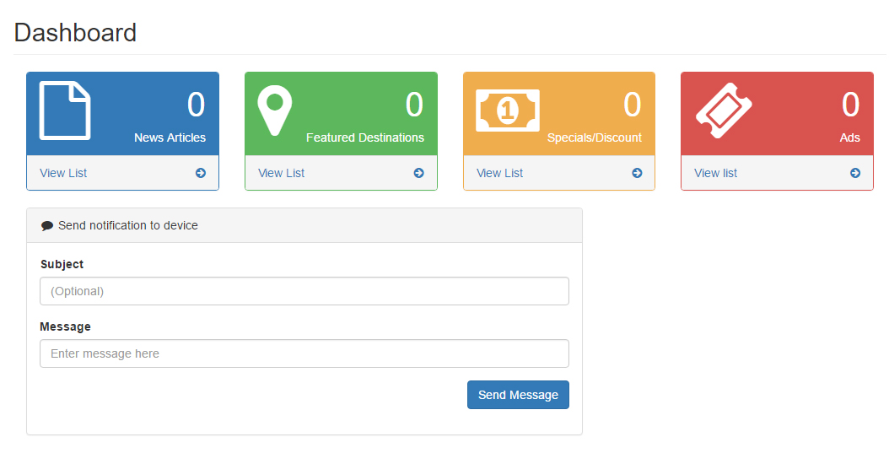

# View Content

Selecting any of the colored sections will give you the content listing, to delete items, click the red **x** then select the confirmation dialog, you can edit an item by selecting the edit icon.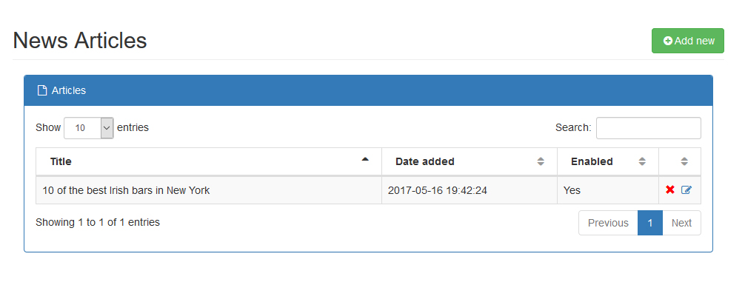

# Adding Content

To add a new content item, click the green **Add new** button from the listing page or use the menu on the left and click Add for the required section.

Fill in the all the necessary information and note the **Publish** select box, content will only be submitted to the app if the publish box is checked.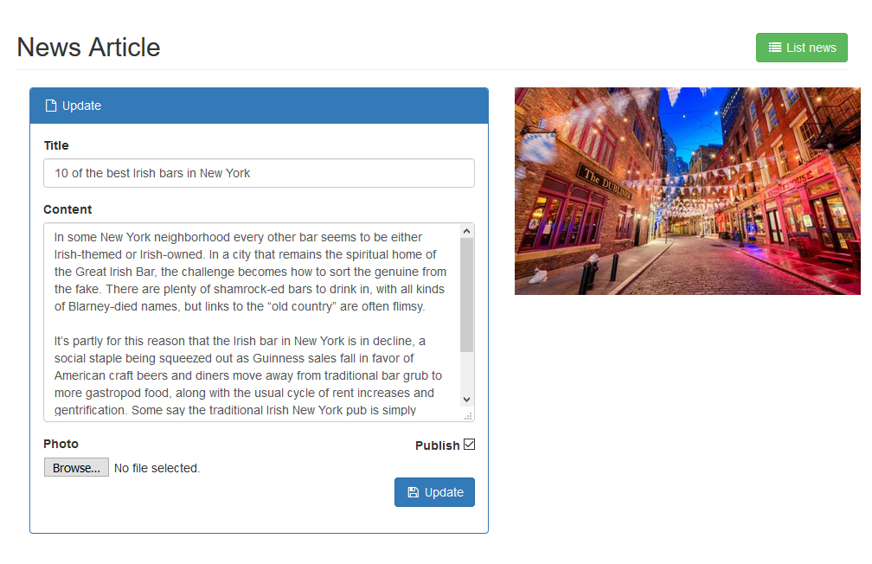

# Adding Image Content

Each section has its own photo select box where you can select the image to upload.

When choosing an image, make sure it is of high quality and formatted for web meaning that the file size is small, **.JPEG** format is usually a good type, and the files size should be less than 1MB, file sizes of 2MB or more will not be uploaded.

The minimum width of the image should be 1024PX (pixels), this should be good enough to cover most device screen size.

# Sign out

|  |  |
| --- | --- |
| To sign out click the icon at the top far right to display the sign out option. | C:\Web\htdocs\trafalgar\doc\logout.jpg |