PFAS Exposure and Liver Outcomes
Plots, interpretation, evidence summary, and research implications
Prepared 23 September 2026

How to read these plots
The figures summarize adjusted estimates from published human studies. Percent changes, odds ratios, regression coefficients, meta-analytic z-scores, and mixture weights answer different questions and are therefore kept separate.
Interpretation guardrail: These observational associations do not alone prove that PFAS caused liver injury. Population, exposure range, year, assay, outcome definition, and statistical adjustment differ across studies.

Main findings
- ALT, AST, and GGT show the most recurring positive signals.
- Mixture analyses find associations even when individual-compound results vary.
- Pediatric PFOS/PFHxS estimates point toward NASH and fibrosis, but come from a small cohort.
- NAFLD and FIB-4 findings are less uniform and can be null, subgroup-specific, or nonlinear.

Liver-enzyme change
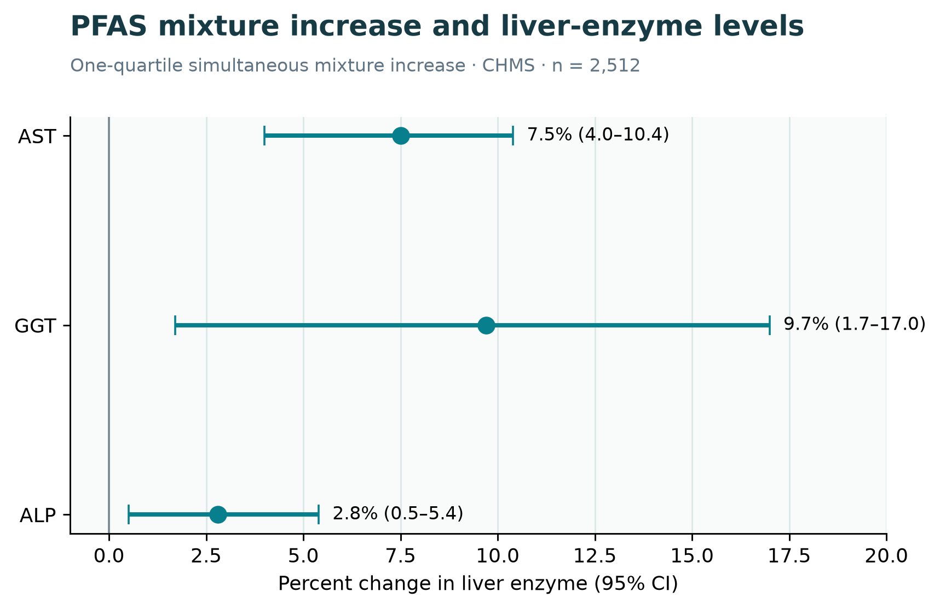
Figure 1. Adjusted percent change per one-quartile simultaneous increase in the PFAS mixture; bars are 95% CIs. Source
AST, GGT, and ALP confidence intervals are above zero. GGT has the largest point estimate but the widest interval. ALT and bilirubin were not consistently associated in this analysis.

Clinical liver outcomes
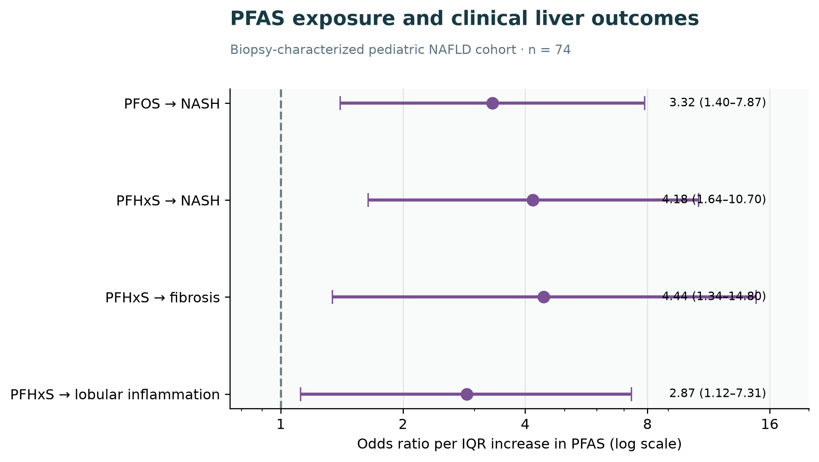
Figure 2. Adjusted odds ratios per IQR increase in PFOS or PFHxS; bars are 95% CIs. Source
The estimates point toward higher odds of NASH, fibrosis, and lobular inflammation. Wide intervals reflect the cohort size of 74, so these are suggestive rather than precise population-wide risk estimates.

Mixture contribution
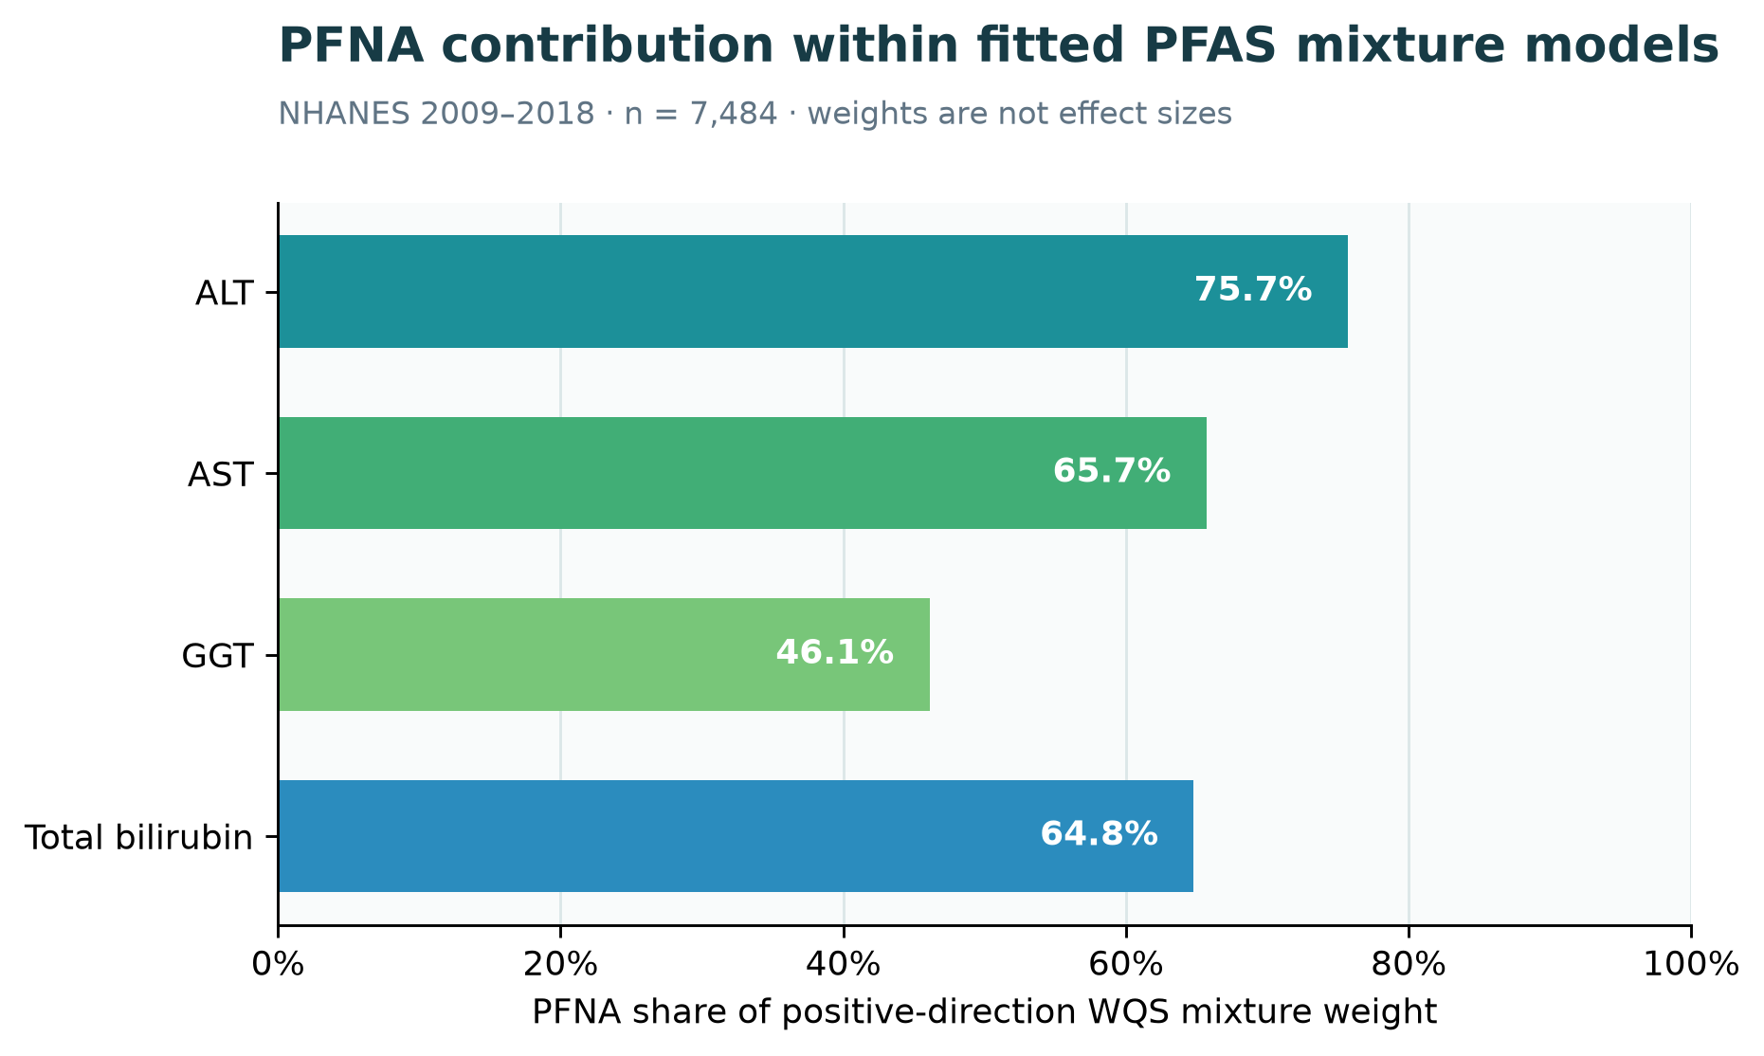
Figure 3. PFNA weight in positive-direction WQS models for four liver biomarkers. Source
PFNA received the largest reported contribution for these outcomes. WQS weights describe mixture composition; they are not percentages of disease caused or effect sizes.

Consistency across studies
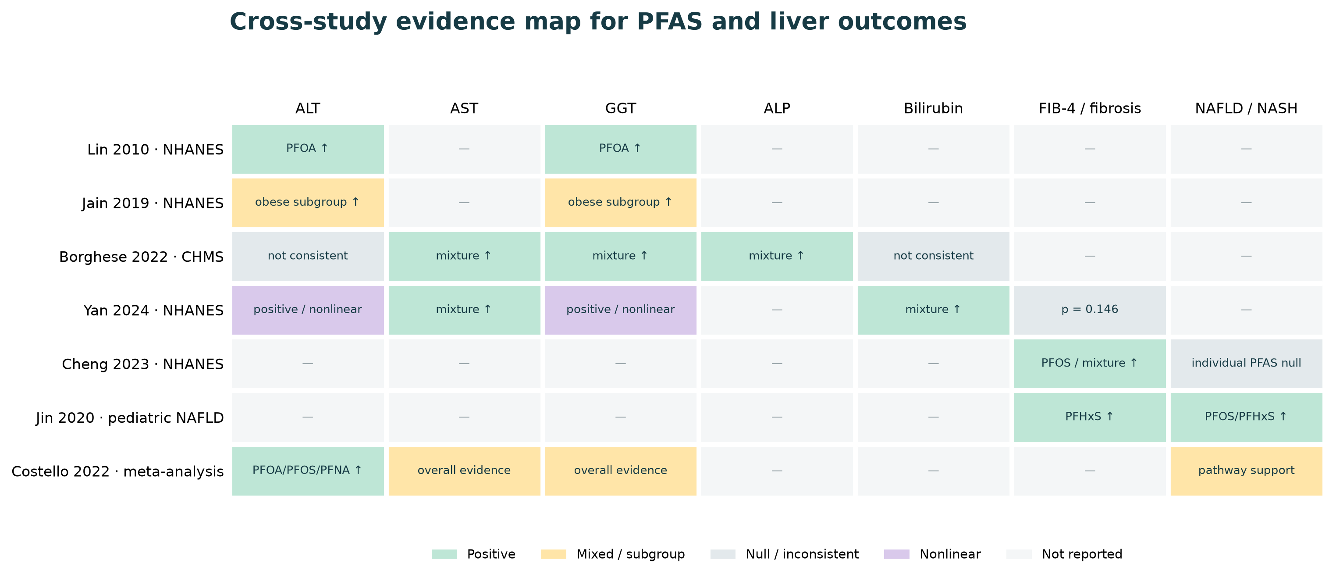
Figure 4. Qualitative map of adjusted findings across selected studies. Source
The map shows recurring enzyme signals and substantial heterogeneity. It also shows why a single correlation between regional PFAS summaries and regional liver outcomes would be misleading.

Selected estimates using other scales
Study | Exposure | Outcome | Adjusted estimate | Population
Lin 2010 | PFOA | ALT | +1.86 U/L (1.24–2.48) | NHANES; n=2,216
Lin 2010 | PFOA | log GGT | β=.08 (.05–.11) | NHANES; n=2,216
Cheng 2023 | PFOS | FIB-4 | β=.07 (.01–.13) | NHANES; n=1,150
Jin 2020 | PFHxS | NAFLD activity | β=.46 (.03–.89) | Pediatric; n=74
Costello 2022 | PFOA | ALT | weighted z=6.20 | 24 studies
Costello 2022 | PFOS | ALT | weighted z=3.55 | 24 studies
Costello 2022 | PFNA | ALT | weighted z=2.27 | 24 studies
These estimates are tabulated rather than placed on one axis because their units and statistical meanings are not commensurate.

Recommended participant-level analysis
Plot log₂ serum PFAS against log-transformed ALT, AST, and GGT for the same participants, using a flexible smoother with a 95% confidence band. Then report adjusted estimates per exposure doubling or per IQR.
Describe — Examine distributions, detection frequencies, missingness, and PFAS correlations.
Visualize — Use individual-level scatter or hexbin plots with nonlinear smoothers.
Adjust — Include age, sex, race/ethnicity, BMI or waist, alcohol, smoking, diabetes, lipids, medications, kidney function, fasting, hepatitis status, and survey design where applicable.
Model mixtures — Compare individual-PFAS models with a prespecified mixture method.
Validate — Report sensitivity analyses, multiplicity control, calibration, and external validation where possible.
Primary endpoints: Use ALT, AST, and GGT as primary continuous outcomes. Treat ALP, bilirubin, FIB-4, and diagnosed NAFLD/NASH as secondary unless sample size and clinical ascertainment are strong.

References
- Borghese et al. 2022 — CHMS mixture analysis
- Jin et al. 2020 — pediatric NAFLD
- Lin et al. 2010 — NHANES liver biomarkers
- Jain and Ducatman 2019 — obesity-stratified NHANES
- Cheng et al. 2023 — NHANES NAFLD and fibrosis
- Yan et al. 2024 — NHANES mixture analysis
- Costello et al. 2022 — systematic review and meta-analysis
The companion PFAS_liver_outcome_effects_data.csv contains the numeric values, study details, confidence intervals, interpretations, and source URLs.

