Isuzu Motors Co., (Thailand) Ltd.

RT50 Frame Shop ASM Line Production Instruction System
(Frame)

MAINTENANCE MANUAL

OMRON

TABLE OF CONTENTS

1. OVERVIEW 1
2. DATABASE BACKUP 1

TABLE OF FIGURES

Figure 2-1 Scheduled Tasks on Control Panel 3
Figure 2-2 Add Scheduled Task 3
Figure 2-3 Scheduled Task Wizard 4
Figure 2-4 Select Program to Schedule 4
Figure 2-5 File-dialog to browse the Program 5
Figure 2-6 Tree Directory for the Program Targeted 5
Figure 2-7 The Targeted Program “SQLCMD.EXE” 6
Figure 2-8 Setting a Name and Period for the Task 6
Figure 2-9 Setting a Time and Date for the Task 7
Figure 2-10 Setting Password and Confirm 7
Figure 2-11 Finish the Scheduled Task Wizard 8
Figure 2-12 Setting Advanced Properties 9
Figure 2-13 Run the Scheduled Task 9

OVERVIEW

This document is about maintenance task which is required for system to run smoothly without problems or to be recovered easily when any problem occurred.

DATABASE BACKUP

The Database Backup is a necessary operation for protecting some important data from unexpected situations such as production data lost, server crashed, or uncatchable error. This operation will backup the database periodically such as monthly, weekly, or daily. In real use, we prefer a daily backup.
The database backup can be done automatically by associating with the Windows Task Scheduler. The Windows Task Scheduler will call our script to run the database backup at the same time everyday and will copy the backup file to the backup location.
However, to set the Windows Task Scheduler for our database backup has to manually configure by advance users or IT technicians. This section will explain this setting step-by-step as follows:
- Specify the backup location on the server. We recommend that the location is “F:\BAK_FPS\” for PIS and “F:\BAK_LMS\” for LMS.
- Find the “Backup_FPS.sql” file in the installation CD and copy it to the backup location “F:\BAK_FPS\” for PIS and find the “Backup_LMS.sql” file in the installation CD and copy it to the backup location “F:\BAK_LMS\” for LMS.
- Open the Windows Task Scheduler by “Start -> Settings -> Control Panel -> Scheduled Tasks” as illustrated in Figure 2-1.
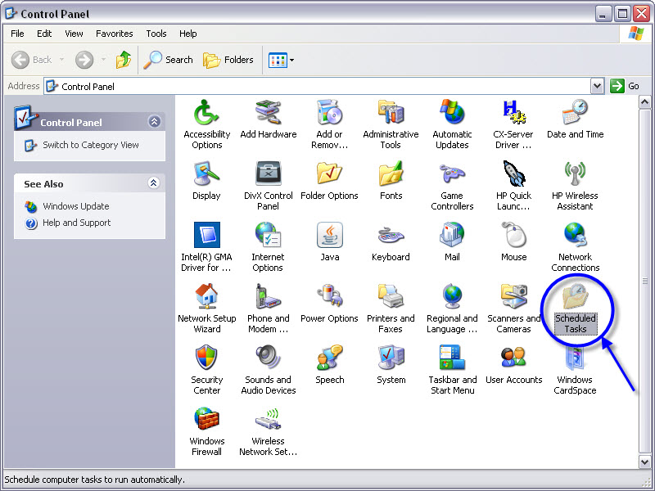
Figure 2-1 Scheduled Tasks on Control Panel

- The “Scheduled Tasks” will be appeared as depicted in Figure 2-2.

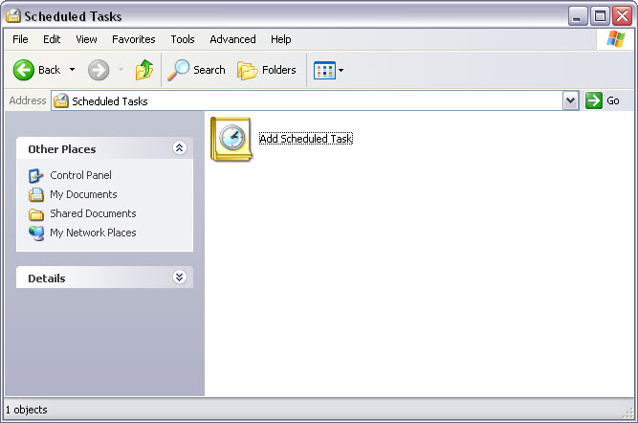
Figure 2-2 Add Scheduled Task

- To double-click on “Add Scheduled Task”, the wizard will be opened as Figure 2-3. Then, click “Next”.

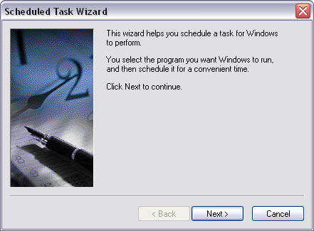
Figure 2-3 Scheduled Task Wizard

- The listed program will be displayed for selection as Figure 2-4, but we will click “Browse”.

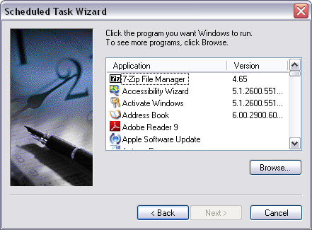
Figure 2-4 Select Program to Schedule

- The file dialog is opened for users to select program to schedule as Figure 2-5.

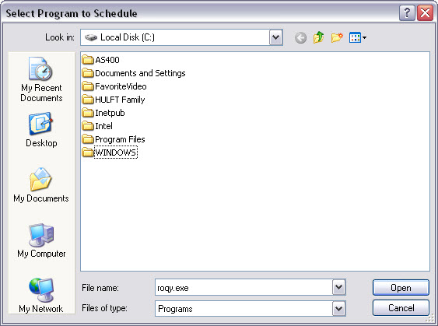
Figure 2-5 File-dialog to browse the Program

- To select the program, look in “C:\Program files\Microsoft\SQLServer\100\ Tools\Binn” as Figure 2-6.

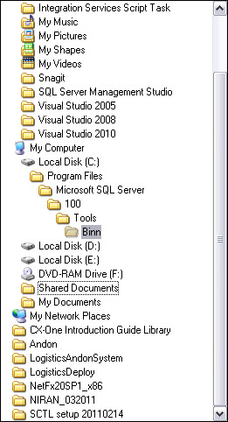
Figure 2-6 Tree Directory for the Program Targeted

- Select the file “SQLCMD.EXE” and click “Open” as Figure 2-7.

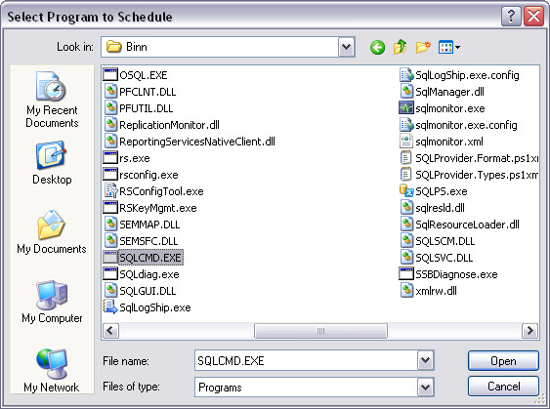
Figure 2-7 The Targeted Program “SQLCMD.EXE”

- Type a name for this task, for example, “FPS Database Backups” for PIS and “LMS Database Backups” for LMS, then select perform this task to “Daily” as Figure 2-8, then click “Next”.

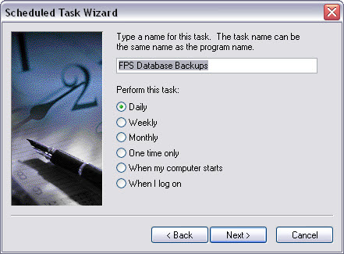
Figure 2-8 Setting a Name and Period for the Task

- Specify time and date to run this task, for example, “23:00” start on “4/18/2554” as Figure 2-9, then click “Next”.

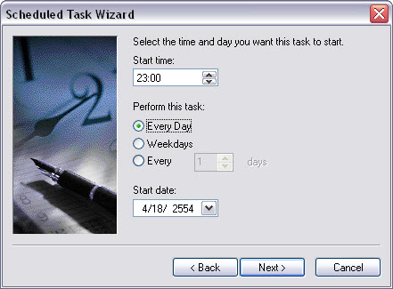
Figure 2-9 Setting a Time and Date for the Task

- Set Administrator’s password of the server as Figure 2-10, then click “Next”.

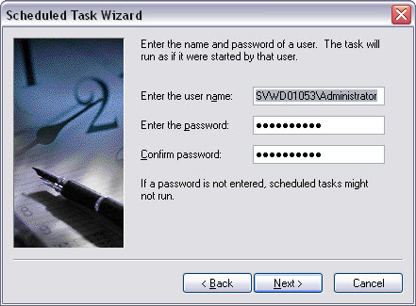
Figure 2-10 Setting Password and Confirm

- “Check” the open advanced properties box as Figure 2-11, then click “Finish”.

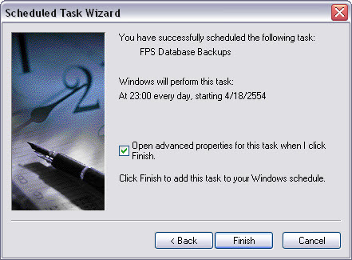
Figure 2-11 Finish the Scheduled Task Wizard

- The advanced properties window will be opened, check all fields as follows:

For PIS
Run: sqlcmd –S SVWD01053 –E –i F:\BAK_FPS\Backup_FPS.sql
For LMS
Run: sqlcmd –S SVWD01053 –E –i F:\BAK_LMS\Backup_LMS.sql

Start in: “C:\Program Files\Microsoft SQL Server\100\Tools\Binn”
Run as: SVWD01053\Administrator
Then click “OK”.
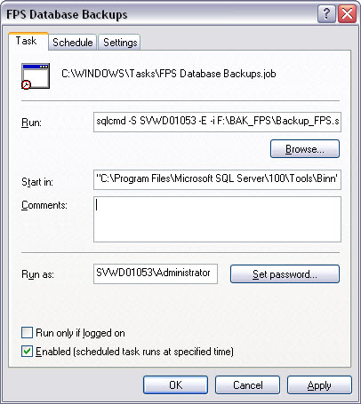
Figure 2-12 Setting Advanced Properties

- Right-click on the “FPS Database Backups” (or “LMS Database Backups”) ask and select “Run” to complete setting.

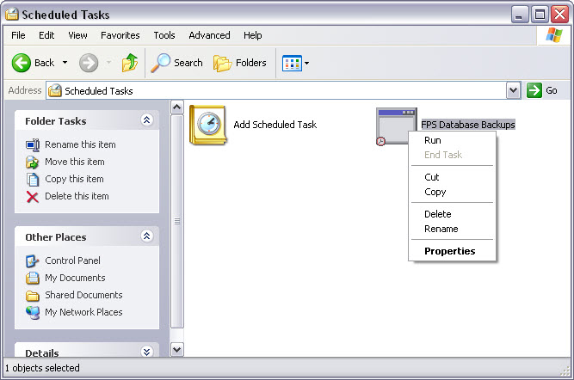
Figure 2-13 Run the Scheduled Task

- Steps 5 to 15 must be done separately for PIS and LMS.

