Isuzu Motors Co., (Thailand) Ltd.

RT50 Frame Shop ASM Line Production Instruction System
(Frame)

OPERATION MANUAL

OMRON

TABLE OF CONTENTS

1. OVERVIEW 5
2. FRAME-SERVICE 5
3. FRAME-SERVER 7
3.1 Manually File Import 9
3.2 Editing FRAME-SERVER Setting File 13
3.3 Editing database connection setting file 14
4. FRAME-CLIENT 16
4.1 Editing Database Connection Setting File 16
4.2 Main Menu: The first screen 18
4.3 Flow Setting 24
4.3.1 Understand the Flow Setting 24
4.3.2 Flow Setting Configuration 28
4.4 Production Data 31
4.4.1 Coloring on the Screen 31
4.4.2 Navigation on the Screen 32
4.4.3 ADDITION function 33
4.4.4 MAKE DATA function 45
4.4.5 SEARCH function 51
4.4.6 SKIP-INSERT function 53
4.4.7 DUMMY function 58
4.5 Instruction Schedule 64
4.5.1 Production Line Navigation 64
4.5.2 Change Function 66
4.5.3 Dummy Instruction 70
4.6 Data Log 74
5. DATABASE BACKUP………………………………………………………...76

TABLE OF FIGURES
Figure 2-1 Windows Task Manager 6
Figure 2-2 Restart PIS Scheduled Service Start Menu Shortcut 6
Figure 3-1 FRAME-SERVER Start Menu Shortcut 7
Figure 3-2 Data collection screen 8
Figure 3-3 Cut/Copy a file to manual import 9
Figure 3-4 Paste the file to the maual import path 10
Figure 3-5 System found new manual import file 11
Figure 3-6 Maual import success message 12
Figure 3-7 Backed up manual imported file 12
Figure 3-8 PIS-SERVER Setting File Start Menu Shortcut 13
Figure 3-9 FRAME-SERVER Connection Setting File Start Menu Shortcut 15
Figure 3-10 FRAME-SERVER Connection Setting File 15
Figure 4-1 FRAME-CLIENT Start Menu Shortcut 16
Figure 4-2 FRAME-CLIENT Connection Setting File Start Menu Shortcut 17
Figure 4-3 FRAME-CLIENT Connection Setting File 17
Figure 4-4 Main Menu Screen 18
Figure 4-5 Production Data Screen 19
Figure 4-6 Instruction Schedule Screen 20
Figure 4-7 Flow Setting Screen 21
Figure 4-8 Data Log Screen 22
Figure 4-9 Shutdown Screen 23
Figure 4-10 Flow Setting with 3 Groups of Field 24
Figure 4-11 UNIT and BLOCK Picture Description 25
Figure 4-12 Advance and Reverse Picture Description 26
Figure 4-13 Table in Flow Setting Screen 28
Figure 4-14 Input Checking Alert in Flow Setting Screen 28
Figure 4-15 Rejected Example in Flow Setting Policy 29
Figure 4-16 Other Rejected Example in Flow Setting Policy 29
Figure 4-17 Accepted Example in Flow Setting Policy 30
Figure 4-18 Buttons in Flow Setting Screen 30
Figure 4-19 Flow Setting Validated Dialog 30
Figure 4-20 Flow Setting Update Confirm Dialog 30
Figure 4-21 Production Data Screen with Coloring 31
Figure 4-22 Navigation Buttons on Production Data Screen 32
Figure 4-23 Move the Selection on the Top of Production Data Screen 33
Figure 4-24 Initial Production Data Screen 34
Figure 4-25 ADDITION Button with Coloring 34
Figure 4-26 Mix Data Screen with ALL Selection 35
Figure 4-27 Top of Mix Data Screen 35
Figure 4-28 Mix Data Screen with LOT Selection 36
Figure 4-29 Mix Data Screen with MULTI-SELECTION 36
Figure 4-30 Production Type Navigation on Mix Data Screen with Coloring 37
Figure 4-31 Mix Data Screen with PILOT Production Type 37
Figure 4-32 Mix Data Screen with EMERGENCY Production Type 38
Figure 4-33 Mix Data Screen with SERVICE Production Type 38
Figure 4-34 Mix Data Screen with CSO Production Type 39
Figure 4-35 Mix Data Screen with CLAIM Production Type 39
Figure 4-36 Function Buttons on the Mix Data Screen 40
Figure 4-37 Confirm Delete Dialog 40
Figure 4-38 Addition Buttons 40
Figure 4-39 Adding a LOT of MASS Production to Last 41
Figure 4-40 ADD TO LAST Confirm Dialog 41
Figure 4-41 Production Data Screen after ADD TO LAST 42
Figure 4-42 Updating a LOT of PILOT Production to the List 42
Figure 4-43 UPDATE Confirm Dialog 43
Figure 4-44 Addition Insert Screen for Choosing Update Position 43
Figure 4-45 Insert Data Confirm Dialog 43
Figure 4-46 Production Data Screen after UPDATE 44
Figure 4-47 Update Different LOT of Production Data 45
Figure 4-48 Update Same LOT of Production Data 45
Figure 4-49 Make Data Screen 46
Figure 4-50 Adding Production Data to the Listbox 47
Figure 4-51 Duplication in Listbox Alert Dialog 47
Figure 4-52 Deleting Production Data from the Listbox 48
Figure 4-53 Clearing the Production Data Textboxes 49
Figure 4-54 Duplication in Mix Data Screen Alert Dialog 49
Figure 4-55 Red Color Shading on the Duplicate Production Data 50
Figure 4-56 Production Data are Appended in the Mix Data Screen 50
Figure 4-57 Search Condition Screen 51
Figure 4-58 Off Date Calendar 51
Figure 4-59 Searching by Control Code 52
Figure 4-60 No Data Match with Search Condition 53
Figure 4-61 Skip the Locked Production Data 53
Figure 4-62 Unable to Skip Dialog 54
Figure 4-63 Skip the Unlocked Production Data 54
Figure 4-64 Skip Options 54
Figure 4-65 Confirm Skip Screen 55
Figure 4-66 Production Data Screen After Skip Operation 56
Figure 4-67 Skip Data Screen 57
Figure 4-68 Insert Confirm Dialog 57
Figure 4-69 Inserted Production Data Shaded with Yellow Color 58
Figure 4-70 Dummy of Production Data 58
Figure 4-71 Dummy of Production Data 59
Figure 4-72 Dummy of Production Data 59
Figure 4-73 Unable to Add Dummy at Locked Data 60
Figure 4-74 Add Dummy Confirm Dialog 61
Figure 4-75 Production Data with Dummy 61
Figure 4-76 Unable to Delete Production Data by DELETE DUMMY Button 62
Figure 4-77 Delete Dummy Confirm Dialog 63
Figure 4-78 Instruction Schedule Screen 64
Figure 4-79 Nine Lines Navigation on Instruction Schedule 64
Figure 4-80 Line Setting in Flow Setting Screen 65
Figure 4-81 Instruction Ordering Association with Flow Setting 66
Figure 4-82 Page Navigation on Instruction Schedule screen 66
Figure 4-83 Change Function on Instruction Schedule screen 67
Figure 4-84 Change Confirm Dialog 67
Figure 4-85 Changed Current Instruction 68
Figure 4-86 Instructed Data Locked on the Production Data Screen 68
Figure 4-87 Finish Instruction Schedule 69
Figure 4-88 All Instructions Finished on Instruction Schedule Screen 70
Figure 4-89 Dummy Instructions on Instruction Schedule Screen 71
Figure 4-90 Dummy Added from Production Data 71
Figure 4-91 Dummy Added from Instruction Schedule 71
Figure 4-92 Change to DUMMY Instruction 72
Figure 4-93 Change to DUMMY Instruction Result 73
Figure 4-94 DUMMY Instruction Change Result 73
Figure 4-95 Data Log Screen 74
Figure 4-96 Save Dialog on Data Log Screen 74
Figure 5-1 Scheduled Tasks on Control Panel 76
Figure 5-2 Add Scheduled Task 77
Figure 5-3 Scheduled Task Wizard 77
Figure 5-4 Select Program to Schedule 78
Figure 5-5 File-dialog to browse the Program 78
Figure 5-6 Tree Directory for the Program Targeted 79
Figure 5-7 The Targeted Program “SQLCMD.EXE” 79
Figure 5-8 Setting a Name and Period for the Task 80
Figure 5-9 Setting a Time and Date for the Task 80
Figure 5-10 Setting Password and Confirm 81
Figure 5-11 Finish the Scheduled Task Wizard 81
Figure 5-12 Setting Advanced Properties 82
Figure 5-13 Run the Scheduled Task 82

OVERVIEW

This system comprise of three main programs, FRAME-SERVER, FRAME-CLIENT, FRAME-SERVICE. The FRAME-SERVER is the program that runs on server and is used for monitoring AS400 related log, for manually import AS400 file, monitoring PLCs communication status, communicate with PLCs, and for manually retrieve file from AS400. For FRAME-CLIENT, it is the program that edit/display detail of production schedules and runs on individual operation terminal. FRAME-SERVICE is a background service that work as a scheduler to retrieve file from AS400, import AS400 file, delete old data in database, delete old local log file, and delete old AS400 file backup.

FRAME-SERVICE

FRAME-SERVICE is a windows service that runs as a background service and automatically starts on windows startup, it’s responsible for daily scheduled tasks including retrieving file from AS400, import retrieved AS400 file, delete old production data, delete old instruction schedule, delete old log, delete old log files and delete old AS400 file backup.
Normally user don’t have to interact with FRAME-SERVICE, user just have to set the parameter in PIS-Setting file for FRAME-SERVICE to operate correctly. For detailed information about editing PIS-Setting file please see Topic 3.2 “Editing PIS-SERVER Setting File”.
When FRAME-SERVICE is running, user can see a service named FRAME-SERVICE in Processes tab of Windows Task Manager as shown in Figure 2-1, but if there is no FRAME-SERVICE running, user can manually restart the FRAME-SERVICE by “Restart PIS Scheduled Service” shortcut in start menu as shown in Figure 2-2.

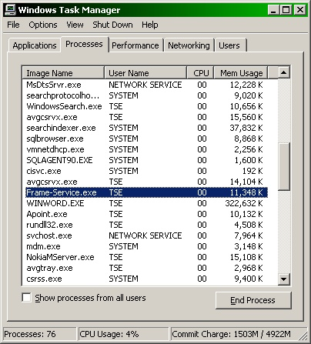
Figure 2-1 Windows Task Manager

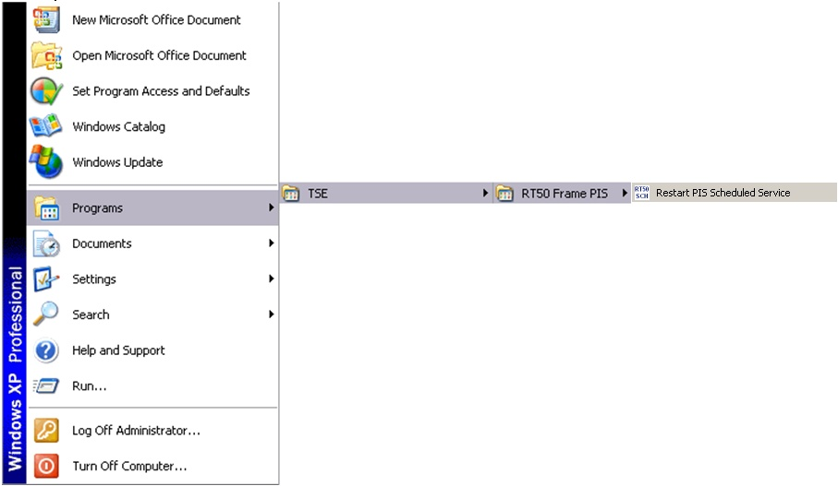
Figure 2-2 Restart PIS Scheduled Service Start Menu Shortcut

FRAME-SERVER

FRAME-SERVER is a program that runs on the server to send production data to ASM Line PLCs, to manually import Production Data file from AS400, to monitor AS400 related activities and to monitor ASM Line PLCs communication status. User can open FRAME-SERVER program by  shortcut on Desktop or by shortcut in start menu shown in Figure 3-1. The screen of FRAME-SERVER is shown in Figure 3-2.

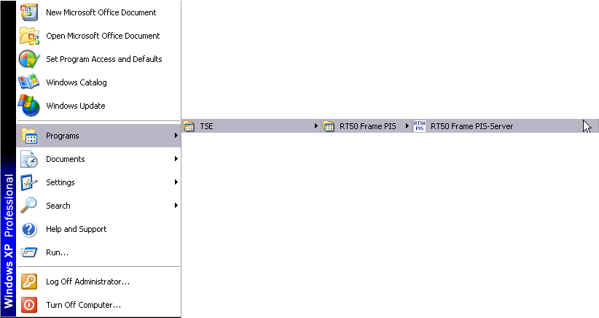
Figure 3-3 FRAME-SERVER Start Menu Shortcut

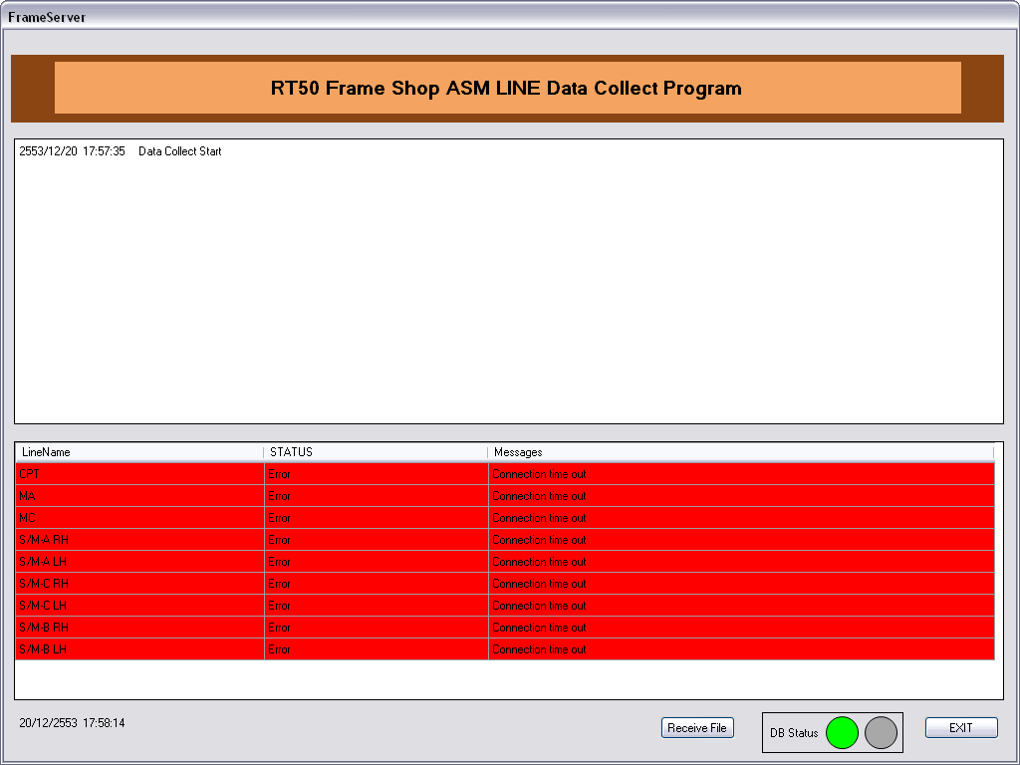
1
2
3
4
5
Figure 3-4 Data collection screen

Following are functions available in FRAME-SERVER program
- AS400 Log Monitoring
User can monitor AS400 file retrieving and importing log message in (1) of Figure 3-2, newest message will be on the top and maximum number of messages that can be shown can be set in “RT50 Body PIS-Setting File”
- ASM Line PLC Connection Status
User can monitor PLC communication status of each production line in (2) of Figure 3-2, if the status shown in “STATUS” column is “Normal” then that line will be displayed in white background, but if the status is “Error” then that line will be displayed in red background. When the status is “Error”, an error message which describes the error will be shown in the “Messages” column.
- Receive File
There are some cases whrere AS400 file cannot be retrieved at the scheduled time, and user may want to retrieve it before the next scheduled time. Button (3) of Figure 3-2 is the Receive File button which is for manually retrieving AS400 file.
- Database Connection Status
(4) of Figure 3-2 displays database connection status of the application, if the system can connect to the database then green color will be shown, but if there is any database connecticity problem then red color will be shown.
- Exit
Button (5) of Figure 3-2 is the Exit button which is for closing the FRAME-SERVER program.

Manually File Import

In some case, for example system has been down when an AS400 file was received, user may want to manually import an AS400 file. In FRAME-SERVER there is a function that will set a specified path as a dropbox and will automatically try to import any file that is placed in the specified path. Note that to manually import a file FRAME-SERVER program must be running. The path is specified in the “WatchPath” of PIS-SERVER Setting File, default path set when install is “C:\AS400\ManualImport”. To import a file user just have to copy the file to the specified path, and after importing whether it success or not, system will automatically move the file to the backup folder specified in “BackupWatchPath” of PIS-SERVER Setting File, and group the files into the folder by date.
To import a file please follow the following steps
- Select a file to import then Cut/Copy it as in Figure 3-3

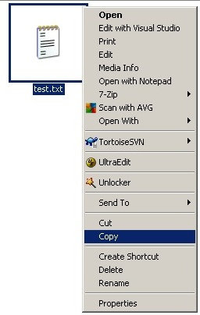
Figure 3-5 Cut/Copy a file to manual import

- Open the manual import path specified in the “WatchPath” of PIS-SERVER Setting File, default path is “C:\AS400\ManualImport” and then Paste it as in Figure 3-4. If system found a new manual import file then there will be messages shown on FRAME-SERVER screen as Figure 3-5.

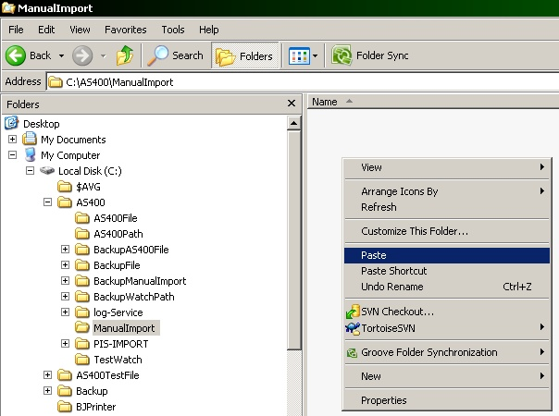
Figure 3-6 Paste the file to the maual import path

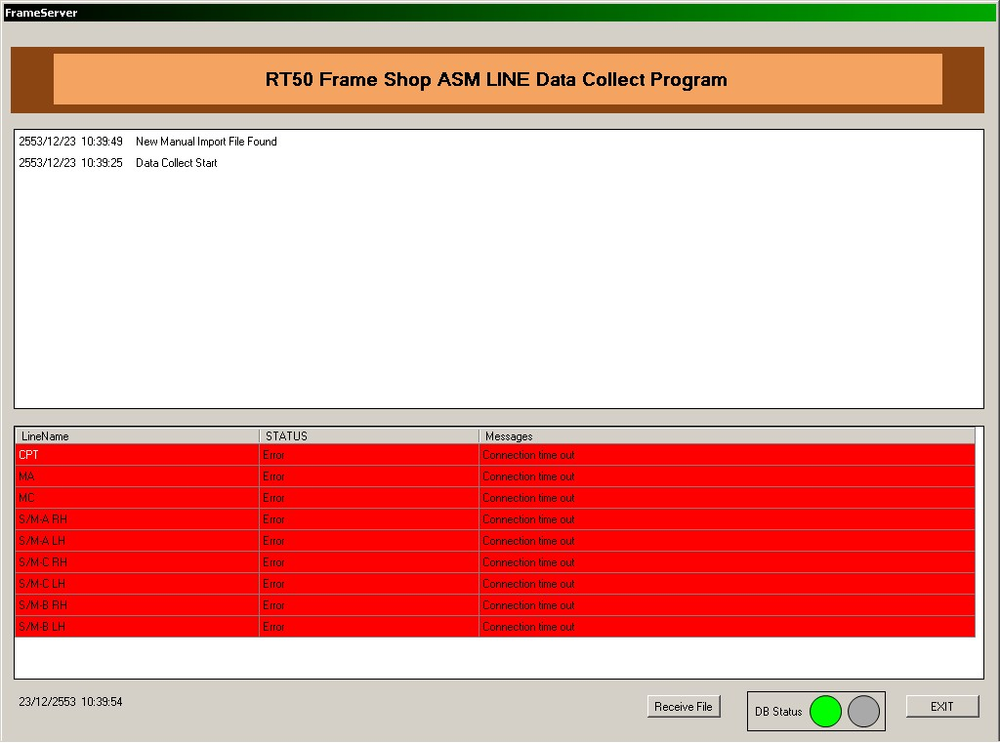
Figure 3-7 System found new manual import file

- After importing is completed, a message will be shown on FRAME-SERVER screen as in Figure 3-6. The imported file is then renamed and moved to backup folder specified in “BackupWatchPath” of PIS-SERVER Setting File, default path is “C:\AS400\ BackupManualImport” and is grouped in to a sub folder by date as in Figure 3-7.

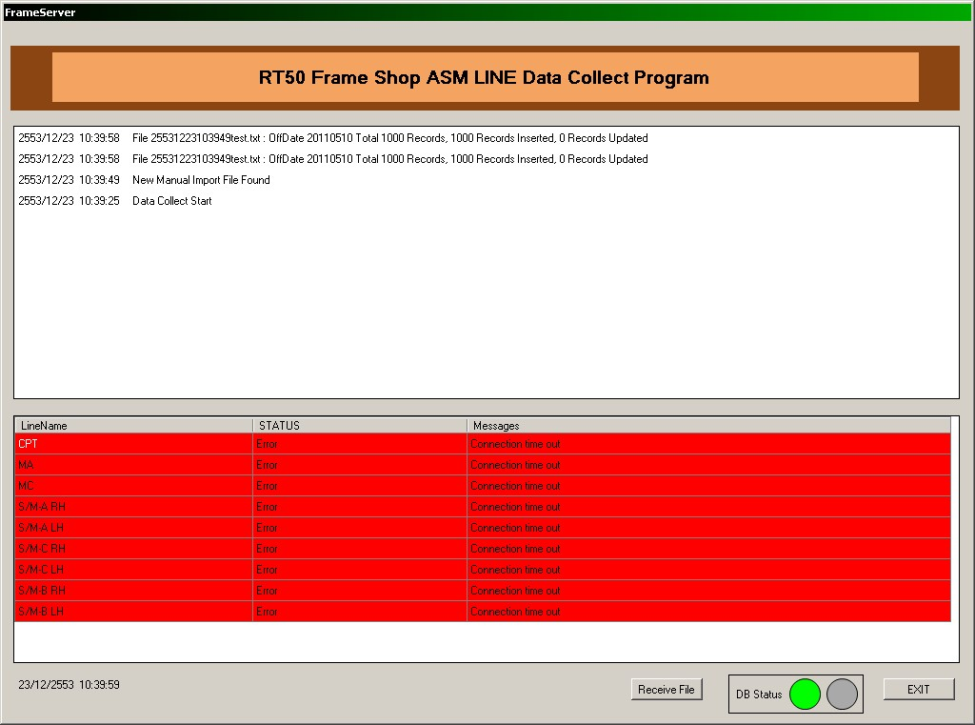
Figure 3-8 Maual import success message

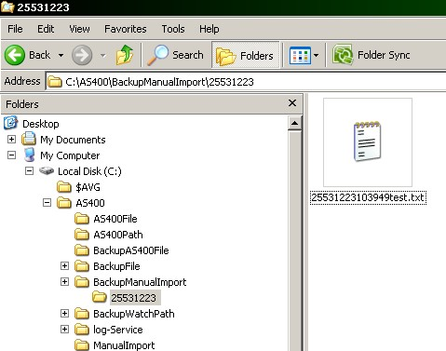
Figure 3-9 Backed up manual imported file

Editing FRAME-SERVER Setting File
Settings in the System Setting screen are production line related setting which are different by line, but there are also some settings that are used only on the server which are stored in an INI file named “PIS-Setting.ini”. There is a shortcut to this file in start menu shown in Figure 3-8.

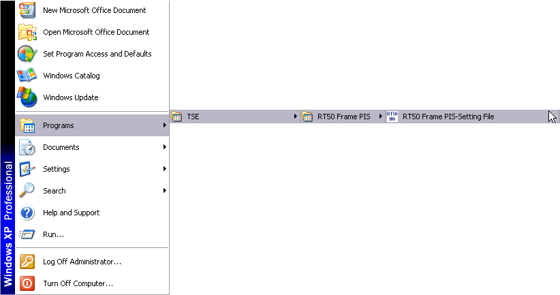
Figure 3-10 PIS-SERVER Setting File Start Menu Shortcut

The settings that can be edited in the PIS-Setting.ini file are shown in the following table.
FIELD | DEFINITION
ServerNode | Node address that server use to communicate with PLCs
ServerStatusAddress | DM address of PLC that server write server status
AS400Path | Path that AS400 file is saved when retrieving file from AS400, this path must match with setting in HULFT
WatchPath | Path that use to manually import AS00 file
BackupAS400Path | Path that retrieved AS400 file is moved to back up
BackupWatchPath | Path that manually import AS400 file is moved to back up
AS400Period | Period that AS400 related log is kept in database before being deleted by scheduled service
PLCPeriod | Period that PLC communication related log is kept in database before being deleted by scheduled service
LogPeriod | Period that opeation related log is kept in database before being deleted by scheduled service
dbPeriod | Period that production data is kept in database and period that backed up files are kept before being deleted by scheduled service
DisplayRowCount | Maximum number of AS400 related log that can be displayed on PIS-SERVER screen
ScheduleTime | Time that scheduled service operates daily
HulftCmdPath | Path that HULFT command, for example “utlrecv”, can be execute
HulftSaveFile | Full path of AS400 file that will be saved by HULFT, this path must match with file receiving setting in HULFT
HulftKickFile | Full path of 0kB file that will be send to AS400 by HULFT, this path must match with file sending setting in HULFT
HulftRecvId | Receiving file ID set in HULFT for retrieving AS400 file, this file ID must match with file ID set in HULFT
HulftSendId | Sending job ID set in HULFT for sending response file to AS400, this job ID must match with job ID set in HULFT
AS400Host | Host name of AS400 set in host file on server

Editing database connection setting file

FRAME-SERVER connects to database using connection setting defined in a configuration file. There is a shortcut to this file in start menu shown in Figure 3-9, detailed in the file is as Figure 3-10, line with the connection related setting is highlighted.

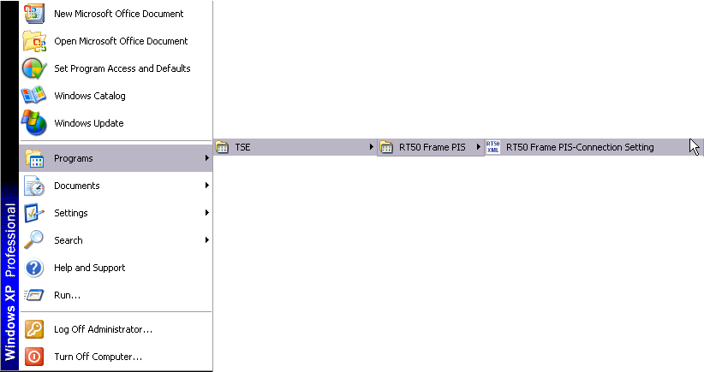
Figure 3-11 FRAME-SERVER Connection Setting File Start Menu Shortcut

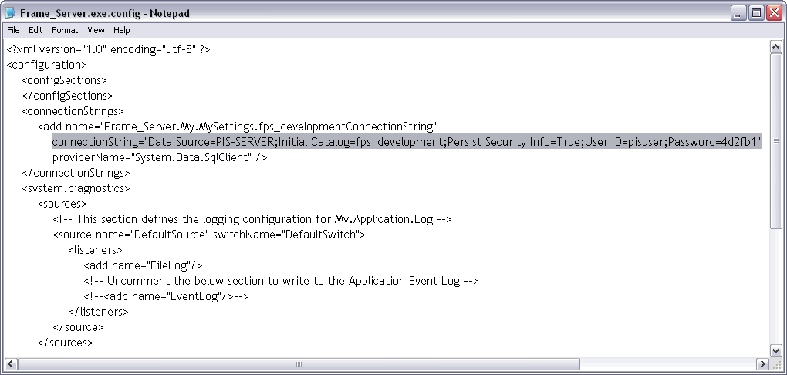
Figure 3-12 FRAME-SERVER Connection Setting File

To edit connection setting, edit following fields in the connection setting file.
FIELD | DEFINITION
Data Source | Host name of database server, in case of this system is host name of the server itself.
Initial Catalog | Name of database used in system
User ID | Username used to access the database
Password | Password used to access the database

FRAME-CLIENT

FRAME-CLIENT is a program that runs on the client PC computer allowing user to add/delete production data, to design production schedules for ASM Line PLCs, and to monitor AS400, PLCs and User operation activities. User can open FRAME-CLIENT program by  shortcut on Desktop or by shortcut in start menu shown in Figure 4-1. The program will be demonstrated as in Figure 4-4.

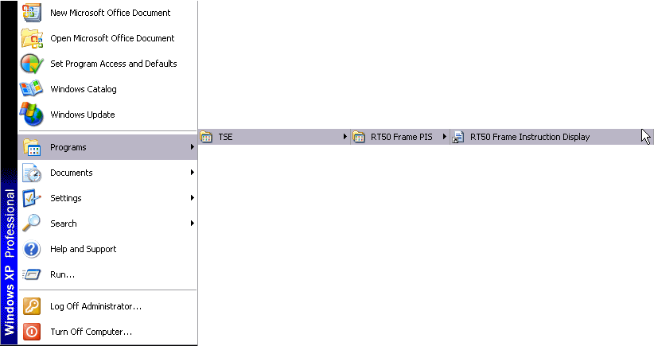
Figure 4-13 FRAME-CLIENT Start Menu Shortcut

Editing Database Connection Setting File

Same as the FRAME-SERVER program, user can edit the database connection setting by going to the start menu -> Programs -> TSE -> RT50 Frame PIS -> RT50 Frame Instruction Connection Setting, as shown in Figure 4-2. The file will be opened in an editor program as illustrated by Figure 4-3.
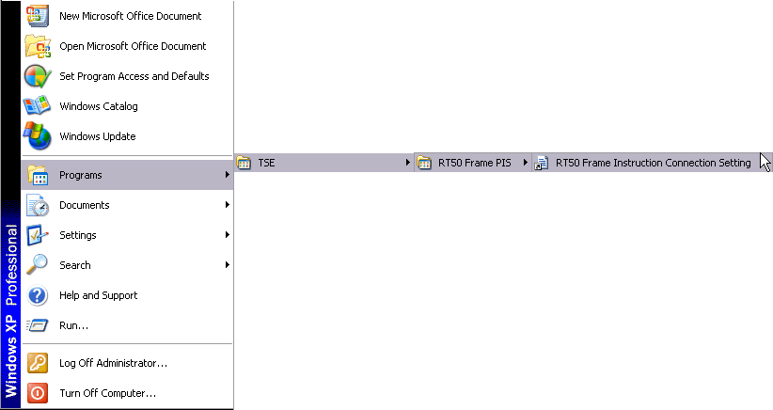
Figure 4-14 FRAME-CLIENT Connection Setting File Start Menu Shortcut

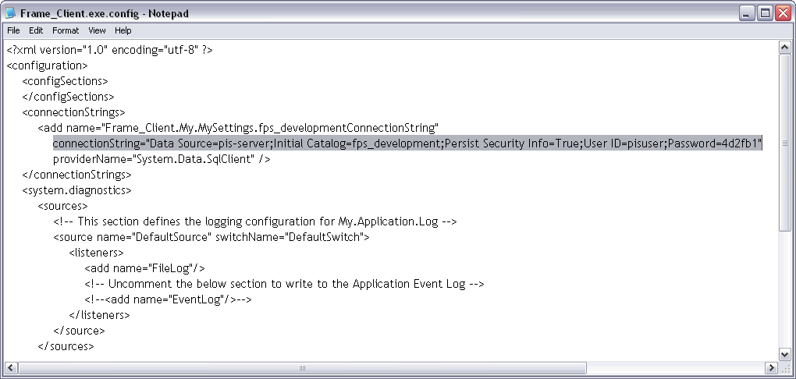
Figure 4-15 FRAME-CLIENT Connection Setting File

To edit connection setting, edit following fields in the connection setting file.
FIELD | DEFINITION
Data Source | Host name of database server, in case of this system is host name of the server itself.
Initial Catalog | Name of database used in system
User ID | Username used to access the database
Password | Password used to access the database

Main Menu: The first screen

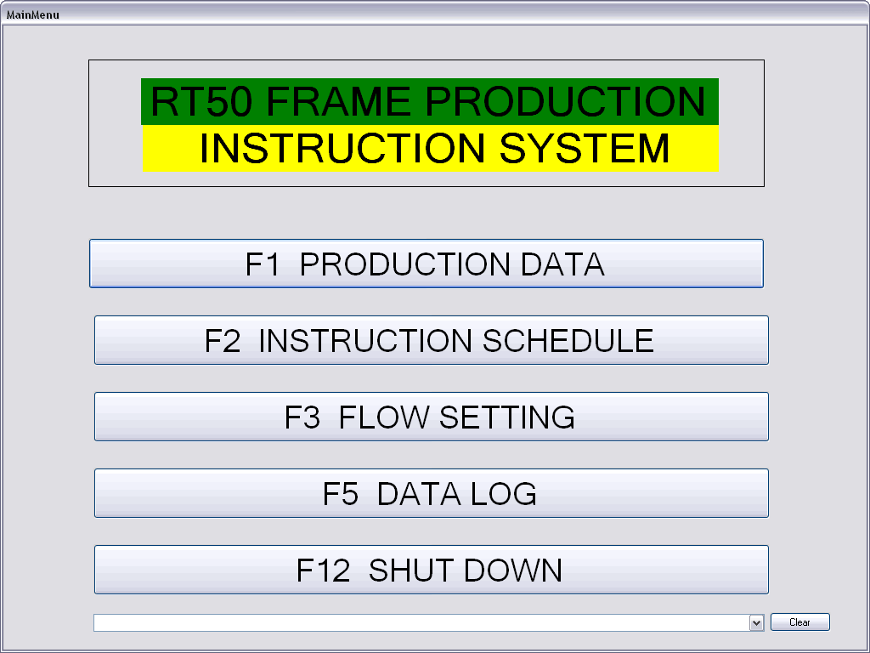
Figure 4-16 Main Menu Screen

The main menu contains 5 screen functions. User can click the mouse at the button or press the key F1 for Production Data, F2 for Instruction Schedule, F3 for Flow Setting, F5 for Data Log, and F12 for Shutdown as illustrated in Figure 4-4.

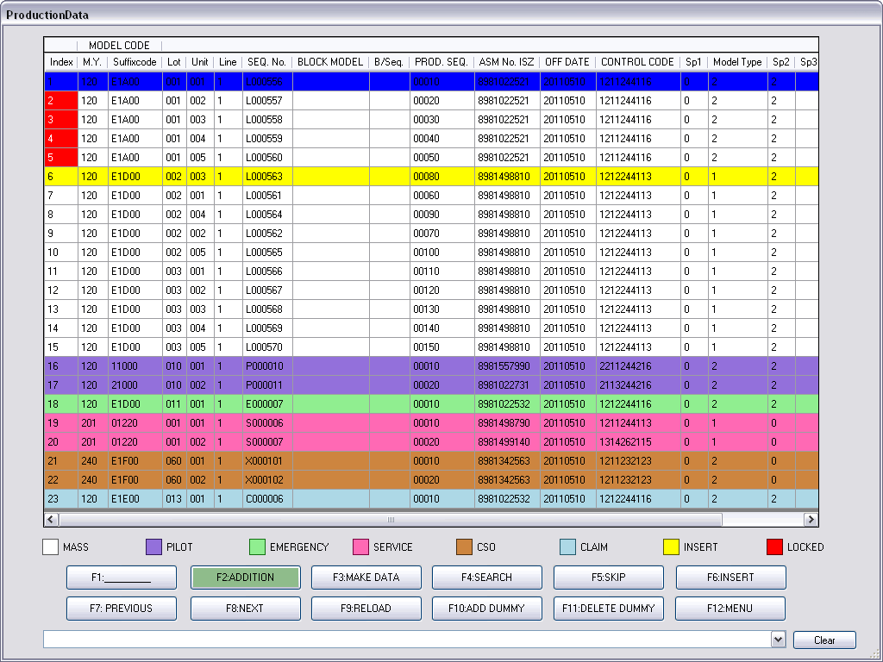
Figure 4-17 Production Data Screen

- Production Data
The FRAME-CLIENT program allows user to add/delete production data, which is gathered from AS400, on the Production Data screen shown in Figure 4-5. User can add new production data to the last of the list or insert to any permitted position of the list. If any production data should be deleted, user can skip them from the list to store in skip list. User can later re-insert the skipped data to the list again. Further, the program provides the data making screen for user to create new production data which is not collected from AS400. After user finish the list and close the Production Data screen, all production data will be sent to the Instruction Schedule screen. User can read more details in the Production Data section.

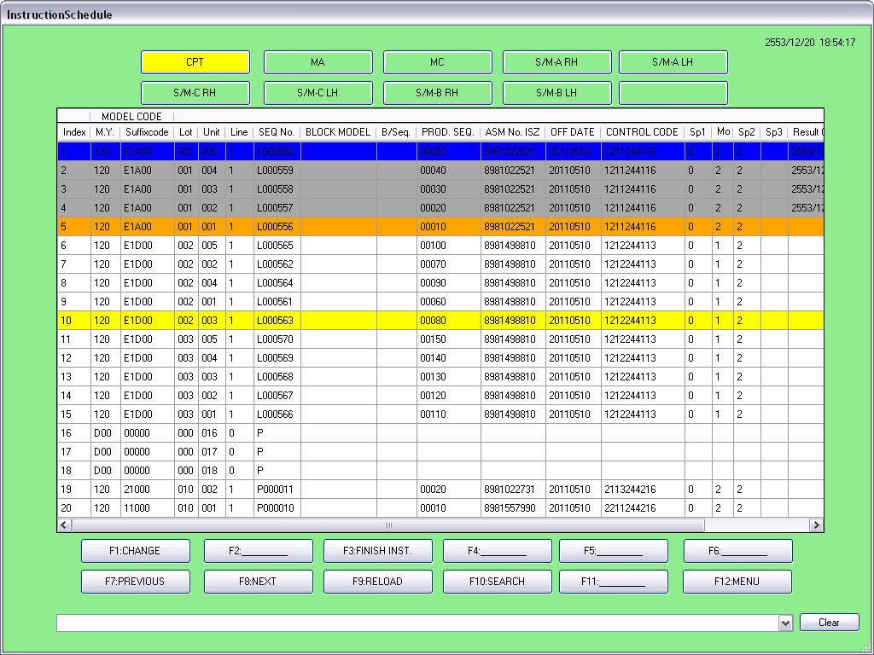
Figure 4-18 Instruction Schedule Screen

- Instruction Schedule
The Instruction Schedule screen, depicted at Figure 4-6, shows user an instruction ordering for each production line. The ordering of the schedule is based on the Flow Setting configuration that different orderings of each production line are accepted (see more details of configuration in the Flow Setting section). User can know which instruction has been sent to PLC lines and which instruction is the next sending. The program allows user to change the current instruction to any position along the list. The change operation gives user a chance to re-send some passed instructions, to ignore any unnecessary instructions, or to finish all instructions. User can see the operation manual in the Instruction Schedule section.

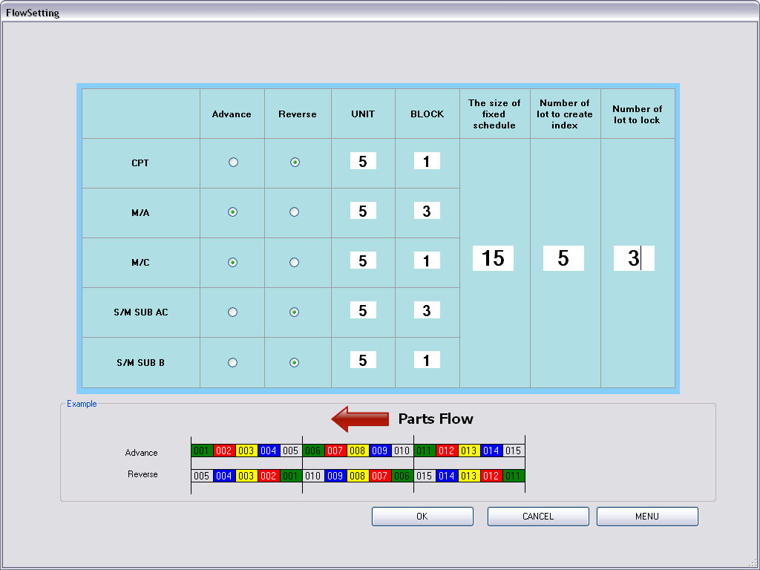
Figure 4-19 Flow Setting Screen

- Flow Setting
The Flow Setting screen, as shown in Figure 4-7, allows user to configure how many instruction in each UNIT, how many UNIT in each BLOCK, or which ordering type (Advance or Reverse) in each UNIT. The program allows user to configure different settings for different production line.
User can set LOCK SIZE for the schedule. The program will create a lock area that means user cannot insert or delete any instruction in this area. Further, user can define No. of lock and No. of prepare to lock to manage the lock area. The more detail and description can find in the Flow Setting section.

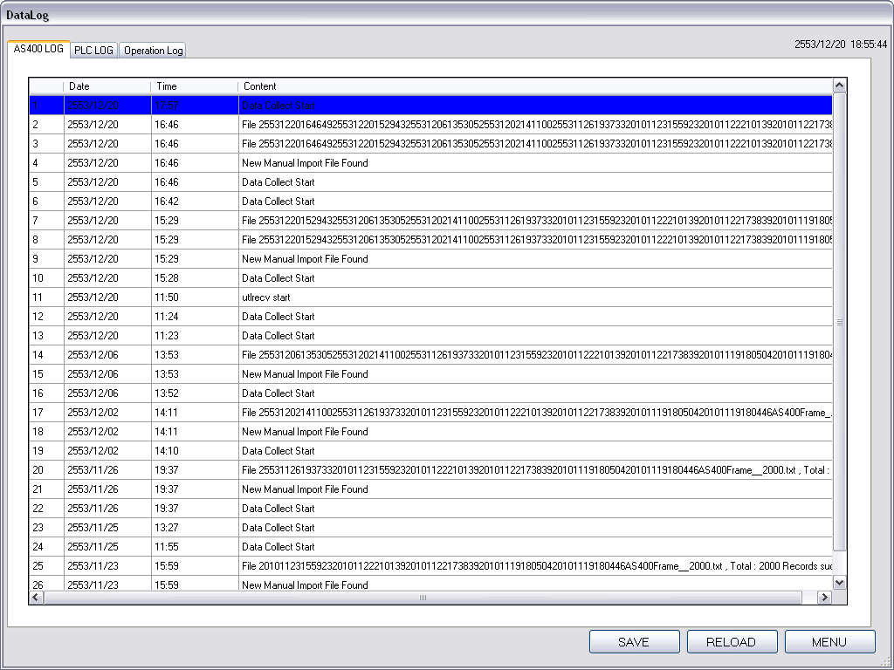
Figure 4-20 Data Log Screen

- Data Log
The FRAME-CLIENT program provides three types of data log, demonstrated at Figure 4-8, as follows.
- AS400 Log – contains log operations of data communication between the FRAME-SERVER and AS400 server. The log will show all history of data receives and occurrence of error data.
- PLC Log – contains log operations of instruction transmission between the FRAME-SERVER and PLC machines. The log will show all sent data and all error in data transfer.
- Operation Log – contains log operations of all user actions taking with the Production Data screen and Instruction Schedule screen. The log will record all add/insert/delete/skip operations on the Production Data screen, all change operations on the Instruction Schedule screen, and all mistaken operations.
The more detail of Data Log is described in the Data Log section.

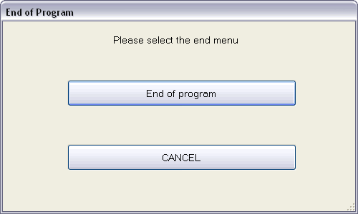
Figure 4-21 Shutdown Screen

- Shutdown
User can terminate the FRAME-CLIENT program by clicking the Shutdown button to show Shutdown Screen as shown in Figure 4-9, then click “End of program” otherwise click CANCEL to return to the Main Menu screen.

Flow Setting

Understand the Flow Setting

2
3
1
Figure 4-22 Flow Setting with 3 Groups of Field

To understand the Flow Setting configuration, we will classify fields into 3 groups as shown in Figure 4-10.

- UNIT and BLOCK
To simply understand, a BLOCK contains UNITs, a UNIT contains instructions. The order of UNITs in BLOCK must be descending. If one BLOCK contains one UNIT, the descending order and no order are indentical.
For Figure 4-11 (a), the setting is UNIT = 5 and BLOCK = 1 that means a BLOCK contains 1 UNITs, a UNIT contains 5 instructions, and the order of UNIT is descending that is identical to the no order.
For Figure 4-11 (b), the setting is UNIT = 5 and BLOCK = 3 that means a BLOCK contains 3 UNITs, a UNIT contains 5 instructions, and the order of UNIT is descending that UNIT #3 is moved to the first order.
a) UNIT = 5, BLOCK = 1
b) UNIT = 5, BLOCK = 3

BLOCK #1

UNIT #3

Instruction #11
Instruction #12
Instruction #13
Instruction #14
Instruction #15

UNIT #2

Instruction #6
Instruction #7
Instruction #8
Instruction #9
Instruction #10

UNIT #1
Instruction #1
Instruction #2
Instruction #3
Instruction #4
Instruction #5

BLOCK #2

UNIT #1

Instruction #6
Instruction #7
Instruction #8
Instruction #9
Instruction #10

BLOCK #3

UNIT #1

Instruction #11
Instruction #12
Instruction #13
Instruction #14
Instruction #15

BLOCK #1

UNIT #1

Instruction #1
Instruction #2
Instruction #3
Instruction #4
Instruction #5

Figure 4-23 UNIT and BLOCK Picture Description

- Advance and Reverse
Advance and Reverse is the ordering types that Advance is ascending order and Reverse is descending order. To set Advance or Reverse means to only change the instruction order in each UNIT.
For Figure 4-12 (a), the setting is UNIT = 5, BLOCK = 3, Advance that means a BLOCK contains 3 UNITs, a UNIT contains 5 instructions, the order of UNIT is descending, and the order of instructions in each UNIT is ascending.
For Figure 4-12 (b), the setting is UNIT = 5, BLOCK = 3, Advance that means a BLOCK contains 3 UNITs, a UNIT contains 5 instructions, the order of UNIT is descending, and the order of instructions in each UNIT is descending.
b) UNIT = 5, BLOCK = 3, Reverse

BLOCK #1

UNIT #3

Instruction #15
Instruction #14
Instruction #13
Instruction #12
Instruction #11

UNIT #2

Instruction #10
Instruction #9
Instruction #8
Instruction #7
Instruction #6

UNIT #1
Instruction #5
Instruction #4
Instruction #3
Instruction #2
Instruction #1
a) UNIT = 5, BLOCK = 3, Advance

BLOCK #1

UNIT #3

Instruction #11
Instruction #12
Instruction #13
Instruction #14
Instruction #15

UNIT #2

Instruction #6
Instruction #7
Instruction #8
Instruction #9
Instruction #10

UNIT #1
Instruction #1
Instruction #2
Instruction #3
Instruction #4
Instruction #5

Figure 4-24 Advance and Reverse Picture Description

- Lock Area
There are 3 fields associated in the Lock Area setting as follows.
- The size of fixed schedule (Lock Size) – is number of instructions to be locked. For example, the value is set to 15 or Lock Size = 15. The program will lock the first 15 non-lock instructions if there are at least 15 non-lock instructions in the production list. So, the program will not lock if number of non-lock instructions is less than the setting value.
- Number of lot to create index (Index Lot) – is maximum number of Lock Size to display on the Instruction Schedule screen. For example, the value is set to 5 and Lock Size = 15. This means 75 instructions (15 x 5 = 75) will be shown on the screen. However, if number of instructions is not full at Lock Size, those instructions will not be displayed on the screen. For example, there are 50 instructions. The first 45 instructions will be displayed. For more example, see at the below table.
 | Lock Size = 15, Index Lot = 5
No. in list | 5 | 15 | 20 | 35 | 50 | 60 | 75 | 80 | 90
No. display | 0 | 15 | 15 | 30 | 45 | 60 | 75 | 75 | 75

- Number of lot to lock (Lock Lot) – is maximum number of Lock Size to lock the instructions. For example, the value is set to 3, Lock Size = 15, and Index Lot = 5. This means 75 instructions (15 x 5 = 75) will be displayed on the screen and first 45 of 75 instructions (15 x 3 = 45) will be locked. If number of instructions is not full at Lock Size, those instructions will not be locked and also not be displayed on the screen. For more example, see at the below table.
 | Lock Size = 15, Index Lot = 5, Lock Lot = 3
No. in list | 5 | 15 | 20 | 35 | 50 | 60 | 75 | 80 | 90
No. of lock | 0 | 15 | 15 | 30 | 45 | 45 | 45 | 45 | 45
No. display | 0 | 15 | 15 | 30 | 45 | 60 | 75 | 75 | 75

Flow Setting Configuration

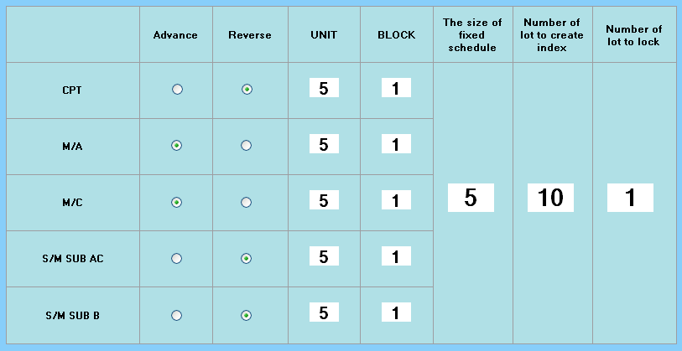
Figure 4-25 Table in Flow Setting Screen

The FRAME-CLIENT program allows user to configure the Flow Setting of five production line types: CPT, M/A, M/C, S/M SUB AC, and S/M SUB B, as shown in Figure 4-13. The value of Advance/Reverse, UNIT, and BLOCK are each line setting, so user can set them different values. “The size of fixed schedule” (Lock Size), “Number of lot to create index” (Index Lot), and “Number of lot to lock” (Lock Lot) are global setting, so they must have same values for all production lines.

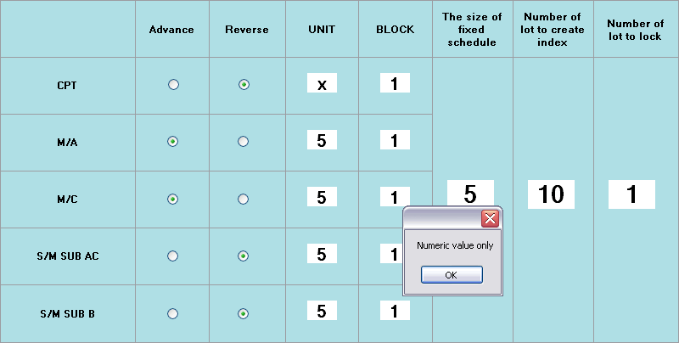
Figure 4-26 Input Checking Alert in Flow Setting Screen

The program forces user to choose either Advance or Reverse for each production line by selecting radio button. For value settings in textbox, the program allows user to input numeric value only. If user tries to put alphabets or special characters, the alert dialog will be displayed as shown in Figure 4-14. The program disallows user to do anything while the value in textbox is still incorrect.

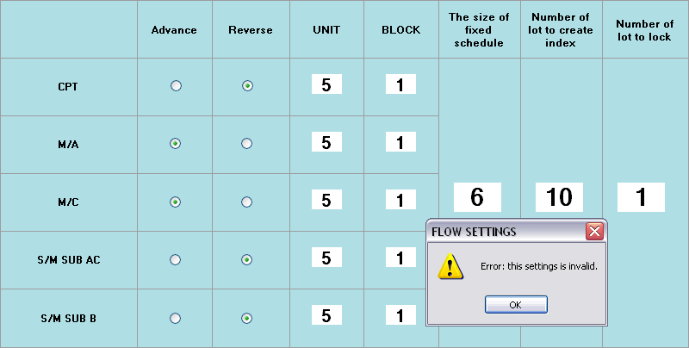
Figure 4-27 Rejected Example in Flow Setting Policy

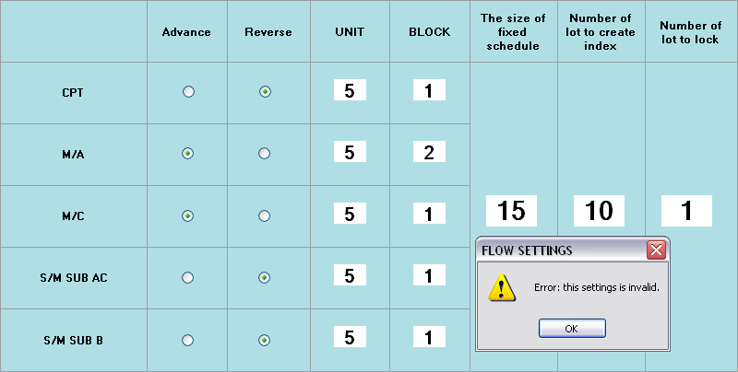
Figure 4-28 Other Rejected Example in Flow Setting Policy

There is one policy of the Flow Setting configuration that is an association among UNIT, BLOCK and Lock Size. The policy is {{Lock Size MOD {UNIT x BLOCK}} = 0}. As shown in Figure 4-15, {{Lock Size = 6 MOD {UNIT = 5 x BLOCK = 1}} NOT 0} is rejected. The alert dialog is displayed after the OK button is clicked. Figure 4-16 shows policy rejected because one of lines is still incorrect. Figure 4-17 shows that accepted policy means all lines must be correct.

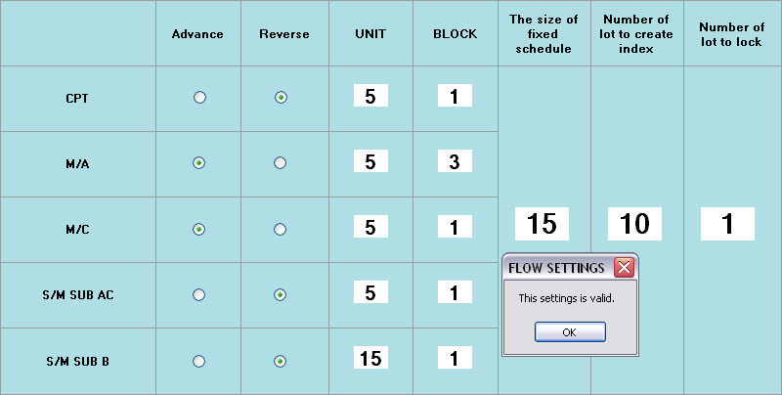
Figure 4-29 Accepted Example in Flow Setting Policy

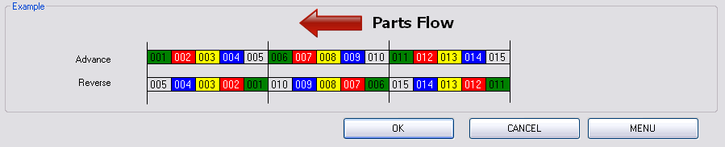
Figure 4-30 Buttons in Flow Setting Screen

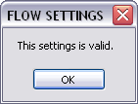
Figure 4-31 Flow Setting Validated Dialog

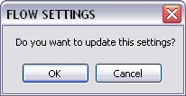
Figure 4-32 Flow Setting Update Confirm Dialog

User can exit from the Flow Setting screen by clicking on CANCEL or MENU button as shown in Figure 4-18. It will be returned to the Main Menu screen without any setting update. To select OK button, the Figure 4-19 dialog will be displayed if the setting is valid. Then, the confirm dialog for setting update will be opened as in Figure 4-20. If user selects OK, the new setting is updated to the database.

Production Data

Coloring on the Screen

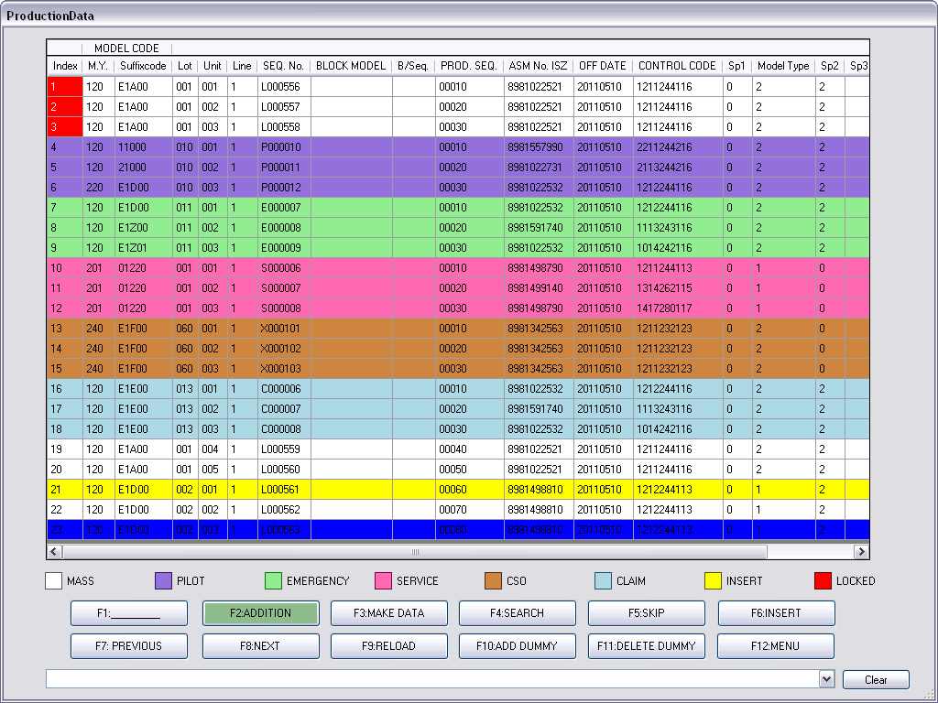
1
2
3
Figure 4-33 Production Data Screen with Coloring

For the production data, there are six types of data: MASS, PILOT, EMERGENCY, SERVICE, CSO, and CLAIM. The Production Data screen helps user to distinguish different types of data by type coloring. In Figure 4-21, the coloring can split into 3 groups as follows.
- Production data types – are 6 types with 6 colors shading on the production data.
- Inserted production data – is the skipped production data which is later re-inserted.
- Locked production data – is the production data which is already transmitted to PLCs or which is covered by the lock area. User cannot do anything with the locked production data

Navigation on the Screen

The program allows user to use UP/DOWN button on keyboard to move the current selection (blue color shading) throughout the production list. For page navigation, user can use PREVIOUS/NEXT buttons (or F7/F8 on keyboard) to change the page, as shown in Figure 4-22. Refreshing the page can be done by clicking RELOAD button or F9.

Figure 4-34 Navigation Buttons on Production Data Screen

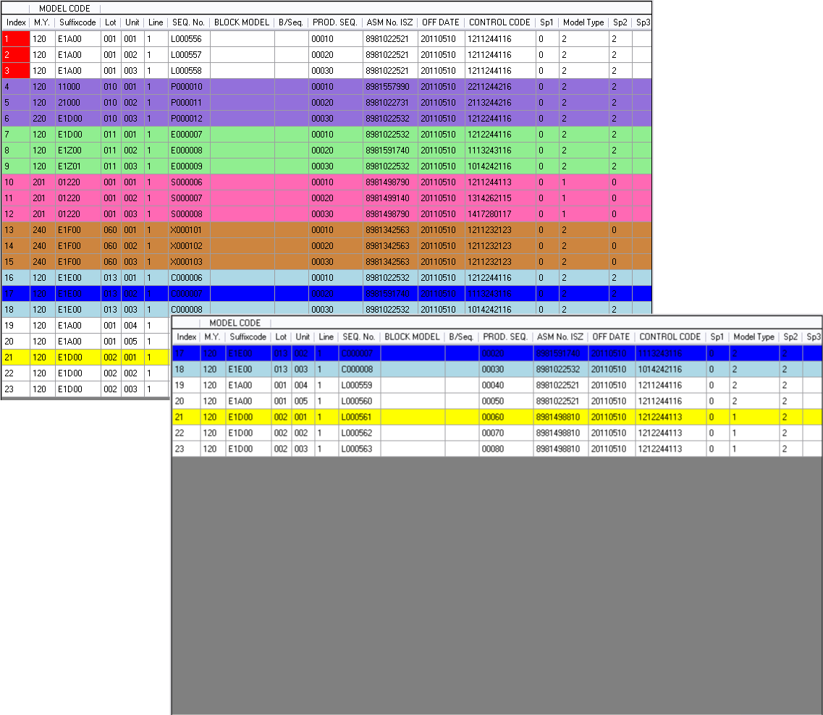
Click on Right-Mouse Button or Press CTRL-T
Figure 4-35 Move the Selection on the Top of Production Data Screen

Sometimes user still focuses on a production data and wants to move it to the top of the screen. The program allows user to do this action by selecting the focused production data, then clicking on right-button of the mouse or CTRL-T on keyboard. The selected production data will be shown at the top of the screen, as shown in Figure 4-23.

ADDITION function

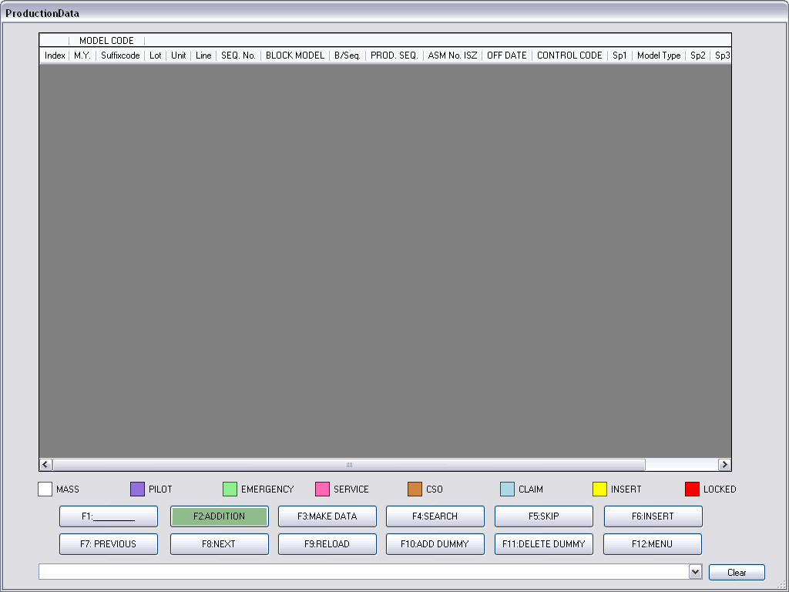
Figure 4-36 Initial Production Data Screen

For initial Production Data screen, there is no production data on the list as shown in Figure 4-24. The production data which are both received from the AS400 server and manually imported from the file will not be displayed on this screen but on the Mix Data screen accessing by clicking the ADDITION button or F2.

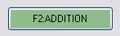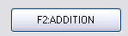
Figure 4-37 ADDITION Button with Coloring

If there are some production data on the Mix Data screen, the ADDITION button will be colored otherwise no color, as demonstrated at Figure 4-25. Entering to the Mix Data screen, Figure 4-26 will be displayed.

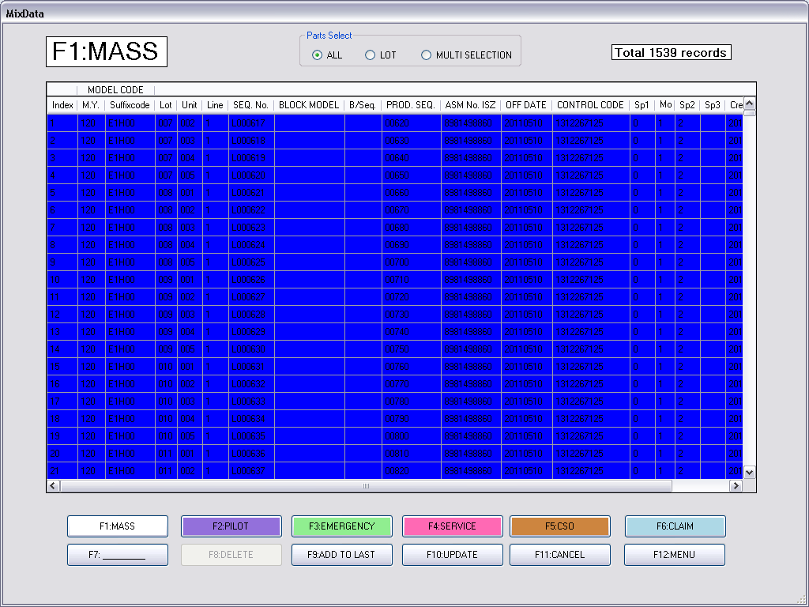
Figure 4-38 Mix Data Screen with ALL Selection

Figure 4-39 Top of Mix Data Screen

At the top of the screen as shown in Figure 4-27, the left-hand text mentions the production data types. The center control box is Parts Select which allows user to select the product data in the list by ALL, LOT, or MULTI-SELECTION. The right-hand information is total number of the production data type.
For Parts Select, if user chooses ALL, all records of the production data will be selected (blue color shading) as in Figure 4-26. In case of LOT selection, user can choose each only one LOT that LOT means a set of production data containing same MODEL CODE and LOT as depicted at Figure 4-28. For MULTI-SELECTION, user can freely choose any production data as demonstrated at Figure 4-29.

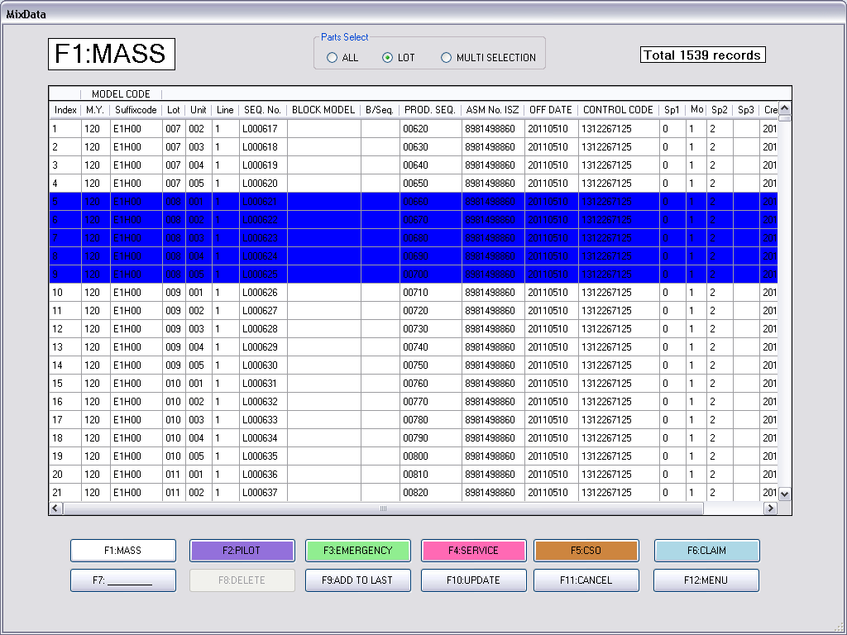
Figure 4-40 Mix Data Screen with LOT Selection

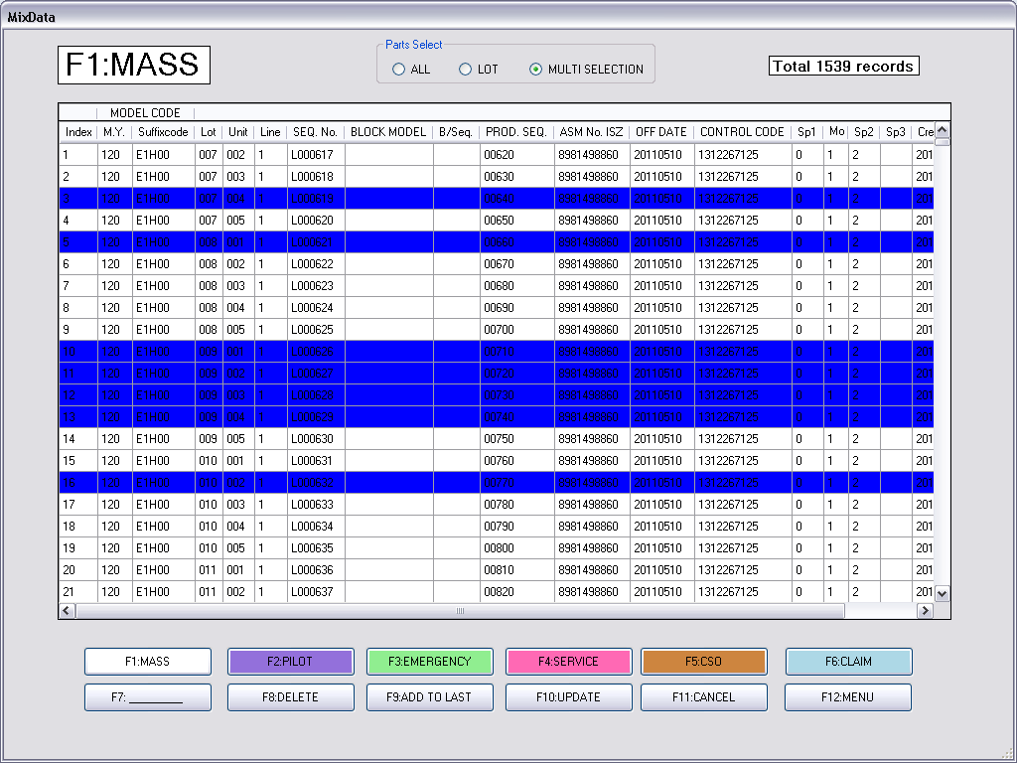
Figure 4-41 Mix Data Screen with MULTI-SELECTION

Figure 4-42 Production Type Navigation on Mix Data Screen with Coloring

At the bottom of the Mix Data screen, there are 6 buttons associated with 6 production types as shown in Figure 4-30. User can see each type of production data by clicking on the buttons. The coloring on the buttons informs user to know whether those types still have production data or not. If the button is shaded, there exists the production data otherwise there is no data. Trying to see various production data types on the screen starting at PILOT until CLAIM is shown in Figure 4-31 to Figure 4-35.

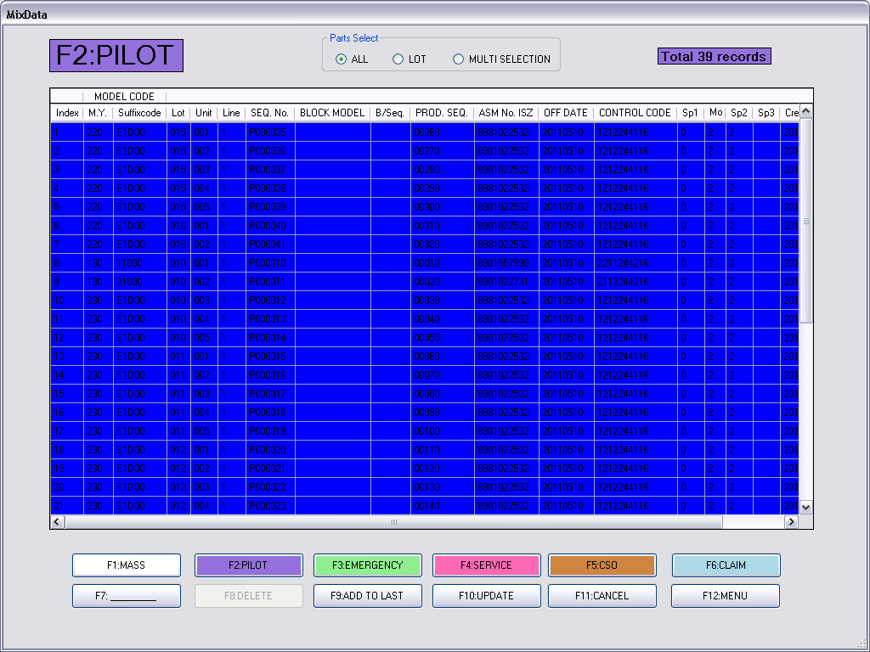
Figure 4-43 Mix Data Screen with PILOT Production Type

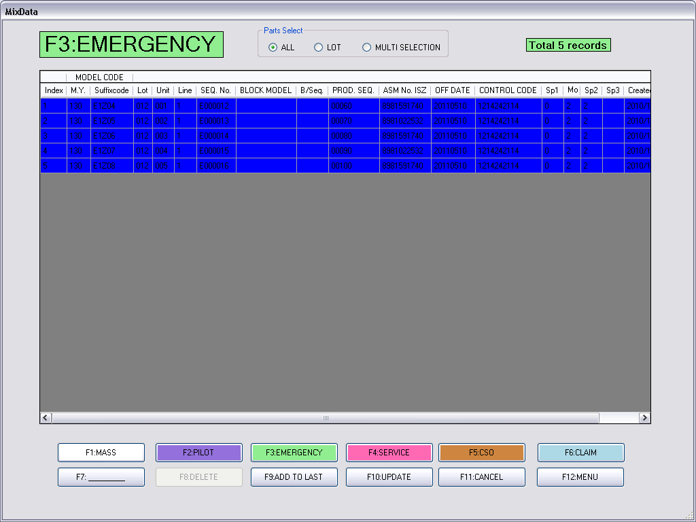
Figure 4-44 Mix Data Screen with EMERGENCY Production Type
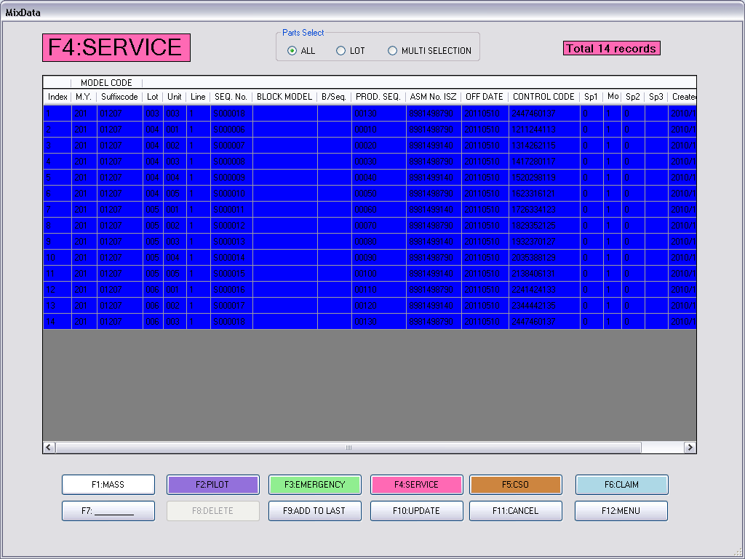
Figure 4-45 Mix Data Screen with SERVICE Production Type

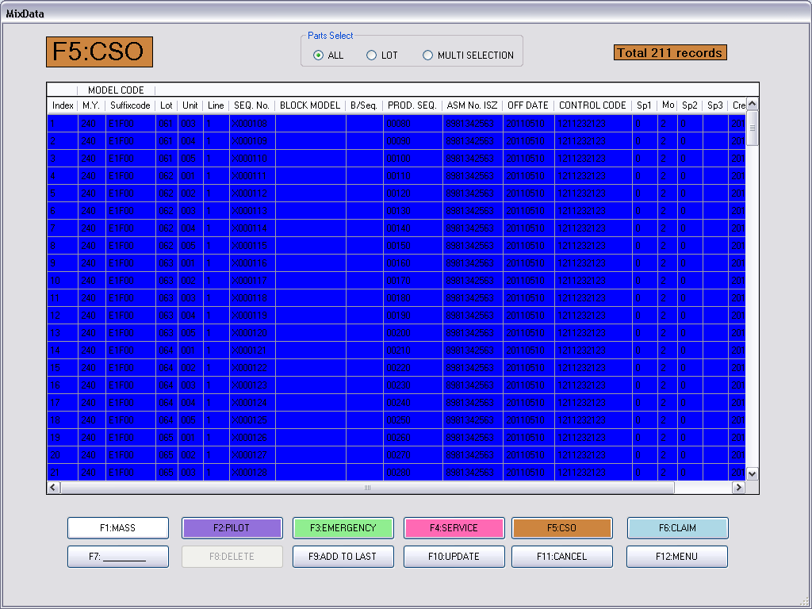
Figure 4-46 Mix Data Screen with CSO Production Type
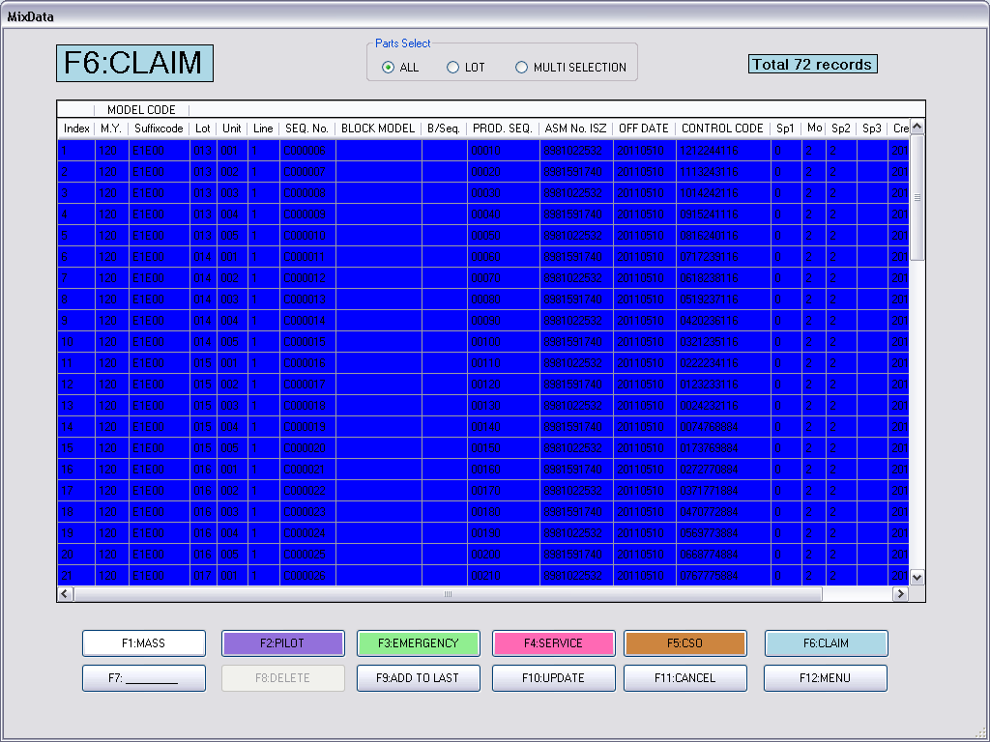
Figure 4-47 Mix Data Screen with CLAIM Production Type

Figure 4-48 Function Buttons on the Mix Data Screen

For the other buttons on the screen as in Figure 4-36, user can remove any production data by choosing MULTI-SELECTION, selecting the production data, and clicking the DELETE button. Then, the Confirm Delete dialog will be appeared as in Figure 4-37. User must have a grant to delete production data so the username and password for delete is required. Note that the default username is “admin” and the default password is “password”. If the default username and password is rejected by the program, user has to contact the system administrator.
For CANCEL and MENU button, choosing CANCEL will let user go to the Production Data screen while clicking MENU button will let user return to the Main Menu screen.

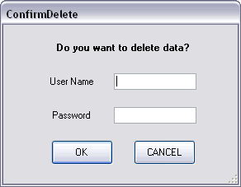
Figure 4-49 Confirm Delete Dialog

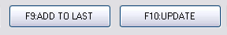
Figure 4-50 Addition Buttons

For two addition buttons as in Figure 4-38, ADD TO LAST is used for appending the data selection to the last of the production data list while UPDATE allows user to insert the data at any the position of the list.

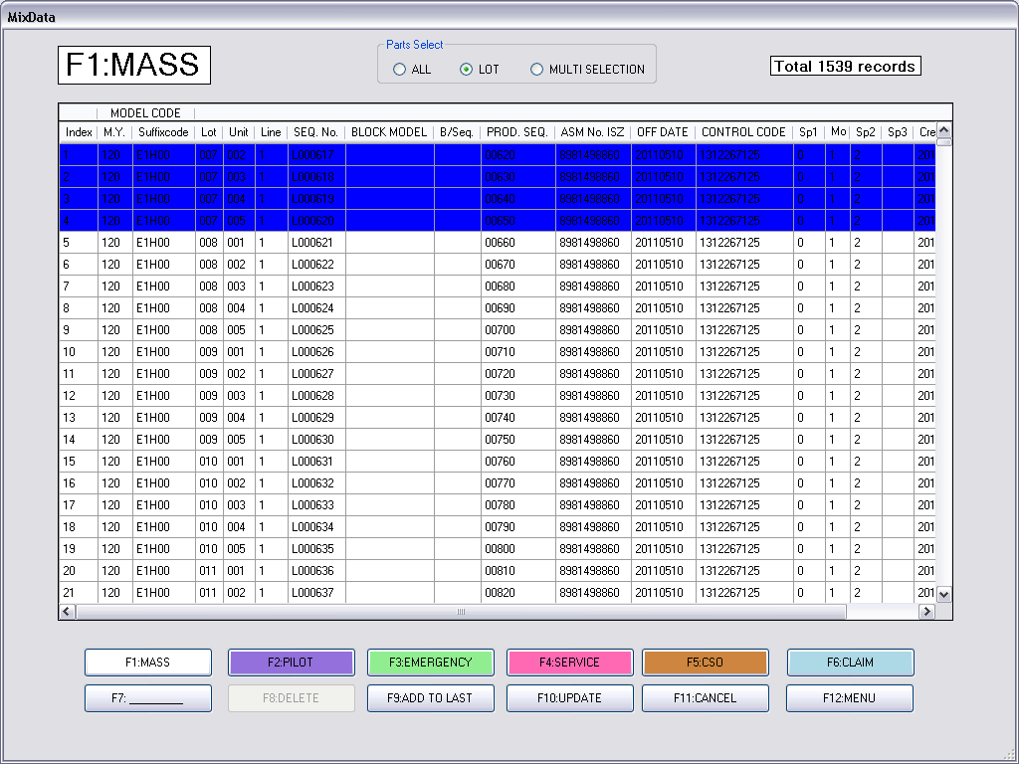
Figure 4-51 Adding a LOT of MASS Production to Last

Begin with ADD TO LAST, Figure 4-39 shows that a LOT of MASS production is selected to ADD TO LAST. The confirm dialog will be displayed as in Figure 3-40. After choosing OK on the confirm dialog, the Mix Data screen must be closed and the Production Data screen will be shown. The LOT of MASS production is appended to the last of the-before-empty list of production as shown in Figure 3-41.

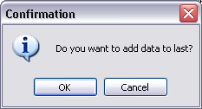
Figure 4-52 ADD TO LAST Confirm Dialog

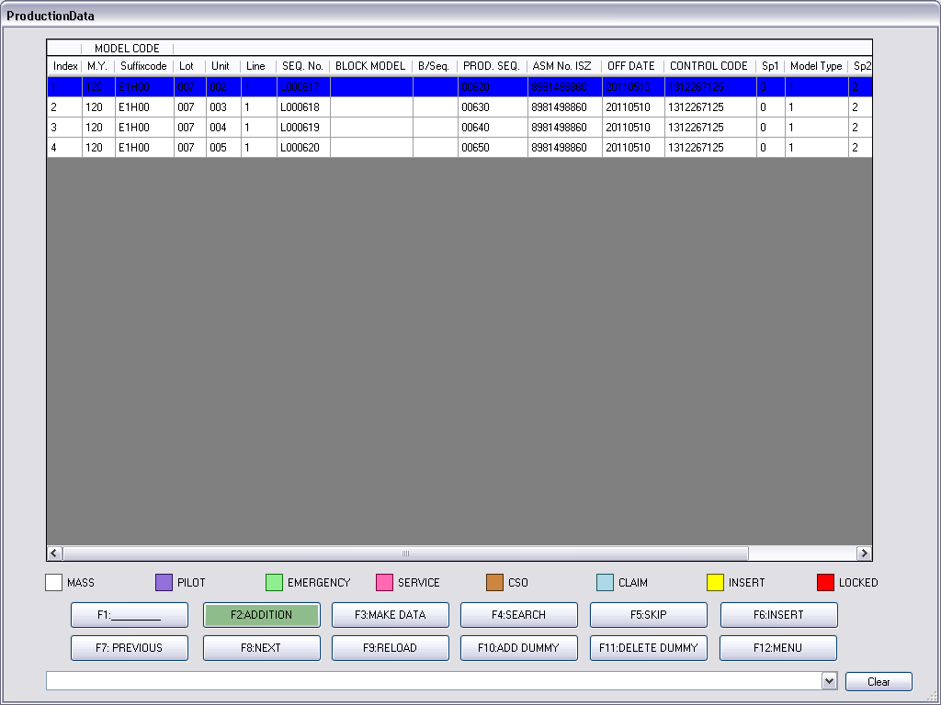
Figure 4-53 Production Data Screen after ADD TO LAST

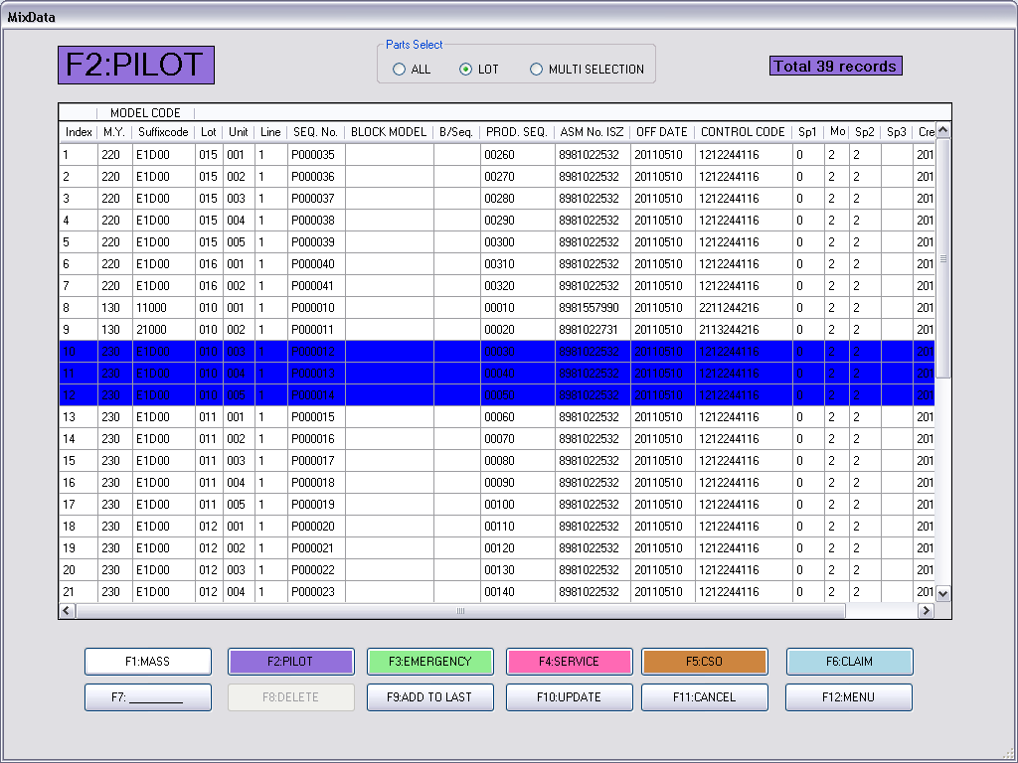
Figure 4-54 Updating a LOT of PILOT Production to the List

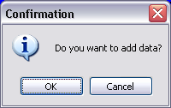
Figure 4-55 UPDATE Confirm Dialog

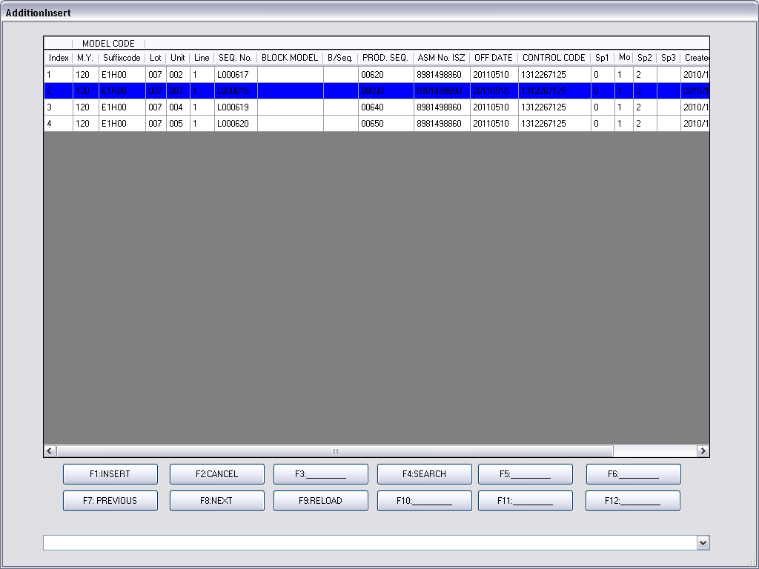
Figure 4-56 Addition Insert Screen for Choosing Update Position

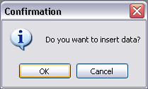
Figure 4-57 Insert Data Confirm Dialog

In case of addition with UPDATE, Figure 4-42 shows that a LOT of PILOT production is selected to UPDATE. The confirm dialog will be displayed as in Figure 4-43. After choosing OK on the confirm dialog, the Mix Data screen must be closed and the Addition Insert screen will be shown as in Figure 4-44. The Addition Insert screen will display the production list identical to the Production Data screen. User has to choose the UPDATE position by clicking on the production data row on the Addition Insert screen. After accepting the confirm dialog, in Figure 4-45, the LOT of PILOT data will be inserted above the selected position. However, the UPDATE result in Figure 4-46 shows that the inserted production is put below the selected position.

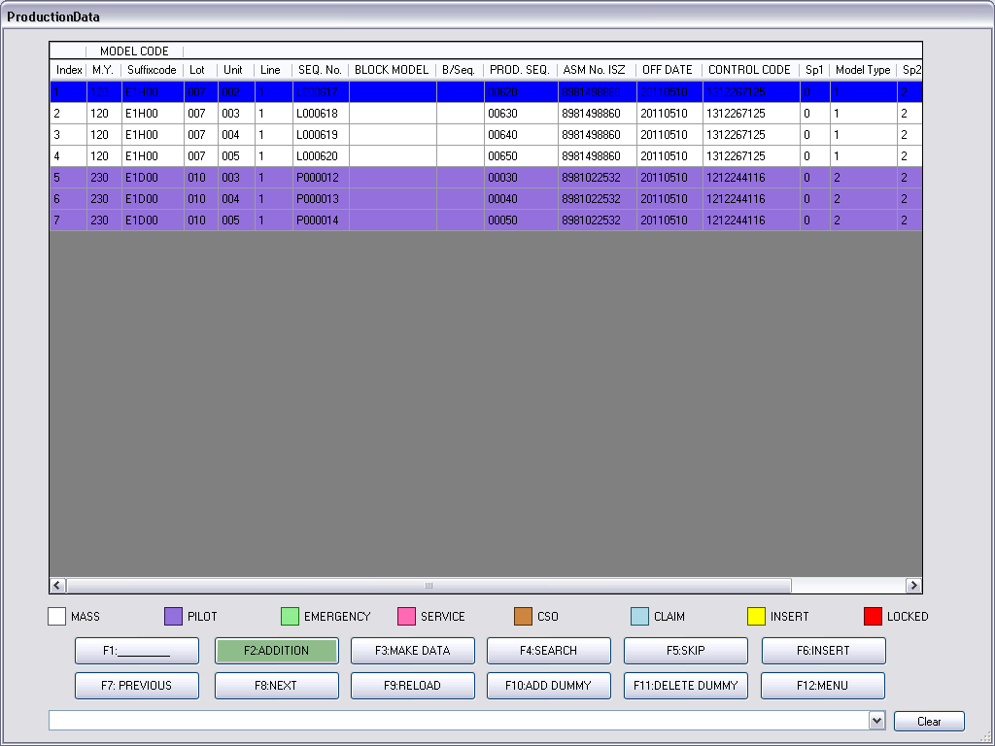
Figure 4-58 Production Data Screen after UPDATE

Note that the update position is concerned with a production LOT. The program disallows different production LOT inserted into any position of other production LOT. Therefore, the program will automatically select new update position to below that LOT. For example in Figure 4-47, a different LOT production data is tried to update in the area of other LOT. After that that production data is updated below the other LOT. For updating position in same LOT, the inserted production data will be updated to above of the selected position, as shown in Figure 4-48.

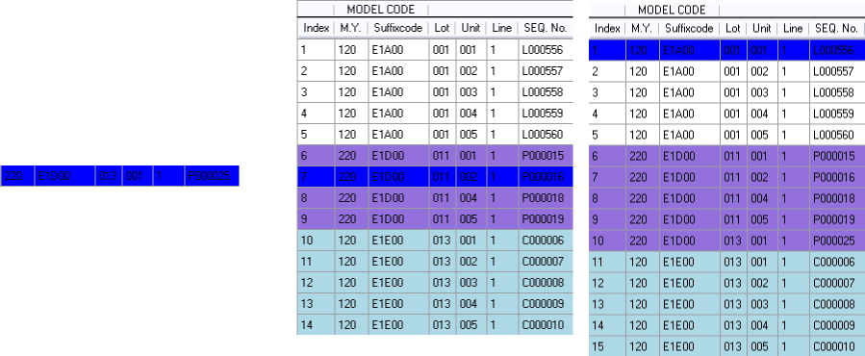
Figure 4-59 Update Different LOT of Production Data

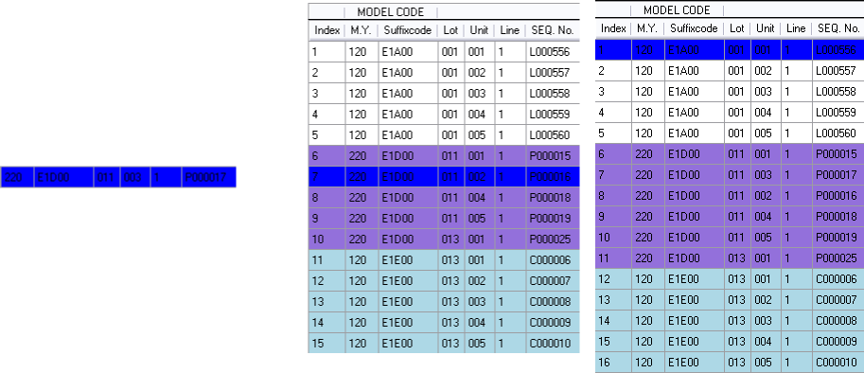
Figure 4-60 Update Same LOT of Production Data

MAKE DATA function

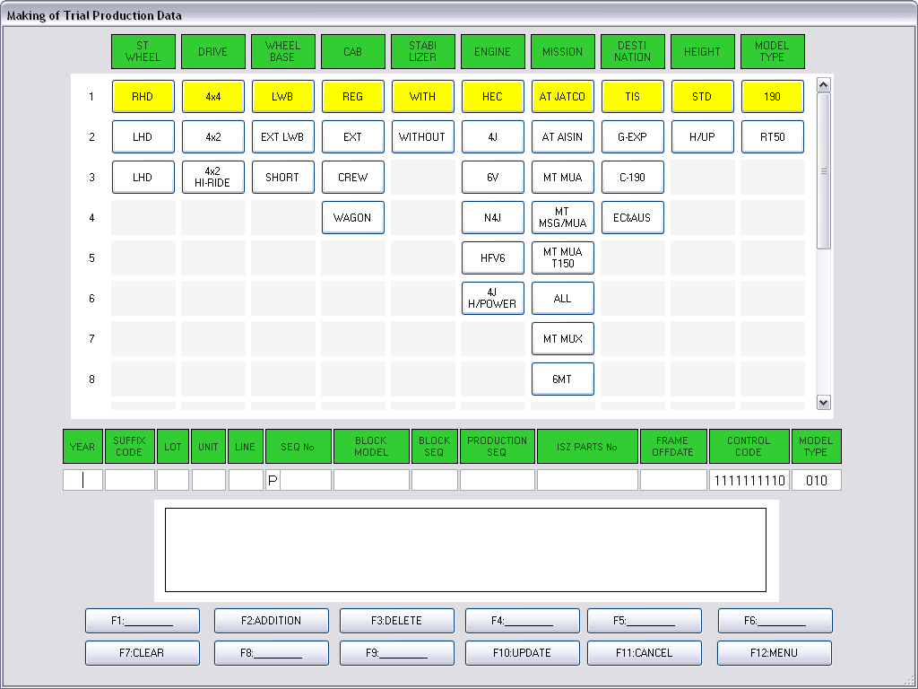
Figure 4-61 Make Data Screen

Without adding production data from AS400 given or file import, the progam provides user the Make Data screen for creating new production data. There are 11 fields of production data which are filled in textboxes as described in the below table.

Fields | Character Length | Character Accepted
YEAR | 3 | 0-9
SUFFIX CODE | 5 | 0-9, A-Z, a-z
LOT | 3 | 0-9
UNIT | 3 | 0-9
LINE | 1 | 1
SEQ No | 6 | 0-9
BLOCK MODEL | 8 | 0-9, A-Z, a-z
BLOCK SEQ | 3 | 0-9
PRODUCTION SEQ | 5 | 0-9
ISZ PARTS No | 10 | 0-9
FRAME OFF DATE | 8 | 0-9

For another 2 fields: CONTROL CODE and MODEL TYPE, user has to set values by selecting the column buttons. The first 9 columns are used for setting 9 digits of CONTROL CODE and the last one is used for MODEL TYPE.

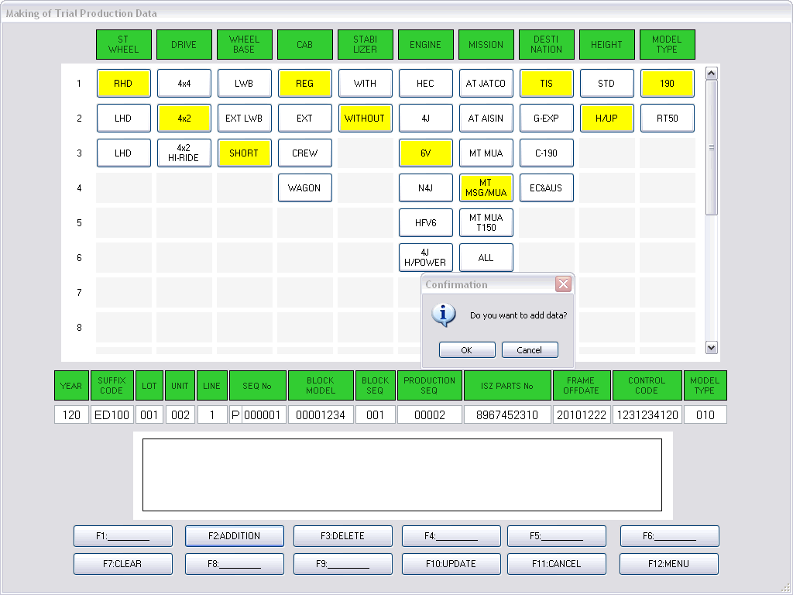
Figure 4-62 Adding Production Data to the Listbox

When the production data was created, user will click on ADDITION button for submitting the data into the listbox as shown in Figure 4-50. The production data which can be added in the listbox must not duplicate both in the listbox and in the Mix Data screen. If the production data is duplicated, an alert dialog will be displayed as in Figure 4-51.

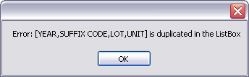
Figure 4-63 Duplication in Listbox Alert Dialog

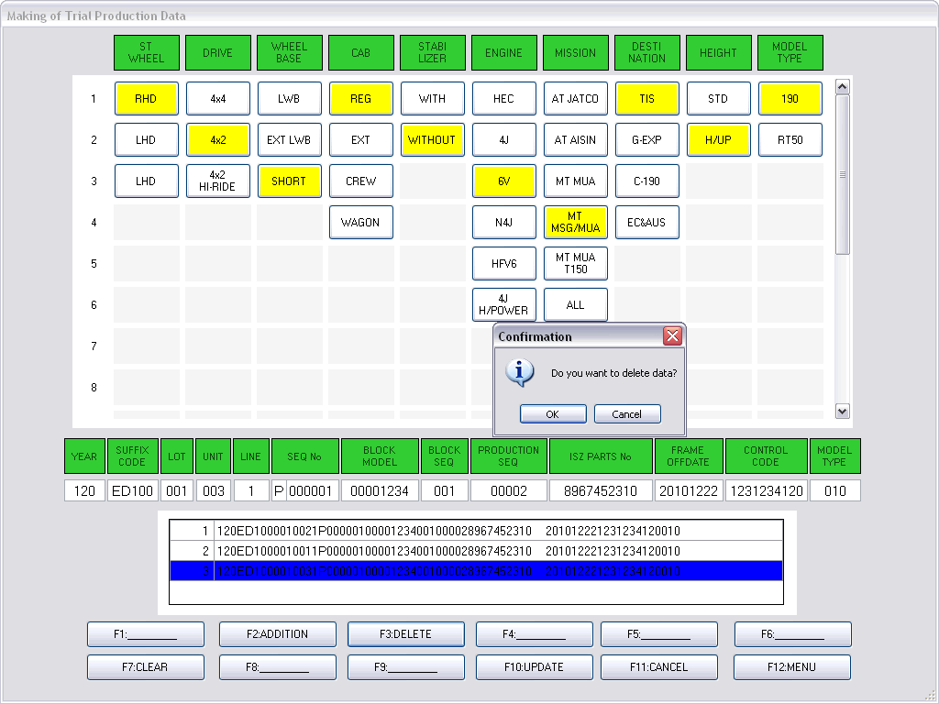
Figure 4-64 Deleting Production Data from the Listbox

User can select one-by-one unnecessary production data in the listbox, then click DELETE button to exclude that data from the listbox as shown in Figure 4-52.
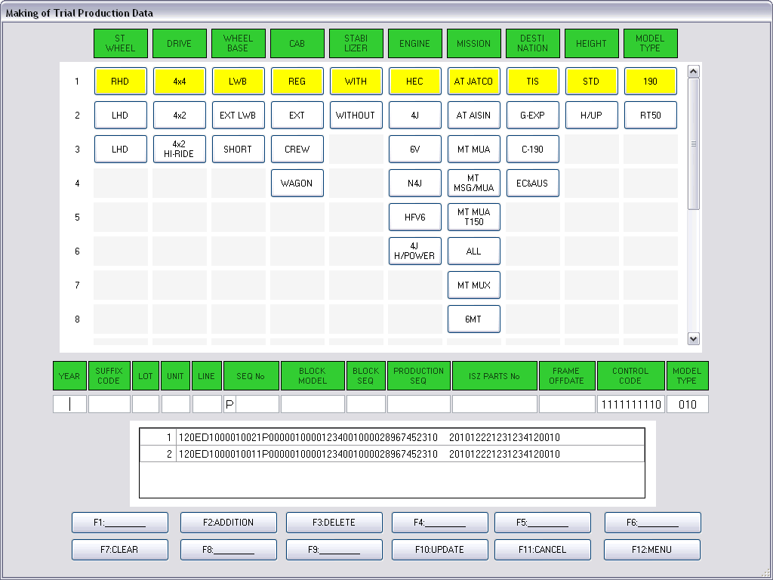
Figure 4-65 Clearing the Production Data Textboxes

User can clear all production data in the textboxes by choosing CLEAR button.

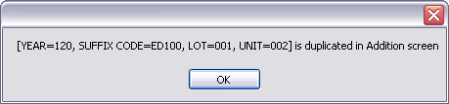
Figure 4-66 Duplication in Mix Data Screen Alert Dialog

If user wants to add production data on the listbox into the Mix Data screen, user has to click UPDATE button. The program will check for the production data duplication. If the duplication occurs, the dialog as in Figure 4-54 will be alerted. The Make Data screen will not be closed and the duplicate production data in the listbox will be shaded in red color, as shown in Figure 4-55. In case of no duplication, the program will close the Make Data screen, then let user back to the Production Data screen. User can see the added production data at the last position of type PILOT on the Mix Data screen as shown in Figure 4-56.
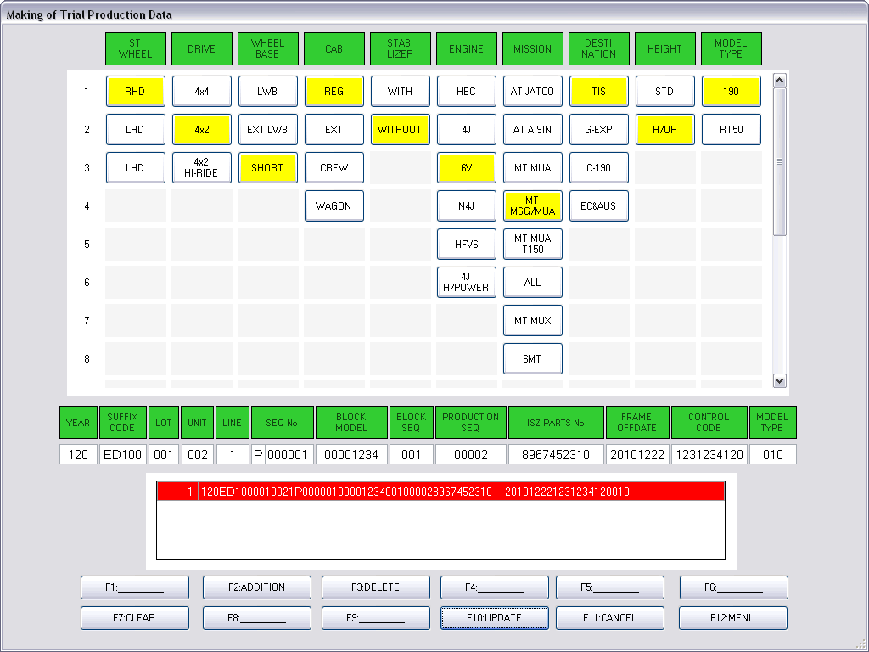
Figure 4-67 Red Color Shading on the Duplicate Production Data

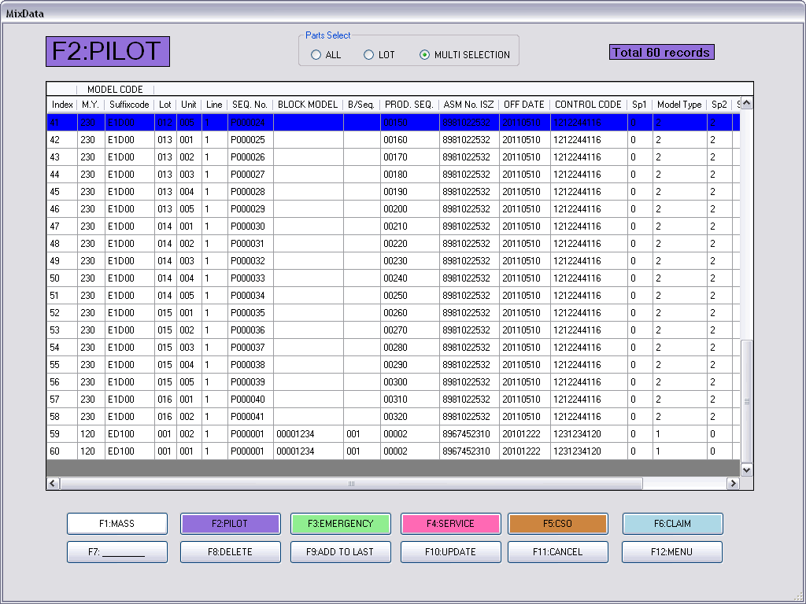
Figure 4-68 Production Data are Appended in the Mix Data Screen

SEARCH function

The program provides user the Search function. Clicking on SEARCH button or F4, the Search Condition screen will be shown as in Figure 4-57. There are 4 conditions available to find the production data: Control Code, Lot No., Suffix Code, and Off Date. To simply input, the program helps user to fill the Off Date condition by Calendar selection. If user clicks on the arrow button behind the textbox, the Calendar as shown in Figure 4-58 will be displayed. It is very simply that user just selects on a date afterthat the program will convert the date to accepted format automatically. After filling the condition and pressing the Execution button, the input format must be checked and alert dialog will be displayed if necessary. Note that it is not important to fill inputs for all search conditions.

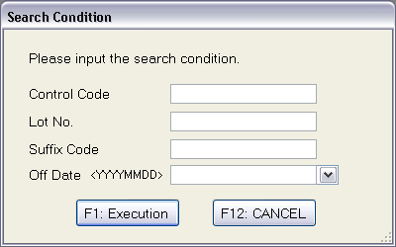
Figure 4-69 Search Condition Screen

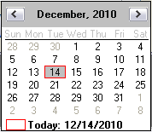
Figure 4-70 Off Date Calendar

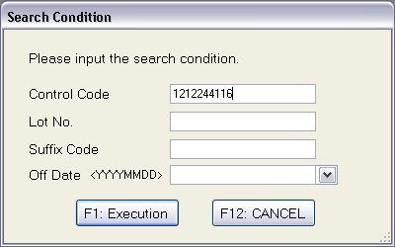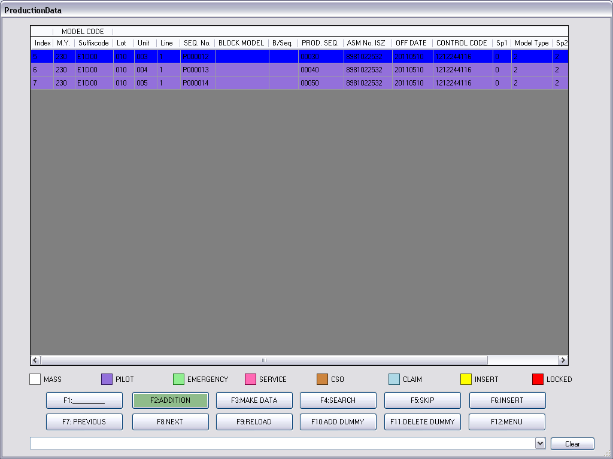
Figure 4-71 Searching by Control Code

If there are some production data matching with the search condition, the first match of the production data will be shown at the top of the Production Data screen as depicted in Figure 4-59. On the other hand, no data match dialog will be alerted as demonstrated at Figure 4-60.

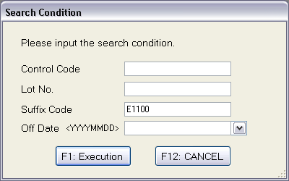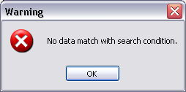
Figure 4-72 No Data Match with Search Condition

SKIP-INSERT function

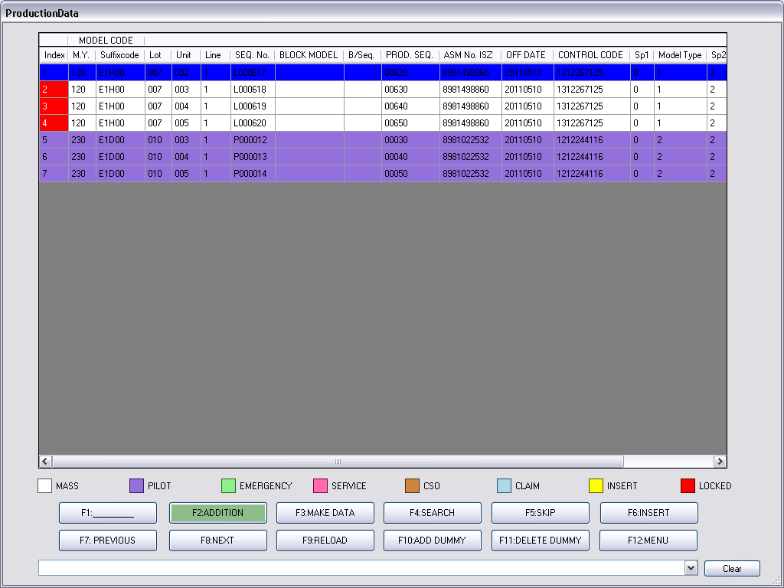
Figure 4-73 Skip the Locked Production Data

On the Production Data screen, not only user can add or insert new production data as mentioned above sub sections, but can also delete or skip unwanted production data by selecting the production data and clicking SKIP button or F5 as shown in Figure 4-61.
Note that user cannot skip locked production data (Red color shaded) so the alert dialog in Fugure 4-62 will be informed if user trys to skip them.

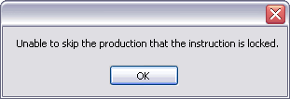
Figure 4-74 Unable to Skip Dialog

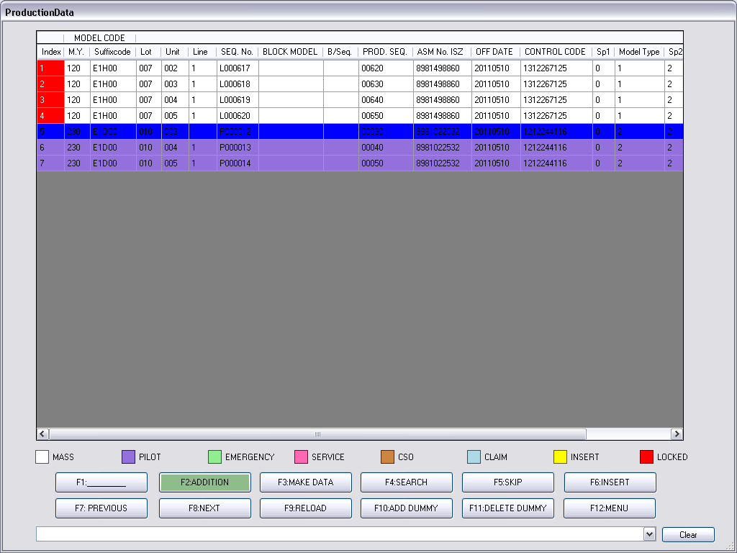
Figure 4-75 Skip the Unlocked Production Data

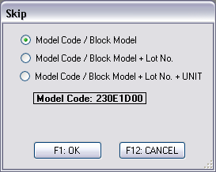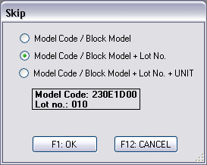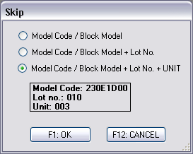
(a) (b) (c)
Figure 4-76 Skip Options

If user trys to skip unlocked production data, the program will show the skip option as illustrated in Figure 4-63. Three skip options are available as follows.
- Model Code/Block Model
- Model Code/Block Model + Lot No.
- Model Code/Block Model + Lot No. + UNIT
To choose (a) option, this means user wants to select all of unlocked production data containing the same Model Code or Block Model with the selected data as shown in Figure 4-64 (a). For another options, (b) means the same Model Code/Block Model with Lot No., (c) means the same Model Code/Block Model with Lot No and UNIT.

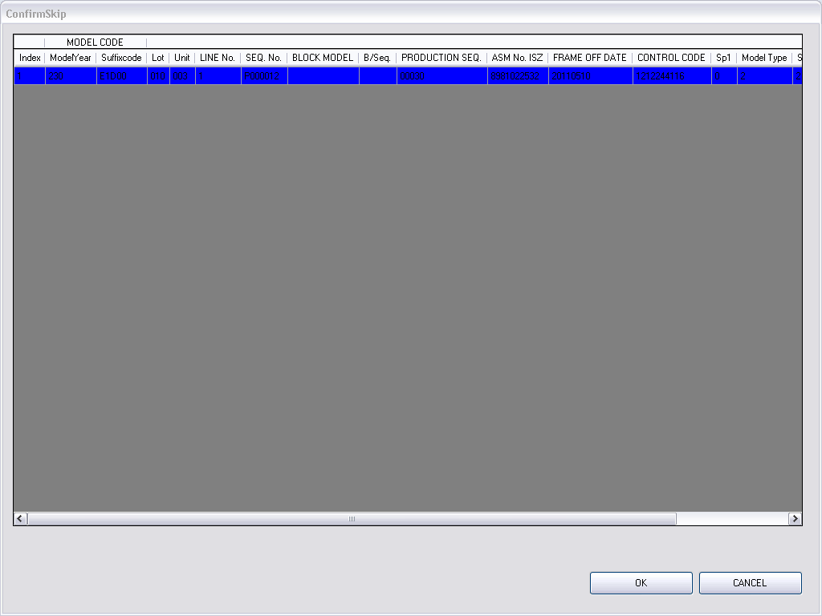
Figure 4-77 Confirm Skip Screen

The Confirm Skip screen will be opened as shown in Figure 4-65 after user selected the options. The skipped production data must be excluded from the Production Data screen but will be moved to the SkipData screen entering by INSERT button which is currently shaded by yellow color because it is contained production data, as shown in Figure 4-66.
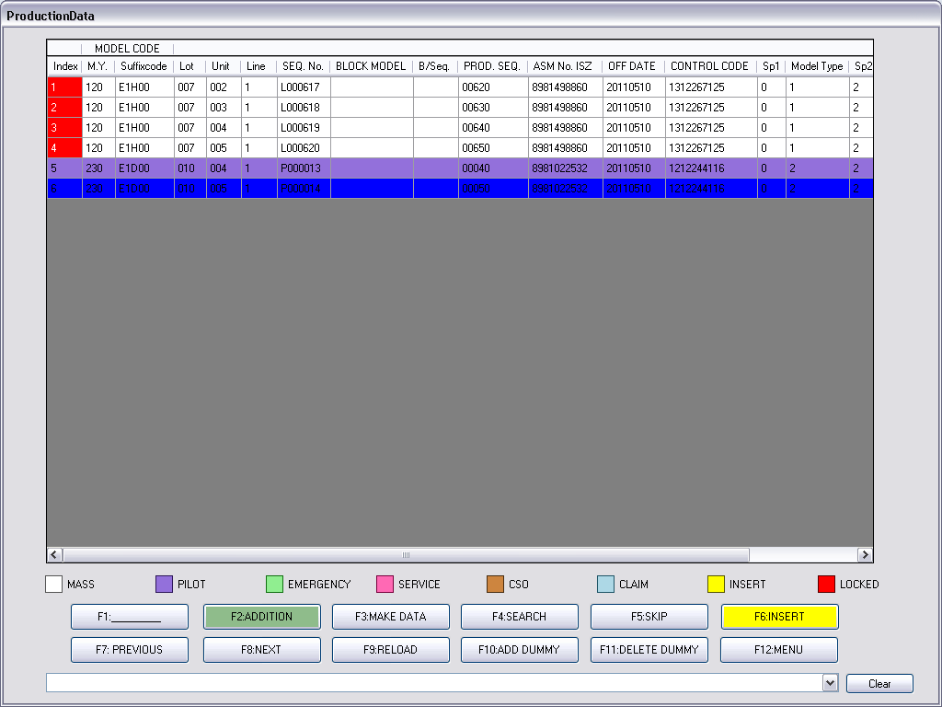
Figure 4-78 Production Data Screen After Skip Operation

Later, the program allows user to re-insert the skipped production data into the Production Data screen by selecting the inserted position on the Production Data screen then clicking on the INSERT button. The Skip Data screen is opened as demonstrated in Figure 4-67. User can choose types of production data and insert options as same as skip options in Figure 4-64. When choosing the production data on the Skip Data screen, the program allows user to DELETE or INSERT those data. By deleting, the grant permission is required. For insertion, the confirm dialog will be shown as in Figure 4-68. After confirmation, the program will return to the Production Data screen. The inserted production data will be shaded with yellow color as depicted in Figure 4-69.

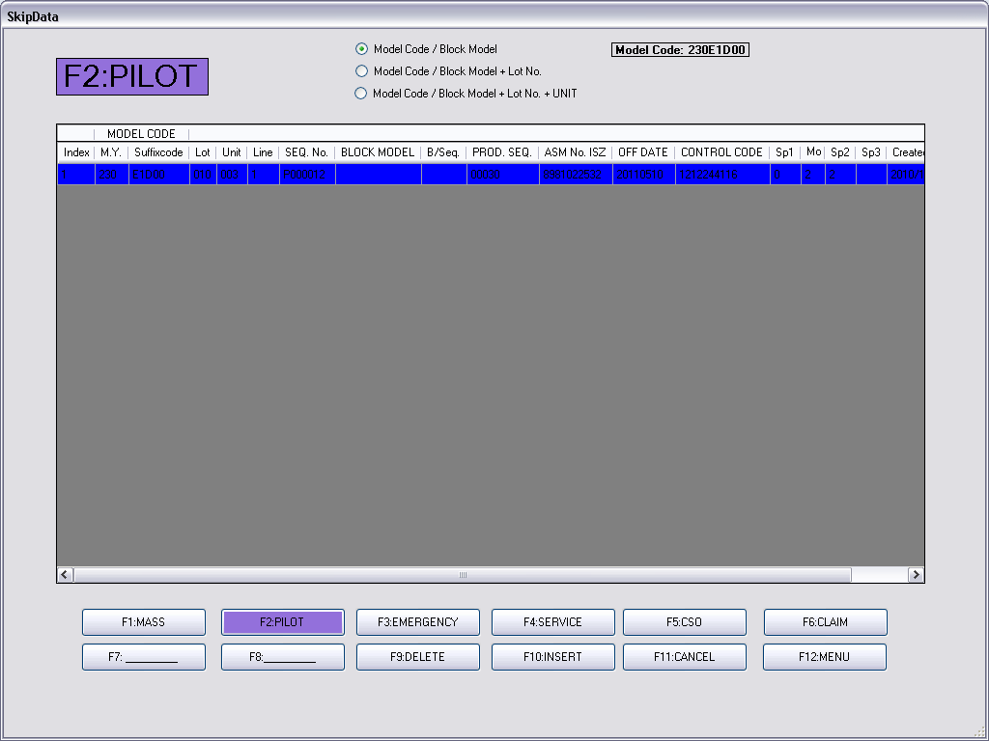
Figure 4-79 Skip Data Screen

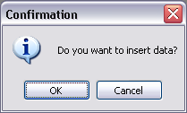
Figure 4-80 Insert Confirm Dialog

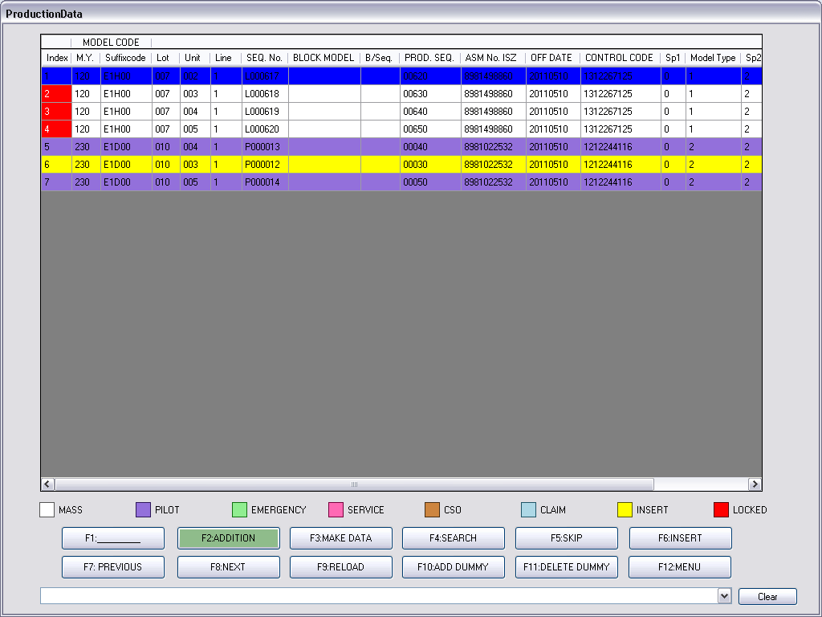
Figure 4-81 Inserted Production Data Shaded with Yellow Color

DUMMY function

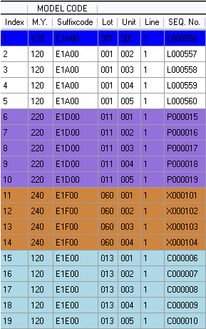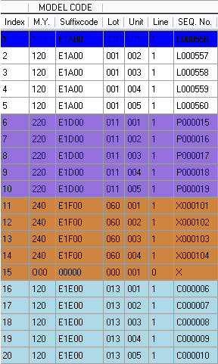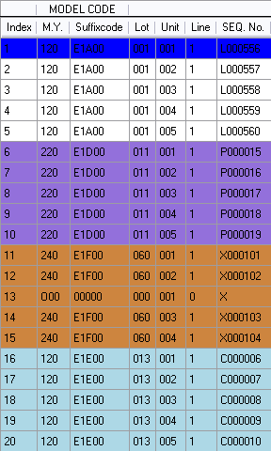
- (b) (c)
Figure 4-82 Dummy of Production Data

The FRAME-CLIENT program provides special function for production data arrangement which is called “DUMMY”. The DUMMY data is shown in the Production Data screen but it will not be transmitted to the PLCs lines because it is just a “fake” data. As mentioned in the Flow Setting section, the production data will be grouped in each UNIT. In case of a group of production data is not fit to a UNIT (less than), user can add some DUMMY data for fitting the UNIT.
As shown in Figure 4-70 (a), assume the UNIT is set to 5, the 11-14 items are not fit to a UNIT. The 15 item may be appended to the 11-14 items group, so the Instruction Schedule may be undesired by the user. To make the 11-14 items to fit, user can add a DUMMY data under the 14 item, as in Figure 4-70 (b), or under any position among the 11-14 items as in Figure 4-70 (c). The group is fit to a UNIT so an ordering of the Instruction Schedule will not incorrect.
Note that DUMMY data added in the Production Data screen will be distinguished by the M.Y. and SEQ. No. fields. For M.Y. field, all DUMMY data have to start with “O” character. For SEQ. No, DUMMY data must have only character code, for example L, Y, D, P, E, X, C, or S, without any numeric character as demonstrated at Figure 4-71.

Figure 4-83 Dummy of Production Data

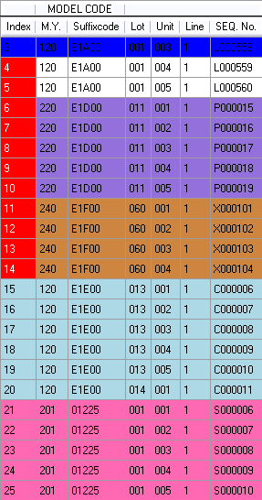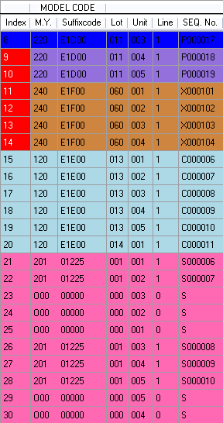
- (b)
Figure 4-84 Dummy of Production Data

In some case, for example, user may want to split a fit group of production data into 2 groups. As shown in Figure 4-72 (a), the 21-25 items are fit to a group. Adding some proper DUMMY into the group will explode one group into 2 groups as shown in Figure 4-72 (b).
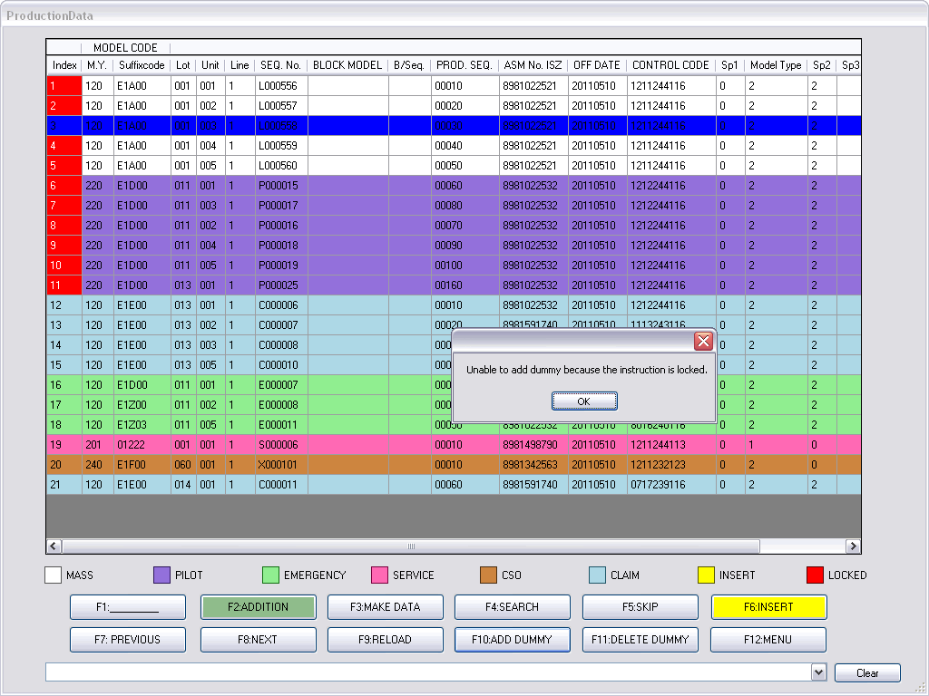
Figure 4-85 Unable to Add Dummy at Locked Data

The program allows user to add each DUMMY at unlocked production data because the production data in the lock area are in transmission schedule that they have not to modify. Further, user cannot add DUMMY data at other DUMMY data. If user trys to add DUMMY data at the locked production data, the alert dialog will be informed, as shown in Figure 4-73. To add DUMMY at available position, the confirm dialog will be displayed as shown in Figure 4-74, as the adding DUMMY result shown in Figure 4-75.
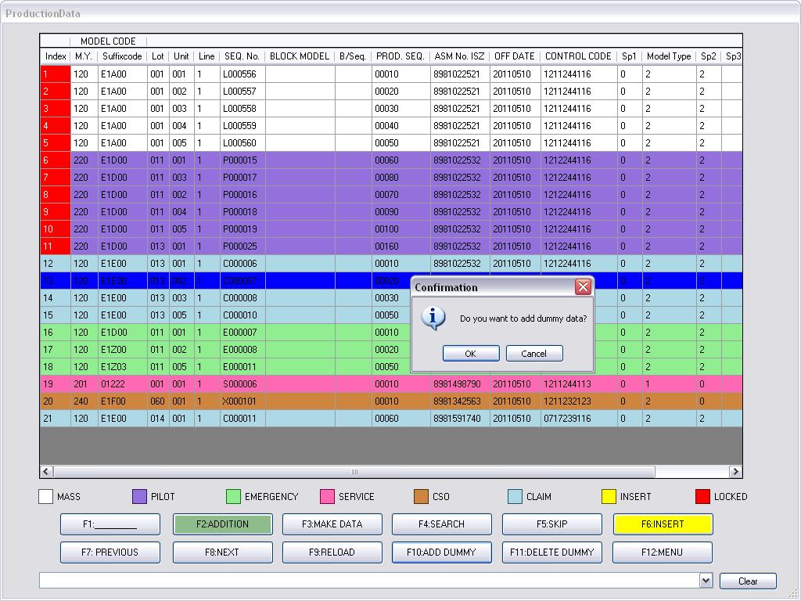
Figure 4-86 Add Dummy Confirm Dialog

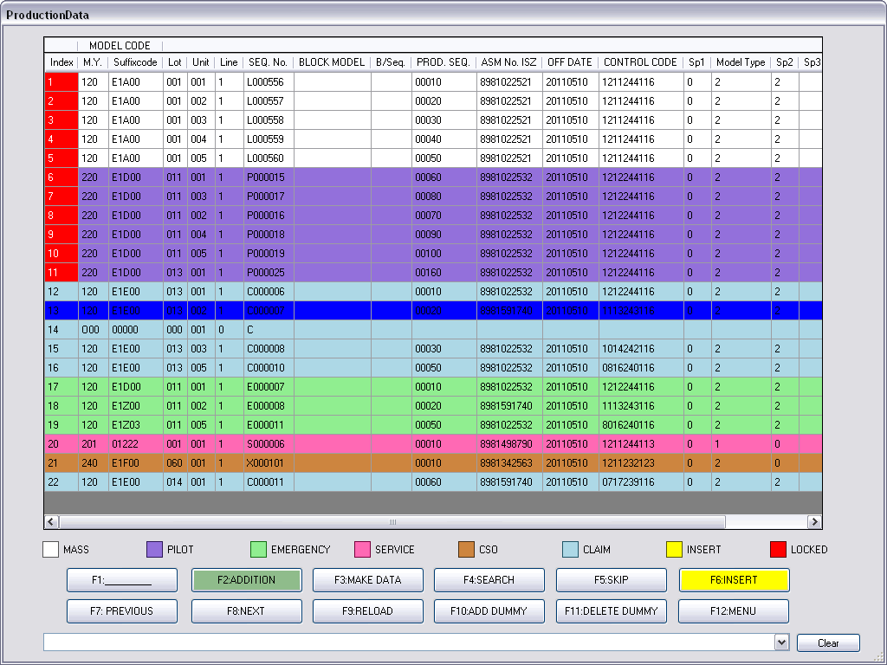
Figure 4-87 Production Data with Dummy

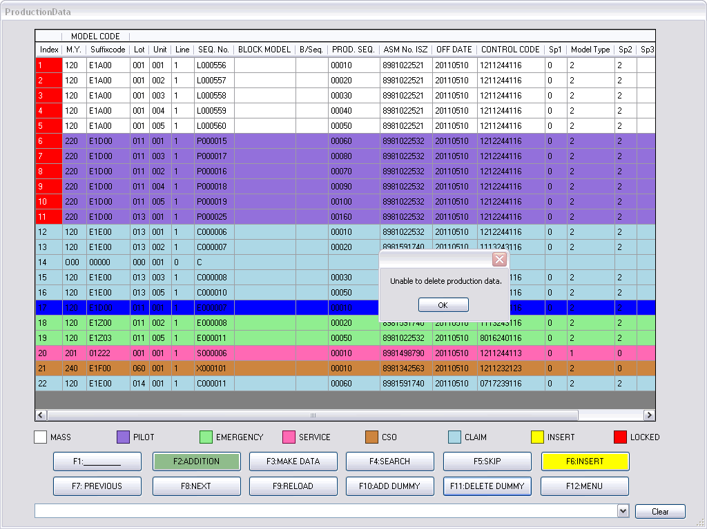
Figure 4-88 Unable to Delete Production Data by DELETE DUMMY Button

To delete DUMMY data, user has to select the DUMMY data and then choose DELETE DUMMY button. The alert dialog will be informed if user trys DELETE DUMMY button with the production data as demonstrated at Figure 4-76. The confirm dialog will be opened when the action is correct as depicted in Figure 4-77.
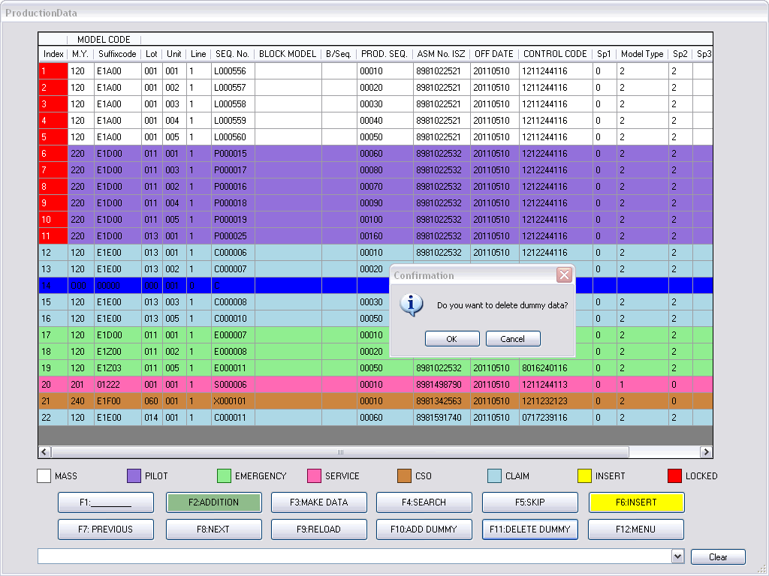
Figure 4-89 Delete Dummy Confirm Dialog

Instruction Schedule

Production Line Navigation

The Instruction Schedule screen shows the instruction data orders that are transmitted to production line PLCs. The screen informs user which instructions have been submitted to PLCs, which instruction is a current item, or how many instructions are sent or not send to PLCs.

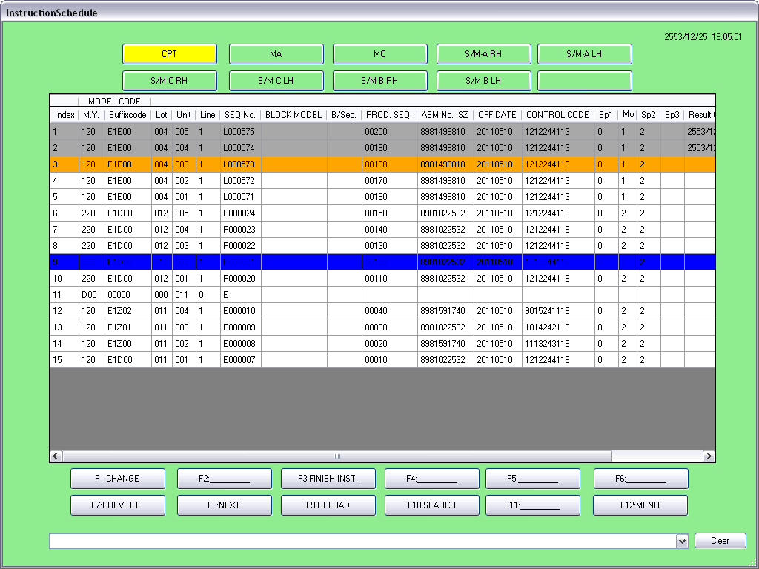
Figure 4-90 Instruction Schedule Screen

As shown in Figure 4-78, the gray color shaded items are sent instructions. The orange instruction is a current item that waiting for a request from PLC. The blue color item is a selected instruction.

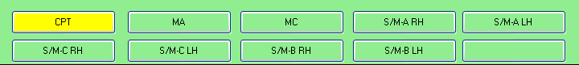
Figure 4-91 Nine Lines Navigation on Instruction Schedule

There are 9 production lines available to monitor on the Instruction Schedule screen. User can select the line buttons appeared on the top of the screen as shown in Figure 4-79. Each production line may be arranged in different orders depending on the line configuration of the Flow Setting as demonstrated at Figure 4-80. There are 5 production line types available on the Flow Setting screen. The various settings of Advance/Reverse, UNIT, and BLOCK make the ordering of each line different.
Figure 4-81 shows the production data order from the Production Data screen on the left. On the right side, the different settings demonstrate the ordering of the production data. Note that “Adv 5, 3” means Advance ordering, UNIT = 5, and BLOCK = 3 while “Adv 5, 1” is Advance, UNIT = 5, BLOCK = 1 that shows the original ordering. “Rev 5, 3” shows Reverse ordering with UNIT = 5 and BLOCK = 3.

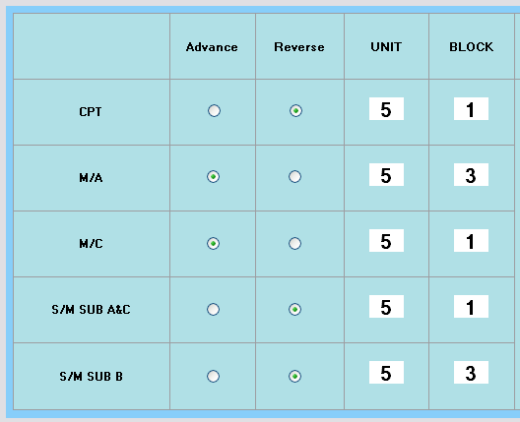
Figure 4-92 Line Setting in Flow Setting Screen

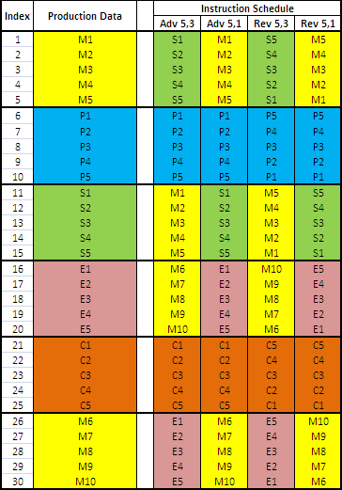
Figure 4-93 Instruction Ordering Association with Flow Setting

Figure 4-94 Page Navigation on Instruction Schedule screen

The Instruction Schedule screen shows 20 instructions per page. Buttons that are used to navigate in Instruction Schedule screens as shown in Figure 4-82. User can change to previous or next page by PREVIOUS and NEXT buttons. Furthur, user can search for instruction by SEARCH button. The search condition screen as same as Figure 4-57 will be displayed.

Change Function

The Instruction Schedule screen provides a function to change the current instruction to any position on the screen. The current instruction is the next item sending to PLC. If user changes the current instruction to a below item (Forward Change), it means that the instruction data between the old current item and the new current item will be skipped and not send to PLC. If user changes the current instruction to an above item (Backward Change), it means that user wants to re-send the transmitted instruction to PLC.

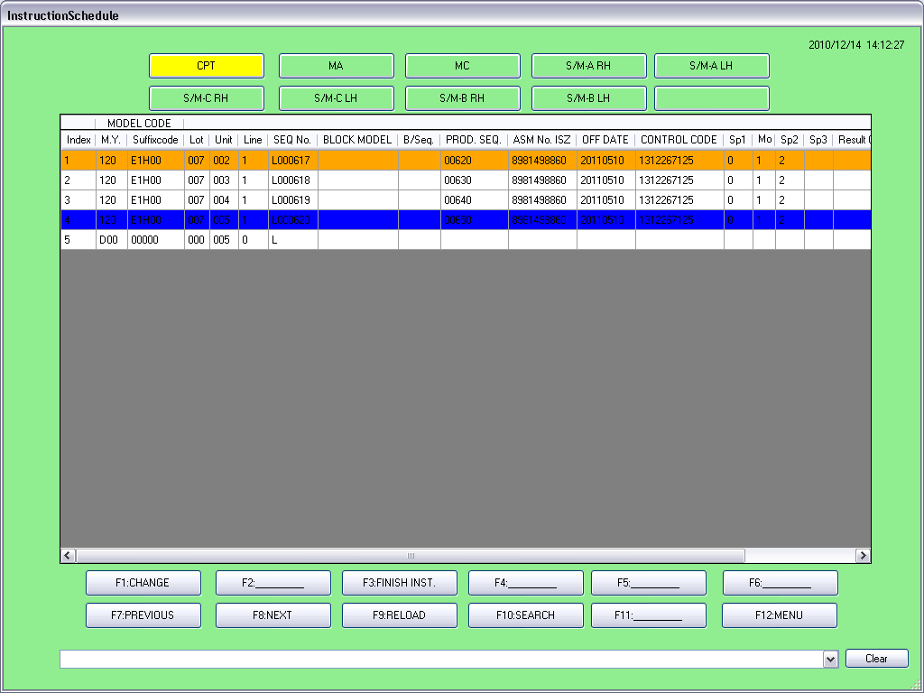
Figure 4-95 Change Function on Instruction Schedule screen

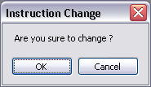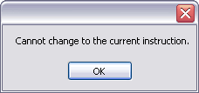
(a) (b)
Figure 4-96 Change Confirm Dialog

Figure 4-83 shows instruction change forward from first item to the 4-th item. When clicking on CHANGE button, the confirm dialog as shown in Figure 4-84 (a) will be displayed. If user selects the current instruction and then clicks CHANGE button, the alert dialog as shown in Figure 4-84 (b) will be informed. The change result shows in Figure 4-85 that new current instruction moves to the 4-th item, so all above instructions will be set to the sent instructions without actual transmission to PLC.
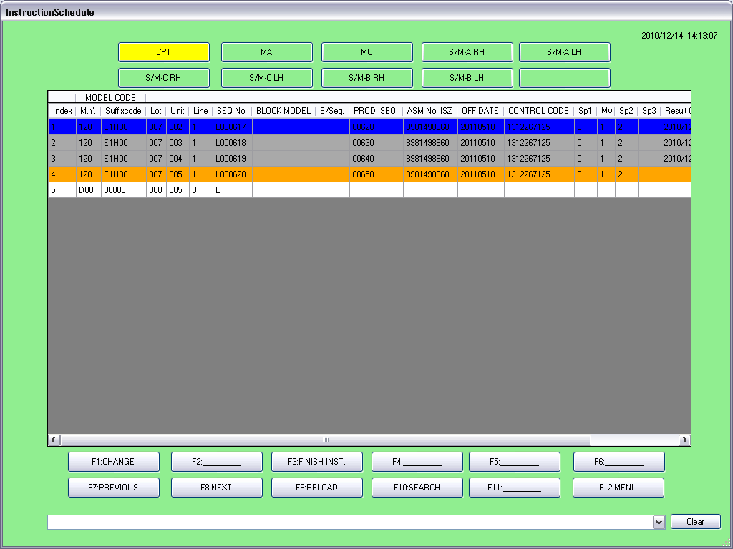
Figure 4-97 Changed Current Instruction

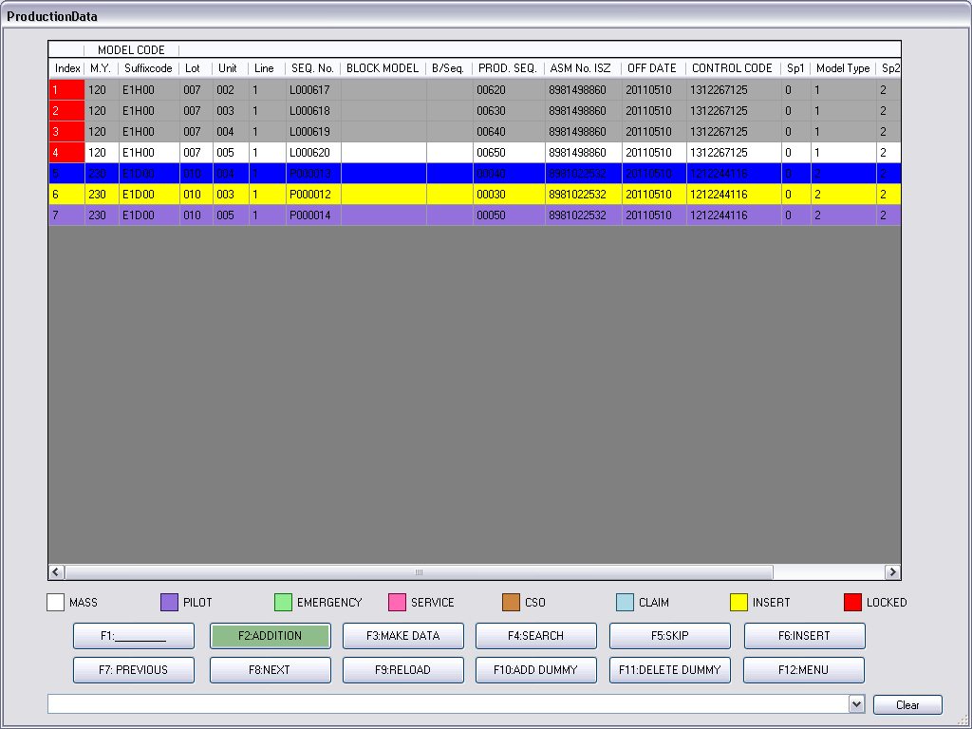
Figure 4-98 Instructed Data Locked on the Production Data Screen

Returning to the Production Data screen as in Figure 4-86, the transmitted instruction will be shaded in gray color and will be locked (red color).

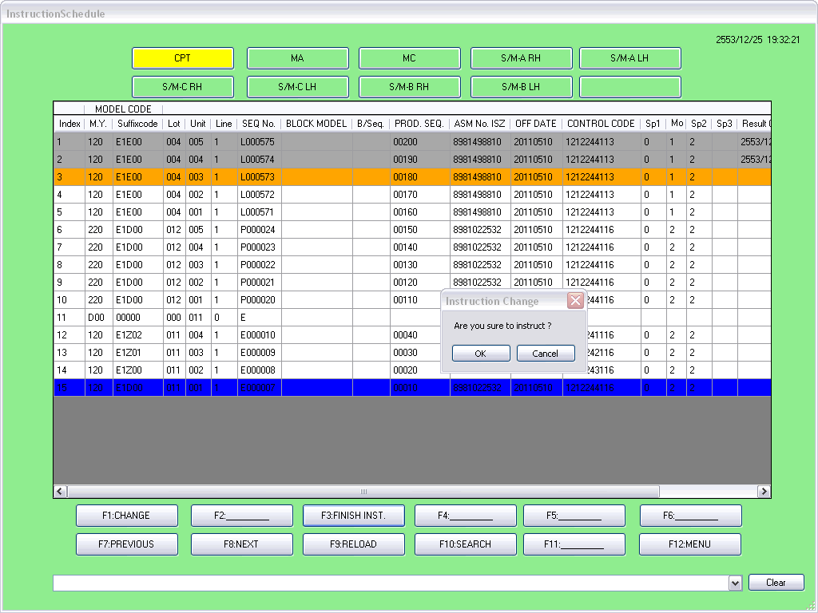
Figure 4-99 Finish Instruction Schedule

In case of changing all instructions to gray color items without actual tramission to PLC, the program provides FINISH-INST button to do that. The use of this button is to select only the last instruction and then click at FINISH-INST button. The confirm dialog will be displayed as depicted in Figure 4-87 and the result as shown in Figure 4-88 that all instructions are shaded with gray color.
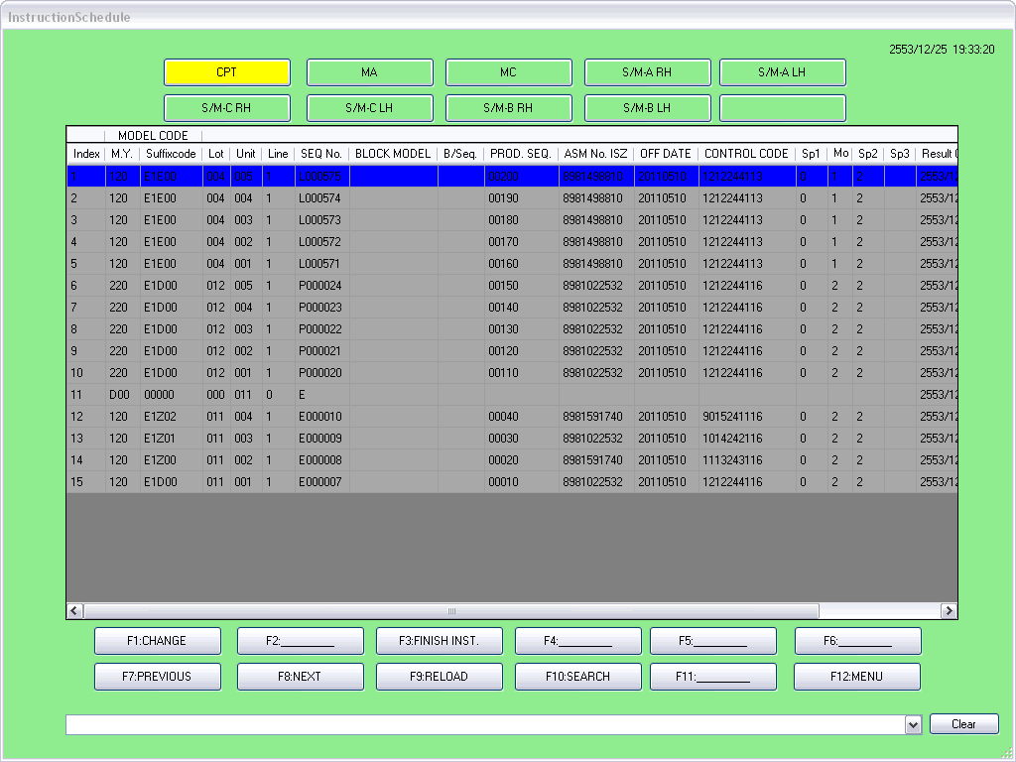
Figure 4-100 All Instructions Finished on Instruction Schedule Screen

Dummy Instruction

DUMMY instruction, as mentioned on 4.4.7 dummy function, is a fake data which uses for data ordering only. On the Instruction Schedule screen, the DUMMY data will be displayed but this type of data must not be transmitted to PLC. When the current instruction line (orange color) moves to a DUMMY item, the FRAME-CLIENT program will skip the DUMMY to next instruction and send to PLC. In case of many consecutive DUMMY data, the program will skip the DUMMY data one-by-one until the actual instruction found. The DUMMY instruction on the Instruction Schedule screen is appeared as shown in Figure 4-89.

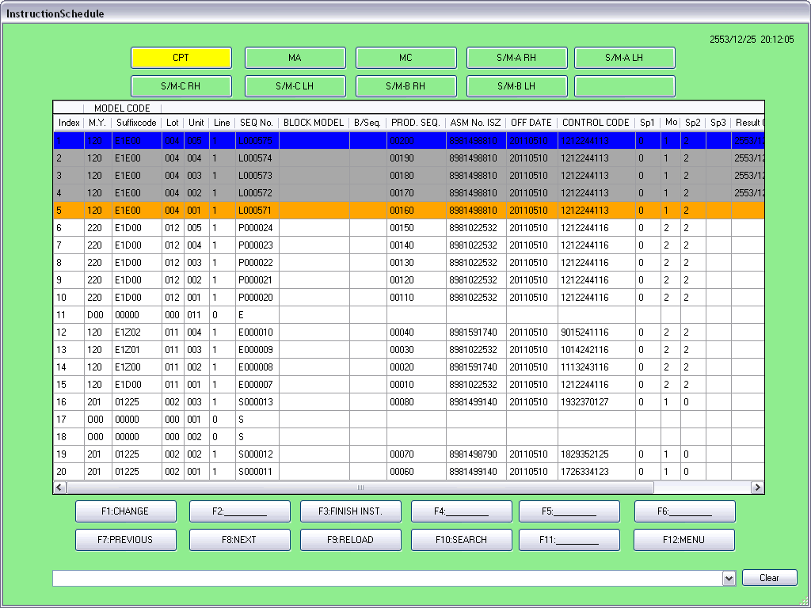
Figure 4-101 Dummy Instructions on Instruction Schedule Screen

Figure 4-102 Dummy Added from Production Data

Figure 4-103 Dummy Added from Instruction Schedule

Note that there are 2 types of DUMMY instructions. The first one is a DUMMY data added from the Production Data screen. This is manual DUMMY addition. The last one is a DUMMY data automatically added from the Instruction Schedule screen. This helps the same type of production data is fit to a group.
The difference of these DUMMY data is manually use and automatically use. If user wants to manually arrange the ordering of production data, user will manage DUMMY data by add/delete on the Production Data screen. The M.Y. value of DUMMY data added from Production Data screen is started with “O” character as shown in Figure 4-90.
If user wants the program to add DUMMY data automatically, user does not need to add DUMMY data at the Production Data screen. However, the program allows user to mix the manual DUMMY and the automatic DUMMY. Note that the M.Y. value of DUMMY data added from Instruction Schedule screen is started with “D” character as shown in Figure 4-91.

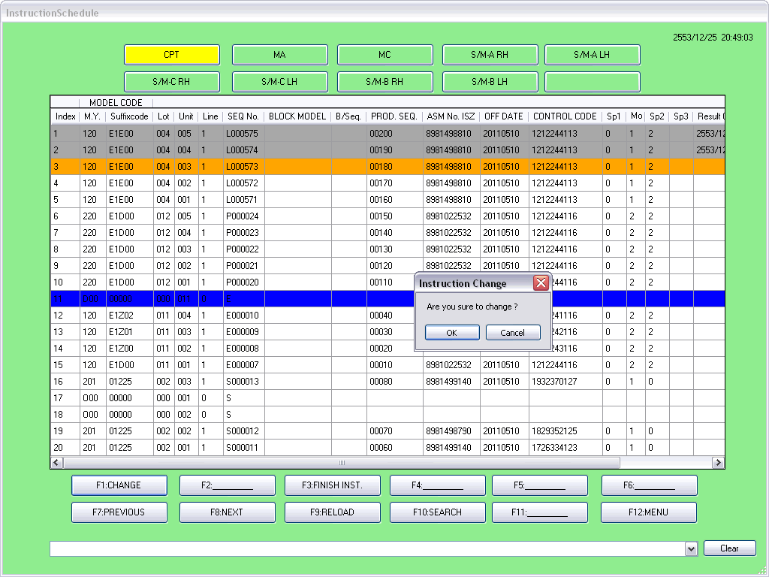
Figure 4-104 Change to DUMMY Instruction

Figure 4-92 shows trying to change DUMMY instruction to current instruction. The program will skip the DUMMY selection to the next available instruction and then take change operation to the available item as result shown in Figure 4-93.
If there are consecutive DUMMY data, the program will skip DUMMY data one-by-one until the available instruction found as shown in Figure 4-94.
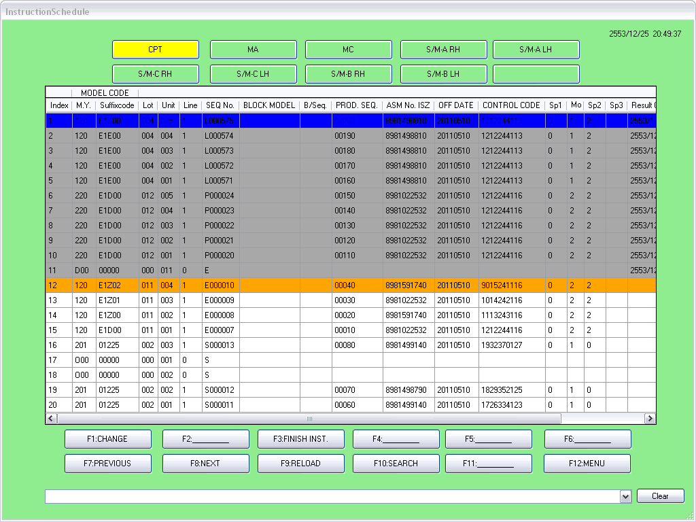
Figure 4-105 Change to DUMMY Instruction Result

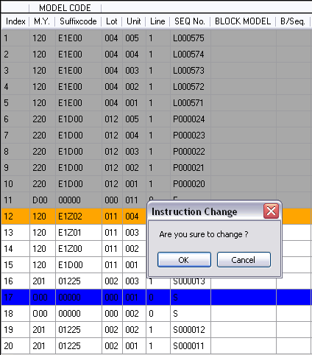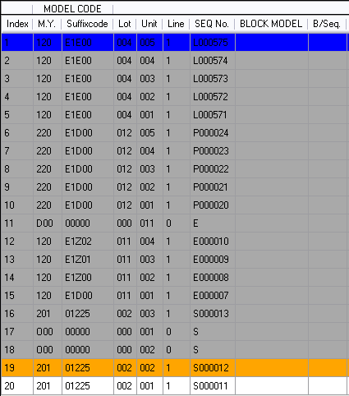
Figure 4-106 DUMMY Instruction Change Result

Data Log

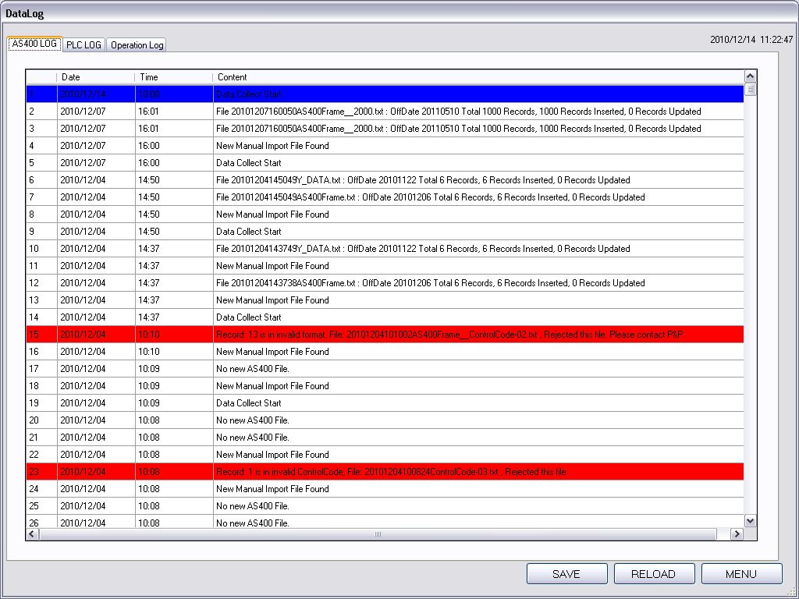
Figure 4-107 Data Log Screen

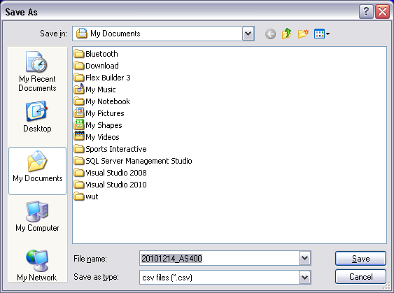
Figure 4-108 Save Dialog on Data Log Screen

The Data Log screen, as shown in Figure 4-95, provides user to track a history of the program used. There are 3 types of log: AS400, PLC, and Operation. AS400 data log will keep all actions of AS400 data sending. PLC data log will record requests from PLC, responses to PLC, and all errors. Operation data log will save all operations on the Production Data screen and Instruction Schedule screen.
The program provides SAVE or EXPORT function when user wants to store the data log in file by clicking on SAVE button. The save dialog will be opened as shown in Figure 4-96.

DATABASE BACKUP

The Database Backup is a necessary operation for protecting some important data from unexpected situations such as production data lost, server crashed, or uncatchable error. This operation will backup the database periodically such as monthly, weekly, or daily. In real use, we prefer a daily backup.
The database backup can be done automatically by associating with the Windows Task Scheduler. The Windows Task Scheduler will call our script to run the database backup at the same time everyday and will copy the backup file to the backup location.
However, to set the Windows Task Scheduler for our database backup has to manually configure by advance users or IT technicians. This section will explain this setting step-by-step as follows:
- Specify the backup location on the server. We recommend that the location is “F:\BAK_FPS\”.
- Find the “Backup_FPS.sql” file and copy it to the backp location “F:\BAK_FPS\”.
- Open the Windows Task Scheduler by “Start -> Settings -> Control Panel -> Scheduled Tasks” as illustrated in Figure 5-1.
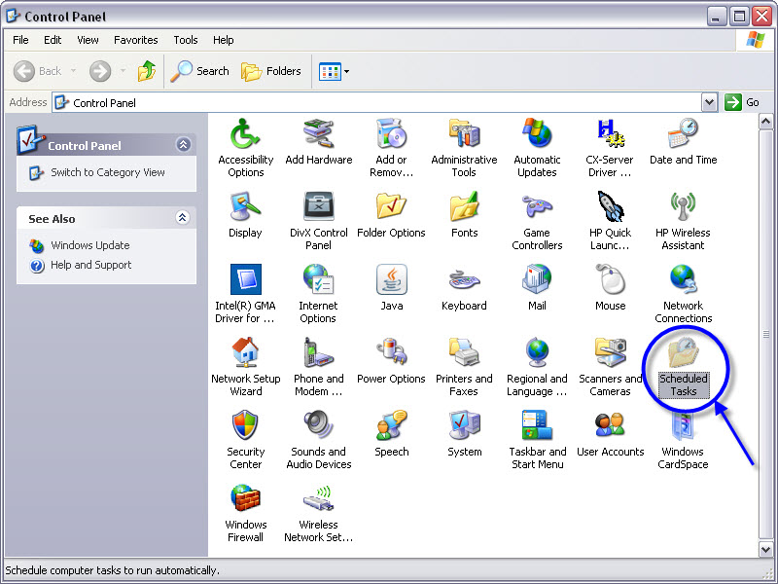
Figure 5-1 Scheduled Tasks on Control Panel
- The “Scheduled Tasks” will be appeared as depicted in Figure 5-2.
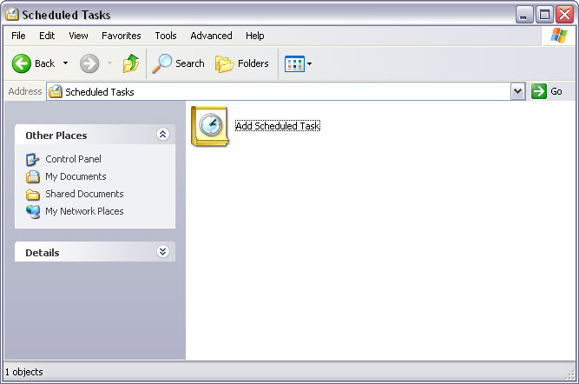
Figure 5-2 Add Scheduled Task

- To double-click on “Add Scheduled Task”, the wizard will be opened as Figure 5-3. Then, click “Next”.
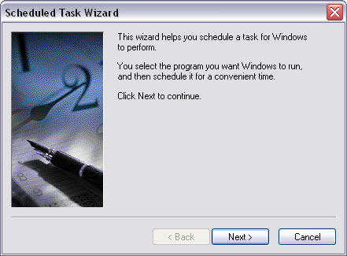
Figure 5-3 Scheduled Task Wizard

- The listed program will be displayed for selection as Figure 5-4, but we will click “Browse”.
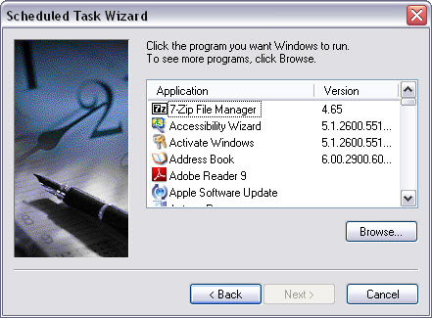
Figure 5-4 Select Program to Schedule
- The file dialog is opened for users to select program to schedule as Figure 5-5.
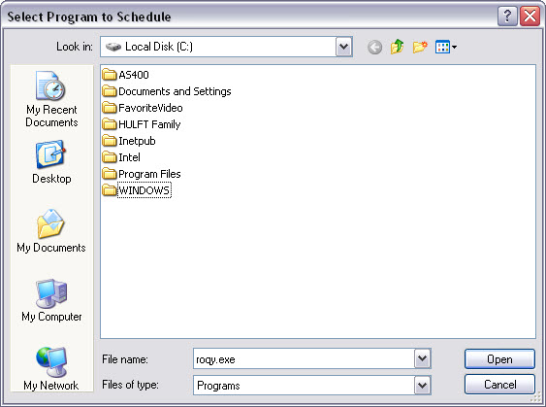
Figure 5-5 File-dialog to browse the Program
- To select the program, look in “C:\Program Files\Microsoft\SQLServer\100\Tools\Binn” as Figure 5-6.
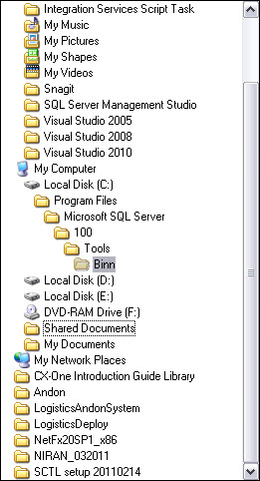
Figure 5-6 Tree Directory for the Program Targeted
- Select the file “SQLCMD.EXE” and click “Open” as Figure 5-7.
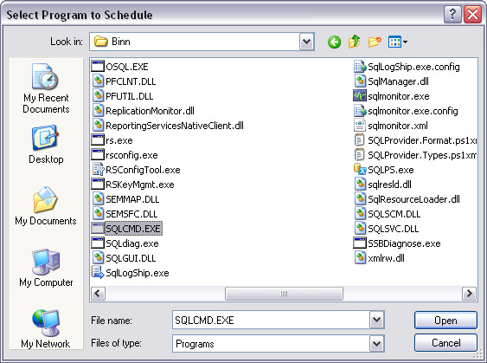
Figure 5-7 The Targeted Program “SQLCMD.EXE”
- Type a name for this task, for example, “FPS Database Backups” and select perform this task to “Daily” as Figure 5-8, then click “Next”.
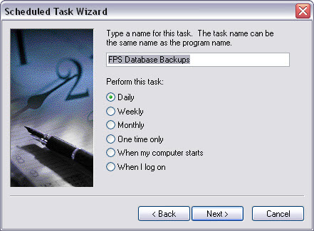
Figure 5-8 Setting a Name and Period for the Task

- Specify time and date to run this task, for example, “23:00” start on “4/18/2554” as Figure 5-9, then click “Next”.
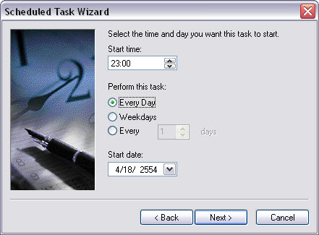
Figure 5-9 Setting a Time and Date for the Task

- Set Administrator’s password of the server as Figure 5-10, then click “Next”.
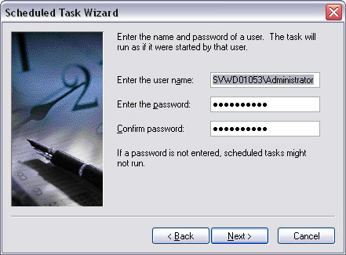
Figure 5-10 Setting Password and Confirm

- “Check” the open advanced properties box as Figure 5-11, then click “Finish”.
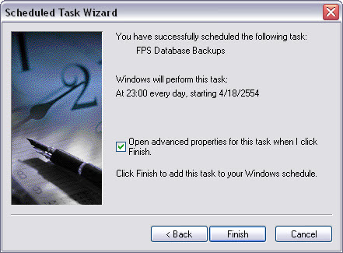
Figure 5-11 Finish the Scheduled Task Wizard

- The advanced properties window will be opened, check all fields as follows:
Run: sqlcmd –S SVWD01053 –E –i F:\BAK_FPS\Backup_FPS.sql
Start in: “C:\Program Files\Microsoft SQL Server\100\Tools\Binn”
Run as: SVWD01053\Administrator
Then click “OK”.
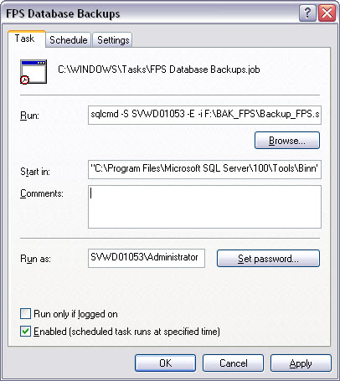
Figure 5-12 Setting Advanced Properties
- Right-click on the “FPS Database Backups” task and select “Run” to complete setting.
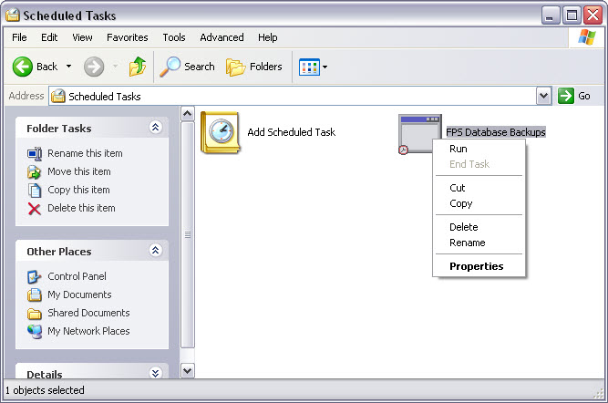
Figure 5-13 Run the Scheduled Task

