Isuzu Motors Co., (Thailand) Ltd.

RT50 Frame No.2 Line
Production Instruction System (PIS)

MAINTENANCE MANUAL

OMRON

TABLE OF CONTENTS

1. OVERVIEW 2
2. DATABASE BACKUP 2

TABLE OF FIGURES

Figure 2-1 PIS-SERVER NO.2 LINE Setting File Start Menu Shortcut 3

OVERVIEW

This document is about maintenance task which is required for system to run smoothly without problems or to be recovered easily when any problem occurred.

DATABASE BACKUP

The Database Backup is a necessary operation for protecting some important data from unexpected situations such as production data lost, server crashed, or uncatchable error. This operation will backup the database periodically such as monthly, weekly, or daily. In real use, we prefer a daily backup.
The database backup can be done automatically by using Batch Service program installed together with FPS-Server Line No.2 Program. This section will explain this setting step-by-step as follows:
- Specify the backup location on the server. We recommend that the location is “F:\BAK_FPS2\” for PIS and “F:\BAK_LMS2\” for LMS.
- Find the “Backup_FPS2.sql” file in the installation CD and copy it to the backup location “F:\BAK_FPS2\” for PIS and find the “Backup_LMS.sql” file in the installation CD and copy it to the backup location “F:\BAK_LMS2\” for LMS.
- Find the full path of SQL command application. Default path is
“C:\Program files\Microsoft\SQLServer\100\ Tools\Binn”
- Copy the “batch” folder in the installation CD and copy it to the “bin” folder of FPS2-Server installation directory. Default path is
“C:\Program Files\TSE\RT50 Frame Line 2 PIS\bin”
- Edit each “.bat” file in “C:\Program Files\TSE\RT50 Frame Line 2 PIS\bin\batch” as following.

{Full path to SQLCMD.exe} -S {server} -U {user} -P {password} -i {Full path of SQL script}

Default command for backing up FPS-Server Line No.2 is as following

"C:\Program Files\Microsoft SQL Server\100\Tools\Binn\sqlcmd.exe" -S SVWD01053 -U dbBack -P omron -i F:\BAK_FPS2\script\Backup_FPS2.sql

- Editing FRAME-SERVER Setting File. There are some settings of Batch Service which are stored in an INI file named “PIS-Setting.ini”. There is a shortcut to this file in start menu shown in Figure 2-1.

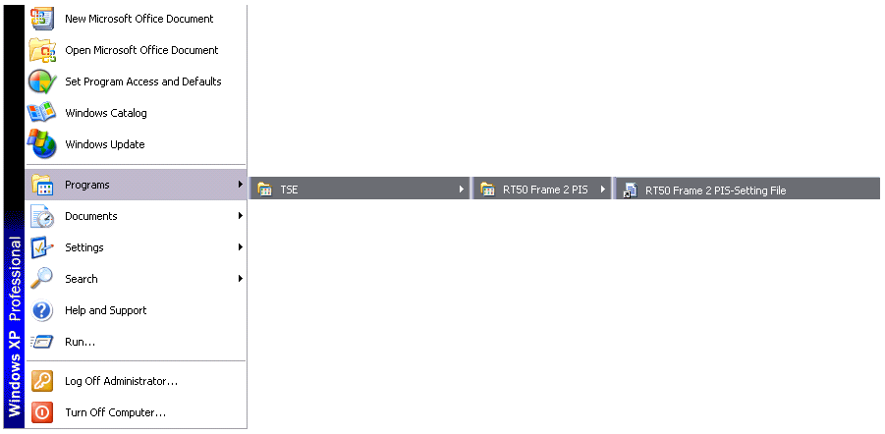
Figure 2-1 PIS-SERVER NO.2 LINE Setting File Start Menu Shortcut

The settings related to Batch Service in the PIS-Setting.ini file are shown in the following table.
FIELD | DEFINITION
BatchTime | Time that Batch Service will execute batch job (Default 0700)
BatchSleepSecond | Sleep time between each batch job to be executed (Default 60)

DELETING OLD BACKUP FILES
Since the auto backup is perform everyday, the number of backup files are always increased and can lead to the case that the harddisk is out full. Manually deleting of old backup files at the backup locations is required. The old backup file can be specified by date time stamp in the backup filename.

