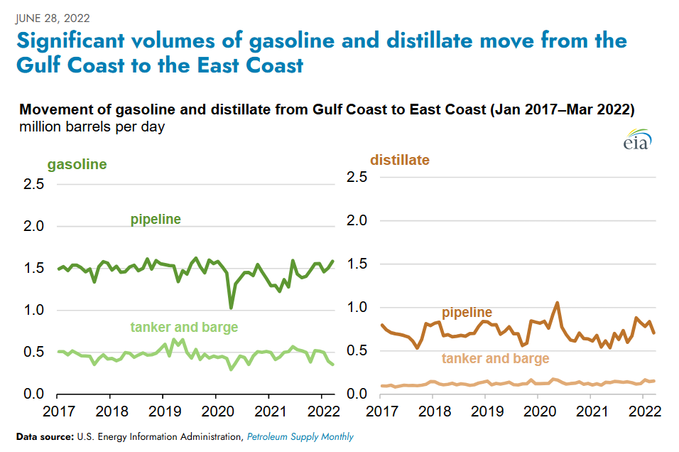  
 [(Source 1)](https://www.eia.gov/todayinenergy/detail.php?id=52919)

**Goal: Predict PADD 1 Arrival flows**

**PADD 1 Arrival flows = colonial pipeline flows + Products (SE) Pipeline flows + tanker& barge + Other PADDs to PADD 1 seaborne + Other PADDs to PADD 1 non-seaborne**

**Supply for PADD 1 = PADD 1 Arrival flows + PADD 1 intra Export**

**Demand for PADD 1 = PADD 1 Departure flows + PADD 1 intra-import**

**Supply – Demand = Stock build**

*(Actually, there will still be a potion in Supply that is production that stay at place, same for Demand Consumption that no import needed. I will assume this part net off for now)*  
**Data to use for each term**

**Colonial pipeline flows**: There are two ways, we will use them to cross check against each other.

1. We will calculate the volume of line 1, then divide the line 1 volume by transit time. We will get throughput. This concept follows little’s law

Linefill (MMbbl)=Throughput (MMbbl/d)×Transit time (days)

1. Use EIA pipeline PADD 3 to PADD 1 data ([From PADD 3 to PADD 1 Movements by Pipeline](https://www.eia.gov/dnav/pet/pet_move_pipe_dc_R10-R30_mbbl_m.htm)) times a percentage of share split between colonial and plantation pipeline to get actual volume for colonial pipeline.

**Tanker& barge**: Assume constant for now.

**Other PADDs to PADD 1 seaborne**: Kpler data or EIA Import data is around the same.

Gasoline Import EIA Data for gasoline includes Motor Gasoline Blending Components + Finished Motor Gasoline.

This aligns with Kpler data when we choose Alkylate, Reformate, Pygas and Gasoline blend stock and Gasoline.

**Tanker & barge**: Only have history data

**Other PADDs to PADD 1 non-seaborne: Get from EIA.**

**Colonial Pipeline Capacity:**

Line 1: 1.37 mbd, Line 2: 1.16 mbd& Line 3: 0.885mbd  
Source 1:

Colonial's Line 1 carries 1.37 million b/d of gasoline and Line 2 carries 1.16 million b/d of distillates from the USGC to Greensboro, North Carolina. Line 3 with a capacity of 885,000 b/d carries both gasoline and distillates from Greensboro to its destination in Linden, New Jersey, and New York Harbor.  
[https://www.spglobal.com/commodity-insights/en/news-research/latest-news/refined-products/040425-colonial-pipeline-shippers-face-off-in-gasoline-liquidity-grade-volatility-tariff-feud](https://www.spglobal.com/commodity-insights/en/news-research/latest-news/refined-products/040425-colonial-pipeline-shippers-face-off-in-gasoline-liquidity-grade-volatility-tariff-feud?utm_source=chatgpt.com)

Source 2:   
The assessments cover the three largest refined products pipelines in the US: the 1.37 million b/d, gasoline-only Line 1 from Pasadena, Texas, to Greensboro, North Carolina; the 1.16 million b/d, distillates-only Line 2 from Pasadena to Greensboro; and the 885,000 b/d, multiproduct Line 3 from Greensboro to Linden, New Jersey. Assessments also reflect the spot price of lines 1 and 3 combined and lines 2 and 3 combined.  
  
[https://www.spglobal.com/content/dam/spglobal/ci/en/documents/platts/en/our-methodology/methodology-specifications/Colonial-Line-Space-FAQ-Feb-2015.pdf](https://www.spglobal.com/content/dam/spglobal/ci/en/documents/platts/en/our-methodology/methodology-specifications/Colonial-Line-Space-FAQ-Feb-2015.pdf?utm_source=chatgpt.com)

**Colonial Pipeline Length/Diameter/Thickness:**

Line 1 length： 1049 miles

Line 1 Diameter: 36- or 40-inch mix

Line 1 Thickness: For 36 inches, it is 0.281 inches. For 40 inches, it is 0.312 to 0.5 inches.

Sources:  
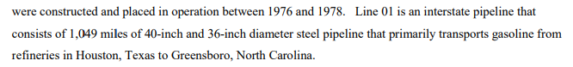 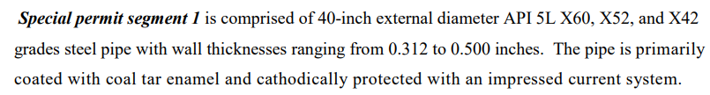

<https://www.phmsa.dot.gov/sites/phmsa.dot.gov/files/2020-08/Colonial-Pipeline-Company-PHMSA-2009-0390-195-310-FEA-FONSI.pdf>



<https://www.ntsb.gov/investigations/AccidentReports/Reports/PAB1904.pdf>

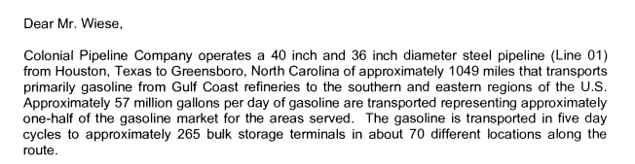

**Calculation**   
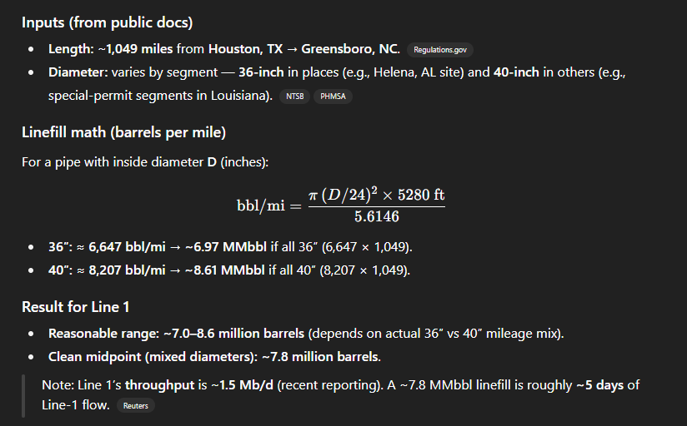

If every day is 1.37 – 1.5 mb, then one cycle is 6.85 mb ~ 7.5 mb.  
Calculate by diameter: 6.97 ~ 8.61 mb.  
Stuff that don’t adds up: 9 days of export, take it as 10 days first. Cycle time 5 days, means 2 cycles will be in the pipeline at one point. So the volume of each cycle must not exceed half the capacity of colonial pipeline, which is around 4.3 mb. This should be the upper bound.

Simple idea 1: Use diameter implied capacity range divided by transit time = volume per cycle.

Avg for line 1 is 8.7 days.

Simple idea 2: HOU to GBR + GBR to LNJ – HOU to LNJ is the time of the oil coming out depending on the volume of the cycle.

More to research on:

1. Incentive Arb time series correlation with transit time. As well as EIA data.
   1. Incentive Arb: Line 1 & Line 3
   2. Transit time: Line 1 & Line 3
   3. EIA data: monthly
2. Colonial pipeline website, there is a map. I think should see is there nearer padd 1 location other than GBR.

Right now is ATJ

We can also calculate the transit time from any point to any point.

Right now, the issue is the implied range is not consistent.

<https://www.colpipe.com/about-us/asset-map/>

And estimate the junction time.

1. More data possibility on T4 side, need more historical data.
2. Implied history line 1 transit time by line 1 + line 3. So that we can have implied range, and then cross check against the actual EIA data.

Info  
1. Under the latest tariff, the minimum volume for unleaded gasoline grades will rise to 75,000 barrels at the Gulf Coast, a five-fold increase from the 15,000 barrels required for fungible deliveries.

<https://www.spglobal.com/commodity-insights/en/news-research/latest-news/refined-products/040425-colonial-pipeline-shippers-face-off-in-gasoline-liquidity-grade-volatility-tariff-feud?utm_source=chatgpt.com>