AI Semiconductor Supercycle Risk Brief
Tail Risk & Volatility Persistence (2018–2023): Evidence from Student‑t GARCH(1,1)
Author: Sirui Zhu | Target Role: Data Analytics (Portfolio/Risk Insight)
Deliverable: 2‑page brief + reproducible code (GitHub)
Key Findings

·Fat tails are real
Non‑normal returns imply Gaussian risk metrics underestimate extreme moves.

·Volatility shocks persist
For NVDA, volatility persistence is near unity (α+β ≈ 0.974) suggests volatility shocks remain elevated for longer.

·Student‑t GARCH outperforms Normal GARCH
NVDA’s AIC improves from 7610.66 (Normal) to 7496.27 (Student‑t), with ν ≈ 6.07 supporting heavy-tails risk.
Business Question

How do tail risk and volatility regimes differ across AI‑semiconductor assets, and which model best captures extreme downside moves?

Asset Universe

NVDA (AI infrastructure leader), INTC (legacy incumbent under transition), TSM (geopolitical/supply‑chain bellwether) and Nasdaq Composite (^IXIC) as the tech market benchmark.

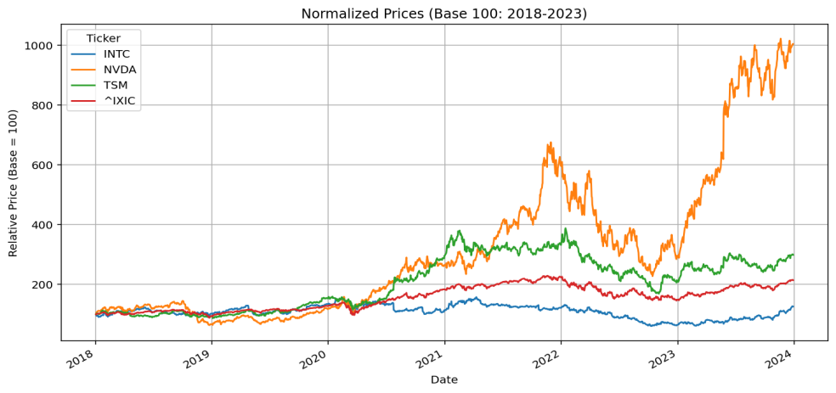
Figure 1 Caption：
Normalized performance highlights divergent regimes and asset‑specific behavior within the same sector, with ^IXIC serving as the systemic benchmark to separate market‑wide vs idiosyncratic risk.
Figure 1. Normalized Prices (Base = 100: 2018 - 2023)
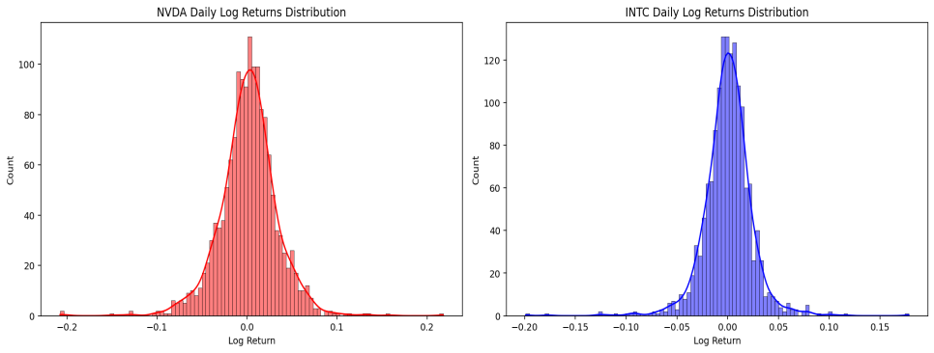
Figure 2 Caption：Histogram + density curves visually demonstrate leptokurtic (fat tailed) return behavior, motivating the switch from Gaussian risk assumptions to Student‑t modeling.
Figure 2. Evidence of Fat Tails (NVDA vs INTC Return Distributions)

Methodology, Model Diagnostics & Actionable Recommendations (Data Analytics Focus)
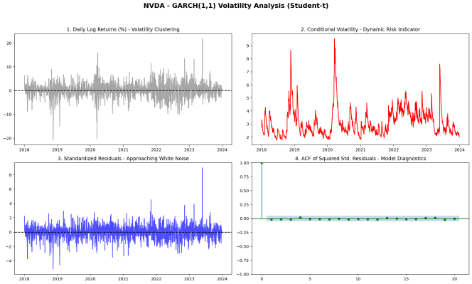
Method
Data Pipeline (Daily, 2018–2023)
·Data source: daily close prices via yfinance for NVDA / INTC / TSM / ^IXIC.
·Quality check: missing values validated; clean time series used for modeling.
·Return transformation: log returns for time‑ additivity and modeling suitability.
·Scaling: returns ×100 for numerical stability in GARCH maximum likelihood estimation
Why this window (2018–2023)?
Chosen to capture a complete macro/tech “super‑cycle” including trade tensions (2018–2019), COVID shock and easing (2020–2021), aggressive tightening (2022), and the generative‑AI breakout (2023).
Daily frequency yields 1,500 observations, improving robustness vs weekly/monthly alternatives.
Modeling Framework
·EDA --- confirm non‑normality (skewness, excess kurtosis)
·Engle’s ARCH LM test --- verify volatility clustering
·Fit GARCH(1,1): Normal vs Student‑t --- compare AIC
·Diagnostics: standardized residuals and ACF of squared residuals (white‑noise check)
Figure 3. GARCH Diagnostics Dashboard（NVDA）
Caption：Conditional volatility (red line) reacts sharply to macro shocks and remains elevated, consistent with high persistence; standardized residual diagnostics support model adequacy.

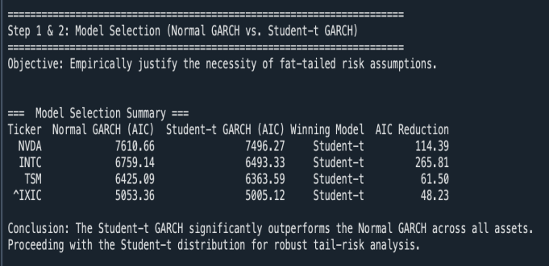
Figure 4. Model Selection: Normal GARCH vs Student‑t GARCH (AIC Comparison)
Caption : Student‑t specifications outperform Normal GARCH across the portfolio, empirically justifying fat tailed risk assumptions under AI‑cycle volatility regimes.

Actionable Recommendations
Portfolio construction implication

High idiosyncratic volatility in NVDA‑type assets requires stronger counter‑balancing with lower‑beta or defensive exposures to stabilize drawdowns during tech sell‑offs
Hedge with duration matched to persistence
Because volatility persistence is very high (α+β approaching 1), risk spikes do not fade quickly. Use long‑dated hedges rather than short term protection when regimes shift.
Upgrade risk metrics

significant fat tails, replace Gaussian VaR with Student‑t Expected Shortfall (CVaR) for downside risk governance in AI cycle assets.

