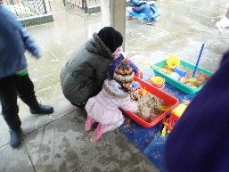
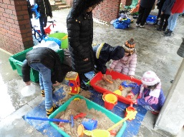


Hillingdon Play Association
Play events at Austin Road
2014
HCT 3
18th February
Play Activities for children to play outdoors:
- Potting & Planting Bulbs
- Sand pit
- Camping & Den Making with Blankets
- Soup & Hot Chocolate to keep warm
- Junk modelling
- Hopscotch
- Whizzy Whizz
- Skipping
- Balls Bats/hoops
- Bird baskets
- Balloon Craft
Our 2nd event was held on the 18th February 2014 from 12-3pm on the Austin Road Estate in the Third quad.
It was supported by 3 play workers and 4 Volunteers in another wet and windy day. Again about 20 children come out and participated in different and varied activities.
We also encouraged the parents to participate and showed them what they can do with their children and where to play with them on the Estate mainly under the walk ways due to the weather.
We arrived on the estate to set up our play zone in torrential rain, waited for the rain to ease and started to set up. We were immediately followed in by the police who had turned up in four police cars to give chase to someone who had run in through the estate. Not to be perturbed we carried on setting up our play zone.
Parents were delighted to see us here again having been cooped up inside due to the awful wet weather during half term. No one was venturing out until they saw us setting up our play zone & taking shelter under the walk ways, this immediately drew interest from the children & parents came out too.
There were people from the council offices visiting while we were setting up. They had come from the Civic Centre to see and evaluate what we were doing for the children on the estate and all said how brilliant they thought it was and it would be great if we could do this for the other estates in the borough. We discussed if it were at all possible to use the empty car park to do future events in wet weather.
Once the weather broke and the rain stopped, play extended out from under the walkways and there was a real buzz about the estate with children playing and parents chatting to each other. The children loved the Whizzy Whizzes and took turns playing & racing each other. They had the perfect grand prix surface. We were joined by the mobile library and the university students and the mobile Austin Road Band came to see all the action in the play zone.
A family visiting their friend on the estate joined in and their two little girls were so engrossed in the sandpit they said “it made their day to find something so easy & free to occupy their children for the afternoon”.
We had the ever popular volunteer Kwame Dallas, a teacher who works with special needs children. He makes swords & animals from balloons and this is hugely popular with the children.
There was no signs of any young teenagers hanging around the estate but it was early afternoon and still very bright despite the clouds above us.

The local Cllr. David Brough also stopped by & chatted about what it was we were doing on the estate. He mentioned that it was heart-warming to see so many of the children outside playing and enjoying all the activities and he really enjoyed the part when two young girls from the Austin Road band proudly sang two songs for him.
He was very impressed with all the activities and said it was a pleasure to see children having so much fun on a very wet cold day and hoped it would continue.
Parents wanted to know when we would be there again. Children were very happy to come and play outside despite the wet weather. They loved finding other children outside to play with. The children loved making bird feeders and tying them to the 2 trees in the quad. They also learned how to plant seeds and bulbs and play with sand and earth.
A few children told us that they cannot wait to see us and they couldn’t sleep because they knew we were coming the next day.




