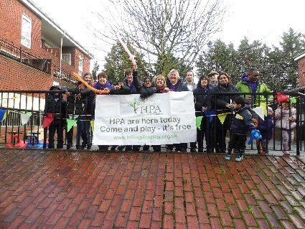
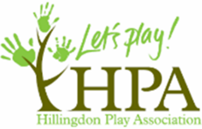

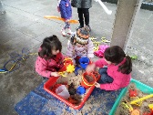
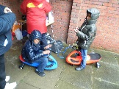
Hillingdon Play Association
Play events at Austin Road
2014
HCT 3
8th February
Play Activities for children to play outdoors:
- Bird feeders
- Painting
- Junk modelling
- Hopscotch
- Skipping
- Rounder’s
- Balls
- Bats/hoops
- Slack liner

Our first event was held on the 8th February 2014 on the Austin Road Estate in the middle quad.
It was supported by 3 play workers and 4 Volunteers. Although a rather wet, cold and windy day we had 18 children come out and participate in different and varied activities.
We also encouraged the parents to participate and showed them what they can do with their children and where to play with them on the Estate, mainly under the walk ways due to the weather.

Some parents were a bit apprehensive as they said they are afraid to let the children play outside because of the signs everywhere saying “NO BALL GAMES”. They also mentioned that there are a lot of young teenagers who tend to shelter and hang around the stairwells in the evening. They find this very intimidating and they say that there is quite a lot of unsocial behaviour from teenagers who do not live on to the estate, but who come to hang out there!
We had a visit from Sue Thomas who is the Housing Manager for the Estate and she was very surprised to see so many children and parents outside and participating in all the activities even though it was a very cold day. She said how nice it was to come and see the children and families having such a good time as she normally only visits when there are complaints. She also said how wonderful it would be if this could be a regular event.
Parents also commented that they would like to see the HPA there on a regular basis as there are no other play opportunities for their children on the Estate.
Children were very happy to come and play outside despite the cold weather. They loved the fact that they could just run around and play without being told to be quiet and NO BALLS GAME HERE!
The estate is really not child friendly and parents expressed that they wished there was more for the children to do on the estate where they could play and make noise and just play together safely!
They were so pleased to see HPA and very grateful for us delivering play opportunities for their children. It has also help parents get to know each other and talk about what they would like to see on their estate.





