Solar Truck Design Concepts and Measurement Analysis

Table of Contents

1 Initial Concept 3
1.1 Summary 3
2 Measurements 3
2.1 Large Trucks with Thermoking 1200 3
2.1.1 Solar Panel Potential 3
2.1.2 Electrical energy usage 3
2.2 Small direct drive trucks 3
2.2.1 Solar Panel Potential 4
2.2.2 Electrical energy usage 4
3 Design Challenges and considerations 4
3.1 Energy feed-in method 4
3.2 Accurate fuel consumption comparisons 5
3.3 Dirt on solar panels 5
4 Design options 5
4.1 Only alternator switch off 6
4.2 Bidirectional Alternator 6
5 Proposed Design 7

Initial Concept

Summary
The basic concept of the solar truck project is to use solar panels to generate electrical energy. This electrical energy will be used to augment existing energy usage of the refrigerated truck. Since existing energy used by the truck is all derived from diesel fuel, the use of solar energy will save fuel usage which will lower running costs as well as lower pollution by decreased fossil fuel usage.

Measurements

Large Trucks with Thermoking 1200
The initial target truck were large refrigerated trucks such as a Nissan UD truck fitted with a Thermoking T-1200R refrigeration unit. These types of trucks (or similar) with this refrigeration unit is very common in the market place and would form an ideal baseline.

Solar Panel Potential
The trucks have a flat roof area of with typically 2.5m x 6m. This is an ideal candidate for installing PV panels, since the roof has the following characteristics:
- Flat: Allows for easy installation and almost no wind resistance
- Large: 2.5x6= 15.6m² giving 2.3kW potential electrical energy
- High: It will be safe from accidental damage, theft or vandalism

Electrical energy usage
The Thermoking T-1200 has its own diesel engine to power the refrigerator directly. This engine has its own starting battery and battery charging alternator. It is also fitted with a 7.5kW three phase electrical motor for running the refrigerator using electrical power when the truck is parked for storage overnight.
The truck has a 24V system, with 2x 12V batteries and 2x battery charging alternators.
The energy generated from the solar panels have to supply the electrical loads in order to be of use and save fuel. Ideally, we would want to use the solar energy to drive the electrical motor of the refrigerator so that it does not need to start up the diesel engine. Unfortunately this will not be possible, since we can get a maximum of 2.3kW (peak) solar energy, and the electrical motor requires 7.5kW (and more during start-up).
The alternative option is to only supply the energy that is currently being generated by the three alternators (one of the thermo king and two of the truck), but this limits the total amount of power that we can feed into the system.

Small direct drive trucks
An alternative truck system for which we could put up solar panels is smaller trucks/bakkies that use a direct-drive thermo king unit. These trucks are typically a Toyota Hilux pickup, with a large rectangular refrigeration area. These units are fitted with a direct drive refrigeration system such as the Thermoking V200 series. Since the units draw their energy directly from the vehicle engine, these systems will not only benefit from better fuel consumption if energy is augmented with solar energy, but the vehicle will have more power available for driving.

Solar Panel Potential
These smaller pickups have a flat roof area of with typically 1.8m x 2.5m. It still has the same advantages of the roof of the larger trucks, except that it is smaller and will not allow the same amount of solar power to be captured. They are still high enough so that the units are safe from vandalism, theft and accidental damage, and the roof area is flat for easy mounting and virtually no wind resistance.

Electrical energy usage
The direct-drive systems are fitted with a compressor that is driven directly from the existing engine. It is fitted on the same belt as the existing engine alternator. The refrigerator also consumes 21A at 12V of electrical energy, which is also powered from the vehicle engine via the alternator. We could supply all the electrical energy used by the vehicle and refrigerator and this will already utilize a large part of the solar energy generated, but it would be more advantageous if we could feed all the the potential solar energy into the system.

Design Challenges and considerations

Energy feed-in method
The simplest method to feed electrical energy into a vehicle system, is to use a charge controller to charge the vehicle battery. The charge controller gets energy directly from the solar panels, and feeds in all available solar energy into the battery until the battery is fully charged. However, since the alternator is also supplying energy to the battery, and the alternator current could be very noisy and the float charge voltage very high, most battery charge controllers will not function correctly while the alternator is still being used. The alternator is also very inefficient at low power levels, and it will be most advantageous if a controller could disconnect the alternator when solar energy is available.
Simply disconnecting the alternator power lines could cause the alternator to generator very high voltages and could damage the alternator of alternator control unit. A safer alternative is to only disconnect the alternator field supply. Theoretically, this should be possible to do with software via a vehicle's OBD port, but we expect most older model trucks will not have alternator field controllable via the OBD port. The next best method is to have a relay fitted that switches off the alternator field power.
By adding alternator on-off control to our system, we can also start using the battery as a storage device, by switching off the alternator when the vehicle needs extra mechanical power for driving, or when we expect solar power to increase later in the day.
For this simple system, the amount of energy that we can feed in is limited by the amount of energy used as electricity by the system. For the large trucks with a T-1200 Thermoking, the only loads that we will actually power off solar power is for all the auxiliary electrical supplies of the truck and Thermoking engine, and the energy required to start the Thermoking. If we assume the systems to be designed to draw 50% rated power from the alternator on average, and knowing that the alternators are rated at 600W each, then we can possibly supply 900W of electrical power.
If we wanted to supply more electrical power, then we would have to convert electrical power to mechanical power to augment either the refrigerator or vehicle engine. This will significantly increase our system cost, but could be a feasible solution to get the most benefit out of the solar panels.

Accurate fuel consumption comparisons
In order to prove how effective the solar panels are at reducing running costs, we have to accurately determine the amount of fuel saved by augmenting the power with solar power. Most vehicles that we plan to test will not have a fuel flow sensor. For vehicles that have a T1200 Thermoking, we would have to measure the fuel used by both the refrigerator and vehicle engine.
Since fuel consumption varies with driver, route, load, external temperature, and number of times the door is opened, we will have to log data over a very long time to get significantly representative data from real life tests. It would be best to do a controlled test to qualify fuel savings, and then real life tests could be logged for a vehicle to validate the controlled test results.
To get fuel sensing, we could use OBD parameters, or install a fuel flow sensor. To keep installation as simple as possible, OBD parameters will be preferred. It is unlikely that the vehicles tested will have fuel consumption as an OBD parameter, but they should have Mass airflow (MAF) rate, as well as vehicle speed. From these values the fuel consumption can be calculated, which will not be highly accurate, but accurate and repeatable enough to qualify the fuel savings that can be expected with a solar system installed.
For diesel engines we can calculate the instantaneous diesel consumption as follows:
CON=(VSS /60 /60 )/(MAF /14.6 /832) = 3.374*VSS/ MAF
by assuming:
Air/Diesel ratio = 14.6
Diesel density = 832 g/l
MAF is the mass of airflow in g/s
VSS is the vehicle speed in m/s
CON is the fuel consumption in km/l.

Dirt on solar panels
For the larger trucks with T-1200 refrigerators, the Thermoking exhaust will have to be routed to an alternative outlet location to avoid the solar panels getting covered in exhaust fumes. this is not difficult but presents an unforeseen expense to the installation.

Design options
In order to make maximum use of the available solar panels' energy, as well as having the most basic system for the initial design, the smaller trucks with a direct drive refrigeration unit will be used.

Only alternator switch off
The most basic solution that will allow us to achieve reasonable fuel savings with minimal installation cost is to have the following system:
- Solar panels sized to match the expected electrical usage
- A means to switch off the vehicle alternators
- A battery charger with maximum power point tracking (MPPT) running off the solar panels
- A micro-controller that will sense all the inputs, and decide when to switch off the alternator, as well as log fuel usage/savings
- A current sensor from the MPPT charger to record electrical power generated from the solar panels
- Interface with vehicle OBD data to get distance traveled and fuel usage parameters
- Voltage sensors on both the vehicle battery and solar panel output going into the MPPT charger

The alternator siwtch-off relay can be wire to be Normally Closed (NC), so that in the case of system failure, the microcontroller can be disconnected and the system will revert back to its default state with the alternator always on.

Bidirectional Alternator
In order to feed more energy into the system, the existing alternator could be used as an electric motor. By replacing the rectifier on the existing alternator with an active rectifier/inverter, and allowing the micro-controller to control power flow in both directions, any excess solar energy can be used to help drive the engine, thereby saving fuel.
The control for this would not be too difficult to implement, since vehicle parameters such as speed, and fuel usage received from OBD data can be used to decide whether to run in motor or alternator mode. This can turn the vehicle into a type of hybrid vehicle that can make use of smart regenerative braking to additionally charge the battery when solar power is not enough to keep the battery fully charged. The system can be developed to fully maximize the hybrid effect if deep cycle batteries are used, or to limit battery charge/discharge to 10% if normal vehicle batteries are used.
The electronics necessary to convert the alternator to a hybrid motor/alternator is however not available as off-the-shelf. The technology certainly exists, and one could be designed, but a cost feasibility analysis will have to be done. The electronics required should have:
- A boost DC/DC converter to step the 12V battery voltage up to 24 or 48V depending on how much energy need to be put into the alternator, with an estimated size of 600W
- A three phase inverter of at least 60A per phase
- A DC/DC step down regulator battery charger to feed the alternator's actively rectified power back to 12V to cahrge the battery
- It has to withstand severe vibrations, heat and be extremely reliable so as not to cause failures which could cost much more than the amount of fuel it will save in its lifetime
Given the fact that no such electronics exists off-the-shelf, and developing it will require a very large development budget, the bidirectional alternator option will have to be analysed further at a later stage.

Proposed Design
The proposed truck to use has a C200 Thermoking directdrive unit, with 2.3 x 1.8m of flat roof space. Two 250W PV panels of 1m x 1.65m can easily be installed on the roof, giving a maximum power output of 500W.
Since the truck normally had a 600W alternator fitted, we can assume that the average load on it would be around 50% or 300W. Field tests will confirm our estimates. The Thermoking is know to draw an additional 21A at 12V which is 252W. This means that we can add an average of 552W into the system using only the PV panels, an MPPT charger and an alternator kill switch.
Using conservative estimates of electrical power on a diesel vehicle requiring 0.48 l of diesel to generate 1kWh of electrical energy, the total savings that we envision for a 5h sunshine a day, 225 operating days a year is R2700. The calculations are shown here:

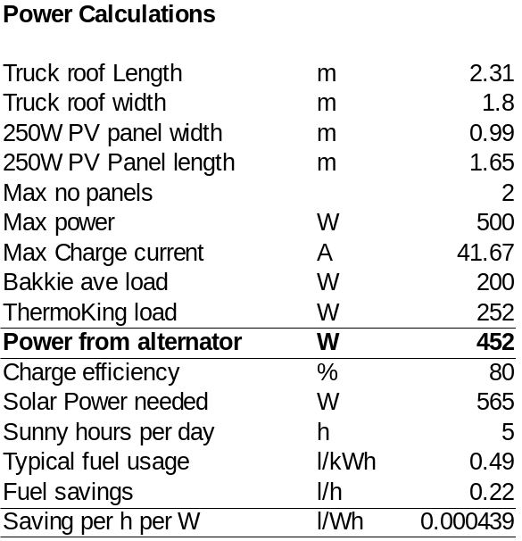

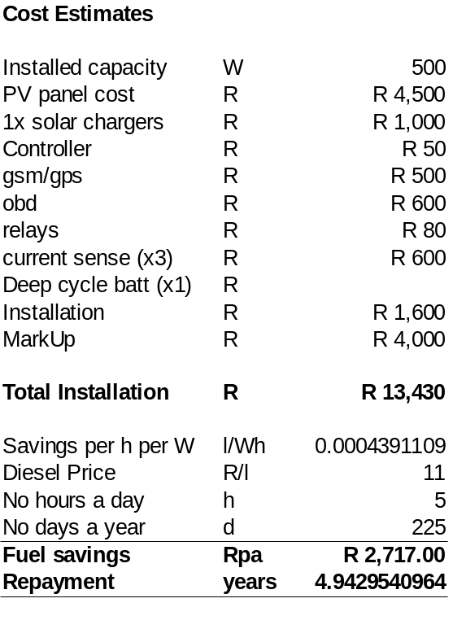

The proposed circuit diagram is shown here:
