The schedule is subject to change as the semester progresses. *(Last modified May 9 2019)*

**TODO**

Make github repo of all parts as sub folders

branch for testing and only commit finsihed to master

GPS data- get 3 states as well as speedometer via gps

all 4 Cameras:

window detectioncalibration: not care about anything thats not out window-auto black it out

object/car detection

“parking sensors” if under a certain speed or maybe at desitnation location by gps

front camera:

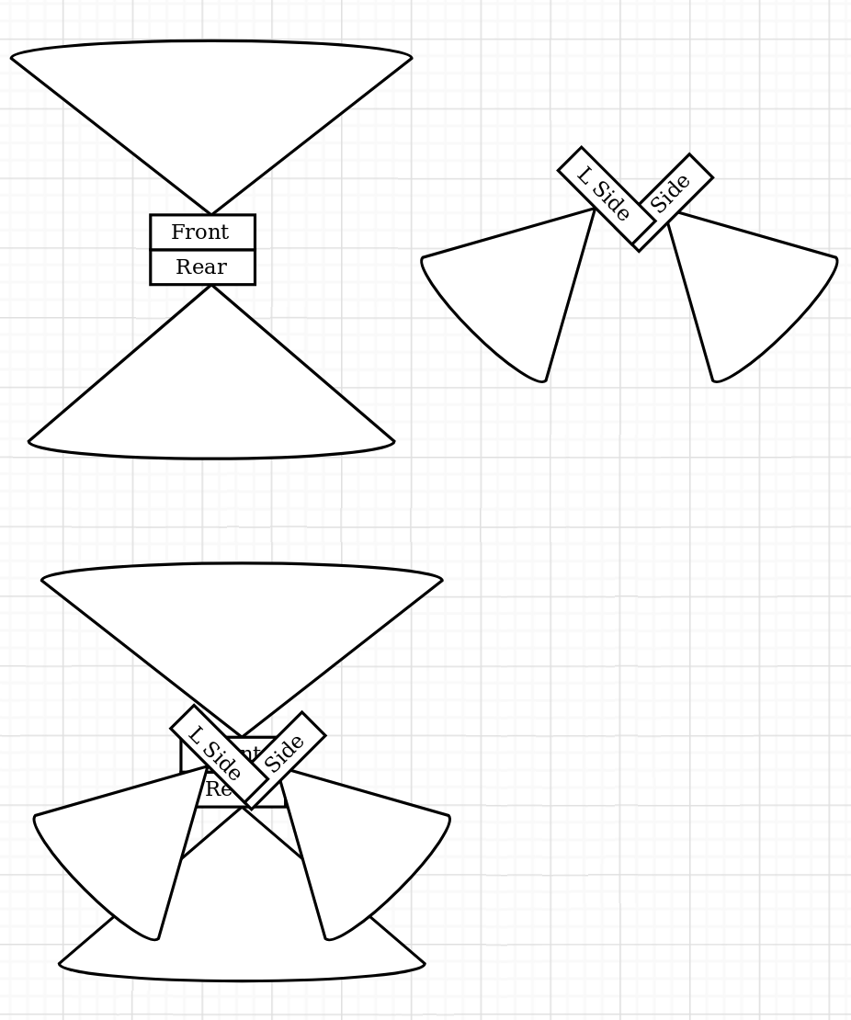 car and road detection

stretch: follow roadsigns for gmaps nav help

back camera:

backup sensor / depth detection

fast car coming from behind detection

side cameras:

blindspot monitor

fast coming from the side

integration via stereo system

different modes and audio cues

set up plug-n-play calibration for any car

auto level or warning or guided setup

rough mockup of angles ->>

|  |  |  |
| --- | --- | --- |
| **Week** | **Notes** | **Deliverables** |
| 1 | Form Teams/Projects | Project Proposal due 5/10, F by 5pm |
| 2 | Form Teams/Projects | Initial Pitch Presentations on 5/15, W |
| 3 | Design | Project Plan due 5/22, W by 5pm |
| 4 | Design | Design Document due 5/29, W by 5pm |
| 5 | Implementation | Weekly Progress Report 1 due 6/5, W by 5pm |
| 6 | Implementation | Weekly Progress Report 2 due 6/12, W by 5pm |
| 7 | Implementation | **Midterm Presentations**  6/17 - 6/21 |
| 8 | Implementation | Weekly Progress Report 3 due 6/26, W by 5pm |
| 9 |  | July 4th Recess |
| 10 | Implementation | **Senior Comprehensive Exam on 7/12 ?**  Weekly Progress Report 4 due 7/10, W by 5pm |
| 11 | Implementation | Practice Presentations on 7/15-17 MW |
| 12 | Implementation | ** **Poster due 7/26** **  **Final Presentation in class July 22,23,24** |
| 13 | Wrap Up | Final Project and Documentation due 7/30, **Tuesday** by 5pm |
| 14 | Wrap Up | Poster showcase Week of 8/5  Note: Showcase schedule is tentative |
| 15 | Final |  |

budget/costs:

switch ? $250? maybe?

$40 x 4 = $160