Rolly Royal Plinko
Description:
RollyRoyal Plinko is a physics-based digital Plinko game developed using the HTML5 Canvas API. The system simulates a ball dropping through a grid of pegs, where its trajectory is dynamically calculated using real-time gravity and collision physics. It serves as a technical showcase of 2D coordinate transformations, featuring a luxury arcade aesthetic built with procedural gradients and interactive animations. A key feature is the "Digital Receipt" system, which uses toDataURL to allow users to export their winning moments as image files.
Purpose:
- Gameplay: RollyRoyal Plinko gives you a fancy arcade feeling. You drop digital balls from the top of a triangular field of pegs. Your goal is to land the ball in the high-money spots at the bottom. Every time you drop a ball, it's a new and exciting event because the ball's path is not always the same as it hits the pegs. The game mixes the excitement of real physics with a beautiful look. You can also save pictures of your biggest wins right away with the digital receipt system.
- Core Mechanics:
  - Dynamic Gravity & Trajectory: Every ball is governed by a simulated gravity constant, ensuring a natural downward acceleration that responds to every collision and bounce.
  - Collision Manifolds & Restitution: Using custom physics logic, the system calculates the exact angle of reflection when a ball hits a peg, factoring in "bounciness" (restitution) to maintain momentum.
- Visual Representation
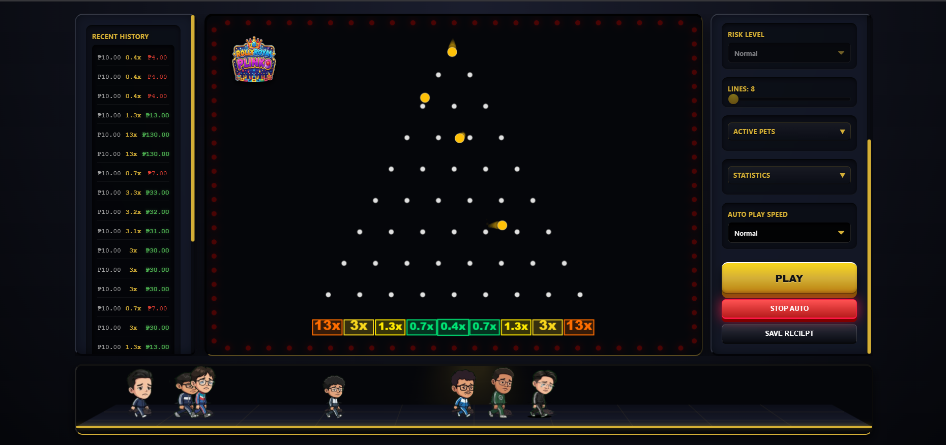
- Graphics Elements
  - Heads-Up Display (HUD):
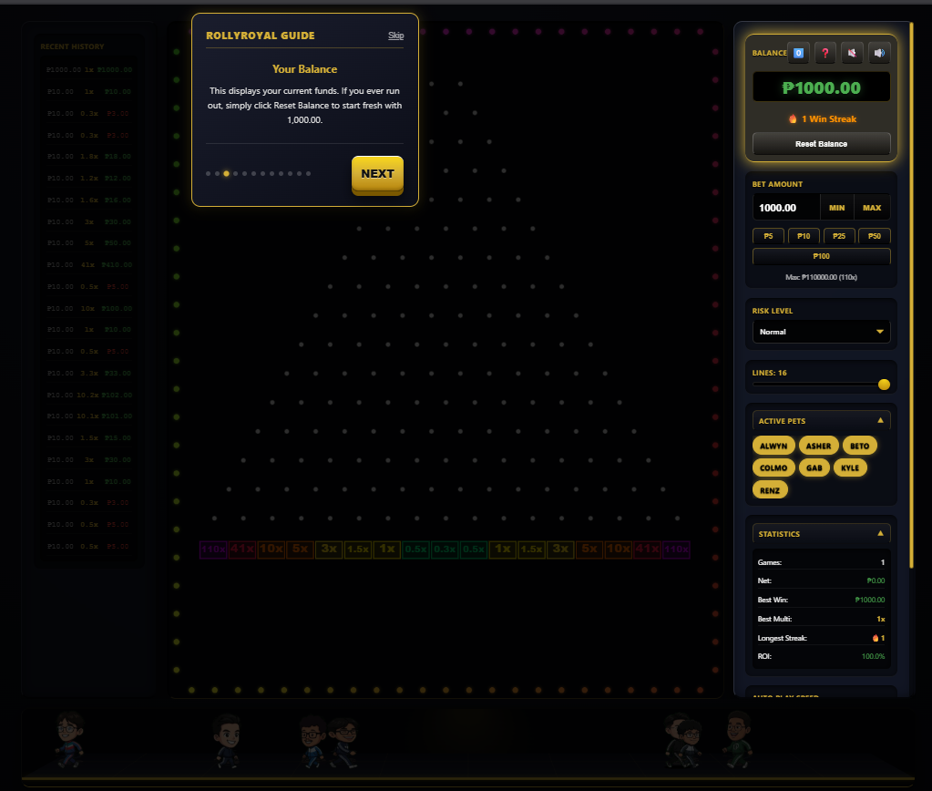
  - Scoreboards or Bet History
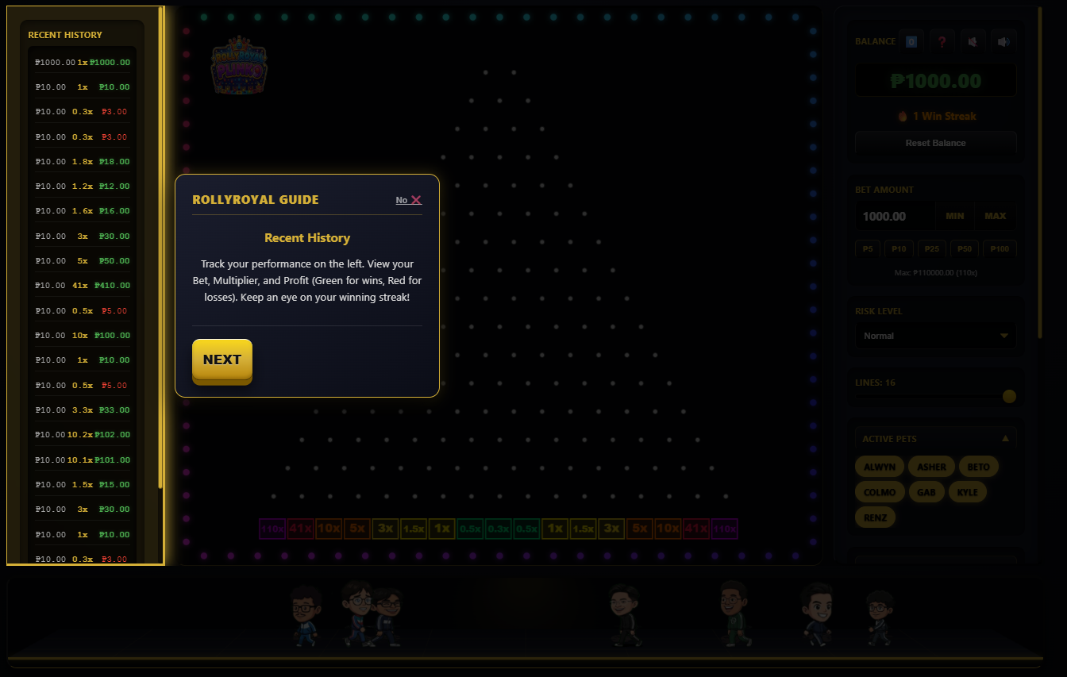
- Rules:
  - The goal is to win money by dropping Plinko Ball and wait till it lands in the highest money slot at the bottom of the board.
- Victory and Loss Condition:
  - Victory Condition:
    - There isn't a single "victory" state that ends the game. Instead, you "win" by increasing your userBalance. Each time the ball lands in a slot that pays out a multiplier, you earn profit, which is added to your balance. The goal is continuous winning and accumulating a higher balance. There are "Jackpot effects" and "Confetti for big wins" to celebrate significant payouts.
  - Loss Condition:
    - The main loss condition is when your userBalance reaches zero (₱0.00). The game will display a "YOU LOSE" Game Over screen, and you'll be prompted to either "Try Again" (which resets your balance to the initial ₱1,000.00) or "Cancel".
- Interactivity Modes
  - This is a single-player game that can be controlled using only mouse (input).
- Challenges:
  - Players cannot choose exactly where the ball drops at the start. The ball falls randomly, so you must learn to play even when you can't control the first bounce.
  - Players pick how risky you want to play. If players choose high risk, they might win a lot of money, but could also lose a lot faster. Low risk means smaller wins, but more often.
  - Players need to be smart about how much money you bet. If you bet too much, especially with high risk, you might quickly run out of money.
  - Players can change how many rows of pegs are on the board. When players change the number of pegs, the ball will fall differently, so players need to adjust their game plan.
  - The game's physics makes the ball bounce in slightly different ways each time. Players can try your best, but players can't truly know where the ball will land.
  - The most important challenge is to keep the game money and try to make it bigger. If players lose all their money, the game is over.
Objectives:
- Advanced Rendering: Leverage the HTML5 Canvas API to implement complex transformations, including translation, rotation, and scaling for all game assets.
- Physics Modeling: Architect a custom physics engine to simulate realistic gravity, velocity, and restitution during dynamic ball-and-peg collisions.
- Aesthetic Engineering: Deliver an arcade-like atmosphere through the strategic application of radial and linear gradients for the game board and UI..
- Data Portability: Integrate the toDataURL method to enable seamless capture and download of the live game state as high-resolution PNG files.
- Performance Optimization: Ensure a fluid user experience by maintaining a consistent 60FPS rendering loop via requestAnimationFrame.
Scope:
- Dynamic Physics: Real-time calculation of ball movement and peg collisions.
- Interactive Controls: Players can strategically influence gameplay outcomes by adjusting bet amounts, risk levels, and the number of peg lines.
- UI Animations: Animated "Jackpot" effects using scaling and rotation triggers.
- Export Feature: Functional "Save Result" button to convert the canvas into a downloadable image.
- Digital Receipt System: Use of toDataURL to allow users to export their winning moments as image files.
Limitation:
- No Real Currency: Designed strictly for educational and simulation purposes.
- Single-Player: Localized experience with no multiplayer or online leaderboards.
- Fixed Board Layout: The peg arrangement is static and cannot be customized by the user.

Members:
20230335-S Adriano, Alwyn S.:
20230114-S Colmo, Joshua Paul M.:
20231211-S Geronimo, Renz C.:
20231193-S Madriaga, Kyle Vincent M.:
20230138-S Leonardo, Rafael Dominic:
20230184-S Manit, John Asher M.:
20230054-S Ofiangga, John Gabrielle D.:

Approved by:
Ms. Tarraya
Professor, Graphics and Visual Computing

Revision & Feature Additions
The following features were designed, implemented, and integrated into RollyRoyal Plinko after the initial submission, transforming it from a physics demo into a fully gamified arcade experience.

1. Gamification Layer (XP, Levels, Achievements, Shop)
A full progression system was built on top of the core physics engine:
• XP & Levels: Players earn XP per game and per win. Accumulating enough XP advances the player's level, displayed in the HUD.
• Achievements: A set of unlockable achievements tracks milestones (e.g., first big win, long streaks). Unlocks trigger toast notifications.
• Shop: An in-game shop allows players to spend Stars on powerups, ball skins, pet skins, and themes.
• Prestige System: At Level 20, players may Prestige — resetting level/XP in exchange for a permanent +5% win multiplier per prestige rank.

2. Currency Consolidation — Stars
The original dual-currency system (balance + coins) was replaced by a single unified currency: Stars. Players start with 100 Stars. All shop purchases, rewards, and daily bonuses use Stars. Existing localStorage data is automatically migrated on first load.

3. Theme System with Animated Backgrounds
Seven visual themes were added, each overriding CSS variables and rendering a unique animated canvas background:
• Default: Classic gold-on-dark arcade look.
• Neon: Cyan/magenta neon glow; balls glow like neon tubes.
• Gold Rush: Warm amber palette; ball rendered as a gold coin emoji.
• Galaxy: Star field with procedural shooting stars streaking across the background.
• Deep Sea: Bioluminescent bubbles rising through a dark teal ocean.
• Inferno: Rising ember particles and heat-distortion atmosphere.
• Cherry Blossom: Drifting pink petals falling across a soft gradient sky.
• Retro Arcade: CRT scanline overlay with a sweeping scan beam; pixel-art atmosphere.

4. Fire Streak System
Consecutive wins build a streak counter displayed in the HUD. At streak thresholds the ball's visual appearance changes:
• Streak >= 5: Orange fire glow.
• Streak >= 10: Blue fire — intense heat visual.
• Streak >= 15: Pink/magenta fire — ultra-hot tier.
The fire effect uses a per-tier color palette applied as a canvas shadow glow on each ball draw call. Streak glow takes visual priority over theme-specific ball glow.

5. Ball Skins
Six cosmetic ball skins purchasable from the Shop:
• Default (solid theme color)
• Flame (red/orange radial gradient)
• Rainbow (hue-rotating per frame)
• Ghost (translucent white)
• Ice (blue crystalline gradient)
• Dark Matter (deep purple with void glow)
Active skin overrides theme ball color at draw time.

6. Lucky Spin — Daily Prize Wheel
A daily prize wheel triggered once per calendar day via the HUD. The wheel is drawn procedurally on an HTML5 Canvas with 8 prize segments. Spin physics use a geometric deceleration curve; the winner is derived from the wheel's final resting angle. Prizes: 5, 10, 20, 35, 50, 100 Stars and powerup items (Lucky Charm, Shield).

7. Jackpot Meter
A fill bar in the HUD tracks a Jackpot Meter (0-100). Each loss increments the meter; a big win drains it. When the meter reaches 100% it pulses and grants the player a powerup reward. This mechanic rewards persistence during bad-luck streaks.

8. Slow-Motion on Big Wins
When a ball lands on a 25x or higher multiplier slot, the physics simulation enters slow-motion for 90 frames — gravity and friction multipliers drop dramatically, creating a cinematic landing moment before the win is registered.

9. Auto-Bet Strategies
A strategy selector in the HUD gives players three betting modes:
• Flat: Bet stays constant every drop.
• Martingale: Bet doubles after each loss; resets to base on win.
• Anti-Martingale: Bet doubles after each win; resets to base on loss.

10. Stats Sparkline
The Stats panel includes a mini line chart rendered on a secondary canvas element. It plots the last 20 balance readings as a gold line chart, giving players a quick visual read of their recent performance trend.

11. Peg Ping Ripples
Each time a ball collides with a peg, an expanding ring ripple is emitted from the peg's position. Ripples scale outward and fade in opacity over ~20 frames, providing tactile visual feedback for every bounce.

12. 2.5D Pet Stage — LABOBO Characters
A dedicated pet stage panel sits below the game board, rendered on a separate canvas. Seven chibi LABOBO characters — one per team member — walk, idle, and react to game events in real time:
• Alwyn
• Asher
• Beto
• Colmo
• Gab
• Kyle
• Renz
Each character is rendered from a sprite sheet (5 animation frames x 3 rows: happy, sad, jackpot). The stage uses a 2.5D perspective illusion with a floor gradient and a faint reflected copy of each sprite beneath them.

13. Pet Behavior & Interaction System
Pets are governed by a personality-driven state machine:
• Happy / Sad: Default walking state. Direction and speed vary per pet personality.
• Jackpot: Triggered on 10x or higher win. Pet jumps with a sine-wave bounce for ~3 seconds.
• Greeting: Two pets within ~1 body-width stop, face each other, and perform an excited head-wobble bob for 2-4 seconds before walking away.
• Chasing: Occasionally a pet sprints toward a random other pet at 2.2x speed. Catching them triggers greeting.
Idle personality actions (randomised every 1.5-5 seconds): small hop with squash-on-landing, speed burst, brief pause, or direction change.

14. Speech Bubble Conversation System
Pets display Terraria-style speech bubbles drawn in screen space — rounded-rectangle body with a triangular tail pointing to the speaker. Bubbles fade in, hold, then fade out. Dialogue is triggered contextually:
• Greeting: Pet A says an opener, Pet B replies ~1 second later.
• Chase: Chaser: "Wait up!" / Target: "Ahh!!".
• Jackpot win: "WOOO!!", "JACKPOT!!", "NO WAY!!".
• Regular win: 50% chance of "Nice!", "EZ money", "Cha-ching!".
• Loss: 60% chance of "Oof...", "Bruh.", "L + ratio".
• Idle: Ambient mumbles: "...", "*yawn*", "la la la".

15. Pet Skins — Pink Variants
Each LABOBO character has an alternate Pink costume skin purchasable from the Shop. Skins are stored per-pet in localStorage and applied at sprite load time via getPetSpriteFile() lookup. Supported formats: PNG and WebP.

Updated Scope Summary
• XP / Level / Prestige progression system
• Achievement system with toast notifications
• In-game Shop with Stars currency
• Seven themed visual environments with animated backgrounds
• Fire streak visual escalation (orange to blue to pink fire)
• Six cosmetic ball skins
• Daily Lucky Spin prize wheel
• Jackpot Meter powerup mechanic
• Slow-motion cinematic on 25x wins
• Martingale / Anti-Martingale auto-bet strategies
• Balance sparkline chart in Stats panel
• Peg collision ripple particles
• 2.5D pet stage with 7 LABOBO chibi characters
• Pet state machine: happy, sad, jackpot, greeting, chasing
• Speech bubble conversation system with contextual dialogue
• Pet cosmetic skins (pink variants) with WebP support

