SOFTWARE REQUIREMENTS
SPECIFICATION
Smart Campus System

Version 1.0 — Draft for Team Review
Prepared by: Rabby Omi Hasan
Student ID: 2401442
Institution: Dongshin University
Department: Information Technology
Date: 13 October 2026

Prepared using the structure of the supplied IEEE-style SRS template.

Document Control
Version | Date | Prepared by | Description
1.0 | 13 Oct 2026 | Rabby Omi Hasan | Initial SRS draft for team review

Revision History
Name | Date | Reason for Changes | Version
Rabby Omi Hasan | 13 Oct 2026 | Initial document | 1.0

Table of Contents
- 1. Introduction
- 2. Overall Description
- 3. External Interface Requirements
- 4. System Features
- 5. Other Nonfunctional Requirements
- 6. Other Requirements
- Appendix A: Glossary
- Appendix B: Analysis Models
- Appendix C: To Be Determined List
Note: In Microsoft Word, right-click this list or use References → Table of Contents to generate an automatic page-numbered contents list if required.

1. Introduction

1.1 Purpose
This Software Requirements Specification (SRS) defines the functional and non-functional requirements for Smart Campus System, version 1.0. It describes the expected behavior, interfaces, constraints, user roles, and quality requirements so that the student team can design, implement, test, and evaluate the same system. This document is a proposed baseline and should be reviewed by the full team and instructor before final submission.

1.2 Document Conventions
- “Shall” indicates a mandatory requirement; “should” indicates a recommended capability.
- Each requirement has a unique identifier (for example, FR-01 or NFR-01) and a priority of High, Medium, or Low.
- Assumptions are explicitly identified and must be confirmed by the team.
- Diagrams illustrate proposed system behavior and may be updated as the implementation is finalized.

1.3 Intended Audience and Reading Suggestions
The intended audience includes the project instructor, student developers, project coordinator, testers, campus administrators, faculty members, and student representatives. Readers should begin with Sections 1–2 for context, review Section 3 for interfaces, use Section 4 to implement and test features, and use Section 5 to validate quality and security.

1.4 Product Scope
Smart Campus System is a proposed web-based platform that brings common campus information and selected academic services into one place. It is intended to help students access timetables, announcements, attendance information, and campus facility reservations; help faculty publish announcements and record attendance; and help administrators manage users, content, facilities, and complaints. The system aims to reduce manual communication, improve access to information, and make campus services easier to use.

1.5 References
- Supplied document: Software Requirements Specification template based on the Karl E. Wiegers SRS template, provided by the course instructor.
- Course project brief and team decisions: to be added by the team before final submission (TBD).
- Any campus policies, API documentation, or design references used during implementation: to be added when confirmed (TBD).

2. Overall Description

2.1 Product Perspective
The Smart Campus System is a new, self-contained campus service application for the purposes of this project. It may be implemented as a responsive web application connected to a centralized database. Users access the application through a browser. The application server validates requests, enforces role permissions, and reads or writes records in the database. External university systems such as a student information system, single sign-on service, or payment gateway are outside the confirmed scope unless the team decides to integrate them.
High-level architecture: Student/Faculty/Admin → Web User Interface → Application/API Layer → Database. All role-specific actions pass through the application layer.

2.2 Product Functions
- Register or sign in and sign out securely.
- View and update permitted profile information.
- View class timetables, campus announcements, and personal attendance records.
- Allow authorized faculty to manage course announcements and record attendance.
- Search available campus facilities and submit reservation requests.
- Submit and track campus service complaints or requests.
- Allow administrators to manage accounts, roles, announcements, facilities, and complaints.
- Provide confirmation and clear error messages for important actions.

2.3 User Classes and Characteristics
User class | Main needs | Permissions
Student | Timetable, announcements, attendance, facility reservations, complaints | Read own academic data; create and track own requests
Faculty | Course information, announcements, attendance entry | Manage assigned course data and attendance
Administrator | User and role management, content and service oversight | Manage system configuration and authorized records
Guest (optional) | View public information | Access only pages explicitly marked public

2.4 Operating Environment
- Client devices: desktop or laptop, tablet, and smartphone.
- Client software: modern web browsers such as Chrome, Edge, Safari, or Firefox.
- Server: a web/application server capable of running the selected project stack.
- Data storage: a relational database such as PostgreSQL or MySQL, depending on the team decision.
- Network: internet or campus network connectivity is required for online use.

2.5 Design and Implementation Constraints
- The interface should be responsive and usable on common screen sizes.
- Only authenticated and authorized users may access protected functions.
- Passwords and other sensitive data must not be stored in plain text.
- The implementation language, framework, hosting platform, and database are to be confirmed by the team (TBD).
- The system must follow the course requirements and any campus privacy or acceptable-use rules supplied by the instructor.

2.6 User Documentation
The project should provide a short user guide describing login, timetable and announcement access, attendance viewing, facility reservation, complaint submission, and administrative tasks. A README file in the GitHub repository should include setup instructions, prerequisites, configuration steps, and test/demo accounts if approved for academic use.

2.7 Assumptions and Dependencies
- Users have access to a compatible device and network connection.
- Students, faculty, and administrators are assigned valid accounts and roles.
- Timetable, course, facility, and user data will be entered by authorized personnel or imported from a source agreed by the team.
- Real payment processing, official university single sign-on, and integrations with existing campus systems are not included unless explicitly approved.
- Availability of hosting, database services, and third-party libraries depends on the team's final technical choices.

3. External Interface Requirements

3.1 User Interfaces
- The landing page should provide clear navigation to login, announcements, timetable, and other permitted functions.
- Authenticated users should see menus appropriate to their roles.
- Forms should label required fields, validate inputs, and show actionable error messages.
- Reservation and complaint screens should display current status and confirmation after submission.
- Pages should use consistent typography, navigation, spacing, and accessible contrast.

3.2 Hardware Interfaces
No specialized hardware is required for the baseline system. The application shall work through standard devices with a display, keyboard or touch input, and network connectivity. Optional card readers, campus sensors, or biometric devices are outside the current scope.

3.3 Software Interfaces
- Web browser ↔ application server: HTTPS requests and responses.
- Application server ↔ database: parameterized database queries through the selected database driver or ORM.
- Authentication: application-managed authentication for the baseline; university SSO integration is TBD.
- Notifications: in-app notifications are in scope; email or push notifications are optional and depend on an approved provider.

3.4 Communications Interfaces
All production traffic should use HTTPS. Client-server messages should use standard HTTP request/response conventions, with JSON for API payloads if a separate API is implemented. The system should handle network errors gracefully and avoid exposing passwords, session tokens, or sensitive personal information in URLs or logs.

4. System Features

4.1 Authentication and Role-Based Access

4.1.1 Description and Priority
Users sign in to access personalized services. High priority.

4.1.2 Stimulus/Response Sequences
A user enters credentials → the system validates the credentials → the system creates an authenticated session and opens the appropriate dashboard, or displays a generic error if validation fails.

4.1.3 Functional Requirements
ID | Requirement | Priority
FR-01 | The system shall allow registered users to sign in using valid credentials. | High
FR-02 | The system shall provide a sign-out function that ends the user's session. | High
FR-03 | The system shall restrict protected functions according to the user's assigned role. | High
FR-04 | The system shall show a clear error when credentials are invalid without revealing which credential was incorrect. | High

4.2 Timetable, Announcements, and Attendance

4.2.1 Description and Priority
Students view current academic information; faculty members manage permitted course information. High priority.

4.2.2 Stimulus/Response Sequences
A student opens a timetable or announcement page → the system retrieves authorized current records → the page displays the information or a clear empty-state message.

4.2.3 Functional Requirements
ID | Requirement | Priority
FR-05 | The system shall allow students to view their available class timetable. | High
FR-06 | The system shall display published campus announcements with a title, content, and publication date. | High
FR-07 | The system shall allow students to view their own attendance records when those records exist. | High
FR-08 | The system shall allow authorized faculty to record or update attendance for assigned courses. | High
FR-09 | The system shall validate that attendance records reference a valid student, course, and class session. | High
FR-10 | The system shall allow authorized faculty or administrators to create, edit, and unpublish announcements. | Medium

4.3 Campus Facility Reservation

4.3.1 Description and Priority
Users can review facility availability and submit a reservation request. Medium priority.

4.3.2 Stimulus/Response Sequences
A user selects a facility and time → the system checks availability → the user submits the request → the system saves it and shows a reference/status, or explains why the request cannot be accepted.

4.3.3 Functional Requirements
ID | Requirement | Priority
FR-11 | The system shall list campus facilities that are available for reservation. | Medium
FR-12 | The system shall validate the requested date, time, and required reservation details. | Medium
FR-13 | The system shall prevent overlapping confirmed reservations for the same facility and time. | High
FR-14 | The system shall allow users to view the status of their own reservation requests. | Medium
FR-15 | The system shall allow authorized administrators to approve, reject, or cancel reservation requests. | Medium

4.4 Complaint and Service Request Management

4.4.1 Description and Priority
Students can submit a campus service complaint or request and monitor its progress. Medium priority.

4.4.2 Stimulus/Response Sequences
A user completes a request form → the system validates and stores the request → a reference number and initial status are shown → authorized staff update the status.

4.4.3 Functional Requirements
ID | Requirement | Priority
FR-16 | The system shall allow an authenticated user to submit a complaint with a category and description. | Medium
FR-17 | The system shall assign a unique reference identifier to each submitted complaint. | Medium
FR-18 | The system shall allow users to view the status of their own complaints. | Medium
FR-19 | The system shall allow authorized staff to update complaint status and add a response. | Medium

4.5 Administration

4.5.1 Description and Priority
Administrators manage access and maintain system data. High priority.

4.5.2 Stimulus/Response Sequences
An administrator signs in → the system verifies the administrator role → the administrator updates an allowed record → the system validates and saves the change, then confirms the result.

4.5.3 Functional Requirements
ID | Requirement | Priority
FR-20 | The system shall allow authorized administrators to create, disable, and update user accounts. | High
FR-21 | The system shall allow administrators to assign approved roles to users. | High
FR-22 | The system shall validate administrative changes and display success or error feedback. | High
FR-23 | The system shall record an audit entry for significant administrative changes where feasible. | Medium

5. Other Nonfunctional Requirements

5.1 Performance Requirements
ID | Requirement | Priority
NFR-01 | Under normal project-demo load, common pages should load within 3 seconds for at least 95% of requests on a stable network. | Medium
NFR-02 | The system should return search and timetable results within 3 seconds for typical test data. | Medium
NFR-03 | The system should show progress or a clear timeout/error message if a request takes longer than expected. | Medium

5.2 Safety Requirements
The system shall not control physical safety equipment in the baseline release. Reservation information must clearly show request status so that users do not mistake a pending request for a confirmed booking. Critical campus safety alerts, if later included, require instructor and campus approval.

5.3 Security Requirements
ID | Requirement | Priority
NFR-04 | The system shall require authentication before showing private student, faculty, or administrative data. | High
NFR-05 | The system shall enforce role-based authorization on the server, not only by hiding interface controls. | High
NFR-06 | Passwords shall be stored using a suitable salted password-hashing algorithm, never as plain text. | High
NFR-07 | The system shall validate and safely handle user input to reduce injection and cross-site scripting risks. | High
NFR-08 | The system shall use HTTPS in any deployed environment that handles credentials or personal data. | High
NFR-09 | The system shall limit access to each student's private attendance and complaint records to authorized users. | High

5.4 Software Quality Attributes
- Usability: common student tasks should be reachable through clear navigation and understandable labels.
- Reliability: saved changes should persist and users should receive confirmation only after a successful save.
- Maintainability: modules, naming, and database schema should be documented and version-controlled.
- Portability: the web interface should work in current major browsers and adapt to mobile screens.
- Testability: each functional requirement should have at least one corresponding test case before release.

5.5 Business Rules
- Only authenticated users can access personalized services.
- Students may view their own private academic records but may not edit official attendance.
- Faculty may manage attendance only for courses assigned to them.
- Only administrators may manage user roles and system-wide configuration.
- A facility reservation is not confirmed until its status is explicitly marked Confirmed or Approved.
- Users may view and update only records permitted by their role and ownership.

6. Other Requirements
- Database: the system should maintain consistent records for users, roles, courses, timetable entries, attendance, announcements, facilities, reservations, and complaints.
- Data integrity: identifiers should be unique, required fields enforced, and related records protected by appropriate foreign-key or equivalent constraints.
- Backup: the team should document a backup and recovery approach appropriate to the chosen hosting environment.
- Privacy: collect only information needed for the project and use synthetic/demo records during public demonstrations.
- Repository: the final SRS, diagrams, setup instructions, and source code should be committed to the team's GitHub repository. Each team member should submit their own copy through the course submission system.

Appendix A: Glossary
Term | Definition
SRS | Software Requirements Specification; documents system behavior and constraints.
Role-based access control | Permissions are determined by a user's assigned role.
Functional requirement | A capability or behavior the system must provide.
Non-functional requirement | A quality, constraint, or performance/security expectation.
Use case | A goal-oriented interaction between an actor and the system.
Sequence diagram | A diagram showing messages exchanged between participants over time.
TBD | To be determined; a detail that needs a team decision.

Appendix B: Analysis Models

B.1 Use Case Diagram
The diagram below summarizes the main interactions of students, faculty, and administrators with the Smart Campus System. Confirm actor permissions with the team before implementation.
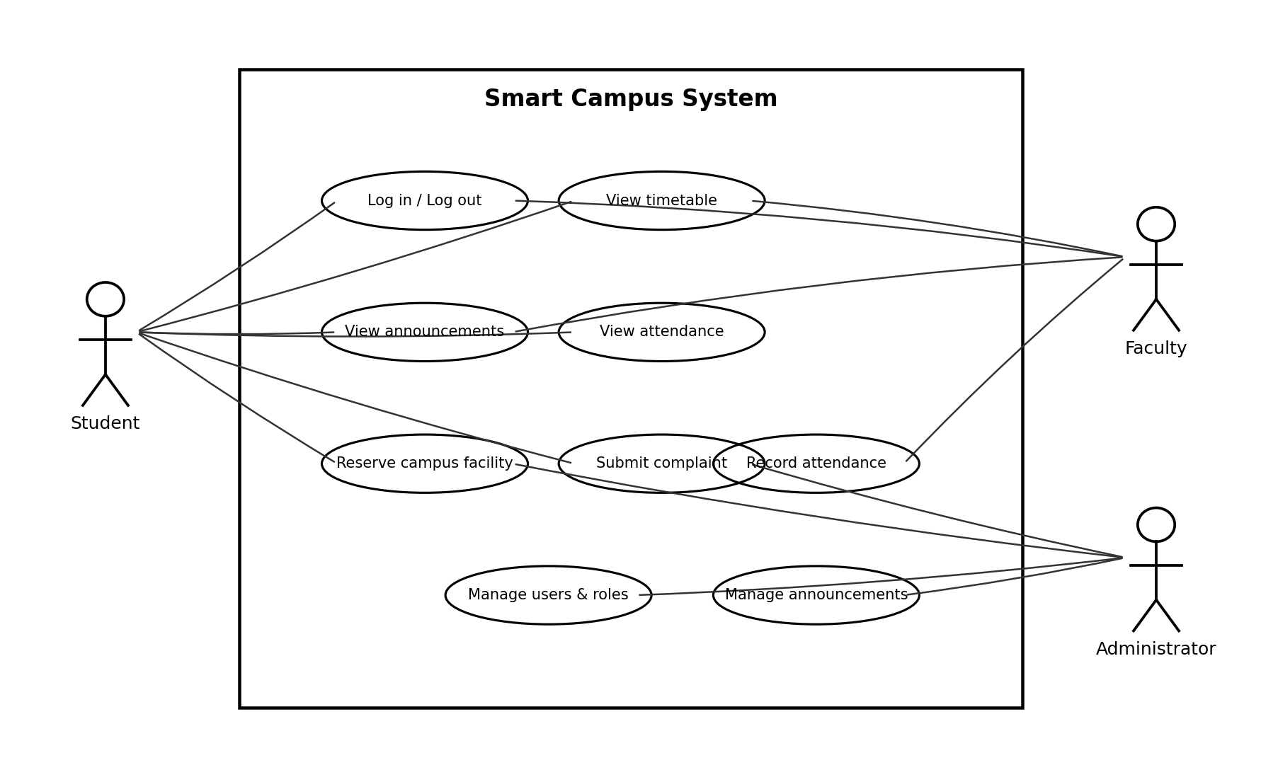

B.2 Sequence Diagram — Student Login and Timetable
This sequence shows a typical login followed by a timetable request. Invalid credentials should stop the flow and return an error rather than display protected data.
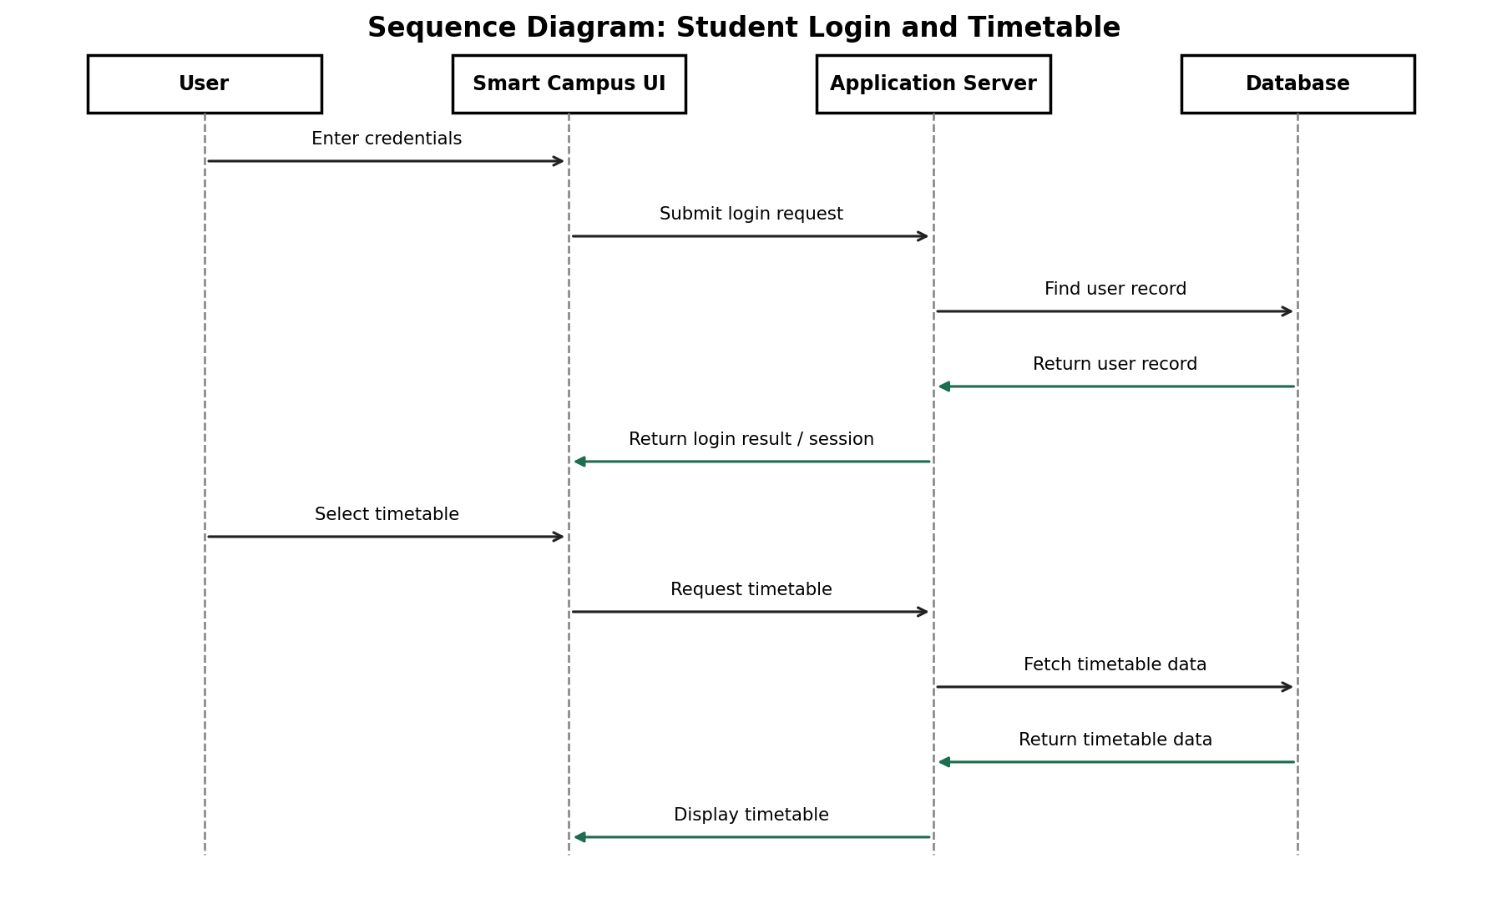

B.3 Sequence Diagram — Faculty Attendance
This sequence shows how faculty attendance submission is authorized, validated, and saved.
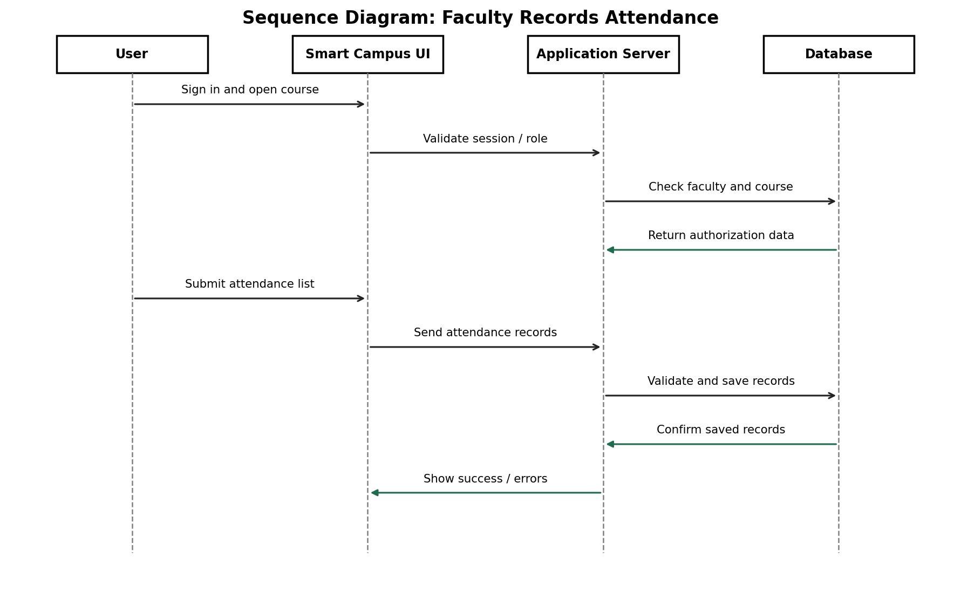

Appendix C: To Be Determined List
- Confirm the final feature scope with all team members and the instructor.
- Confirm implementation language, web framework, database, and deployment platform.
- Confirm whether the system will use university SSO, email notifications, or existing campus data integrations.
- Confirm exact reservation approval rules and whether facility reservations are in the assessed release.
- Add team member names, course name, instructor name, and any project-specific references required by the course.
- Validate performance targets and privacy requirements against the instructor's rubric.

Submission Checklist
- ☐ Review the document as a team and replace assumptions that do not match the actual implementation.
- ☐ Confirm the use case and sequence diagrams match the features your team will build.
- ☐ Update the version/date and add any missing team/course information.
- ☐ Save the final document in the format required by your instructor.
- ☐ Upload the document individually before the deadline.
- ☐ Commit the same approved document and diagrams to the project's GitHub repository.

