PokerMasters

I.E.S. San Vicente

San Vicente del Raspeig (Alicante)

2017/2018

Teachers:

José Ignacio Cabanes / Ignacio Iborra

Student:

César Martín Sogorb

**1. Introduction**

**Project name**

PokerMasters

**Made by**

César Martín Sogorb

**Short description of the Project**

The project is a game of Poker “Texas Hold’em” in console with multiplayer mode in which you can play in local or network. The games will be from 2 to 10 players.

**2. Functionality of the Project**

Upon accessing the program, a welcome will be displayed on the screen, a user name will be requested with which you will be identified with the other users and the different game modes:

-Play in local

-Play in network

-Game rules

-Credits

-High Scores

-Exit game

The game of poker will be explained in the rules of the game.

In the local play mode, the user can play in the same network as the adversaries, settings the local network in which the game will be played.

In network play mode, the user can choose the network by settings the network in which the game will be played.

The rules of the game will be for people who do not know how to play or who have any questions at the time of playing that will possess the following:

- Hold'em is usually played using small blind ("small blind") and big blind ("big blind") bets. These bets are called "blinds" since the player bets without having seen any of the cards on the table.

The small blind is set by the player to the left of the dealer, and is equal to half of the big blind.

The big blind is provided by the player to the left of the previous one and is equivalent to the minimum bet. In tournaments, the amount of the blinds increases as the tournament progresses.

2 cards are dealt to each player face down, your cards should not be shown to anyone else, the bets are placed on the big and small blind to whom they touch.

After the first phase, 1 card of the deck is burned and 3 cards are opened with which the players who have paid to enter this phase must form the best combination and decide whether to pass or increase if everyone passes the turn if someone goes up the bet those who want to continue to Turn must pay the amount.

If the player wishes to leave the game, the chips will be lost.

You must get the best hand of the following:

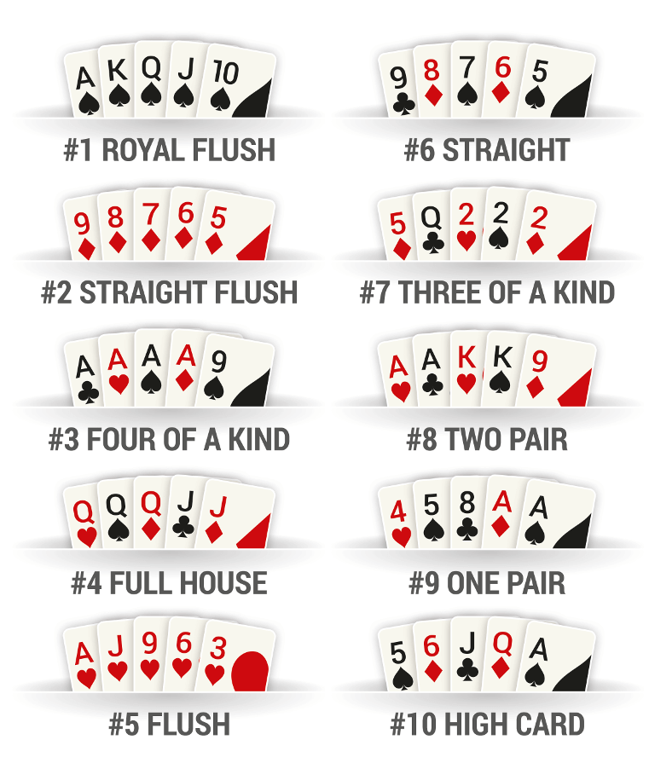

The winner ends when a player obtains the chips of all the players.

Within the game, there will be 3 options that will be raise, check / call and fold, in the option to raise will also be the amount you want to raise.

**3. Screen prototype**

The game screen will look like this:

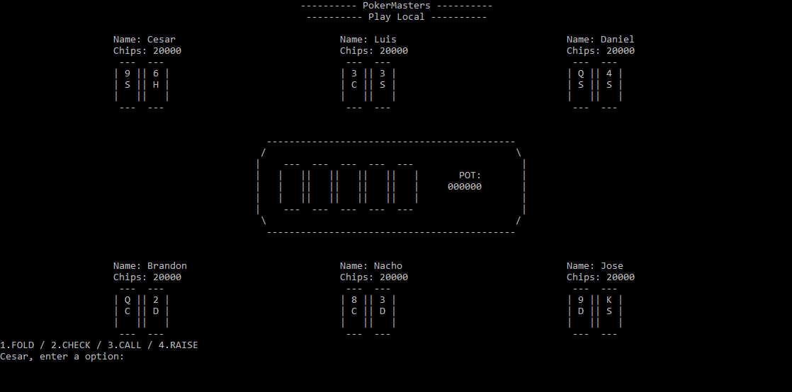

**4. Analysis**

**4a Requisites**

|  |  |
| --- | --- |
| **Requisite** | **Date achieved** |
| That the program shuffles and distributes different cards to each of the players. | Done |
| That the program allows the player to bet, place bets. | Done |
| That the program allows to play in local. | Done |
| That the program allows to play in network. |  |
| That the program performs the distribution of letters in the correct order. |  |
| Show the actions performed in the information table. |  |
| That the program allows the bank to perform actions with the chips. |  |
| Perform the absent mode correctly. |  |
| That the program allows a player who has lost the chips to re-engage the game. |  |
| That the visual screens work correctly. |  |

**4c. Classes diagram**

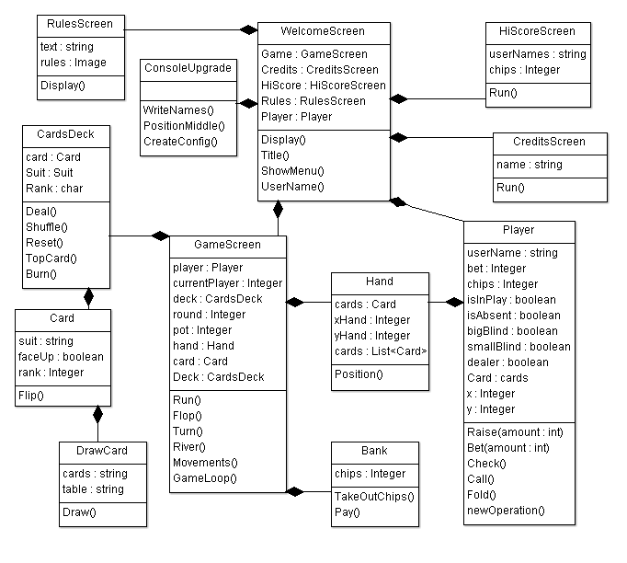

**5. Initial planning and expected deliveries**

5a. Expected deliveries

* **Version 1:** Start screen with username input that the player will have to identify himself, where the different game modes that the player wanted will come out. And according to what you have chosen, the list of games that the player can access.

Make skeletons of someone classes.

* **Version 2:** Screen of the board, where will be the players who are in the game in each position with their username, chips and their cards.

We will create the rest of the classes so that they will be like the class diagram, we will use a list/stack for the cards that exist in the game, in the class Cards so that there will be a deck of cards where the cards will be taken and distributed to the players, the created classes will be player, deck of cards and cards with corresponding methods.

* **Version 3:** Console Upgrade. To simplify tasks, what we will do is create the Console Upgrade class, which is about positioning the users placed on the game table or introducing the player's characteristics on the welcome screen.
* **Version 4:** Implementation of the letter class with its methods and the deck class.

Implement the method to distribute, taking into account that there are 2 cards to each player, and taking into account that when all have been dealt, we will burn a card and put 3 in the middle, another will be burned and another card will be dried to the middle, the last one will be burned and the last card will be drawn.

* **Version 5:** Chips and Dealer. Make the bet, each player has some chips, when you make the bet you must remove the chips you have bet and put in the middle.

Choose Dealer that is the player with the highest card of:   
Spades > Hearts > Clubs > Diamonds

Cards distribution. The first time it is dealt knowing who the Dealer is, it is dealt blindly small, big blind, under the gun, to the dealer.

And the one who goes after the big blind speaks (The last one to speak is the big blind)

With the 3 cards in the middle (flop), the last one to speak is the Dealer.

Blind big and small blind and dealer, where the player to the left of the big blind is the first to start playing, and they are choosing each player whether to bet or not. The big blind is the minimum bet that must be made and the small blind is half the big blind.

* **Version 6:** Perform the 3 buttons to fold, call or check and raise, when the blinds have been made, the one to the left of the big blind will begin. You must choose between fold, call (in case of not being big blind) or fold, or raising the bet.

If you raise the bet you must pass another round to see if they match or not, if they do not equal they must leave the round.

We will implement a method that will increase the blinds by time of the game so that from time to time the blinds will increase.

* **Version 7:** Each player has a bet execution time that time will be 30 seconds with a beep or sound. (Can the game window be superimposed on everything the user has?) And screen notice.

We will create the method to request time that will be that the player having time to execute the play, may have extra time by pressing a button that will only be available to each player for 3 times in each game.

* **Version 8:** Logic of the cards, the best card is the AS, followed by K, Q, J, and from 10 to 2.

Know which is greater than which and in that case that wins.

Carry out a letter order:

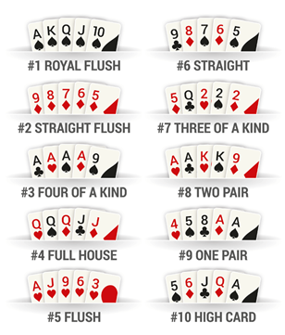

What we will do here is create a method so that we will compare the cards that are in play when the bet is over. And according to who wins, the pot will be taken.

* **Version 9:** Logic of the cards v2, if a player makes "All in" the other players must match with the same money corresponding to the "All in" and distribute the pot among the winning parties. And the proportional part of the amount that is the "All in" will be distributed.

When you draw the 5 cards from the middle, you must show the cards of each player that keeps betting, and if you have not reached the 5 cards but you have won one before, you can decide whether to show them or not. (Know who has won or not).

For this we will implement a method that what will do is compare the cards of those who made the all in and distribute the pot among the players who have done all in. With a boolean we will allow all in or not, you can’t bet normally as in the other moves.

* **Version 10:** When a player has no chips, he can re-start if he has the minimum chips to return to the game. By eliminating from your account the total chips you have, the player will be given a number of chips for each start of the game. (User configuration .txt)

The Bank class will be created so that we can take out chips for a price that we will have to pay later.

* **Version 11:** Informative table of actions performed. So the actions performed will be written in a box in case a player has not seen the play can see who has won and what cards.
* **Version 12:** Credit and game rules screen, where the characteristics of the game of poker, how to play and the scoreboard will be shown.
* **Version 13:** Absent mode, is that if the player does not perform any execution during the 30 seconds of its necessary time, the absent mode will be assigned so that the minimum bets will be automatically made and the cards will be dealt as if they were playing.
* **Version 14:** Local mode, to be able to create a game (host), where the parameters of the game that will be created will be displayed, regardless of the number of players, starting money and creating the game. Join heading where the IP address and port where you want to connect and connect.
* **Version 15:** Create server where the game will be played and players will play this game. (Create server with my desktop computer at home and connect from class to my home computer).

It will be done by C # with the firewalls removed to prevent possible connection failures. The server will remain on so that clients will connect to the IP provided by the server.

**5b. Real deliveries**

* Version 1 (May 14): The skeletons of all the classes with their functions have been created and the welcome screen has been created where the user enters his name with which he will play and will show him the menu where he will choose the desired option and access the chosen mode.
* Version 2 (May 15): Correction when establishing the user's name.

Set the player's position on the board with his chips and his cards.

We have made the cards and the deck of cards, but it does not work correctly.

* Version 3 (May 16):The sample of the username has also been corrected when it is in game.

CardDecks and Card classes have been corrected because I have not I know how to use the enum well and I have investigated in order to fix it.

ConsoleUpgrade class has been created with the Position and WriteNames methods to position the players and write the characteristics of the player on the welcome screen. Created the structure to choose the movements

* Version 4 (May 17): Now the deck can draw the cards to the player and to the table, deleting them from the list and showing them in the screen also added the table picture.
* Version 5 (May 18): I tried to established the pot and chips with each player and we can show the pot in game table.
* Version 6 (May 21): The number of players with their respective positions has been established. An index has been established to know what number of player is playing.

The bet to deduct chips from players has been established.

* Version 7 (May 22): The number of players between 1 and 6 has been limited.

A panel has been drawn for the different options that the player has.

Fixed the pot and chips of players at the time of betting.

The screen notice about the game could not be made.

* Version 8 (May 23): The updates of the cards have been fixed at the time of the shifts.

Established to shuffle the cards has been established.

Created the order of the turns until the flop.

* Version 9 (May 24): The game loop has been established for the time of the turns, that when all the players fold they leave the game. Realized the blinds but does not bet automatically. The dealer has been eliminated since it gave problems and the big blind will be a dealer too. The update of the chips after betting has been corrected.

I have solved all the visual aspect so that the user can go through all the menus correctly.

* Version 10 (May 25): Correction to update the pot and not the table with the cards on the table. Visual form arranged with your returns to the menus, but there is a problem

when you choose a screen and you want to return to exit the game.

Established the file script config.txt with the logs. Started a list for card clashes to know who wins or who does not.

* Version 11 (May 28): Fixed the order of the shifts. Established the result of couple, double pair, trio and poker. Configuration of files established in the Console Upgrade.
* Version 12 (May 29): Screen of rules game and credits game created.

Heritage established in the classes ConsoleUpgrade.cs, DrawCard.cs, GameScreen.cs

**6. File Formats**

6a. Plain files format

At the version 10, the configuration data about the files will be saved on files. (To do…)

Where will userName, Chips, times you have taken money, times paid.

**7. Problems found and solutions**

**8. Improvements or restrictions to the starting design**

He changed version 10 to 9.