
Draft Version 30. June. 2025

The Republic of Uganda
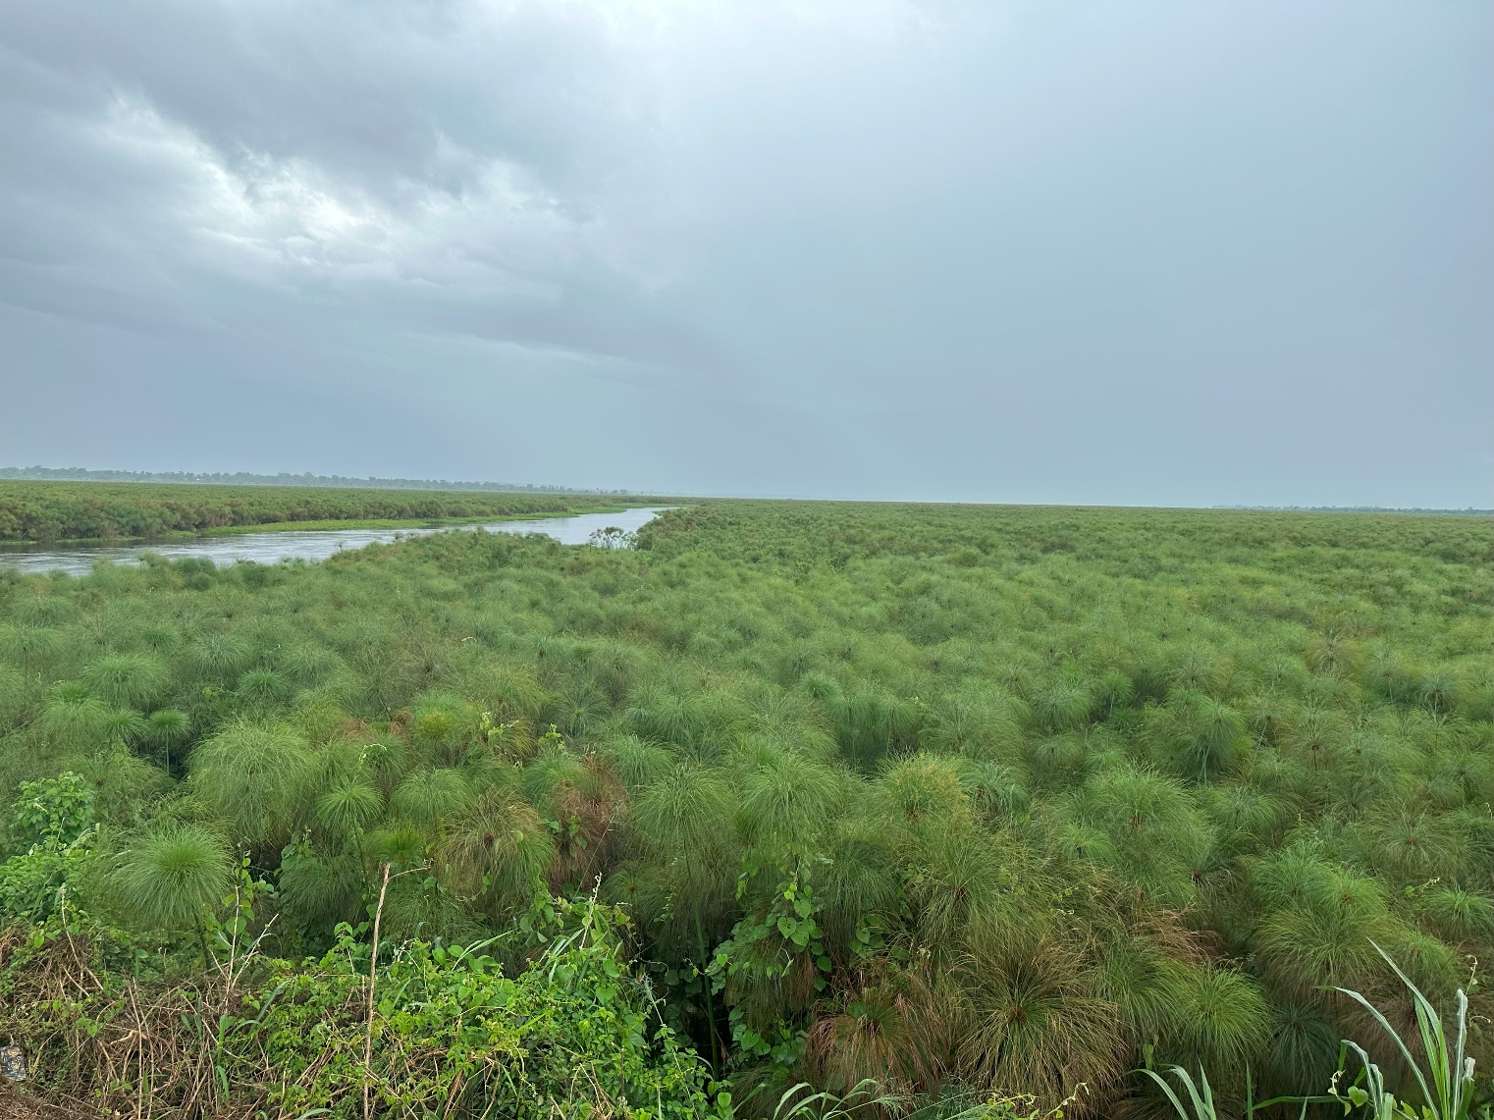
LONG-TERM CLIMATE STRATEGY OF UGANDA

“A Uganda that prospers throughout its transformation into a climate resilient and low-carbon society by 2050”
Ministry of Water and Environment


2025

Table of contents
Abbreviations and acronyms iv
Foreword vi
Preface i
Acknowlegements i
Executive summary 2
1. Introduction 4
1.1 Context and scope 4
1.1.1 International context 4
1.1.2 Role of the LTS 4
1.1.3 Key elements of the LTS 5
1.2 LTS development process 6
1.2.1 Stakeholder engagement 7
1.2.2 Core assessment 7
2 National context 8
2.1 Uganda’s geographical and climate profile 8
2.2 Future climate projections 8
2.3 Vulnerability to climate change 11
2.4 Key Vulnerable Sectors 13
2.5 Socio-Economic Context 14
2.6 Natural Resources and Energy 16
2.7 Greenhouse Gas Emissions 18
2.8 Alignment of LTS with Uganda’s Policy Framework 18
2.8.1 Uganda Vision 2040 and National Development Plans. 21
2.8.2 Uganda’s Updated Nationally Determined Contribution (NDC) 21
2.8.3 Energy Policy and Transition Plan 22
2.8.4 Other Relevant Policies 24
2.9 Policy integration 25
3 Ambition, Vision, and Strategic Framework 26
3.1 Uganda’s Overarching Climate Ambition 26
3.1.1 Vision Statement 26
3.1.2 Development Pillars 27
3.1.3 Protection and sustainable use of all terrestrial and aquatic ecosystems 28
3.1.4 Developing climate-resilient and low carbon productive sectors and systems 30
3.1.5 Promoting green growth, sustained in a resource efficient circular economy and creation of green jobs for the youth 34
3.1.6 Supporting community engagement and empowerment for sustainable land management and climate adaptation 36
3.1.7 Strengthening climate governance 37
3.1.8 Strengthening climate finance and investments 39
4 Sectoral Low Carbon Strategies 42
4.1 Rationale and Approach 42
4.2 BAU and NZE 2065 Overviews 42
4.2.1 Business-As-Usual (BAU) 42
4.2.2 Low-emission scenario 2065 43
4.2.3 Overview of Key Sectors and Transition to In-Depth Assessment 45
4.2.4 AFOLU 45
Forestry 48
4.2.5 Energy 53
4.2.6 Transport 56
4.2.7 Buildings 60
4.2.8 Industry Energy Use and Industrial Processes and Product Use (IPPU) 64
4.2.9 Waste 66
4.3 Adaptation and resilience 70
4.3.1 Adaptation priorities and needs 70
4.3.2 Co-benefits of adaptation actions and synergies with mitigation 71
5 Implementation plan 74
5.1 Institutional and legal arrangements 74
5.1.1 Policies and actions 74
5.1.2 Governance arrangements: LTS steering 74
5.1.3 Institutional arrangements 75
5.2 Engagement with local governments and non-state actors 77
5.2.1 Stakeholder engagement strategies 77
5.2.2 Capacity building and awareness 77
5.2.3 Private sector, academia and civil society roles 77
5.3 Monitoring, Reporting, and Verification 77
5.3.1 Indicators and milestones 78
5.3.2 Timeline and monitoring framework 78
5.3.3 Reporting and verification (roles) 79
5.4 International cooperation 80
5.4.1 Participation in global climate initiatives 80
5.4.2 Regional partnerships 80
5.4.3 Technology transfer and innovation 80
5.5 Investment and Financing 80
5.5.1 Mitigation Investment Requirements 81
5.5.2 Adaptation Investment Requirements 81
5.5.3 Financing Strategy and Resource Mobilization 82
References 84
Appendices 86
Annex 1: Methodoloy framework for emission modelling 86
Annex 2: Policy Framwork Assessment Tables 88
NDP Integration 88
NDP Integration 89

List of figures
Figure 1 Key elements of the LTS Framework 5
Figure 2 Strategic LTS impact elements 5
Figure 3 Climate impact across key climatic zones 8
Figure 4: Percentage change in average annual temperature (left) and rainfall (right) for Africa by 2100 from 1960-1990 baseline climate (IPCC, 2014) 9
Figure 5: Uganda Climate Drivers (Source: IPCC AR6 (2022). 9
Figure 6 Regional climate risk projections 10
Figure 7 Uganda Population Development 13
Figure 8: Sectoral trends in GHG emissions for Uganda (Source: Third National Communication) ^{[1]} 17
Figure 9 Overview of Uganda’s relevant policies and climate framework informing the LTS 19
Figure 10. Overview Vision, Pillars and Sectoral NetZero Strategies 26
Figure 11 Integrated Financing Framework for the LTS Implementation 38
Figure 12 Overview Emission scenario BAU 43
Figure 13 Low Carbon Scenario 2065 45
Figure 14 Agriculture Sector Emission Trajectories 47
Figure 15 Forestry Sector Emission Trajectories 51
Figure 16 Electricity Demand BAU vs. Low Carbon 2065 55
Figure 18 Transport Sector Emission Trajectories 59
Figure 17 Building Sector Emission Trajectories 63
Figure 20 Industry Sector Emission Trajectories 66
Figure 19 Waste Sector Emissions Trajectories 68
Figure 21: Key institutions involved in climate change 75
Figure 22 Relationships between an LTS and other key elements of the Paris Agreement 78

List of tables
Table-1: Results from the climate vulnerability and risk assessment, by sector 12
Table 2. Land cover change in Uganda, 2005-2019 16
Table 3 Building blocks of an integrated climate governance framework 37
Table 3-1: Roles and responsibilities of key institutions 76
Table 5 Mitigation Investment Requirements by Sector (USD Billions, 2023 prices) 81
Table 6 Adaptation Investment Requirements by Sector (USD Billions, 2023 prices) 82
Table 7 Climate Finance Sources by Period (Distribution of financing sources %) 83

Abbreviations and acronyms
AFOLU | Agriculture, Forestry and Other Land Use
BAU | Business As Usual
BUR | Biennial Update Report
CCD | Climate Change Department
CCS | Carbon Capture and Storage
CCUS | Carbon Capture, Utilization, and Storage
ERP | Electricity Regulatory Authority
ETP | Energy Transition Plan
GDP | Gross Domestic Product
GHG | Greenhouse Gas
GIZ | Deutsche Gesellschaft für Internationale Zusammenarbeit (GIZ) GmbH
GoU | Government of Uganda
ICEV | Internal Combustion Engine Vehicle
IEA | International Energy Agency
IPCC | Intergovernmental Panel on Climate Change
IPFs | Indicative Planning Figures
IPPU | Industrial Processes, and Product Use
LT-LEDS | Long-Term Climate Change Strategy
LTS | Long-Term Climate Change Strategy
LULUCF | Land use, land use change and Forestry (LULUCF)
MDA | Ministries, Departments, and Agencies
MEMD | Ministry of Energy and Mineral Development
MoWE | Ministry of Water and Environment
MRV | Monitoring, Reporting and Verification
MtCO₂e | Million Tonnes of Carbon Dioxide Equivalent
MW | Megawatt
NAP | National Action Plan
NAPA | National Adaptation Programme of Action
NC | National Communication
NCCAC | National Climate Change Advisory Committee
NDC | Nationally Determined Contribution
NDP | National Development Plan
NGO | Non-governmental Organization
NZE | Net Zero Emissions
NZEB | Near-Zero Energy Building
PPP | Public-Private Partnerships
PV | Photovoltaic
REHC | Regional Energy Hub Case
SDG | Sustainable Development Goals
TORs | Terms of References
UNDP | United Nations Development Programme
UNFCCC | United Nations Framework Convention on Climate Change
VA | Vulnerability Assessment

Foreword
Climate change is no longer a distant concern; it is a lived reality shaping the daily lives of Ugandans—from the farmer in Karamoja facing prolonged drought to the trader in Mbale coping with intensified floods. Our collective response must be bold, inclusive and anchored in the aspiration set out in Vision 2040 to transform Uganda into a modern and prosperous nation.
This Long-Term Climate Strategy (LTS) provides the strategic compass for navigating that transformation. It demonstrates how Uganda will harness its abundant renewable resources, protect its invaluable ecosystems, and build climate-resilient communities, while sustaining strong economic growth under the forthcoming National Development Plan IV and the 10-Fold Growth Strategy. The LTS is both a national commitment and a call for partnership—with our citizens, the private sector, civil society and the international community.
I commend the Ministry of Water and Environment, the Climate Change Department, and all stakeholders—particularly our youth and women, who have been at the forefront of the consultations—for shaping a plan that balances ambition with realism. Implementation will demand resources, innovation and, above all, unity of purpose across government and society. I therefore urge every ministry, department, agency, local government and development partner to align policies, budgets and investments with this strategy.
Together, we can seize the opportunities of green growth, safeguard our people from climate risks, and bequeath to future generations a Uganda that thrives in harmony with its environment.

Rt Hon. Robinah Nabbanja,
Prime Minister of the Republic of Uganda
OFFICE OF THE PRIME MINISTER

Preface
Uganda has developed this Long-Term Climate Strategy (LTS) to chart a pragmatic pathway towards a prosperous, climate-resilient and low-carbon economy. Building on Vision 2040, the forthcoming National Development Plan IV (NDP IV) and the 10-Fold Growth Strategy, the LTS provides the long-range compass that aligns Uganda’s socio-economic transformation with the objectives of the Paris Agreement.
The Ministry of Water and Environment gratefully recognises the technical and financial support received through the UNDP Climate Promise and the earlier cooperation with GIZ. Their contributions, together with the insights of countless national stakeholders, were instrumental in preparing this strategy.
While historic responsibility for global emissions rests largely with industrialised economies, all countries must now do their part. Uganda therefore embraces an ambitious yet realistic transition to renewable and other low-emission energy sources, strengthening adaptation, and unlocking green growth opportunities for our youthful population.

Hon. Sam Cheptoris
Minisiter for Water and Environment
MINISTRY OF WATER AND ENVIRONMENT

Acknowlegements
The development of Uganda's Long-Term Climate Strategy has been a collaborative effort involving numerous stakeholders and partners. The Ministry of Water and Environment and the Climate Change Department gratefully acknowledges the invaluable technical and financial support provided by:
The United Nations Development Programme (UNDP) through the Climate Promise initiative, which provided critical support for the finalization and enhancement of this strategy, including stakeholder consultations, technical modeling, and capacity building activities during 2024-2025.
The Deutsche Gesellschaft für Internationale Zusammenarbeit (GIZ) GmbH, which laid the foundational groundwork for this strategy through initial assessments and stakeholder engagement during 2020-2021.
We also thank all government ministries, departments and agencies, civil society organizations, private sector representatives, academia, development partners, and community representatives who contributed their time, expertise, and insights throughout the development process.

Alfred Okot Okidi
Permnannet Secretary
MINISTRY OF WATER AND ENVIRONMENT

Executive summary
Uganda's Long-Term Climate Strategy (LTS) outlines the country's ambitious vision to create a prosperous, climate-resilient and net-zero carbon society by 2065. Consistent with Article 4.19 of the Paris Agreement—and in line with UNFCCC Decision 1/CP.21 inviting Parties to communicate "mid-century, long-term low-GHG emission development strategies" reflecting national circumstances—the LTS complements Vision 2040, the forthcoming National Development Plan IV (NDP IV) and the 10-Fold Growth Strategy, while guiding successive updates of the Nationally Determined Contribution.
As a low-income nation, Uganda faces multiple socio-economic challenges: a large share of households depends on subsistence agriculture, a significant portion of the population lives below the poverty line, and rapid population growth is projected to nearly double the population by 2040—putting added pressure on land, forests and water. Despite these constraints, Uganda today has one of the lowest per-capita emission footprints worldwide and is expected to remain among the lowest emitters. The LTS therefore commits to peak national emissions in the 2030s, continually lower economy-wide GHG intensity, and achieve net-zero emissions no later than 2065, contingent on technology readiness and scaled-up international support. This calibrated ambition enables a low-carbon development pathway—leveraging renewable energy, climate-smart agriculture and nature-based solutions—while safeguarding inclusive and sustainable growth.
────────────────────────────────────────────────────────
Vision and Strategic Framework
────────────────────────────────────────────────────────
Uganda's LTS is anchored in Vision 2040 and operationalised through forthcoming NDP IV and the 10-Fold Growth Strategy, providing a coherent roadmap that aligns economic transformation with a just, inclusive energy transition and sets the nation on a low-carbon pathway by mid-century, achieving climate neutrality across all sectors no later than 2065. Central to this framework is implementation of the Energy Transition Plan (ETP 2023), which charts a phased shift from biomass and fossil fuels toward a diversified portfolio of renewables, efficiency, and—where cost-effective—emerging options such as geothermal and nuclear.
The strategy establishes cross-sectoral coordination architecture—connecting energy, transport, industry, buildings, agriculture and land use—so that all sectors contribute to, and benefit from, the energy transition. By embedding the ETP into the LTS governance structure, Uganda positions itself to attract climate finance, foster technology transfer and deliver green jobs, while remaining among the world's lowest per-capita emitters.
────────────────────────────────────────────────────────
Sectoral Assessment for Net-Zero Pathways
────────────────────────────────────────────────────────
Uganda’s greenhouse gas emissions are concentrated in a set of priority sectors: Agriculture, Forestry and Other Land Use (AFOLU), Energy, Transport, Waste and Industrial Processes and Product Use (IPPU). Each sector faces unique challenges and offers distinct mitigation and adaptation opportunities:
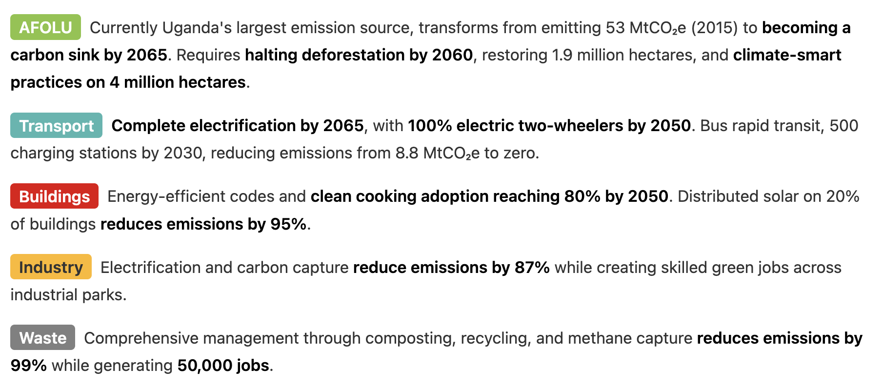
────────────────────────────────────────────────────────
Adaptation and Resilience
────────────────────────────────────────────────────────
The strategy prioritizes adaptation across 13 vulnerable sectors:
- Water security through climate-proof infrastructure benefiting 5 million people
- Ecosystem-based adaptation including wetland restoration covering 250,000 hectares
- Climate-resilient agriculture supporting 8.5 million smallholder farmers
- Early warning systems reducing disaster losses by 70%
- Health system strengthening preventing climate-sensitive diseases
────────────────────────────────────────────────────────
Implementation Approach
────────────────────────────────────────────────────────
Achieving Uganda’s net-zero vision necessitates:
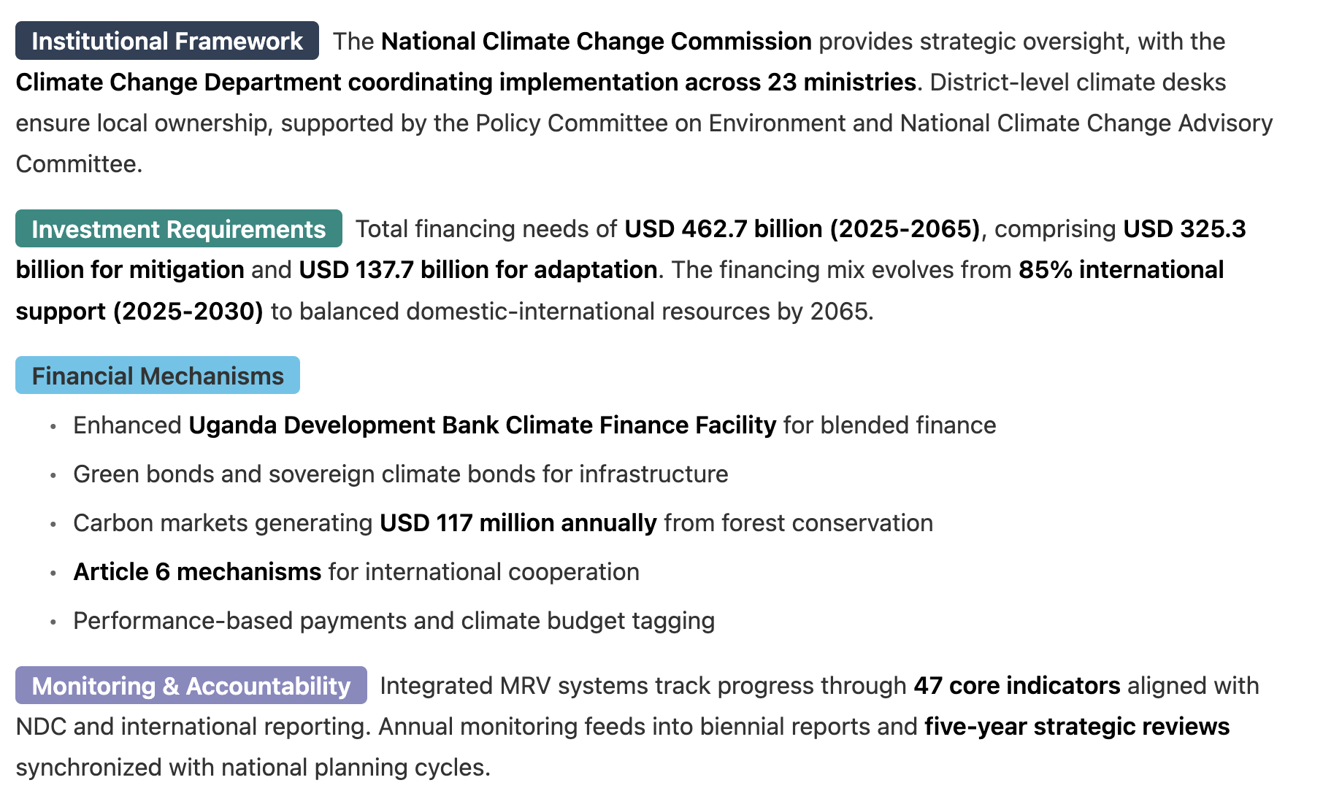
Uganda’s LTS sets out a bold but achievable agenda, merging development ambitions and opportunities with the urgent need for climate action. By tapping into the synergies of mitigation and adaptation across sectors, Uganda can safeguard its natural resource base, foster inclusive economic growth, and position itself as a leader in equitable, sustainable development. Success will hinge on sustained commitment—both nationally and from international partners—to deliver the finance, capacity, and technology needed to fulfil the vision of a climate-resilient, low-carbon Uganda by 2050 or 2065.
Transformative Outcomes. By 2065, successful implementation delivers:
- Economic: 10-fold GDP growth to USD 500 billion with 500,000 green jobs
- Environmental: 40% reduction in cumulative emissions versus business-as-usual
- Social: Universal energy access, improved health from eliminated air pollution
- Regional: Uganda as East Africa's renewable energy hub and circular economy leader

Introduction
This report fulfils Uganda's international climate change commitments while aligning with national development priorities by presenting the country’s inaugural long-term climate strategy (LTS). For consistency, this report uses the term LTS, encompassing Long-term Low Emissions Development Strategies (LT-LEDS). The LTS articulates a comprehensive vision and outlines pathways for Uganda to transition towards an inclusive, resilient, and low-emission society by mid-century, with the goal of achieving climate neutrality by 2065. This target is contingent upon adequate international support, accelerated technological advancements, and careful alignment with national development priorities. These pathways aim to ensure sustained economic prosperity while addressing critical climate challenges.

Context and scope

International context
Uganda demonstrates its strong determination and proactive commitment to address climate change on a global level. Uganda ratified the United Nations Framework Convention on Climate Change (UNFCCC) in 1993 as a Non-Annex 1 Party and the Paris Agreement in 2016. By doing so, the country follows the requirements and best practices to combat climate change as an integral part of the international community.
The UNFCCC Decision 1/CP.21 - Adoption of the Paris Agreement - invites countries to communicate, by 2020, “mid-century, long-term low greenhouse gas emission development strategies, taking into account their common but differentiated responsibilities and respective capabilities, in the light of different national circumstances” (Article 4, paragraph 19, of the Paris Agreement). Subsequently, countries were urged to communicate their LTS to facilitate just transitions to net-zero emissions by or around mid-century, and update them regularly, as appropriate, in line with the best available science (Decision 1/CMA.4). The Convention also notes the importance of aligning Nationally Determined Contributions (NDCs) with each country's respective LTS.
Further commitments under the UNFCCC include the elaboration, regular update, and submission of National GHG Inventories, Biennial Update Reports (BUR), National Communications on Climate Change (NC), and NDCs. Uganda has so far submitted three NCs (2002, 2014, and 2022), a first BUR (2019), and a revised NDC (2022).
To date, 75 countries have submitted their respective LTS to the UNFCCC . This has enabled the international community to analyze and learn from best practices in the development of LTS. Uganda has leveraged this accumulated experience throughout the process of developing its LTS in coordination with the revision of the NDC, and subsequently refined the LTS.

Role of the LTS
The development of Uganda's Long-Term Strategy represents a transformative national commitment to climate action, strategically designed to attract both domestic and international investment while ensuring equitable development. Led by the Climate Change Department (CCD) under the Ministry of Water and Environment (MoWE), this comprehensive process was officially launched on 11 November 2020, coinciding with Uganda's NDC update to ensure seamless integration of short-term (2030) and long-term (2065) climate strategies.
Building Investment Confidence and Market Signals. This LTS serves as a important foundation providing clear policy signals and predictable regulatory frameworks that attracts equially domestic capital, and simultaneously, supports unlocking and leveraging international climate finance. By demonstrating Uganda's commitment to systematic, evidence-based climate action aligned with Vision 2040's middle-income country aspirations, the strategy supports attracting investment opportunities across renewable energy, sustainable transport, climate-smart agriculture, and green industrial development.
Comprehensive Sectoral Integration and Just Transition. The strategy comprehensively addresses sector-specific transformations across energy generation (renewable scale-up and grid modernization), transport (electric vehicles and sustainable logistics), buildings (energy-efficient codes and green construction), industry (cleaner production and circular economy), AFOLU (climate-smart agriculture and carbon sequestration), and waste management (waste-to-energy and reduced landfill emissions). Central to this approach is ensuring a just transition that protects vulnerable communities, creates green jobs, and addresses potential socio-economic disruptions through targeted social protection and retraining programs.
National Development Alignment and Regional Integration. The LTS is strategically aligned with Uganda's Vision 2040, National Development Plans (NDP III and IV), and sectoral policies, while incorporating regional frameworks including Africa's Agenda 2063 and the African Continental Free Trade Area (AfCFTA). This alignment ensures climate action supports inclusive growth, poverty reduction, and sustainable industrialization, with particular attention to gender equality, youth empowerment, and rural community development.
Adaptation, Resilience, and Technology Framework. Building climate-resilient infrastructure across water, agriculture, and transport sectors is prioritized, utilizing both ecosystem-based adaptation and technological solutions. The strategy incorporates early-warning systems, climate risk financing, disaster preparedness mechanisms, and nature-based solutions. Technology transfer partnerships, public-private collaborations, and local innovation capacity development are central to achieving transformation while ensuring accessibility and affordability, particularly for rural and low-income communities.
Implementation and Accountability Systems. Robust monitoring, reporting, and verification (MRV) systems utilizing data analytics, and IPCC methodology-aligned climate modeling ensure transparent progress tracking. The strategy establishes clear governance structures, stakeholder engagement mechanisms, and capacity building programs across government agencies, local authorities, and communities. Policy coherence frameworks ensure whole-of-government coordination while facilitating access to international climate finance through mechanisms like the Green Climate Fund and Global Environment Facility.

Key elements of the LTS
Uganda's Long-Term Strategy (LTS) represents a comprehensive framework that harmonizes the country's climate action ambitions with its development aspirations. This strategic document provides a cohesive approach to achieving both climate resilience and sustainable economic growth through 2065 Building on Uganda's.
The LTS serves multiple critical functions. First, it establishes a clear vision for Uganda's low-carbon development pathway. Second, it provides detailed guidance for policy alignment across sectors. Third, it outlines specific mechanisms for implementing climate actions while advancing national development priorities.
Building on Uganda's extensive existing policy frameworks, including Vision 2040, the National Development Plans (NDPs), the 10-Fold Growth Strategy, the Green Growth Development Strategy, the National Climate Change Act and Policy, the Energy Policy and Transition Plan, the updated NDC, and relevant sectoral policies (e.g., National Industrial Policy)—the LTS addresses key strategic elements:
Figure 1 Key elements of the LTS Framework
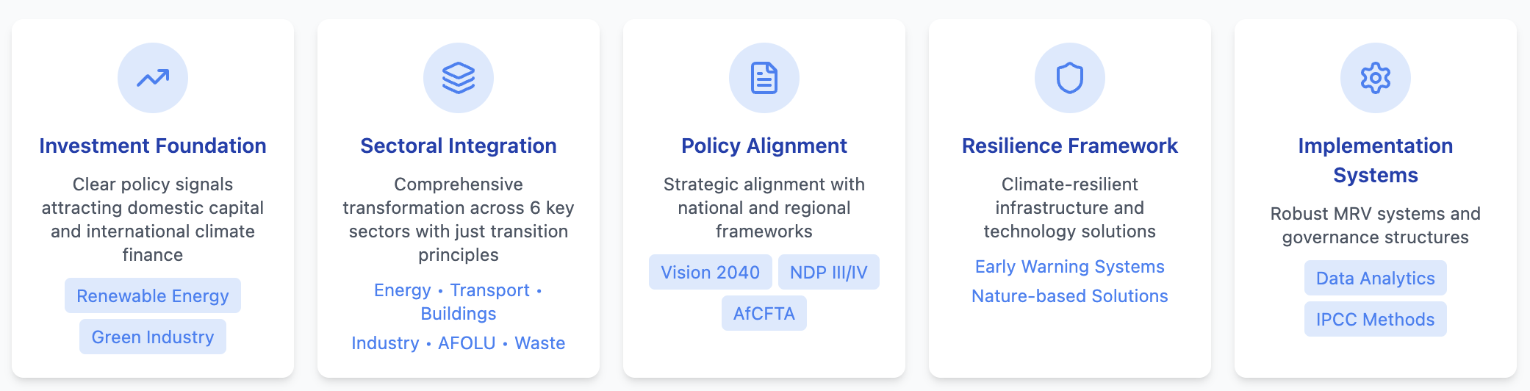
Through this integrated approach, the LTS ensures that Uganda's response to climate change strengthens rather than constrains its development trajectory, while positioning the country at the forefront on sustainable development within East Africa.
Furthermore, this LTS will serve as a crucial guidepost, informing the development and increasing the ambition of subsequent NDCs, including the upcoming NDC 3.0, ensuring short-term actions consistently contribute to the long-term vision
The LTS serves, as illustrated in Figure 2 key impact elements of Uganda’s climate-policy aligned socio-economic development and the required climate finance required for the successful implementation

Figure 2 Strategic LTS impact elements
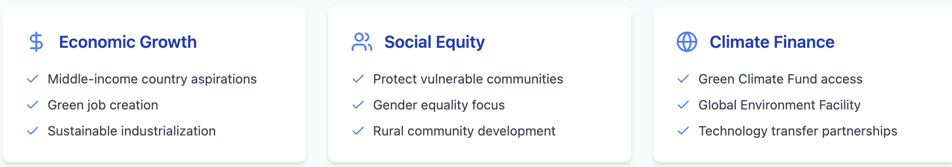
This LTS is designed to be a living document that can be updated periodically in the future, in line with the evolving national developments and priorities. It is suggested that Uganda’s LTS is updated in parallel with future NDC updates and, therefore, forms part of an integrated assessment of Uganda’s long-term and short-term climate priorities. This will ensure the LTS remains relevant in the future and continues to provide a marker of Uganda’s long-term ambition to adapt to climate change and contribute to the collective ability to meet the Paris Agreement’s climate goals.

LTS development process
The development of Uganda’s LTS represents a national commitment to addressing climate change, led by the Climate Change Department (CCD) under the Ministry of Water and Environment (MoWE). Officially launched on 11 November 2020, the LTS development process coincided with the update of Uganda’s Nationally Determined Contribution (NDC). This parallel approach ensures continuity, as the NDC focuses on short-term actions up to 2030, while the LTS addresses Uganda’s long-term climate strategies. Uganda’s updated NDC was published in September 2022.
In 2024, the Government resumes work on updating and finalizing the LTS, aligning it with the Third National Development Plan (NDP III, 2020–2025), NDP IV, Uganda Vision 2040, the updated NDC, and the Third National Communication (2022) submitted to the UNFCCC. This alignment leverages advanced climate and socio-economic data, further solidifying Uganda’s strategy.

Stakeholder engagement
Stakeholder engagement is central to the development of the LTS. A participatory process characterized by extensive consultations with diverse stakeholders ensures the strategy reflects broad consensus. Between March and April 2021, consultations focus on Uganda’s climate risks, vulnerabilities, and draft greenhouse gas emission pathways. These sessions include hybrid workshops (both in-person and remote) engaging youth organizations, civil society, and regional governments across five districts: Entebbe, Mbarara, Mbale, Gulu, and Arua.
Further consultations in August 2021 adopt a sectoral focus, aiming to validate the draft NDC and LTS documents. By early 2025, the CCD facilitates additional discussions to refine and validate the LTS, engaging the National Climate Change Advisory Committee (NCCAC). A national-level workshop in March 2025 serves as the culmination of this iterative process, incorporating the latest stakeholder insights and fostering consensus.

Core assessment
The analytical work supporting Uganda’s LTS is a collaborative effort involving Deutsche Gesellschaft für Internationale Zusammenarbeit (GIZ) GmbH and the United Nations Development Programme (UNDP). Initial assessments conducted under GIZ’s guidance are subsequently refined under UNDP’s direction to align with Uganda’s evolving climate priorities.
Policies and Document Review. A meticulous review of key national documents ensures the LTS aligns with Uganda’s development goals and international climate commitments. This review encompasses Uganda’s updated Nationally Determined Contribution (NDC), the Energy Policy for Uganda (2023), the Energy Transition Plan (ETP), Vision 2040, the National Development Plan III (NDP III), the midterm review of NDP III, NDP IV, the draft LTS, the Climate Change Policy, third National Communication and sectoral plans, including those for energy and health. This detailed assessment identifies areas requiring updates, opportunities for increased ambition, and gaps that need addressing. The findings help align the LTS with the latest sectoral priorities and national goals, emphasizing Uganda’s commitment to sustainable development.
Adaptation Analysis. Adaptation planning forms a crucial component of the LTS. The analysis leverages existing climate scenarios prepared for Uganda to assess sectoral climate risks and vulnerabilities. This provides the basis for defining the LTS’s key adaptation pillars and ensures that the strategy adequately addresses climate resilience.
Mitigation Modelling. A bottom-up modelling approach projects greenhouse gas (GHG) emissions and identifies mitigation potentials across a Business-as-Usual (BAU), reflecting current trends without additional mitigation measures and a low carbon scenario leading to Net Zero 2065.
The modelling incorporates data from Uganda’s National GHG Inventory, the Uganda Bureau of Statistics, and sectoral reports, adhering to IPCC 2006 and 2019 guidelines. Key assumptions include population growth, economic development, technological advancements, and policy implementation.
Key economic-wide and sectoral modelling assumptions are explained in detail in Chapter 4. The underlying assumptions include Uganda’s population, Gross Domestic Growth as laid out in it development plans, anticipated technological advancements and the effective current and future implementation of policies including Uganda’s NDCs and Energy Policies.
The Net-zero Emission Scenario 2065 follows a comprehensive pathway targeting net-zero emissions across all sectors, reflecting Uganda’s climate ambition.
These scenarios inform economy-wide and sector-specific emissions reduction targets, ensuring coherence with Uganda’s NDC, national development plans, and broader policies. The refinement of mitigation models incorporates macroeconomic inputs from NDP IV, obtained in January 2025, enhancing the accuracy of projections under both net-zero and low-carbon scenarios. Sector-specific analyses identify emissions reduction opportunities and sustainable practices, strengthening Uganda’s transition toward a low-carbon economy.
This analytical foundation ensures the LTS pathways are technically sound and tailored to Uganda’s national circumstances. The final strategy underwent review and validation involving key bodies like the National Climate Change Advisory Committee (NCCAC) to ensure coherence and national approval.

National context
Uganda’s long-term low-emission development strategy (LTS) rests on an understanding of the country’s unique climate profile, socio-economic context, natural resource base, and existing policy frameworks. This chapter presents an overview of Uganda’s national circumstances, highlighting the interplay between current conditions and the pathway toward a sustainable, inclusive, and low-carbon future.

Uganda’s geographical and climate profile
Uganda is located along the equator in East Africa, spanning approximately 241,555 square kilometers of land and water, of which around 37,000 km² comprise water surfaces. Its climate is predominantly tropical, with temperatures generally ranging between 20°C and 27°C. Higher altitudes in the southwest and eastern highlands experience cooler conditions, whereas regions in the north may record daytime highs above 30°C (TNC, 2022). Two rainfall regimes dominate much of the country: bimodal in the south and central, with long rains typically from March to June and shorter rains from September to December, and a single, more extended rainy season in the northern part of the country.
However, Uganda exhibits significant regional climatic diversity. The northeastern region, particularly Karamoja, experiences semi-arid conditions with lower annual rainfall (often below 750mm) and higher temperature variability, making it exceptionally vulnerable to drought and food insecurity. Conversely, the mountainous areas in the southwest (Kigezi highlands) and east (Mount Elgon) experience cooler temperatures and higher rainfall, but are prone to landslides and flash floods. The central region, influenced by Lake Victoria, benefits from moderated temperatures but faces intensified rainfall events. Understanding these regional specificities is crucial for tailoring effective climate adaptation and mitigation strategies within this LTS.
The geographical and seasonal variations in temperature and rainfall are mainly influenced by dynamics of the Inter Tropical Convergence Zone (ITCZ); topography, e.g. by the plateau and mountain ranges in the western and Eastern parts of the country; and the presence of water bodies such as Lake Victoria in the central (TNC, 2022; World Bank Group, 2015).
Although overall rainfall in Uganda is relatively abundant compared to arid parts of Africa, its distribution is often uneven across regions and seasons, with annual rainfall varying from 750-2400mm. Events such as droughts, heavy storms, and flooding periodically interrupt agricultural, commercial, and domestic activities. Lake Victoria, the country’s largest water body, exerts a strong local climatic influence in central Uganda, helping moderate temperatures but also intensifying rainfall events in surrounding districts. (TNC, 2022; NDC,2022)

Future climate projections
Observed Climate Variability and Impacts: Uganda is already experiencing significant climate variability, manifesting as increased frequency and intensity of extreme weather events. Figure 1 illustrate vulnerability patterns observed over the last decades in Ugandas regions with distinc climatic zone:
- The western Albertine Rift combines diverse ecosystems with rainfall ranging from 700mm in the valley to 1,500mm in highlands (Rwenzori Mountains). Critical water towers show measurable glacial retreat.
- The northern region transitions between semi-arid and sub-humid conditions with unimodal rainfall (800-1,200mm). Post-conflict recovery compounds climate vulnerability.
- The northeastern Karamoja region experiences semi-arid conditions with annual rainfall between 350-750mm concentrated in a single season. Temperature extremes regularly exceed 35°C, affecting 1.2 million inhabitants. Drought cycles have shortened from 5 years to 2-3 years, with livestock mortality reaching 60% during severe events.
- The southwestern highlands (Kigezi) at 1,500-2,500m elevation receive 1,000-1,480mm rainfall. Population density of 300-500 persons/km² combined with cultivation of over 90% of arable land limits adaptation options.
- The central region benefits from Lake Victoria's moderating influence, maintaining temperatures of 17-27°C. However, increasingly erratic bimodal rainfall (900-1,200mm) causes urban flooding, while lake level fluctuations affect 3 million shoreline residents.
- The eastern highlands (Mount Elgon) receive 1,200-2,000mm rainfall annually at elevations of 1,500-4,321m. Temperature increases of 1.5°C have shifted arabica coffee zones upward by 200m. Annual landslides affect approximately 50,000 people.
Figure 3 Climate impact across key climatic zones
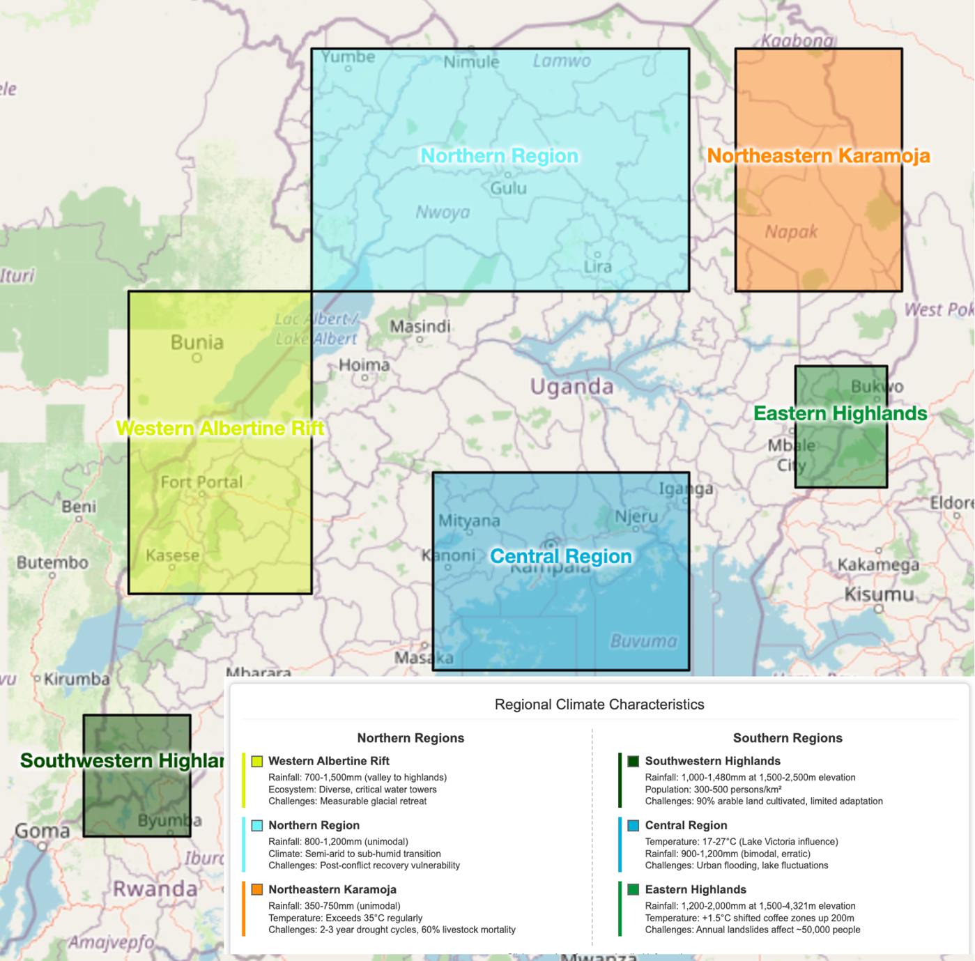
These observed impacts underscore Uganda's high sensitivity to climate change and the urgent need for adaptation measures, which this LTS aims to address alongside long-term mitigation towards climate neutrality by 2065.
Scientific assessments, including those by the Intergovernmental Panel on Climate Change (IPCC) and Uganda’s Third National Communication (2022), indicate that temperatures in Uganda are expected to rise faster than the global average by mid-century.
Projections suggest a mean annual temperature increase of 1.8°C to 3°C by around 2050 under higher-emission scenarios. Rainfall patterns are less certain, but studies point toward more frequent episodes of intense rainfall, resulting in an elevated risk of flash floods and soil erosion.
The IPCC Fifth Assessment Report (AR5) noted that due to climate change, temperatures in the African continent are likely to rise more quickly than other land areas, particularly in more arid regions. The projected change in average temperature and rainfall for Africa by 2100 are shown in Figure 1.
For East Africa, there is a high confidence in the direction of change of specific climate impacts and drivers (IPCC Sixth AR6, 2022). There is high confidence of an increase in mean air temperature and extreme heat, in the intensity of future lake heatwaves, as well as in increases in heavy precipitation and pluvial floods; and in turn a decrease of cold spells and frost, of snow and ice sheets. There is low confidence in the direction of change for mean precipitation, riverine floods and other impacts.
Figure 4: Percentage change in average annual temperature (left) and rainfall (right) for Africa by 2100 from 1960-1990 baseline climate (IPCC, 2014)
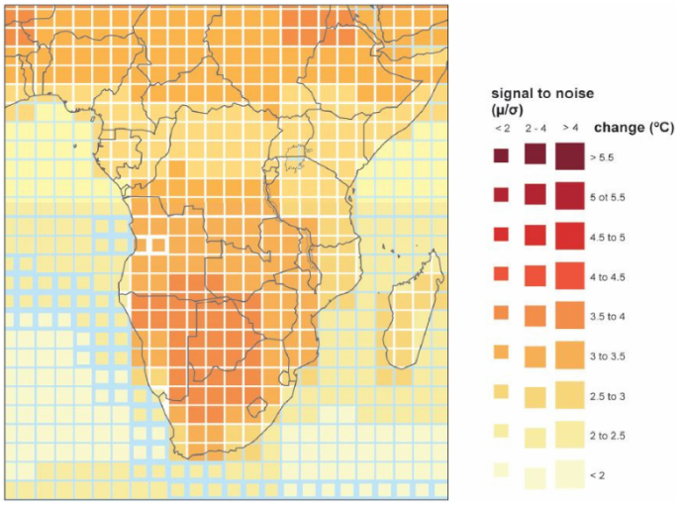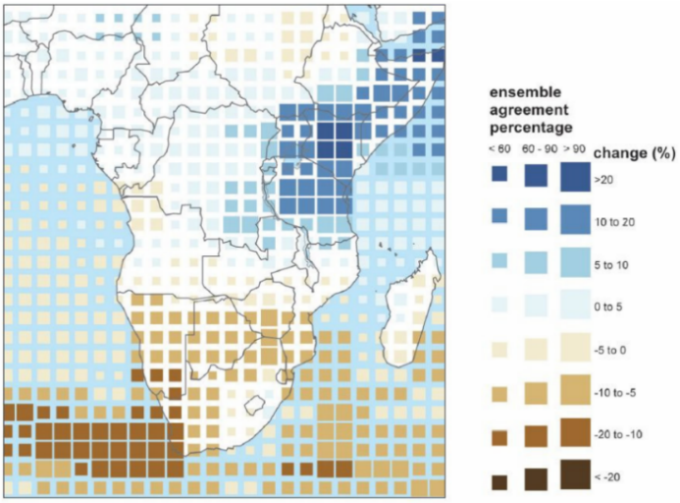
Figure 1 illustrates the climate areas with particular concern for Uganda including include hotter days, increasing mean temperatures, increasing number days with extreme heat, shifting rainfall seasons, and an increased likelihood of extreme events such as prolonged droughts and heavy precipitation with floods.
Warming trends could threaten key growth sectors like agriculture and hydropower, while intensifying pressures on land, water, and energy resources. Such projected changes underscore the importance of timely and targeted adaptation measures, particularly in rural districts where livelihoods depend heavily on rain-fed agriculture. Uganda has recorded such disasters severely affecting people and their livelihoods in the last decades.
The areas in the figure indicate an upward trend, the areas with dark red color have high confidence, the orange areas have medium confidence and the grey area have low confidence (IPCC Sixth AR6, 2022).

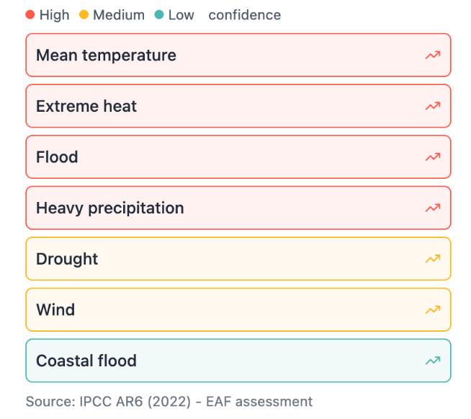
Figure 4 provides a comparative overview of climate risk projections across four distinct regions of Uganda, highlighting key metrics that capture regional exposure and vulnerability to major climate hazards. By quantifying population at risk, projected temperature increases, drought frequency, and flood risk on standardized scales, this figure enables policymakers and stakeholders to identify priority areas and tailor adaptation strategies to the specific climate challenges faced by Northern, Central, Mountain, and Karamoja regions.
Figure 5: Uganda Climate Drivers (Source: IPCC AR6 (2022).

Figure 6 Regional climate risk projections
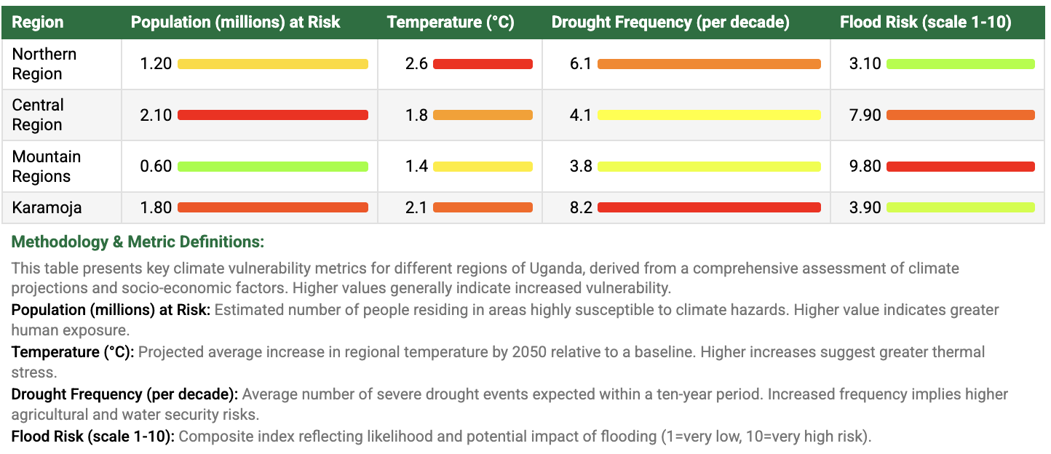
A more detailed assessment of the climate change projections relevant for Uganda are included in Annex A.

Vulnerability to climate change
Climate is a key determinant of the state of other natural resources, such as water resources, forests, wildlife, and biodiversity, which form the foundation for socio-economic development in key sectors like agriculture, fisheries, tourism, transport, and health (TNC, 2022). These sectors are highly sensitive to climatic changes, making Uganda’s economy particularly vulnerable to the impacts of climate change (TNC, 2022; Ministry of Water and Environment, 2014). Uganda ranks 152 on the ND-GAIN Country Index (2025), positioning it as the 36th most vulnerable country globally and the 30th least ready country to adapt to climate change (readiness rank 163 of 192 countries).
Gender-Age-Disability Specific Vulnerabilities. Women allocate 2-6 hours daily for water collection (increased from 1-2 hours), walking up to 10km during droughts. Despite producing 70% of food crops, women hold land titles for only 27% of agricultural land. Rural women (90%) depend on increasingly scarce fuelwood, spending 20% more collection time than a decade ago. Women's income decreases by 35% during droughts compared to 20% for men. Female representation remains at 18% in water user committees and 12% in disaster management structures. Climate-induced crop failures correlate with a 30% increase in male suicide rates. Young men constitute 70% of climate migrants. Heat stress disproportionately affects men in outdoor occupations. Age-Differentiated Impacts: Children (0-17 years, representing 50.3% of population) bear 60% of climate-related disease burden. Climate events cause 300,000 children to miss school annually. Stunting rates increase by 40% in drought-affected areas. Youth (18-35 years) face 75% unemployment where climate impacts affect agriculture. They constitute 80% of urban climate migrants. Climate disasters interrupt education for 500,000 youth annually. Elderly populations (60+ years) show 70% higher mortality during heat waves. Without assistance, 40% cannot evacuate during floods. Climate migration leaves 200,000 elderly without family support systems. Disability Considerations: Persons with disabilities (12% of population) lack access to early warning systems (80%) in accessible formats. During flood evacuations, 90% report being left behind. They experience 50% greater income loss during climate shocks.
Regional differentiaded impacts were descripbed in the previous subchapter. Communities in arid regions like Figure 1, mountainous areas prone to landslides, or impoverished urban settlements face distinct and often heightened risks compared to the national average. Karamoja shows compounded vulnerabilities: 65% poverty rate, 8% female literacy, 40% child malnutrition, 15% disability prevalence. Urban slums feature 40% female-headed households, 85% youth unemployment, 70% flood exposure, disease outbreak rates 5 times the national average.
This LTS acknowledges these differentiated vulnerabilities and aims to ensure that adaptation planning and implementation prioritize the specific needs of marginalized and disproportionately affected groups, fostering equitable resilience.
Water, ecosystems, and agriculture are among the most vulnerable sectors. Specifically, surface and groundwater resources, water supply systems, forests, rangelands, wetlands, and key crops—such as coffee, banana, maize, tea, cotton, rice, and beans—are highly sensitive to climatic changes. Vulnerabilities in these sectors also increase the sensitivity of all other sectors of the economy, in particular tourism and health. Tourist attractions and destinations are dependent on climate sensitive resources e.g. biodiversity, wildlife, water, and health depends on the availability of safe and uncontaminated natural resources and food.
Uganda’s landlocked position at the heart of Africa further exacerbates its climate vulnerabilities through spillover effects from neighboring countries and global disruptions. These transnational climate impacts, as highlighted in the Transnational Climate Impacts Index (Stockholm Environment Institute, 2016), stem from:
- Dependency on remittance flows from Ugandan emigrant workers in climate-vulnerable countries.
- Reliance on foreign direct investments (FDI), as climate impacts may reduce asset value and disrupt returns on investment.
- High proportions of asylum seekers and refugees, including migration from other climate-vulnerable nations.
Projected Impacts and Adaptation Needs. Without intervention, the extent and cost of damages are projected to rise exponentially by 2050. Actions must focus on reducing sectoral climate sensitivities, improving adaptive capacities, and decreasing exposure to climate hazards. Key climate hazards in Uganda include floods, droughts, landslides, heavy storms, and epidemics (TNC, 2022).
- Flooding: Flooding is one of the most significant climate hazards, particularly in low-lying areas and regions near water bodies. Increased rainfall intensity is expected to amplify flood risks, causing damage to infrastructure, disrupting human settlements, and hindering overall development. For example, infrastructure damages from flooding could impede transportation networks and economic productivity.
- Agriculture and Livelihoods: Reduced agricultural productivity due to climatic changes threatens food security and export earnings. For instance, a 2°C temperature rise would render much of Uganda unsuitable for coffee cultivation. Coffee, which accounts for 17% of Uganda’s exports and provides employment for 1.7 million people, is particularly vulnerable.
- Ecosystem Services and Tourism: Climate change will cause a loss of biodiversity and ecosystem services, further impacting sectors like tourism. Tourism demand relies on healthy natural assets and a safe environment. Reduced water supply, ecosystem degradation, and infrastructure damages would diminish the appeal of Uganda’s tourist destinations. Development of tourism is one of the key future development areas highlighted in Uganda National Development Plan (NDPIV, 2025).

Key Vulnerable Sectors
As part of the NDC update process and to support the development of the LTS, Uganda conducted a comprehensive climate change risk and vulnerability assessment. The following sectors were assessed: Agriculture; Built infrastructure; Business; Energy; Fisheries; Forestry; Health; Manufacturing; Mining and Quarrying; Transport; Water; Ecosystems. For each sector climate vulnerability and climate impact ratings were assigned based on extensive desk research and expert judgement. As a result of the assessment, the likelihood of the impacts was qualitatively assessed to identify the level of climate risk.
Sectors were provided climate vulnerability, impact and risk scores from 1 to 5 (i.e. least to greatest). The results from the analysis are presented in Table-1: Results from the climate vulnerability and risk assessment, by sector below. The sectors identified as being most vulnerable to climate change and related hazards (rating above 4) are: Ecosystems (excluding forests), Water and Agriculture. However, there is also significant risk in other sectors, particularly in terms of the general business sector, mining and quarrying, transport, and the built environment. With a high dependency on hydropower, the energy sector is also potentially at risk due to climate change as it is also closely linked to the water and the environmental sector.
Table-1: Results from the climate vulnerability and risk assessment, by sector
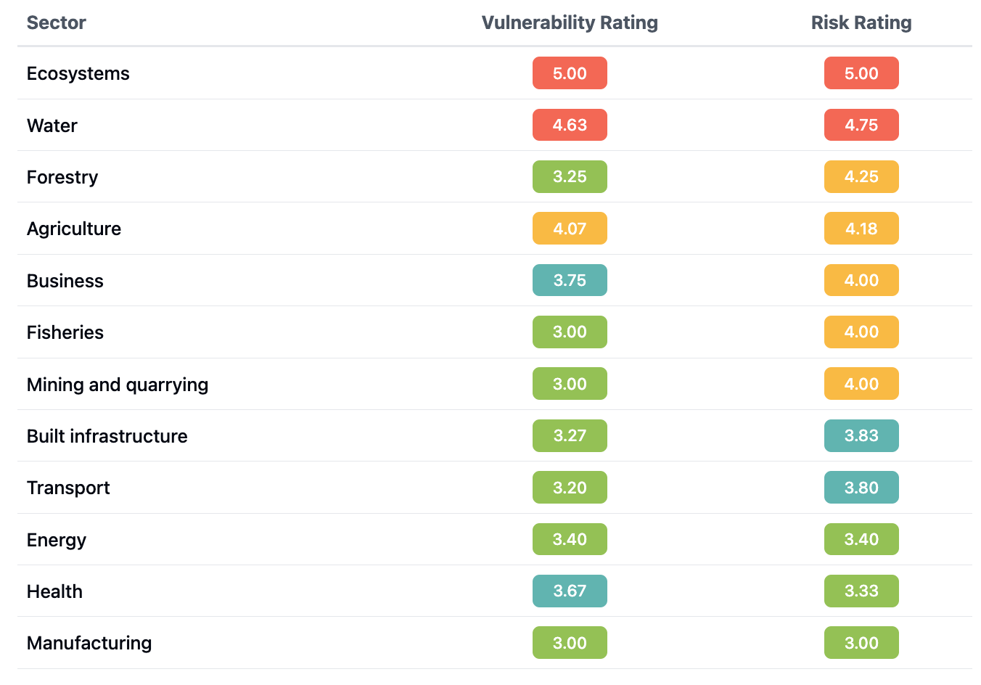

Socio-Economic Context
With a population of 45.9 million in 2024, Uganda has a distinct demographic structure characterized by a very large population of children and adolescents (typically defined as ages 0-17) and a rapidly growing working-age population (ages 15-64) (UBOS), 2024). This dynamic presents both an opportunity for a demographic dividend and significant pressure on resources and services. This occurs against a backdrop of growing urbanization with 27% of Ugandans now residing in urban areas (Uganda Bureau of Statistics, 2024). Projections indicate the population will reach 72 million by 2040 - double the 2015 levels. Figure 3 illustrates the total and urban population growth.
The population growth will put increasing pressure on resource sustainability, particularly regarding land, forest, water, and energy systems. The gender distribution remains balanced, with approximately equal proportions of males and females across age groups.
Socioeconomic vulnerabilities persist throughout Uganda. Despite progress in development, 16.1 % of the population continues to live below the national poverty line, with many communities heavily dependent on agricultural activities and subsistence farming and informal employment for their livelihoods. The accelerating pace of urbanization has led to the proliferation of informal settlements, creating complex urban challenges. These settlements face critical infrastructure gaps, particularly in housing adequacy, waste management systems, and sanitation services.
Figure 7 Uganda Population Development
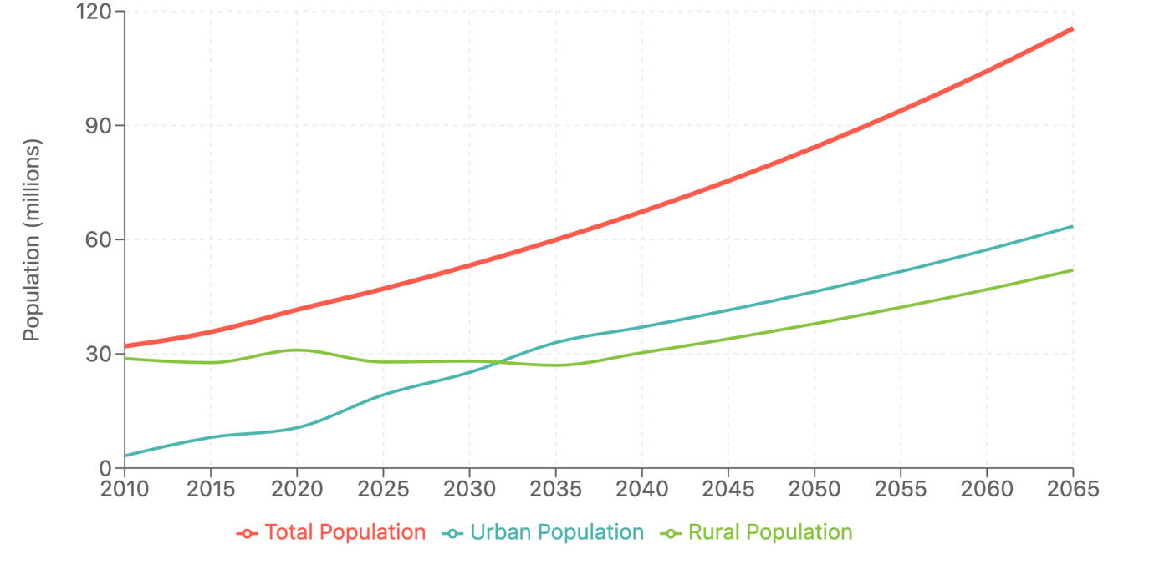
Employment and poverty. Uganda’s workforce is characterized by a high labour force participation rate, with approximately with approximately 74% of the working-age population engaged in some form of work (Source: LFS 2021/Census 2024). However, a significant share of the workforce is engaged in vulnerable employment within the informal sector, which often lacks stability, income security, and quality standards (World Bank, 2020). Vulnerable employment constitutes a considerable portion of Uganda’s economic activity, with rural areas having higher employment rates (78%) compared to urban areas (67%). However, much of the rural workforce relies on subsistence farming, which provides minimal income and lacks security. Gender disparities persist, as men (78%) are more likely to participate in formal (Source: LFS 2021/Census 2024).
Poverty Levels. Approximately 16.1% of Uganda’s population lives below the national poverty line, reflecting a persistent challenge despite slight improvements over time (Uganda Bureau of Statistics, 2025). Poverty levels have remained relatively static, keeping Uganda in the low-income country category. Rural areas account for a larger proportion of those living in poverty, with an estimated 5.3 million rural residents affected compared to 1.7 million in urban areas. Notably, the absolute number of people in urban poverty has risen over the years, highlighting increasing vulnerabilities in these areas (Uganda Bureau of Statistics, 2025). At the household level, 39% of households participate in the subsistence economy, where members engage in agriculture primarily for personal or family use, with limited sales or barter. Some households also earn income but remain below the poverty line. Among these households, 56% rely entirely on subsistence farming, underscoring the critical role of agriculture in the lives of many Ugandans. Additionally, 42% of the national population in 2019 lived below the international poverty line of $2.15 per day.
Employment and Sectoral Challenges. The agriculture, forestry, and fishing sectors continue to dominate Uganda's employment landscape, representing 40.1% of the total workforce ,marking a gradual increase from 35.8% in 2016/17 indicating sustained reliance on agricultural employment. Rural-urban employment show that rural areas remain heavily dependent on agriculture (55.0% of employment), while urban areas show a more diversified structure with agriculture accounting for only 22.0% of urban employment and services dominating at 63.9% compared to 33.7% in rural areas. The services sector accounts for 47.3% of employment, down from 50.3% in 2016/17, while the industrial sector remains relatively small at 12.6% nationally, showing a slight decline from 13.8% in 2016/17, with marginally higher representation in urban areas (14.1%) compared to rural areas (11.3%).
While these trends highlight the challenges in achieving rapid structural transformation, they also present opportunities for Uganda's Fourth National Development Plan (NDPIV) to leverage the large agricultural workforce through value addition, agro-industrialization, and rural development initiatives transitioning from subsistence farming to more productive agricultural enterprises and manufacturing, particularly given the demonstrated potential for economic diversification in urban areas where industrial and service sectors show stronger foundations for expansion.
Transitioning to a Net Zero economy necessitates a transformative approach to these employment patterns. A significant challenge lies in reducing agriculture’s dependence on unsustainable practices while safeguarding livelihoods. Uganda’s NDPIV prioritizes fostering low-carbon industries, such as renewable energy, green manufacturing, and sustainable agriculture, to create resilient and diverse economic opportunities. This shift not only promises economic growth but also aligns with the NDPIV’s target of achieving inclusive growth and employment creation. Additionally, the Plan’s focus on gender-sensitive and inclusive strategies to empower marginalized groups, including women and youth, strengthens the foundation for equitable benefits from this transition.
Economic Performance. Uganda's economic performance has shown a trajectory of steady growth over the years, though with fluctuations reflecting both domestic and global economic dynamics. Uganda's Gross Domestic Product (GDP) growth has demonstrated a trajectory of steady improvement over several years, with annual growth rates ranging between 3.8% and 6.8% during recent fiscal cycles. This reflects the country's capacity to achieve economic expansion despite domestic and global challenges. While this period demonstrated progress, the NDPIV acknowledges the need for accelerated growth to achieve Uganda's Vision 2040 targets.
More recently, in 2023, Uganda's GDP growth was projected at 5.2%. This growth, though positive, remains below the double-digit growth rates envisioned by the NDPIV to realize a 10-fold economic growth over the next 15 years. The projected annual inflation rate for 2023 stands at 5.2%, which is within the Bank of Uganda's targeted range but requires continued prudent monetary policy management as highlighted by the NDPIV. GDP per capita, a key indicator of individual prosperity, has also steadily increased, slightly exceeding $1,000.
The NDP IV, which is a 5-year plan starting in FY 2025/26, recognizes the significant strides made since 2016, which laid the foundation for economic transformation through investments in infrastructure and human capital. This includes an increase in domestic revenue mobilization, rising export receipts, expansion of the road network and increased access to electricity, among other achievements.
The NDPIV acknowledges the need for accelerated growth to achieve Uganda's Vision 2040 targets. Introduced as a new, ambitious goal for the planning cycle beginning with NDP IV (FY 2025/26), the government aims to achieve a 10-fold expansion of the economy (from approx. USD 50 billion to USD 500 billion) over the next 15 years. As such, NDPIV prioritizes investments in key growth sectors such as agriculture, tourism, minerals, oil & gas, science and technology and the ICT. It lays out clear strategies to close implementation gaps and address distortions that impede the effective utilization of factors of production such as land, capital, labor and knowledge. In particular, value addition and sustainable industrialization will be prioritized to maximize output from resources, to create new jobs and incomes for the majority of Ugandans. The plan also acknowledges the challenges in the financial space and proposes innovative financing mechanisms and leveraging private sector to achieve the development aspirations.

Natural Resources and Energy
Uganda’s rich natural endowments—including fertile soils, abundant water supplies, and expansive forests—form a critical foundation for economic growth and human well-being.
Agriculture occupies a central position in the national economy, with roughly 80% of the country’s land considered arable; however, only 35% of this arable land is currently under cultivation (TNC, 2022). Of that cultivated area, the vast majority supports subsistence production rather than commercial farming, which accounts for just 0.42% of Uganda’s total land area. Such heavy reliance on small-scale, rain-fed agriculture underscores the vulnerability of rural livelihoods to climate fluctuations and signals an opportunity to expand sustainable commercial ventures that align with Uganda’s long-term development and emission-reduction goals.
Deforestation represents one of the most pressing environmental challenges, with a 1.4% annual forest loss rate recorded between 2000 and 2015 (Ministry of Water and Environment, 2019). Natural woodlands and forests are particularly affected, experiencing yearly deforestation rates exceeding 2%. This loss is attributed to multiple factors, including clearing land for agriculture, extracting fuelwood, and expanding built-up areas. As Table 2 indicates, large swaths of bush land have been converted to other land uses, while plantations have grown considerably in certain regions. When combined with extensive soil erosion, overharvesting, and pollution, nearly all of the country’s landscapes—about 97%—have undergone some form of degradation. Such persistent degradation erodes biodiversity, lowers agricultural yields, and undermines ecosystem services essential for public health and economic stability. Table 2 illustrates land use changes for critical ecosystems and natural resources
Table 2. Land cover change in Uganda, 2005-2019
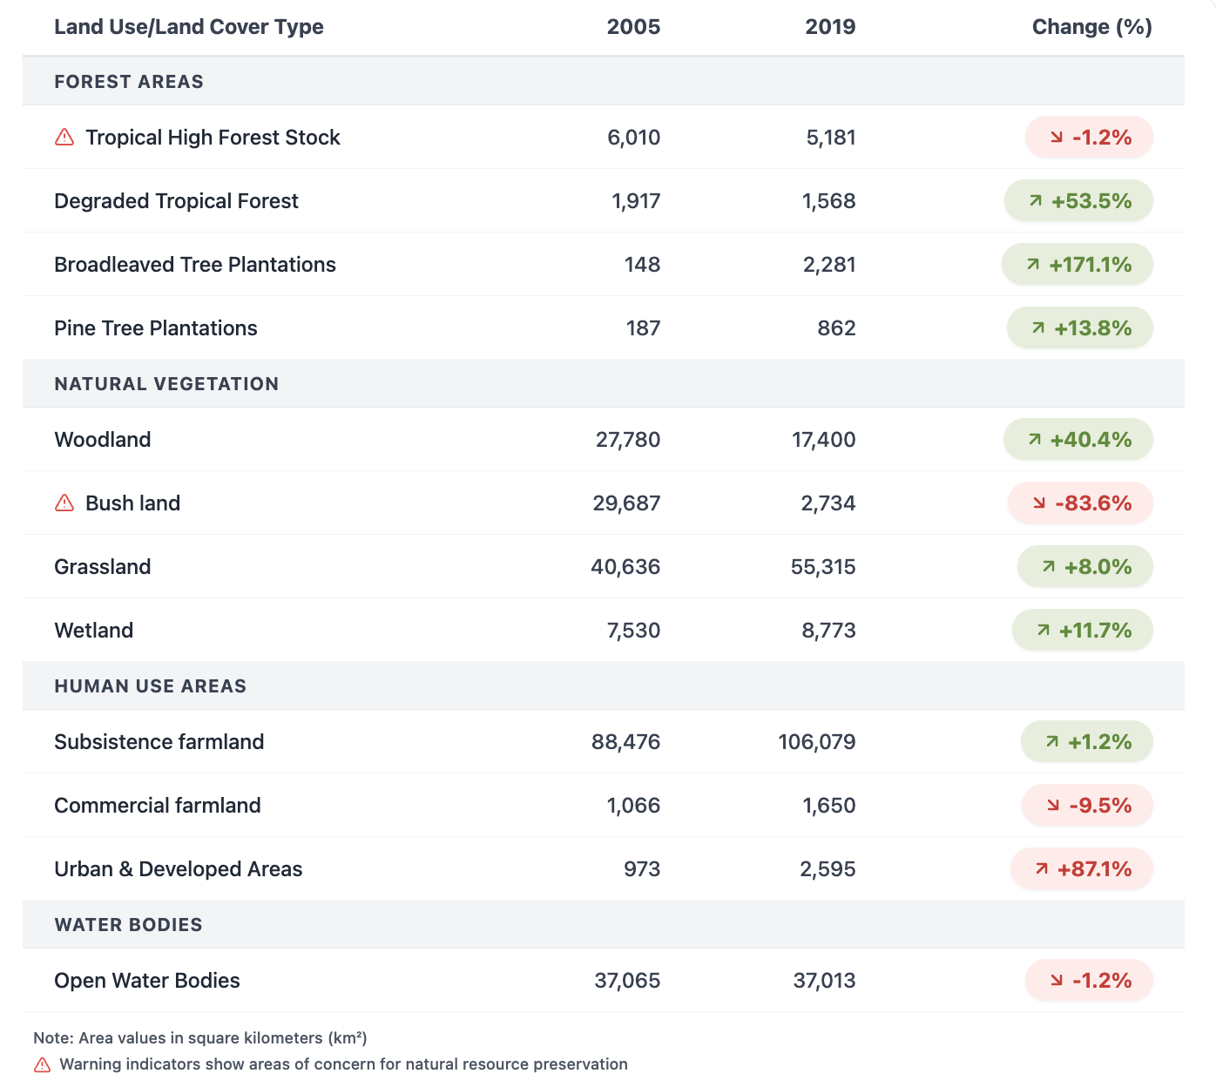

Alongside forestry resources, Uganda’s water assets, both surface and groundwater, are vital for household needs, irrigation, and inland navigation. Wetlands, in particular, sustain local communities by supplying water, fuel, and construction materials, while also mitigating floods and filtering pollutants. As population pressure intensifies, preserving and responsibly managing these wetlands becomes increasingly important for maintaining water quality, conserving biodiversity, and moderating climate extremes.
In the energy sector, hydropower plants currently generate most of Uganda’s electricity, yet this resource accounts for less than 2% of the overall energy supply when considering biomass usage in households. Electricity installed generation capacity rose from 183 MW in 1997 to 1.5 GW in 2021, reflecting greater demand from industrial and commercial enterprises. However, electrification remains at roughly 45% nationwide, with only 24% of households connected to the grid. As a result, biomass remains the most significant source of energy for cooking and heating, and kerosene is still commonly used for lighting. In particular, firewood collection and wood collection for charcoal production —63.1% from natural forests or bush land—plays a major role in deforestation and habitat loss (World Wildlife Fund, 2015).
Ensuring a successful transition to a resilient, low-emission economy will require transforming how land, forests, water resources, and energy supplies are managed. Protecting and restoring degraded landscapes is essential, not only for agriculture and ecosystem services but also for generating carbon offsets and supporting Uganda’s path toward a Net Zero target. By encouraging responsible biomass use, expanding electrification through renewables, and investing in innovative land-use practices, Uganda can safeguard its natural capital, reduce emissions, and create opportunities for green economic growth that benefits urban and rural communities alike. An in depth assessment particularly for sustainable use of energy, energy use in buildings, the management of agriculture and forestry is included in Chapter 4.

Greenhouse Gas Emissions

Current Emission Sources. Uganda’s GHG emissions rose from about 53 million tonnes of carbon dioxide equivalent (MtCO₂e) in 2005 to over 90 MtCO₂e in 2015. Land use, land-use change, and forestry (LULUCF) account for the largest share, mainly because of biomass reliance and deforestation. Agriculture is the second-largest emitter, largely due to methane releases from livestock and nitrous oxide from soils. Energy and waste sectors remain relatively small but have shown steady growth, correlated with expanding transport demand and unregulated waste disposal sites.
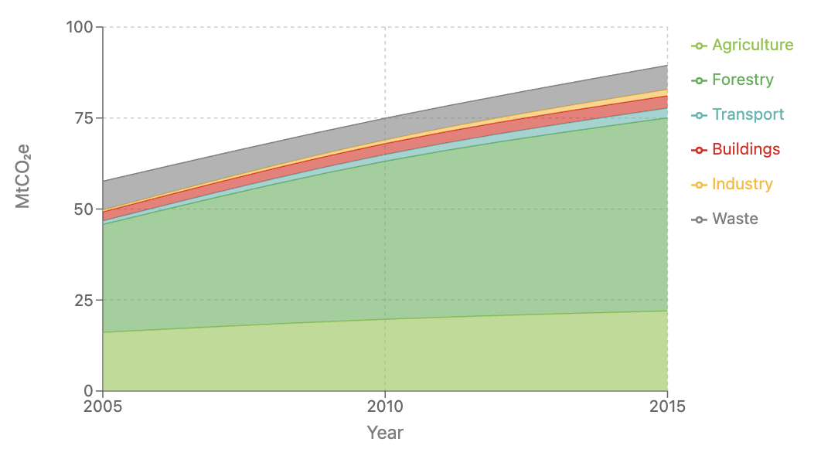
Figure 8: Sectoral trends in GHG emissions for Uganda (Source: Third National Communication) ^{[1]}

The emissions per capita are estimated at 0.1 tCO2eq. (NDC, 2022). Thus, Uganda currently makes only a very small contribution towards global, and has a low emissions intensity compared to other countries.

Projected Future Emissions. Under a business-as-usual scenario, Uganda’s GHG emissions will peak at around 90 to 100 MtCO₂e over the next decades, driven by population increase, higher energy demands, and the expansion of cultivated land. If major policy, technological, and behavioral shifts do not occur, the substantial reliance on traditional biomass, minimal energy efficiency measures, and continued deforestation could lock the economy into a high-emissions pathway. Nevertheless, strategies outlined in the LTS, including transitioning to cleaner energy and adopting sustainable agricultural techniques, can offer alternative trajectories that reconcile economic growth with emissions reductions. Projected Future Emission and mitigation options and scenarios will be discussed in detail in Chapter 3.

Alignment of LTS with Uganda’s Policy Framework
Uganda’s Long-Term Strategy builds on a robust policy environment that jointly pursues socio-economic and sustainable development and climate resilience. Foundational policies—such as Vision 2040, the National Climate Change Act (2021), and Uganda’s updated Nationally Determined Contribution (2022)—affirm the country’s commitment to balancing economic growth with sustainability. Meanwhile, core frameworks like the National Development Plans (NDP III and IV), the Renewable Energy Policy (2007), and the National Adaptation Plan for Agriculture (2018) embed considerations of resilience, resource efficiency, and gender equity into sectoral strategies.
Public institutions, civil society, the private sector, and development partners play integral roles in shaping and implementing these policies. While the Climate Change Department under the Ministry of Water and Environment coordinates nationwide climate action, other ministries (Energy, Agriculture, Finance) lead cross-cutting initiatives. The engagement of non-state actors in research, innovation, and outreach further refines climate interventions to local contexts. Ensuring consistent application of these frameworks, however, depends on stronger institutional capacities, adequate funding, and improved data and monitoring systems.
The LTS emerges from a detailed assessment of Uganda’s policy landscape, uniting diverse objectives around a long-term vision of low-emission, climate-resilient development. The detailed assessment and the mapping of the relevant policies and frameworks and its relationship are listed in Annex B. The information of the LTS through the main relevant policies, namely the NDC, the NDP, the Energy Policies and the ETP is illustrated in Figure 5.
Figure 9 Overview of Uganda’s relevant policies and climate framework informing the LTS
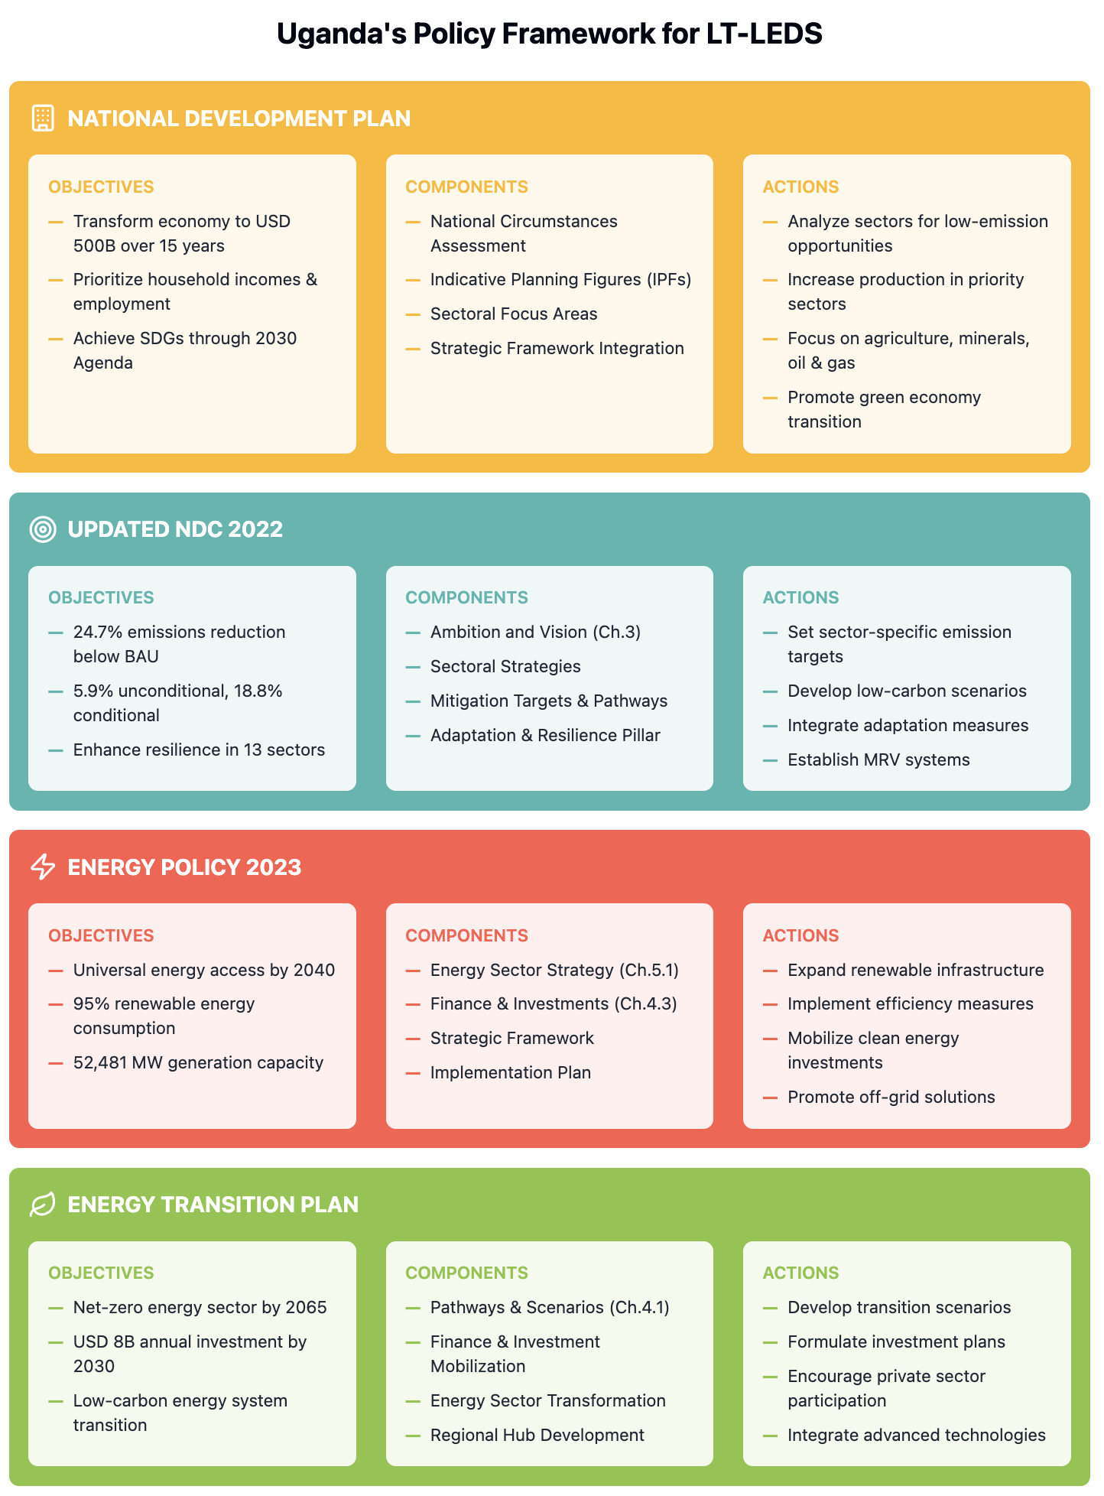
The following describes the integration of each of the policy and policy framework components into the LTS.

Uganda Vision 2040 and National Development Plans.
Uganda’s long-term development vision, articulated in Vision 2040, aspires to “transform Ugandan society from a peasant to a modern and prosperous country within 30 years” (National Planning Authority, 2010). This ambition involves transitioning Uganda from its current low-income status to a competitive, upper-middle-income economy. Vision 2040 highlights both the risks and opportunities of climate change: on one hand, unchecked climate impacts threaten growth in critical sectors like agriculture and forestry and tourism; on the other, effective adaptation and mitigation strategies can catalyze the emergence of new industries, including renewable energy and green manufacturing.
Implementation of Vision 2040 proceeds through six five-year National Development Plans (NDPs).
- NDP I (2010/11–2014/15): Focused on productive capacity and job creation.
- NDP II (2014/15–2019/20): Prioritized agriculture, tourism, and oil and gas, alongside infrastructure and human capital.
- NDP III: Driving Sustainable Industrialization and Livelihoods
NDP III (2020/21–2024/25) seeks to “increase household incomes and improve quality of life for Ugandans.” It advances sustainable industrialization, with an emphasis on agro-industrialization, import substitution, mineral-based industries, oil and gas, energy security, and the digital economy. Under its strategy, the government aims for a 7% economic growth rate, a rise in per capita income to USD 1,300, a reduction in poverty to 15.4%, and a narrowing of income inequalities. NDP III also focuses on improving health and education outcomes so that economic transformation is both inclusive and equitable.
- NDP IV
Spanning 2025/26–2029/30, NDP IV continues the theme of “Sustainable Industrialization for Inclusive Growth, Employment, and Wealth Creation” while placing greater emphasis on increasing employment rates, household incomes, and climate resilience. Preliminary targets involve multiplying Uganda’s economy from USD 50 billion to USD 500 billion within 15 years, bolstered by key infrastructure projects such as the Standard Gauge Railway and new oil and gas developments. Recognizing the intertwined challenges of development and climate change, NDP IV underscores the importance of fiscal discipline through Indicative Planning Figures (IPFs) and integrates environmental sustainability measures to safeguard socio-economic progress.
By situating climate risk management at the heart of Uganda’s economic planning, the LTS aligns with Vision 2040 and the NDPs, ensuring that decarbonization and adaptation measures reinforce national aspirations

Uganda’s Updated Nationally Determined Contribution (NDC)
Uganda’s revised NDC, submitted in 2022, strengthens the country’s stance under the Paris Agreement, reflecting greater ambition for both mitigation and adaptation. Building on the 2016 submission, the updated NDC:
- Commits to reducing GHG emissions by 24.7% below the business-as-usual (BAU) scenario by 2030, translating to a reduction of 36.75 MtCO₂e from a projected 148.8 MtCO₂e.
- Identifies adaptation priorities across 13 sectors, including agriculture, water, forestry, ecosystems, transport, energy, mining, urban areas, disaster risk reduction, fisheries, tourism, health, and education.
- Emphasizes a whole-of-society approach, involving government bodies, civil society, and the private sector in a participatory process.
- Estimates total financing needs at approximately USD 28.1 billion through 2030, deriving USD 4.1 billion domestically and seeking USD 24 billion in international support.
- Establishes robust monitoring, reporting, and verification (MRV) systems to track progress and inform regular policy adjustments.
The LTS aligns with and extends these commitments by mapping out longer-term pathways for reaching near-zero or net-zero emissions between 2050 and 2065. This positions Uganda’s 2030 targets within a broader trajectory of sustainable growth, supporting the country’s transition to a low-carbon and climate-resilient economy. Key integration points include, updating emissions projections, modelling mitigation pathways to reaching NetZero Emissions by 2065, expanding sectoral coverage with an in-depth assessment of the energy, transport, the buildings, IPPU, AFOLU, waste sector, and broadening adaptation priorities, with corresponding recalibrated financing and investment needs.
By building on these foundations, Uganda’s LTS provides a cohesive framework for achieving both near- and long-term climate goals while ensuring alignment with socio-economic development objectives.

Energy Policy and Transition Plan
Uganda’s Energy Policy of Uganda (2023) aims to ensure universal access to modern, affordable, and reliable energy services by 2040, while bolstering Uganda’s transition to a low-carbon economy. The policy, formulated in response to the country's rapid economic growth, urbanization, and escalating energy demands, recognizes the imperative to adopt sustainable energy solutions. It envisions achieving universal access to sustainable, affordable, and quality energy services for all Ugandans by 2040, underpinned by a mission to ensure reliable, equitable, efficient, and environmentally sustainable development and utilization of energy resources and services. Key objectives include:
- Rapidly increasing electricity generation capacity, targeting over 52 GW.
- Achieving at least 95 percent renewable energy consumption by promoting hydropower, solar, geothermal, hydrogen, and other low-emission resources.
- Improving energy efficiency across all sectors, including transportation, industry, and buildings, by implementing energy-efficient practices and technologies.
- Expanding off-grid and mini-grid systems for rural communities to reduce reliance on traditional biomass and kerosene.
To ensure measurable progress, the policy sets ambitious targets for 2040, including achieving 100% household access to clean and modern energy, increasing electricity consumption per capita, and reducing energy intensity to 3.7 MJ per USD GDP. The policy also aims to manage CO₂ emissions from energy activities to 13.1 MtCO₂e and utilization of atomic energy for applications such as disease diagnosis, treatment, industrial uses, research, and development.
This policy prioritizes equity and inclusivity by seeking to minimize energy gaps between urban and rural populations. It creates a conducive environment for private sector participation and sustainable financing while exploring emerging energy resources, such as nuclear energy for peaceful applications. The policy supports local economic development, aligns with broader efforts under the LTS, and underscores the need to manage environmental safeguards, ensuring energy development is conducted with respect to environmental, health, and social considerations. By linking national goals with global climate objectives, the Energy Policy underlines Uganda’s commitment to decarbonizing its power sector, creating green job opportunities, and achieving specific targets, including 100% household access to clean energy and managing CO₂ emissions at 13.1 MtCO₂e by 2040.
Energy Transition Plan. Uganda’s Energy Transition Plan (ETP), developed by the Ministry of Energy and Mineral Development (MEMD) in cooperation with the International Energy Agency (IEA), provides a comprehensive roadmap for transforming the national energy sector. It addresses multiple objectives—ranging from universal energy access to long-term decarbonization—while highlighting the investments, technologies, and policy frameworks needed to achieve these goals. By doing so, the ETP complements Uganda’s broader aspirations for economic growth, improved livelihoods, and alignment with global climate commitments
Universal Access to Energy. A central focus of the ETP is to ensure that all Ugandans have access to modern, reliable, and affordable energy services by 2030. This target encompasses both electricity and cleaner cooking solutions, recognizing that the majority of the population continues to rely on biomass or inefficient fuels such as charcoal and kerosene for everyday needs. In the short term, efforts include expanding grid connections to millions of additional households and scaling up off-grid systems—especially solar home kits and mini-grids—to serve remote communities. These measures not only reduce the health risks associated with indoor air pollution but also enable households to engage in productive activities such as small-scale manufacturing or digital services.
Diversification of the Energy Mix. The ETP identifies a diversified energy mix as essential for improving reliability, enhancing energy security, and reducing dependence on fossil fuels. Building on Uganda’s abundant renewable resources—hydropower, solar, and geothermal—the plan seeks to expand installed renewable energy capacity significantly over the next two decades. In tandem with these efforts, the ETP encourages research and pilot projects in emerging areas such as hydrogen production, particularly for industrial applications like steel manufacturing. By broadening its energy base, Uganda positions itself to mitigate the risks of supply disruptions and price volatility, while also leveraging potential export markets if production outpaces domestic demand
Emission Mitigation and Energy Efficiency. Aligned with Uganda’s commitments under the Paris Agreement, the ETP sets a target of reducing energy-related emissions by 20 percent to 17.8 MtCO2e against the baseline emissions of 23 Mt CO2-eq by 2030. This goal involves transitioning away from biomass and heavy fossil fuel use in power generation and transportation, along with scaling up energy efficiency measures across all sectors. Proposals include implementing tighter fuel standards, deploying electric vehicles in public transport, and upgrading industrial processes to reduce consumption. Additionally, the plan endorses carbon capture, utilization, and storage (CCUS) as a critical technology for sectors like cement and steel, where emissions are challenging to eliminate entirely through efficiency gains alone.
Positioning as a Regional Energy Hub: In the medium to long term, the ETP aspires for Uganda to serve as a key energy supplier to neighboring countries. Initiatives to achieve this include improving cross-border interconnections, enhancing transmission infrastructure, and coordinating with regional partners on energy trade frameworks. A successful shift to a more efficient and renewables-dominated energy system could open export opportunities for surplus power and innovative energy technologies. This positioning would further stabilize Uganda’s energy sector finances, reduce overall costs through economies of scale, and contribute to shared climate solutions across the East African region.
Investment Requirements: Realizing the ETP’s ambitions demands substantial financial resources, estimated at around USD 8 billion per year by the end of the current decade. These funds are earmarked for modernizing generation, transmission, and distribution infrastructure, as well as adopting advanced technologies such as CCUS. The ETP encourages a mix of public and private financing—recognizing the importance of public-sector involvement in foundational projects, alongside private capital for renewable energy ventures and innovations. It highlights the need for new financing models, including green bonds, public-private partnerships, and targeted international climate finance to meet the scale of required investment
Pathway to Net Zero Emissions in the energy sector: A defining element of the ETP is its long-term vision for a fully decarbonized energy sector by 2065. Achieving this would involve a phased transition that begins with near-term actions—such as electrification of transport, modernization of cooking fuels, and large-scale deployment of renewables—and culminates in advanced energy applications. Hydrogen fuel cells, next-generation batteries, and nuclear energy are identified as potential contributors to net-zero outcomes. By 2050, the ETP projects that renewable energy could account for over half of Uganda’s total final energy consumption, setting the stage for continued emissions reductions in subsequent decades.
Integration of the ETP into LTS
Key elements from the ETP were integrated into the LTS include:
- Universal Energy Access: The LTS supports targeted initiatives for electricity grid expansion and cleaner cooking, ensuring that energy improvements also yield social and economic benefits for marginalized communities
- Diversification of Energy Mix: Drawing on the ETP, the LTS encourages investments in renewables, including hydro, solar, geothermal, and nuclear (where appropriate). This approach promotes a balanced energy portfolio that enhances national security and mitigates climate risks.
- Emission Mitigation Measures: By advocating for more stringent energy-efficiency standards and supporting the adoption of CCUS, the LTS aligns with the ETP’s mitigation targets. These strategies contribute to emissions reductions in industries, buildings, and the transport sector.
- Regional Energy Hub Ambitions: The LTS underscores the value of international partnerships, cross-border power trade, and shared infrastructure projects. These efforts position Uganda to capitalize on surplus renewables and expand its influence in East Africa’s emerging green economy.
- Investment Mobilization: Recognizing the ETP’s annual financing requirement of USD 8 billion, the LTS outlines strategies for attracting and managing these funds effectively, from innovative mechanisms like green bonds to direct international climate finance.
- Pathway to Net Energy Zero Emissions: Both the ETP and the LTS chart a systematic path to decarbonizing Uganda’s energy sector, identifying milestones for technology deployment, policy reform, and capacity building. Their combined focus on stakeholder engagement, equitable development, and robust governance ensures that Uganda’s progress toward net zero is both inclusive and sustainable.

Other Relevant Policies
In addition to the National Development Plans (NDPs), the updated Nationally Determined Contribution (NDC), and Uganda’s energy sector strategies, the country has introduced a variety of policies and legislative instruments that further solidify its commitment to climate action. These policies address specific sectors or cross-cutting themes and, taken together, reinforce the foundations of a climate-resilient and low-emission development pathway.
One cornerstone of this expanded policy environment is the National Climate Change Act (2021). This Act establishes a legal and institutional framework for both mitigation and adaptation, giving statutory authority to the Ministry of Water and Environment’s Climate Change Department to coordinate national climate responses. Through the Act, the government can set sectoral emission targets, promote climate-smart planning at the district level, and streamline the mobilization of climate finance. The Act also facilitates coordination among ministries, ensuring that climate considerations inform public investments and service delivery across Uganda.
Complementing this legal foundation, the National Adaptation Plan (NAP) process provides a structured approach to identifying and addressing climate vulnerabilities. It emphasizes evidence-based risk assessments, enabling policymakers to prioritize interventions in sectors such as agriculture, water resource management, infrastructure, and public health. By focusing on long-term resilience, the NAP ensures that future infrastructure projects, land-use plans, and social programs incorporate climate risk considerations, thereby protecting livelihoods and reducing the costs of climate-related damages.
Meanwhile, sector-specific policies bring targeted measures for reducing emissions and enhancing resilience. For instance, the National Forestry Policy sets guidelines for sustainable forest management, aligning with efforts to reduce deforestation and boost carbon sequestration. In agriculture, policies such as the National Agricultural Policy and the Agricultural Extension Strategy support climate-smart farming techniques that enhance food security while minimizing the environmental footprint of production. Similarly, the National Biodiversity Strategy and Action Plan safeguards ecosystems by advocating the sustainable use of natural resources and the preservation of critical habitats, thus reinforcing both adaptation and mitigation goals. In health, Uganda’s policies underscore the links between climate change and disease patterns, stressing the need for robust surveillance, early warning systems, and community-based health initiatives to manage climate-induced risks.
Other frameworks, such as the Uganda Green Growth Development Strategy, integrate low-emission practices across sectors like transport, manufacturing, and urban development, encouraging a holistic approach to economic transformation. These instruments often promote inclusive decision-making processes that amplify the voices of women, youth, and local communities. By recognizing diverse perspectives and fostering stakeholder engagement, Uganda’s climate-related policies strive to ensure that the benefits of adaptation and mitigation measures are shared equitably.

Policy integration
Uganda’s LTS serves as a unifying framework that ties together the country’s various climate and development policies. By systematically reviewing each strategy—from the National Development Plans and the updated Nationally Determined Contribution (NDC), to sector-focused regulations in forestry, agriculture, and energy related sectors including transport, building, industry, waste and energy generation - the LTS identifies areas where existing goals and actions either reinforce or overlap one another. This process not only highlights common objectives, such as boosting livelihoods or reducing greenhouse gas emissions, but also reveals any gaps that may require additional attention.
The mapping exercise underpinning this approach makes it easier for policymakers and stakeholders to see where individual sectoral interventions can deliver complementary benefits. For instance, efforts to expand renewable energy capacity may also advance rural electrification targets under the NDPs, while simultaneously cutting emissions in line with the NDC. Similarly, land restoration and conservation measures appearing in forestry and agriculture policies can help preserve biodiversity, support livelihoods, and strengthen adaptive capacity. Aligning these efforts within a single long-term strategy helps reduce duplication, optimize resource allocation, and streamline decision-making processes.
The LTS promotes collaborative action among ministries, local authorities, private enterprises, and civil society groups, ensuring that climate and development initiatives are coordinated rather than fragmented. The result is a clear “matrix” of policy linkages, in which each action within the LTS can be traced back to corresponding goals in Uganda’s broader policy framework. Such transparency enhances accountability, allowing progress toward both climate resilience and socio-economic objectives to be tracked more effectively.
In the long run, this coherent approach to policy integration will help Uganda achieve its development ambitions while minimizing adverse environmental impacts. It provides a structure for engaging development partners and for accessing climate finance, as it demonstrates how different interventions fit into an overarching national plan. By reinforcing synergies and filling gaps, policy integration under the LTS helps Uganda move confidently toward a future that is prosperous, equitable, and climate-resilient.

Ambition, Vision, and Strategic Framework
Drawing on the discussion of Uganda’s climate challenges and opportunities in preceding chapters, this section sets out the country’s central goal of achieving a low-emission, climate-resilient, and prosperous future by 2065. It explains the overarching commitments embedded in Uganda’s Long-Term Strategy, emphasizing their alignment with both national and global climate objectives. The intention is to provide a concise vision that informs all subsequent actions, including the timing and magnitude of potential emissions reductions.

Uganda’s Overarching Climate Ambition
In alignment with the country’s policies, Uganda has structured its long-term climate vision following three main goals: economic prosperity, climate resilience and low-carbon development. Uganda envisions a transformation towards a resilient, inclusive and low-carbon society by 2050, aiming to further achieving net zero emissions no later than 2065.
Aligned with Uganda’s vision of green growth and a climate-resilient economy, this Long-Term Strategy evaluates mitigation potential against a Business-as-Usual baseline and presents a single Low-Emission Pathway that puts the country on course for net-zero greenhouse-gas emissions by 2065, with an interim milestone of deep reductions by 2050 to keep that goal firmly within reach.
Uganda had defined an adaptation-first approach due to the country’s vulnerabilities. Mainstreaming adaptation in all development sectors and enhancing community resilience are inherent to achieve this vision and thus have been integrated in all strategic pathways and scenarios.

Vision Statement
This strategy puts forward a transformative future for Uganda, where national development and climate goals are pursued in tandem rather than at odds. Under this vision, Uganda aspires to:
“A Uganda that prospers to its transformation towards a climate-resilient, inclusive, and low-carbon society by 2065.”
The vision stems from a careful review of national and sub-national strategies, validated through consultations with key authorities. It weaves together three fundamental goals—prosperity, climate resilience, and low-carbon development—which already feature prominently in Uganda’s policy landscape.
- Prosperity. The emphasis on prosperity is grounded in Vision 2040 and the country’s National Development Plans, all of which call for robust economic growth while preserving vital natural resources. This vision broadens the idea of prosperity to encompass equitable access to essentials such as education, healthcare, housing, and nutritious food. It also commits to generating stable jobs and raising incomes, primarily through the industrialization of key sectors. By underscoring inclusivity, the strategy aligns with both Uganda’s vision of improved quality of life for all citizens and African Agenda 2063’s broader aspirations for economic transformation and peace.
- Climate Resilience. Recognizing the urgent need to adapt to climate-related hazards, the second goal highlights resilience as the cornerstone for safeguarding Uganda’s social, economic, and environmental systems. This means reducing exposure to climate impacts, strengthening the capacity to manage emergencies, and building coping mechanisms to handle future uncertainties. Drawing on Uganda’s National Adaptation Programme of Action (2007) and updated NDC (2022), the strategy prioritizes mainstreaming resilience measures into all key sectors, ensuring that development gains are neither undermined nor reversed by extreme weather events.
- Low to NetZero-Carbon Development. The third element directly reflects the Paris Agreement’s call to limit global temperature increases, with Uganda aiming to peak emissions and its transition to a low and NetZero Emission development by 2065. This objective aligns also with Uganda’s relevant climate policies and frameworks as outlined in Chapter 2. The strategy further demonstrates that enhanced mitigation ambition—encompassing circular economy approaches, renewable energy adoption, and emission-reducing technologies—remains both feasible and beneficial, supporting the nation’s broader objectives to reduce poverty and boost economic growth.
Figure 6 presents a high-level view of how this vision translates into development pillars and sectoral net-zero pathways. The pillars serve as the foundation, shaping Uganda’s pursuit of prosperity, climate resilience, and low-carbon advancement. Their articulation across each sector ensures that the strategy’s long-term options for action are well-coordinated and structured. Through this integrated approach, Uganda’s LTS both complements and contributes to the broader suite of plans and policies that guide the country’s sustainable development agenda. Uganda’s NetZero Vision 2065 envisions a country that prospers as a climate-resilient, inclusive, and low-carbon society by 2065. This vision is driven by the core pillars of prosperity, climate-resilience, and low/net-zero carbon, which underpin the development pillars and sectoral net-zero sectoral strategies.
Figure 10. Overview Vision, Pillars and Sectoral NetZero Strategies
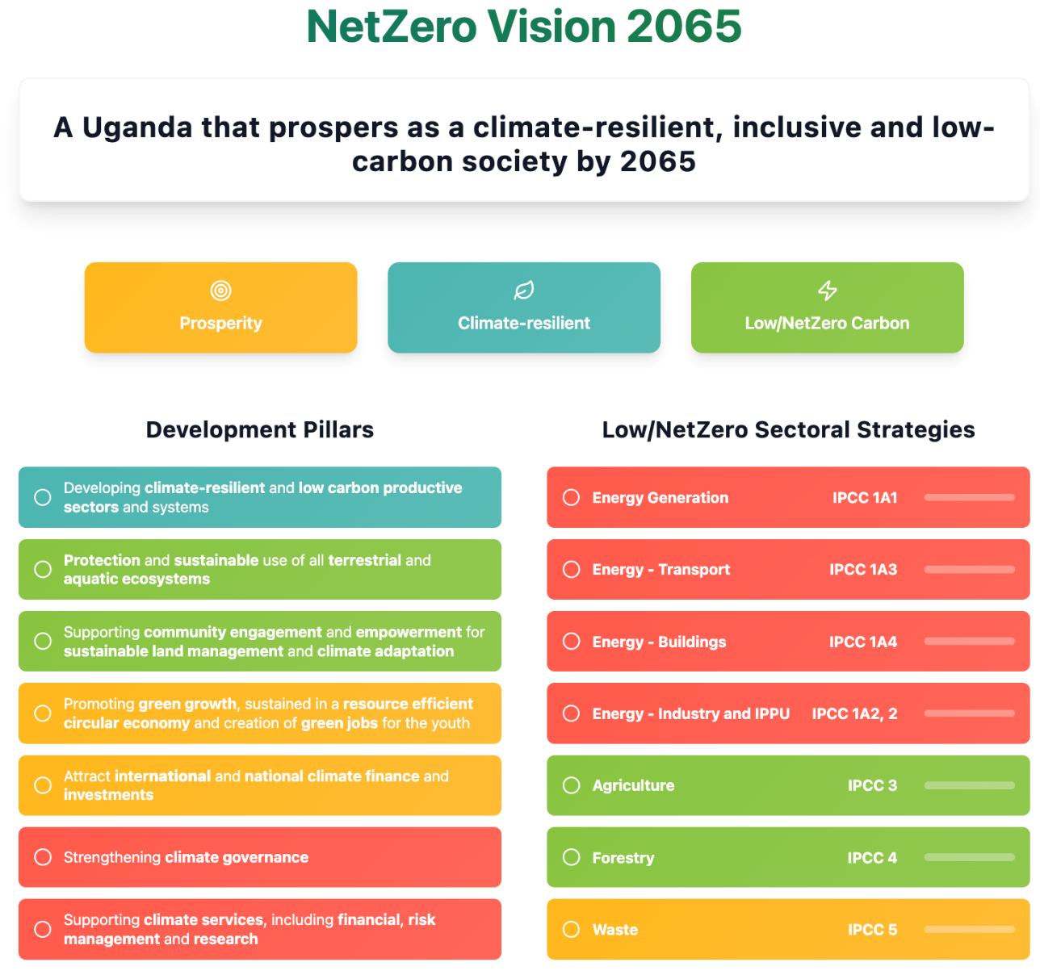

Development Pillars
Uganda intends to develop a climate resilient and low carbon economy by mainstreaming climate adaptation and climate mitigation across all sectors and at all levels of governance. This requires considering climate adaptation and climate mitigation together rather than separately to avoid unintended consequences, most notably the possibility of maladaptation, missed opportunities for co-benefits or mitigation actions compromising climate vulnerabilities.
Therefore, this strategy suggests a set of pillars that underpin, guide and articulate all aspects of the vision and pathways for implementation. These pillars coherently sustain Uganda’s long-term climate vision and serve as guiding principles for strategic implementation. They provide a framework for short- and medium-term planning and encompass all key development, adaptation and mitigation needs. As such, they are all necessary, important and highly interconnected across all sectors and levels of governance. The pillars are transversal and equally important towards the goals of prosperity, resilience and low-carbon development. It is not intended that one pillar should be prioritized over another at the level of the strategy, especially given its long-time horizon.
The LTS’ guiding pillars take account of:
- Uganda’s development aspirations articulated in the Vision 2040 and in the main climate and energy policies presented in the previous chapter.
- The need to reduce sectors’ climate sensitivities, increase associated adaptive capacities, and thereby reducing climate vulnerabilities, as well as to reduce the magnitude of exposure to climate-related hazards. The probability of resultant impacts was identified by a detailed climate vulnerability, impact and risk assessment, which covered all sectors (Agriculture, Build Infrastructure, Business, Energy, Fisheries, Forestry, Health, Manufacturing, Mining and Quarrying, Transport, Water, and Ecosystems).
- An analysis of mitigation options across all sectors and the resulting emissions pathways, including the suggested low-carbon and net zero scenarios.
The pillars and pathways together with their actions presented here have been revised from their previous proposition during the NDC update process in 2022. This revision not only simplified the original pillars structure to enhance clarity, but also ensured that they directly resonate with key national documents like Uganda’s NDP IV, the updated NDC, the Energy Policy for Uganda (2023), the Vision 2040, the National Climate Change Action Plan (NCCAP) and its District Climate Change Action Plans (DCCAPs). This strategic framework identifies specific long-term options for action for each pathway to enhance Uganda’s climate resilience, limit its GHG emissions and promote its future prosperity.
A series of long-term options for actions have been identified and aligned. These options for action represent specific activities or measures that may be taken, over the long-term, to achieve the goals of the strategy. The actions are necessarily high level as they are intended as ‘strategic’ guidance on long-term options. The detailed selection, development and implementation of specific actions will, therefore, be decided at all levels of governance, across and within sectors, as part of short- and medium-term planning.
The options for action that are primarily focused on enhancing climate resilience were identified from the detailed assessment of climate vulnerabilities and risks. They are intended to reduce climate sensitivities, increase adaptive capacities, and reduce the exposure of resultant vulnerabilities to risks of climate impacts. The options for action that are primarily focused on achieving the low carbon goal were derived from the identification and assessment of individual mitigation measures during development of the mitigation pathways. While the individual actions were identified with either an adaptation or mitigation lens the options for action are not mutually exclusive and, as part of the identification, consideration was given to adaptation-mitigation co-benefits and trade-offs, including the need to avoid maladaptation.
These actions are neither exhaustive nor prescriptive and should be complemented and/or amended through ongoing policy planning processes between now and 2065 to ensure that the strategy remains relevant to Uganda’s changing needs.

Protection and sustainable use of all terrestrial and aquatic ecosystems
This pillar emphasizes the conservation of Uganda’s rich biodiversity, enhancing carbon sequestration, and supporting livelihoods reliant on natural resources. Protecting and sustainably managing ecosystems is essential for reducing emissions and to ensure the resilience of communities dependent on these vital resources.
This pillar is about safeguarding ecosystems from unsustainable use through better management to optimize productivity. It governs aquatic ecosystems and land-use at a macro level to ensure that cross-sectoral or cross-regional ecosystem-use activities do not adversely affect productivity. It builds on NCCP's goal to embed climate considerations into legal and institutional frameworks. This objective is also supported by the land, housing, urban development sector planning standards which mainstream climate change into physical planning standards and guidelines, national land-use policy and the physical planning act. In addition, this pathway considers the use of land for energy generation to support a clean development and industrialization. Key initiatives include implementing comprehensive land-use regulations, expanding reforestation and afforestation projects, and promoting sustainable agriculture practices.
It also emphasizes effective management of aquatic ecosystems, including sustainable fisheries management, pollution control measures, wetland conservation, and integrated water resource management, alongside community engagement and robust legal frameworks to ensure the long-term health and productivity of these essential aquatic environments.
It aligns with the National Environment Management Act (2019), National Biodiversity Strategy Action Plan (NBSAPIII 2024), National Forestry Policy (2001), the National Land Policy (2013) and the Fisheries and Aquaculture Act (2023), this pillar contributes significantly to Sustainable Development Goals (SDGs) 13 (Climate Action), 14 (Life Below Water), and 15 (Life on Land) as well as the Kunming Montreal Global Biodiversity Plan (KMGBF) (target 2, 3, 8, 10, and 11) .
Long-term climate actions for implementing a land-use regulatory framework to increase land productivity nation-wide
- Developing a nation-wide climate-resilient land-use regulatory framework and monitoring and evaluation system
- Implement strong policies to stop deforestation
- Implement strong policies to promote afforestation and recovering of degraded lands, paying attention to the recuperation of soils, and protection of Protected Areas such as game parks to safeguard critical habitats.
- Supporting the development of sustainable intensive agriculture to prevent agricultural expansion
- Analyze and develop regulations for the use of land to support the generation of renewable energies (e.g. solar)
- Appointing land use planning monitors at local and regional level to report on land-use
- Updating the Town and Country Planning Act and the Physical Planning Act currently regulating Urban Land Use and Planning
Long-term climate actions for implementing aquatic ecosystems use regulatory framework to increase productivity nationwide
- Developing a nation-wide climate-resilient aquatic ecosystem use regulatory framework and monitoring and evaluation system: This focuses on managing activities impacting aquatic environments (fishing, water extraction, sand and mineral mining, waste disposal/ pollution) in the face of climate change.
- Strengthen enforcement capacity to ensure compliance with regulations, coupled with robust monitoring programs to track ecosystem health, water quality, and the effectiveness of implemented measures.
- Implement strong policies to prevent the destruction of aquatic habitats (wetlands, Fish Breeding Areas, Peatlands).
- Implement strong policies to promote the restoration of degraded aquatic ecosystems (wetlands, shorelines, rivers) and the fish stocks recovery, paying attention to regulation of fishing effort, the improvement of water quality and sedimentation.
- Supporting the development of sustainable aquaculture practices while improving access to quality fish seed and feed to reduce pressure on wild fish populations and ecosystem degradation: Intensive, sustainable aquaculture can reduce fishing pressure and act as an alternative livelihood for fisher communities.
- Analyze and develop regulations for the use of aquatic resources to support the generation of renewable energies (e.g., hydropower, geothermal) while minimizing environmental impacts.
- Updating relevant Acts to integrate aquatic ecosystem considerations, strengthen protection of wetlands and rivers and regulate Urban water Use and Planning: This ensures legal frameworks adequately protect aquatic environments in the face of development.
- Update existing regulations (e.g. Fisheries and Aquaculture 2023) to explicitly incorporate climate change considerations into fisheries management, nature conservation, water resource allocation, pollution control, protection of wetlands and rivers and infrastructure development related to aquatic ecosystems. This includes setting adaptive quotas based on projected climate impacts on fish stocks and establishing buffer zones that account for water level changes and increased flooding risks.
- Invest in research to improve understanding of the impacts of climate change on aquatic ecosystems and respective environmental impacts from use to inform management decisions.
- Implement Integrated Water Resource Management (IWRM) principles to balance competing water demands (agriculture, industry, domestic use, ecosystem needs) under changing climate conditions.

Developing climate-resilient and low carbon productive sectors and systems
The second pillar focuses on transforming Uganda’s key economic sectors into climate-resilient and low-carbon industries, and where possible, towards net-zero sectors. This involves transitioning to renewable energy sources, increasing energy efficiency, and promoting the adoption of low-carbon technologies within industries such as manufacturing and construction. By reducing sector-specific emissions, this pillar plays a crucial role in Uganda’s commitment to a sustainable and prosperous economy.
Strategic pathways include integrating solar, wind, and hydropower technologies, establishing greenhouse gas (GHG) emission standards, and supporting research and development of innovative low-emission solutions. Aligned with the Energy Policy for Uganda (2023) and the National Climate Change Policy (2015), this pillar supports SDGs 7 (Affordable and Clean Energy), 9 (Industry, Innovation, and Infrastructure), and 12 (Responsible Consumption and Production).
Long-term climate actions for supporting resilient and low carbon production and value chains in agriculture, forestry, fisheries and other key economic activities
This pathway is essential and needs mainstreaming across all sectors. It is about promoting resilient and low carbon production systems in agriculture, agroforestry, livestock, fisheries, aquaculture and other key activities to sustain healthy livelihoods. To enhance resilience and reduce the footprint of production activities, it is necessary to provide financial and technical support to farmers and producers, but also along the value chains. The pathway encompasses actions that encourage the use of nature-based solutions and encouraging changes in consumption patterns so that the market for resilient and low-impact foods is sustained. The pathway echoes the goals of the National Climate Change Policy (NCCP) to promote climate change practices that enhance resilient local practices and improve food storage and commercialization management solidifying food security as a factor of resilience.
- Rolling out and supporting the production and consumption of resilient crops, livestock, timber and aquatic species, including considerations of locally produced, seasonality, climate- resilient varieties (e.g. against drought), among others.
- Supporting nature-based solutions for adaptation in agriculture and agroforestry – i.e. conservation agriculture and ecologically compatible cropping systems; agroforestry and mixed production systems to support food security and income generation.
- Developing a risk management system focused on enhancing resilience locally (at farm level) and for commercial food production; this can incorporate weather-based insurance schemes to protect farmers from losses caused by climate impacts, together with improved climate information systems.
- Encouraging climate smart agricultural practices, such as rainwater harvesting and irrigation, agroforestry and vegetable production in greenhouses.
- Supporting measures in the livestock sub-sector, including changing to exotic cattle varieties and breeding, livestock breeding research, improving feed quality, feed supplements and manure management
- Promoting organic fertilizers and reducing the use of toxic agrochemicals
- Supporting sustainable practices for fisheries, evaluating measures such as quotas and fish catch size limits during critical seasons or for endangered species.
- Promoting certifications for organic production, fair trade and avoided deforestation, with the possibility to enter international carbon markets (which requires a robust MRV system for AFOLU sector).
- Promoting information and marketing for consumers to incentivize preferences for locally sourced foods and with lower environmental impacts
- Promoting agro-processing including in fisheries and commercial forestry to reduce post-harvest losses through value addition and contribute to food security and poverty reduction.
Long-term actions for supporting climate-resilient water supply and treatment systems and increasing water supply capacity
This pathway is concerned with increasing water supply capacity through diversification of water sources and by improving distribution efficiencies. This is consistent with the NCCP goal that climate change concerns are integrated into the sustainable and long-term conservation of water resources, with effective utilisation and management of water storage and supply. The pathway builds on actions within the water and environment sector development plan (2015-2020) which calls for the construction, operation and maintenance of appropriate and climate resilient community water supply systems for rural areas.
- Improving efficiency in existing distribution systems – rehabilitate production and supply infrastructure, upgrade metering, and minimise leakages.
- Expanding wastewater-treatment capacity and grey-water reuse in both urban and rural settlements.
- Mainstreaming sustainable water management across all economic sectors (agriculture, energy, industry, tourism, households).
- Promoting water harvesting and efficient use at household, community, institutional and sector levels.
- Deploying nature-based solutions (e.g., catchment restoration, wetland protection) to enhance water storage and supply reliability.
- Rolling out water-saving technologies in the energy sector, including turbine retrofits and cooling-water recycling for hydropower and thermal plants.
- Scaling water for production – develop and rehabilitate irrigation schemes, construct multipurpose water reservoirs, and install on-site treatment/storage systems for agro-processing zones to ensure reliable, climate-resilient supply.
Long-term actions for increasing energy generation and supply based on renewable energy sources, a resilient and net zero electricity system, and reduced dependence on charcoal and firewood
This pathway sets out long-term actions to expand clean, renewable and other zero-carbon energy sources— including a potential, longer-term introduction of small modular nuclear reactors. By diversifying Uganda’s energy mix and improving end-use efficiency, it builds a resilient, net-zero electricity system, taking off pressure from the unsustainable use of wood, safeguards forest ecosystems and improves public health. The approach aligns with NDP IV and the NCCP objective of promoting the use of clean and renewable energy through diversification into sustainable, climate-resilient sources rather than shifting dependence to options vulnerable to climate variability.

Priority actions
- Promote efficient biomass use and fuel switching. Scale-up advanced cookstoves in households, institutions and small businesses. Accelerate a switch from charcoal to electric cooking in urban areas.
- Boost industrial efficiency and low-carbon fuels. Tighten energy-performance standards, deploy waste-heat recovery and electrify process heat where feasible. Expand clean electricity supply.
- Renewables: build grid-scale solar PV, wind and run-of-river hydro; extend standalone solar systems and mini-grids for rural electrification and energy storage systems. Uganda will benefit from the significant decline of global prices for these systems over the last decades and further projected declining prices over the coming decades.
- Nuclear (zero-carbon back-up): conduct feasibility studies, develop regulation and human-capital pipelines for potential deployment of small modular reactors beyond 2040.
- Waste-to-energy: install anaerobic-digestion and biomass gasification plants to turn municipal and agro-waste into power and heat.
- Strengthen the grid and cut system losses. Rehabilitate transmission and distribution infrastructure, upgrade metering and adopt smart-grid solutions to minimise technical and commercial losses.
- Enable investment and skills. Provide fiscal incentives, blended-finance facilities and green-bond frameworks to crowd in private capital. Integrate clean-energy curricula in tertiary institutions to create a skilled workforce and green jobs.
These measures collectively drive Uganda’s transition to a diversified, climate-resilient and net-zero energy system.
Long-term actions for encouraging low carbon mobility and creating climate-resilient transport infrastructure and systems
A well-designed, efficient transport network can cut greenhouse-gas emissions, strengthen climate resilience and unlock economic growth. Uganda therefore aims to decarbonise the sector while ensuring that new infrastructure is climate-proof and avoids maladaptation. Key pillars include rigorous environmental- and social-impact assessment (ESIA), an accelerated shift to non-motorised and public transit, strategic freight management and, above all, the rapid electrification of vehicles and powertrains.
- Non-motorised transport (NMT): Design and build continuous, protected cycling lanes, shaded sidewalks, safe crossings and secure bike parking, prioritising urban corridors and school/workplace catchments; Launch city-wide bike-share and e-scooter programmes integrated with public transit cards.
- Public & mass transit: Develop bus rapid-transit (BRT) corridors, commuter rail and park-and-ride hubs to shift passenger kilometres from private cars; Introduce integrated ticketing and real-time information systems to enhance user experience.
- Electrification: Mandate electric fleets for new urban buses and government vehicles from 2030; create charging depots powered by renewable energy; Provide fiscal incentives and concessional finance for electric two- and three-wheelers, taxis and logistics vans; Pilot battery-swap schemes for motorcycles and light freight.
- Freight optimisation: Adopt “avoid–shift–improve” planning: consolidate urban deliveries, invest in inter-modal rail and lake transport, and digitise logistics to cut empty runs; Enforce axle-load controls and eco-driving training.
- Fuel efficiency & alternative fuels: Implement progressively tighter fuel-economy standards for light-, medium- and heavy-duty vehicles.• Set blending mandates and quality standards for sustainable biofuels; explore green-hydrogen pilots for long-haul trucks post-2040.
- Climate-resilient infrastructure: Update design codes for roads, bridges and rail to withstand higher temperatures, heavier rainfall and flooding; Upgrade drainage, elevate critical sections and use heat-resistant paving materials.
- Behaviour change & finance: Run nationwide information campaigns promoting public transport and active mobility.Offer tax rebates, import-duty waivers and carbon-credit schemes to crowd-in private capital for low-carbon transport projects.
Long-term actions for strengthening the regulations, standards and incentives for resilient and low carbon construction practices in buildings and other infrastructures to support resilient urban planning
Strengthening regulations, standards and incentives for climate-smart construction is essential to resilient urban planning and net-zero development. The measures below align with the National Climate Change Policy (NCCP), the Urban Development Policy, the 2015-2020 Urban Development Sector Plan and the National Housing Policy.
- Climate-smart construction codes & permits – Revise the National Building Code by 2028 to include climate-risk screening, passive-design requirements and embodied-carbon limits; require life-cycle assessments (LCA) for major projects.
- Low-carbon building materials – Prioritise compressed-earth blocks, sustainably sourced timber, bamboo and pozzolana-blended cement in public tenders; develop labelling standards for recycled and bio-based materials.
- Climate-smart cities network – Establish a peer-learning platform linking Kampala, Gulu, Mbarara and secondary towns to share hazard maps, data portals and performance dashboards; publish an annual “Top 10 Climate-Smart Cities” index.
- Performance-based incentives – Create a Climate-Smart Infrastructure Fund that offers grants or interest-rate buy-downs to municipalities meeting green-building and resilience benchmarks.
- Integrated land-use & transit-oriented development (TOD) – Cluster housing, jobs and services around mass-transit nodes; apply zoning and density bonuses to curb sprawl and shorten trip lengths.
- Strategic siting to minimise travel – Use planning regulations to locate industrial parks, schools and health facilities where they reduce the need for long-distance commuting and freight transport.
- Global city networks – Support major municipalities in joining the C40 Cities network (or similar) to access technical assistance, best practice and climate-finance pipelines.
Long-term actions for developing climate resilient health systems
Healthy populations are the bedrock of a climate-resilient society. Uganda’s Health National Adaptation Plan (H-NAP) already recognises climate change as a major health threat and sets out sector-specific adaptation measures. Building on the H-NAP, the National Climate Change Policy (NCCP) and the NDC, this LTS outlines the following long-term actions to create a robust, low-carbon and fully climate-proof health system.
- Governance & coordination — Activate the H-NAP’s technical working groups and inter-ministerial committee; strengthen the regulatory framework to embed climate risk management across all health programmes.
- Governance & coordination — Activate the H-NAP’s technical working groups and inter-ministerial committee; strengthen regulations so that every national health programme screens for climate risk.
- Climate-health surveillance & data — Run a national, open-access platform that tracks climate-sensitive diseases, heat-stress events and air-quality data in real time, feeding evidence into policy and research.
- Disaster-risk management & early warning — Embed health indicators and response protocols in the national early-warning system; use mobile alerts and climate dashboards to trigger rapid medical deployment.
- Capacity building & education — Integrate climate-health modules in medical, nursing and public-health curricula; roll out continuous training on adaptation and low-carbon practices for the existing workforce.
- Guidelines & mainstreaming — Publish standard operating procedures for climate-smart facility design, resilient supply chains and low-carbon procurement; distribute practical toolkits to district health offices.
- Community engagement & risk communication — Deliver nationwide campaigns—especially targeting women, children and other vulnerable groups—on climate-related health risks and best-practice prevention.
- Climate-proof, low-carbon infrastructure — Prioritise construction and retrofits that make hospitals and clinics flood-safe, energy-efficient and resource-savvy; ring-fence capital and maintenance budgets.
- Ensure access — Protect critical transport links to health facilities by climate-proofing roads, bridges and public-transport routes, guaranteeing patient and supply access during extreme events.
- Private-sector collaboration — Engage insurers, pharmaceutical firms, construction companies and tech start-ups to co-finance resilient infrastructure, expand climate-linked health products and scale awareness campaigns and micro-insurance solutions.
- Multi-sectoral partnerships & resource mobilisation — Leverage regional and international climate-health funds and forge alliances with NGOs, academia, development partners and other ministries to unlock technical assistance and blended finance.

Promoting green growth, sustained in a resource efficient circular economy and creation of green jobs for the youth
Uganda’s transition to a green, inclusive economy rests on scaling circular-economy practices, mobilising climate-aligned finance and equipping young people with green skills. Pillar C therefore builds on the Green Growth Development Strategy (2017) while integrating the National Green Taxonomy now being drafted by the Climate Finance Unit of the Ministry of Finance, Planning & Economic Development (CFU-MoFPED) . The taxonomy will provide a common classification for low-carbon, climate-resilient activities, unlocking public and private capital and ensuring full coherence with SDGs 8 (Decent Work & Economic Growth), 12 (Responsible Consumption & Production) and 13 (Climate Action).
- National Green Taxonomy & sustainable finance — Finalise, publish and periodically update the taxonomy; embed it in budget tagging, green-bond frameworks and concessional credit lines to steer investment toward verified green activities, and to channel international climate finance through the CFU-MoFPED .
- Circular-economy & waste minimisation — Roll out extended-producer-responsibility schemes, city-wide recycling and composting hubs, and incentives for industrial symbiosis that turn by-products into inputs for other value chains.
- Green skills & youth employment — Expand vocational curricula in eco-design, renewable-energy maintenance, resource-efficient manufacturing and sustainable agriculture; create incubation funds for youth-led green start-ups.
- Resource-efficient production — Implement mandatory energy- and water-efficiency audits for large firms; provide tax rebates for adopting clean-production technologies and low-carbon materials.
- Sustainable consumption incentives — Introduce eco-labelling and green-public-procurement standards; apply differential VAT/excise rates favouring repair, reuse and low-impact products.
- Innovation & knowledge platforms — Set up a national circular-economy innovation hub to connect universities, SMEs and investors, accelerating R&D and technology transfer.
By coupling the emerging National Green Taxonomy with circular-economy interventions and targeted youth programmes, this pillar will cut material waste, open new markets and generate high-quality green jobs—ensuring no one is left behind in Uganda’s journey to a resilient, net-zero future.
Long term actions for encouraging a resource-efficient circular economy, especially optimizing the use of water and energy, and creating green jobs and economic opportunities for the youth in the transition to an inclusive and green economy
Uganda’s shift to an inclusive, green economy hinges on closing material, water and energy loops across value chains and ensuring young people secure the skills and jobs created in this transition. A strategic opportunity lies in turning the Uganda Investment Authority’s 22 planned Industrial & Business Parks into eco-industrial parks (EIPs)—purpose-built hubs where companies share resources, exchange by-products and co-invest in clean infrastructure. Doing so will cut waste, shrink energy and water demand, lower emissions and spark innovation-led growth nationwide.
Implementation will follow a three-phase approach across the 22 parks, beginning with foundational circular infrastructure in the first five parks (Namanve, Mbale, Mbarara, Luzira, Jinja) by 2027, advancing to enhanced industrial symbiosis systems in eight additional parks by 2030, and achieving world-class eco-industrial standards across all remaining parks by 2035 to 2040. Each park could integrate specialized circular value chains—such as agro-processing waste-to-energy loops in Mbale, solar-powered manufacturing symbiosis in Soroti, and livestock value chain optimization in Mbarara—while collectively targeting 22,000 green jobs with dedicated quotas ensuring 40% youth and 35% women participation. The phased rollout could include mandatory performance benchmarks for resource productivity, waste diversion rates, and renewable energy adoption, supported by a comprehensive financing framework offering capital grants for shared infrastructure, tax incentives for circular technologies, and startup funding for youth entrepreneurs developing innovative resource-exchange solutions. Possible interventions are mapped out here:
- Eco-industrial park design standards — Integrate circular-economy and resource-efficiency criteria (energy- and water-use benchmarks, waste-heat recovery, by-product exchange) into the master plans, zoning regulations and tenant covenants of all new parks; require park developers to meet UNIDO/World Bank EIP performance indicators.
- Shared clean infrastructure — Build common on-site services—solar or biogas micro-grids, waste-to-energy units, shared effluent-treatment plants, grey-water recycling loops and centralised materials-sorting facilities—to give tenants circular solutions at scale and at lower cost.
- Industrial-symbiosis & by-product marketplaces — Establish a digital “resource-match” platform, run by Uganda Investment Authority (UIA) or a private operator, that pairs one firm’s waste or excess heat/water with another’s input needs; offer seed grants for the first industrial-symbiosis pilots in each park.
- Green-skills & youth employment programmes — Partner with TVET centres near the parks to train young people in eco-design, energy-efficient maintenance, waste-auditing and industrial-symbiosis management; embed apprenticeships and on-the-job learning quotas in investment agreements.
- Circular-procurement & financing incentives — Align park-level procurement with the forthcoming National Green Taxonomy; provide tax holidays, accelerated depreciation or concessional loans for tenants that install circular-economy technologies (e.g., closed-loop cooling, modular product design).
- Performance monitoring & disclosure — Require annual reporting on material-, water- and energy-intensity, waste diversion and jobs created; publish a “Green League Table” to foster competition among parks and attract ESG-minded investors.
- Replication & scale-out — Use lessons learned from flagship parks (e.g., Namanve, Mbale, Soroti) to update national EIP guidelines and roll them out to the remaining sites and future industrial clusters.
By embedding circular-economy principles, Uganda country can optimise water and energy use, reduce emissions, divert waste from landfills, and create thousands of high-quality green jobs for its youth—accelerating the broader transition to a resilient, low-carbon economy.
Long term actions for developing eco-tourism to restore and protect ecosystems while generating local income
Uganda will leverage eco-tourism as a strategic bridge between conservation and development. This pathway aligns squarely with NDP IV, which lists tourism among the country’s seven priority export services and calls for nature-based product diversification to boost GDP and jobs . It also supports the Ten-Fold Growth Strategy, whose target of a ten-times GDP expansion by 2040 rests on high-value sectors such as sustainable tourism and upgraded visitor infrastructure . Regionally, the actions advance Uganda’s African Continental Free Trade Area (AfCFTA) Implementation Strategy, designed to capture larger intra-African tourist flows and raise foreign-exchange earnings from services trade . The pathway dovetails with the National Climate Change Policy (NCCP) provisions on wildlife conservation and climate-resilient tourist facilities and reflects priorities in the Tourism Development Master Plan 2014-2024 for community-based, low-impact products .
- Map & market “green trails” — Identify low-impact trekking, cycling and bird-watching circuits in and between protected areas; bundle them with certified community lodges to lengthen visitor stay while limiting ecological disturbance. NDP IV linkage: expands high-value nature-based products and disperses earnings to rural hubs.
- Community-led restoration tourism — Create visitor programmes where tourists pay to plant indigenous trees, remove invasive species or rebuild wetland boardwalks alongside local eco-champions, directly funding ecosystem repair. Ten-Fold Growth synergy: channels private spending into natural-capital regeneration and green youth jobs.
- Equitable benefit-sharing schemes — Strengthen Uganda Wildlife Authority’s revenue-sharing formula (e.g., 20 % of gate fees) and extend it to concession fees and carbon credits, ensuring local communities capture a fair share as regional arrivals rise under AfCFTA.
- Eco-industrial tourism supply chains — Adopt circular procurement for lodges (biomass briquettes, refillable amenities, solar mini-grids) and certify suppliers through the forthcoming National Green Taxonomy to unlock green-finance incentives from MoFPED’s Climate Finance Unit.
- Low-carbon mobility corridors — Pilot electric safari vehicles, e-bikes and solar boat safaris on Lake Victoria and in the Albertine Rift, aligning with the transport pathway to cut diesel use and meet NCCP resilience targets.
- Regional AfCFTA eco-tourism circuits — Bundle Uganda’s gorilla and forest experiences with Kenyan coastal sanctuaries and Rwandan cultural sites, using single-visa or mutual-recognition arrangements to ease cross-border travel and fulfil AfCFTA service-trade objectives.
- Youth green-skills academies — Embed eco-guiding, circular-hospitality and renewable-energy maintenance in vocational curricula; finance apprenticeships through NDP IV skills-development windows and Ten-Fold Growth job-creation funds.
- Climate-smart infrastructure standards — Apply resilient design codes (elevated walkways, rainwater harvesting, passive cooling) to all new tourism facilities, implementing NCCP guidance on climate-proof assets while satisfying investors’ ESG criteria.
These integrated measures restore natural capital, spread income to local communities, and position eco-tourism as a flagship contributor to Uganda’s NDP IV, Ten-Fold Growth and AfCFTA ambitions—creating a resilient, inclusive and low-carbon tourism economy that leaves no one behind.

Supporting community engagement and empowerment for sustainable land management and climate adaptation
Uganda’s fourth pillar on its LTS on inclusive, climate-resilient development translates its high-level vision of an inclusive, climate-resilient society into concrete, community-centred interventions. The measures below draw on the National Climate Change Policy (2015) , Vision 2040 land-reform commitments , the REDD+ Strategy (2017), and flagship adaptation programmes such as the GCF-financed wetlands project and FAO Farmer/Agro-Pastoral Field Schools. Together they empower women, youth, indigenous peoples and other marginalised groups to become stewards of land, forests, wetlands and rangelands—delivering practical progress on SDGs 5, 10 and 11.
Long-term actions for community engagement & sustainable land management
- Community field schools & peer learning – Scale the Farmer-Field-School/Community-LandCare model to every agro-ecological zone so smallholders master soil- and water-conservation techniques; successful graduates gain micro-grants for land-restoration investments.
- Participatory forest & wetland management – Expand Collaborative Forest Management agreements and community wetland-user groups created under the REDD+ Strategy and GCF wetlands project; guarantee equitable sharing of eco-tourism, carbon-credit and non-timber-product revenues.
- Gender- and youth-responsive adaptation funds – Establish a ring-fenced window in the national Climate Finance Facility issuing small grants (USD 5 000–50 000) to women’s groups and youth cooperatives for nature-based solutions and resilient value chains.
- Local climate-information services – Install solar-powered automatic weather stations and train community “infomediaries” to translate forecasts into planting, grazing and public-health advisories, fulfilling NCCP commitments on community-based early warning.
- Secure & inclusive land tenure – Fast-track registration of customary land certificates and community titles so households have the security needed to invest in long-term soil health and tree planting, as envisioned in Vision 2040.
- Village climate-action planning – Embed participatory micro-catchment plans in District Development Plans; empower community natural-resource committees to set bylaws on burning, grazing and water extraction, with technical back-stopping from district extension teams.
- Performance-based incentives – Pilot a national “Sustainable Land Stewardship Scorecard” that rewards communities surpassing erosion-control, tree-cover and water-harvesting targets with co-financing for local infrastructure (e.g., feeder-road upgrades, solar mini-grids).
- Private-sector & NGO partnerships – Broker deals with eco-tourism operators, out-grower schemes and conservation NGOs to co-finance landscape restoration and guarantee market access for climate-smart commodities produced by community groups.
Long-term actions for institutionalising & scaling indigenous knowledge
- Document indigenous practices – Catalogue traditional know-how on water harvesting, food preservation, animal husbandry and climate observation through participatory rural appraisals; store results in an open-access digital archive linked to the REDD+ MRV system.
- Validate & disseminate – Assess documented practices for resilience impact; integrate proven methods into national extension manuals and Farmer Field School curricula.
- Incorporate in formal education – Embed indigenous agro-ecological and ecosystem-management knowledge in primary, secondary and vocational syllabi to preserve cultural heritage and enhance future adaptive capacity.
- Co-design adaptation solutions – Involve elders and indigenous leaders in tourism planning, ecosystem conservation and fisheries management to ensure measures respect cultural values and land-use traditions.
- Replace harmful practices – Where traditional methods prove damaging (e.g., slash-and-burn on fragile slopes), design participatory transition plans that introduce sustainable alternatives without eroding cultural identity.
By coupling hands-on capacity-building, inclusive finance, secure tenure and the respectful integration of indigenous knowledge, Uganda can turn communities into frontline partners for sustainable land management and climate adaptation—anchoring resilience in the very places where climate impacts are felt first and hardest.

Strengthening climate governance
Uganda’s climte governance pillar establishes the institutional architecture and administrative systems required to implement Uganda's climate commitments effectively. Climate action governance encompasses the structures, processes, and mechanisms through which climate policies are formulated, implemented, monitored, and enforced across all levels of government and society.
Building on the National Climate Change Act (2021) and Policy (2015), this governance framework ensures:
- Clear institutional mandates and coordination mechanisms
- Transparent decision-making processes with stakeholder participation
- Accountable implementation of climate actions
- Effective monitoring and reporting systems
- Equitable distribution of climate finance and benefits
While not explicitly an environmental justice framework, these governance arrangements inherently promote justice outcomes by ensuring inclusive participation, protecting vulnerable groups' interests, and maintaining transparency in climate action. Table 3 outlines 8 building blocks that constitute Uganda's climate action governance architecture:

Table 3 Building blocks of an integrated climate governance framework
Building block | Possible interventions
Institutional coordination & role clarity | - Legislate a National Climate Change Commission (NCCC) as proposed in the Policy to steer strategy, standards and oversight.  - An Inter-Ministerial Climate Change Task Force (Environment, Energy, Agriculture, Transport, Finance) to mainstream climate in sector plans and NDP IV.  - A climate desks in district and municipal authorities and link them to the NCCC through a digital collaboration portal.
Capacity-building & green skills | - A national training programmes for officials, CSOs and private-sector actors on finance access, MRV and climate-risk screening; supported by the Climate Finance Unit (CFU) at MoFPED.  - Training of educators and updated curricula in primary, secondary and university streams to include compulsory modules on adaptation, mitigation and indigenous knowledge.
Regulatory frameworks & policy alignment | - Regulations that embed climate-risk tests in ESIAs and require independent Environmental & Social Risk Assessments for all large infrastructure (per the National Environment Act 2019).  - Guidelines that make FSC forest certification mandatory for public timber procurement.  - Adoption of a green-public-procurement (GPP) regulation under the PPDA Act, prioritising low-carbon goods and services.
Climate-finance governance | - Operationalisation of the the Act’s Climate Change Fund with clear criteria aligned to the forthcoming National Green Taxonomy; channel resources through the CFU for transparency.  - Publication of annual Climate Public Expenditure and Institutional Review (CPEIR) reports and tracking surveys.
Monitoring, Reporting & Verification (MRV) | - Scale the Integrated MRV (iMRV) platform for mitigation and adaptation actions and link it to sector dashboards.  - Upgrade the GHG inventory—especially AFOLU, IPPU and buildings (energy)—using the UNFCCC SCALA MRV tool.  - Integrate real-time climate and hydrological data from the upgraded early-warning system.
Transparency & accountability | - Launch an open-data portal (hosted by the Climate Change Department) that publishes emissions, finance and adaptation indicators in near-real time.  - Commission biennial third-party audits of LT-LEDS implementation and publish findings for parliamentary and public scrutiny.
Multi-stakeholder partnerships | - Establish a Public-Private Climate Action Platform for co-investment in renewables, e-mobility and nature-based solutions; harness PPAs and PPPs.  - Formalise collaboration with CSOs and indigenous institutions through memoranda of cooperation; embed “local climate champions” in each district, drawing on Farmer Field School networks.  - Align international support (GCF, GEF, World Bank) behind a single pipeline tracked in the MRV-Finance module.
Adaptive management & learning | - Adopt an annual stock-take & adaptive-management cycle: assess progress with defined KPIs, update sector targets and budgets, and feed lessons into policy revisions.  - Run national and regional knowledge-sharing forums to circulate best practice across EAC partners and the AfCFTA climate-action platform.

Strengthening climate finance and investments
Uganda's Climate Finance & Investment Pillar transforms climate ambitions into bankable opportunities, mobilizing the required climate finance through innovative financing mechanisms and strategic partnerships that de-risk private sector participation while ensuring climate resilience and social protection.
Figure 11 illustrates and integrated Climate Finance Framework for financing the LTS implementation. This Climate Finance Framework covers the financing for the NDC implementation and the ETP (≈ US $28 billion by 2023), the needed international financing support of 85% of the financing needs, covering 13 sectors and establishing the financing for the full implementation path to full decarbonisation.
Figure 11 Integrated Financing Framework for the LTS Implementation
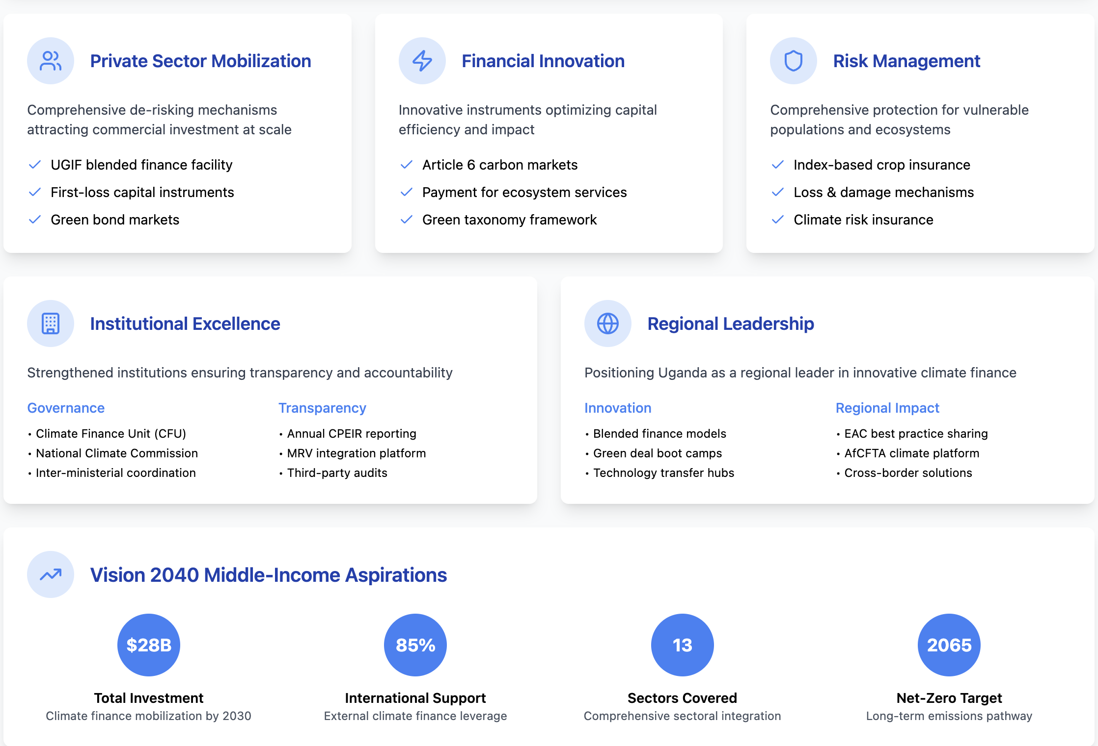
Below, the key elements of the Integrated Financing Framework, including its institutional setup, the required private sector capital and financing mobilization, financial innovation and risk management component are explained in more detail.

STRATEGIC FINANCING ARCHITECTURE.
Governance & Coordination Framework. Uganda establishes a National Climate Change Commission (NCCC) to steer investment standards and pipeline development, while reactivating the Inter-Ministerial Climate Task-Force ensures every sector plan and NDP IV chapter includes tagged mitigation and adaptation targets. District-level "climate desks" link directly to the Climate Finance Unit (CFU) through a comprehensive finance-tracking dashboard, creating seamless coordination from national policy to local implementation.
Ready Investment Framework. Uganda's climate finance strategy transitions from grant-dependency to sustainable blended finance models that attract diversified capital at scale. The forthcoming National Green Taxonomy establishes clear investment criteria and green budget tagging protocols, providing investors with transparent, standardized metrics for eligible climate assets. This regulatory foundation enables systematic channeling of both domestic and international capital toward high-impact climate projects.
Institutional Coordination Platform. The newly established Climate Finance Unit (CFU) serves as Uganda's central coordination hub, integrating all climate finance flows through a comprehensive national tracking dashboard. This institutional innovation eliminates fragmented donor channels while ensuring full transparency through annual Climate Public Expenditure & Institutional Reviews (CPEIR), enabling evidence-based resource allocation and impact measurement.
INNOVATIVE FINANCING MECHANISMS.
Enhanced UDB Climate Finance Facility. Building on the existing Uganda Development Bank Climate Finance Facility, Uganda significantly strengthens this proven platform to serve as the primary vehicle for blended finance operations. The enhanced facility leverages public first-loss capital alongside multilateral development bank and commercial tranches, with UDB pledging for concessional lending to green projects, systematically de-risking climate investments and unlocking private sector participation across renewable energy, sustainable transport, and climate-smart agriculture sectors.
Capital Market Development. Technical assistance partnerships, including GGGI collaboration, support the structuring of sovereign and municipal green and resilience bonds targeting renewable energy infrastructure, flood protection systems, and agroforestry initiatives. These instruments tap into growing ESG investment demand while building Uganda's domestic capital market capacity for long-term climate financing.
CARBON MARKETS & ECOSYSTEM SERVICES
Article 6 Carbon Market Integration. Uganda's Article 6 readiness program targets completion by 2026, establishing a robust national registry and benefit-sharing framework for high-integrity Internationally Transferred Mitigation Outcomes (ITMOs). This enables Uganda to monetize cookstove, peatland restoration, and solar mini-grid projects while ensuring equitable distribution of carbon finance benefits to local communities and environmental protection initiatives.
Payment for Ecosystem Services Expansion. Expanded PES schemes in Mount Elgon and Albertine Rift ecosystems generate sustainable revenue streams through voluntary carbon markets and eco-tourism levies, providing natural disaster risk reduction while creating sustainable livelihoods for local communities. These nature-based solutions demonstrate how climate finance can deliver multiple co-benefits across conservation, adaptation, and economic development.
RISK MANAGEMENT AND RESILIENCE FINANCING.
Comprehensive Risk Transfer Systems. Scaled index-based and picture-based crop insurance expands coverage from 5,000 to 50,000 farmers under the public-private Agriculture Insurance Scheme, protecting smallholder farmers from climate-induced losses while maintaining agricultural productivity and food security. This complements prospective membership in the African Climate Risk Insurance Pool. These mechanisms provide essential social protection while maintaining agricultural productivity and food security.
Loss and Damage Response Framework
Recognizing the increasing climate risks facing Uganda's vulnerable populations, a comprehensive Loss and Damage (L&D) financing mechanism addresses both slow-onset and extreme weather impacts. This framework integrates:
- Disaster Risk Reduction (DRR) Infrastructure: Pre-positioning financing for flood protection, drought-resistant water systems, and climate-resilient infrastructure across vulnerable regions
- Rapid Response Mechanisms: Pre-negotiated emergency funding protocols activated through early warning systems, ensuring immediate support for climate-displaced communities
- Ecosystem-Based Adaptation: Expanded Payment for Ecosystem Services (PES) schemes in Mount Elgon and Albertine Rift ecosystems, providing natural disaster risk reduction while generating sustainable livelihoods
- Community Resilience Building: Targeted financing for community-level adaptation infrastructure, including climate-resilient housing, rainwater harvesting, and sustainable land management practices
"Green CAPACITY BUILDING & PIPELINE DEVELOPMENT
Comprehensive Skills Development. “Deal Boot Camps" delivered through CFU, PSFU, and GGGI partnerships build pipeline preparation skills across SMEs, local banks, and district planners, closing the project bankability gap that traditionally constrains private sector climate investment. These initiatives complement climate-finance modules integrated into civil-service colleges and business-school curricula, stemming talent loss while building local expertise in climate finance structuring.
Institutional Strengthening. Systematic capacity building ensures every level of government and the private sector can identify, structure, and implement bankable climate projects, creating a sustainable pipeline of investment-ready opportunities that attract both domestic and international capital.
TRANSPARENCY & ADAPTIVE MANAGEMENT
Integrated Monitoring Systems. Finance-flow tracking integration into the national MRV platform being upgraded for Paris Agreement reporting ensures comprehensive visibility of climate finance effectiveness. Biennial third-party audits of LT-LEDS finance implementation with results published on an open-data portal demonstrate accountability and enable continuous improvement of financing mechanisms.
Evidence-Based Optimization. Regular monitoring and evaluation feeds directly into adaptive management systems, ensuring financing mechanisms evolve based on performance data and changing climate and economic conditions, maximizing both climate impact and financial sustainability.
IMPLEMENTATION IMPACT & VALUE PROPOSITION
Systemic Transformation. Uganda's Climate Finance & Investment Pillar turns the LT-LEDS into a bankable pipeline by integrating strong governance, the National Green Taxonomy, and green-budget tagging that maximizes every public investment. This comprehensive approach introduces innovative public instruments through sovereign and municipal bonds while leveraging blended-finance vehicles to de-risk commercial capital systematically.
Constraint Resolution. The framework addresses today's key constraints strategically: shrinking fiscal space is offset by earmarking future oil royalties for the statutory Climate Change Fund while crowding-in private capital; fragmented donor channels are unified through the CFU's finance-tracking dashboard and annual CPEIR; the project-bankability gap is closed through targeted capacity-building boot camps and UGIF first-loss capital; opaque carbon-market governance is resolved via Article 6 registry and clear benefit-sharing rules; and under-insured loss-and-damage risks are mitigated through nationwide index insurance and rapid-payout risk-transfer mechanisms.

Sectoral Low Carbon Strategies

Rationale and Approach
Uganda faces the dual challenge of rapidly increasing economic activity and acute climate vulnerability, necessitating a long-term strategy that marries development needs with stringent emission-reduction targets. This Sectoral Low Carbon Strategy framework is built on the understanding that timely action can yield multiple benefits: preventing irreversible ecosystem damage, improving public health, and unlocking new green economic opportunities.
The rationale for a sector-focused approach is threefold:
- Different Emission Profiles: Sectors vary considerably in their respective emission drivers—transport depends largely on liquid fuels, while agriculture sees methane and nitrous oxide from livestock and cropland. A sector-tailored strategy allows for more precise interventions and realistic timelines.
- Targeted Policy Mechanisms: Many climate policies work best when calibrated to specific sectors. For instance, fuel-efficiency standards and electrification targets in transport differ from land-use regulations or extension services needed in agriculture.
- Improved Monitoring and Accountability: Segmenting the national emission inventory by sector helps track progress more accurately, enabling mid-course policy adjustments and clearer accountability among implementing agencies.
Each sector’s long-term trajectory was explored through a bottom-up modelling approach, which provides granular insights into technology uptake, infrastructure requirements, and cost implications. This modelling incorporates Uganda’s updated NDC target-setting, as well as the indicative planning figures from NDP IV, to ensure coherence between short-term development plans and the country’s longer-term climate ambitions.

BAU and NZE 2065 Overviews
To capture the range of possible emission pathways and investment needs, Uganda’s LTS applies two core scenarios. These scenarios build on a combination of historical data, sector-specific analyses, and policy assumptions that reflect different levels of ambition, technological uptake, and financing availability.

Business-As-Usual (BAU)
Outcome: Under BAU, national GHG emissions follow an unsustainable trajectory, declining from 99.41 MtCO₂e in 2020 to 50.03 MtCO₂e by 2065, with significant fluctuations including a peak of 99.41 MtCO₂e in 2020. This apparent reduction masks critical sectoral imbalances and results primarily from forest resource depletion rather than deliberate mitigation measures. Key sectoral outcomes include:
- Agriculture emissions increase steadily from 19.70 MtCO₂e in 2010 to 32.11 MtCO₂e by 2065, representing a 63% increase driven by expanding livestock populations and intensified fertilizer application
- Forest cover experiences catastrophic decline, with the forestry sector transitioning from Uganda's largest emissions source (43.43 MtCO₂e in 2010) to near-zero emissions (0.38 MtCO₂e) by 2065, reflecting near-complete resource exhaustion
- Energy emissions (transport, buildings, industry) collectively rise from 2.42 MtCO₂e in 2010 to 9.56 MtCO₂e by 2065, with transport emissions peaking at 8.80 MtCO₂e in 2050
- Industry emissions demonstrate significant growth, increasing from 2.03 MtCO₂e in 2010 to 4.03 MtCO₂e by 2065—a two-fold expansions
- Waste emissions increase 1.8-fold from 3.73 MtCO₂e in 2010 to 6.59 MtCO₂e by 2065, maintaining steady growth throughout the period

Data Sources: National GHG inventories (Third National Communication 2022), Uganda Bureau of Statistics data (Census 2024, Statistical Abstracts), existing policy documents without enhanced climate measures, and historical sectoral growth trends from 2010-2020.
Key Assumptions:
- Population growth continues at 2.9% annually, reaching approximately 84 million by 2050
- Economic growth maintains 4-5% annual GDP increase without decoupling from emissions
- No significant policy interventions beyond current commitments
- Technology adoption follows natural replacement rates
- International climate finance remains at current levels
Figure 7 illustrates the Business as Usual (BAU) scenario trajectory. The forestry sector demonstrates an unsustainable pattern, peaking at 53.06 MtCO₂e in 2015 before declining to near-zero by 2065—a trajectory driven by resource depletion rather than conservation. Agriculture and waste sectors show continuous growth, while energy-related emissions (EnEm) stabilize around 31 MtCO₂e from 2035 onwards, indicating persistent fossil fuel dependence.
Figure 12 Overview Emission scenario BAU
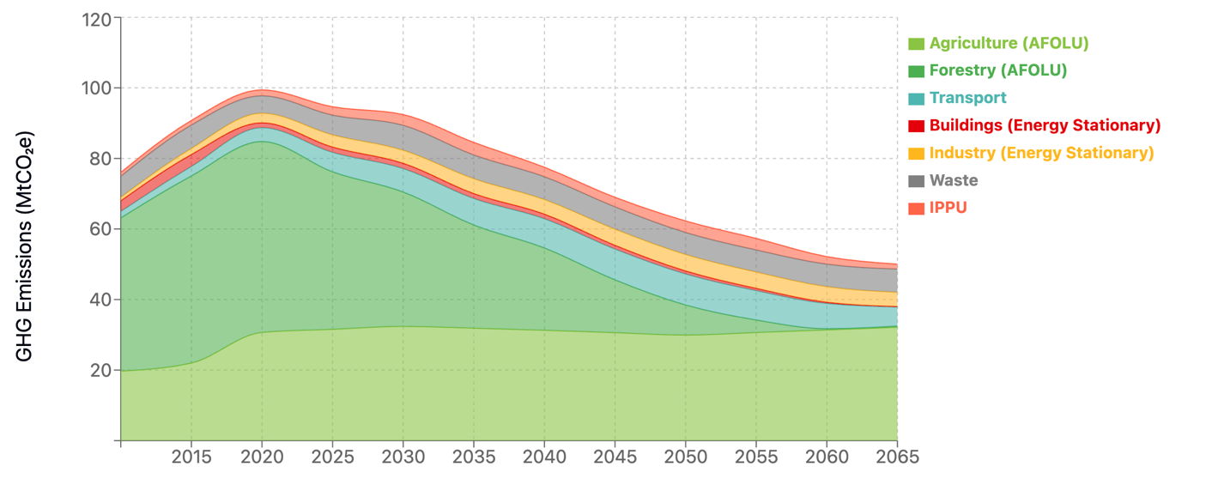
Cumulative Impact: Total emissions from 2025-2065 reach approximately 3.4 Gt CO₂e. Despite the apparent emissions reduction, this pathway represents ecological collapse rather than sustainable development, with forest depletion exposing Uganda to severe climate vulnerability, biodiversity loss, and compromised ecosystem services. The trajectory necessitates massive adaptation investments while forfeiting critical natural capital.

Low-emission scenario 2065
- Description: The NZE2065 scenario establishes a systematic pathway to near net-zero emissions by 2065, achieving near zero emissions in the target year. This scenario implements comprehensive policies addressing deforestation, renewable energy deployment, and efficiency improvements through phased introduction. The approach enables sustainable economic transformation while balancing development imperatives and ensuring just transition principles.
- Data Sources: The NZE2065 scenario applies an integrated implementation framework combining proven green technologies with systematic knowledge transfer mechanisms. This framework coordinates ambitious policy measures across sectors, leverages diversified financing instruments including climate finance and private sector investment, and strengthens institutional capacity at national and sub-national levels.
- Outcome: Emissions decline systematically through 2065, driven by so far Uganda’s largest emission sources, the AFOLU sector. This measured approach optimizes technology deployment schedules, reduces immediate financing pressures through phased implementation, and enables cost reductions through learning curves. Cumulative emissions from 2025-2065 total of about 2 Gt CO₂e, representing a 40% reduction compared to BAU (3.4 Gt CO₂e).
The Low Carbon Scenario achieves systematic emissions reductions across all sectors, contrasting sharply with the BAU pathway where emissions remain at about 50 MtCO₂e by 2065—sustained primarily by growth in agriculture, industry, and waste sectors despite forest depletion. A particularly notable transformation in the NZE2065 pathway is the forestry sector's shift from Uganda's largest emissions source in 2015 (53.06 MtCO₂e) to a carbon sink of -0.36 MtCO₂e by 2065. This transformation demonstrates the catalytic role of forest conservation and sustainable management in achieving long-term climate objectives.
The practical implementation of this transformation requires coordinated interventions across four pillars:
- Energy transition: Systematic shift of rural and urban households from biomass dependence (charcoal and firewood) to electricity and transitional fuels. This transition necessitates grid expansion reaching 90% population coverage by 2050, affordable electricity tariffs through renewable energy deployment, and targeted subsidies for vulnerable households during the transition period.
- Alternative livelihoods: Development of sustainable economic opportunities for forest-dependent communities through:
  - Agroforestry systems integrating tree crops with food production
  - Value-added processing of sustainable forest products
  - Eco-tourism development in conserved forest areas
  - Payment for ecosystem services programs
- Strengthened forest governance: Enhanced enforcement capacity through:
  - Digital monitoring systems for real-time forest cover tracking
  - Community-based forest management structures
  - Transparent benefit-sharing mechanisms
  - Coordinated inter-agency enforcement protocols
- Financial mechanisms: Economic incentives ensuring conservation viability through:
  - Carbon credit programs generating revenue from forest conservation
  - Performance-based payments for reduced deforestation
  - Green bonds financing reforestation initiatives
  - Biodiversity offset schemes
This transformation demonstrates critical cross-sectoral interdependencies. Renewable-based electrification serves multiple functions: reducing forest pressure through alternative energy provision, enabling transport sector decarbonization through electric mobility, and powering industrial processes with clean energy. The Low Carbon 2065 pathway's success therefore depends on synchronized implementation across all sectors, with the energy transition serving as the foundational enabler for both forest conservation and economy-wide decarbonization.
This transformation is interdependent with broader sectoral changes—renewable-based electrification not only reduces pressure on forests but also enables sustainable net-zero emission development in the transport and industry sectors. The success of the NZ2065 pathway thus relies on coordinated action across all sectors, with the energy transition serving as the foundational enabler for both forest conservation and economy-wide decarbonization.
Figure 13 Low Carbon Scenario 2065
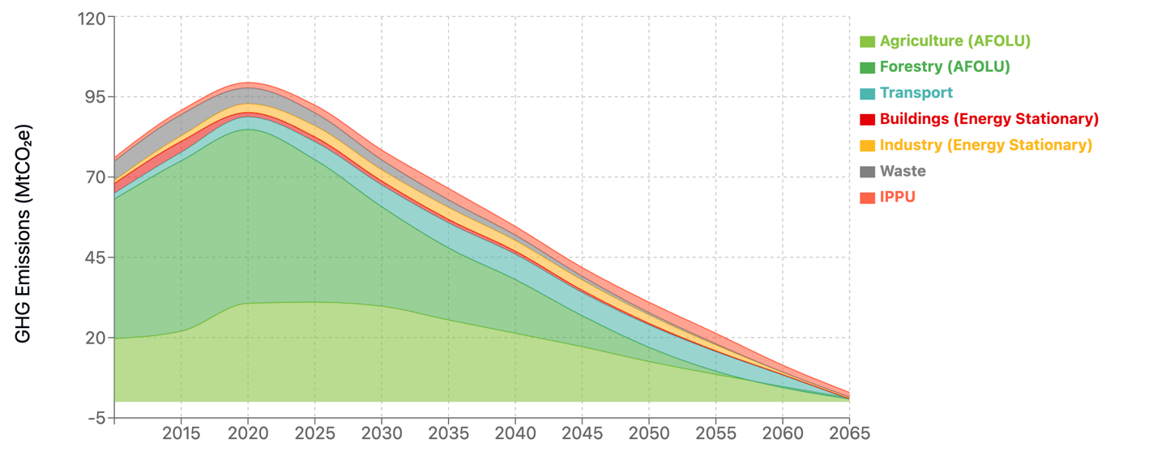

Overview of Key Sectors and Transition to In-Depth Assessment
Although Uganda’s economy is rapidly evolving, emissions continue to be driven by a few key sectors: energy generation, transport, buildings, industry (including industrial processes and product use), agriculture (and other land uses), and waste. Combined, these sectors underpin the majority of the country’s economic activity, while also shaping the scale and trajectory of national greenhouse gas (GHG) emissions. Each sector faces unique challenges and opportunities:
- Agriculture, Forestry, and Other Land Use (AFOLU): As a cornerstone of Uganda’s livelihoods and exports, this sector is responsible for substantial methane and nitrous oxide emissions, while deforestation erodes carbon sinks.
- Energy: Hydropower is central to Uganda’s electricity mix, but growing demand for electricity requires the diversification into additional, increasingly affordable renewable energy sources foremost solar and wind. The energy sector includes energy generation as well as use, especially in the Buidlings sector, which is challenged by Uganda’s expanding urban areas and population growth adding pressure on energy demand for heating, cooking, and electricity.
- Transport: Road vehicles account for most passenger and freight movement. Rapid motorization and inadequate public transit infrastructure lead to rising fuel consumption, local air pollution, and GHG emissions.
- Waste: Urbanization and limited infrastructure for solid waste and wastewater treatment drive significant methane emissions, highlighting the need for improved waste management systems.
- Industry energy use and Industrial Processes and Product Use (IPPU): From cement production to food processing, industrial growth supports Uganda’s development goals but can also lock in high-emission technologies if cleaner processes are not adopted early.
To accomplish this the assessment for each sector builds on IPCC Tier 1 and 2 methodologies for greenhouse gas accounting, and scenario modeling that factors in Uganda’s growth plans (as reflected in NDP IV and the updated NDC). Each sector analysis concludes with a roadmap outlining near-, medium-, and long-term steps needed to achieve net-zero emissions by 2050 or 2065, while also enhancing Uganda’s ability to cope with climate impacts.

AFOLU

Agriculture
Agriculture remains a cornerstone of Uganda's economy and a primary livelihood source for millions of households. The sector contributes significantly to national GDP, food security, and rural employment. Over the past decade, growth in both crops and livestock has expanded Uganda's agricultural output and bolstered exports of commodities such as coffee, tea, and livestock products. At the same time, agriculture has become a leading source of greenhouse gas (GHG) emissions in the country, driven by livestock enteric fermentation, manure management, crop residue burning, and conversion of forested areas to farmland. Projections indicate that, if no mitigation measures are adopted, emissions from agriculture could rise from about 20 million tonnes of CO₂-equivalent (MtCO₂e) in 2010 to 32.1 MtCO₂e by 2065 under a Business as Usual (BAU) scenario.
Key Drivers. Uganda’s agricultural emissions stem primarily from three interconnected drivers: livestock population growth, expansion of cultivated land, and increased use of fertilizers to enhance crop yields. Between 2010 and 2020, the cattle population climbed from 12 million to over 15 million head, while sheep and goats rose from 18 million to about 18.1 million. Over the longer term, under BAU, cattle numbers could exceed 18 million by 2065. Similarly, synthetic fertilizer usage—particularly nitrogen-based fertilizers—has increased to boost productivity, with nitrogen inputs rising from about 709 million kilograms in 2010 toward 1.34 billion kilograms by 2065 in BAU. Land conversion from forests to cropland, though small in area compared to the livestock and soils sub-sectors, remains a steady contributor to emissions.
Underlying these trends are demographic pressures and rising domestic demand for meat, dairy, and grains. Policies aimed at achieving national food security—such as expanded irrigation and fertilizer subsidies—also influence emissions trajectories by encouraging more intensive production. Additionally, the quest for higher-value markets has prompted larger-scale commercial farming, with mechanization and year-round cultivation practices becoming more common.
Alignment with National Plans. Uganda’s Vision 2040 and the forthcoming National Development Plan IV (NDP IV) emphasize the modernization of agriculture, aiming to transition from subsistence farming to productive commercial agriculture. The country’s Nationally Determined Contribution (NDC) under the Paris Agreement also identifies agriculture as a priority sector for emission reductions, stressing climate-smart farming approaches, reduced land degradation, and improved livestock management. Sector-specific goals include enhancing agricultural productivity through irrigation, better seeds, and fertilizer usage, while simultaneously promoting sustainable land-use practices. These objectives shape the policy environment in which any long-term low-emission development pathways must operate.
Methodology and Modelling Approach
Activity Data and Assumptions. The modelling of agricultural emissions draws on activity data for livestock (cattle, sheep, and goats), crop production (including fertilizer application, rice cultivation, and residue burning), and land-use changes (notably the conversion of forested lands to agriculture). Growth rates for livestock reflect historical trends in herd size and project them forward under differing policy assumptions. Fertilizer use is modeled based on both government input targets and private-sector adoption, whereas land-use change projections account for controlled deforestation patterns and shifts to alternative land-use practices.
Key assumptions include estimations on livestock growth, fertilizer usage and land-use. BAU assumes a steady increase in herd sizes tied to population and market demand. The Low Carbon Scenario 2065 incorporates measures such as improved feeding efficiency and selective breeding to stabilize herd sizes and progressively reduce emission factors. Nitrogen inputs continue rising to satisfy food production goals under BAU. In the Low Carbon Scenario 2065, a systematic shift to more efficient fertilizer application methods and organic alternatives curtails absolute nitrogen use after 2030. Forest conversion trends continue as usual under BAU, while the Low Carbon Scenario 2065 assumes stronger enforcement of land-use policies and adoption of agroforestry, reducing the extent of new farmland created through deforestation. Activity data were transformed into emissions estimates using standard emission factors, drawn from Intergovernmental Panel on Climate Change (IPCC) guidelines and validated with local data where available.
Scenario Framework. The model features two core scenarios. BAU (Business as Usual) foresees no major policy or technological changes beyond current practices. Livestock numbers, fertilizer use, and deforestation all continue their historical patterns. Low Carbon Scenario 2065 assumes comprehensive measures to stabilize livestock populations, scale up climate-smart practices, curtail burning, and substantially reduce synthetic fertilizer use through precision agriculture and organic alternatives. Technological adoption (e.g., biogas from manure, precision agriculture, improved livestock management) is implemented systematically over the 2025-2065 period.
Relevant Policies & Measures in Each Scenario. In BAU, existing policy directives on agricultural modernization remain the main reference, with limited enforcement of environmental regulations. In the Low Carbon Scenario 2065, expanded policies incentivize transitions to lower-emission livestock systems, rapid adoption of organic soil amendments and precision fertilizer application, enhanced manure management systems, and comprehensive sustainable land management practices. This scenario envisions strong enforcement of environmental regulations while maintaining essential food security and productivity targets through climate-smart agricultural innovations.
Mitigation Pathways (Scenarios)
BAU Scenario. Under BAU, total agricultural emissions rise from 20 MtCO₂e in 2010 to 32.1 MtCO₂e in 2065. This increase largely mirrors population-driven livestock expansion: cattle headcount grows from 12 million in 2010 to over 18.5 million in 2065, while sheep and goats rise from 18 million to 21.3 million. Fertilizer usage nearly doubles, with nitrogen applications surpassing 1.34 million tons by 2065. Although the area of forest-to-farmland conversion is relatively modest each year, it accumulates over decades. By 2065, the sector's emissions profile under BAU remains dominated by enteric fermentation, manure management, and expanded use of nitrogenous fertilizers.
Low Emission 2065 Scenario. The Low Carbon Scenario 2065 takes a systematic approach to agricultural transformation, implementing climate-smart practices while maintaining food security. Cattle numbers are stabilized at around 15.4 million head from 2025 onwards, preventing the continued expansion seen under BAU. Emission factors are progressively reduced through improved livestock management, declining from 50 kg CH₄/head/year to zero by 2065. Fertilizer usage is substantially curtailed, with nitrogen applications reduced by over 75% compared to BAU levels through precision agriculture and organic farming practices. Enhanced manure management and significant reductions in cropland fires contribute to further emission reductions. Agricultural emissions in the Low Carbon Scenario 2065 decline demonstrating the transformative potential of sustainable agricultural practices.Figure 14 illustrates the agriculture sector emission trajectories in the scenarios.

Figure 14 Agriculture Sector Emission Trajectories
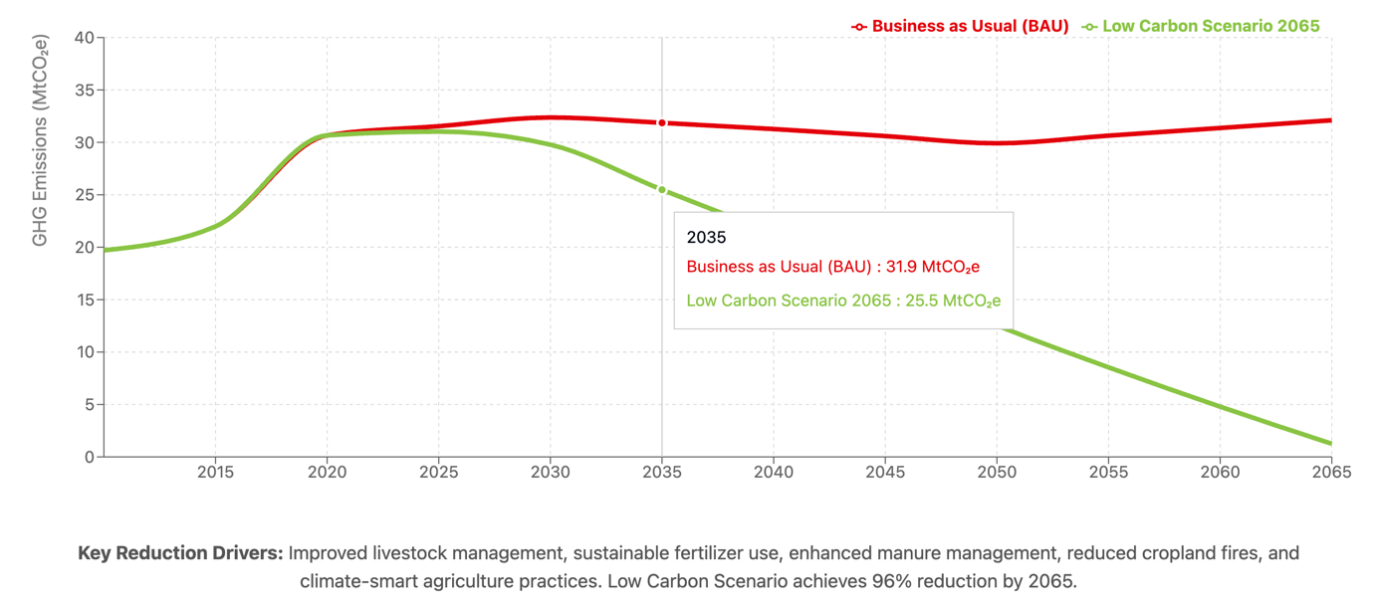
Roadmap to Net-Zero
Short-Term (to 2030). The foundation for agricultural transformation centers on establishing robust institutional frameworks and proven interventions. The Ministry of Agriculture, Animal Industry and Fisheries (MAAIF) will coordinate implementation of climate-smart agriculture programs aligned with the National Adaptation Plan and updated NDC commitments. Priority measures include strengthening agricultural extension services to disseminate improved livestock management practices and sustainable land-use techniques. Farmer field schools and demonstration sites will showcase efficient feeding systems, improved manure management, and precision fertilizer application methods. The National Agricultural Research Organisation (NARO) will accelerate development and distribution of climate-adapted crop varieties while promoting conservation agriculture practices. District Natural Resource Departments will enhance monitoring and enforcement of land-use regulations to reduce forest-to-agriculture conversion. Financial mechanisms will be developed through the Ministry of Finance, Planning and Economic Development to support smallholder adoption of low-emission technologies, including potential pilot programs for carbon credits and climate-smart agriculture loans through participating financial institutions.
Medium-Term (2030–2040). Proven interventions scale systematically across the sector. National livestock improvement programs target emission factor reductions from 50 to 35.7 kg CH₄/head/year for cattle through selective breeding, improved feed formulations, and rotational grazing systems. Veterinary service coverage expands to reach most of livestock farmers, supported by trained community animal health workers. Crop residue burning decreases by 75% through provision of mechanical shredders and establishment of community composting facilities. Agricultural extension services double their technical staff to officers trained in low-emission technologies. Nitrogen fertilizer efficiency improves through widespread adoption of soil testing, targeted application protocols, and integration of organic amendments. Green financing mechanisms mobilize climate bonds, results-based payments, and blended finance facilities supporting agribusiness transitions to sustainable value chains.
Long-Term (2040–2065). The sector achieves fundamental transformation toward climate neutrality. Livestock systems complete their transition with emission factors approaching zero through advanced breeding programs, optimized herd structures maintaining productivity with 15.4 million cattle, and comprehensive methane capture from large-scale operations. Synthetic nitrogen fertilizer use decreases by 90% from BAU levels through universal adoption of precision agriculture, biological nitrogen fixation, and circular nutrient management. Agroforestry covers 3 million hectares, sequestering 5-10 MtCO₂e annually while diversifying farm incomes. Rice cultivation emissions reduce by 90% through alternate wetting-drying techniques and methane-inhibiting varieties.
Milestones and Indicators. Progress monitoring employs quantifiable metrics aligned with national reporting systems. Livestock population stabilizes at current levels of 15.4 million cattle and 18.5 million small ruminants by 2030, maintaining these levels through 2065 while improving productivity per animal by 150%. Emission intensity decreases progressively: 25% reduction by 2030, 60% by 2040, and 95% by 2065 compared to 2020 levels. Synthetic nitrogen application efficiency improves from 0.84 kg N/USD agricultural GDP in 2020 to 0.15 kg N/USD by 2065. Climate-smart agriculture coverage expands from 15% of farmland in 2025 to 40% by 2030, 70% by 2040, and 95% by 2065. Forest-to-agriculture conversion rates decline from 240 hectares annually in 2020 to under 32 hectares by 2065, while net afforestation through agroforestry adds 100,000 hectares annually from 2030 onward.
Such indicators reinforce Uganda’s broader climate and sustainable development goals, as outlined in the NDC and Vision 2040. By staying on track with these benchmarks, agriculture can continue contributing to rural livelihoods and food security while steadily reducing emissions. In the long run, a mix of innovation, policy commitment, and international support will position Uganda’s agricultural sector as a model for low-emission, climate-resilient development.

Forestry
Relevance of the Forestry Sector for Uganda. The forestry sector plays a critical role in Uganda's economy, contributing to livelihoods, energy supply, and environmental services. Approximately 90% of the population relies on wood fuel for cooking, making the sector pivotal to the energy matrix. Forests also contribute significantly to Uganda's biodiversity, provide carbon sequestration, and support agricultural practices, which are vital for both the rural and urban populations. The sector is also a source of timber, non-timber products, and employment, especially in rural areas.
However, this sector faces unprecedented pressure from accelerating deforestation rates, driven by rapid urbanization, extensive agricultural expansion, and escalating unsustainable wood demand that has grown from 8.8 million tonnes in 2010 to over 13.5 million tonnes by 2020. The scale of environmental degradation is substantial, with Uganda experiencing annual deforestation of approximately 90,000 hectares, resulting in forest cover declining from 13.17% in 2020 under current trajectories. The unsustainable sourcing fraction remains critically high at 60-80%, indicating that the majority of wood extraction continues to deplete forest resources faster than they can regenerate. Over the years, Uganda has seen substantial deforestation and soil carbon loss, with forests being cleared for both subsistence and commercial purposes. The land-use changes from deforestation have led to significant carbon emissions affecting the country's overall emissions profile and representing one of the largest sources of national greenhouse gas emissions.
In the face of global climate change challenges, the forestry sector offers substantial opportunities for climate mitigation, as it is capable of absorbing carbon dioxide through reforestation and afforestation efforts, with potential sequestration rates of 10 tCO₂ per hectare annually under properly managed reforestation programs. Current reforestation efforts, while expanding from 15,000 hectares in 2020 to planned 50,000 hectares by 2030, remain insufficient to offset deforestation losses without dramatic scaling and policy intervention. However, addressing the sector's sustainability and mitigating its emissions requires urgent and comprehensive reforms in land management, forestry practices, and alternative livelihood strategies to reduce pressure on forest resources while meeting the population's energy and economic needs.
Key Emission Drivers. The primary drivers of emissions and growth in Uganda's forestry sector include population growth, steadily increasing demand for fuelwood and timber (growing from 8.8 million tonnes in 2010 to 13.5 million tonnes in 2020, with projections reaching 16.3 million tonnes by 2030), and the expansion of agricultural land requiring approximately 90,000+ hectares of annual forest conversion. Between 2010 and 2020, forestry emissions increased from 43.43 to 54.14 MtCO₂e, reflecting a 25% growth in deforestation activities. By 2020, total forestry sector emissions reached 54.14 MtCO₂e under current trends, with approximately 90,155 hectares of forest land affected annually through deforestation activities.
Current deforestation patterns are influenced by wood harvesting practices, where unsustainable sources contribute 60% of the timber used for fuel and construction in 2020, with projections showing a gradual decline to 50% by 2030 under existing policies. Emission intensity averages 336.2 tCO₂ per hectare of deforested land, while soil carbon losses contribute an additional 20 tCO₂ per hectare annually. While reforestation efforts are expanding significantly from 15,000 hectares in 2020 to ambitious targets of 50,000 hectares by 2030, these initiatives face challenges in fully offsetting deforestation losses. Under BAU trajectories, forestry emissions show a catastrophic decline from 54.14 MtCO₂e in 2020 to just 0.38 MtCO₂e by 2065, representing near-complete forest resource depletion rather than conservation success.
The emission balance highlights critical intervention needs: while reforestation provides valuable carbon sequestration potential, current deforestation activities generate over 50 MtCO₂e annually (as of 2020), indicating significant potential for enhanced mitigation approaches through scaled interventions. Key structural and policy factors influencing this trajectory include land tenure challenges, opportunities for strengthened enforcement of forest protection laws, and the need for enhanced incentives for sustainable land-use practices. Additionally, economic incentives for timber and wood fuel production remain strong, presenting opportunities to develop market-based solutions that support the transition to sustainable forestry management practices. Addressing the current unsustainable sourcing patterns (maintaining 40-60% through 2040) represents a key opportunity for promoting alternative energy sources and improved harvesting methods.
Alignment with National Plans. Uganda's forestry sector is a key element in its National Development Plan (NDP IV) and Nationally Determined Contributions (NDC). Both documents emphasize the importance of reducing deforestation and promoting afforestation and reforestation to meet climate targets. The NDC specifically targets restoring degraded landscapes and forests as part of Uganda's commitment to the Paris Agreement.
In alignment with Vision 2040, the country aims to achieve a balanced approach to land-use, emphasizing the protection of natural resources and fostering green growth. The NDC sets specific targets for reducing emissions from the forestry sector, including afforestation of degraded lands and sustainable forest management practices. These national commitments are reflected in the modeling scenarios, which demonstrate that achieving the Low Emission 2065 pathway could result in the forestry sector transitioning from a net emitter of 54.14 MtCO₂e in 2020 to a carbon sink (-0.36 MtCO₂e) by 2065, representing significant progress toward national climate goals.

The modeling results indicate that Uganda's forestry sector has substantial potential to contribute to national emission reduction targets, with the Low Emission 2065 scenario showing emission reductions of approximately 48% by 2050 compared to BAU levels (4.42 MtCO₂e versus 8.54 MtCO₂e). This pathway achieves meaningful progress while maintaining forest cover above 10% by 2065, demonstrating a balanced approach to development and conservation. This aligns with Vision 2040's emphasis on sustainable resource management, as forest cover stabilizes and begins recovering under the Low Emission 2065 scenario, contrasting with the continued decline projected under business-as-usual approaches.
The scale of reforestation required to meet these targets—expanding from current levels of 15,000 hectares annually to 50,000 hectares by 2030 under the Low Emission 2065 scenario—aligns with the NDC's emphasis on landscape restoration and demonstrates the feasibility of achieving national commitments through coordinated policy implementation and investment in sustainable forest management practices.
Methodology and Modelling Approach. Activity Data and Assumptions. The modeling approach for the forestry sector relies on comprehensive data collection, including deforestation rates, wood demand trajectories, forest cover changes, and soil carbon dynamics. Historical data from 2010 to 2020 serves as a baseline to project future trends in deforestation, reforestation, and soil carbon loss through 2065. Key assumptions include wood demand growth patterns ranging from 8.8 million tonnes in 2010 to 13.5 million tonnes in 2020, with varying trajectories depending on policy interventions and sustainable sourcing practices.
The model incorporates detailed emission factors including 336.2-340.0 tCO₂ per hectare for deforestation activities, 20 tCO₂ per hectare for soil carbon loss, and -10 tCO₂ per hectare for reforestation carbon sequestration. Activity data assumptions account for the fraction of wood sourced unsustainably, which ranges from 80% in 2010 to varying levels (0-60%) by 2065 depending on scenario implementation.
The model also incorporates assumptions regarding wood demand drivers, including population growth, urbanization, and industrialization patterns. Forest degradation factors are included, with 2.4-3.3% of forest area experiencing degradation annually, contributing additional emissions through biomass loss. These comprehensive assumptions form the basis for the Business-As-Usual (BAU) and Low Emission 2065 (NZE2065) scenarios, which reflect different levels of policy intervention and mitigation ambition.
Pathways (Scenarios)
BAU Scenario: This scenario assumes that current trends continue without significant changes in policy or technology. Wood demand rises substantially to 16.3 million tonnes by 2030 before gradually declining, while deforestation persists at high rates of 70,000-90,000 hectares annually through 2040. The scenario results in declining emissions from 54.14 MtCO₂e in 2020 to 0.38 MtCO₂e by 2065, reflecting near-complete forest resource depletion rather than successful mitigation. Forest cover declines dramatically from 13.17% in 2020 to near-zero by 2065, with unsustainable wood sourcing remaining at 40-50% throughout the projection period. Reforestation efforts remain limited, reaching only 60,000 hectares by 2065, insufficient to offset deforestation impacts.
NZE 2065 Scenario: This pathway represents a moderate but decisive policy intervention approach where systematic measures are implemented to reduce deforestation and enhance reforestation. Wood demand is managed more sustainably, peaking at 13.5 million tonnes in 2030 before declining to 3.7 million tonnes by 2065. Deforestation activities are progressively reduced, with annual forest conversion declining from 90,074 hectares in 2020 to zero by 2060. Enhanced reforestation efforts are scaled to 30,000-50,000 hectares annually from 2025 through 2055, providing consistent carbon sequestration. Under this scenario, total forestry emissions decrease from 54.14 MtCO₂e in 2020 to 4.42 MtCO₂e by 2050, achieving a carbon sink of -0.36 MtCO₂e by 2065. Forest cover stabilizes and begins recovery, reaching 10.99% by 2065, while unsustainable wood sourcing is eliminated entirely by 2060, demonstrating a transition to fully sustainable forest management practices. Figure 15 illustrates the forestry sector emission trajectories in the three scenarios.
Figure 15 Forestry Sector Emission Trajectories
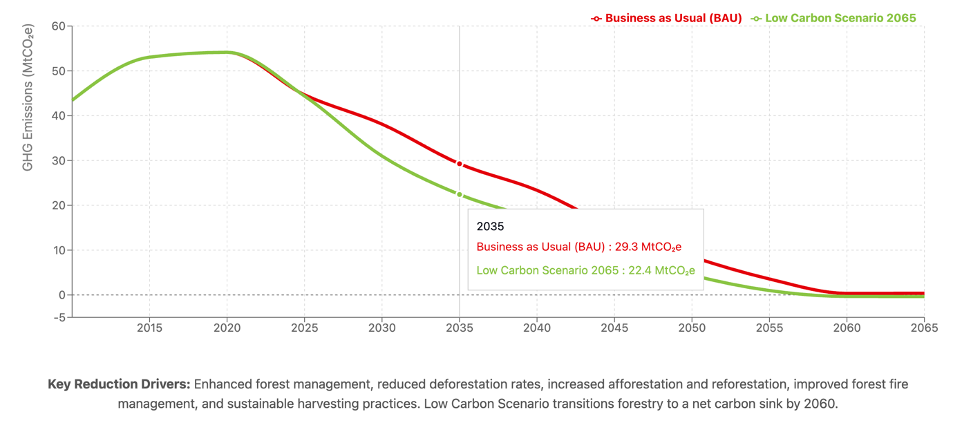
Relevant Policies & Measures in Each Scenario
In the BAU scenario, there are limited or no new policies implemented beyond existing practices. The trend of land-use change, wood demand, and deforestation continues unchecked, with no substantial intervention in sustainable land management or reforestation. Wood demand continues to escalate to 16.3 million tonnes by 2030, while unsustainable sourcing remains at 40-50% throughout the projection period. Reforestation efforts remain modest, reaching only 60,000 hectares annually by 2065, insufficient to counterbalance ongoing deforestation of 70,000-90,000 hectares annually through 2040.
In the Low Emission Scenario 2065, significant but measured policies are implemented starting around 2025-2030, including:
- Strengthened Forest Protection: Progressive enforcement of forest protection laws and reduction of illegal logging activities, resulting in the elimination of deforestation by 2060.
- Incentives for Sustainable Wood Production: Comprehensive subsidies and market-based incentives for sustainable timber and fuelwood harvesting, achieving complete elimination of unsustainable wood sourcing by 2060.
- Enhanced Reforestation Initiatives: Scaled reforestation programs expanding from 30,000 hectares annually in 2025 to 50,000 hectares by 2030, maintained through 2055 to provide consistent carbon sequestration on degraded lands.
- Sustainable Wood Demand Management: Policy interventions to manage wood demand sustainably, capping demand at 13.5 million tonnes by 2030 and reducing it to 3.7 million tonnes by 2065 through alternative energy promotion and efficiency improvements.
- Community-Based Forest Management: Focus on community-based management approaches and institutional capacity building, ensuring long-term sustainability of forest resources while supporting local livelihoods.
The Low Emission Scenario 2065 implements these policies with a realistic timeline that allows for institutional capacity building and stakeholder engagement, achieving substantial emission reductions while maintaining economic and social sustainability.
Roadmap
Short-Term (to 2030)
Stabilize deforestation at 75,000 hectares annually, scale reforestation to 50,000 hectares per year, reduce unsustainable wood sourcing to 50%, and achieve wood demand management at 13.5 million tonnes.
2040: Reduce deforestation to 52,000 hectares annually, maintain consistent reforestation at 40,000 hectares, decrease unsustainable sourcing to 40%, and demonstrate emission reductions of approximately 69% compared to 2020 level (16.75 MtCO₂e vs 54.14 MtCO₂e)
2050: Achieve near net-zero emissions of 4.4 MtCO₂ (85% reduction from 2020), continue reforestation at 40,000 hectares annually, reduce unsustainable sourcing to 20%, and maintain wood demand at sustainable levels of 6.4 million tonnes.
2065: Attain carbon neutrality with -0.36 MtCO₂ emissions, eliminate deforestation entirely, sustain reforestation at 10,000 hectares annually, and achieve 100% sustainable wood sourcing.
Milestones and Indicators. Key milestones include:
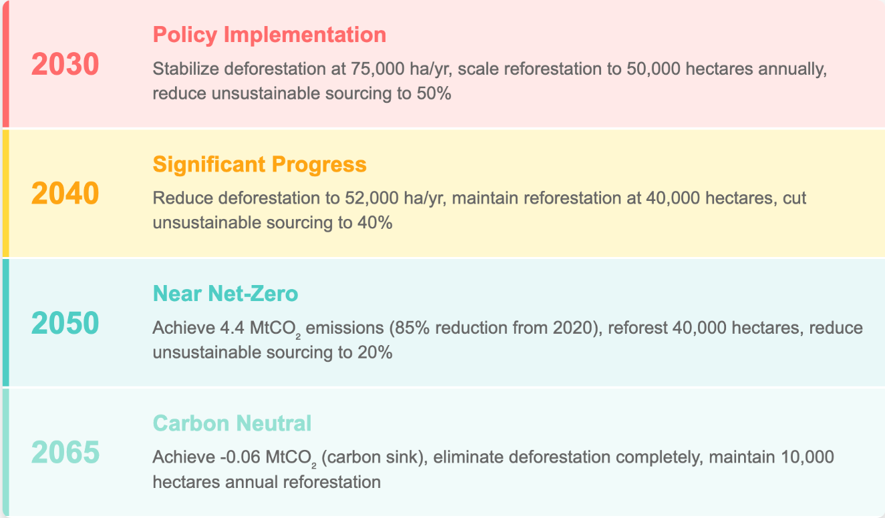
Indicators of success include the total area of forest restored (cumulative 1.9 million hectares by 2065 under the Low Emission Scenario), the emissions reductions achieved (from 54.14 MtCO₂e in 2020 to carbon sink of -0.36 MtCO₂e by 2065), and the proportion of wood demand met sustainably (increasing from 40% in 2020 to 100% by 2060). Forest cover recovery should demonstrate stabilization and gradual improvement, reaching 10.99% by 2065 compared to the projected near-zero under business-as-usual scenarios, representing a preservation of over 1 million hectares of additional forest cover.
The forestry sector in Uganda holds significant potential for carbon mitigation, biodiversity preservation, and sustainable development. Under the Low Emission Scenario 2065, the sector demonstrates the capacity to transition from a net emitter of 54.14 MtCO₂e annually to a carbon sink of -0.36 MtCO₂e, while simultaneously providing sustainable wood resources for 90% of the population that relies on wood fuel for cooking. By transitioning to sustainable forest management and investing in scaled reforestation programs, Uganda can not only achieve its climate commitments but also create an estimated 200,000+ jobs in sustainable forestry, improve rural livelihoods through community-based forest management, and enhance resilience to climate change through ecosystem services preservation. The economic benefits include sustainable timber and non-timber forest products valued at over $500 million annually, while carbon sequestration services could generate additional revenue through international carbon markets. With a clear roadmap based on the Low Emission Scenario 2065 and the right mix of policies, targeted investments of approximately $2 billion through 2065, and robust public-private cooperation, Uganda can ensure that its forests contribute to both its climate goals and its sustainable development aspirations while serving as a model for forest-dependent developing countries globally.

Energy
Importance of the Electricity Generation Sector for Uganda
The electricity generation sector serves as the backbone of Uganda's sustainable development trajectory, with three fundamental contributions to national progress: catalyzing industrial transformation, enhancing quality of life through universal access, and enabling inclusive socio-economic development. Currently anchored by substantial hydropower resources, the sector addresses growing energy demands across industrial, transport, residential, and commercial segments. The past decade has witnessed accelerated electricity consumption growth, driven by rapid urbanization, industrial expansion, and increased household electrification rates.
The sector faces unprecedented expansion requirements to support Uganda's development ambitions. While the country benefits from significant hydroelectric potential, strategic diversification and alignment with decarbonization objectives are essential for achieving long-term energy security and sustainability goals.
Key Growth Drivers and Demand Projection.
The electricity generation sector's evolution is shaped by interconnected drivers including demographic expansion, accelerating urbanization, technological innovation, and structural economic transformation. According to the updated modelling results, electricity demand demonstrates exponential growth trajectories across all scenarios, with particularly pronounced increases in the buildings and industry sectors.
Under the Business-as-Usual (BAU) scenario, total electricity demand escalates from 3 TWh in 2010 to 114 TWh by 2065, representing a 38-fold increase. The Low Carbon Scenario (NZE2065) projects even higher demand, reaching 124 TWh by 2065, driven by comprehensive electrification across transport and industrial processes.
Sectoral demand evolution reveals distinct patterns:
- Transport sector: Minimal current demand transforms to 7-9 TWh by 2065, reflecting progressive vehicle fleet electrification
- Buildings sector: Grows from 2 TWh (2010) to 67 TWh (BAU) or 62 TWh (NZE2065) by 2065
- Industry sector: Expands from 1 TWh (2010) to 17 TWh (BAU) or 23 TWh (NZE2065) by 2065
Global Context and Renewable Energy Economics. Uganda's projected electricity demand trajectory aligns with transformative global and African energy transitions toward comprehensive renewable-powered electrification. This convergence reflects fundamental shifts in energy economics and decarbonization imperatives across developing economies.
The dramatic cost reductions in renewable technologies have reshaped energy investment decisions worldwide. Solar photovoltaic costs have declined by over 90% since 2010, while battery storage systems have experienced similar price trajectories, establishing renewable energy as the most economically competitive generation option for new capacity additions. These technology cost curves, combined with improving performance characteristics, position renewable-powered electrification as the cornerstone of cost-effective decarbonization strategies globally.
For Uganda, this global transition presents exceptional opportunities. The country's abundant solar resources, complementing existing hydropower assets, enable participation in this renewable energy revolution while achieving development objectives. Renewable-powered electrification emerges not merely as a climate imperative but as the optimal pathway for delivering affordable, reliable electricity to support industrialization, improve living standards, and enhance economic competitiveness. This approach simultaneously addresses energy access gaps, reduces long-term electricity costs, and positions Uganda advantageously within emerging green economy value chains.
Alignment with National Plans. Uganda's electricity generation sector is central to achieving the targets outlined in the country's National Development Plan (NDP), Vision 2040, and Nationally Determined Contributions (NDC) under the Paris Agreement. These documents emphasize the importance of expanding renewable energy sources, improving energy efficiency, and reducing emissions from the energy sector. The adoption of technologies like solar, wind, and energy storage aligns with Uganda's NDC commitments to increase the share of renewables in the national energy mix and reduce carbon emissions from energy production.
Methodology and Modelling Approach. Activity Data and Assumptions. The electricity generation sector analysis employs an integrated modelling framework that captures cross-sectoral electricity demand dynamics from transport, buildings, industry, and waste management systems. This comprehensive approach synthesizes historical consumption patterns with forward-looking projections grounded in sector-specific growth trajectories and technology adoption pathways.
The model's demand-side architecture incorporates differentiated growth assumptions reflecting sectoral transformation dynamics:
- Buildings and industry sectors: Projected annual growth rates of 7-9%, driven by urbanization, industrial expansion, and increasing appliance penetration
- Transport sector: Accelerating growth trajectory as electric vehicle adoption transitions from nascent stages to mainstream deployment post-2030
- Waste management: Modest electricity requirements for treatment facilities and emerging waste-to-energy applications
The supply-side optimization determines least-cost generation portfolios capable of meeting projected demand while respecting technical, environmental, and policy constraints. The model evaluates technology options across Uganda's diverse energy resource base, with hydropower providing baseload stability, solar photovoltaics offering scalable capacity additions, wind power contributing geographical and temporal diversity, and nuclear power assessed as a strategic option for post-2035 deployment. Energy storage integration ensures system reliability and enables higher renewable energy penetration levels.
Scenario Framework. The electricity generation sector analysis employs two primary scenarios to evaluate alternative development pathways for Uganda's energy transition:
- BAU (Business-as-Usual): This scenario represents a continuation of current trends and policies without additional decarbonization interventions. Electricity demand grows from 2 TWh (2010) to 91 TWh (2065), driven by conventional development patterns. The generation mix maintains hydropower dominance at 40% by 2065, complemented by solar expansion to 27,405 MW. Wind power remains limited at 2,071 MW (5% of generation), while minimal storage deployment (6 TWh) constrains system flexibility. This pathway reflects organic technology adoption rates without accelerated policy support or strategic diversification efforts.
- Low Carbon 2065 (NZE2065): This ambitious decarbonization scenario achieves net-zero emissions by 2065 through comprehensive sector transformation. Total electricity demand reaches 124 TWh by 2065, exceeding BAU levels due to widespread electrification of transport and industrial processes. The generation portfolio demonstrates strategic diversification: hydropower's share moderates to 43% while absolute capacity grows to 4,253 MW; solar PV scales dramatically to 35,856 MW becoming the largest generation source; wind power expands to 8,505 MW; and nuclear power provides 2,502 MW of firm capacity from 2035 onwards. Energy storage deployment of 9 TWh enables high renewable penetration while maintaining grid stability. This scenario represents Uganda's maximum feasible contribution to global climate objectives while advancing national development goals.

Figure 10 illustrates the electricity sector demand trajectories in the two scenarios.
Figure 16 Electricity Demand BAU vs. Low Carbon 2065
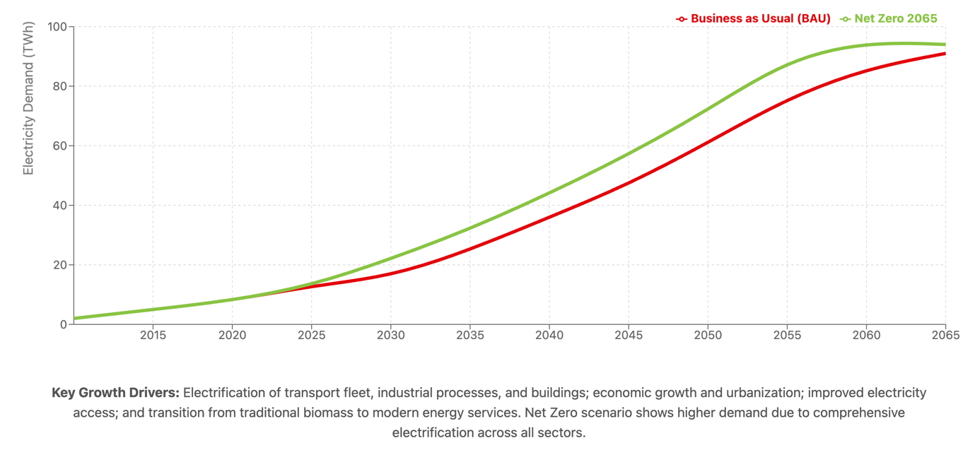
Low Carbon Roadmap 2065
Short-Term (to 2030). Deploy about 4.7 GW of solar capacity, leveraging dramatic cost reductions and Uganda's excellent solar resources
- Grid infrastructure modernization: Upgrade transmission networks to accommodate distributed generation and prepare for variable renewable integration
- Regulatory framework establishment: Implement feed-in tariffs, net metering policies, and standardized power purchase agreements to attract private investment
- Energy efficiency programs: Launch national building codes and industrial efficiency standards to moderate demand growth
- Pilot project implementation: Demonstrate grid-scale battery storage, smart grid technologies, and hybrid renewable systems
This period establishes the foundation for exponential growth, with electricity demand reaching 22 TWh under the Low Carbon scenario.
Medium-Term (2030–2040). The 2030s represent the critical acceleration phase where renewable technologies achieve market dominance and system transformation deepens. Key milestones include:
- Technology diversification: Expand wind power to 607 MW and introduce 595 MW of nuclear capacity while solar reaches 8,921 MW
- Storage deployment at scale: Install 3 TWh of battery storage to enable higher renewable penetration and grid stability
- Sector coupling advancement: Accelerate transport electrification and industrial fuel switching, driving demand to 44 TWh
- Grid intelligence enhancement: Deploy advanced demand response systems, real-time optimization, and predictive maintenance capabilities
- Regional integration: Strengthen interconnections within the East African Power Pool for resource optimization
This decade witnesses the electricity sector's transformation from hydropower dependence to diversified renewable portfolio management.
Long-Term (2040–2050/2065). The final phase achieves comprehensive decarbonization while meeting dramatically increased electricity demands of 94 TWh by 2065. Strategic achievements include:
- Renewable dominance: Solar capacity reaches 30 GW, becoming Uganda's largest generation source at 48% of supply
- System flexibility maximization: Deploy 7 TWh of storage capacity enabling near-100% renewable operation during favorable conditions
- Nuclear baseload establishment: Commission 1.9 GW of nuclear capacity providing firm, carbon-free generation
- Complete sector electrification: Achieve full electrification of viable transport modes, industrial processes, and building systems
- Residual emissions management: Deploy targeted interventions for hard-to-abate sectors while maintaining grid reliability
By 2065, Uganda's electricity sector exemplifies successful transition from fossil fuel dependence to clean, reliable, and affordable energy supply supporting national development within planetary boundaries. The Low Carbon pathway demonstrates that achieving 94 TWh of clean electricity—a 47-fold increase from 2010—remains technically feasible and economically advantageous when considering co-benefits of reduced air pollution, enhanced energy security, and industrial competitiveness.

Transport
Importance of the Transport Sector for Uganda. Transport infrastructure serves as Uganda's economic circulatory system, facilitating trade flows, enabling workforce mobility, and ensuring access to markets and essential services. The sector's structure reflects road transport dominance, with the national fleet comprising motorcycles (2-3 wheelers), passenger vehicles, light commercial vehicles, heavy freight trucks, and public buses. Rapid motorization, particularly in expanding urban centers and peri-urban corridors, drives escalating fuel consumption and greenhouse gas emissions. While rail, inland waterways, and aviation currently represent minor modal shares, strategic investments position these alternatives for expanded roles as Uganda's economy diversifies and regional integration deepens.
Key Emission Drivers The transport sector's evolution reflects converging forces reshaping mobility patterns and emissions trajectories:
Fleet Expansion Dynamics: Vehicle populations demonstrate explosive growth, with total fleet size projected to expand from 875,000 units (2020) to 7.3 million (2065) under business-as-usual trajectories. Motorcycles dominate numerically, growing from 480,000 (2020) to 4.4 million (2065), providing affordable mobility and livelihood opportunities. Passenger vehicles increase from 300,000 to 2.2 million over the same period, reflecting urbanization and rising middle-class aspirations.
Utilization Intensity Variations: Annual vehicle usage patterns significantly impact aggregate emissions. Motorcycles average 10,000 km/year supporting last-mile connectivity, while heavy-duty trucks exceed 80,000 km/year serving national and regional freight corridors. These high utilization rates amplify individual vehicle emissions impacts, making efficiency improvements and fuel transitions particularly impactful.
Modal Split Persistence: Road transport maintains 95% modal dominance despite recognized benefits of rail and water alternatives for bulk freight movement. Current infrastructure limitations and service gaps constrain modal shift potential, though planned investments in the Standard Gauge Railway and inland water transport modernization could alter future dynamics.
Technology Transition Barriers: The global shift toward electric mobility presents both opportunities and challenges for African nations balancing multiple development priorities. Battery costs have declined 90% since 2010 to below $100/kWh, progressively improving the economic case for electric vehicles. In East African markets, total cost of ownership calculations increasingly favor electric options, with motorcycle operators documenting operational savings of 40-60% despite higher initial purchase prices. These economic fundamentals, combined with innovative financing models like battery-as-a-service and mobile money integration, demonstrate pathways for technology adoption adapted to local contexts.
The transition timeline remains critical given vehicle fleet longevity of 15-20 years. Uganda's projected fleet expansion from 875,000 to 7.3 million vehicles by 2065 underscores how current investment decisions shape long-term emissions trajectories. Supporting this transition requires carefully designed interventions including differentiated financing mechanisms (reducing EV loan rates from 15-20% to 7-10%), strategic infrastructure investments, and regulatory frameworks that create market certainty while recognizing diverse stakeholder interests. Successfully navigating this transition could generate substantial economic benefits—including reduced fuel import bills, improved urban air quality, and emerging green economy employment—while contributing to national climate commitments. The pace and nature of this transition will ultimately depend on aligning various policy objectives and building consensus across different sectors of government and society.
Alignment with National Plans. Uganda's transport transformation agenda operates within an integrated policy architecture spanning economic development, climate action, and infrastructure modernization. The National Development Plan IV (NDPIV) prioritizes sustainable transport infrastructure while explicitly incorporating green mobility objectives, establishing multimodal integration targets and urban mass transit systems to serve expanding metropolitan populations. This development framework directly supports enhanced climate ambitions, with transport sector interventions contributing substantially to Uganda's NDC commitment to reduce emissions by 24.7% below baseline by 2030.
Vision 2040's sustainable transport pillars—modern vehicle fleets, integrated public transit, and regional connectivity—establish long-term transformation parameters while creating investment certainty for private sector participation. The convergence of these frameworks enables coordinated action: infrastructure investments prioritize corridors supporting both economic growth and modal shift potential, while regulatory reforms incentivize cleaner technologies aligned with fiscal sustainability objectives. However, achieving the envisioned low-emission transport future depends on implementation effectiveness, institutional coordination across ministries, and sustained political commitment transcending individual planning cycles. The extent to which these ambitious blueprints translate into measurable emission reductions and improved mobility outcomes will shape Uganda's development trajectory for decades.
Methodology and Modelling Approach. The transport sector analysis employs a comprehensive bottom-up modelling framework capturing vehicle stock evolution, utilization patterns, and technology transitions from 2010 through 2065. The model disaggregates the fleet into eight categories—motorcycles, passenger cars, light-duty vehicles, heavy-duty vehicles, buses, rail, shipping, and aviation—each with distinct operational characteristics and emission profiles.
Stock Dynamics: Vehicle populations are projected using economic growth correlations, urbanization rates, and income elasticities. The 2025 baseline includes 800,000 motorcycles across all scenarios, with divergent electric vehicle adoption rates: 3% (BAU), 5% (Low Carbon).
Activity Metrics: Road vehicles track annual kilometers traveled, while aviation and shipping measure operational hours. Rail projections incorporate route-kilometers and service frequencies. These activity levels multiply with stock numbers to determine aggregate energy demand.
Efficiency Evolution: Fuel consumption rates improve gradually, with motorcycles reducing from 0.139 L/km (2020) to 0.127 L/km (2065), while heavy vehicles achieve similar proportional gains. Electric vehicle efficiency assumptions reflect 0.15-0.30 kWh/km depending on vehicle class.
Emission Calculations: The model converts fuel consumption to energy demand (GJ) and CO₂ emissions using standard combustion factors. Electric vehicle emissions depend on grid carbon intensity, creating important interactions with power sector decarbonization pathways. The framework enables scenario comparison across business-as-usual trends versus ambitious electrification and efficiency trajectories aligned with net-zero objectives.
Scenario Framework. The transport sector analysis employs two contrasting scenarios that illuminate feasible decarbonization pathways while accounting for Uganda's development context and fiscal constraints.
Business-as-Usual (BAU) projects continuation of current policies without additional interventions. Electric vehicle adoption proceeds organically, reaching 80% penetration for motorcycles (2-3 wheelers) and 80% for passenger cars by 2065. Fuel economy improvements occur through natural fleet turnover, achieving 15-20% efficiency gains over the analysis period. This trajectory reflects market dynamics absent transformative policy support, resulting in transport emissions declining from a peak of 8.8 MtCO₂ (2050) to 5.43 MtCO₂ (2065).
Low Carbon 2065 implements comprehensive policy interventions achieving complete transport electrification by 2065. This ambitious pathway features accelerated EV adoption—100% for all vehicle categories by 2065—supported by stringent efficiency standards and expanded public transit infrastructure. The scenario achieves zero direct transport emissions by 2050, demonstrating technical feasibility of complete sector decarbonization.
Relevant Policies and Measures in Each Scenario. Each scenario deploys distinct policy packages integrating fiscal, monetary, and environmental instruments. BAU maintains fragmented implementation—existing 35% import duties apply uniformly, fuel pricing excludes carbon considerations, and minimal coordination exists between transport and climate objectives. Market-driven efficiency improvements achieve marginal 2% annual gains without accelerating fleet modernization.
Low Carbon 2065 demonstrates comprehensive policy integration where fiscal incentives (differentiated import duties creating 40% EV cost advantages), monetary mechanisms (5% concessional financing versus 15% market rates), and environmental regulations (Euro 5 standards by 2030) reinforce each other. This synchronized approach accelerates fleet turnover through vehicle age restrictions and feebate systems that make inefficient vehicles economically unviable.
Both scenarios incorporate infrastructure investments, but with different ambitions. BAU maintains current rail utilization at 2% of freight tonnage, while Low Carbon 2065 expands Standard Gauge Railway capacity to capture 30% of long-distance freight by 2040. Similarly, public transport receives transformative investment under Low Carbon 2065—300km of BRT systems and integrated modal hubs—versus incremental improvements in BAU. This policy coherence enables Low Carbon 2065 to achieve complete decarbonization by 2050, while BAU's fragmented approach yields only partial emission reductions despite higher long-term economic costs.
Mitigation Pathways (Scenarios)
BAU Scenario. The BAU scenario projects vehicle fleet expansion from 875,313 units (2020) to 4.53 million (2050), reaching 7.28 million by 2065. This 6% annual growth rate, while double the 2.9% population growth, aligns with observed motorization patterns in comparable African economies experiencing similar GDP per capita transitions. The projection accounts for:
- Economic formalization: As Uganda's informal sector (employing 70% of youth) transitions toward formal employment, motorcycle taxis (boda-bodas) become primary income-generating assets
- Urban sprawl dynamics: Expanding cities without adequate public transport drive private vehicle dependency
- Freight demand growth: GDP growth of 6-7% annually generates proportional commercial vehicle requirements
Energy demand implications: The projected 139 million GJ energy consumption (2050) generating 8.8 MtCO₂e. In the BAU scenario, Uganda follows the carbon-intensive development path in the transport sector. This highlights the critical importance of leapfrogging to electric mobility before lock-in occurs.
Low Carbon 2065 Scenario. Comprehensive electrification pathway achieving zero emissions by 2050:
- Two/three-wheelers: 90% electric (2045), 100% (2050)
- Passenger vehicles: 100% sales (2045), fleet conversion (2060)
- Commercial fleet: Phased transition completing 2065
- Aviation/shipping: Alternative fuels post-2040
Critical enablers include battery cost parity (2030), PPP-based charging infrastructure, concessional financing mechanisms, and local manufacturing capacity. Transport electricity demand of 7 TWh (2050) is offset by renewable grid expansion, demonstrating feasible complete decarbonization.
Strategic Pathways. Uganda's transport future presents clear alternatives:
- Business-as-Usual: Petroleum-dependent motorization with escalating economic and environmental costs
- Low Carbon 2065: Technology leapfrogging through integrated policy and infrastructure investment
Both scenarios accommodate mobility growth—differentiation lies in energy sourcing. Domestic renewable electricity replacing imported petroleum transforms constraints into opportunities, aligning development imperatives with climate objectives while positioning Uganda within emerging green economy value chains. Figure 12 illustrates the transport sector emission trajectories in the two scenarios.
Figure 18 Transport Sector Emission Trajectories
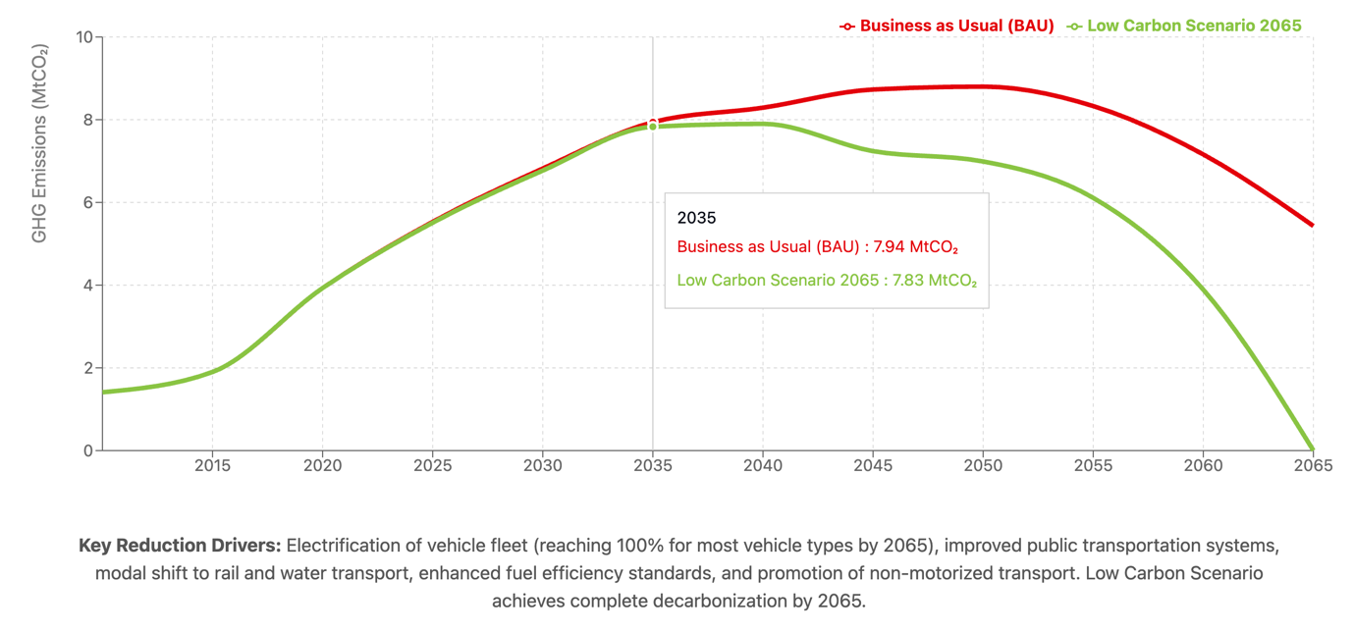
Low Carbon Roadmap. Short-Term (to 2030). The critical decade establishes transformation prerequisites through regulatory harmonization (Euro 4/5 standards, vehicle age limits, EV certification), market catalysts (100,000 e-motorcycles via $300 incentives and battery-as-service models), and infrastructure foundations (500 charging stations, 375km rail rehabilitation). Early demonstrations—200 e-buses on key corridors and modal shift incentives—build market confidence for scaled deployment.
Medium-Term (2030–2040). Technology mainstreaming achieves 40% passenger EV market share through 5,000 charging points nationwide, 60% commercial fleet electrification leveraging 70% operational savings, and 1,000 urban e-buses reducing air pollution by 35%. Infrastructure scaling includes highway charging every 50km, vehicle-to-grid integration, and 10 multimodal terminals. Carbon pricing generates $200 million annually while zero-emission zones accelerate fleet transitions.
Long-Term (2040–2050/2065). Complete transformation deploys 90% road electrification by 2050, hydrogen solutions for long-haul transport, and sustainable aviation fuels. Advanced systems—autonomous EVs, high-speed electric rail, and mobility-as-service platforms—optimize efficiency while reducing private ownership 30%. Circular economy principles govern battery recycling and component reuse.
Milestones and Indicators. Progress indicators track transformation: electric motorcycles reach 25% (2030), 75% passenger EVs (2040), and complete decarbonization (2050) under Low Carbon pathways. This contrasts sharply with BAU's 8.8 MtCO₂ emissions by 2050. Success requires sustained political commitment, innovative finance reducing investor risk, regional standard harmonization, technical capacity building, and inclusive transition ensuring informal operator participation.
The 5.43 MtCO₂ (BAU) versus zero emissions (Low Carbon) divergence by 2065 underscores that decisive near-term action determines whether Uganda perpetuates carbon dependence or pioneers sustainable mobility transformation, capturing associated economic benefits while contributing to global climate objectives.

Buildings
The LTS building sector analysis encompasses residential, commercial, and institutional structures across Uganda's diverse urban and rural landscapes. This sector serves as a fundamental enabler of socio-economic progress, catalyzing construction-driven economic growth, generating substantial employment opportunities, and providing essential infrastructure for healthcare, education, and commercial activities. Simultaneously, buildings represent a major component of national energy demand and greenhouse gas emissions, primarily through traditional biomass utilization (fuelwood and charcoal) for cooking and heating, diesel-powered backup generation systems, and expanding grid electricity consumption.
Uganda's demographic transformation and rapid urbanization have catalyzed unprecedented built environment expansion. The modelling reveals striking growth trajectories: urban residential floor area expands from 40 million m² (2010) to 120 million m² (2025) and reaches 442 million m² by 2065. Rural buildings, while maintaining smaller per-household footprints, demonstrate parallel expansion driven by population growth and gradual income improvements, increasing from 105 million m² (2010) to 288 million m² (2065).
Key Emissions Drivers and Energy Patterns. Building sector emissions stem from interconnected factors including demographic expansion, persistent biomass dependence for thermal energy services, and diesel generation for power reliability. The modelling quantifies these dynamics:
- Electricity demand: Grows from 11 TWh (2025) under both scenarios to 18.3 TWh (BAU) or 18.3 TWh (Low Carbon) by 2030, reflecting universal electrification progress
- Biomass consumption: Remains substantial at 8.5 million tonnes annually (2025), particularly in rural households where clean alternatives face adoption barriers
- Diesel usage: Peaks at 9.7 million liters (2025) before declining as grid reliability improves
Structural constraints perpetuate these patterns: infrastructure gaps limiting modern energy access, technology adoption barriers including high upfront costs, and affordability challenges for clean cooking solutions maintain biomass dominance across rural and peri-urban communities.
Policy Alignment and Transformation Pathways. Uganda's Third National Development Plan (NDPIII), enhanced Nationally Determined Contributions (NDCs), and Vision 2040 collectively establish ambitious building sector transformation objectives. These frameworks prioritize comprehensive energy efficiency improvements, universal clean energy access, and systematic biomass dependency reduction.
The NDC specifically targets residential cooking emissions through efficient cookstove deployment and alternative fuel adoption, projecting 50% penetration by 2030. Vision 2040's universal electrification goal directly transforms building energy profiles, enabling the transition from traditional fuels to clean electricity for lighting, cooking, and productive uses.
These integrated policies position the building sector as a critical contributor to national development and climate objectives, requiring coordinated interventions across technology deployment, financing mechanisms, and behavioral change programs to achieve the envisioned transformation from high-carbon traditional energy use to efficient, electrified building operations.
Building Sector Modelling Framework
The building sector analysis employs a comprehensive bottom-up modelling approach covering four distinct subcategories: urban residential, rural residential, commercial, and institutional buildings. The model integrates granular datasets encompassing demographic projections, household characteristics, building floor areas, technology deployment (cookstoves, generators, appliances), and fuel consumption patterns (electricity, diesel, fuelwood, charcoal) to generate robust emissions projections.
Floor area projections derive from demographic modeling and urbanization trends, with total building stock expanding from 146 million m² (2010) to 730 million m² (2065). Energy demand calculations apply differentiated intensity factors by building type and location, capturing the heterogeneous nature of Uganda's built environment. The framework explicitly tracks fuel substitution dynamics, distinguishing grid electricity consumption from diesel generation and traditional biomass use. Progressive efficiency improvements are incorporated, exemplified by urban residential energy intensity declining from 100 kWh/m²/year (2010) to 63-72 kWh/m²/year by 2065 depending on scenario ambition.
Scenario Architecture. Two primary scenarios frame the analysis:
Business-as-Usual (BAU) projects forward existing policy frameworks without additional interventions. This pathway maintains current building standards, organic grid expansion rates, and market-driven technology adoption, resulting in gradual efficiency improvements but persistent biomass dependence.
Low Carbon 2065 (NZE2065) implements comprehensive policy interventions including mandatory efficiency standards achieving 30-40% improvement by 2050, accelerated cooking electrification reaching 80% penetration, and targeted incentives driving rooftop solar deployment to 10-22% of suitable buildings. This scenario represents Uganda's maximum feasible contribution to global climate objectives while advancing energy access goals.
Key Modelling Assumptions.
The BAU scenario incorporates continuation of existing building codes yielding 5% efficiency improvement per decade and grid expansion reaching 60% household connectivity by 2040.
The Low Carbon scenario strengthens these foundations through:
- Enhanced building energy codes mandating 40% efficiency improvement for new construction by 2035
- National clean cooking program distributing 5 million improved cookstoves and promoting LPG/electric alternatives
- Accelerated rural electrification achieving 95% connectivity by 2040 through grid extension and mini-grids
- Solar rooftop incentive scheme with feed-in tariffs and net metering driving 20% adoption in commercial buildings.
Technology penetration rates reflect implementation feasibility: Low Carbon scenarios project 20% distributed solar adoption and 75% diesel generator phase-out by 2050, while maintaining higher electrification rates and faster clean cooking transitions than BAU pathways. These differentiated assumptions generate distinct emission trajectories, with Low Carbon achieving 75% reduction versus BAU by 2065.
Mitigation Pathways (Scenarios).
BAU Scenario. The BAU pathway projects continued building stock expansion aligned with demographic growth. Urban residential units increase from 0.8 million (2010) to 5.2 million (2065), while rural dwellings expand correspondingly despite maintaining smaller average floor areas. Infrastructure constraints limit electricity consumption growth from 1.7 TWh (2010) to 67 TWh (2065), with rural areas experiencing particularly slow grid expansion.
Traditional biomass maintains dominance in rural cooking applications, with fuelwood consumption sustained at 8.2 million tonnes (2030) before gradually declining. This persistent biomass dependence continues exerting pressure on forest resources. Diesel generation for reliability and off-grid applications contributes direct emissions of 1.50 MtCO₂ (2030), declining slowly to 0.20 MtCO₂ by 2065 as grid coverage improves and urban households transition to electric cooking. This long-term reduction remains uncertain, contingent on sustained infrastructure investment and technology adoption rates exceeding historical trends.
Low Carbon 2065 Scenario. The Low Carbon pathway implements comprehensive transformation through stringent efficiency standards, scaled clean cooking deployment, and accelerated electrification programs. Electricity demand reaches 18.3 TWh by 2030—comparable to BAU—but serves expanded end-uses as households and businesses substitute electricity for biomass and diesel.
Distributed solar adoption accelerates, achieving 5% penetration in suitable buildings by 2030 and expanding to 20% by 2050, reducing grid supply requirements and enhancing energy resilience. Clean cooking technologies—including improved biomass stoves, LPG systems, and electric appliances—reduce fuelwood demand to 6.6 million tonnes (2030), a 20% reduction versus BAU.
These interventions yield substantial emissions reductions: building sector CO₂ drops to 1.24 MtCO₂ by 2030 (18% below BAU) and approaches 0.05 MtCO₂ by 2065, representing near-complete decarbonization. This transformation pathway directly supports Uganda's enhanced climate commitments while delivering co-benefits including reduced indoor air pollution, decreased deforestation pressure, and improved energy security through domestic renewable resources.
The contrast between scenarios demonstrates that achieving deep decarbonization requires proactive policy implementation rather than reliance on organic market evolution. The Low Carbon pathway's success depends on coordinated interventions across efficiency standards, clean cooking programs, and renewable energy deployment, supported by innovative financing mechanisms and sustained political commitmen

Figure 17 Building Sector Emission Trajectories
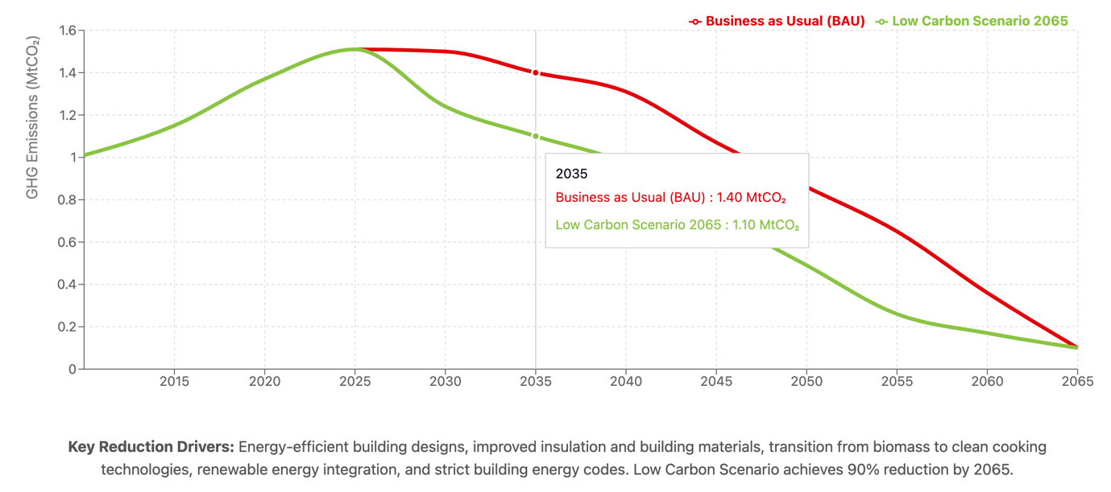
Roadmap to Net-Zero. Short-Term (to 2030).
The immediate decade establishes critical market transformation foundations through three strategic pillars: enhanced building performance standards, scaled clean cooking deployment, and accelerated urban and rural electrification. Implementation priorities include:
- Building code modernization: Mandatory efficiency standards for new construction achieving 30% energy reduction by 2030
- Clean cooking market transformation: Deploy 2 million improved cookstoves and 500,000 LPG/electric cooking systems through targeted subsidies
- Demonstration project pipeline: Establish 50 showcase buildings featuring integrated efficiency, solar PV, and electric cooking to build market confidence
- Fiscal incentive framework: Zero-rate VAT on solar equipment, efficiency retrofits, and clean cooking appliances while introducing accelerated depreciation for commercial green buildings
These interventions create enabling conditions for accelerated technology adoption while building institutional capacity and consumer awareness essential for deeper transformation.
Medium-Term Acceleration (2030-2040)
The transformation decade shifts from demonstration to mass deployment, achieving market scale for proven solutions. Strategic actions include:
- Technology mainstreaming: Electric cooking penetration reaches 60% in urban areas leveraging expanded grid capacity and appliance financing programs
- Financial ecosystem development: Establish dedicated green building finance facilities offering concessional loans for efficiency retrofits and distributed renewable energy
- Institutional strengthening: Build technical capacity within 100 district construction authorities for enforcement of efficiency standards and quality assurance
- Rural energy service expansion: Deploy 500 mini-grid systems integrating productive uses to enable rural building electrification
By 2040, these scaled interventions reduce building emissions below 1.0 MtCO₂ under the Low Carbon pathway, demonstrating feasibility of deep decarbonization.
Long-Term Consolidation (2040-2065)
The final phase achieves comprehensive electrification supported by fully renewable grid supply, eliminating remaining fossil fuel dependencies. Advanced solutions gain market dominance:
- Technology integration: Smart building systems with integrated solar-plus-storage become standard for commercial and institutional facilities
- Complete fuel transition: Phase out remaining diesel generators and biomass cooking through targeted support for last-mile communities
- Circular economy adoption: Mandate sustainable materials and lifecycle approaches for all new construction
The Low Carbon scenario achieves near-zero emissions by 2065, demonstrating complete sector transformation feasibility.
Critical Success Metrics. Progress monitoring focuses on quantifiable indicators:
- Rural electric cooking adoption: From 5% (2025) to 40% (2035) to 80% (2050)
- Building energy intensity: Reduce from 150 kWh/m²/year to below 80 kWh/m²/year for new construction
- Distributed solar penetration: 5% (2030), 15% (2040), 25% (2050) of suitable roof area
- Clean cooking access: 100% households using improved technologies by 2040
Transformative Co-Benefits. This transition delivers multiple development dividends: reduced deforestation pressure saving 2 million hectares of forest by 2050, improved health outcomes from eliminated indoor air pollution preventing 10,000 premature deaths annually, and green job creation generating 200,000 employment opportunities across the clean energy value chain.
Success requires sustained collaboration between government leadership setting ambitious standards, private sector innovation delivering cost-effective solutions, development partner support for capacity building, and community engagement ensuring inclusive benefits distribution. This integrated approach positions Uganda's building sector as a regional leader in sustainable development while contributing decisively to national climate objectives.

Industry Energy Use and Industrial Processes and Product Use (IPPU)
Uganda's industrial sector, comprising cement manufacturing, food processing, chemicals, and diverse manufacturing activities, demonstrates rapid transformation from small-scale primary processing toward value-added production. Cement production exemplifies this trajectory, expanding from 1 million tonnes (2010) to 2 million tonnes (2020), with projections reaching about 25 million tonnes by 2065—reflecting infrastructure demands and urbanization pressures. Similar growth characterizes food processing (expanding 5% annually), chemicals (4.5% annually), and manufacturing (6% annually), positioning industry as both GDP driver and emissions source.
Industrial emissions originate from dual pathways: combustion for thermal energy and electricity generation contributes 60% of sector emissions, while process and product use emissions (Industrial Product and Process Utilisation / IPPU) — inherent to chemical transformations in cement (limestone calcination), chemical production and the F-gas related emissions —contributes 40%. Process emissions prove particularly challenging, growing from 1 MtCO₂ (2010) to projected 1.4 MtCO₂ (2065) under BAU, as they cannot be eliminated through fuel switching alone.
Key drivers. Industrial expansion reflects converging forces: population growth (2.9% annually) drives construction materials demand, with cement consumption increasing from 50 kg/capita to projected 350 kg/capita by 2065. Rising incomes triple manufacturing goods consumption by 2040. Infrastructure programs—5,000km roads, 20 industrial parks, expanded hydropower—create sustained industrial demand. Technology constraints persist as capital limitations force continued operation of equipment 20-30 years beyond optimal efficiency. Energy pricing historically subsidizing fossil fuels (15% below cost-reflective tariffs) disincentivizes efficiency investments, though recent reforms begin addressing these distortions.
Alignment with National Plans. Vision 2040 positions industrialization as the vehicle for middle-income achievement, targeting manufacturing at 25% of GDP. NDPIV operationalizes this through specific targets: 40% value addition for agricultural products, 500,000 manufacturing jobs by 2030, and establishment of specialized economic zones. The enhanced NDC commits to 20% industrial energy intensity improvement by 2030 and exploration of carbon capture for cement. These frameworks create policy coherence while signaling long-term direction for private investment in clean technologies. Success requires balancing rapid industrialization imperatives with sustainability objectives, ensuring Uganda's industrial emergence avoids high-carbon lock-in plaguing earlier developers.
Methodology and Modelling Approach
Industrial sector analysis employs bottom-up modelling integrating production forecasts, technology evolution, and emission factors across four subsectors: cement, food/beverages, chemicals, and manufacturing. Historical baselines (2010-2020) project forward using GDP elasticities, infrastructure plans, and market analysis. Production scaling reflects differentiated growth: cement expands 8% annually reaching 25 million tonnes (2065), food processing 5% annually, chemicals 4.5%, and manufacturing 6%.
The model tracks three parameters: energy intensity (kWh/tonne product) declining through technology upgrades—cement from 1,200 to 600 kWh/t, chemicals from 1,500 to 1,100 kWh/t; process emissions (tCO₂/tonne) reducing through chemistry innovations—cement from 0.60 to 0.05 tCO₂/t; and fuel mix transitions from 80% fossil to 25-100% electricity depending on scenario. The increase of electrification of industrial processes is a key decarbonisation and energy efficiency driver across both developed and developing countries. Efficiency improvements reflect capital stock turnover rates, technology costs, and policy effectiveness in driving adoption.
Scenario Framework. Business-as-Usual maintains current policies: mandatory energy audits for facilities exceeding 1 MW, gradual boiler efficiency improvements (2% annually), and market-driven electrification reaching 75% by 2065. Process emissions decline marginally through incremental improvements.
Low Carbon 2065 implements comprehensive interventions: concessional financing at 5% for industrial upgrades, efficiency standards achieving 40% improvement by 2040, carbon pricing rising to $50/tCO₂, and technology partnerships facilitating best-available technology adoption. Electrification reaches 85-95% across subsectors by 2065, while breakthrough technologies address process emissions.
Relevant Policies & Measures in Each Scenario. Policy differentiation reflects implementation feasibility. BAU relies on existing institutional capacity and market forces. Low Carbon 2065 requires coordinated action across fiscal incentives ($200 million annual subsidies), regulatory enforcement (efficiency standards, emission limits), infrastructure investments (reliable electricity supply), and international cooperation (technology transfer, climate finance). Success depends on balancing industrial competitiveness with sustainability objectives through carefully sequenced interventions.
Mitigation Pathways (Scenarios)
BAU Scenario. Industrial production expansion drives electricity demand from 1.0 TWh (2010) to 17 TWh (2065), while fossil fuel combustion emissions increase from 2 to 4 MtCO₂—including process emissions from 1.1 to 1.4 MtCO₂. Cement dominates growth, reaching about 25 million tonnes production with process emissions persisting at 0.05 tCO₂/tonne despite marginal improvements. Manufacturing expansion in textiles, assembly, and packaging maintains 40% fossil fuel dependence for thermal processes. Total sector emissions double despite efficiency gains, reflecting production growth outpacing technology improvements.
NZE 2065 Scenario. Strategic interventions achieve 87% emission reduction through systematic decarbonization. Electricity demand reaches 23 TWh by 2065, supporting 85% electrification across subsectors. Key transformations include:
- Cement: Electric and hybrid kilns reduce fuel emissions 90% while carbon capture addresses 80% of process emissions by 2050
- Food/beverages: Complete electrification of processes below 200°C, biomass gasification for high-temperature applications
- Chemicals: Green hydrogen replaces fossil feedstocks, reducing process emissions 70%
- Manufacturing: Heat pumps and electric furnaces eliminate combustion emissions
Process emission solutions deploy progressively: alternative cement chemistries reduce clinker factor 50% by 2040, HFC phase-out in cooling applications by 2035, and CCUS demonstration projects capture 2 MtCO₂ annually from 2045. Total emissions decline from 3.45 MtCO₂ (2025) to 0.53 MtCO₂ (2065).
Implementation requires reliable clean electricity growing to 23 TWh, $2 billion industrial modernization investments, and sustained policy support balancing competitiveness with climate objectives. Success demonstrates that emerging economies can achieve industrial transformation without replicating carbon-intensive development patterns, positioning Uganda as a green manufacturing hub within African markets. Figure 14 illustrates the building sector emission trajectories in the three scenarios.
Figure 20 Industry Sector Emission Trajectories
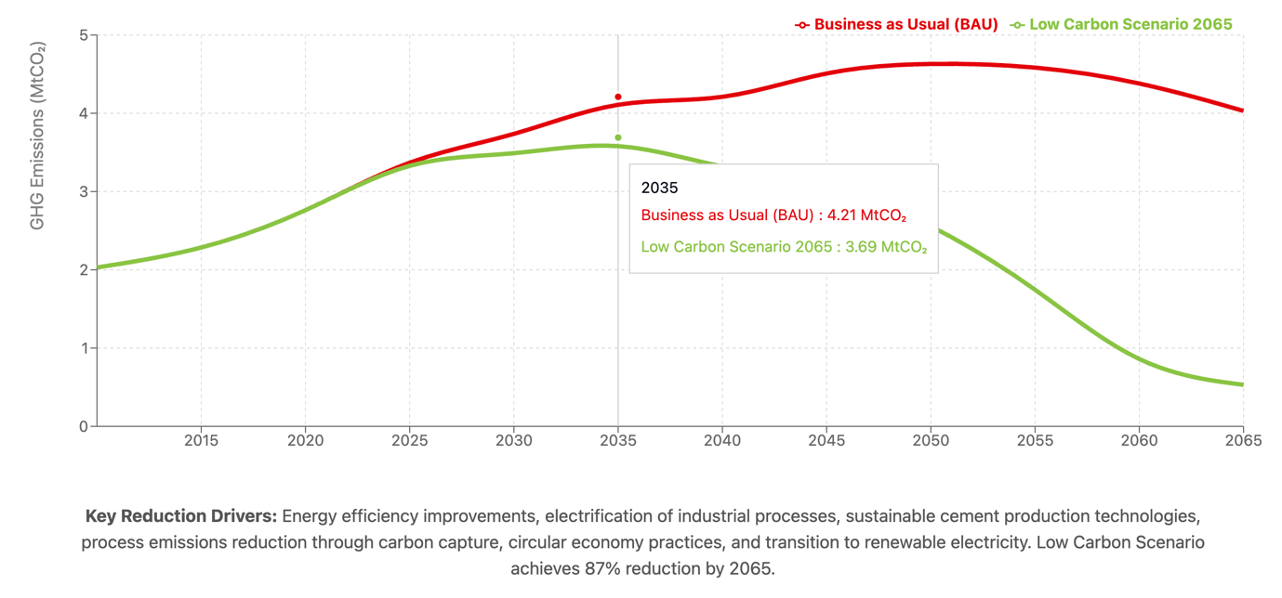

Waste
Uganda's waste management sector faces pressures requiring integrated solutions. Municipal solid waste generation has doubled from 5 million tonnes (2010) to projected 10 million tonnes (2030), concentrated in expanding urban centers—Kampala, Gulu, Mbarara—where collection coverage reaches only 40%. Current disposal infrastructure remains inadequate: 70% of waste enters uncontrolled dumps lacking engineering controls, generating 5.88 MtCO₂e emissions (2010) through methane release 28 times more potent than CO₂.
Baseline projections reveal escalating challenges. Without intervention, emissions reach 6.6 MtCO₂e by 2065—a 167% increase tracking demographic and consumption growth. Yet this trajectory underestimates transformation potential. Modern waste systems demonstrate capacity to convert liabilities into assets: resource recovery generates $300 million annually in comparable African cities, waste-to-energy facilities produce 50-100 MW baseload power, and circular economy approaches create 50,000 jobs per million tonnes processed. Uganda's waste sector stands at an inflection point where addressing immediate public health needs through improved collection and disposal simultaneously enables long-term climate mitigation through methane capture, organic diversion, and energy recovery—transforming environmental burdens into development opportunities.
Key drivers. Waste sector dynamics reflect interconnected demographic and economic transformations. Population growth at 2.9% annually combines with shifting consumption patterns to expand waste volumes while increasing organic content from 65% to projected 75% by 2040. Industrial diversification introduces hazardous waste streams growing 7% annually, while dietary transitions toward processed foods alter waste composition, straining existing infrastructure designed for predominantly organic waste.
Technical deficits compound these pressures. Current landfill operations lack engineered controls—no sites employ methane capture despite 60% of emissions originating from landfill gas. Wastewater treatment capacity covers only 30% of generated volumes, with existing facilities achieving 40% efficiency due to overloading and maintenance gaps. Infrastructure investments lag requirements by $200 million annually, perpetuating reliance on rudimentary disposal methods. While policy frameworks exist—including the National Waste Management Strategy and Environmental Act—implementation remains fragmented across 134 districts with varying capacities. Technology adoption proceeds slowly: only 5% of organic waste undergoes composting despite 70% technical potential, reflecting gaps between policy ambition and operational reality. These constraints create opportunities for leapfrogging to integrated waste management systems incorporating proven technologies adapted to local contexts.
Alignment with National Plans. The importance of the waste sector is recognized in Uganda’s overarching development frameworks, such as the National Development Plan (NDP IV) and Vision 2040, both of which emphasize better solid waste management and improved sanitation services as pivotal for sustainable urban development. Uganda’s updated Nationally Determined Contribution (NDC) similarly highlights the need to reduce landfill emissions and improve wastewater treatment, aligning the sector with national climate commitments and sustainable development goals. Although specific targets vary across policy documents, they consistently call for enhanced waste management infrastructure, methane capture, and broader resource recovery initiatives as part of the country’s medium- and long-term strategies.
Methodology and Modelling Approach
The waste sector analysis employs activity-based modelling integrating municipal solid waste generation data, wastewater production volumes, and emerging treatment system deployments. Historical baselines from national statistics and district-level surveys project forward using demographic growth rates (2.9% annually), urbanization trajectories (25% to 40% by 2050), and service expansion targets.
Emission calculations apply IPCC methodology with locally calibrated factors: landfills generate 0.020 tCH₄/tonne MSW under anaerobic conditions, while wastewater produces 0.100 tCH₄/m³ without treatment. Technology interventions modify these factors—methane capture achieves 0.003-0.006 tCH₄/tonne depending on efficiency, while aerobic composting generates minimal emissions at 0.005 tCO₂/tonne. Energy consumption for treatment operations applies grid emission factors declining from 0.0005 to 0.0001 tCO₂/kWh as renewable generation expands.
Relevant Policies and Measures in Each Scenario. Policies already in place (e.g., basic landfill regulations, incremental wastewater system expansions) shape the BAU scenario. MIT1 assumes an aggressive rollout of waste minimization, widespread composting, and advanced methane capture technologies in landfills and wastewater treatment facilities. NZE 2065 envisions a more moderate adoption of similar measures, reflecting partial policy enforcement or slower technological uptake.
Mitigation Pathways (Scenarios)
Business-as-Usual Trajectory. Business-as-Usual maintains current waste management practices with marginal improvements. Collection coverage expands linearly reaching 60% urban and 20% rural by 2065. Technology adoption remains minimal—5% organic diversion to composting, no methane capture systems, and basic wastewater treatment for 30% of flows.
Low Carbon 2065 Transformation Low Carbon 2065 implements systematic transformation through policy-driven technology deployment. Waste diversion reaches 70% through composting and recycling by 2050. Methane capture at major landfills achieves 85% efficiency from 2035. Wastewater treatment with biogas recovery covers 95% of urban flows by 2060. These interventions reduce emission factors 80-95% below baseline values, enabling near-complete sector decarbonization despite waste volume growth.
Total emissions under Low Carbon 2065 decline from 4.16 MtCO₂e (2025)—when scenarios diverge—to 0.05 MtCO₂e (2065), achieving 99% reduction. Implementation requires $500 million capital investment over 40 years, generating returns through resource recovery ($200 million annually), carbon finance ($50 million), and health cost savings ($100 million).
Financial sustainability emerges through blended mechanisms: user fees covering operational costs ($5-8/household/month), tipping charges for commercial waste ($20-30/tonne), extended producer responsibility for packaging ($40 million annually), and international climate finance supporting infrastructure. Regulatory frameworks enforce waste segregation at source, landfill engineering standards, and industrial discharge limits. Institutional coordination integrates national policy setting with district-level implementation through dedicated waste management authorities.
This transformation creates 50,000 direct jobs—waste collection (20,000), recycling operations (15,000), composting facilities (10,000), and technical services (5,000). Additional benefits include reduced healthcare expenditure ($2 billion over 40 years), improved urban aesthetics supporting tourism, and demonstration effects catalyzing regional adoption. The waste sector evolution from major emission source (15.71 MtCO₂e BAU) to negligible contributor (0.01 MtCO₂e Low Carbon) exemplifies how integrated planning converts environmental challenges into sustainable development opportunities.
Figure 19 Waste Sector Emissions Trajectories
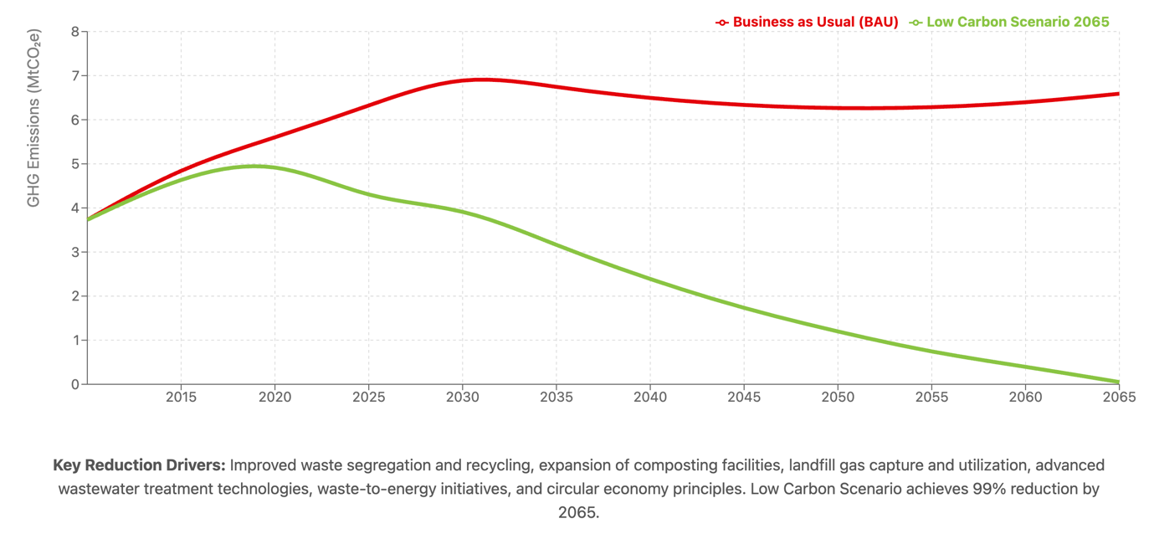
Roadmap to Net-Zero
Short-Term (to 2030). Regulatory frameworks mandate waste segregation at source while implementing polluter-pays principles generating $50 million annually. Infrastructure development establishes 20 controlled landfills with gas management systems replacing open dumps serving 5 million people. Composting demonstration in 50 municipalities processes 500,000 tonnes annually, proving technical and financial viability. Private sector mobilization through 30 waste-to-resource enterprises creates 10,000 jobs while establishing market precedents. Wastewater treatment expansion achieves 60% urban coverage through decentralized systems. Financial mechanisms—household fees ($3-5/month), commercial tipping charges ($20/tonne), and carbon credits—establish operational sustainability.
Medium-Term Scaling (2030-2040). Commercial deployment expands composting to 1.5 million tonnes across 100 centers while achieving 30% material recovery through recycling. Energy generation emerges through 10 waste-to-energy facilities (50 MW total) and 20 biogas digesters. Mandatory gas capture at landfills exceeding 50,000 tonnes/year reduces methane emissions 70%. Wastewater treatment reaches 80% coverage incorporating nutrient recovery valued at $30 million annually. Extended producer responsibility and industrial discharge fees generate $100 million supporting infrastructure expansion while incentivizing waste reduction at source.
Long-Term Optimization (2040-2065). Complete transformation eliminates uncontrolled disposal. Engineered landfills receiving only inert residuals (15% of waste) achieve 90% gas capture. Advanced biological and thermal treatment processes 85% of waste streams. Industrial symbiosis networks divert 80% of industrial waste to productive use. Rural coverage through 200 decentralized facilities ensures universal access. Revenue generation ($300 million annually) exceeds operational costs, demonstrating sector financial sustainability.
Critical Success Metrics. Quantifiable milestones track progress: waste diversion (30% by 2030, 60% by 2040, 85% by 2050), methane capture efficiency (40% by 2030, 70% by 2040, 90% by 2050), and wastewater treatment coverage (50% by 2030, 80% by 2040, 95% by 2050).
Economic returns justify investments: $300 million annual resource recovery revenue, $100 million import substitution through organic fertilizer, and 50,000 direct jobs. Environmental benefits include 60% reduction in water source contamination and 99% methane emission reduction versus BAU (15.71 MtCO₂e). Public health improvements eliminate diseases affecting 2 million annually while enhancing urban livability.
Strategic investments of $500 million generate $5 billion returns over 40 years through resource sales, health savings, and carbon finance. Success transforms waste management from cost center to profit center, demonstrating how environmental protection drives economic growth. Implementation requires sustained political leadership, community behavior change achieving 80% source segregation, and private sector innovation in waste-to-value technologies. This transition positions Uganda as Africa's circular economy leader while achieving climate commitments.
Milestones and Indicators. Quantifiable milestones track transformation: organic diversion (30% by 2030, 60% by 2040, 85% by 2050), methane capture at major sites (40% by 2030, 70% by 2040, 90% by 2050), and wastewater treatment with biogas recovery (50% by 2030, 80% by 2040, 95% by 2050).
Economic dividends compound over time. Resource recovery generates $300 million annually by 2050 through compost sales ($80 million), recyclables ($120 million), and energy production ($100 million). Import substitution saves $100 million on chemical fertilizers while creating 50,000 jobs across collection, processing, and value-addition. Environmental benefits prevent contamination affecting 5 million people dependent on shallow wells while reducing methane emissions from 15.71 MtCO₂e (BAU) to 0.01 MtCO₂e (Low Carbon 2065). Health improvements eliminate cholera, dysentery, and respiratory diseases currently affecting 2 million annually, saving $100 million in treatment costs.
Investment returns demonstrate compelling economics. Strategic deployment of $500 million over 40 years generates $5 billion in resource revenues, health savings, and carbon finance. Cost recovery achieves 120% by 2040 through user fees, resource sales, and environmental services. This transformation requires institutional coordination between environment, finance, and local government ministries; private sector capacity building in 200 enterprises; and community behavioral change achieving 80% participation in source segregation. Success repositions waste management from liability to asset, proving that environmental protection catalyzes economic development while establishing Uganda as Africa's circular economy pioneer.
Roadmap to Net-Zero
Short-Term (to 2030). In the near term, Uganda's waste sector can establish foundational infrastructure and systems by prioritizing collection coverage expansion and controlled disposal. Priorities include constructing engineered landfills with gas capture systems in major urban centers, establishing waste segregation at source programs reaching 50% of urban households, and deploying composting facilities processing 750,000 tonnes annually. Development partners and climate finance can support initial investments in landfill gas-to-energy projects demonstrating 5-10 MW generation potential. Parallel efforts to formalize the informal waste sector—integrating 10,000 waste pickers into structured recycling value chains—will improve livelihoods while enhancing material recovery. By 2030, early-stage anaerobic digestion facilities processing organic waste could provide proof of concept for decentralized waste-to-energy solutions, achieving initial emission reductions from 7.07 to 4.04 MtCO₂e under the Low Carbon scenario.
Medium-Term (2030–2040). From 2030 to 2040, scaled implementation of proven technologies and expanded coverage consolidates early gains. Waste collection services extend to 80% of urban and 40% of rural populations, while material recovery facilities systematically divert recyclables and organics from disposal. Large-scale composting operations process 1.25 million tonnes annually, producing organic fertilizer for agriculture while eliminating methane emissions. Waste-to-energy facilities commissioned in Kampala and secondary cities generate 50-75 MW cumulative capacity, providing baseload renewable power. Extended producer responsibility programs incentivize packaging redesign and recovery, while industrial symbiosis networks enable waste exchange between facilities. The waste management workforce expands to 50,000 formal jobs with technical training in modern processing technologies. Emissions decline to 2.37 MtCO₂e by 2040, achieving 65% reduction from baseline.
Long-Term (2040–2050/2065). After 2040, comprehensive circular economy transformation accelerates emission reductions toward near-zero. Advanced material recovery achieves 70% diversion from landfills, while remaining residual waste undergoes thermal treatment with energy recovery. Anaerobic digestion networks process 2 million tonnes of organic waste annually, generating biogas for transport and cooking. Legacy landfills undergo systematic mining and remediation, recovering materials and eliminating fugitive emissions. By 2065, integrated waste management systems achieve 99% emission reduction to 0.05 MtCO₂e, with residual emissions from remote areas offset through carbon sequestration. The sector generates $300 million annual revenue from recovered materials, energy sales, and carbon credits while providing 100,000 green jobs across the value chain.
Milestones and Indicators. Progress toward near-zero emissions tracks through key metrics: waste collection coverage reaching 95% nationally by 2050, organic waste diversion surpassing 80% through composting and digestion by 2045, and methane capture efficiency exceeding 90% at all disposal sites by 2040. Material recovery rates—plastics recycling at 60%, metals at 80%, paper at 70%—demonstrate circular economy advancement. Landfill emissions intensity declining from 0.9 tCO₂e/tonne to under 0.1 by 2050 validates technical interventions. These milestones align with Uganda's NDC targets while supporting Vision 2040 objectives for sustainable cities and public health improvement,
Uganda's waste sector transformation from environmental liability to economic asset demonstrates sustainable development potential. By systematically building infrastructure, enabling policies, and market mechanisms, the country can achieve comprehensive waste management serving all citizens while eliminating emissions. Strategic investments totaling $500 million through 2065 generate positive returns through resource recovery, energy generation, and health benefits. With clear implementation pathways and sustained commitment, the waste sector becomes a model for converting environmental challenges into development opportunities, ensuring clean, healthy communities for current and future generations.

Adaptation and resilience

Adaptation priorities and needs
Adaptation is a key priority for Uganda. Climate change is impacting and is projected to impact physical infrastructure, food security, water resources, agriculture, energy, health, and ecosystems. The country has been strengthening the adaptation framework, having developed a NAPA in 2007, a Strategic Program for Climate Resilience (SPCR) in 2017; a NAP for Agriculture (2018) and a NAP for Health (2024); and is also in the process of developing a NAP. The TNC also highlights adaptation as a key response to climate change in the country. As part of the NDC update process in 2021/2022, Uganda conducted a comprehensive climate change risk and vulnerability assessment (see Table-1: Results from the climate vulnerability and risk assessment, by sector).
The vulnerability and risk assessment from the updated NDC confirms the priority sectors for adaptation in Uganda as ecosystems, water, agriculture, and forestry. Other sectors have significant risk, mainly Fisheries, Energy, Manufacturing and Mining, the Cities and Built environment, Transport, and Health. For all sectors, a significant cross-cutting issue remains the disaster risk sector.
Taking the results of these efforts together, Uganda’s priority adaptation actions comprise :
- Enhanced ecosystems resilience
- Achieving climate-resilient and sustainable sectors: water and sanitation; agriculture and fisheries; transport; energy; health; cities and urban areas; Manufacturing, Industry and Mining sector
- Increased Forest Cover
- Reduced disaster risk and losses
- Informed citizens to address climate change
- A transformed green and resilient Tourism sector
In order to achieve these goals, the financial constraints, gaps and needs, identified in the NC (2022), remain valid:
Accessing financial and technical support: This comprises the capacity to identify financial sources and opportunities; to set up strategic partnerships; and capacity to write fundable proposals for climate finance from the various funding windows, such as, the GCF, GEF. As mentioned above, it is also convenient to strengthen climate governance and reporting capacity in order to enhance funding acquisition.
Developing and/or downscaling climate scenarios and GHG data tailored to local context and transforming them into actionable priorities: First, the public sector and key sectors require better resolution data in order to facilitate decision making, but also for the correct operationalization of an early warning system and MRV. National in-house capacity, in particular in key sectors, is required for effective adaptation assessment, planning and implementation, taking into account specific needs at the national, sub-national and sectoral levels. Methods and tools for translating climate data and climate change scenarios to the local context have yet to be institutionalized.
Risk and vulnerability assessment and risk management: Sector-specific risk and vulnerability assessments and management have yet to be institutionalized to enhance understanding and management of risks and impacts. Institutionalization of risk and vulnerability assessment and risk management at all levels of governance and in key sectors will enhance adaptation action and facilitate funding allocation. Also, it will facilitate the generation of adaptation evidence and information to feed into a monitoring and reporting system.

Access to and use of technology: Assessment of potential technical, institutional and financial capacity to develop and use technological responses to climate change, informed by prior technology needs assessment (TNA) and Technology Action Plans (TAPs) in adaptation and mitigation have been undertaken for example in the Water, Agriculture and Forestry sectors. TNAs and TAPs further inform where needs and gaps remain regarding the access and use of the identified technologies, including finance and know-how.
Linkage between climate and development planning: Linking climate change adaptation and planning with development agendas is essential. Uganda has been making enormous progress, as evidenced in the NDP IV, the NDC and this LTS. However, Uganda is still facing barriers emanating from gaps in understanding of the concept of integrating adaptation into development planning; and low capacity to integrate international processes that are relevant to adaptation planning using the appropriate frameworks. Bridging these gaps will result in effective funding for adaptation.

Co-benefits of adaptation actions and synergies with mitigation
The development pillars and strategic actions cover synergies between adaptation, mitigation and overall development goals and pay particular attention to the key priority sectors for adaptation. The section below highlights how integrated strategies can align Uganda’s priorities for agriculture, forestry, energy, transport, fisheries, health, water and sanitation, and urban areas, with its goals for a prosperous, inclusive, resilient and low-carbon development.
Protection and Sustainable Use of Ecosystems:
The sustainable management of Uganda's terrestrial and aquatic ecosystems forms a cornerstone of the country's pathway to net-zero emissions by 2065 under the NZE2065 scenario. This integrated approach recognizes the interconnected nature of forest, agricultural, and aquatic systems in delivering both mitigation and adaptation benefits.
Terrestrial Ecosystems
- Forest Conservation and Restoration: Strategic reforestation and afforestation initiatives target an increase in forest cover from 12.4% to 24% by 2050, sequestering an estimated 2.96 MtCO₂e annually. These interventions simultaneously protect critical water catchments, reduce soil erosion by up to 45% in targeted areas, and enhance habitat connectivity for biodiversity conservation. The restoration of 2.5 million hectares of degraded forest landscapes will create resilient carbon sinks while supporting the livelihoods of 3.2 million forest-adjacent communities.
- Climate-Smart Agriculture: The transformation of agricultural systems through agroforestry and agroecological practices addresses the sector's projected emissions reduction from 21.98 MtCO₂e in 2015 to 3.45 MtCO₂e by 2050. Implementation of integrated soil fertility management on 4 million hectares will enhance soil organic carbon by 0.5-1.2 tons per hectare annually, improving food security for 8.5 million smallholder farmers while reducing pressure on natural forests. These practices decrease emissions from deforestation and land degradation by 67% compared to business-as-usual scenarios.
Aquatic Ecosystems
- Wetland Conservation and Restoration: Uganda's wetlands, covering 13% of the national territory, represent significant carbon storage potential through peat and sediment accumulation. The restoration of 250,000 hectares of degraded wetlands by 2040 will sequester approximately 1.8 MtCO₂e annually while improving water quality regulation and flood control services. Priority interventions in the Lake Victoria, Lake Kyoga, and Albert Nile basins will benefit 2.1 million people dependent on wetland resources.
- Sustainable Fisheries Management: The fisheries sector, supporting 1.2 million Ugandans directly, requires ecosystem-based management approaches to maintain productivity under changing climatic conditions. Implementation of co-management systems across major water bodies will reduce fishing pressure, allowing stock recovery.
- Climate-resilient aquaculture development including cage based and land-based systems will diversify protein sources, increase annual fish production from aquaculture to over 1,000,000 tons and reduce pressure on capture fisheries by 2030 while improved post-harvest handling and value addition will reduce post harvest losses and increase total earnings from fisheries.
Integrated Ecosystem Services and Climate Finance
The combined management of terrestrial and aquatic ecosystems positions Uganda to access international climate finance mechanisms. Forest carbon credits from REDD+ initiatives are projected to generate $85 million annually by 2035, while wetland conservation projects qualifying under voluntary carbon standards could yield an additional $32 million per year. Blue carbon initiatives in wetland systems present emerging opportunities, with pilot projects demonstrating sequestration rates of 3-8 tCO₂e per hectare annually. These financial flows will support the sustainable management of 3.8 million hectares of critical ecosystems while providing alternative livelihoods for 450,000 households currently dependent on unsustainable resource extraction.
Reforestation and afforestation in forestry increase carbon sequestration while protecting water resources, reducing soil erosion, and enhancing biodiversity resilience.
Sustainable agriculture practices, such as agroforestry and agroecology improve food security and soil health while reducing emissions from deforestation and land degradation.
In addition, sequestering carbon can help to enter international carbon markets and profit from climate finance.
Developing Climate-Resilient and Low-Carbon Productive Sectors and systems:
- Climate-smart agriculture supports resilience in crop and livestock systems against climate variability while lowering methane emissions and promoting efficient fertilizer use.
- Renewable energy deployment in the energy sector, such as off-grid solar and mini-grids, reduces emissions while providing reliable and adaptive energy systems for rural and urban areas. Moreover, it reduces dependency on charcoal and deforestation, which are critical issues for the country.
- Electrification and low-carbon solutions in transport, including electric buses and rail systems, cut emissions while ensuring resilient and reliable mobility during climate disruptions.
Promoting Green Growth, Circular Economy and green jobs:
- Recycling and waste-to-energy systems in urban areas reduce methane emissions from landfills while managing urban waste to prevent water and sanitation challenges during floods.
- Energy-efficient technologies in manufacturing reduce emissions and enhance resilience by reducing reliance on fossil fuels and improving sector-wide sustainability.
Supporting Community Engagement and Empowerment:
- Community-driven ecosystem management in forestry and fisheries builds local capacity to adapt to climate change impacts while maintaining critical carbon sinks.
- Incorporating indigenous knowledge into water and land management improves localized adaptation strategies and reduces emissions from unsustainable practices.
Strengthening Climate Governance:
- Integrating climate risk assessments into urban planning ensures resilient cities and infrastructure while promoting the use of low-carbon building materials and designs.
- Embedding adaptation priorities in public procurement ensures key sectors and systems, such as health and transport infrastructure, are climate-proof, making public investments sustainable. Also, it promotes low-emission technologies and the transition towards green growth and green jobs.
Strengthening Climate Finance and Investments:
- Mobilizing climate finance for renewable energy and urban water infrastructure supports adaptation by improving access to clean energy and safe water, while reducing emissions from traditional energy and water systems.
- Payment for ecosystem services incentivizes sustainable land and forest management, enhancing adaptive capacity in rural areas while maintaining natural carbon sequestration.
- Leveraging international climate finance can support both adaptation action and mitigation, in particular through accessing technology and innovation, technical assistance, capacity building, among others.
Supporting Climate Services:
- Early warning systems in health, agriculture, fisheries, and water management enhance preparedness and reduce vulnerability to disasters, and can foster land-use practices that contribute to reducing emissions.
- Improved climate information and knowledge sharing for health, urban planning, and agriculture can incentivize innovations in low-carbon and resilient technologies, green building designs, among others.

Implementation plan
This chapter describes the implementation arrangements for the strategy, including the governance and institutional arrangements, the means of operationalising the strategy, and the plans for monitoring and evaluation. The successful implementation of Uganda's Long-Term Strategy requires robust institutional frameworks, effective stakeholder engagement, and comprehensive monitoring systems that build upon existing national processes while introducing new mechanisms where needed.

5.1 Institutional and legal arrangements

Policies and actions
The implementation of Uganda's LTS builds upon the existing policy landscape while introducing new measures to support long-term climate action. At its core, the strategy aligns with Vision 2040 and the National Development Plans, ensuring that climate considerations are mainstreamed into sectoral policies and reflected in national budgeting processes. This integration is supported by the National Climate Change Act, which provides the legal foundation for climate action in Uganda.
The policy framework emphasizes coordination across government levels and sectors, recognizing that effective climate action requires coherent responses across multiple domains. To achieve this, inter-ministerial coordination platforms will be strengthened, and policy coherence frameworks will be developed to ensure alignment between climate objectives and broader development goals. Regular policy reviews will allow for updates and adjustments based on implementation experience and emerging needs.

Governance arrangements: LTS steering
The governance structure for LTS implementation operates through a multi-tiered system that ensures oversight and coordination at all levels. At the national level, the Policy Committee on Environment (PCE) provides high-level strategic guidance, while the National Climate Change Advisory Committee (NCCAC) offers technical input on implementation approaches. The Climate Change Department (CCD) serves as the central coordinating body, ensuring that activities across sectors and levels of government align with the strategy's objectives.
Sector Working Groups play a crucial role in translating the strategy's broad directions into specific sectoral actions. These groups bring together relevant stakeholders to develop detailed implementation plans, monitor progress, and address challenges as they arise. Technical committees provide specialized expertise on specific aspects of implementation, ensuring that actions are based on sound scientific and technical foundations.
The governance arrangements for the LTS is also underpinned by the Uganda’s National Climate Change Act (NCCA), which became law in August 2021. The Act provides a comprehensive framework for climate action in Uganda, including the following requirements:
- Development of a Framework Strategy on Climate Change in Uganda, which shall guide Government in planning and budgeting for financing, and monitoring of climate change programme and actions.
- Development of a National Climate Change Action Plan (NCCAP).
- Development of Climate Change Action Plans at District level (DCCAP).
- Setting of a national reference level for GHG emissions and targets for the reduction of greenhouse gas emissions for each year.
- Integration of climate change matters within the development of plans, projects and budgets of each District for approval by the council.
- Development of a financing mechanism for research, data collection, and systematic observation, implementation of climate change projects and research and innovation.
The Act, therefore, provides a framework within which the strategy’s pillars and long-term options for action can be embedded, as well as providing a mechanism for financing those actions.

Institutional arrangements
The institutional framework for implementing the LTS builds on Uganda's existing climate governance structures while introducing new mechanisms where needed. The Ministry of Water and Environment, through its Climate Change Department, serves as the lead institution, providing overall coordination and guidance. The National Planning Authority plays a crucial role in ensuring that climate considerations are integrated into development planning processes across all sectors.
Supporting institutions, including sector ministries, research organizations, civil society groups, and private sector entities, contribute their expertise and resources to implementation efforts. This network of institutions ensures that the strategy benefits from diverse perspectives and capabilities while maintaining coherent direction toward its long-term objectives.
Figure 21: Key institutions involved in climate change
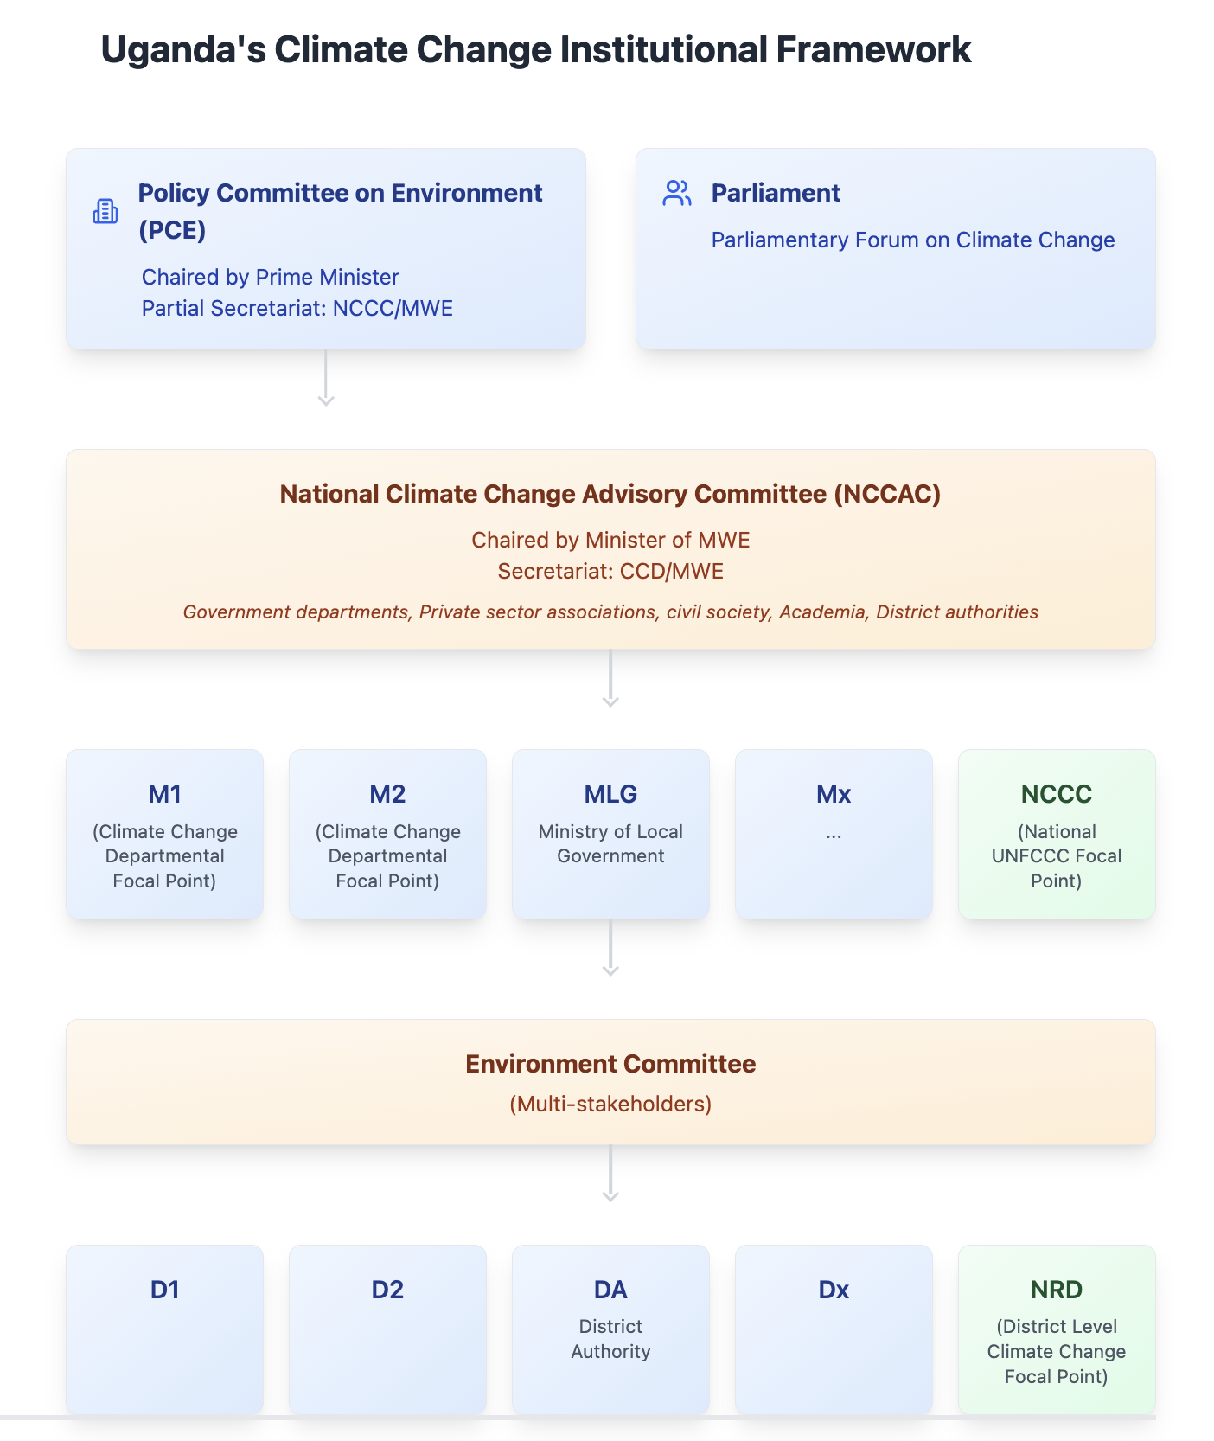

These arrangements were strengthened in the NCCA which specifies the role and responsibility of the Department responsible for climate change (Ministry of Water and the Environment), the Policy Committee on Environment (PCE), the National Climate Change Advisory Committee (NCCAC), the lead agencies involved in the climate activities, the District departments responsible for climate change, District committees responsible for climate change and the lower local government departments responsible for climate change.

Table 3-1: Roles and responsibilities of key institutions

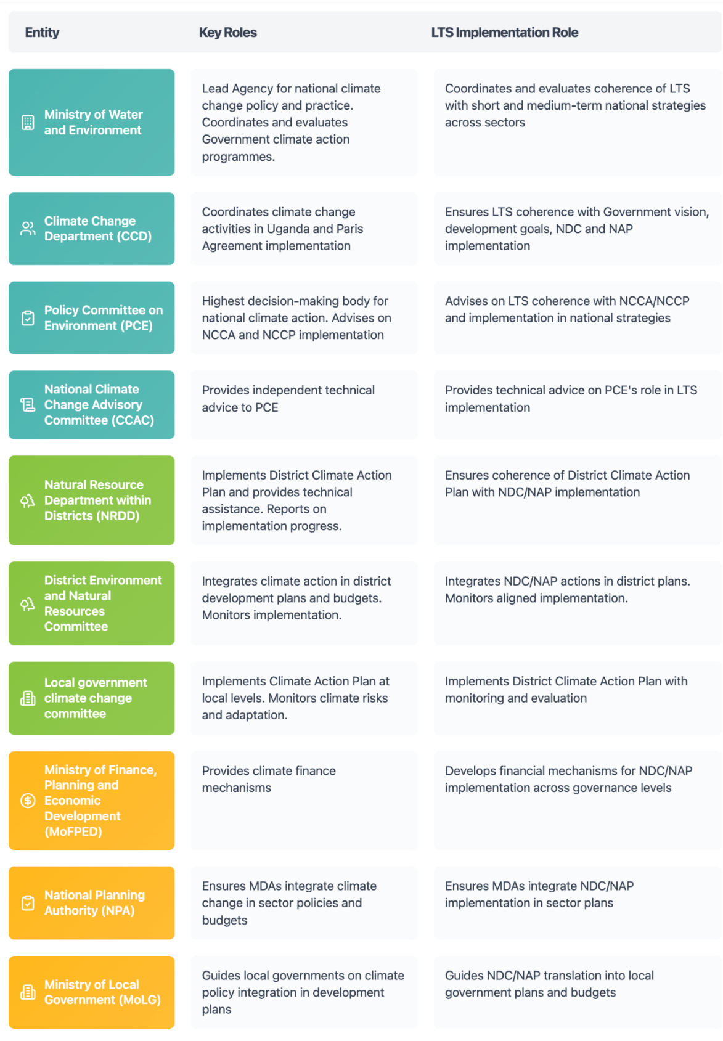

Engagement with local governments and non-state actors

Stakeholder engagement strategies
The successful implementation of the LTS depends on meaningful engagement with a wide range of stakeholders across Ugandan society. A comprehensive stakeholder engagement strategy ensures that all relevant voices are heard and that implementation benefits from diverse perspectives and expertise. Regular consultations provide opportunities for stakeholders to contribute to planning processes and share feedback on implementation progress.
Multi-stakeholder platforms facilitate ongoing dialogue and collaboration, while dedicated communication channels ensure that information flows effectively between implementing partners and affected communities. These engagement mechanisms are designed to be inclusive and accessible, ensuring that marginalized groups have opportunities to participate in decision-making processes.

Capacity building and awareness
Building capacity for climate action is a central element of the implementation strategy. Technical training programs enhance the skills and knowledge of government officials and implementing partners, while institutional strengthening initiatives improve organizational effectiveness and efficiency. These efforts focus on developing practical capabilities for climate action while building long-term institutional memory and expertise.
Public awareness and education programs play a crucial role in building support for climate action and enabling behavior change. These programs use diverse channels and approaches to reach different audiences, ensuring that climate information is accessible and relevant to local contexts. Knowledge sharing platforms facilitate learning across institutions and communities, accelerating the adoption of effective practices.

Private sector, academia and civil society roles
The private sector plays a vital role in implementing the LTS through investments in low-carbon technologies, innovation in climate solutions, and participation in market-based implementation mechanisms. Business engagement strategies focus on creating enabling conditions for private sector participation while ensuring that climate actions align with business interests and capabilities.
Academic institutions contribute through research and development support, technical analysis, and capacity building programs. Their work helps ensure that implementation decisions are based on sound evidence while building the knowledge base for future climate action. Civil society organizations facilitate community engagement, support implementation at the local level, and contribute to monitoring and accountability processes.

Monitoring, Reporting, and Verification
Monitoring and Evaluation are essential to ensure effectiveness and accountability of climate change actions. As described above, the LTS provides a framework for future decision-making, including short- and long-term plans, to ensure that Uganda’s development contributes to achievement of a low-carbon resilient future by 2050 and does not lead to unintended consequences.
As such, the monitoring and evaluation of mitigation and adaptation actions needs to be embedded into the processes and systems for the respective plans. The responsibilities for monitoring and evaluation the NCCAP and the DCCAPs along with any local plans, was described in Table 4-1.
The pillars and long-term actions of the strategy are designed to guide near- and medium-term implementation processes and be integrated into sectoral strategies, and district plans. The LTS is therefore operationalised through the development of short- medium-term actions which provide the ‘stepping-stones’ to the longer-term actions. These short- and medium-term actions will be captured in other climate plans, such as the NDC, the NCCAP, the DCCAPs and through the NAP process, as well as in sectoral plans. This is illustrated in the figure below.
Figure 22 Relationships between an LTS and other key elements of the Paris Agreement

The development of the LTS has already been done in parallel with the update of Uganda’s NDC. 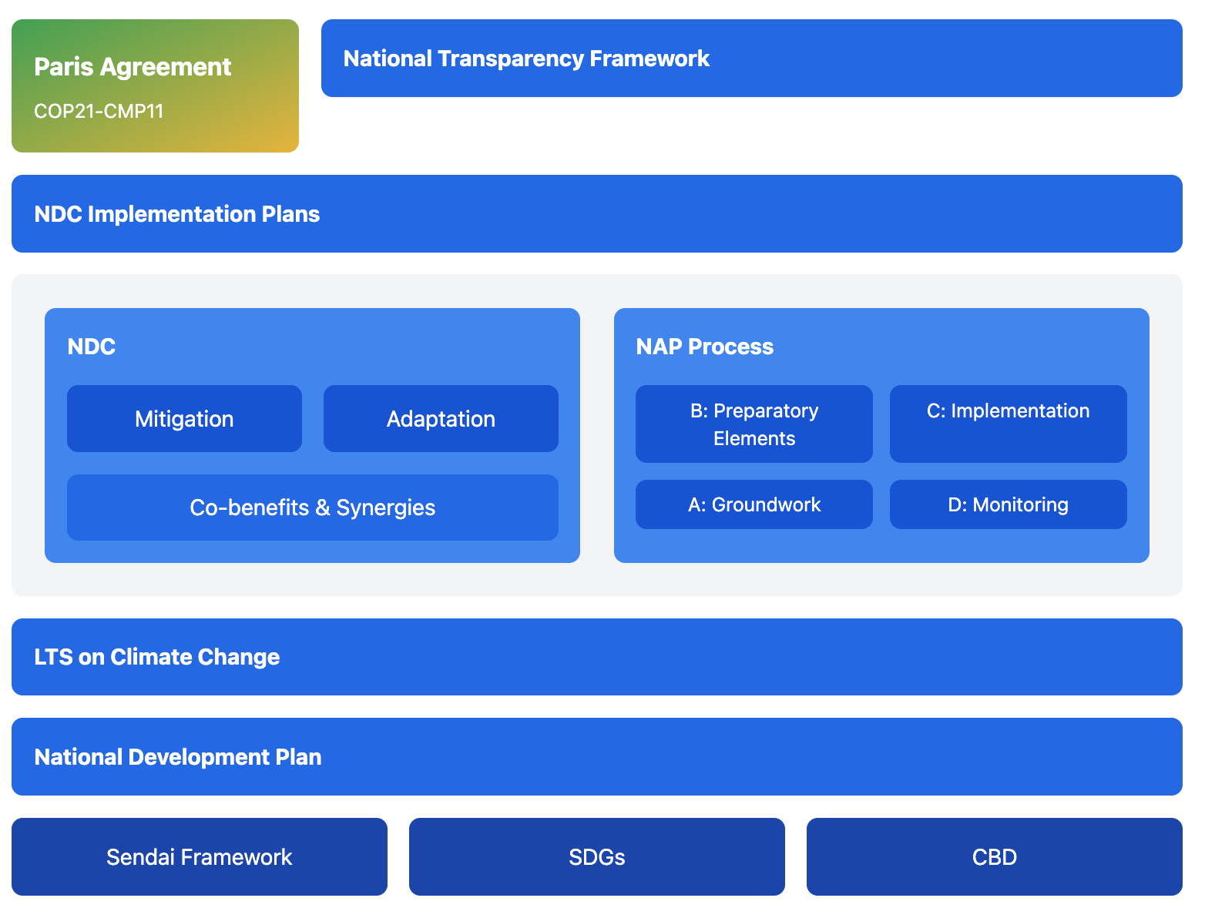

Indicators and milestones
The monitoring framework for the LTS incorporates comprehensive indicators to track progress toward both emissions reduction and adaptation objectives. These indicators are designed to capture both quantitative and qualitative aspects of implementation, providing a nuanced understanding of progress and impacts. Core metrics track emissions reductions across sectors, while adaptation indicators assess improvements in climate resilience and adaptive capacity.
The framework includes clear milestones for different time periods, allowing for regular assessment of progress and early identification of implementation challenges. Short-term targets focus on establishing necessary systems and initiating key actions, while medium- and long-term objectives track progress toward fundamental transformations in key sectors and systems.

Timeline and monitoring framework
The LTS monitoring framework operates as an integrated component of Uganda's national Measurement, Reporting and Verification (MRV) system, ensuring coherent tracking of both near-term climate actions and long-term transformational pathways. This integration leverages existing institutional structures while adding LTS-specific elements to capture progress toward net-zero targets.
Integration with National MRV Architecture. The framework builds upon Uganda's Climate Change Data Management System (CCDMS), adding a dedicated LTS module that interfaces with existing NDC and NAP tracking mechanisms. The Climate Change Department (CCD) coordinates this integration through established MRV focal points across 23 Ministries, Departments and Agencies (MDAs), utilizing existing data collection protocols while incorporating additional long-term indicators.
Multi-Temporal Monitoring Structure
Annual Monitoring Cycles: Synchronized with the national GHG inventory process, annual monitoring tracks 47 core LTS indicators across six thematic areas. These indicators overlap with 68% of existing NDC indicators, requiring only 15 additional data points specific to long-term transformation tracking. Sector MDAs submit data through standardized templates within the CCDMS, with automated quality assurance checks ensuring consistency with IPCC guidelines and national circumstances.
Biennial Reporting: Aligned with Uganda's Biennial Transparency Report (BTR) submissions, the framework generates progress assessments every two years. These reports integrate LTS achievement metrics with NDC implementation progress, utilizing the same verification procedures established for international reporting. The Natural Resource Departments within Districts (NRDDs) provide sub-national data inputs through the existing local government reporting mechanisms.
Five-Year Strategic Reviews: Comprehensive evaluations coincide with National Development Plan cycles and NDC revision periods, assessing progress toward 2050/2065 targets. These reviews examine 12 transformational change indicators not captured in shorter-term monitoring, including technology adoption rates, institutional capacity indices, and systemic behavior changes. The National Planning Authority (NPA) integrates findings into subsequent development planning processes, ensuring LTS objectives influence medium-term resource allocation.
Institutional Coordination Mechanisms. The Policy Committee on Environment (PCE) oversees strategic alignment between LTS monitoring outputs and policy adjustments, receiving quarterly briefings from the National Climate Change Advisory Committee (CCAC). Technical validation occurs through the existing MRV Technical Working Group, expanded to include three LTS-specific experts representing long-term modeling, transformational change assessment, and climate finance tracking.
Data Management and Quality Assurance. All LTS data flows through the national MRV portal, with automated integration to relevant reporting platforms including the UNFCCC reporting tools and climate finance tracking systems. Quality assurance follows the established three-tier verification process: self-assessment by data providers, technical review by sector experts, and final validation by the CCD. Long-term data series undergo additional trend analysis to identify anomalies and ensure consistency with projection models. The monitoring system operates on multiple timeframes to ensure both regular tracking of implementation progress and periodic assessment of strategic alignment. Annual monitoring processes provide frequent updates on key indicators and implementation progress, allowing for timely adjustments to implementation approaches. These are complemented by more comprehensive periodic reviews that assess broader trends and impacts. Five-year evaluation cycles align with national development planning processes and international reporting requirements, providing opportunities for strategic updates and course corrections. Long-term assessments examine progress toward transformational changes and help identify emerging challenges and opportunities that may require strategic adjustments.

Reporting and verification (roles)
Reporting and verification responsibilities are clearly defined across different levels of the implementation system. The Climate Change Department coordinates overall reporting processes, while sector ministries provide detailed information on implementation progress in their respective areas. Quality assurance processes ensure the reliability and consistency of reported information.
Local governments play a crucial role in gathering implementation data and verifying outcomes at the community level. Their reports provide essential ground-level information about implementation progress and challenges. External verification mechanisms, including independent assessments and third-party verification processes, enhance the credibility of reported results and support learning and improvement.

International cooperation

Participation in global climate initiatives
Uganda actively participates in global climate initiatives, recognizing that international cooperation is essential for achieving its climate objectives. This engagement includes active participation in UNFCCC processes, including implementation of the Paris Agreement and contribution to global stocktake exercises. Through these mechanisms, Uganda both contributes to and benefits from global climate action efforts.
The country engages with various global partnerships that provide access to climate finance, technology transfer, and capacity building support. These partnerships help Uganda access resources and expertise needed for implementation while sharing its own experiences and lessons learned with the global community.

Regional partnerships
Regional cooperation forms a crucial element of Uganda's implementation strategy, particularly through engagement with the East African Community and African Union mechanisms. These partnerships facilitate coordinated approaches to shared challenges, including management of transboundary resources and development of regional climate solutions.
Bilateral partnerships with other countries provide additional opportunities for technical exchange and resource sharing. These relationships support implementation through knowledge exchange, capacity building, and collaborative projects that address shared climate challenges.

Technology transfer and innovation
Technology cooperation focuses on identifying and addressing Uganda's specific technology needs for both mitigation and adaptation. This includes comprehensive assessment of technology requirements, development of capacity for technology adoption and maintenance, and support for implementation of new solutions.
Innovation support mechanisms encourage development and testing of locally appropriate climate solutions while facilitating access to global innovations. These efforts include support for research and development, pilot projects to test new approaches, and mechanisms to scale successful innovations. Knowledge exchange networks enable Uganda to learn from international experience while sharing its own innovations with other countries.
Through these various implementation mechanisms, Uganda aims to translate its climate ambitions into concrete action while building long-term capacity for climate response. Success depends on effective coordination across all levels of government, robust stakeholder engagement, and strong international partnerships. Regular monitoring and evaluation will ensure the strategy remains on track and adapts to changing circumstances while maintaining progress toward its long-term objectives.

Investment and Financing
Achieving Uganda's long-term climate objectives requires unprecedented mobilization of financial resources across all economic sectors. The investment framework presented here builds on the foundation established in Uganda's Updated NDC (2022), which identified USD 28.1 billion in climate finance needs through 2030, and extends the analysis through 2065 to align with the net-zero pathway.
The total investment requirement for implementing Uganda's Long-Term Strategy amounts to USD 462.7 billion over the period 2025-2065, comprising USD 325.3 billion for mitigation actions and USD 137.7 billion for adaptation measures. These investments, while substantial, represent essential capital allocation for sustainable development that yields multiple co-benefits including improved public health, energy security, and economic competitiveness.

Mitigation Investment Requirements
Mitigation investments focus on transforming Uganda's energy system, modernizing transport infrastructure, sustaining forest resources, and decarbonizing industrial processes. The investment trajectory reflects a front-loaded profile, with capital-intensive infrastructure development concentrated in the 2030s and 2040s, followed by maintenance and optimization phases.
Table 5 Mitigation Investment Requirements by Sector (USD Billions, 2023 prices)
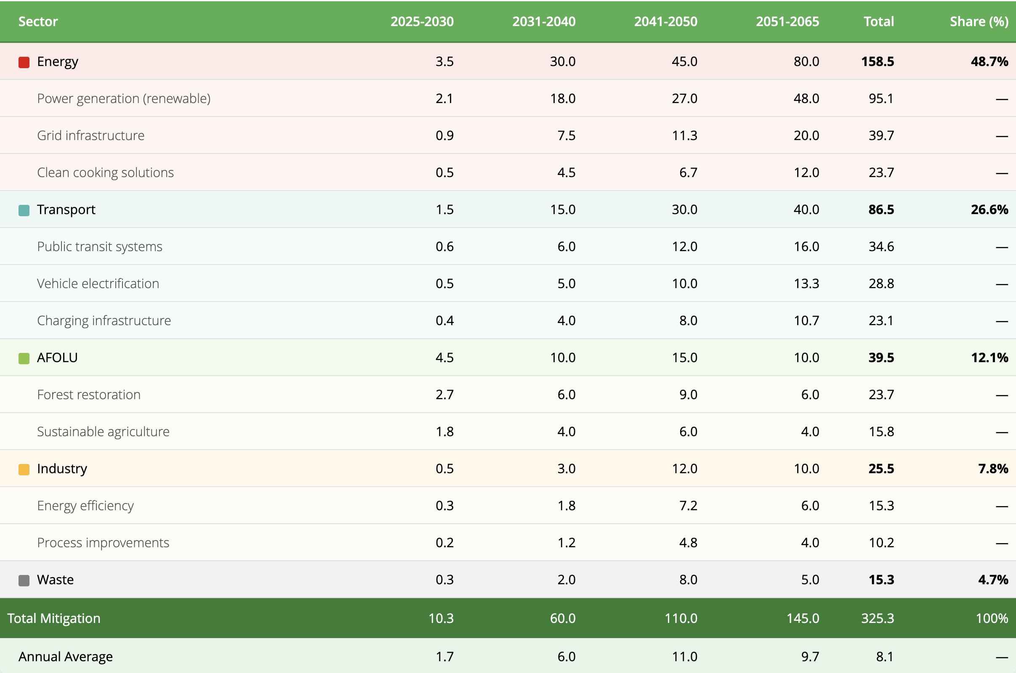
Key Investment Drivers and Assumptions
Energy Sector (48.7% of mitigation investment): The dominance of energy investments reflects Uganda's transition from a biomass-dependent economy to a modern renewable energy system. Investment requirements are moderated by projected technology cost reductions: solar PV costs declining by 50-70% by 2040, and battery storage achieving similar cost improvements. The NZE2065 scenario requires 30,376 MW of solar capacity and 7 TWh of storage by 2065.
Transport Sector (26.6% of mitigation investment): Investments accelerate rapidly post-2030 as electric vehicle technology achieves cost parity with conventional vehicles. The investment profile includes both public infrastructure (bus rapid transit, rail electrification) and private vehicle fleet transformation, with 100% electrification of new vehicles targeted by 2065.
AFOLU Sector (12.1% of mitigation investment): Front-loaded investments reflect the urgency of halting deforestation and establishing carbon sinks. The relatively lower share compared to other sectors demonstrates the cost-effectiveness of nature-based solutions, with investments of USD 39.5 billion potentially sequestering over 1.5 billion tonnes of CO₂ cumulatively.

Adaptation Investment Requirements
Adaptation investments follow an ascending trajectory, reflecting intensifying climate impacts and growing exposure of population and assets. Unlike mitigation, where technological maturation enables cost reductions, adaptation costs escalate as climate hazards worsen and early low-cost options are exhausted.

Table 6 Adaptation Investment Requirements by Sector (USD Billions, 2023 prices)
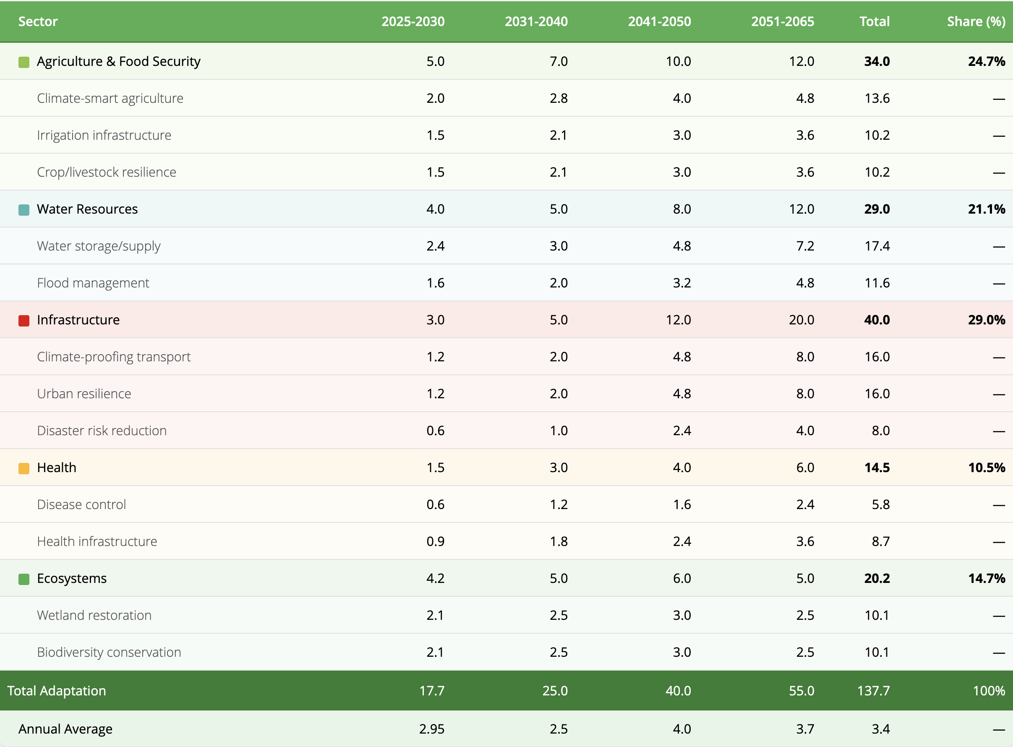
Critical Adaptation Considerations
Infrastructure (29.0% of adaptation investment): The largest share by 2065 reflects Uganda's transformation into an urbanized, infrastructure-dependent economy. Climate-proofing design standards add 5-15% to baseline infrastructure costs but prevent catastrophic losses from extreme events.
Agriculture and Water (45.8% combined): These foundational sectors require continuous investment to protect livelihoods and ensure water-food security for a population projected to exceed 104 million by 2060. Investments include both soft measures (early warning systems, climate-smart practices) and hard infrastructure (irrigation, flood defenses).
Ecosystem-based Adaptation (14.7%): Uganda's emphasis on nature-based solutions reflects their cost-effectiveness and multiple co-benefits. Wetland restoration alone can provide flood protection equivalent to engineered solutions at a fraction of the cost while supporting biodiversity and livelihoods.

Financing Strategy and Resource Mobilization
The scale of required investment—averaging USD 11.6 billion annually—necessitates a diversified financing approach combining domestic resources, international climate finance, and private sector engagement. Particular, initial international funding is essential to catalyze the investment required for the transformation.

Table 7 Climate Finance Sources by Period (Distribution of financing sources %)
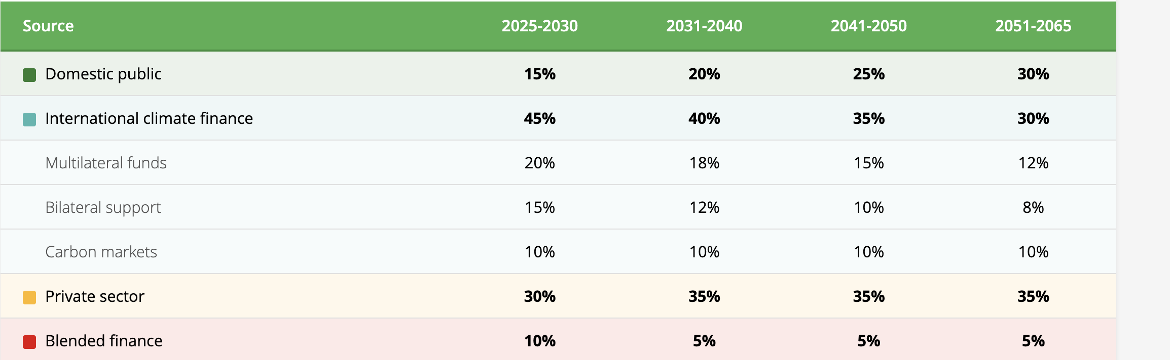
Implementation Priorities
- Near-term (2025-2030): Establish enabling frameworks for climate finance, including green bonds, carbon pricing mechanisms, and public-private partnership structures. Focus on high-impact, cost-effective measures in AFOLU and early renewable energy deployment.
- Medium-term (2031-2040): Scale infrastructure investments leveraging improved technology costs and growing domestic capacity. Transition from grant-dependent to investment-oriented financing as projects demonstrate commercial viability.
- Long-term (2041-2065): Maintain investment momentum while shifting toward maintenance and optimization. Leverage established carbon markets and mature clean technology markets for sustainable financing.
The investment plan's success depends on sustained political commitment, effective institutional coordination through the Climate Change Department, and Uganda's ability to access international climate finance at scale. Early action to establish robust monitoring and evaluation systems will ensure efficient resource allocation and demonstrate results to maintain investor confidence throughout the implementation period.

References
Baastel/ FAO. (2016). Cost Benefit Analysis (CBA) of Climate Change Adaptation and Prioritization in Agriculture, Environment and Water Sectors in Uganda. FAO.
Directorate of Relief, Disaster Preparedness and Refugees, Office of the Prime Minister (2010). The national policy for disaster preparedness and management. 89 p.
Government of Uganda (2007). Climate Change: Uganda National Adaptation Programmes of Action (NAPA) submitted to UNFCCC.
Ministry of Water and Environment, (2014). Uganda’s Second National Communication to the UNFCCC. Ministry of Water and Environment.
Government of Uganda (2015). National Climate Change Policy. Ministry of Water and Environment.
Government of Uganda (2020). Third National Development Plan 2020/21 - 2024/25. National Planning Authority. Kampala Uganda.
IPCC. (2014). Climate Change 2014 Synthesis Report Fifth Assessment. . https://ar5-syr.ipcc.ch/topic_summary.php#node145.
Ministry of Water and Environment, (2014). Uganda’s Second National Communication to the UNFCCC.
Ministry of Water and Environment (2015): Uganda’s Intended Nationally Determined Contribution (INDC). Accessible online: https://www4.unfccc.int/sites/ndcstaging/PublishedDocuments/Uganda%20First/INDC%20Uganda%20final%20%2014%20October%20%202015.pdf
Ministry of Water and Environment (2015). Economic Assessment of the impacts of climate change in Uganda. Final Report.
Ministry of Water and Environment, (2017). National REDD+ Strategy and Action Plan.
Ministry of Water and Environment (2022). Updated Nationally Determined Contribution (NDC). September, 2022. 69 p. Accessible online: https://unfccc.int/sites/default/files/NDC/2022-09/Updated%20NDC%20_Uganda_2022%20Final.pdf

Ministry of Water and Environment (2022). Uganda’s Third National Communication to the United Nations Framework Convention on Climate Change. July, 2022. 318 p. Accessible online: https://unfccc.int/documents/562307
National Planning Authority (2018). The Uganda Green Growth Development Strategy 2017/18 – 2030/31.
National Planning Authority (2010) Uganda Vision 2040.
Seneviratne et al. (2012). Changes in climate extremes and their impacts on the natural. Managing the Risks of Extreme Events and Disasters to Advance Climate Change Adaptation. . Retrieved from https://www.ipcc.ch/site/assets/uploads/2018/03/SREX-Chap3_FIN.
Stockholm Environment Institute (2016). Introducing the Transnational Climate Impacts Index: Indicators of country-level exposure – methodology report. Working Paper 2016-07. Available at: https://cdn.sei.org/wp-content/uploads/2016/06/introducing-the-transnational-climate-impacts-index-indicators-of-country-level-exposure-methodology-report.pdf
Trisos, C.H., I.O. Adelekan, E. Totin, A. Ayanlade, J. Efitre, A. Gemeda, K. Kalaba, C. Lennard, C. Masao, Y. Mgaya, G. Ngaruiya, D. Olago, N.P. Simpson, and S. Zakieldeen, 2022: Africa. In: Climate Change 2022: Impacts, Adaptation and Vulnerability. Contribution of Working Group II to the Sixth Assessment Report of the Intergovernmental Panel on Climate Change [H.-O. Pörtner, D.C. Roberts, M. Tignor, E.S. Poloczanska, K. Mintenbeck, A. Alegría, M. Craig, S. Langsdorf, S. Löschke, V. Möller, A. Okem, B. Rama (eds.)]. Cambridge University Press, Cambridge, UK and New York, NY, USA, pp. 1285–1455, doi:10.1017/9781009325844.011.
Uganda Bureau of Statistics (2019). National Population Projections by Single age and sex (2015-2040).
Uganda Bureau of Statistics (2020a). Leveraging Uganda’s Population Dynamics for a Resilient Future amidst COVID-1.
Uganda Bureau of Statistics (2020b). Statistical abstract 2020.
Uganda Bureau of Statistics (2021). Uganda National Household Survey, 2019/20.
Uganda Bureau of Statistics (2024). The National Population and Housing Census 2024 – Preliminary Report, Kampala, Uganda. 43 p.

UNFCCC/ The Republic of Uganda. (In draft). Long term low carbon, climate resilient agricultural development pathways for Uganda actions for meeting the goals of the Paris Agreement.
World Bank Group (2015). Uganda: Strategic Climate Diagnostics, World Bank Group
World Bank. (2015). Climate profile for Uganda. http://muccri.mak.ac.ug/sites/default/files/Publications/Climate%20Profile%20for%20Uganda.pdf.
World Bank. (2020). Climate risk country profile. https://climateknowledgeportal.worldbank.org/sites/default/files/2020-06/15464-WB_Uganda%20Country%20Profile-WEB_v1.pdf.
WWF (2015). Energy report for Uganda: A 100% renewable energy future by 2050

Appendices

Annex 1: Methodoloy framework for emission modelling
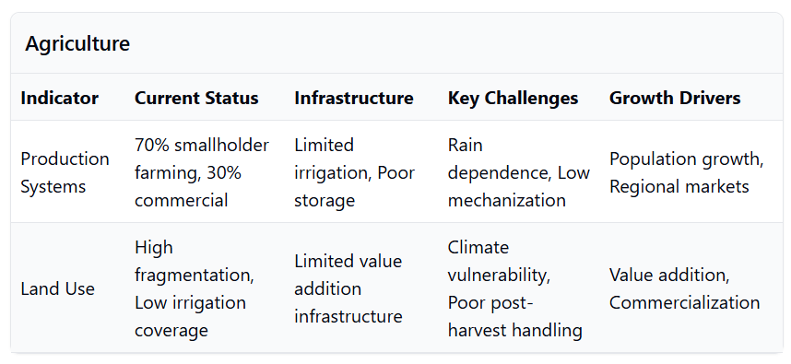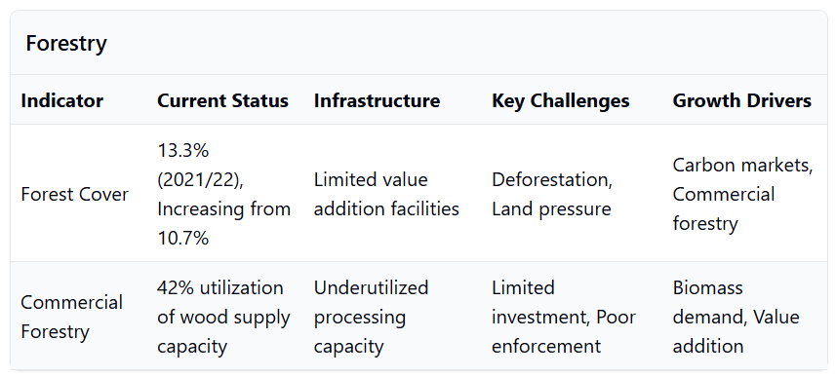
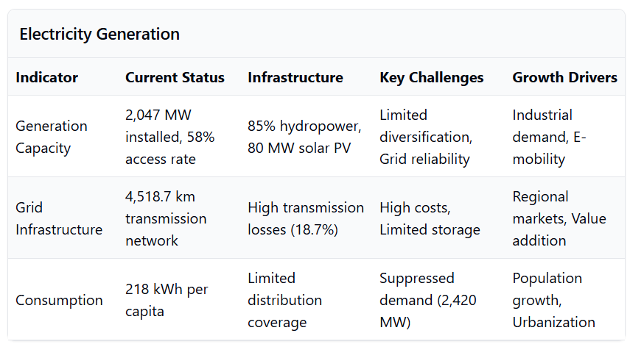
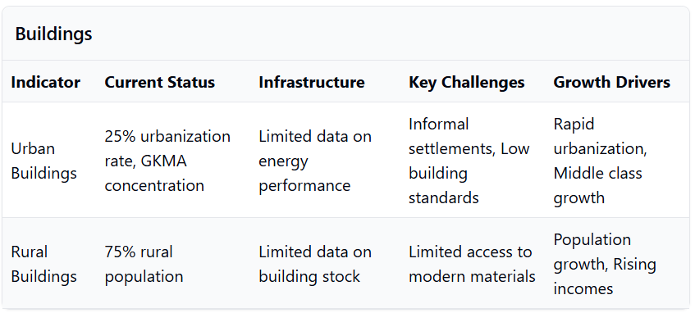
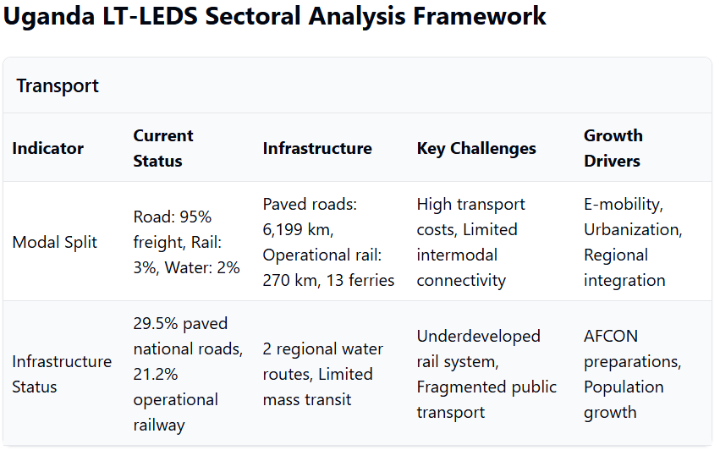
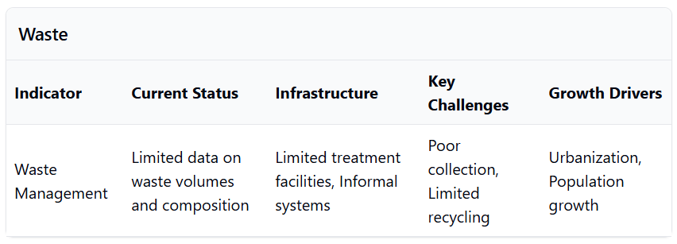
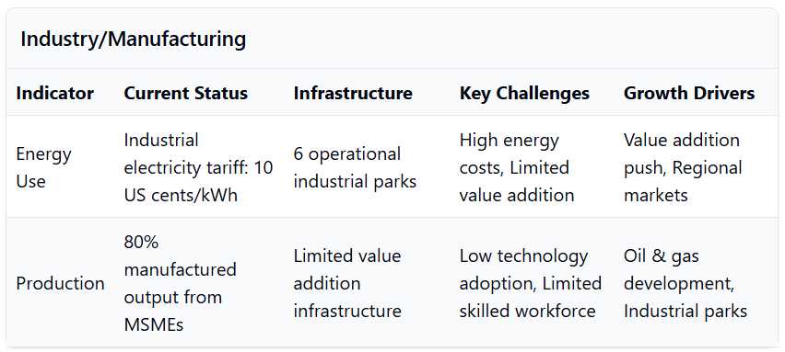

Annex 2: Policy Framwork Assessment Tables

NDP Integration
The LTS builds up on key element of the National Development Plans (NDP III and IV)
Table 1 Information of the NDP to the LT-LEDS
Structure Elements (from TS_Structure) | Relevant NDP Information and Data | How NDP Informs LT-LEDS
Introduction: 1.1.3 Role of the Long-Term Low Emission Development Strategy (LT-LEDS) | NDP acknowledges the importance of achieving the SDGs, which include climate action goals, and aims to be the final plan delivering on the 2030 Agenda. | This reinforces the need to align NDP IV with the LT-LEDS to ensure that development goals contribute to long-term climate objectives.
National Circumstances: 2.1 Economy (all sub-sections) | NDP prioritizes "higher household incomes and employment for sustainable socio-economic transformation," implying a continued focus on key economic sectors like agriculture, energy, and industry, all relevant to the LT-LEDS. The plan aims to transform the economy ten-fold to USD 500 billion over the next 15 years. | Information on these sectors will be crucial for understanding their current emissions profiles, identifying low-emission development opportunities, and assessing the potential impacts of climate change on economic activities.
Ambition and Vision: 3.1 Headline Ambition | NDP targets double-digit economic growth while emphasizing sustainability, indicating a commitment to achieving ambitious economic goals within environmental limits. | This ambition should be translated into specific low-emission development targets within the LT-LEDS, outlining the desired balance between economic growth and emissions reduction.
Strategic Framework: 4.1 Pathways and Scenarios | The introduction of Indicative Planning Figures (IPFs) in NDP aims for prudent resource allocation, suggesting a scenario-based approach to planning. | The LT-LEDS should consider these IPFs and develop scenarios that explore alternative low-emission development pathways, assessing their feasibility, costs, and benefits.
Strategic Framework: 4.2 Sector Transformations and Priorities | NDP emphasizes increasing production, productivity, and value addition in key sectors, including agriculture, minerals, oil & gas, tourism, and ICT. | The LT-LEDS should analyze these sectors, identifying opportunities for low-emission technologies, practices, and investments, promoting a shift towards a green economy.
Strategic Framework: 4.3 Finance and Investments | While details are pending, NDP will likely focus on financing mechanisms to support its ambitious development goals, including public and private investments. | The LT-LEDS should consider these financing mechanisms and develop strategies to mobilize resources for low-emission development projects, leveraging public funds, private capital, and international climate finance.
Sectoral Strategies: (all sectors) | Detailed sectoral strategies will be outlined in the NDP IV draft. | The LT-LEDS should build upon these strategies, incorporating climate considerations and identifying specific actions to reduce emissions, enhance resilience, and promote sustainable practices within each sector.
Implementation Plan: 6.2 Engagement with Local Governments and Non-State Actors | NDP emphasizes stakeholder engagement during the formulation process, indicating a commitment to participatory planning. | This participatory approach should be carried forward into the development and implementation of the LT-LEDS, ensuring that diverse perspectives are considered, and local communities are involved in climate action.

NDP Integration
The LTS builds up on key element of the NDC (NDC 2022)
Relevant elements from the latest NDC to inform the LT-LEDS
LT-LEDS Structure Element | Relevant NDC Information/Data | How NDC Informs LT-LEDS
Vision and Objectives | - Mitigation Target: 24.7% reduction below BAU by 2030  - Breakdown: 5.9% unconditional, 18.8% conditional  - Adaptation Focus: 13 priority sectors | Aligns LT-LEDS goals with more ambitious NDC targets, ensuring the vision supports enhanced climate ambitions and comprehensive adaptation strategies.
Emissions Projections | - Baseline Projection: 90.1 MtCO₂e in 2015  - Projected BAU Emissions: 148.8 MtCO₂e by 2030 | Updates LT-LEDS emissions baseline and future projections to reflect the latest official data, ensuring accuracy in climate planning and target setting.
Mitigation Targets | - Economy-wide Target: 24.7% below BAU by 2030  - Components: 5.9% unconditional, 18.8% conditional | Revises LT-LEDS mitigation goals to be more ambitious, incorporating both unconditional and conditional commitments from the NDC, thereby strengthening overall mitigation strategies.
Sectoral Coverage | - Included Sectors: Transport, Waste, Industrial Processes and Product Use (IPPU), energy and AFOLU  - Mitigation Potentials by 2030:  — Transport: 2.78 MtCO₂e  — Waste: 1.10 MtCO₂e  — IPPU: 0.14 MtCO₂e | Expands the scope of LT-LEDS to encompass additional sectors identified in the NDC, allowing for comprehensive mitigation strategies across all relevant industries and enhancing sectoral inclusivity.
Adaptation Priorities | - Number of Sectors: Expanded from 7 to 13  New Sectors: Fisheries, Tourism, Education  Focus Areas: Enhancing resilience of communities, infrastructure, and ecosystems | Broadens the focus of LT-LEDS adaptation measures, ensuring a more inclusive and resilient approach to climate impacts across diverse sectors, as emphasized in the updated NDC.
Financing Needs | - Total Financing Requirement: USD 28.1 billion to 2030  - Domestic Resources: USD 4.1 billion (15%)  - International Support: USD 24 billion (85%) | Updates financial planning in the LT-LEDS to reflect the latest estimates from the NDC, facilitating appropriate resource allocation, funding strategies, and prioritization of financial commitments.
Long-term Vision | - Goal: Transitioning to a low-carbon and climate-resilient economy by 2050 | Maintains and reinforces the overarching long-term goals, ensuring consistency between the LT-LEDS and NDC's future aspirations and providing a stable foundation for sustained climate action.
Institutional Arrangements | - Current Framework: Remains valid | Confirms that the existing institutional setup is sufficient, allowing for seamless integration of new updates from the NDC without the need for restructuring, thereby ensuring implementation stability.
Stakeholder Engagement | - - Approach: Whole-of-society consistent with NDC  - Participants: Government agencies, civil society, private sector | Reinforces the need for broad-based stakeholder involvement, enhancing collaborative efforts in climate action implementation and ensuring that strategies are well-supported and inclusive.
Gender Mainstreaming | - Focus: Gender-responsive climate action aligns with NDC | Ensures that gender considerations are integrated into the LT-LEDS, promoting inclusive and equitable climate strategies that address the needs and roles of all genders in climate resilience.
Monitoring and Reporting | - MRV System: Robust framework to track progress towards NDC targets | Integrates a comprehensive MRV system within the LT-LEDS to ensure transparency, accountability, and informed policymaking, facilitating ongoing assessment and adjustment of climate strategies.
Sectoral Mitigation Actions | - Energy: Transition to renewables, improve efficiency, reduce biomass reliance  - Agriculture (AFOLU): Sustainable practices, reforestation, afforestation  - Waste: Recycling, composting, waste-to-energy technologies  - IPPU: Cleaner technologies  - Transport: Public transport, non-motorized transport, electric vehicles | Details specific mitigation actions for each sector, providing actionable strategies and measurable targets that inform the LT-LEDS's sectoral plans and interventions, ensuring targeted and effective outcomes.

Energy Policy Integration
The LTS builds up on key element of the NDC (NDC III and IV)
The LTS builds upon Uganda's Energy Policy, particularly the Energy Policy document from 2023, which sets a clear roadmap for the country's energy sector development and especially in alignment with the LTS. Key elements from the Energy Policy, particularly the objectives and specific targets, have been incorporated into the LTS to ensure that Uganda's long-term strategy is both comprehensive and aligned with national goals.
The following table delineates how specific elements of the LT-LEDS structure are informed by Uganda’s Energy Policy:
Relevant elements from the Energy Policy to inform the LT-LEDS
LT-LEDS Structure Element | Relevant Energy Policy Information and Data | How the Energy Policy Informs LT-LEDS
Introduction | - Overview of Uganda's energy landscape, Policy Vision: Achieve universal access to sustainable, affordable, and quality energy services by 2040.  - Mission: Ensure reliable, equitable, efficient, and environmentally sustainable development, management, and utilization of energy resources and services.  - Foundational role of Energy Policy in guiding energy initiatives. | Establishes the foundational context and alignment of LT-LEDS with national energy objectives.
National Circumstances | - Economic growth: Uganda’s GDP has grown at an average of 4.5% annually since 2010.  - Population dynamics: Population projected to reach 100 million by 2050.  - Current energy statistics: Installed capacity at 1,378.1 MW, peak demand 850 MW, 57% electricity access (19% on-grid, 38% off-grid).  - Climate context: Vulnerability to climate change affects hydropower reliability. | Provides a comprehensive understanding of the socio-economic and environmental backdrop for the LT-LEDS.
Ambition and Vision | - Economic growth: Uganda’s GDP has grown at an average of 4.5% annually since 2010.  - Population dynamics: Population projected to reach 100 million by 2050.  - Current energy statistics: Installed capacity at 1,378.1 MW, peak demand 850 MW, 57% electricity access (19% on-grid, 38% off-grid).  - Climate context: Vulnerability to climate change affects hydropower reliability. | Guides the long-term ambitions of LT-LEDS to align with national energy aspirations.  Ensures that LT-LEDS is driven by Uganda’s overarching Vision 2040 and Sustainable Development Goals, fostering a unified development trajectory.
Strategic Framework | - Economic growth: Uganda’s GDP has grown at an average of 4.5% annually since 2010.  - Population dynamics: Population projected to reach 100 million by 2050.  - Current energy statistics: Installed capacity at 1,378.1 MW, peak demand 850 MW, 57% electricity access (19% on-grid, 38% off-grid)  - Climate context: Vulnerability to climate change affects hydropower reliability. | Forms the strategic pillars of the LT-LEDS, ensuring that energy strategies support emission reduction.
Sectoral Strategies | - Detailed strategies for energy generation, transmission, distribution, and renewable energy development.  Policies on nuclear energy and emerging resources. | Directly informs the sector-specific actions and targets within the LT-LEDS, ensuring integrated policy implementation.
Finance and Investments | - Emphasis on attracting private investment, leveraging Public-Private Partnerships (PPPs), sustainable financing mechanisms.  - Financial incentives and innovative financing models for renewable energy projects.  - Specific targets: Increase electricity generation capacity to 52,481 MW by 2040.  - Investment Cost Estimates: Detailed in policy targets. | Shapes the financial strategies within LT-LEDS to ensure funding aligns with sustainable and low-emission goals.
Implementation Plan | - Institutional arrangements: Roles of Ministry of Energy and Mineral Development, Electricity Regulatory Authority (ERA), Uganda National Electricity Company (UNEC), Atomic Energy Council (AEC).  - Coordination mechanisms among key agencies.  - Roles of central and local governments, private sector, and development partners.  - Implementation Drivers: Competency, Organization, Leadership. | Ensures that LT-LEDS has a clear implementation roadmap supported by robust institutional frameworks.
Monitoring, Reporting, and Verification (MRV) | - Key performance indicators, monitoring frameworks, and evaluation strategies.  Regular assessment based on specific targets. | Provides the metrics and processes for tracking progress and evaluating the effectiveness of LT-LEDS initiatives.
Cross-Cutting Themes | - Gender mainstreaming, health andoccupational safety, climate resilience, and social safeguards.  Inclusive and sustainable development themes. | Integrates vital social and environmental considerations into the LT-LEDS, promoting inclusive and sustainable development.
Conclusion | - Summary of key strategies, outcomes, and next steps for energy sector development.  Alignment with Vision 2040 and SDGs. | Offers a cohesive wrap-up that ensures LT-LEDS objectives are sustainably anchored in policy outcomes.

Energy Transition Plan
The LTS builds up on key element of the NDC (NDC III and IV)
The LTS builds upon Uganda's Energy Policy, particularly the Energy Policy document from 2023, which sets a clear roadmap for the country's energy sector development and especially in alignment with the LTS. Key elements from the Energy Policy, particularly the objectives and specific targets, have been incorporated into the LTS to ensure that Uganda's long-term strategy is both comprehensive and aligned with national goals.

The following table delineates how specific elements of the LT-LEDS structure are informed by Uganda’s Energy Policy:
LEDS structure and ETP
Structure Elements | Relevant ETP Information and Data | How the ETP Informs LT-LEDS
Introduction | The ETP establishes Uganda's strategic vision for transforming its energy sector to support sustainable economic growth and reduce emissions. It highlights the country's commitment to achieving universal energy access and transitioning to a diversified, low-carbon energy mix. | Provides the foundational context and strategic objectives for the LT-LEDS, ensuring that Uganda's long-term energy and climate goals are aligned with its development trajectory. The ETP’s genesis and role in shaping national energy policies underscore its relevance to the LT-LEDS framework.
National Circumstances | Detailed overview of Uganda’s economy, population growth, energy resources, and current energy consumption patterns. ETPP Excel data shows significant projections for energy demand across various sectors from 2010 to 2050. | Integrates socio-economic and energy sector-specific data into the LT-LEDS, enabling evidence-based planning and prioritization of strategies. Understanding national circumstances ensures that the LT-LEDS is tailored to Uganda’s unique developmental and energy needs.
Ambition and Vision | ETP’s vision includes achieving universal energy access by 2030, net-zero emissions by 2065, and positioning Uganda as a regional energy hub. The plan outlines ambitious targets for electricity generation from renewable sources and emphasizes the integration of advanced technologies like hydrogen-based steel production and CCUS. | Aligns the LT-LEDS’s ambition with the ETP’s long-term vision, reinforcing the commitment to inclusive, sustainable, and low-carbon development. The ETP’s clear targets and strategic directions shape the overarching goals and provide a roadmap for the LT-LEDS’s objectives.
Energy Supply Pathways and Scenarios | ETP outlines multiple scenarios including the main ETP scenario, Regional Energy Hub Case (REHC), and No Nuclear Case (NNC). Each scenario details different pathways for energy generation, diversification, and emission trajectories. The ETPP provides specific data points on energy supply and demand projections under each scenario. | Offers diverse pathways for energy supply within the LT-LEDS, allowing for adaptive and flexible strategies that can respond to different future conditions and uncertainties. Incorporating these scenarios ensures that the LT-LEDS remains resilient and can accommodate various development and technological outcomes.
Sectoral Strategies | Comprehensive strategies for key sectors: Energy (electricity access and generation), Transport (vehicle electrification and efficiency), Buildings (energy efficiency and clean building standards), Industry (energy efficiency and low-emission technologies), Agriculture (bioenergy and sustainable practices), Forestry and Land Use (conservation and restoration), Waste Management (circular economy approaches). Each includes specific targets and investment needs as per ETP and ETPP data. | Ensures that the LT-LEDS addresses each major sector's specific challenges and opportunities, providing tailored policies and measures. By integrating ETP’s sectoral strategies, the LT-LEDS can foster coordinated and sector-specific interventions that collectively drive Uganda’s low-emission development.
Strategic Framework | ETP includes quantitative analyses of future technology and emissions scenarios, impact assessments of policies and measures, estimates of investment needs, and policy recommendations for each sector. It emphasizes the importance of assumptions, choices, and trade-offs in shaping the energy transition. | Utilizes ETP’s strategic framework to guide the LT-LEDS’s approach to technology adoption, policy formulation, and investment planning. The thorough analysis facilitates the development of a robust and evidence-based strategic framework within the LT-LEDS, ensuring informed decision-making and effective implementation of low-emission strategies.
Finance and Investments | The ETP outlines a need for approximately USD 8 billion annually by the end of the decade, focusing on renewable energy projects, electricity access, and clean cooking solutions. It highlights the importance of mobilizing public and private sector investments, international climate finance, and innovative financing models to meet these investment requirements. | Informs the LT-LEDS’s financial strategies by providing detailed investment needs and sources. The emphasis on diversified funding sources and innovative financing models from the ETP ensures that the LT-LEDS incorporates robust financial planning to secure the necessary resources for energy transition initiatives.
Implementation Plan | ETP discusses institutional and legal arrangements, stakeholder engagement, investment mobilization, and monitoring frameworks. It emphasizes the necessity of periodic reviews and adaptability based on implementation experiences and technological advancements. | Forms the basis for the LT-LEDS’s implementation strategy, detailing the necessary steps, responsible institutions, and monitoring mechanisms. The focus on adaptability and periodic reviews ensures that the LT-LEDS remains responsive to evolving challenges and can incorporate lessons learned from the ETP’s implementation phase.
Cross-Cutting Themes | ETP identifies equity and fairness, education and capacity building, and international cooperation as essential cross-cutting themes. It emphasizes the importance of inclusive participation, enhancing human capital, and strengthening regional and international partnerships to support Uganda’s energy transition and low-emission development objectives. | Ensures that the LT-LEDS incorporates these cross-cutting themes, promoting an equitable and inclusive energy transition. Addressing equity and capacity building enhances social acceptance and effectiveness of low-emission strategies, while international cooperation facilitates access to technology, finance, and best practices.
Conclusion | ETP summarizes key strategies, calls to action, and Uganda’s commitment to sustainable development and global climate goals. It reinforces the importance of coordinated efforts from government, private sector, and civil society to achieve the outlined objectives and ensure a resilient and low-carbon energy future. | Reinforces the LT-LEDS’s conclusion by aligning it with the ETP’s commitments and strategies. Emphasizes the need for collaborative efforts and sustained commitment to achieving sustainable and low-emission development, ensuring that the LT-LEDS addresses both immediate and long-term energy and climate challenges.
 | ETP includes detailed tables, data sources, methodological notes, and additional information supporting the analysis and projections, including:
 | Comprehensive list of references and sources used in the ETP, including data from the IEA, Uganda’s Ministry of Energy and Mineral Development, and other stakeholders. | Ensures that the LT-LEDS is grounded in credible and authoritative sources, enhancing its legitimacy and reliability. Encourages the inclusion of a robust references section in the LT-LEDS to support evidence-based decision-making and policy formulation.

Other Policies
Policy alignment for the LT-LEDS update
Policy Name | Year | Key elements | Information for LT-LEDS
Renewable Energy Policy | 2007 | - Increase the share of renewable energy in the energy mix  - Promote the development of renewable energy technologies  - Enhance rural electrification and access for the urban poor.  - Mainstream gender and poverty issues in energy development. | - Integrate Renewable Energy Targets: The LT-LEDS should set ambitious targets for increasing the share of renewables in the energy mix, aligning with the policy objectives.  - Technology Promotion: Include strategies to support research, development, and deployment of renewable energy technologies.  - Rural Electrification: Prioritize renewable energy solutions for rural areas to enhance access and reduce emissions.  - Gender and Poverty Mainstreaming: Ensure that LT-LEDS actions are inclusive, addressing gender disparities and targeting poverty reduction through energy projects.
National Climate Change Policy | 2015 | - Enhance Uganda's resilience to climate change impacts.  - Promote sustainable development through climate adaptation and mitigation strategies.  - Foster stakeholder engagement in climate action initiatives. | - Adaptation: Incorporate adaptation measures across all sectors to enhance resilience  - Sustainable Development Integration: Align mitigation strategies with sustainable development goals, ensuring that economic growth is achieved with minimal environmental impact.  - Stakeholder Engagement: Develop mechanisms within the LT-LEDS for continuous stakeholder involvement, ensuring that policies are informed by diverse perspectives.
Vision 2040 | 2013 | - Transform Uganda from a low-income to an upper-middle-income country by 2040.  - Improve infrastructure, human capital, and governance.  - Promote sustainable development and equitable distribution of resources. | - Alignment with National Goals: Ensure that the LT-LEDS supports the economic transformation goals by promoting low-carbon pathways that contribute to GDP growth.  - Infrastructure Development: Advocate for green infrastructure investments, such as energy-efficient buildings and sustainable transport systems.  - Equity Considerations: Incorporate policies that promote equitable access to resources and benefits from low-emission development.
National Agricultural Policy | 2013 | - Improve agricultural productivity and food security.  - Promote sustainable agricultural practices.  - Enhance access to agricultural markets and services. | - Climate-Smart Agriculture: Integrate climate-smart agriculture practices into the LT-LEDS to reduce emissions and enhance resilience.  - Sustainable Practices: Encourage adoption of sustainable land use, soil conservation, and water management techniques.  - Market Access: Support the development of value chains for sustainably produced agricultural products, enhancing livelihoods and reducing poverty.
National Land Policy | 2013 | - Promote equitable access to land and secure land tenure.  - Enhance land use planning and management.  - Ensure sustainable land resource management. | - Land Use Planning: Incorporate land use planning in the LT-LEDS to optimize land for conservation, agriculture, and development while minimizing emissions.  - Secure Tenure: Recognize the role of secure land tenure in enabling investment in sustainable practices.  - Sustainable Management: Promote policies that prevent deforestation and land degradation, contributing to emission reductions from the AFOLU sector.
National Health Policy | 2010 | - Improve access to quality health services.  - Promote health education and disease prevention.  - Strengthen health systems and infrastructure. | - Health Co-benefits: Emphasize the health benefits of mitigation actions, such as reduced air pollution leading to lower respiratory diseases.  - Health Infrastructure: Promote the development of climate-resilient health infrastructure within the LT-LEDS.  - Public Awareness: Include educational campaigns on the health impacts of climate change and the importance of mitigation and adaptation measures.
Health – National Adaptation Plan 2024 |  | - TBD | - TBD
National Irrigation Policy | 2017 | - Promote sustainable irrigation practices  - Enhance water resource management for agriculture.  - Improve food security through irrigation development. | - Efficient Water Use: Encourage efficient irrigation technologies to reduce energy consumption and enhance water conservation.  - Water Management: Integrate water resource management strategies into the LT-LEDS to address climate-induced water scarcity.  - Agricultural Resilience: Support irrigation practices that increase crop yields and resilience to climate
National Forestry Policy | 2001 | - Promote sustainable forest management and conservation.  - Enhance community participation in forestry management.  - Increase forest cover and biodiversity conservation. | - Forest Conservation: Establish targets for reducing deforestation and increasing afforestation/reforestation efforts.  - Community Engagement: Involve local communities in forest management to ensure sustainable outcomes.  - Carbon Sequestration: Recognize forests as critical carbon sinks and incorporate measures to enhance their capacity within mitigation strategies.
National Biodiversity Strategy and Action Plan | 2016 | - Protect and conserve Uganda's biodiversity.  - Promote sustainable use of biological resources.  - Enhance community involvement in biodiversity conservation efforts. | - Biodiversity Protection: Align LT-LEDS actions with biodiversity conservation to prevent habitat loss due to climate change impacts.  - Ecosystem Services: Acknowledge the role of biodiversity in providing ecosystem services that support mitigation and adaptation.  - Community Involvement: Strengthen community-based conservation initiatives within LT-LEDS to enhance local stewardship of natural resources.
National Climate Change Act^{[1]} | 2021 | - Provide a legal framework for climate change adaptation and mitigation.  - Establish mechanisms for compliance and emissions trading.  - Facilitate climate change financing and incentives for adaptation measures. | - Legal Compliance: Ensure that LT-LEDS strategies are compliant with the Act's provisions, providing a legal basis for implementation.  - Emissions Trading Mechanisms: Explore the development of carbon markets as part of the LT-LEDS financial strategies.  - Financing Mechanisms: Leverage financial incentives and funding opportunities outlined in the Act to support LT-LEDS initiatives.
Uganda Green Growth Development Strategy^{[2]} | 2017 | - Promote sustainable economic growth through green initiatives.  - Enhance resource efficiency and reduce environmental impacts.  - Foster innovation and investment in green technologies. | - Green Growth Integration: Embed green growth principles into LT-LEDS to drive sustainable economic development.  - Resource Efficiency: Implement measures to improve energy and material efficiency across sectors.  - Innovation and Technology: Support research and development of green technologies, encouraging private sector investment and public-private partnerships within the LT-LEDS framework.

^{[1]} National Climate Change Act (2021):
https://media.ulii.org/media/legislation/75186/source_file/3ac4235934e609c0/2021-nn.pdf
^{[2]} Uganda Green Growth Development Strategy (2017):
https://climate-laws.org/document/uganda-green-growth-development-strategy-2017-2018-2030-2031_7e67

Policy Integration
The table below shows the mapping for the integration of the different policies into the LT-LEDS.
Policy Name | Policy Objectives | LT-LEDS Components Informed | LT-LEDS Actions
Uganda's Updated NDC (2022) | - Reduce GHG emissions by 24.7% below BAU by 2030 (5.9% unconditional, 18.8% conditional)  - Enhance resilience across 13 priority sectors | - Ambition and Vision (Chapter 3)  - Sectoral Strategies (Chapter Mitigation Targets and Pathways  - Adaptation and Resilience Pillar | - Set economy-wide and sector-specific emission reduction targets aligned with NDC goals  - Develop low-carbon scenarios consistent with NDC commitments  - Integrate adaptation measures across all sectors  - Establish MRV systems in line with NDC requirements
Energy Policy for Uganda (2023) | - Achieve universal access to sustainable energy by 2040  - Increase renewable energy generation  - Improve energy efficiency | - Energy Sector Strategy (Chapter 5.1)  - Finance and Investments (Chapter 4.3)  - Strategic Framework  - Implementation Plan | - Expand renewable energy infrastructure  - Implement energy efficiency measures in industry and buildings  - Mobilize investments for clean energy projects  - Promote off-grid solutions for rural electrification
Energy Transition Plan (ETP) | - - Transition to a low-carbon energy system  - Achieve net-zero emissions in the energy sector by 2065  - Mobilize USD 8 billion annually | - Pathways and Scenarios (Chapter 4.1)  - Finance and Investment Mobilization (Chapter 6.3)  - Energy Sector Transformation | - Develop detailed energy transition scenarios  - Formulate investment plans for energy projects  - Encourage private sector participation  - Integrate advanced technologies like CCUS and energy storage
National Development Plan IV (NDP IV) | - Achieve higher household incomes and employment  - Sustainably industrialize for inclusive growth  - Enhance infrastructure and human capital | - National Circumstances (Chapter 2)  - Ambition and Vision (Chapter 3)  - Industry and Manufacturing Strategy (Chapter 5.4)  - Cross-Cutting Themes | - Align LT-LEDS targets with economic development goals  - Promote sustainable industrial practices  - Invest in human capital development  - Address social inclusion and gender equity in climate actions
National Climate Change Policy (2015) | - Enhance resilience to climate impacts  - Promote low-carbon development  - Integrate climate change into national planning | - Adaptation and Resilience Pillar (Chapter 4.4)  - Institutional Arrangements (Chapter 6.1)  - Implementation Plan | - Incorporate adaptation strategies across sectors  - Strengthen institutional frameworks for climate action  - Mainstream climate considerations in all development policies
Renewable Energy Policy (2007) | - Increase the share of renewable energy  - Promote private sector investment in renewables  - Enhance energy access | - Energy Sector Strategy (Chapter 5.1)  - Finance and Investments (Chapter 4.3)  - Implementation Plan | - Provide incentives for renewable energy investment  - Develop policies to support renewable energy market  - Implement rural electrification programs using renewables
National Agricultural Policy (2013) | - Improve agricultural productivity  - Promote sustainable agricultural practices  - Enhance market access | - Agriculture Sector Strategy (Chapter 5.5)  - Cross-Cutting Themes (Equity and Fairness)  - Finance and Investments | - Implement climate-smart agriculture practices  - Support smallholder farmers with training and resources  - Develop value chains for sustainable agricultural products
National Forestry Policy (2001) | - Promote sustainable forest management  - Increase forest cover  - Enhance community participation | - Forestry and Land Use Strategy (Chapter 5.6)  - Cross-Cutting Themes (Community Engagement)  - Adaptation and Resilience Pillar | - Implement afforestation and reforestation programs  - Involve communities in forest conservation  - Develop policies to prevent deforestation and illegal logging
Uganda Green Growth Development Strategy (2017) | - - Promote sustainable economic growth  - Enhance resource efficiency  - Foster innovation in green technologies | - Strategic Framework (Chapter 4)  - Industry and Manufacturing Strategy (Chapter 5.4)  - Finance and Investment Mobilization | - Encourage eco-innovation and clean technologies  - Implement resource efficiency programs in industry  - Provide financial incentives for green initiatives
National Climate Change Act (2021) | - Provide legal framework for climate action  - Establish compliance mechanisms  - Facilitate climate finance | - Institutional and Legal Arrangements (Chapter 6.1)  - Monitoring, Reporting, and Verification (Chapter 6.4)  - Finance and Investments | - Align LT-LEDS actions with legal requirements  - Develop MRV systems as mandated by the Act  - Access climate finance opportunities through established mechanisms

MINISTRY OF WATER AND ENVIRONMENT
P.O. Box 20026, Kampala, Uganda Tel: +256 414 505 942
Website: www.mwe.go.ug

Report of the Conference of the Parties on its twenty-first session, held in Paris from 30 November to 11 December 2015. Addendum. Part two: Action taken by the Conference of the Parties at its twenty-first session. (unfccc.int).
As of 15 January 2025 (https://unfccc.int/process/the-paris-agreement/long-term-strategies)
Ministry of Water and Environment (2022). Updated Nationally Determined Contribution (NDC). 69 p.
Directorate of Relief, Disaster Preparedness and Refugees, Office of the Prime Minister (2010). The national policy for disaster preparedness and management. 89 p.
Trisos, C.H., I.O. Adelekan, E. Totin, A. Ayanlade, J. Efitre, A. Gemeda, K. Kalaba, C. Lennard, C. Masao, Y. Mgaya, G. Ngaruiya, D. Olago, N.P. Simpson, and S. Zakieldeen, 2022: Africa. In: Climate Change 2022: Impacts, Adaptation and Vulnerability. Contribution of Working Group II to the Sixth Assessment Report of the Intergovernmental Panel on Climate Change [H.-O. Pörtner, D.C. Roberts, M. Tignor, E.S. Poloczanska, K. Mintenbeck, A. Alegría, M. Craig, S. Langsdorf, S. Löschke, V. Möller, A. Okem, B. Rama (eds.)]. Cambridge University Press, Cambridge, UK and New York, NY, USA, pp. 1285–1455, doi:10.1017/9781009325844.011.
Uganda Bureau of Statistics (2024) - National Population and Housing Census 2024 Final Report; World Bank Climate Risk Country Profile Uganda (2021); PreventionWeb Climate Risk Country Profile Uganda; Uganda Updated NDC (2022); PIK-Potsdam Climate Risk Analysis Uganda (2020); GIZ Climate Risk Profile Uganda (2021); Uganda Flood Risk Assessment (FAO 2023); ESD Copernicus Lake Victoria Floods Study (2024); MDPI Flood Vulnerability Eastern Uganda (2022); KRSU Indigenous Early Warning Karamoja (2023)
ND-GAIN Country Index, available at https://gain-new.crc.nd.edu/country/uganda#:~:text=The%20high%20vulnerability%20score%20and,a%20great%20urgency%20for%20action.
Some crops have a lower sensitivity, such as sweet potatoes, Irish potatoes and cassava.
Scores were provided from 0 to 5, 5 representing the highest level of vulnerability and/or risk. As these are economic sectors, “forests” are included as part of the “ecosystems”, while “forestry” refers to the economic activity enabled by forests, such as timber trade, etc.
Uganda Bureau of Statistics (2024). The National Population and Housing Census 2024 – Preliminary Report, Kampala, Uganda. 43 p.
Source: UBOS and NFA, 2019 (https://www.ubos.org/explore-statistics/14/).
Source: Uganda Energy Transition Plan - National Renewable Energy Platform
Energy Policy for Uganda (2023): https://www.globalrightsalert.org/sites/default/files/2024-02/Energy%20Policy%20for%20Uganda%202023-14082023docx_230911_114502%20%281%29.pdf
Energy Transition Plan (ETP): https://www.iea.org/reports/uganda-energy-transition-plan
Ministry of Health (2024) Health – National Adaptation Plan (H-NAP) 2025-2030, Kampala, Government of Uganda
UDB-CFF-Brochure_14042023.pdf
BloombergNEF (2024) Battery Price Survey; IEA Global EV Outlook 2024
UNEP (2024) "Sustainable Transport Solutions for East African Cities"; operational data from regional e-mobility operators
Uganda Bureau of Statistics (2024) Vehicle Registration Database; National Transport Master Plan projections
African Development Bank (2023) "Balancing Development Priorities in Transport Sector Transformation"
NDC (2022).

