BSc Honours in Information Technology
Software Engineering
  - SE3110 Quality Management in Software Engineering
Year 3 Semester 1 2026

Software Testing and Quality Evaluation
  - TalentFlow AI
Intelligent Recruitment and Employee Management Platform
SE3090 integrated system | Group SE012

Student | Registration number | Primary component
S.H.V.A Rosa | IT24100197 | Company and Job Management
Hewapathirana S.A | IT24100097 | Candidate and Application Management
Madhushan W.M.G | IT24100715 | Interview and Hiring Management
Dewmini G.D.C.P | IT24102755 | Employee and Onboarding Management

Assignment deadline 8 October 2026
Verification and report revision 9 October 2026
Repository https://github.com/sishanhewa/SE3090_SE012
This report records executable tests, real application screenshots, tool-generated results, defects and retesting. The test case register and evidence bundle accompany the report.

Contents
1 Executive Summary 3
2 System Scope and Quality Risks 4
3 Test Plan 5
4 Test Environment and Reproduction 7
5 Backend and Database Testing 9
6 React Web Application Testing 12
7 Flutter Mobile Application Testing 15
8 Integrated Workflow and API Security 16
9 Agentic AI Evaluation 18
10 Performance and Stress Testing 20
11 Defect Report and Retesting 23
12 Test Execution Summary and Coverage 25
13 Individual Responsibilities and Viva Demonstrations 26
14 GitHub Actions and Contribution Evidence 27
15 AI Assistance Declaration 29
16 Conclusion 30
Appendix A Complete Test Case Register 31
Appendix B Evidence Inventory and References 46
The complete test case register contains inputs or execution steps, expected outcomes, actual outcomes and status. Raw logs and rerun scripts are provided in the supporting bundle.

1 Executive Summary
TalentFlow AI was evaluated across its ASP.NET Core API, PostgreSQL database, React web application, Flutter mobile application and Python agentic AI subsystem. The final local verification executed 176 automated cases and checks: 56 backend, 25 React, 16 Flutter, 52 AI, 22 live API workflow and security checks, and five PostgreSQL checks. All 176 passed after the verified fixes. The load and stress scenarios are reported separately because their HTTP checks are repeated measurements, not additional unique functional test cases.
Live integration testing exposed a reproducible application withdrawal failure that service mocks did not reveal. Two prompt-injection detection bypasses were reproduced and repaired; Unicode obfuscation now has an explicit blocking assertion. The report includes baseline failures, implementation changes, regression results and tool outputs.
The 50-user load scenario produced 4,795 requests with no failed requests and a p95 duration of 59.02 ms. The 200-user authentication stress scenario produced 28,328 requests with no failed requests and a p95 duration of 892.00 ms. These are local measurements on a seeded dataset, not a production capacity guarantee.
The passing result is bounded by test scope. Instrumented backend line coverage is 13.70%; external Gemini answer quality, Google Calendar behavior, production hosting, a complete hire-to-onboarding UI journey, mobile device hardware and broad penetration testing were not established by this run.
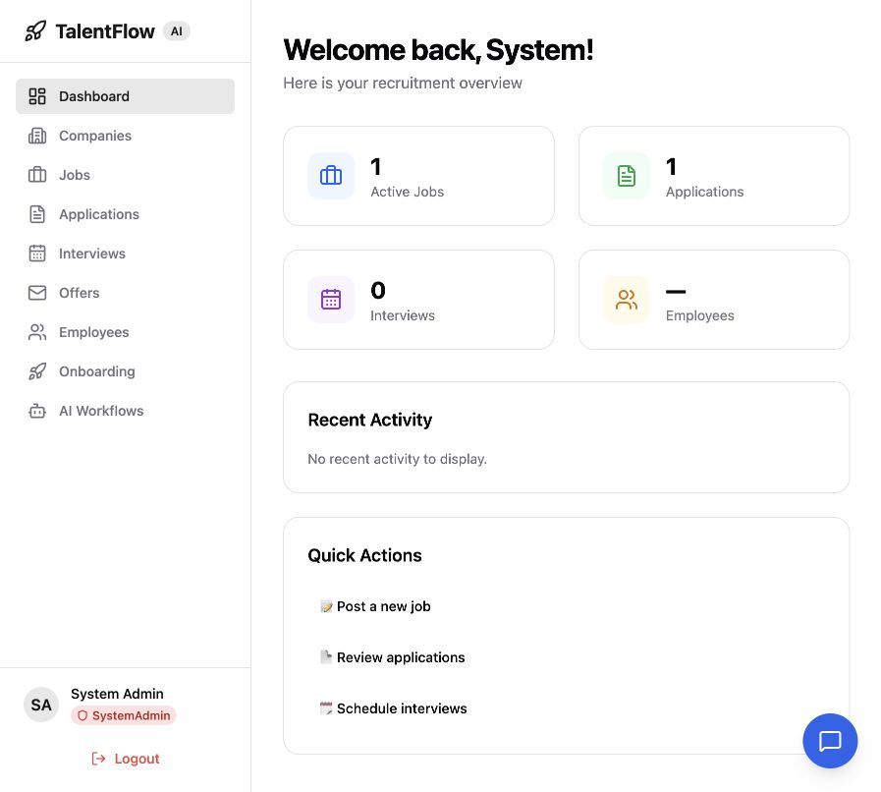
Figure 1 TalentFlow admin dashboard after signing in to the isolated verification system

2 System Scope and Quality Risks

2 1 Architecture and implemented technology
The React administration interface and Flutter candidate interface use a shared ASP.NET Core REST API. Entity Framework Core with Npgsql persists system data in PostgreSQL. The Python FastAPI subsystem coordinates candidate analysis, validation and interview planning. AI recommendations remain subject to workflow review; tests use deterministic data and controlled substitutes for external dependencies.
Layer | Implemented technology and role
Backend | ASP.NET Core .NET 8; application, domain and infrastructure layers; Identity and JWT authentication
Database | PostgreSQL 16 with EF Core migrations and relational constraints
Web | React and TypeScript; Vite; Zustand; React Query; React Hook Form and Zod
Mobile | Flutter and Dart; production screens use Provider, package:http and GoRouter. Riverpod and Dio are declared dependencies but are not the exercised login implementation.
AI | FastAPI, LangGraph, Gemini client, Pydantic schemas and an agent tool allowlist

2 2 Scope and exclusions
In scope are service validation and state changes, authentication UI, mobile login and job list behavior, routing guards, candidate application submission and withdrawal through the real API, database constraints, AI tool permissions and prompt safety, and local performance. The integrated acceptance scenario completes the application submission, staff review and candidate withdrawal lifecycle using the same persisted application ID.
Service-to-EF InMemory tests are described as persistence or business-logic tests, not proof of PostgreSQL constraint behavior. PostgreSQL constraints are separately exercised through psql. The existing .NET integration test project contains no discoverable tests; the live API script provides the executed API integration evidence.
Risk | Impact | Verification
Unauthorized access or role escalation | Candidate or company data exposed | TC-SEC-001 to TC-SEC-009; malformed token, role and owner checks
Invalid or duplicate applications | Incorrect recruitment state | ApplicationService tests; live duplicate check; PostgreSQL unique constraint
History persistence failure | Action fails or audit trail is missing | New repository regression and live withdrawal retest
Unsafe AI recommendation or tool use | Unreviewed changes or data access | Tool allowlist tests, scoring validator tests, coordinator approval tests
Slow API under concurrency | Poor usability and failed requests | k6 50-user load and 200-user authentication stress scenarios
Misleading test evidence | Results cannot be explained or reproduced | Raw results, per-case register, explicit test boundaries and rerun commands

3 Test Plan

3 1 Objectives and strategy
The strategy starts with isolated service and component tests, then verifies selected behavior against the actual API and PostgreSQL database. Normal, invalid, boundary and failure inputs are selected around the system risks. Functional tests assert status codes, returned values, visible UI, persisted state or exceptions; performance tests apply configured latency and error-rate thresholds.
Area | Tool and execution | Acceptance criterion | Assigned owner
Backend | xUnit, Moq, FluentAssertions and EF InMemory | All 56 final assertions pass | Own component members
PostgreSQL | psql with exception assertions and rollback | Five checks pass with exit code 0 | Lead shared verification
React | Vitest, React Testing Library and JSDOM | 25 tests pass; web build succeeds | Lead
Flutter | flutter_test with fake auth and MockClient | 16 production widget and router tests pass | Interview and Hiring member
API integration and security | Python standard-library HTTP test script | 22 checks pass; persisted state and owner isolation hold | Lead shared verification
AI | pytest and pytest-asyncio | 52 deterministic cases pass; no xfail masks remain | Lead and safety owner
Performance | k6 load and authentication stress scripts | Each configured latency and error threshold passes | Company and Job member

3 2 Entry and exit criteria
Entry requires the correct project checkout, installed dependencies, a seeded isolated PostgreSQL database, a running API, known development test accounts and a traceable source snapshot. Exit requires completion of selected executable cases, investigation of failures, retesting of fixes, readable screenshot evidence, a case register and documented residual risks. The local exit criteria were met for the selected scope. Remote component delivery depends on the account workflow recorded in Section 14.

3 3 Verification sequence and test data
Phase on 9 October 2026 | Activity | Recorded outcome
Review | Compare brief, supplied draft and Group 020 sample; inspect source and CI | Correct scope, statistics and evidence requirements
Baseline | Run supplied backend, web, mobile and AI suites | 55 backend; 25 web; 32 mobile; 55 AI passes and two AI xfails
Integration | Run candidate application lifecycle against real API and DB | Withdrawal HTTP 500 reproduced
Repair and retest | Repair history tracking and prompt safety; strengthen weak tests | 56 backend, 25 web, 16 production mobile and 52 AI passes
Quality evaluation | Run live security, database, k6 and coverage checks | 22 API and five DB checks pass; both k6 scenarios pass
Documentation | Record cases, evidence, limitations and contribution workflow | Revised report and supporting bundle

Synthetic candidate addresses use the example.test domain. Fresh identifiers prevent duplicate fixture collisions. API tests retain JWTs in memory and omit their values from evidence. Database checks roll back their mutations. The verification database is talentflow_se3110_verification on the local Docker PostgreSQL instance; the existing project database was not used for these mutations.

4 Test Environment and Reproduction
Item | Observed configuration
Operating environment | macOS Apple Silicon
.NET SDK | 8.0.423; target framework net8.0
PostgreSQL | 16.15 in Docker; host port 5433
Node runtime | 24.19.0 for local execution; CI configured for Node 22
React runner | Vitest 3.2.7 with JSDOM; tests use @testing-library/jest-dom
Flutter and Dart | Flutter 3.38.3; Dart 3.10.1
AI Python | Python 3.12.4 in project virtual environment; CI Python 3.13
k6 | Official macOS ARM64 release 2.3.0
Verification endpoints | API http://127.0.0.1:5155; web http://127.0.0.1:5178 via API proxy

4 1 Rerun commands
From the repository root, use the following commands after installing dependencies and starting the isolated API. For API execution, set ConnectionStrings__DefaultConnection to the verification database and ASPNETCORE_ENVIRONMENT to Development. The development seeder applies migrations and creates sample data. Use a fresh disposable database when reproducing the integration tests.
dotnet test backend/tests/TalentFlow.UnitTests --logger "trx;LogFileName=backend.trx" --collect:"XPlat Code Coverage"
cd frontend/react-app && npm ci && npm run test -- --run --reporter=verbose
cd frontend/flutter_app && flutter pub get && flutter test --reporter expanded
cd agentic-ai && pip install -r requirements.txt && pytest tests/ -v --junitxml=test-results.xml
python docs/testing/scripts/live_api_tests.py --base-url http://127.0.0.1:5155/api
docker exec -i talentflow-postgres psql -U talentflow_user -d talentflow_se3110_verification < docs/testing/scripts/database_checks.sql
k6 run -e SUMMARY_PATH=load-summary.json performance/k6/load_test_api.js
k6 run -e SUMMARY_PATH=stress-summary.json performance/k6/stress_test_auth.js
TEST_ADMIN_EMAIL and TEST_ADMIN_PASSWORD can override the development fixture credentials. Performance scripts use BASE_URL for the API base and SUMMARY_PATH for the generated JSON. Do not point these mutation and load scripts at a production database. The evidence inventory includes the scripts and exact result exports used for this report.
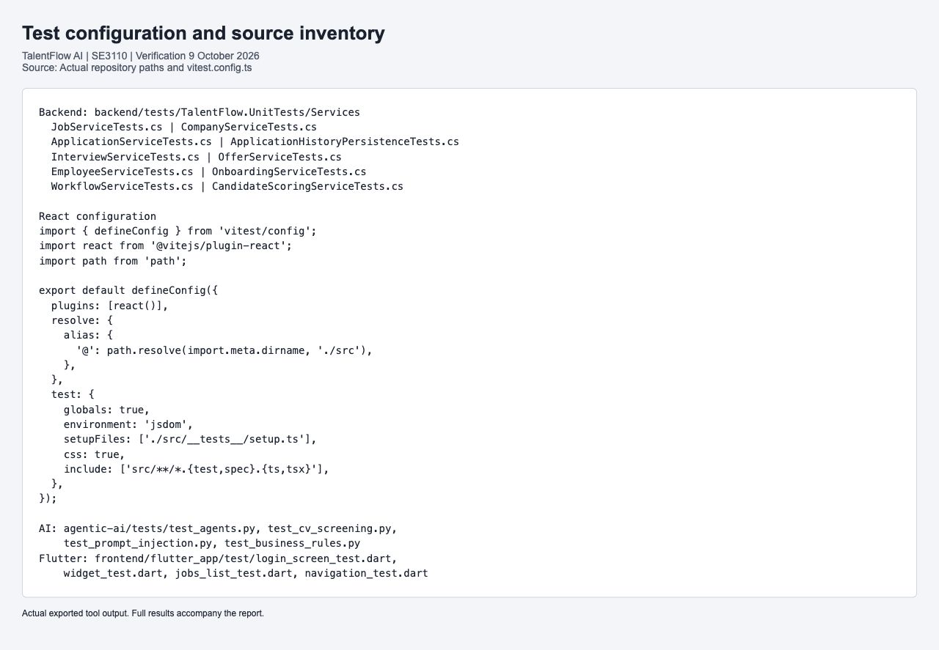
Figure 2 Actual test source locations and React runner configuration

5 Backend and Database Testing

5 1 Backend service coverage
The backend tests use the Arrange Act Assert pattern. Moq isolates repositories where appropriate; EF InMemory supports selected service and persistence scenarios. Assertions check error codes and responses, validation guards, workflow decisions and persisted records. The final result is 56 passed, zero failed and zero skipped.
Test class | Executed | Primary behavior
ApplicationHistoryPersistenceTests | 1 | New history insertion and persisted withdrawal
ApplicationServiceTests | 7 | Service creation, retrieval, validation or deterministic business rules
CandidateScoringServiceTests | 2 | Service creation, retrieval, validation or deterministic business rules
CompanyServiceTests | 8 | Company CRUD, paging and minimal input
EmployeeServiceTests | 1 | Service creation, retrieval, validation or deterministic business rules
GoogleCalendarServiceTests | 4 | Service creation, retrieval, validation or deterministic business rules
InterviewServiceTests | 7 | Scheduling guards, status, duration and conflicts
JobServiceTests | 2 | Service creation, retrieval, validation or deterministic business rules
OfferServiceTests | 6 | Missing records and prerequisite guards
OnboardingServiceTests | 9 | Template and task operations; assignment ownership guards
SchedulingServiceTests | 4 | Service creation, retrieval, validation or deterministic business rules
WorkflowServiceTests | 5 | Workflow state and approval rejection persistence

Some supplied offer tests provide null dependencies and exercise an earlier prerequisite guard, rather than proving salary validation. This report does not treat those cases as a verified successful offer lifecycle. The validation ordering observation is recorded separately in the defect register.
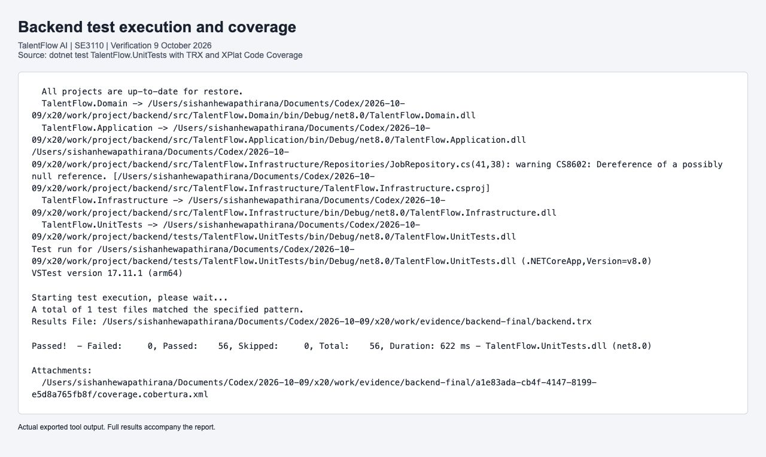
Figure 3 Actual backend test output with 56 passes and generated coverage attachment

5 2 PostgreSQL constraints and persistence
Five additional checks execute against PostgreSQL, not an in-memory substitute. SQL exception handling expects the database to reject a duplicate job and candidate pair, an orphan history row and a NULL status. A join checks that the completed live withdrawal has matching history, and a savepoint test verifies rollback restores previous values. Unexpected acceptance raises an exception, and ON_ERROR_STOP turns it into a failing command.
Case | Expected and observed result
TC-DB-001 | PostgreSQL unique_violation prevents duplicate application; PASS notice emitted; psql exit code 0
TC-DB-002 | PostgreSQL foreign_key_violation rejects unknown ApplicationId; PASS notice emitted; psql exit code 0
TC-DB-003 | PostgreSQL not_null_violation rejects NULL status; PASS notice emitted; psql exit code 0
TC-DB-004 | Join finds Withdrawn application with Withdrawn history; PASS notice emitted; psql exit code 0
TC-DB-005 | CoverLetter sentinel does not survive rollback to savepoint; PASS notice emitted; psql exit code 0

The isolated API applied InitialCreate and Sprint3_WorkflowAndOnboarding migrations successfully. These checks establish selected relational guarantees and rollback behavior; they do not measure migration upgrades from every historical schema or concurrent duplicate-request races.
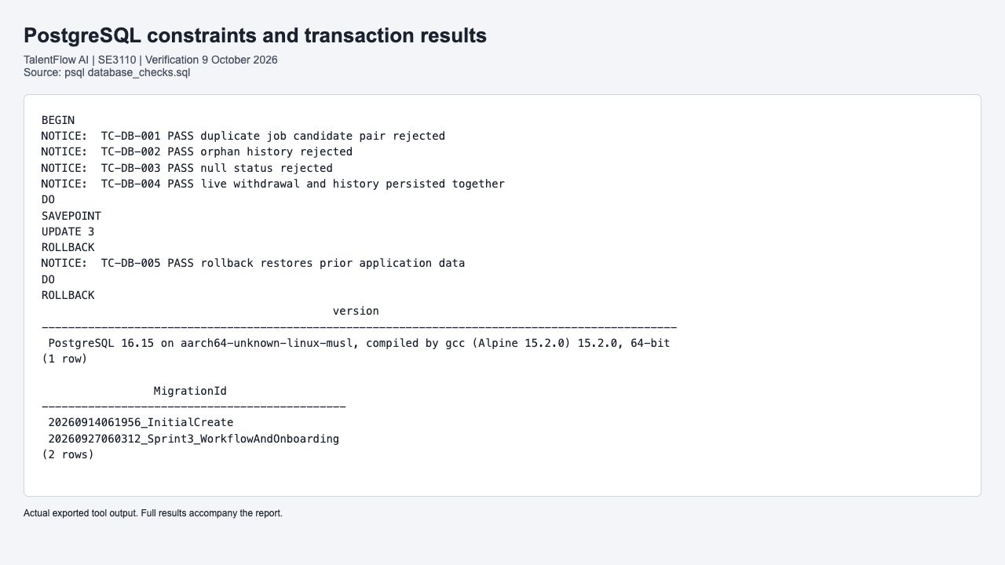
Figure 4 Actual PostgreSQL assertion notices, rollback output, version and applied migrations

6 React Web Application Testing
Vitest executed 17 LoginPage component cases and eight authStore cases. The login component cases exercise rendering, email and password controls, validation, submission, error clearing, visible failure, pending state and navigation. AuthStore cases exercise login, logout, loading and failure state transitions with controlled API substitutes. All 25 passed, and TypeScript checking and the Vite production build completed successfully.
Component rendering uses MemoryRouter and mocked authentication behavior. These tests do not establish every protected page, every recruitment form or browser compatibility. The real browser screenshots separately verify that the administration app signs in and retrieves job and application data through the API proxy.
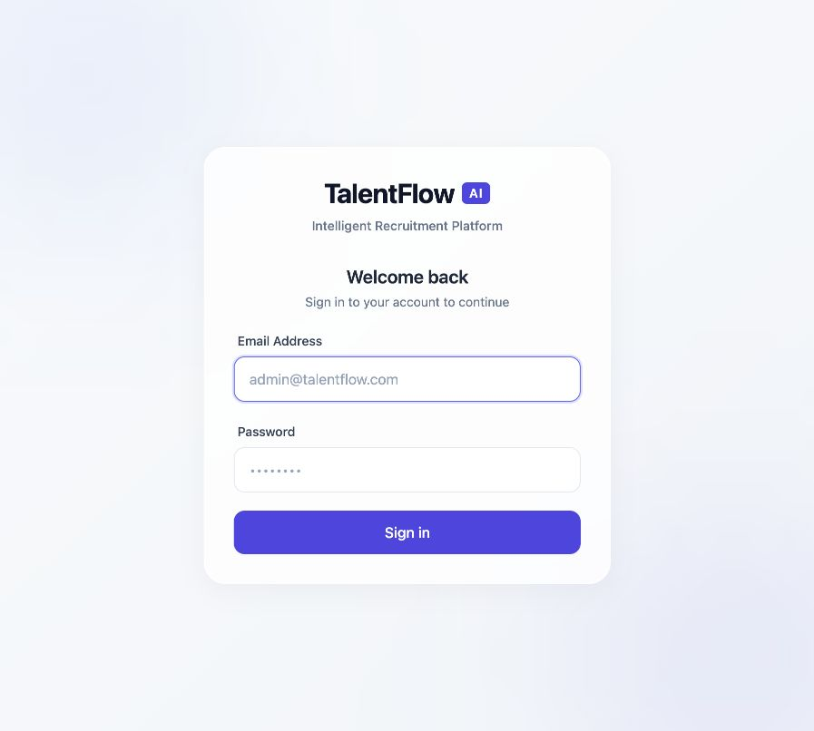
Figure 5 Real TalentFlow administration login page
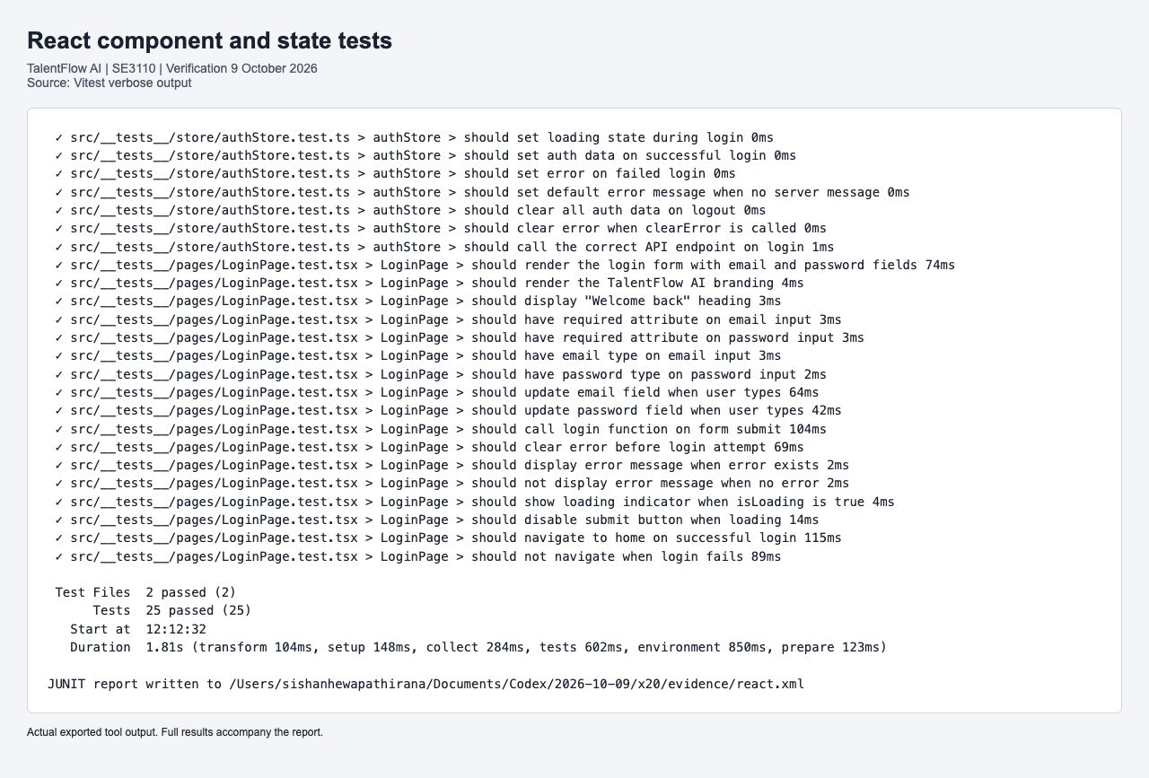
Figure 6 Actual Vitest output for LoginPage and authStore with 25 passes
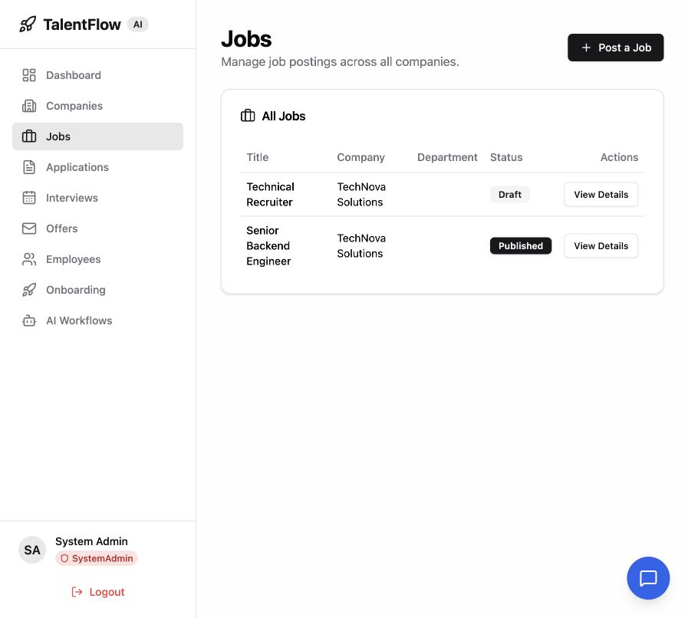
Figure 7 Real TalentFlow job list loaded from the verification API

7 Flutter Mobile Application Testing
The final mobile suite contains 16 executable cases against the production app: eight LoginScreen tests, five JobListScreen tests, two production GoRouter tests and the existing unauthenticated-app widget test. The supplied generic widget samples and tests that asserted locally recreated filtering logic were replaced. This deliberately reduces the headline count while increasing relevance to TalentFlow.
Production target | Cases | Assertions and dependencies
LoginScreen | 8 | Branding and fields, masked password, submitted credentials, failed login, pending button, retry behavior and successful GoRouter navigation. AuthProvider is replaced with a deterministic fake.
JobListScreen | 5 | Returned title and department, empty list, safe HTTP failure, published-job query and newest-first sort. Real widget and ApiClient execute with package:http MockClient.
GoRouter and TalentFlowApp | 3 | Unauthenticated startup and redirect from protected home to login; public login remains accessible.

The job-list failure case confirms the current behavior of showing No jobs found after an API error; it does not claim a dedicated network-error message exists. Mobile integration with a real device, CV file picking, onboarding and interview screens remains outside this widget test run. Flutter analysis completes with informational findings; no analyzer warnings or errors remain in the final test sources.
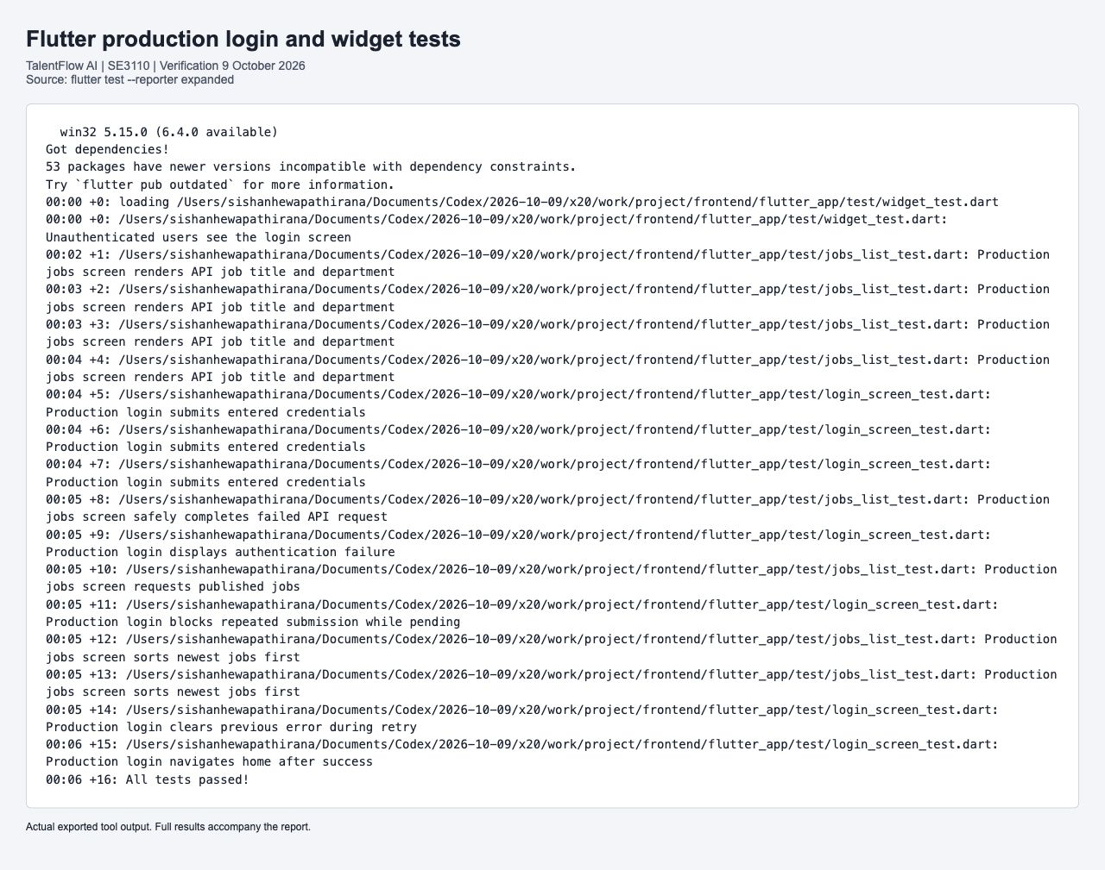
Figure 8 Actual Flutter output from the revised production widget and router suite

8 Integrated Workflow and API Security

8 1 Complete application lifecycle scenario
The live integration script executes a complete selected application lifecycle against the running API and PostgreSQL. It authenticates the seeded administrator, registers two synthetic candidates, creates their profiles and retrieves a published job. Candidate one submits an application. Candidate one and the administrator read the same persisted application ID. A duplicate submission is rejected. Candidate one withdraws the application; the administrator verifies its Withdrawn state and the audit history.
This scenario crosses authentication, candidate profiles, jobs, applications, authorization, persistence and history. The web application screenshot shows the same verification dataset with the withdrawn application visible. It is an API-level integrated workflow with a browser observation, not a claim that the entire recruitment-to-onboarding process was automated through the UI.
Stage | Expected result | Actual result
Sign in and register candidates | 200 admin login; 201 candidates and profiles | Passed
Browse and submit | Published job available; 201 Submitted application | Passed
Read and prevent duplicate | 200 owner and admin reads; 409 duplicate | Passed
Withdraw and verify | 204 withdrawal; 200 Withdrawn read and history | Passed after DEFECT-004 repair

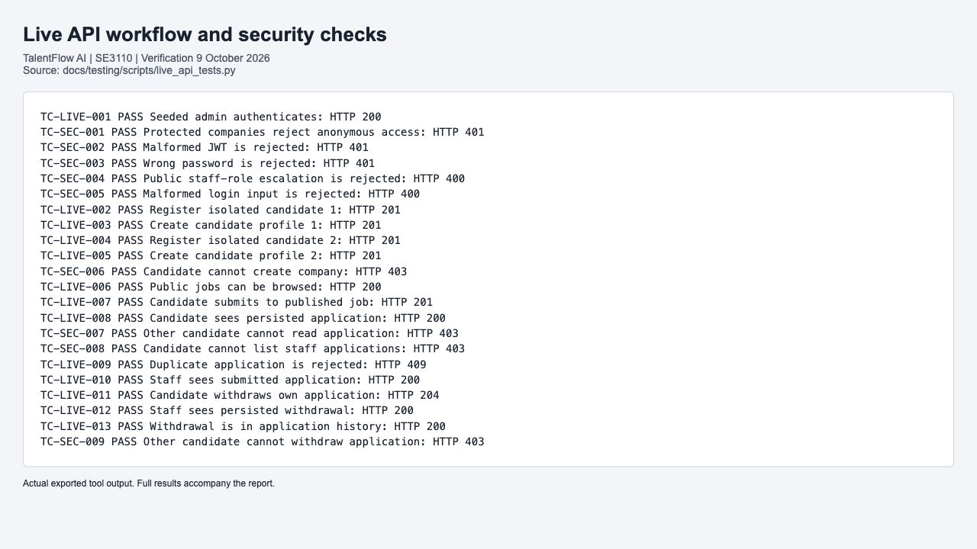
Figure 9 Actual live API execution output with 22 passing workflow and security checks
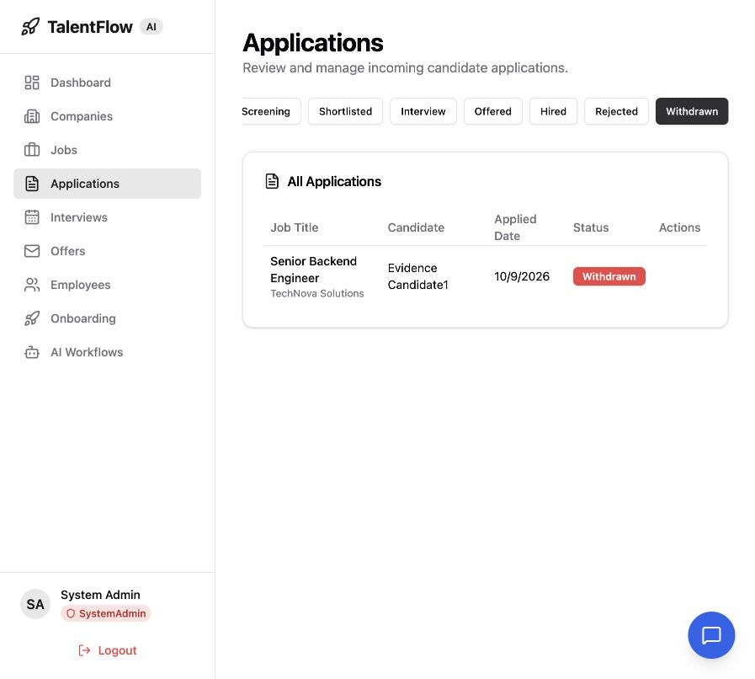
Figure 10 Withdrawn candidate application displayed in the real TalentFlow administration interface

8 2 Authentication and authorization checks
Nine checks cover anonymous access to protected companies, malformed JWT rejection, wrong-password rejection, attempted public SystemAdmin registration, malformed login input, candidate company-creation denial, another candidate reading an application, candidate access to a staff-only listing and another candidate attempting withdrawal. Expected statuses are 401, 400 or 403 depending on the control. The anonymous job listing is intentionally public and returns 200.
Security checks assert outcomes from the actual middleware and controller path. Prompt safety and AI tool restrictions are evaluated separately. This is targeted automated security verification, not an OWASP ZAP scan, penetration test, proof of SQL injection resistance or complete tenant isolation audit. No broad security scan is claimed.

9 Agentic AI Evaluation
The final AI suite has 52 passing cases. It evaluates production validation tools, tool permissions, resume parsing, coordinator recommendation and approval behavior, production scoring boundaries, Pydantic requirements and prompt detection. External HTTP and model responses are substituted in relevant unit tests, so the evaluation is deterministic and rerunnable without sending candidate data to Gemini.

9 1 Prompt safety baseline and repair
The supplied prompt tests reproduced two expected failures: new system instructions inside delimiters and a DAN jailbreak. The validator relied on substring patterns that did not include those forms. The repair adds explicit instruction and bypass patterns and normalizes compatibility characters while removing Unicode format characters before matching. The Unicode case now asserts a blocked result instead of merely checking that a result dictionary exists.
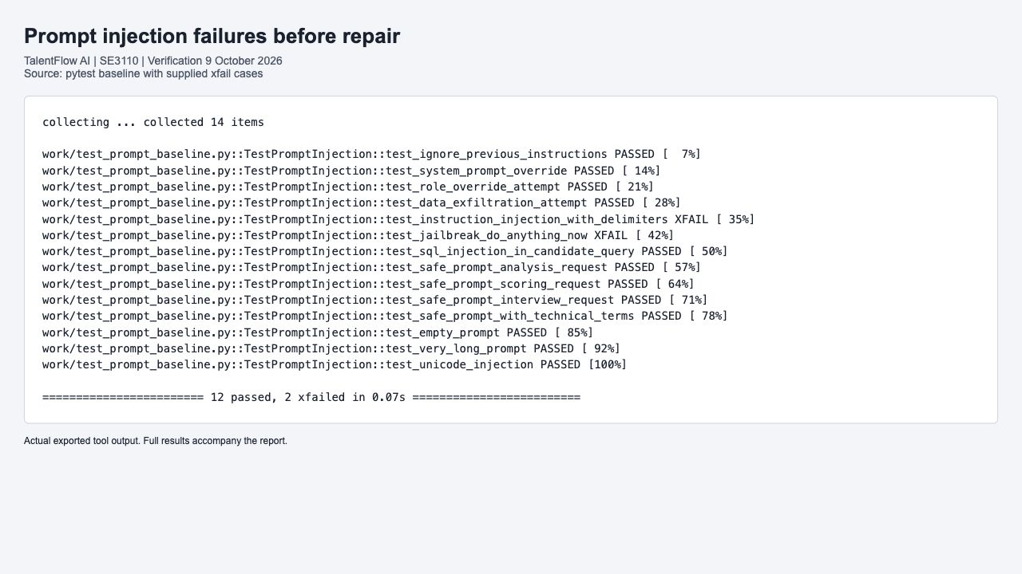
Figure 11 Supplied prompt-safety baseline showing the two documented expected failures
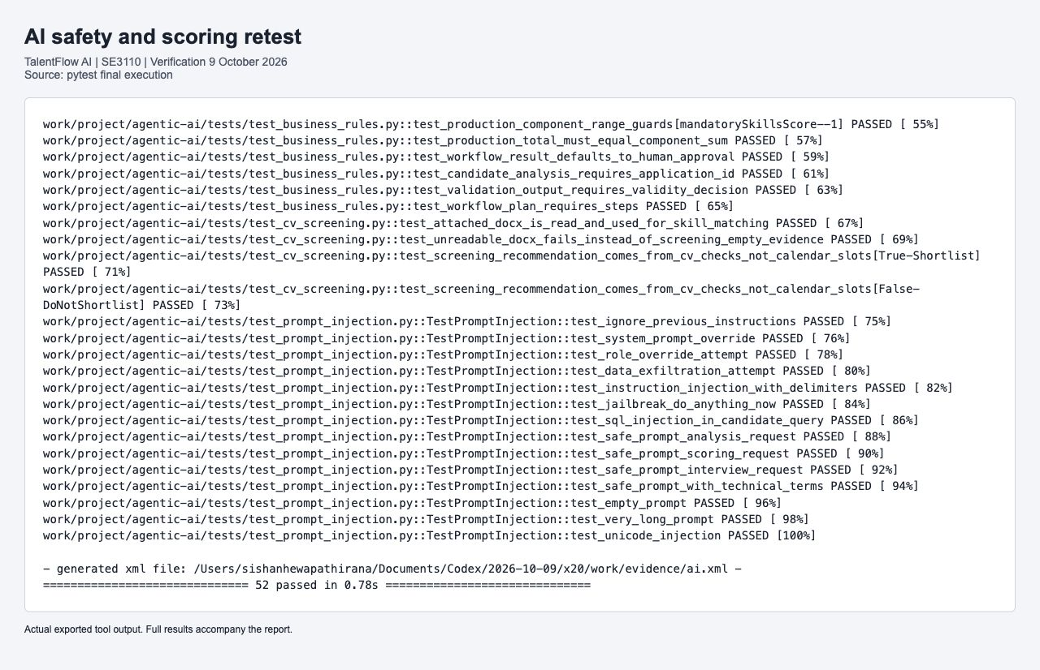
Figure 12 Final AI tool output after prompt repairs and meaningful scoring tests

9 2 Scoring and approval boundaries
The rewritten business-rule tests call validate_scoring rather than recomputing an independent scoring formula in the test. They check total scores 0, 59, 60, 74, 75 and 100, wrong recommendations, each component maximum, a negative score and an inconsistent sum. Coordinator tests independently confirm that CV checks determine recommendations and that human approval remains required. Schema cases test required fields and defaults; constructing a valid plan alone is not evidence that a generator always produces a valid plan.
Regex and substring detection are a limited defensive layer. These tests establish the observed handling of the selected strings; they do not prove resistance to every obfuscated injection, data-exfiltration request or model jailbreak. Several legacy prompt cases only assert the response shape, and are not counted as evidence of attack prevention.

10 Performance and Stress Testing

10 1 Load scenario
The load test ramps from zero to 10 users in 30 seconds, then to 50 in one minute, holds 50 for one minute and ramps down over 30 seconds. Each iteration authenticates and reads jobs, applications, companies and interviews, with pacing between requests. The fixture password was corrected to match the actual seeder, and the interviews check now requires HTTP 200 rather than accepting an unauthorized 401 response.

10 2 Authentication stress scenario
The stress test ramps through 10, 50, 100, 150 and 200 users, holds 200 for 30 seconds, then ramps down over one minute. Iterations authenticate and pause for half a second. The duration is four minutes plus any finishing iterations. This run did not reach a failure breakpoint, so a maximum sustainable capacity is not inferred.
Metric | 50-user load | 200-user auth stress
HTTP requests | 4,795 | 28,328
Request rate per second | 26.16 | 117.84
Average duration ms | 16.26 | 358.48
p95 duration ms | 59.02 | 892.00
Failed HTTP requests | 0 | 0
Configured p95 limit | 2000 ms | 5000 ms
Configured error-rate limit | 10 percent | 30 percent
Threshold result | All passed | All passed

Additional load threshold | Measured p95 | Result
Login below 3000 ms | 64.84 ms | Passed
Job listing below 1500 ms | 5.72 ms | Passed

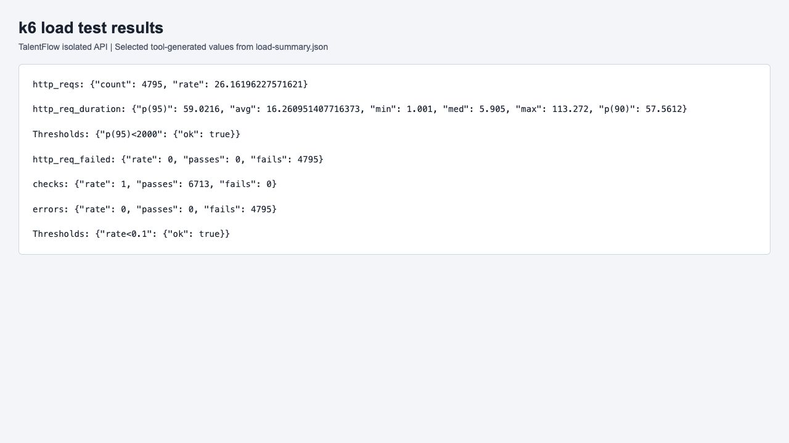
Figure 13 Actual k6 load-test metric values and threshold results
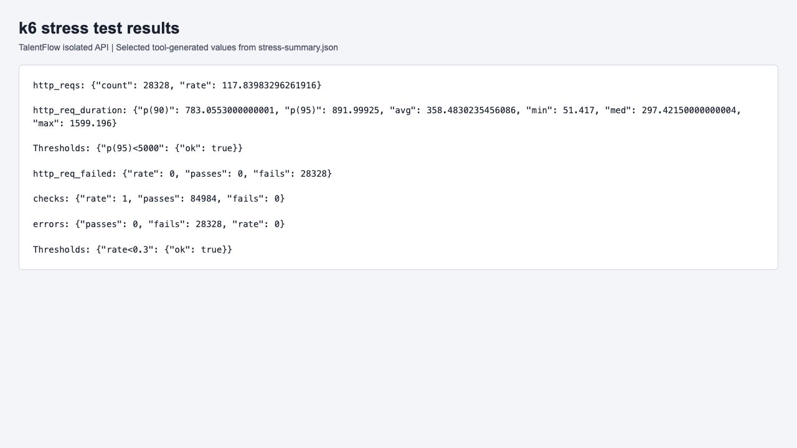
Figure 14 Actual k6 authentication stress-test metric values and threshold results
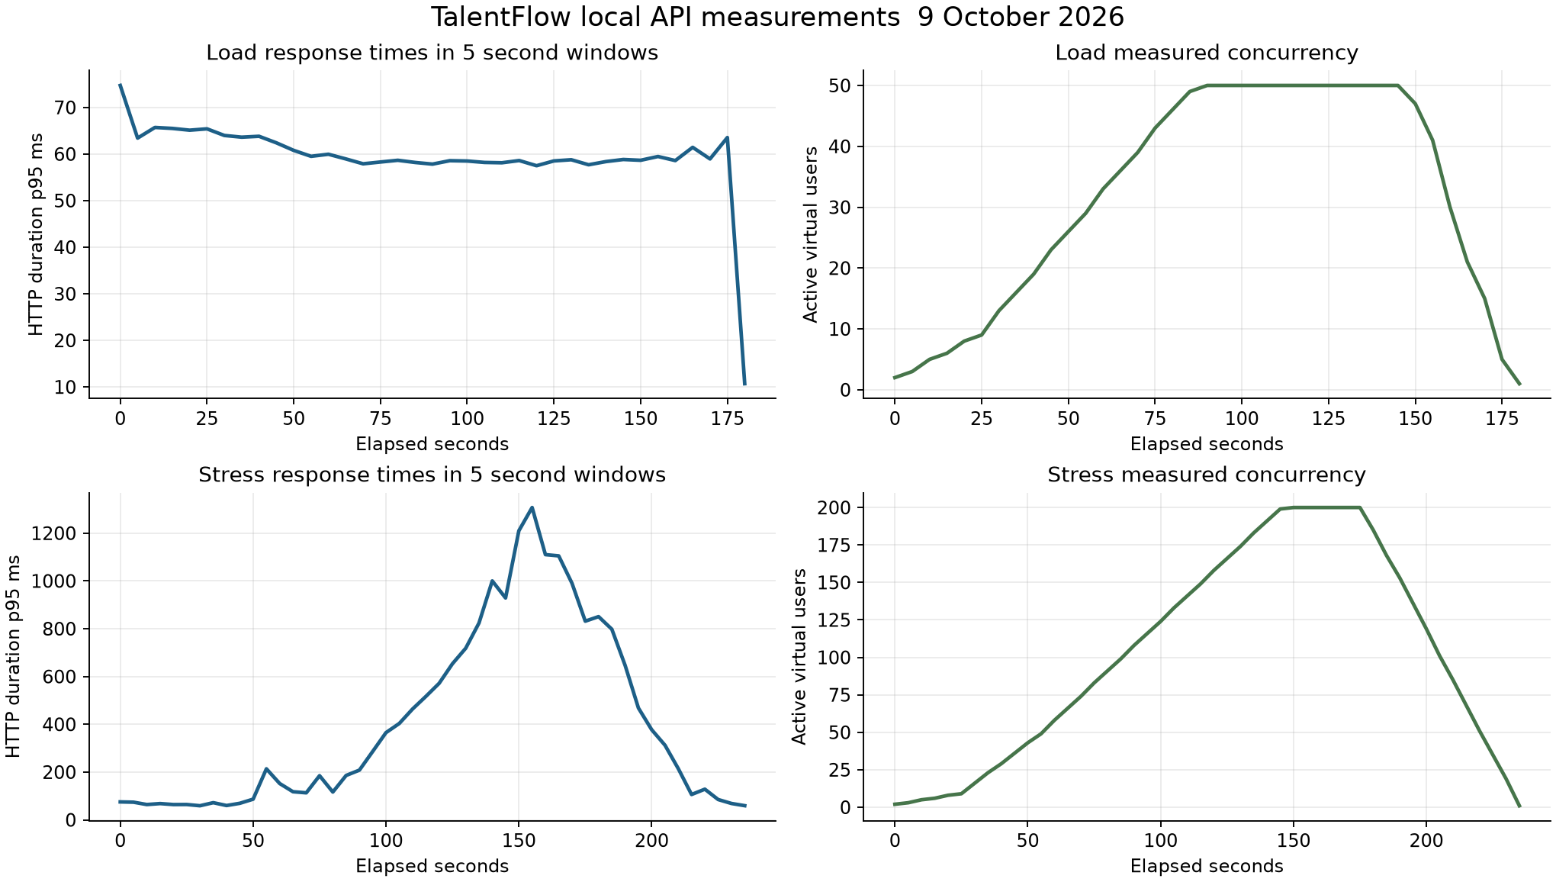
Figure 15 Measured concurrency and response-time trends from the k6 time-series exports
Measurements share one development host for the load generator and services. Database volume is small and seeded. Development logging is enabled, network travel is local and real production infrastructure is not represented. Stress thresholds allow a relatively high error rate by design, although this run observed zero. No spike, soak, recovery from process failure or external-service load result is claimed.

11 Defect Report and Retesting
ID and issue | Severity and priority | Status | Evidence and outcome
DEFECT-001  Delimiter instruction bypass | High / High | Fixed and retested | New system instructions in a code block returned safe=True; prompt retest now returns safe=False.
DEFECT-002  DAN jailbreak bypass | High / High | Fixed and retested | DAN and bypass-all-restrictions input returned safe=True; explicit patterns now block it.
DEFECT-003  Offer validation ordering | Low / Medium | Open observation | Salary/date guards follow database prerequisite checks. No production acceptance of invalid salary was demonstrated; the supplied null-context test does not prove that behavior.
DEFECT-004  Withdrawal history persistence | High / High | Fixed and retested | Live candidate withdrawal returned 500 with DbUpdateConcurrencyException; explicit Added history state now gives 204 and persists history.
DEFECT-005  React CI has no committed tests | Medium / High | Tests merged; build import fix verified | Prior workflow failed with No test files found. React tests/config are prepared on the assigned lead branch.
DEFECT-006  AI CI lint blockers | Medium / Medium | Fixed; GitHub verified | Unused imports, import placement and a dead assignment blocked pytest. Shared lint repair passed local Ruff and remote AI CI.
DEFECT-007  Flutter CI points to wrong directory | Medium / High | Fixed; GitHub verified | Workflow referenced flutter-app instead of flutter_app. Trigger and working directory repaired; remote workflow succeeds.
DEFECT-008  Load scripts use wrong credentials and weak auth assertion | Medium / High | Fixed and retested | Admin fixture password mismatched seeder; interview list accepted 401. Corrected fixture and 200-only assertion pass the live load run.
DEFECT-009  Uncommitted CV tool removal breaks AI imports | High / High | Isolated checkout restored and verified | User working copy removes get_application and get_application_resume, preventing collection. Verification uses the committed implementation; original open checkout remains untouched.

11 1 Reproduction and retesting of withdrawal
Preconditions: isolated PostgreSQL database, a published job, a registered Candidate with a profile and a Submitted application. Reproduce by POSTing to /api/Applications/{id}/withdraw using the owner JWT. Before repair, HTTP 500 was returned. API logs show EF sending UPDATE ApplicationHistory for a newly created row and PostgreSQL affecting zero rows. Repository graph traversal marked the client-generated history ID as an existing record.
ApplicationRepository.UpdateAsync now marks detached history entries Added and sets their ApplicationId before the repository updates the graph. The regression reloads a persisted application, adds withdrawal history, saves and verifies the state and one history row. The live retest independently confirms 204, a subsequent Withdrawn read and a history entry. Both backend regression and PostgreSQL checks pass.
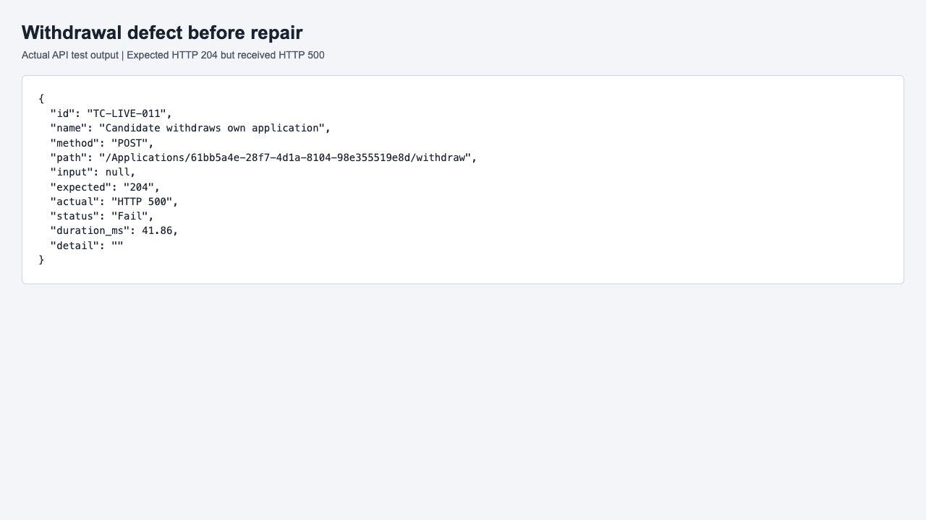
Figure 16 Actual failing withdrawal check before the persistence repair

11 2 Prompt defect reproduction
For DEFECT-001, call validate_prompt_safety with a triple-backtick block containing New system instructions and an approval request. For DEFECT-002, use the supplied DAN and Bypass all restrictions prompt. The original baseline marks both assertions expected-fail. After the detector change, the xfail decorators are removed and both assertions pass normally. A zero-width-character variant of Ignore previous instructions is also required to block.

12 Test Execution Summary and Coverage
Suite | Executed | Passed | Failed | Evidence
Backend | 56 | 56 | 0 | backend.trx and cobertura XML
React | 25 | 25 | 0 | react.xml and verbose output
Flutter | 16 | 16 | 0 | flutter-results.jsonl and expanded output
AI | 52 | 52 | 0 | ai.xml and verbose output
Live API | 22 | 22 | 0 | live-api.json
PostgreSQL | 5 | 5 | 0 | database.log
Total | 176 | 176 | 0 | Unique automated cases and checks

Performance HTTP checks are intentionally excluded from the functional total. The baseline and final suite sizes differ because weak sample tests were replaced and production regressions were added. A higher count alone is not evidence of better coverage. The final pass rate for the selected 176 cases is 100 percent; it does not represent 100 percent feature, branch or line coverage.

12 1 Measured backend coverage
Instrumented assembly | Line coverage | Branch coverage
TalentFlow.Application | 36.86 percent | 50.00 percent
TalentFlow.Domain | 41.04 percent | 100.00 percent
TalentFlow.Infrastructure | 12.05 percent | 14.64 percent
Total instrumented code | 1,585 / 11,568 lines = 13.70 percent | 185 / 1249 branches = 14.81 percent

Coverage is generated by coverlet from the unit-test run. It includes Application, Domain and Infrastructure assemblies, and does not include the API assembly or UI code. The measured gap supports adding controller and authorization integration tests, completed offer and onboarding paths, and more persistence and failure scenarios. No React, Flutter or AI coverage percentage is claimed because those coverage exports were not collected.

12 2 Residual issues and priorities
Priority next steps are broader tenant isolation checks, an automated hire-to-onboarding path with controlled AI and calendar dependencies, actual mobile file upload and onboarding integration tests, and a security scan of a disposable deployment. Review Flutter informational analysis findings, the backend nullable-reference warning and the web bundle-size warning. Treat the prompt filter as a limited layer supported by server-side authorization and human approval.

13 Individual Responsibilities and Viva Demonstrations
The following ownership follows the supplied team assignments and component branches. It identifies who should review and demonstrate each contribution. Git author configuration records assigned responsibility; AI-assisted work must still be understood and explained personally. This report does not infer historic authorship from an uncommitted file or turn assigned responsibility into proof of a personal viva demonstration.

S H V A Rosa IT24100197
Assigned component: Company and Job Management.
Test sources and related changes: CompanyServiceTests.cs; existing JobServiceTests.cs; performance/k6/load_test_api.js and stress_test_auth.js.
Viva demonstration: Run company service tests; explain Moq repository behavior and missing-record assertions. Run a short k6 demonstration with controlled test credentials, then explain p95, request count and error thresholds.

Hewapathirana S A IT24100097
Assigned component: Candidate and Application Management.
Test sources and related changes: ApplicationServiceTests.cs; ApplicationHistoryPersistenceTests.cs; ApplicationRepository.cs; React LoginPage and authStore tests; prompt-injection test cases.
Viva demonstration: Demonstrate the withdrawal regression and persisted history. Explain why a mocked repository missed a relational failure. Run React tests and the live API application scenario, including owner denial and duplicate rejection.

Madhushan W M G IT24100715
Assigned component: Interview and Hiring Management.
Test sources and related changes: InterviewServiceTests.cs; OfferServiceTests.cs; Flutter production login, job list and router tests.
Viva demonstration: Demonstrate an interview duration boundary or invalid state. Run the real LoginScreen failure and navigation tests; explain fake AuthProvider and MockClient boundaries. Explain why an offer prerequisite test is not a completed offer workflow.

Dewmini G D C P IT24102755
Assigned component: Employee and Onboarding Management.
Test sources and related changes: OnboardingServiceTests.cs; existing employee tests; production AI scoring tests; tool_permissions.py prompt repair.
Viva demonstration: Demonstrate forbidden onboarding assignment or missing task. Run scoring boundaries and prompt bypass regressions; explain allowlists, normalization and the need for human approval.

14 GitHub Actions and Contribution Evidence
Repository: https://github.com/sishanhewa/SE3090_SE012. Four GitHub Actions workflows exist: Backend CI, React CI, Flutter CI and AI Service CI. The initial history showed backend successes, repeated React failures due to absent committed tests, and AI failures at Ruff. Flutter did not trigger for its actual directory because its path filter used a different folder spelling.
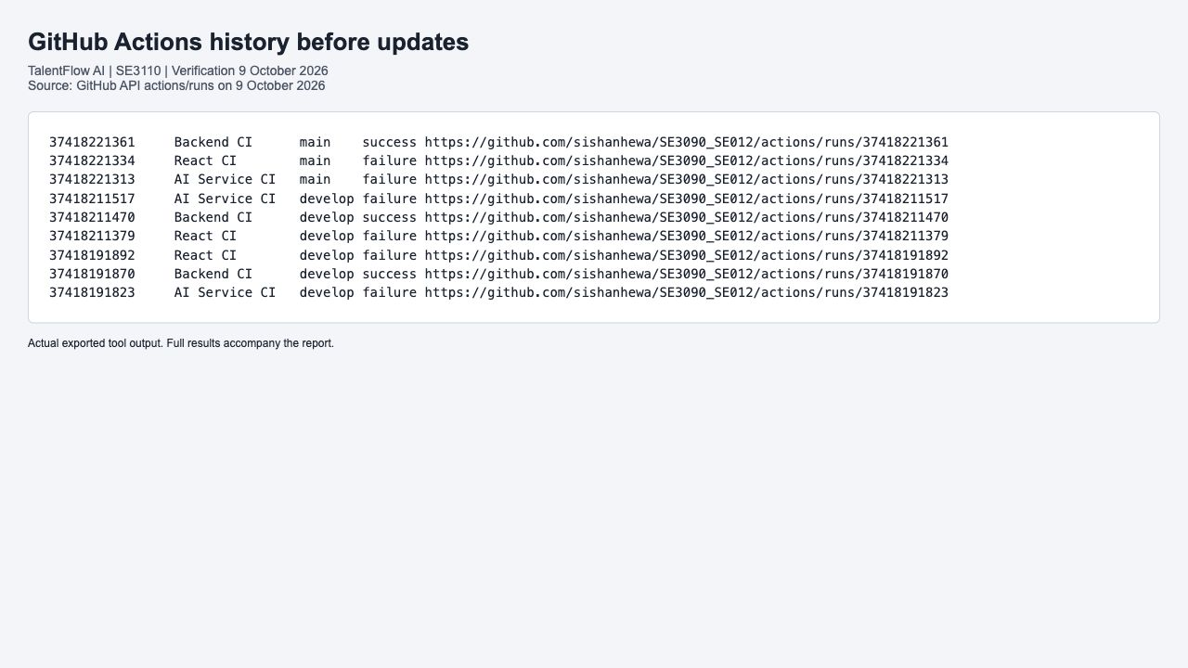
Figure 17 Actual GitHub Actions history retrieved before the testing updates
Shared CI repairs use develop and the supplied team lead identity sishanhewa with sishanhewa4@gmail.com. They correct Flutter paths, add workflow-change triggers and develop pull-request targets, repair AI lint blockers, upload web and AI XML results and use the actual JwtSettings configuration prefix. The shared commit 3983a74 was pushed successfully.
Workflow | Observed result | Run ID | Run link
React CI | success | 37897709413 | https://github.com/sishanhewa/SE3090_SE012/actions/runs/37897709413
AI Service CI | failure | 37897302609 | https://github.com/sishanhewa/SE3090_SE012/actions/runs/37897302609
Backend CI | success | 37897302567 | https://github.com/sishanhewa/SE3090_SE012/actions/runs/37897302567
Flutter CI | success | 37896382097 | https://github.com/sishanhewa/SE3090_SE012/actions/runs/37896382097

The shared CI repair made Backend, Flutter and AI workflows succeed. The lead application and React tests were subsequently merged through pull request 2 at commit 37367e4. Strict TypeScript checking then exposed two unused test imports, which were corrected and retested. AI safety tests require the prepared safety-owner implementation to accompany them. The table records the actual remote state at retrieval; it does not substitute for the complete local test run.
Prescribed branch | Configured author | Testing commit
develop | sishanhewa | 3983a74d30f8
feature/s1-company-jobs | vihara-rosa | 6cfc9bb32605
feature/s2-candidates-apps | sishanhewa | b5caa824f59e
feature/s3-interviews-hiring | gaveeshamadhushan | 755a7e8c569a
feature/s4-employees-onboarding | chenu222 | 3c3710eecb9f

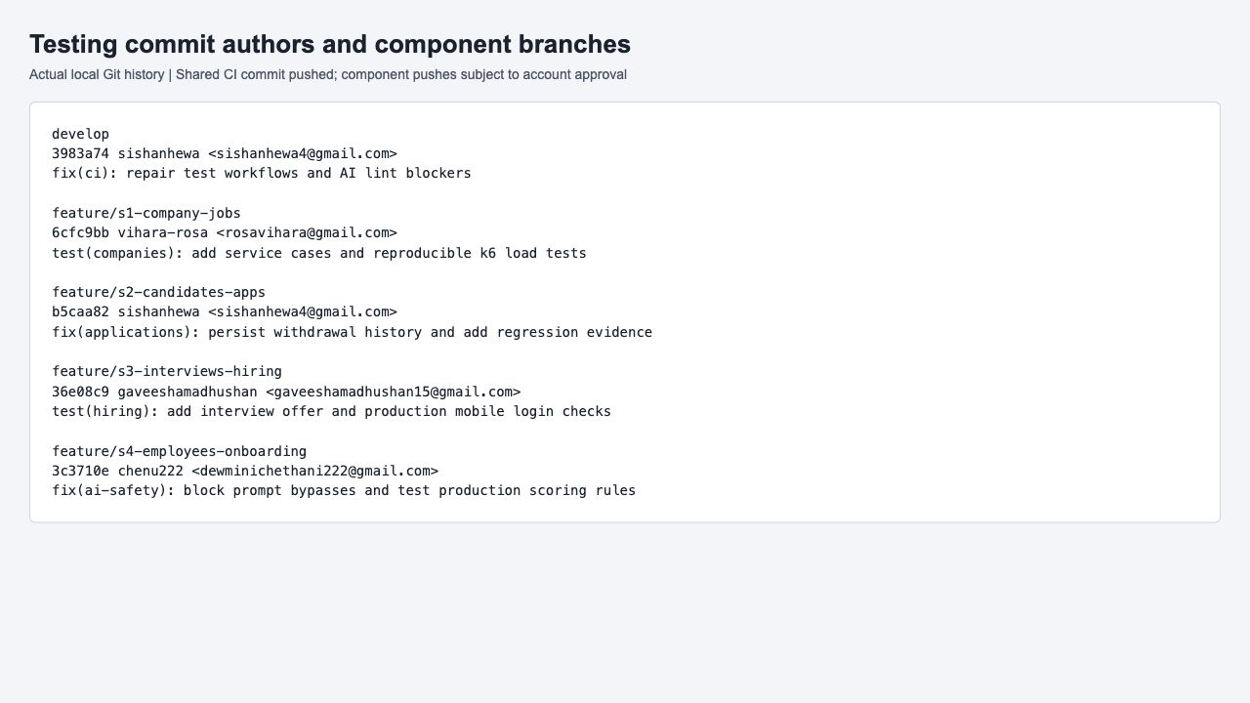
Figure 18 Actual component commit metadata and configured author identities
Only the lead GitHub account sishanhewa is authenticated in this environment. Lead pull requests https://github.com/sishanhewa/SE3090_SE012/pull/2 and https://github.com/sishanhewa/SE3090_SE012/pull/3 are merged. The second removes unused React test imports that blocked the strict TypeScript build. Member-specific commits are prepared using their exact configured names and emails on the prescribed feature branches after merging develop. Pushes through another account require the workflow exception requested from the project owner. The shared and lead-account work can be delivered with the existing authentication. The supporting delivery status file records the final remote state and pull-request links.

15 AI Assistance Declaration
AI assistance was used to audit the supplied draft, compare it with the assignment and reference report, inspect source and CI failures, develop and revise tests, diagnose and repair defects, generate the case register, collect evidence and edit this report. Test execution and result exports were checked against the actual TalentFlow code. No screenshots or numerical test results were generated as imagined outcomes.
AI assistance record | Declaration
Purpose and tool | OpenAI Codex supported the SE3110 evaluation of the existing SE3090 TalentFlow system, using the assignment brief and Group 020 report as a structural reference.
Assistance scope | Assistance supported test design, tooling, debugging, interpretation and report preparation.
Verification evidence | Actual TRX, XML, JSON, SQL, k6 exports and cursor-free browser captures support the recorded outcomes.
Student responsibility | Each member remains responsible for reviewing the assigned changes, understanding the tests and personally demonstrating them in the viva.
Reflection | Weak constant-only and generic-widget tests were replaced; low measured coverage and untested external integrations are explicitly identified.

This declaration records assistance, verification, responsibility and reflection. Each student remains responsible for following the module CLEAR requirements and acknowledging any additional AI tools used in their own work.

16 Conclusion
The final local verification supplies executable evidence for backend, database, web, mobile, integrated workflow, targeted security, AI and performance testing. All 176 selected automated cases passed after retesting, and both configured k6 scenarios met their thresholds. The most significant observed application defect was the withdrawal history persistence failure; its repair is verified by a regression and a live PostgreSQL workflow.
The results support the correctness of the tested behavior and provide a reproducible demonstration basis. They also expose clear remaining work: wider API and business-workflow coverage, live mobile integration, external-service evaluation and broader security assessment. Individual members must review and demonstrate their assigned work, and remote Git delivery must be read together with the account status and source commit of each CI run.

Appendix A Complete Test Case Register
The register below records every case executed in the final functional run. Preconditions are stated for each suite. Each record identifies the named automated scenario, execution/input or key expected assertion, actual outcome and status. The accompanying CSV retains the complete assertion text, source path and steps without shortening. Case IDs identify this verified run; they replace the draft register where its IDs or counts were inconsistent.

Backend cases
Preconditions: Fresh mocks or isolated EF InMemory context; build .NET 8 unit test project.
Execution: run the suite command in Section 4. Each row maps to the exact named test in the accompanying source. Inputs and fixtures are constructed in that test; the listed assertion is checked by the runner.
Case and scenario | Input or expected assertions | Actual result
TC-BE-001  Update Async Inserts New History And Persists Withdrawal | Expected assertions: Assert.Equal(ApplicationStatus.Withdrawn, (await repository.GetByIdAsync(application.Id))!.Status); ; Assert.Equal(1, await context.ApplicationHistory.CountAsync(h => h.ApplicationId == application.Id)); | Pass  All assertions satisfied
TC-BE-002  Create Application Async Fail When Deadline Has Passed | Expected assertions: result.IsSuccess.Should().BeFalse(); ; result.Error.Should().Contain("deadline"); | Pass  All assertions satisfied
TC-BE-003  Create Application Async Fail When Duplicate Application | Expected assertions: result.IsSuccess.Should().BeFalse(); ; result.ErrorCode.Should().Be("CONFLICT"); | Pass  All assertions satisfied
TC-BE-004  Create Application Async Fail When Job Is Closed | Expected assertions: result.IsSuccess.Should().BeFalse(); | Pass  All assertions satisfied
TC-BE-005  Create Application Async Return Bad Request When Job Is Not Published | Expected assertions: result.IsSuccess.Should().BeFalse(); ; result.Error.Should().Contain("applications"); | Pass  All assertions satisfied
TC-BE-006  Create Application Async Return Not Found When Job Does Not Exist | Expected assertions: result.IsSuccess.Should().BeFalse(); ; result.ErrorCode.Should().Be("NOT_FOUND"); | Pass  All assertions satisfied
TC-BE-007  Get Application By Id Async Return Not Found When Not Exists | Expected assertions: result.IsSuccess.Should().BeFalse(); | Pass  All assertions satisfied
TC-BE-008  Withdraw Application Async Return Not Found When Application Does Not Exist | Expected assertions: result.IsSuccess.Should().BeFalse(); ; result.ErrorCode.Should().Be("NOT_FOUND"); | Pass  All assertions satisfied
TC-BE-009  Calculate Score Non Existent Application Returns Not Found | Expected assertions: Assert.False(result.IsSuccess); | Pass  All assertions satisfied
TC-BE-010  Score Breakdown Maximum Possible Is100 | Expected assertions: Assert.Equal(100, mandatoryMax + preferredMax + experienceMax + educationMax + certMax); | Pass  All assertions satisfied
TC-BE-011  Create Company Async Handle Minimal Request | Expected assertions: result.IsSuccess.Should().BeTrue(); | Pass  All assertions satisfied
TC-BE-012  Create Company Async Return Success When Valid Request | Expected assertions: result.IsSuccess.Should().BeTrue(); ; result.Data.Should().NotBeNull(); ; result.Data!.Name.Should().Be("Tech Corp"); ; result.Data.IsActive.Should().BeTrue(); | Pass  All assertions satisfied
TC-BE-013  Create Company Async Set Is Active True | Expected assertions: capturedCompany.IsActive.Should().BeTrue(); | Pass  All assertions satisfied
TC-BE-014  Get Companies Async Return Paged Result | Expected assertions: result.IsSuccess.Should().BeTrue(); ; result.Data!.Items.Should().HaveCount(2); | Pass  All assertions satisfied
TC-BE-015  Get Company By Id Async Return Company When Exists | Expected assertions: result.IsSuccess.Should().BeTrue(); ; result.Data!.Id.Should().Be(companyId); ; result.Data.Name.Should().Be("Existing Corp"); | Pass  All assertions satisfied
TC-BE-016  Get Company By Id Async Return Not Found When Does Not Exist | Expected assertions: result.IsSuccess.Should().BeFalse(); ; result.ErrorCode.Should().Be("NOT_FOUND"); | Pass  All assertions satisfied
TC-BE-017  Update Company Async Return Not Found When Does Not Exist | Expected assertions: result.IsSuccess.Should().BeFalse(); ; result.ErrorCode.Should().Be("NOT_FOUND"); | Pass  All assertions satisfied
TC-BE-018  Update Company Async Return Success When Company Exists | Expected assertions: result.IsSuccess.Should().BeTrue(); ; result.Data!.Name.Should().Be("New Name"); ; _companyRepositoryMock.Verify(repo => repo.UpdateAsync(It.IsAny<Company>(), It.IsAny<CancellationToken>()), Times.Once); | Pass  All assertions satisfied
TC-BE-019  Get Employee By Id Async Return Not Found When Employee Does Not Exist | Expected assertions: result.IsSuccess.Should().BeFalse(); ; result.ErrorCode.Should().Be("NOT_FOUND"); | Pass  All assertions satisfied
TC-BE-020  Configured Calendar Signs Token And Sends Candidate With Correct End Time | Expected assertions: Assert.True(result.IsSuccess); ; Assert.Contains("sendUpdates=all", handler.EventUri!.Query); ; Assert.Equal("tf1234567890abcdef1234567890abcdef", ; Assert.Equal(start.AddHours(1).ToString("o"), ; Assert.Equal("candidate@example.com", | Pass  All assertions satisfied
TC-BE-021  Free Busy Slots Are Converted To Utc Before Conflict Checking | Expected assertions: Assert.True(result.IsSuccess); ; Assert.Equal(new DateTime(2026, 10, 8, 9, 30, 0, DateTimeKind.Utc), result.Data![0].Start); | Pass  All assertions satisfied
TC-BE-022  Missing Credentials Never Report Invitation Or Availability As Successful | Expected assertions: Assert.False(invitation.IsSuccess); ; Assert.False(availability.IsSuccess); | Pass  All assertions satisfied
TC-BE-023  Organizer OAuth Updates Calendar Only When Google Confirms Success | Expected assertions: Assert.True(confirmed.IsSuccess); ; Assert.Contains("grant_type=refresh_token", handler.TokenBody); ; Assert.Equal(start.AddHours(1).ToString("o"), ; Assert.False(failed.IsSuccess); | Pass  All assertions satisfied
TC-BE-024  Schedule Interview Async Fail When Active Interview Already Exists | Expected assertions: result.IsSuccess.Should().BeFalse(); ; result.ErrorCode.Should().Be("CONFLICT"); | Pass  All assertions satisfied
TC-BE-025  Schedule Interview Async Fail When Application Not Shortlisted | Expected assertions: result.IsSuccess.Should().BeFalse(); ; result.Error.Should().Contain("Shortlisted"); | Pass  All assertions satisfied
TC-BE-026  Schedule Interview Async Fail When Duration Too Long | Expected assertions: result.IsSuccess.Should().BeFalse(); ; result.Error.Should().Contain("480"); | Pass  All assertions satisfied
TC-BE-027  Schedule Interview Async Fail When Duration Too Short | Expected assertions: result.IsSuccess.Should().BeFalse(); ; result.Error.Should().Contain("15"); | Pass  All assertions satisfied
TC-BE-028  Schedule Interview Async Fail When Scheduled In Past | Expected assertions: result.IsSuccess.Should().BeFalse(); | Pass  All assertions satisfied
TC-BE-029  Schedule Interview Async Reject Duration Below15 Boundary Test | Expected assertions: result.IsSuccess.Should().BeFalse(); ; result.Error.Should().Contain("15"); | Pass  All assertions satisfied
TC-BE-030  Schedule Interview Async Return Not Found When Application Does Not Exist | Expected assertions: result.IsSuccess.Should().BeFalse(); ; result.ErrorCode.Should().Be("NOT_FOUND"); | Pass  All assertions satisfied
TC-BE-031  Create Job Async Return Success When Valid Request | Expected assertions: result.IsSuccess.Should().BeTrue(); ; result.Data.Should().NotBeNull(); ; result.Data!.Title.Should().Be(request.Title); ; result.Data.Status.Should().Be(JobStatus.Draft.ToString()); ; _jobRepositoryMock.Verify(repo => repo.AddAsync(It.Is<Job>(j => j.Title == request.Title), It.IsAny<CancellationToken>()), Times.Once); | Pass  All assertions satisfied
TC-BE-032  Get Job By Id Async Return Not Found When Job Does Not Exist | Expected assertions: result.IsSuccess.Should().BeFalse(); ; result.ErrorCode.Should().Be("NOT_FOUND"); | Pass  All assertions satisfied
TC-BE-033  Create Offer Async Fail When Application Not In Interview Status | Expected assertions: result.IsSuccess.Should().BeFalse(); ; result.Error.Should().Contain("interview"); | Pass  All assertions satisfied
TC-BE-034  Create Offer Async Fail When Salary Is Negative | Expected assertions: result.IsSuccess.Should().BeFalse(); ; result.Error.Should().Contain("interview"); | Pass  All assertions satisfied
TC-BE-035  Create Offer Async Fail When Salary Is Zero | Expected assertions: result.IsSuccess.Should().BeFalse(); | Pass  All assertions satisfied
TC-BE-036  Create Offer Async Return Not Found When Application Does Not Exist | Expected assertions: result.IsSuccess.Should().BeFalse(); ; result.ErrorCode.Should().Be("NOT_FOUND"); | Pass  All assertions satisfied
TC-BE-037  Get Offer By Id Async Return Not Found When Offer Does Not Exist | Expected assertions: result.IsSuccess.Should().BeFalse(); ; result.ErrorCode.Should().Be("NOT_FOUND"); | Pass  All assertions satisfied
TC-BE-038  Get Offer By Id Async Return Offer When Exists | Expected assertions: result.IsSuccess.Should().BeTrue(); ; result.Data!.Position.Should().Be("Backend Developer"); | Pass  All assertions satisfied
TC-BE-039  Assign Onboarding Async Return Conflict When Already Assigned | Expected assertions: Assert.False(result.IsSuccess); ; Assert.Equal("CONFLICT", result.ErrorCode); | Pass  All assertions satisfied
TC-BE-040  Assign Onboarding Async Return Forbidden When Company Mismatch | Expected assertions: Assert.False(result.IsSuccess); ; Assert.Equal("FORBIDDEN", result.ErrorCode); | Pass  All assertions satisfied
TC-BE-041  Assign Onboarding Async Return Not Found When Employee Does Not Exist | Expected assertions: Assert.False(result.IsSuccess); | Pass  All assertions satisfied
TC-BE-042  Assign Onboarding Async Return Not Found When Template Does Not Exist | Expected assertions: Assert.False(result.IsSuccess); ; Assert.Equal("NOT_FOUND", result.ErrorCode); | Pass  All assertions satisfied
TC-BE-043  Complete Onboarding Task Async Mark Task As Completed | Expected assertions: Assert.True(result.IsSuccess); ; Assert.True(result.Data!.IsCompleted); ; Assert.NotNull(result.Data.CompletedAt); ; Assert.Equal("Completed reading", result.Data.Notes); | Pass  All assertions satisfied
TC-BE-044  Complete Onboarding Task Async Return Not Found When Task Does Not Exist | Expected assertions: Assert.False(result.IsSuccess); ; Assert.Equal("NOT_FOUND", result.ErrorCode); | Pass  All assertions satisfied
TC-BE-045  Create Template Async Persist Company Id | Expected assertions: Assert.True(result.IsSuccess); ; Assert.Equal(companyId, result.Data!.CompanyId); | Pass  All assertions satisfied
TC-BE-046  Create Template Async Return Success With Valid Data | Expected assertions: Assert.True(result.IsSuccess); ; Assert.Equal("Standard Onboarding", result.Data!.Name); ; Assert.Equal(3, result.Data.Tasks.Count); | Pass  All assertions satisfied
TC-BE-047  Get Templates By Company Async Return Empty When No Templates | Expected assertions: Assert.True(result.IsSuccess); ; Assert.Empty(result.Data!); | Pass  All assertions satisfied
TC-BE-048  Get Available Slots Empty Schedule Returns Slots | Expected assertions: Assert.True(result.IsSuccess); ; Assert.NotEmpty(result.Data!); | Pass  All assertions satisfied
TC-BE-049  Get Available Slots Uses Configured Business Time Zone Without Panel | Expected assertions: Assert.True(result.IsSuccess); ; Assert.NotEmpty(result.Data!); ; Assert.All(result.Data!, slot => ; Assert.InRange(local.Hour, 9, 16); ; Assert.NotEqual(DayOfWeek.Saturday, local.DayOfWeek); ; Assert.NotEqual(DayOfWeek.Sunday, local.DayOfWeek); | Pass  All assertions satisfied
TC-BE-050  Has Candidate Conflict No Existing Interviews Returns False | Expected assertions: Assert.True(result.IsSuccess); ; Assert.False(result.Data); | Pass  All assertions satisfied
TC-BE-051  Has Interviewer Conflict No Existing Interviews Returns False | Expected assertions: Assert.True(result.IsSuccess); ; Assert.False(result.Data); | Pass  All assertions satisfied
TC-BE-052  Approve Workflow Wrong Status Returns Fail | Expected assertions: Assert.False(result.IsSuccess); | Pass  All assertions satisfied
TC-BE-053  Get Workflow Non Existent Returns Not Found | Expected assertions: Assert.False(result.IsSuccess); | Pass  All assertions satisfied
TC-BE-054  Reject Workflow Records Human Decision And Rejects Application | Expected assertions: Assert.True(result.IsSuccess); ; Assert.Equal(ApplicationStatus.Rejected, application.Status); ; Assert.Contains(context.ApplicationHistory, h => h.ApplicationId == application.Id && ; Assert.Contains(context.WorkflowApprovals, a => a.WorkflowExecutionId == workflow.Id && | Pass  All assertions satisfied
TC-BE-055  Reject Workflow Requires Reason | Expected assertions: Assert.False(result.IsSuccess); ; Assert.Equal(WorkflowStatus.AwaitingApproval, workflow.Status); | Pass  All assertions satisfied
TC-BE-056  Reject Workflow Wrong Status Returns Fail | Expected assertions: Assert.False(result.IsSuccess); | Pass  All assertions satisfied

Source files: backend/tests/TalentFlow.UnitTests/Services/ApplicationHistoryPersistenceTests.cs; backend/tests/TalentFlow.UnitTests/Services/ApplicationServiceTests.cs; backend/tests/TalentFlow.UnitTests/Services/CandidateScoringServiceTests.cs; backend/tests/TalentFlow.UnitTests/Services/CompanyServiceTests.cs; backend/tests/TalentFlow.UnitTests/Services/EmployeeServiceTests.cs; backend/tests/TalentFlow.UnitTests/Services/GoogleCalendarServiceTests.cs; backend/tests/TalentFlow.UnitTests/Services/InterviewServiceTests.cs; backend/tests/TalentFlow.UnitTests/Services/JobServiceTests.cs; backend/tests/TalentFlow.UnitTests/Services/OfferServiceTests.cs; backend/tests/TalentFlow.UnitTests/Services/OnboardingServiceTests.cs; backend/tests/TalentFlow.UnitTests/Services/SchedulingServiceTests.cs; backend/tests/TalentFlow.UnitTests/Services/WorkflowServiceTests.cs

React cases
Preconditions: JSDOM; reset auth mocks; MemoryRouter for login component tests.
Execution: run the suite command in Section 4. Each row maps to the exact named test in the accompanying source. Inputs and fixtures are constructed in that test; the listed assertion is checked by the runner.
Case and scenario | Input or expected assertions | Actual result
TC-WEB-001  should render the login form with email and password fields | Expected assertions: expect(screen.getByLabelText(/email address/i)).toBeInTheDocument(); ; expect(screen.getByLabelText(/password/i)).toBeInTheDocument(); ; expect(screen.getByRole('button', { name: /sign in/i })).toBeInTheDocument(); | Pass  All assertions satisfied
TC-WEB-002  should render the Talent Flow AI branding | Expected assertions: expect(screen.getByText('TalentFlow')).toBeInTheDocument(); ; expect(screen.getByText('AI')).toBeInTheDocument(); ; expect(screen.getByText(/intelligent recruitment platform/i)).toBeInTheDocument(); | Pass  All assertions satisfied
TC-WEB-003  should display "Welcome back" heading | Expected assertions: expect(screen.getByText(/welcome back/i)).toBeInTheDocument(); | Pass  All assertions satisfied
TC-WEB-004  should have required attribute on email input | Expected assertions: expect(emailInput).toBeRequired(); | Pass  All assertions satisfied
TC-WEB-005  should have required attribute on password input | Expected assertions: expect(passwordInput).toBeRequired(); | Pass  All assertions satisfied
TC-WEB-006  should have email type on email input | Expected assertions: expect(emailInput).toHaveAttribute('type', 'email'); | Pass  All assertions satisfied
TC-WEB-007  should have password type on password input | Expected assertions: expect(passwordInput).toHaveAttribute('type', 'password'); | Pass  All assertions satisfied
TC-WEB-008  should update email field when user types | Expected assertions: expect(emailInput).toHaveValue('admin@talentflow.com'); | Pass  All assertions satisfied
TC-WEB-009  should update password field when user types | Expected assertions: expect(passwordInput).toHaveValue('securePass123'); | Pass  All assertions satisfied
TC-WEB-010  should call login function on form submit | Expected assertions: expect(mockLogin).toHaveBeenCalledWith('admin@talentflow.com', 'password123'); | Pass  All assertions satisfied
TC-WEB-011  should clear error before login attempt | Expected assertions: expect(mockClearError).toHaveBeenCalled(); | Pass  All assertions satisfied
TC-WEB-012  should display error message when error exists | Expected assertions: expect(screen.getByText('Invalid email or password')).toBeInTheDocument(); | Pass  All assertions satisfied
TC-WEB-013  should not display error message when no error | Expected assertions: expect(screen.queryByText(/invalid/i)).not.toBeInTheDocument(); | Pass  All assertions satisfied
TC-WEB-014  should show loading indicator when is Loading is true | Expected assertions: expect(screen.getByText(/signing in/i)).toBeInTheDocument(); | Pass  All assertions satisfied
TC-WEB-015  should disable submit button when loading | Expected assertions: expect(submitButton).toBeDisabled(); | Pass  All assertions satisfied
TC-WEB-016  should navigate to home on successful login | Expected assertions: expect(mockNavigate).toHaveBeenCalledWith('/'); | Pass  All assertions satisfied
TC-WEB-017  should not navigate when login fails | Expected assertions: expect(mockNavigate).not.toHaveBeenCalled(); | Pass  All assertions satisfied
TC-WEB-018  should have correct initial state | Expected assertions: expect(state.accessToken).toBeNull(); ; expect(state.refreshToken).toBeNull(); ; expect(state.user).toBeNull(); ; expect(state.isAuthenticated).toBe(false); ; expect(state.isLoading).toBe(false); ; expect(state.error).toBeNull(); | Pass  All assertions satisfied
TC-WEB-019  should set loading state during login | Expected assertions: expect(useAuthStore.getState().isLoading).toBe(true); ; expect(useAuthStore.getState().error).toBeNull(); | Pass  All assertions satisfied
TC-WEB-020  should set auth data on successful login | Expected assertions: expect(state.accessToken).toBe('mock-access-token'); ; expect(state.refreshToken).toBe('mock-refresh-token'); ; expect(state.user).toEqual(mockUser); ; expect(state.isAuthenticated).toBe(true); ; expect(state.isLoading).toBe(false); ; expect(state.error).toBeNull(); | Pass  All assertions satisfied
TC-WEB-021  should set error on failed login | Expected assertions: expect(state.error).toBe('Invalid email or password'); ; expect(state.isAuthenticated).toBe(false); ; expect(state.isLoading).toBe(false); ; expect(state.accessToken).toBeNull(); | Pass  All assertions satisfied
TC-WEB-022  should set default error message when no server message | Expected assertions: expect(state.error).toBe('Login failed. Please check your credentials.'); ; expect(state.isLoading).toBe(false); | Pass  All assertions satisfied
TC-WEB-023  should clear all auth data on logout | Expected assertions: expect(state.accessToken).toBeNull(); ; expect(state.refreshToken).toBeNull(); ; expect(state.user).toBeNull(); ; expect(state.isAuthenticated).toBe(false); ; expect(state.error).toBeNull(); | Pass  All assertions satisfied
TC-WEB-024  should clear error when clear Error is called | Expected assertions: expect(useAuthStore.getState().error).toBeNull(); | Pass  All assertions satisfied
TC-WEB-025  should call the correct API endpoint on login | Expected assertions: expect(apiClient.post).toHaveBeenCalledWith('/Auth/login', { | Pass  All assertions satisfied

Source files: frontend/react-app/src/__tests__/pages/LoginPage.test.tsx; frontend/react-app/src/__tests__/store/authStore.test.ts

Flutter cases
Preconditions: Flutter widget test binding; real production screens; fake AuthProvider or MockClient; fresh preference store.
Execution: run the suite command in Section 4. Each row maps to the exact named test in the accompanying source. Inputs and fixtures are constructed in that test; the listed assertion is checked by the runner.
Case and scenario | Input or expected assertions | Actual result
TC-MOB-001  Unauthenticated users see the login screen | Expected assertions: expect(find.byType(LoginScreen), findsOneWidget); | Pass  All assertions satisfied
TC-MOB-002  Production jobs screen renders API job title and department | Expected assertions: expect(find.text('Available Jobs'), findsOneWidget); ; expect(find.text('Backend Engineer'), findsOneWidget); ; expect(find.text('Engineering'), findsNWidgets(2)); | Pass  All assertions satisfied
TC-MOB-003  Production login displays branding and input fields | Expected assertions: expect(find.text('TalentFlow'), findsOneWidget); ; expect(find.byType(TextField), findsNWidgets(2)); ; expect(find.text('Login'), findsOneWidget); | Pass  All assertions satisfied
TC-MOB-004  Production router protects home when unauthenticated | Expected assertions: expect(find.byType(LoginScreen), findsOneWidget); ; expect(router.routeInformationProvider.value.uri.path, '/login'); | Pass  All assertions satisfied
TC-MOB-005  Production login masks the password | Expected assertions: expect(fields[0].keyboardType, TextInputType.emailAddress); ; expect(fields[1].obscureText, isTrue); | Pass  All assertions satisfied
TC-MOB-006  Production login submits entered credentials | Expected assertions: expect(auth.email, 'candidate@example.test'); ; expect(auth.password, 'Evidence@123'); | Pass  All assertions satisfied
TC-MOB-007  Production router allows the public login route | Expected assertions: expect(find.byType(LoginScreen), findsOneWidget); ; expect(router.routeInformationProvider.value.uri.path, '/login'); | Pass  All assertions satisfied
TC-MOB-008  Production jobs screen displays empty API result | Expected assertions: expect(find.text('No jobs found'), findsOneWidget); ; expect(find.byType(CircularProgressIndicator), findsNothing); | Pass  All assertions satisfied
TC-MOB-009  Production login displays authentication failure | Expected assertions: expect(find.text('Invalid email or password'), findsOneWidget); | Pass  All assertions satisfied
TC-MOB-010  Production jobs screen safely completes failed API request | Expected assertions: expect(find.text('No jobs found'), findsOneWidget); ; expect(find.byType(CircularProgressIndicator), findsNothing); ; expect(tester.takeException(), isNull); | Pass  All assertions satisfied
TC-MOB-011  Production login blocks repeated submission while pending | Expected assertions: expect(tester.widget<ElevatedButton>(find.byType(ElevatedButton)).onPressed, isNull); ; expect(find.byType(CircularProgressIndicator), findsOneWidget); | Pass  All assertions satisfied
TC-MOB-012  Production jobs screen requests published jobs | Expected assertions: expect(requested!.path, '/api/jobs'); ; expect(requested!.queryParameters['Status'], '1'); | Pass  All assertions satisfied
TC-MOB-013  Production login re-enables submission after failure | Expected assertions: expect(tester.widget<ElevatedButton>(find.byType(ElevatedButton)).onPressed, isNotNull); | Pass  All assertions satisfied
TC-MOB-014  Production login clears previous error during retry | Expected assertions: expect(find.text('Invalid email or password'), findsNothing); | Pass  All assertions satisfied
TC-MOB-015  Production jobs screen sorts newest jobs first | Expected assertions: expect(tester.getTopLeft(find.text('Newer role')).dy, ; lessThan(tester.getTopLeft(find.text('Older role')).dy)); | Pass  All assertions satisfied
TC-MOB-016  Production login navigates home after success | Expected assertions: expect(find.text('Verified home'), findsOneWidget); | Pass  All assertions satisfied

Source files: frontend/flutter_app/test/jobs_list_test.dart; frontend/flutter_app/test/login_screen_test.dart; frontend/flutter_app/test/navigation_test.dart; frontend/flutter_app/test/widget_test.dart

AI cases
Preconditions: Python dependencies installed; deterministic input; external HTTP/Gemini replaced where applicable.
Execution: run the suite command in Section 4. Each row maps to the exact named test in the accompanying source. Inputs and fixtures are constructed in that test; the listed assertion is checked by the runner.
Case and scenario | Input or expected assertions | Actual result
TC-AI-001  test validate scoring valid | Expected assertions: assert result["is_valid"] is True ; assert len(result["errors"]) == 0 | Pass  All assertions satisfied
TC-AI-002  test validate scoring wrong total | Expected assertions: assert result["is_valid"] is False ; assert any("does not equal" in e for e in result["errors"]) | Pass  All assertions satisfied
TC-AI-003  test validate scoring wrong recommendation | Expected assertions: assert result["is_valid"] is False ; assert any("NotRecommended" in e for e in result["errors"]) | Pass  All assertions satisfied
TC-AI-004  test validate scoring out of range | Expected assertions: assert result["is_valid"] is False ; assert any("out of range" in e for e in result["errors"]) | Pass  All assertions satisfied
TC-AI-005  test validate application state valid | Expected assertions: assert result["is_valid"] is True | Pass  All assertions satisfied
TC-AI-006  test validate application state wrong status | Expected assertions: assert result["is_valid"] is False ; assert any("Screening" in e for e in result["errors"]) | Pass  All assertions satisfied
TC-AI-007  test validate schema missing fields | Expected assertions: assert result["is_valid"] is False ; assert any("job_id" in str(e) for e in result["errors"]) | Pass  All assertions satisfied
TC-AI-008  test validate authorization correct role | Expected assertions: assert result["is_valid"] is True | Pass  All assertions satisfied
TC-AI-009  test validate authorization wrong company | Expected assertions: assert result["is_valid"] is False ; assert any("company" in e.lower() for e in result["errors"]) | Pass  All assertions satisfied
TC-AI-010  test allowed tool | Expected assertions: assert check_tool_permission( | Pass  All assertions satisfied
TC-AI-011  test blocked tool | Expected assertions: with pytest.raises(ToolPermissionError) as exc_info: ; assert "blocked" in str(exc_info.value).lower() | Pass  All assertions satisfied
TC-AI-012  test unauthorized tool | Expected assertions: with pytest.raises(ToolPermissionError): | Pass  All assertions satisfied
TC-AI-013  test prompt safety clean | Expected assertions: assert result["safe"] is True | Pass  All assertions satisfied
TC-AI-014  test prompt safety injection | Expected assertions: assert result["safe"] is False ; assert len(result["detected_patterns"]) > 0 | Pass  All assertions satisfied
TC-AI-015  test candidate analysis output schema | Expected assertions: assert output.application_id == "app-1" ; assert len(output.mandatory_skill_matches) == 1 ; assert output.meets_experience_requirement is True | Pass  All assertions satisfied
TC-AI-016  test validation output schema | Expected assertions: assert output.is_valid is True ; assert output.risk_level == "Low" ; assert len(output.warnings) == 1 | Pass  All assertions satisfied
TC-AI-017  test workflow plan schema | Expected assertions: assert len(plan.steps) == 2 ; assert plan.steps[1].depends_on == [1] | Pass  All assertions satisfied
TC-AI-018  test production recommendation boundaries[100-Eligible For Interview-parts0] | Expected assertions: assert result["is_valid"] is True ; assert invalid["is_valid"] is False | Pass  All assertions satisfied
TC-AI-019  test production recommendation boundaries[75-Eligible For Interview-parts1] | Expected assertions: assert result["is_valid"] is True ; assert invalid["is_valid"] is False | Pass  All assertions satisfied
TC-AI-020  test production recommendation boundaries[74-Manual Review-parts2] | Expected assertions: assert result["is_valid"] is True ; assert invalid["is_valid"] is False | Pass  All assertions satisfied
TC-AI-021  test production recommendation boundaries[60-Manual Review-parts3] | Expected assertions: assert result["is_valid"] is True ; assert invalid["is_valid"] is False | Pass  All assertions satisfied
TC-AI-022  test production recommendation boundaries[59-Not Recommended-parts4] | Expected assertions: assert result["is_valid"] is True ; assert invalid["is_valid"] is False | Pass  All assertions satisfied
TC-AI-023  test production recommendation boundaries[0-Not Recommended-parts5] | Expected assertions: assert result["is_valid"] is True ; assert invalid["is_valid"] is False | Pass  All assertions satisfied
TC-AI-024  test production component range guards[mandatory Skills Score-41] | Expected assertions: assert result["is_valid"] is False ; assert any("out of range" in error for error in result["errors"]) | Pass  All assertions satisfied
TC-AI-025  test production component range guards[preferred Skills Score-21] | Expected assertions: assert result["is_valid"] is False ; assert any("out of range" in error for error in result["errors"]) | Pass  All assertions satisfied
TC-AI-026  test production component range guards[experience Score-26] | Expected assertions: assert result["is_valid"] is False ; assert any("out of range" in error for error in result["errors"]) | Pass  All assertions satisfied
TC-AI-027  test production component range guards[education Score-11] | Expected assertions: assert result["is_valid"] is False ; assert any("out of range" in error for error in result["errors"]) | Pass  All assertions satisfied
TC-AI-028  test production component range guards[certification Score-6] | Expected assertions: assert result["is_valid"] is False ; assert any("out of range" in error for error in result["errors"]) | Pass  All assertions satisfied
TC-AI-029  test production component range guards[mandatory Skills Score--1] | Expected assertions: assert result["is_valid"] is False ; assert any("out of range" in error for error in result["errors"]) | Pass  All assertions satisfied
TC-AI-030  test production total must equal component sum | Expected assertions: assert result["is_valid"] is False ; assert any("component sum" in error for error in result["errors"]) | Pass  All assertions satisfied
TC-AI-031  test workflow result defaults to human approval | Expected assertions: assert result.requires_approval is True | Pass  All assertions satisfied
TC-AI-032  test candidate analysis requires application id | Expected assertions: with pytest.raises(ValidationError): | Pass  All assertions satisfied
TC-AI-033  test validation output requires validity decision | Expected assertions: with pytest.raises(ValidationError): | Pass  All assertions satisfied
TC-AI-034  test workflow plan requires steps | Expected assertions: with pytest.raises(ValidationError): | Pass  All assertions satisfied
TC-AI-035  test attached docx is read and used for skill matching | Expected assertions: assert url.endswith("/applications/app-1/resume") ; assert headers["Authorization"] == "Bearer recruiter-token" ; assert [match.is_matched for match in matches] == [True, False] | Pass  All assertions satisfied
TC-AI-036  test unreadable docx fails instead of screening empty evidence | Expected assertions: with pytest.raises(ValueError, match="No readable text"): | Pass  All assertions satisfied
TC-AI-037  test screening recommendation comes from cv checks not calendar slots[True-Shortlist] | Expected assertions: assert result.screening_recommendation == expected ; assert result.requires_approval is True | Pass  All assertions satisfied
TC-AI-038  test screening recommendation comes from cv checks not calendar slots[False-Do Not Shortlist] | Expected assertions: assert result.screening_recommendation == expected ; assert result.requires_approval is True | Pass  All assertions satisfied
TC-AI-039  test ignore previous instructions | Expected assertions: assert result["safe"] is False ; assert len(result["detected_patterns"]) > 0 | Pass  All assertions satisfied
TC-AI-040  test system prompt override | Expected assertions: assert result["safe"] is False | Pass  All assertions satisfied
TC-AI-041  test role override attempt | Expected assertions: assert result["safe"] is False | Pass  All assertions satisfied
TC-AI-042  test data exfiltration attempt | Expected assertions: assert "safe" in result | Pass  All assertions satisfied
TC-AI-043  test instruction injection with delimiters | Expected assertions: assert result["safe"] is False | Pass  All assertions satisfied
TC-AI-044  test jailbreak do anything now | Expected assertions: assert result["safe"] is False | Pass  All assertions satisfied
TC-AI-045  test sql injection in candidate query | Expected assertions: assert "safe" in result | Pass  All assertions satisfied
TC-AI-046  test safe prompt analysis request | Expected assertions: assert result["safe"] is True | Pass  All assertions satisfied
TC-AI-047  test safe prompt scoring request | Expected assertions: assert result["safe"] is True | Pass  All assertions satisfied
TC-AI-048  test safe prompt interview request | Expected assertions: assert result["safe"] is True | Pass  All assertions satisfied
TC-AI-049  test safe prompt with technical terms | Expected assertions: assert result["safe"] is True | Pass  All assertions satisfied
TC-AI-050  test empty prompt | Expected assertions: assert result["safe"] is True | Pass  All assertions satisfied
TC-AI-051  test very long prompt | Expected assertions: assert "safe" in result | Pass  All assertions satisfied
TC-AI-052  test unicode injection | Expected assertions: assert result["safe"] is False ; assert result["action"] == "blocked" | Pass  All assertions satisfied

Source files: agentic-ai/tests/test_agents.py; agentic-ai/tests/test_business_rules.py; agentic-ai/tests/test_cv_screening.py; agentic-ai/tests/test_prompt_injection.py

Live API cases
Preconditions: Isolated seeded PostgreSQL database and running API; create two synthetic candidate accounts; retain returned IDs and JWTs in memory.
Case and scenario | Input or expected assertions | Actual result
TC-LIVE-001  Seeded admin authenticates | Steps: POST /Auth/login ; input: credentials redacted  Expected: 200 and body assertions | Pass  HTTP 200
TC-SEC-001  Protected companies reject anonymous access | Steps: GET /Companies ; input: None  Expected: 401 | Pass  HTTP 401
TC-SEC-002  Malformed JWT is rejected | Steps: GET /Auth/me ; input: credentials redacted  Expected: 401 | Pass  HTTP 401
TC-SEC-003  Wrong password is rejected | Steps: POST /Auth/login ; input: credentials redacted  Expected: 401 | Pass  HTTP 401
TC-SEC-004  Public staff-role escalation is rejected | Steps: POST /Auth/register ; input: credentials redacted  Expected: 400 | Pass  HTTP 400
TC-SEC-005  Malformed login input is rejected | Steps: POST /Auth/login ; input: credentials redacted  Expected: 400 | Pass  HTTP 400
TC-LIVE-002  Register isolated candidate 1 | Steps: POST /Auth/register ; input: credentials redacted  Expected: 201 and body assertions | Pass  HTTP 201
TC-LIVE-003  Create candidate profile 1 | Steps: POST /CandidateProfiles ; input: {'summary': 'SE3110 isolated integration verification'}  Expected: 201 and body assertions | Pass  HTTP 201
TC-LIVE-004  Register isolated candidate 2 | Steps: POST /Auth/register ; input: credentials redacted  Expected: 201 and body assertions | Pass  HTTP 201
TC-LIVE-005  Create candidate profile 2 | Steps: POST /CandidateProfiles ; input: {'summary': 'SE3110 isolated integration verification'}  Expected: 201 and body assertions | Pass  HTTP 201
TC-SEC-006  Candidate cannot create company | Steps: POST /Companies ; input: {'name': 'Unauthorized evidence company'}  Expected: 403 | Pass  HTTP 403
TC-LIVE-006  Public jobs can be browsed | Steps: GET /jobs ; input: None  Expected: 200 and body assertions | Pass  HTTP 200
TC-LIVE-007  Candidate submits to published job | Steps: POST /Applications/jobs/9fd61350-85e1-4aaa-b4a9-64714b2a0e32 ; input: {'coverLetter': 'SE3110 live workflow evidence'}  Expected: 201 and body assertions | Pass  HTTP 201
TC-LIVE-008  Candidate sees persisted application | Steps: GET /Applications/5e4be457-f637-4252-930d-3b858db248f2 ; input: None  Expected: 200 and body assertions | Pass  HTTP 200
TC-SEC-007  Other candidate cannot read application | Steps: GET /Applications/5e4be457-f637-4252-930d-3b858db248f2 ; input: None  Expected: 403 | Pass  HTTP 403
TC-SEC-008  Candidate cannot list staff applications | Steps: GET /Applications ; input: None  Expected: 403 | Pass  HTTP 403
TC-LIVE-009  Duplicate application is rejected | Steps: POST /Applications/jobs/9fd61350-85e1-4aaa-b4a9-64714b2a0e32 ; input: {'coverLetter': 'Duplicate'}  Expected: 409 | Pass  HTTP 409
TC-LIVE-010  Staff sees submitted application | Steps: GET /Applications/5e4be457-f637-4252-930d-3b858db248f2 ; input: None  Expected: 200 and body assertions | Pass  HTTP 200
TC-LIVE-011  Candidate withdraws own application | Steps: POST /Applications/5e4be457-f637-4252-930d-3b858db248f2/withdraw ; input: None  Expected: 204 | Pass  HTTP 204
TC-LIVE-012  Staff sees persisted withdrawal | Steps: GET /Applications/5e4be457-f637-4252-930d-3b858db248f2 ; input: None  Expected: 200 and body assertions | Pass  HTTP 200
TC-LIVE-013  Withdrawal is in application history | Steps: GET /Applications/5e4be457-f637-4252-930d-3b858db248f2/history ; input: None  Expected: 200 and body assertions | Pass  HTTP 200
TC-SEC-009  Other candidate cannot withdraw application | Steps: POST /Applications/5e4be457-f637-4252-930d-3b858db248f2/withdraw ; input: None  Expected: 403 | Pass  HTTP 403

Source files: docs/testing/scripts/live_api_tests.py

PostgreSQL cases
Preconditions: Run live API workflow first; psql connection to isolated verification database.
Case and scenario | Input or expected assertions | Actual result
TC-DB-001  Duplicate job candidate pair | Steps: Execute database_checks.sql with ON_ERROR_STOP; assertions raise an exception on unexpected behavior; rollback all test mutations.  Expected: PostgreSQL unique_violation prevents duplicate application | Pass  PASS notice emitted; psql exit code 0
TC-DB-002  Orphan application history | Steps: Execute database_checks.sql with ON_ERROR_STOP; assertions raise an exception on unexpected behavior; rollback all test mutations.  Expected: PostgreSQL foreign_key_violation rejects unknown ApplicationId | Pass  PASS notice emitted; psql exit code 0
TC-DB-003  Null application status | Steps: Execute database_checks.sql with ON_ERROR_STOP; assertions raise an exception on unexpected behavior; rollback all test mutations.  Expected: PostgreSQL not_null_violation rejects NULL status | Pass  PASS notice emitted; psql exit code 0
TC-DB-004  Persisted withdrawal and history | Steps: Execute database_checks.sql with ON_ERROR_STOP; assertions raise an exception on unexpected behavior; rollback all test mutations.  Expected: Join finds Withdrawn application with Withdrawn history | Pass  PASS notice emitted; psql exit code 0
TC-DB-005  Rollback restores previous values | Steps: Execute database_checks.sql with ON_ERROR_STOP; assertions raise an exception on unexpected behavior; rollback all test mutations.  Expected: CoverLetter sentinel does not survive rollback to savepoint | Pass  PASS notice emitted; psql exit code 0

Source files: docs/testing/scripts/database_checks.sql

Appendix B Evidence Inventory and References

Evidence inventory
Artifact | Purpose
SE3110_SE012_Test_Cases.csv | All 176 cases with complete preconditions, steps, expected outcome, actual outcome, status and source path
backend.trx and coverage.cobertura.xml | 56 final backend results and measured line/branch coverage
react.xml and react.log | 25 web test records and verbose output
flutter-results.jsonl and flutter-final.log | 16 production Flutter test records and output
ai.xml and ai-final.log | 52 final AI test records; baseline prompt failure log retained separately
live-api.json and live-api-before-fix.json | 22 final API checks and the pre-repair withdrawal failure
database.log and database_checks.sql | PostgreSQL constraint and transaction assertions and reproducible SQL
load-summary.json and stress-summary.json | Actual k6 metrics and threshold results
screenshots | Cursor-free captures of the actual TalentFlow UI and saved tool outputs
automated test source and workflow files | Source needed to rerun the documented tests
delivery-status.md | Final remote branch and pull-request state; local and remote source scope

List of figures
1 TalentFlow admin dashboard after signing in to the isolated verification system
2 Actual test source locations and React runner configuration
3 Actual backend test output with 56 passes and generated coverage attachment
4 Actual PostgreSQL assertion notices, rollback output, version and applied migrations
5 Real TalentFlow administration login page
6 Actual Vitest output for LoginPage and authStore with 25 passes
7 Real TalentFlow job list loaded from the verification API
8 Actual Flutter output from the revised production widget and router suite
9 Actual live API execution output with 22 passing workflow and security checks
10 Withdrawn candidate application displayed in the real TalentFlow administration interface
11 Supplied prompt-safety baseline showing the two documented expected failures
12 Final AI tool output after prompt repairs and meaningful scoring tests
13 Actual k6 load-test metric values and threshold results
14 Actual k6 authentication stress-test metric values and threshold results
15 Measured concurrency and response-time trends from the k6 time-series exports
16 Actual failing withdrawal check before the persistence repair
17 Actual GitHub Actions history retrieved before the testing updates
18 Actual component commit metadata and configured author identities

References
SE3110 Assignment PDF, Software Testing and Quality Evaluation of the SE3090 Integrated System, four pages, supplied course brief.
TalentFlow AI SE3090_SE012 repository and the supplied working-tree test sources, inspected and executed on 9 October 2026.
SE3110 Assignment Group020 SoftwareTestingReport PDF, 104 pages. Used to compare report structure, individual demonstration content and evidence organization; no results or screenshots were reused.
SE3110 Assignment SE012 SoftwareTestingReport DOCX, supplied AI-generated draft. Revised claims were checked against actual source and execution evidence.
priority_instructions.md and .agents/AGENTS.md in the project, used for exact configured authors and prescribed branches.
GitHub Actions run links and exact source commits listed in Section 14.

