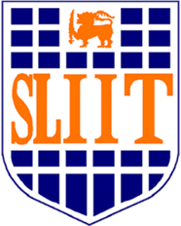
Sri Lanka Institute of Information Technology

IT2130 – Operating Systems and System Administration
Year 2, Semester 2- 2026

Practical Answer Submission

Practical Sheet No: XX

Student ID
Student Name
Campus/ Center name
Specialization
Batch No

