Speech Alignment using Montreal Forced Aligner and Praat
Name: Sisira Gonugodugu
Date: 06-11-2025
Assignment: IIIT Hyderabad Internship Task

1. Objective
The objective of this assignment is to perform forced alignment of given speech audio files and their corresponding transcripts using the Montreal Forced Aligner (MFA) tool, and to visualize the alignment in Praat. This process helps analyze how accurately the text aligns with the spoken words.

2. Steps Followed
• Installed Anaconda and created a new environment named 'aligner'.
• Installed Montreal Forced Aligner (MFA) and configured necessary models (dictionary and acoustic).
• Validated the corpus using the command:
mfa validate <corpus_path> <dictionary>
• Performed forced alignment using:
mfa align <corpus_path> <dictionary> <acoustic_model> <output_path>
• Installed Praat and used it to visualize the alignment results.
• Opened aligned .TextGrid and .wav files in Praat using 'Read from file...' and 'View & Edit'.
• Inspected the word and phoneme boundaries and saved screenshots for analysis.

3. Results
The alignment process successfully produced TextGrid files for each audio file. The Praat visualization shows word and phoneme boundaries aligned with the waveform and spectrogram.
Below are example alignment screenshots :
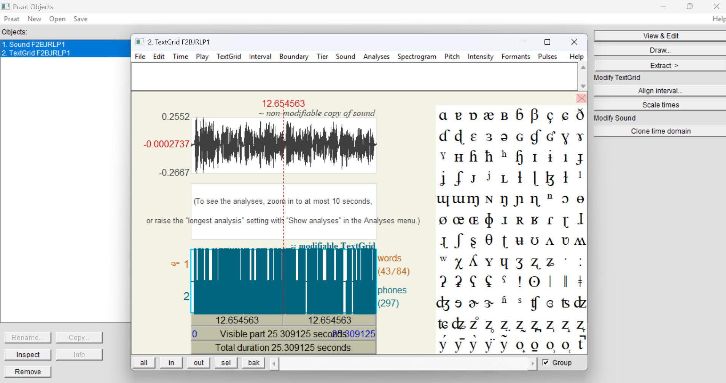

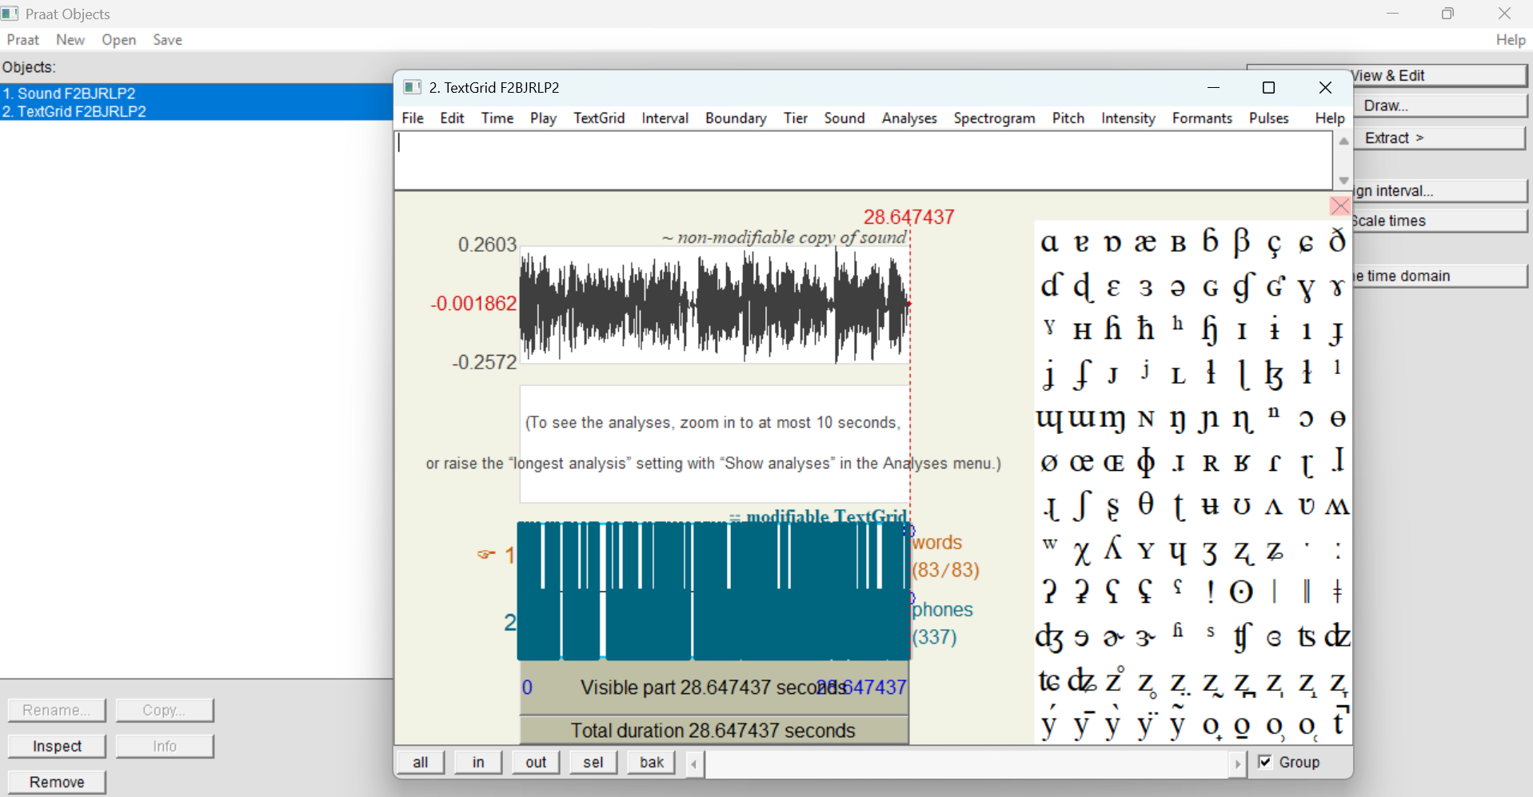

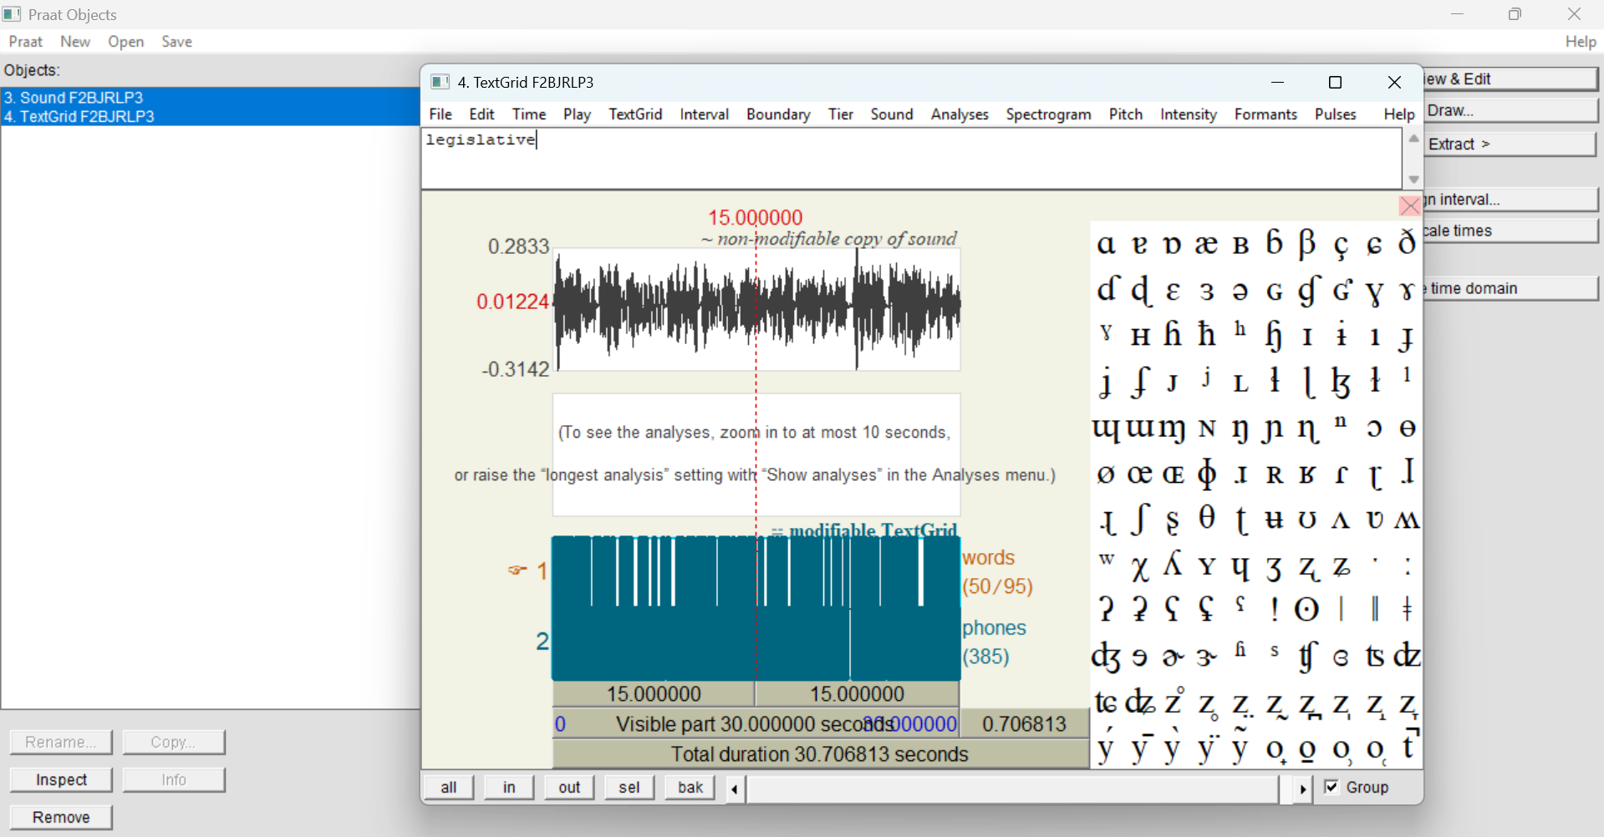

4. Observations
From the visual analysis in Praat, most word and phoneme boundaries were accurately placed. Some minor deviations were observed in background noise or unclear speech segments.

5. Conclusion
The forced alignment was successfully completed using Montreal Forced Aligner. Praat visualization confirmed accurate alignment between speech and text. This task helped in understanding the workflow of speech-text alignment and phonetic analysis.
Signature: G.Sisira

