**AWS instance run**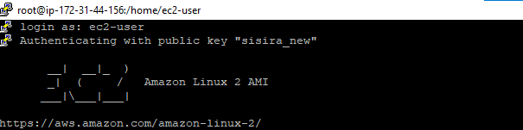

**PWD**



**SUDO SU**



**YUM INSTALL DOCKER -Y**



**DOCKER –VERSION**



**DOCKER INFO**

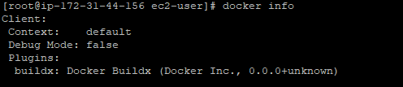

**SERVICE DOCKER STATUS**

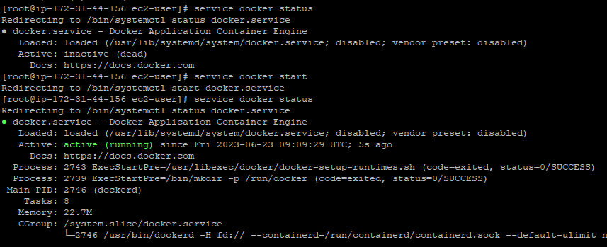

**SERVICE DOCKER START**



**DOCKER PS -a**



**DOCKER PULL UBUNTU**

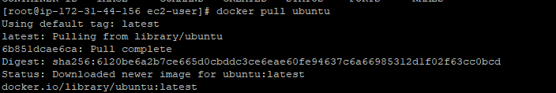

**DOCKER IMAGES**

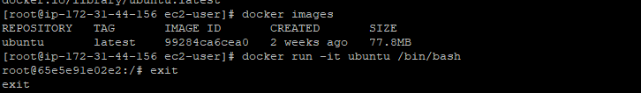

**DOCKER PS**



**DOCKER PS -a**

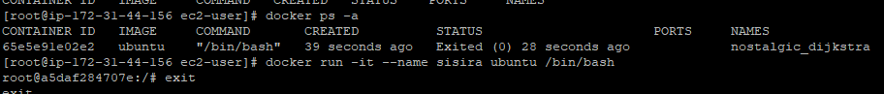

**Docker run it ubuntu /bin/bash**





**Docker run - -it ubuntu /bin/bash**

