SLO Assessment Committee Work Spring 2023
- Reviewed assessment processes at other CCCs (see page 3)
- Based on discussions, the committee proposed a tentative assessment schedule (see below)
- Worked with IR and IT on process for uploading data into eLumen
- Met with Curriculum Committee about SLOs in CORs and relationship between C-ID objectives and SLOs
- Met with the VPAA to request support for assessment (technical support with eLumen, assigning assessments, etc.)

Committee Goals AY 23-24
- Develop an assessment philosophy for approval by Senate
- Refine and present an assessment plan for approval by Senate

Committee/Coordinator Tasks AY 23-24
- Create training documentation for assessing SLOs in eLumen
- Assist faculty to map CSLOs to PSLOs/GESLOs accurately in eLumen
- Assist faculty in completing the first rounds of assessment

Guiding Principles
We are working to create a process that:
- Is efficient.
- Generates meaningful information that supports student success.
- Meets standards for accreditation.
- Is collaborative and integrative with other areas on campus.
- Is focused on equity.
- Is measurable.

Assessment Philosophy Questions (see attached article)
- Why assess student learning outcomes?
- What is assessment?
- How will assessment improve learning?
- Who will conduct outcomes assessment?
- Who will develop the processes of assessment?
- What will assessment be used for?
- What will assessment not be used for?
- What is the college’s role in assessing student learning?
- How will we use assessment of student learning?

Proposed Schedule
CSLOs
At least 3 course-level student learning outcomes (CSLOs) per course in all courses will be assessed on a 3-year cycle. Each program/discipline will determine how they want to structure their assessment schedule and if they will do additional assessments.

PSLOs
Program-level student learning outcomes (PSLOs) will be assessed indirectly by the CSLO data. This will require CSLOs to be mapped to their corresponding PSLOs where appropriate. PSLOs can also be assessed directly.

ISLOs and GESLOs
Institution-level student learning outcomes (ISLOs) and general education student learning outcomes (GESLOs) will be assessed according to the schedule determined by the College (below). According to the current approved schedule, each GE and ISLO will be assessed every two years. Like PSLOs, GESLOs and ISLOs can be assessed indirectly by mapping CSLOs to the appropriate ISLOs and GESLOs. ISLOs and GESLOs can also be assessed directly.

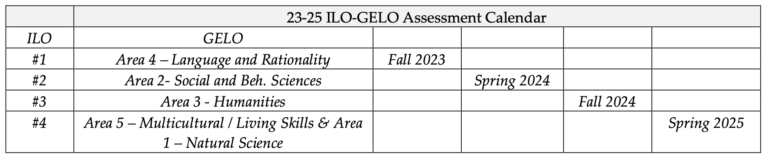

College | # of CSLOs/course | PSLOs/ILOs | Tools | Notes
Modesto JC | All CSLOs every two years | All assessed every two years, use data roll-up | eLumen | Disaggregate data when possible
Long Beach City College | 2 years cycle for all courses (have 6-year curriculum cycle), assess every semester | Data roll-up | Assess in Canvas using SLO assessment shells | Using disaggregated data
Cerritos College | All CSLOs assessed at least once every 3 years | Data roll-up? | eLumen | Programs/departments determine their assessment schedules, create plan with program review
Clovis Community College | All CSLOs every two years | Data roll-up, every two years, staggered timeline | Homegrown system | Disciplines/departments have their own timelines for assessment
College of the Redwoods | All CSLOs every 4 years | Data roll-up | eLumen | Data not disaggregated?
Glendale College | Minimum of 2 CSLOs per course within 3-year, recommend assessing all | Every 3 years, recommend assessing more than one at a time, data roll-up? | eLumen | Using disaggregated data
Fullerton College | All CSLOs must be assessed at least once prior to program review (2 or 3 years) | Data roll-up | eLumen | Recommend qualitatively similar assessments

