INTERNATIONAL ORGANIZATION FOR STANDARDIZATION
ORGANISATION INTERNATIONALE DE NORMALISATION
ISO/IEC JTC1/SC29/WG11
CODING OF MOVING PICTURES AND ASSOCIATED AUDIO

ISO/IEC JTC1/SC29/WG11/N3701
October 2000 (LaBaule)

Title: Text of ISO/IEC CD 15938-1 Information technology - Multimedia content description interface – Part 1 Systems
Source: Systems Sub-group
Editor: Claude Seyrat (Expway), Michael Wollborn (Bosch), Ali Tabatabai (Sony), Olivier Avaro (France Telecom R&D)
Status: Committee Draft

ISO/IEC JTC 1/SC 29/WG 11 N 3701
ISO/IEC 15938-1:2001(E)
ISO/IEC JTC 1/SC 29/WG 11
Modified by the SC 29 Secretariat
Information technology – Multimedia content description interface –
Part 1: Systems
Contents
1 Scope 7
2 Normative References 7
3 Terms and Definitions 7
4 Abbreviations and Symbols 8
5 Systems architecture 8
5.1 Terminal architecture 8
5.2 Normative interfaces 10
5.2.1 Description the normative interfaces 10
5.2.2 Validation of the standard 11
6 MPEG-7 Access Unit 11
6.1 MPEG7_DecoderConfig DDL Representation Syntax 12
6.2 MPEG7_DecoderConfig Binary Representation Syntax 12
6.3 MPEG7_DecoderConfig Description Scheme semantics 13
6.4 MPEG7_AccessUnit DDL Syntax Representation 13
6.5 MPEG7_AccessUnit Binary Syntax Representation 14
6.6 MPEG7_AccessUnit Description Scheme semantics 14
7 MPEG-7 Binary Format 15
7.1 Introduction 15
7.2 Binary Format for MPEG-7 Data (“MPEG-7 BiM”) 15
7.2.1 General Structure 15
7.2.2 Navigation 18
7.2.3 Content Manipulation 21
7.2.4 Decoding of sub-trees 22
Annex A (informative) Bibliography 33
Annex B (informative) Patent statements 34
Annex C (informative) MPEG-7 meta data flow 35
Annex D (informative) Informative Educational Examples for the MPEG-7 BiM 38
D.1 Example for general structure 38
D.2 Example for decoding of sub-trees 39
D.2.1 General Example 39
D.2.2 Substitution group realization 41
D.2.3 Syntax tree generation 41
D.2.4 Syntax tree simplification 42
D.2.5 Attributes coding 43
D.2.6 Decoding automata 44
D.2.7 Realized automaton 45
D.2.8 Infinite unsigned integer coding 46
D.2.9 Polymorphism coding 46
Figures
Figure 1 - MPEG-7 Architecture 9
Figure 2 - MPEG-7 Normative Interfaces 10
Figure 3 - Validation process 11
Figure 4 - A Description Tree as a Combination of its’ Fragments 12
Figure 5 - Example for tree representation of MPEG-7 description 16
Figure 6 - Principle structure of a BiM fragment 17
Figure 7 - Bit representation of #position for elements with maxOccurs > 8 20
Figure 8.a - Absolute path with respect to the Root Node 20
Figure 9 - The positions of the current node for different states within a BiM fragment. 21
Figure 10 - The general binary coding format 23
Figure 11 - The decoding process 24
Figure 12 - The schema compilation 25
Figure 13 - Attributes coding format 29
Figure 14 - Fast access feature 31
Figure 15 - MPEG-7 Metadata Flow 35
Figure 16 - A complexType automaton 40
Figure 17 - The syntax tree of coordinate mapping 42
Figure 18 - A complex syntax tree 43
Figure 19 - A reduced syntax tree 43
Figure 20 - Attributes automata 44
Figure 21 - An item automaton 44
Figure 22 - A choice automaton 45
Figure 23 - An occurrence automaton 45
Figure 24 - An other occurrence automaton 45
Figure 25 - A sequence automaton 45
Figure 26 - An other sequence automaton 45
Figure 27 - Automaton with key realized 46

Tables
Table 1 - IDs of MPEG-7 top-level elements (DS types) 18
Table 2 - Code Table of Navigation Commands 18
Table 3 - Prototype of a Tree Branch Code Table of an Element or named Complex Type 19
Table 4 - Prototype of a Tree Branch Code Table of an Element or named Simple Type 20
Table 5 - Code Table of Content Manipulation Commands 21

Foreword
ISO (the International Organization for Standardization) and IEC (the International Electrotechnical Commission) form the specialized system for worldwide standardization. National bodies that are members of ISO or IEC participate in the development of International Standards through technical committees established by the respective organization to deal with particular fields of technical activity. ISO and IEC technical committees collaborate in fields of mutual interest. Other international organizations, governmental and non-governmental, in liaison with ISO and IEC, also take part in the work.
In the field of information technology, ISO and IEC have established a joint technical committee, ISO/IEC JTC 1. Draft International Standards adopted by the joint technical committee are circulated to national bodies for voting. Publication as an International Standard requires approval by at least 75 % of the national bodies casting a vote.
The MPEG-7 standard also known as "Multimedia Content Description Interface" aims at providing standardized core technologies allowing description of audiovisual data content in multimedia environments. In order to achieve this broad goal, MPEG-7 will standardize:
- Descriptors (D): representations of Features, that define the syntax and the semantics of each feature representation,
- Description Schemes (DS), that specify the structure and semantics of the relationships between their components, which may be both Ds and DSs,
- A Description Definition Language (DDL), to allow the creation of new DSs and, possibly, Ds and to allows the extension and modification of existing DSs,
- System tools, to support multiplexing of description, synchronization issues, transmission mechanisms, file format, etc.
The MPEG-7 standard consists of the following parts, under the general title Information Technology - Multimedia Content Description Interface:
- Part 1: Systems. Architecture of the standard, tools that are needed to prepare MPEG-7 Descriptions for efficient transport and storage, and to allow synchronization between content and descriptions. Also tools related to managing and protecting intellectual property. Representation of DSs and Ds and especially binary representation.
- Part 2: Description Definition Language (DDL). Language for defining new DSs and perhaps eventually also for new Ds.
- Part 3: Visual. Visual elements (Ds and DSs).
- Part 4: Audio. Audio elements (Ds and DSs).
- Part 5: Multimedia description schemesmes. Elements (Ds and DSs) that are generic, i.e. neither purely visual nor purely audio.
- Part 6: Reference software. Software implementation of relevant parts of the MPEG-7 Standard.
- Part 7: Conformance testing. Guidelines and procedures for testing conformance of MPEG-7 implementations.
This document represents the current Committee Draft of Part 1 of the MPEG-7 standard, the Systems Committee Draft.

Introduction

Overview
The MPEG-7 standard also known as "Multimedia Content Description Interface" aims at providing standardized core technologies allowing the description of audiovisual data content in multimedia environments [1]. This is a challenging task given the broad spectrum of requirements and targeted multimedia applications, and the broad number of audiovisual features of importance in such context. In order to achieve this broad goal, MPEG-7 will standardize:
- Descriptors (D): representations of Features, that define the syntax and the semantics of each feature representation;
- Description Schemes (DS), that specify the structure and semantics of the relationships between their components, which may be both Ds and DSs;
- A Description Definition Language (DDL), to allow the creation of new DSs and, possibly, Ds and to allows the extension and modification of existing DSs;
- System tools, to support multiplexing of description, synchronization issues, transmission mechanisms, file format, etc.
This part of the specification describes the Systems layer, comprising the tools that are needed to prepare MPEG-7 Descriptions for efficient transport and storage, and to allow synchronization between content and descriptions. Also tools related to managing and protecting intellectual property.

Overview of this part of ISO/IEC 15938
This part of ISO/IEC 15938 specifies the following tools:
- a terminal architecture defined as a normative compression layer interfaced with a non-normative delivery layer,
- an MPEG-7 elementary stream format composed of textual or binary access units,
- an interface of the standard for the textual format,
- an interface of the standard for the binary format.

The structure of this document is the following:
- Clause 5 specifies the terminal architecture.
- Clause 6 specifies the MPEG-7 access units format.
- Clause 7 specifies the Binary format for MPEG-7 data.
- Annexes A and B contain the Bibliography and Patent Statements respectively.
- Annex C contains an informative overview of the flow of metadata through the content creation and delivery lifecycle.
- Annex D contains informative examples for the binary format for MPEG-7 description (BiM).
Information technology – Multimedia content description interface –
Part 1: Systems

Scope
This part of ISO/IEC 15938 specifies system level functionnalities for the communication of multimedia content descriptions. It provides an unambiguous specification which will enable MPEG-7 users and developers:
- to develop MPEG-7 conformant decoders,
- to prepare MPEG-7 Descriptions for efficient transport and storage,
- to allow synchronization between content and descriptions.

Normative References
The following ITU-T Recommendations and International Standards contain provisions, which, through reference in this text, constitute provisions of ISO/IEC 15938. At the time of publication, the editions indicated were valid. All Recommendations and Standards are subject to revision, and parties to agreements based on ISO/IEC 15938 are encouraged to investigate the possibility of applying the most recent editions of the standards indicated below. Members of IEC and ISO maintain registers of currently valid International Standards. The Telecommunication Standardization Bureau maintains a list of currently valid ITU-T Recommendations.

Terms and Definitions

Access Units
A fragment that is atomic in time i.e., the smallest description entity to which a time element can be attached.

Commands
Commands provide the dynamic aspects of the MPEG-7 description carriage.

ComplexType
A complexType is a definition of a set of attribute declarations and a content type applicable to the attributes and children of an element instance respectively.

Content Manipulation Command
A command that tells the decoder which transformation should be applied to the description.

Fast Access
The process of skipping undesired parts of the stream without entirely decoding them.

Navigation Command
A command that tells the decoder which instantiated part of the description it will receive.

Navigation Path
The absolute or relative address of the tree node for which the decoder will receive the description.

Random Access
The process of beginning to read and decode a coded representation at an arbitrary point within the description stream.

Root Element
The most global element of a description i.e. the element that contains the entire description.

Schema
The set of Schema Components which define a class of XML documents by expressing syntactic, structural and value constraints applicable to document instances.

SimpleType
The set of constraints on string values or lists of strings. Simple types cannot have element content and cannot carry attributes.

Terminal
The entity that uses coded representation of the multimedia content.

Top Level Element
The children of the root element. Top level elements are chosen among a finite set of possible element defined in part 3, 4 and 5 of the standard.

Abbreviations and Symbols
BIM | BInary format for Mpeg-7
D | Descriptor
DDL | Description Definition Language
DS | Description Scheme
TBC | Tree Branch Codes
UCS | Universal Character Set
URI | Uniform Resource Identifier
URL | Uniform Resource Locator
UTF | UCS transformation formats
XML | Extensible Markup Language 1.0
XPath | XML Path Language

Systems architecture

Terminal architecture
The information representation specified in the MPEG-7 standard provides the means to represent coded multimedia content description information. The entity that makes used of such coded representation of the multimedia content is generically referred to as "terminal". This terminal may correspond to a standalone application or be part of an application system.
The objective of this section is to provide the description of a terminal making use of MPEG-7 representations. The architecture of such terminal is depicted in Figure 1 and its overall operation is described in this section. The following sections further described the overall operation of the tools specified in this part of the MPEG-7 specification.
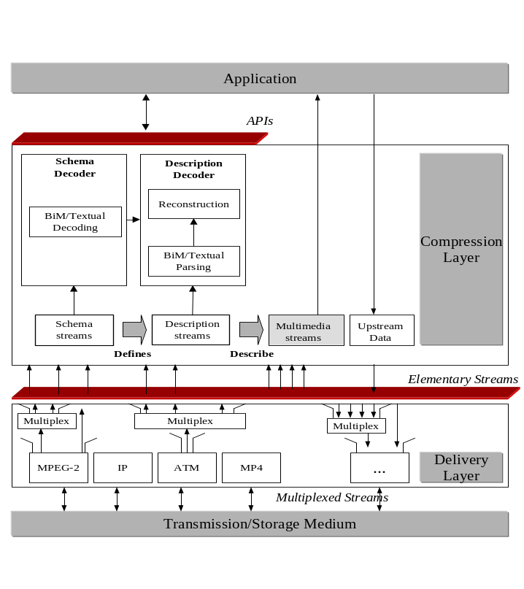
Figure 1 - MPEG-7 Architecture
At the bottom of Figure 1 is the transmission/storage medium. This refers to the lower layers of the delivery infrastructure (network layer and below, as well as storage). These layers deliver multiplexed streams to the Delivery layer. The transport of the MPEG-7 data can occur on a variety of delivery systems. This includes for example MPEG-2 Transport Streams, IP (Internet Protocol), or MPEG-4 (MP4) files or streams. The delivery layer encompasses mechanisms allowing synchronization, framing and multiplexing of MPEG-7 content. MPEG-7 content may be delivered independently or together with the content they describe. The delivery of MPEG-7 content on particular systems is outside the scope of this specification. Not all MPEG-7 streams have to be downstream (server to the client). The MPEG-7 architecture allows to convey data back from the terminal to the transmitter or server, such as queries or request.
The Delivery layer provides to the Compression layer MPEG-7 elementary streams. MPEG-7 elementary streams consist in consecutive individually accessible portion of data named Access Units. An access unit is the smallest data entity to which timing information can be attributed MPEG-7 elementary streams contain information of different nature:
- Schema information: this information defines the structure of the MPEG-7 description;
- Descriptions information: this information is either the complete description of the multimedia content or fragments of the description.
The delivery layer of a complete application may also be capable of providing the multimedia content data if requested. Such delivery mechanisms is outside the scope of this specification. Existing delivery tools may be used for this purpose.
MPEG-7 data can be represented either in textual format, in binary format or a mixture of the two formats, depending on application usage. MPEG-7 defines a unique mapping between the binary format and the textual format. A bi-directional loss-less mapping between the textual representation and the binary representation is possible. Still, it shall not always be used : some applications may not want to transmit all the information contained in the textual representation and may prefer to use a more bandwidth efficient binary lossy transmission.
The syntax of the textual format is defined in Part 2 (Description Definition Language) of the standard. The syntax of the binary format is defined in Part 1 (Systems) of the standard. Schema are defined in Parts 3, 4 and 5 (Visual, Audio and Multimedia Description Schemes) of the standard.
At the compression layer, the flow of Access Units (either textual or binary encoded) is parsed, and the content description is reconstructed. MPEG-7 does not mandate the reconstruction of a textual representation as an intermediate step of the decoding process. The MPEG-7 binary stream can be either parsed by the BiM parser, transformed in textual format and then transmitted in textual format to further reconstruction processing, or the binary stream can be parsed by the BiM parser and then transmitted in proprietary format to further processing.
MPEG-7 Access Units are further structured as commands encapsulating the schema or the description information. Commands provide the dynamic aspects of the MPEG-7 content. They allow a description to be delivered in a single chunk or to be fragmented in small pieces. They allow basic operations on the MPEG-7 content such as updating a descriptor, deleting part of the description or adding new DDL structure. The reconstruction stage of the compression layer updates the description information and associated schema information by consuming these commands. Further structure of the schema or description is out of the scope to this specification.

Normative interfaces

Description the normative interfaces
The objective of this section is to describe MPEG-7 normative interfaces. MPEG-7 has two normative interfaces as depicted in Figure 2 and further described in this section.
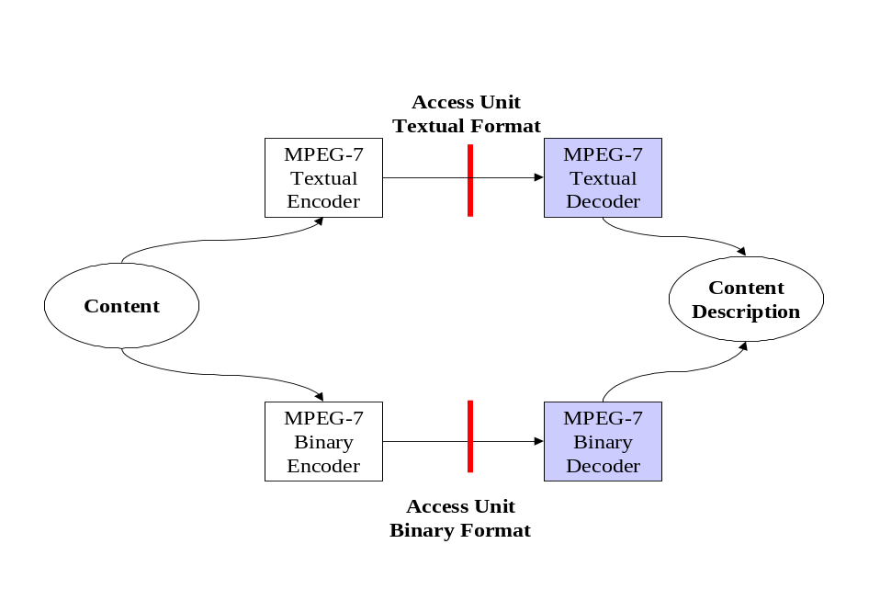
Figure 2 - MPEG-7 Normative Interfaces
Content : These are the data to be represented according to the format described by this specification. Content refer either to essence or to content description.
MPEG-7 Binary/Textual Encoder : These processes transform the content into a format compliant to this specification. The definition of these processes is outside the scope of this specification. They may include complex processing of the content such as features extraction.
Textual Format interface : This interface describes the format of the textual access units. The MPEG-7 Textual Decoder consumes a flow of such Access Units and reconstruct the content description in a normative way.
Binary Format Interface : This interface describes the format of the binary access units. The MPEG-7 Binary Decoder consumes a flow of such Access Units and reconstruct the content description in a normative way.
MPEG-7 Binary/Textual Decoder : These processes transform data compliant to this specification into a content description. The format of the reconstructed content description is outside the scope of this specification.

Validation of the standard
The objective of this section is to describe how proof can be established that the binary representation and the textual representation provide dual representations of the content. The process is described in Figure 3 and further described in this section.
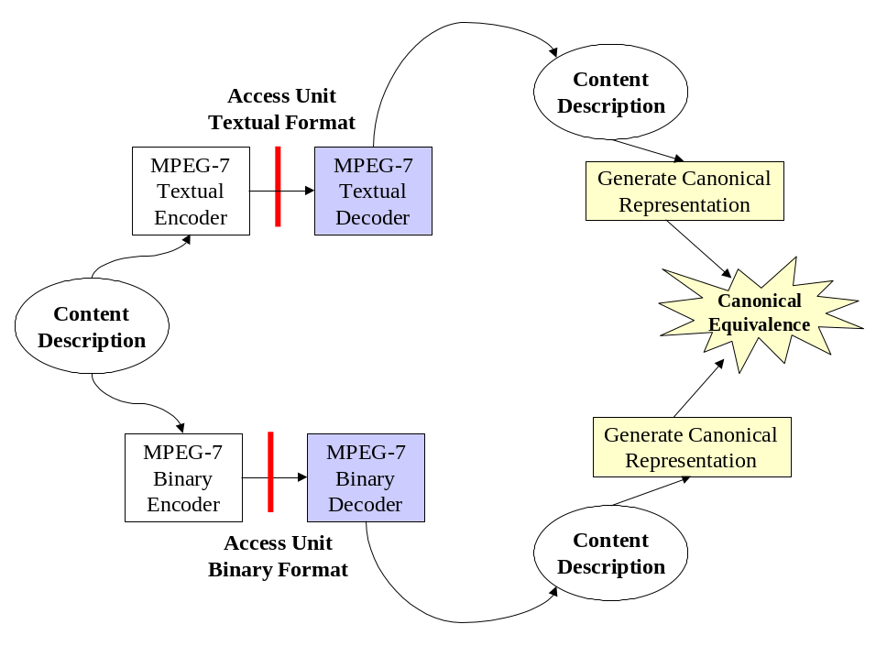
Figure 3 - Validation process
In addition to the elements described in section 5.2.1, the validation process involves the definition of a canonical representation of a content description. In the canonical space, content description can be compared. The validation process works as follows:
- A content description is encoded in a loss-less way in textual and in binary format, generating two different representation of the same entity.
- The two encoded descriptions are decoded with their respective binary and textual decoders.
- Two canonical descriptions are generated from the reconstructed content descriptions.
- The two canonical descriptions shall be equivalent.
The definition of the canonical representation of an XML document is defined in Canonical XML [10].

MPEG-7 Access Unit
In general, a content description tree can be modeled as a combination of sub-trees called fragments as shown in Figure 4.
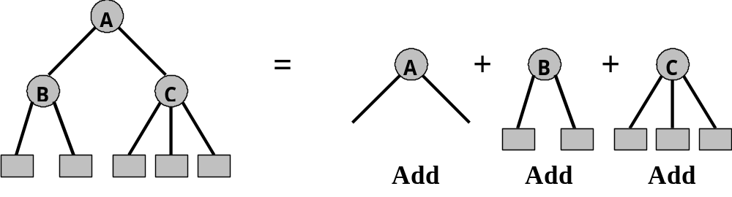
Figure 4 - A Description Tree as a Combination of its’ Fragments
By definition, an “Access Unit” (AU) is a fragment that is atomic in time i.e., it is the smallest description entity to which a time element can be attached.
The operational model assumed here is that issuing various update commands, that use these fragments as their values, can generate a content description tree. To provide information about the MPEG-7 decoder type and the resources needed for decoding the associated elementary stream a global element called MPEG7_DecoderConfig, which is initialized at the beginning of the session, is also defined.
In case when MPEG-4 system is used as the transport layer, this descriptor is the DecoderSpecificInfo in a DecoderConfigDescriptor. Similarly, AUs can be encapsulated into MPEG-4 Systems’ semantic entities called “SyncLayerPacket” packets to carry information such as AU start/end/random access flags, decoding/composition time stamps and clock reference for timing recovery etc. In the following sections we show DDL and binary syntax for both MPEG7_DecoderConfig and MPEG7_AccessUnit together with their semantics.

MPEG7_DecoderConfig DDL Representation Syntax
<complexType name=MPEG7_DecoderConfig>
<element name=”schemaReference” type=”vectorURI”
minOccurs=”0” maxOccurs=”1”/>
<attribute name=”predefined” type=”unsignedInt8” use=”required”/>
</complexType>

<simpleType name=”uriReferenceList” base=”uriReference” derivedBy=”list”/>

<complexType name=”vectorURI” base=”uriReferenceList” derivedBy=”extension”>
<attribute ref =”mpeg7:dim”/>
</complexType>

MPEG7_DecoderConfig Binary Representation Syntax
MPEG7_DecoderConfig { | Number of bits | Mnemonic
predefined | 8 | bslbf
if(predefined == 0) {
dim | 8 | bslbf
for(k=1; k < dim; k++) {
length | 8 | bslbf
vectorURI[k] | 8*length | bslbf
}
initial_AU_Length | 8 | bslbf
initial_AU | 8*Initial_AU_length | bslbf
}

MPEG7_DecoderConfig Description Scheme semantics
Predefined: indicates whether to use a predefined configuration. If predefined == 0, then the list of URIs used follows; if predefined != 0, then dim (the number of URIs) is zero, and a well-known set of schemas is used by this stream as indicated by the value of the “predefined” attribute. In this draft, there are no such well-known sets defined.
vectorURI: a list of URIs to reference the schemas (using the namespaces construct). . Note that a small ‘inline’ schema may be supplied by a DATA: URL. Not all terminals, however, may be capable of parsing new schemas; some may be restricted to recognizing particular URIs.
initial_AU_Length: indicates the length of “initial_AU” in bytes.
initial_AU: supplies the initial (base-level, permanent) the ‘reset’ and initial states description, supplied inline, that forms the basis of the ‘reset’ and initial states.

MPEG7_AccessUnit DDL Syntax Representation
<complexType name=”MPEG7_AccessUnit”>
<element name=”update” type=”updateCommand”
minOccurs=”1” maxOccurs=”unbounded”/>
<attribute name= “executionOrder”>
<simpleType base=”string”>
<enumeration value=”sequential”/>
<enumeration value=”parallel”/>
</simpleType>
</attribute>
</complexType>

<complexType name=”updateCommand”>
<element name=”command” type=”updateType”/>
<element name=”location” type=”updateLocation”/>
<element name=”value” type=”updateValue”/>
</complexType/>

<simpleType name=”updateType” base=”string”>
<enumeration value=”add”/>
<enumeration value=”delete”/>
<enumeration value=”change”/>
<enumeration value=”reset”/>
</simpleType>

<complexType name=”updateLocation”>
<attribute name=”fragmentID” type=”uriReference”/>
<attribute name=”position” type=”boolean” use=”default” value=”1”/>
</complexType>

<complexType name=”updateValue” minOccurs=”0” maxOccurs=”1”>
<choice>
<element name=”binaryValue” type=”binaryUpdate”/>
<element name=”textualValue” type=”textualUpdate”/>
<element ref=”resetContentDescription”/>
</choice>
<attribute name=”schemaIndex” type=”integer”/>
</complexType>

<simpleType name=”listOfByte” base=”Byte” derivedBy=”list”>

<complexType name=”VectorB” base=”listOfByte” derivedBy=”extension”>
<attribute ref =”mpeg7:dim”/>
</complexType>

<complexType name=”binaryValue”>
<element name=”value” type=”VectorB”/>
<attribute name=”binaryType” type=”NOTATION” use=”optional”/>
</complexType>

<complexType name=”textualValue”>
<any namespace= “##any” processContent=”skip”
minOccurs=”1” maxOccurs=”unbounded”/>
</complexType>

MPEG7_AccessUnit Binary Syntax Representation

MPEG7_AccessUnit { | Number of bits | Mnemonic
execution_order | 1 | bslbf
while(thereAreUpdateCommands) {
updateType | 2 | bslbf
updateLocation | ? | ?
if(updateType!=”delete” )
updateValue | ? | ?
}
}

MPEG7_AccessUnit Description Scheme semantics
Each Access Unit in the stream consists of a set of update commands, and an indication whether they should be applied serially or whether they may be applied in parallel (i.e. they are independent).
An update command consists of four parts:
- updateType: indicates the type of update command used (add, delete, change and reset). The “reset” command replaces the whole content description tree with a (predefined/referenced) content.
- updateLocation: uses a XPath-like fragment identifier where the update is to take place. There is also a flag indicating whether we add before or after the identified node. Note that some XPath constructs may have more compact binary representations than others (notably, node names will necessarily be sent as text and may be long, and therefore relative node numbers can be more compactly expressed).
- updateValue: indicates the value to be added or replaced. Note that this is made optional, because of “delete” command. The value may be binary (an array of bytes”, textual (array of strings) or a reference to a globally declared element to be used for “reset”. In case of binary update, using “NOTATION” will point to which decoder to use for decoding the binary bitstream. Notice that we are supplying a schemaReference as well by using “schemaIndex”. That is the update value is divided logically into the encoding of the value itself, and the ‘type’ of the value (which may be atomic, or reference one of the schemas).
- executionOrder: indicates whether the group of update commands can be executed independently (parallel) or sequential.
In MPEG-4 systems, each access unit is placed into sync layer packet(s), which supply the framing, timing, synchronization, and random access points. In general, a random access point would consist of a ‘reset’ command and some adds that re-establish the state at that time. Note that the MP4 file format permits ‘shadow’ sync points, which are only supplied when random-accessing, replacing the normal incremental frame at that time.

MPEG-7 Binary Format

Introduction
This section of the MPEG-7 Systems Specification describes the binary format for the representation and update of MPEG-7 description schemes instances. In the remainder of this section it is also referred to as “BiM”, i.e. Binary format for MPEG-7 data. The BiM may be used as an alternative to the textual MPEG-7 format, which is described by the XML language [7] according to the MPEG-7 D and DS definitions. For these definitions, the MPEG-7 Description Definition Language (DDL) specified in ISO/IEC 15938-2 is used.
There are two main reasons for having a binary format for MEG-7 data. First, in general the transmission or storage of the textual format requires a much higher bandwidth for storage or transmission than necessary from a theoretical point of view. Therefore, an efficient compression of the textual format is applied when converting it to binary. Second, the textual format is not very appropriate for streaming applications. For example, it allows the transmission of a description tree only in the so-called depth-first tree order. However, for streaming applications more flexibility is required with respect to the transmission order of the elements. The BiM provides this flexibility.
In the following, the general properties of the BiM are described:
- The BiM as specified in this document only allows the representation and update of MPEG-7 DS instances, not of new Ds or DSs. This latter functionality will possibly be provided by an amendment of this specification at a later stage.
- It is possible to encode a textual description into BiM, and to decode a binary description into textual format. If applied in sequence, both textual descriptions will be “canonically” equivalent, see section 5.2.2.
- In order to generate a binary description, one can either generate a textual description first and then encode it into BiM, or one can directly generate the binary format, without previously using the textual format.
- In order to “consume” a binary description, a decoder can either convert the binary format into a textual description or it can directly parse the binary stream
- The BiM allows to randomly search and / or randomly access elements of a binary MPEG-7 description directly on the bitstream, without parsing the complete bitstream before these elements

Binary Format for MPEG-7 Data (“MPEG-7 BiM”)

General Structure

Tree representation of description schemes
In general, each MPEG-7 description starts with a so-called MPEG-7 root element, which can contain one or more MPEG-7 description schemes. Those MPEG-7 DSs that are children of a root element are in the following referred to as “top level elements”. Since all MPEG-7 descriptions are hierarchically defined, they can be interpreted as a description tree, as shown in Figure 5.
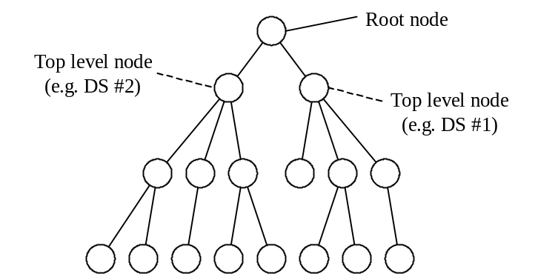
Figure 5 - Example for tree representation of MPEG-7 description
Since a tree representation of the description is used, the root element and the top-level element are also referred to as “root node” and “top-level node” in the remainder of this document. This tree representation will also be used in this section in order to describe how the binary format is decoded.
The very first part of each MPEG-7 bitstream is a binary header, which specifies the MPEG-7 root element and possibly either version or profile/level indication information. The syntax and semantics of a binary MPEG-7 stream is described in the following.

MPEG-7 BiM Stream
This section specifies the syntax and the semantics of a binary MPEG-7 stream, also referred to as “MPEG-7 BiM stream”

Syntax of ‘MPEG-7BiMStream’
Mpeg7BiMStream() { | Number of bits | Mnemonic
M7_Startcode | 24 | bslbf
M7_ProfileAndLevelIndication | 5 | bslbf
M7_RootElement | 3 | bslbf
while (RootCommand != exit_root) {
BiM_Fragment()
}
}

Semantics of ‘MPEG-7BiMStream’
M7_Startcode
The “M7_StartCode” marks the start of an MPEG-7 elementary stream. It is represented by the bitstring “0000F0” in hexadecimal.
M7_ProfileAndLevelIndication
This is a 5 bit code used to signal the profile and level identification. The meaning of the code is specified in the following table.
M7_ProfileAndLevelIndication | Meaning
00000 | Reserved
00001 – 11111 | To be determined

M7_RootElement
This is a 3 bit code specifying which MPEG-7 root element is contained in the bitstream. The meaning of the code is specified in the following table.
M7_RootElement | Meaning
000 | Reserved
001 | MPEG-7 Main
010 | MPEG-7 Unit
011 – 111 | Reserved

BiM Fragment
When the root node information has been received by the decoder, the remainder of the bitstream consists of so-called BiM fragments. Each BiM fragment looks in principle like follows:
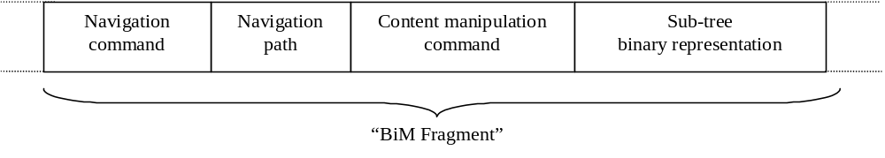
Figure 6 - Principle structure of a BiM fragment
As shown, a BiM fragment consists mainly of 4 parts, which will be shortly described in the following. The first part is the so-called “navigation command”, which tells the decoder which instantiated part of the description scheme it will receive next. Three kinds of addressing description elements are possible:
- the so-called relative addressing with respect to the node the decoder is currently in
- the absolute addressing with respect to the current top-level node of the DS in which the decoder is currently in
- The absolute addressing with respect to the root node
The navigation commands are described in detail in section 7.2.2.
The next part of the BiM fragment is the navigation path, i.e. the absolute or relative address of the tree node for which the decoder will receive the information contained in the BiM fragment. The address (also referred to as identifier or ID) of the top-level DSs consists of an 8 bit code that is specified in the following table. In order to be able to leave the root node and thus to finish the MPEG-7 bitstream, in addition to the top-level DS IDs a specific bit code is present which signals the “exit root” command.

ID_of_TopLevelElement | MPEG-7 top level DS type
0000 0000 | Reserved
0000 0001 | BasicDescription
0000 0010 | ContentDescription
0000 0011 | ContentTypeDescription
0000 0100 | ImageDescription
0000 0101 | VideoDescription
0000 0110 | AudioDescription
0000 0111 | AudioVisualDescription
0000 1000 | MixedContentDescription
0000 1001 | CollectionDescription
0000 1010 | ContentAbstraction
0000 1011 | WorldDescription
0000 1100 | ModelDescription
0000 1101 | ViewDescription
0000 1110 | SummaryDescription
0000 1111 | VariationsDescription
0001 0000 | UserDescription
0001 0001 – 1111 1110 | Reserved
1111 1111 | Exit root node
Table 1 - IDs of MPEG-7 top-level elements (DS types)
The addresses for subsequent sub-elements (children) of top-level DSs are calculated using local path codes (in the remainder of this document also referred to as “tree-branch-codes”) between nodes and their children. The calculation of these addresses is described in detail in section 7.2.2.
The third part of a BiM fragment is a so-called “content manipulation command”, which tells the decoder what kind of content manipulation it receives for the node it just has been sent to by the navigation. Three possible commands are provided, i.e. “add” a sub-tree, “update” a sub-tree and “delete” a sub-tree; the sub-tree includes in the node element in which the decoder currently is. Then the command is executed: in case of “add” or “update”, the content of the sub-tree is contained in the fourth component of the BiM fragment; in case of “delete” the fourth component of the BiM fragment is empty. After the command has been executed (i.e. the sub-tree information is decoded or the existing sub-tree is deleted), the decoder implicitly goes back to its parent node. The content manipulation commands are described in detail in section 7.2.3. The binary decoding of a sub-tree is described in detail in section 7.2.4.
Due to the flexible navigation possibilities, the BiM allows to transmit the elements of a description scheme in nearly arbitrary order. Further, the use of global addressing enables the fast search and filtering of the BiM stream without prior parsing. Some informative examples for decoding an MPEG-7 BiM stream are given in Annex D.

Navigation
The navigation section of the BiM Fragment is itself divided into two parts: The navigation command and the navigation path. The navigation command has a fixed bit length of 2 bits and is followed by the navigation path of variable length as shown in Figure 6. The navigation path is composed of consecutive Tree Branch Codes (TBCs) where each TBC describes a fraction of the path at a node within the tree of the description. Thus the navigation path is a sequence of local navigation paths which specify a tree branch at each node contained in the path through the tree (see Figure 8). The navigation command specifies how the navigation path has to be interpreted by a BiM decoder:
Code table for navigation commands
Code | Navigation Path | Navigation Command
00 | ID_of_TopLevelElement + <TBCs> | Navigate in absolute addressing mode from the ROOT node of the MPEG-7 description to the node specified by the ID of the top level node and by the subsequent TBCs.
01 | <TBCs> | Navigate in absolute addressing mode from the current top level node to the node specified by the TBCs
10 | <TBCs> | Navigate in relative addressing mode from the current node to the node specified by the TBCs
11 | --- | Reserved
Table 2 - Code Table of Navigation Commands
The codes for the ID_of_TopLevelElement are specified in Table 1 in section 7.2.1. In the node table of the MPEG-7 Root Nodes (see section 7.2.1.2.2) a specific code for the termination of the description transmission is specified.
The <TBCs> which are parameter of the navigation command and follow the navigation command code in the bitstream are generated from the Schema on which the instantiated description is based on. The schema definition specifies the possible children of one node in the description which have to be addressed by different TBCs. In the schema definition the possible types of children are specified and their maximal number of occurrences. Accordingly to address tree branches within an instantiated element resp. node of the description, the TBC contains the specification of the children element (SchemaBranch) and the position if it can be instantiated more than once. A complete navigation path resp. <TBCs> is an ordered list of consecutive Tree Branch Codes (TBCs).
A code table and its TBCs are specific for every named element of complexType or named complexType in the description scheme. So for navigation the type of the instantiated element determines also the code table which is used. Thus all elements resp. nodes of the same complex type have the same code table. Each child element and attribute of a node is assigned a code word that refers to it. These code words are called Tree-Branch-Codes (TBC) and are generated from the description scheme by a normative algorithm described in the following.
As already mentioned above the TBC are composed of two parts: the SchemaBranch which corresponds to the different child element definitions specified in the schema and the position which is only present if according to the schema definition multiple occurrences of this child are possible. For navigation within the description tree there is also a code to refer to the father node. Furthermore, a code word is used to terminate a path and implicitly switch to the command mode. Table 3 shows the prototype of such a code table.

Element or ComplexType name
TBC |  | Tree Branch
#SchemaBranch | #position | Tree Branch
000 | -- | Reference to father
001 | Pos. Code | Reference to first child
010 | Pos. Code | Reference to second child
011 | ...
100
...
111 | -- | This TBC signals the termination of the navigation path. Please note that after having received this TBC, the decoder is assumed to be in command mode for receiving further content manipulation commands
Table 3 - Prototype of a Tree Branch Code Table of an Element or named Complex Type

The assignment of the TBC is performed according to the following rules:
- The number of different children is known from the description scheme and defines the length of the SchemaBranch bitfield in the TBC according to the following rule: ⎡ld(#of child elements + # of attributes + 2)⎤, where ld is the logarithm to basis two and ⎡x⎤ determines the smallest integer y for which y≥x is true.
- The all-zero SchemaBranch code is always assigned to the reference to the father node.
- The SchemaBranch codes referring to the children are assigned sequentially in the order these are defined in the schema definition of this named element or type in the respective part of ISO/IEC 15938.
- The all-one SchemaBranch code is always used for terminating the path and switching to command mode.
- If a child can have multiple occurrences then the field <#position> specifies the number of the child in the instantiated description according to the following rule: The bit representation of the field #position is the minimal number of bits needed to represent the number of maxOccurs in the schema definition. If the number of bits exceeds 3 then the first bit (Ext) specifies if an extension of 4 bits is present (see Figure 7). These four bit have the same semantic as the previous four bits except that in the following the extension is 8 bits with the first one reserved to signal an extension.
Figure 7 - Bit representation of #position for elements with maxOccurs > 8
Elements which are grouped in a substitution group have additionally to code the address within that substitution group as an attribute after the TBC (this is not shown in the example figure above). This additional code is called SubstGrpSelect. Each element within an substitution group is assigned a SubstGrpSelect . The SubstGrpSelect codes referring to the elements are assigned sequentially starting from zero in the order these are defined in the schema definition.
Attributes, Elements of simpleType and named simpleTypes are represented by one leaf-table. A prototype of such a leaf-table is shown in Table 4.

Element or SimpleType name
TBC | Tree Branch
 | Terminate navigation and switch to command mode
Table 4 - Prototype of a Tree Branch Code Table of an Element or named Simple Type
SimpleTypes can not contain children elements. Accordingly the leaf table contains only the termination of the navigation and switches to the command node which has not to be addressed explicitly.
A path is constructed by concatenating TBCs. As every node except of the leaf node has a reference to its father, it is also possible to move upwards in the description tree hierarchy when using a relative path.
Absolute and relative navigation paths are aimed at locating an instance node within the tree structure to which the subsequent content manipulation command applies. While an absolute path expresses the way to go from the MPEG-7 description root of the instance structure or the Top Level Node of the current node to the target element, a relative path is intended to specify the path starting from current position respectively node (see Figure 8).
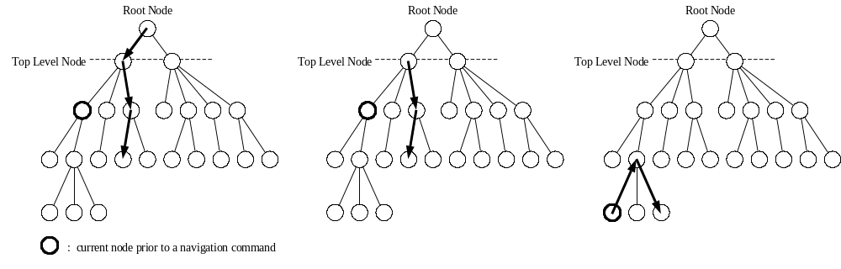
Figure 8.a - Absolute path with respect to the Root Node | Figure 8.b - Absolute path with respect to the Top Level Node | Figure 8.c – relative path with respect to the current node

Content Manipulation
Also the content manipulation section of the BiM Fragment is composed of two parts: the content manipulation command and the subtree binary representation. This section specifies syntax and semantics of the content manipulation commands used in BiM. The subtree binary representation is specified in the next section.
After terminating a navigation command including the navigation path, a content manipulation command is expected. Likewise, after terminating a content manipulation command including the binary representation of a subtree, a navigation command is expected which is the beginning of a new BiM Fragment.
When initializing the decoder, the current node is defaulted to the ROOT node and a navigation command is expected.
The code tables for the for the content manipulation commands defined in BiM are shown in Table 5 below.

Code table for content manipulation commands
Code Word | Command Name | Specification
000 | --- | Reserved
001 | AddSubtree | Add the content for the current node including its subtree only if the current node is empty with respect to the transmitted subtree
010 | UpdateSubtree | Update the content for the current node including its subtree even if existing content is going to be overwritten
011 | DeleteSubtree | Delete the current node including its subtree
100 – 110 | --- | Reserved
111 | ESCAPE | Reserved for future extension
Table 5 - Code Table of Content Manipulation Commands
Commands are applied to the current node. The current node (resp. position in the tree of the description) after navigation is the node referred to by the complete navigation path, excluding the termination TBC (see Figure 9). The content manipulation command (add, update, delete) is then applied to the subtree including the current node itself. After the content manipulation command has been issued, the current node is set to the father of the node after navigation.
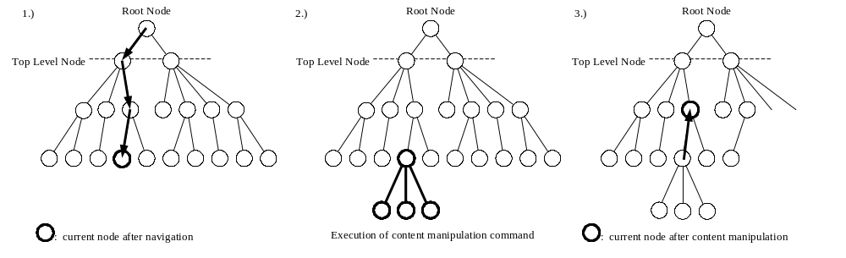
Figure 9 - The positions of the current node for different states within a BiM fragment.
The command code table contains the following codes:
- AddSubtree: adds the subtree including the current position in the tree. The command is followed by the binary representation of the subtree (see section 7.2.4). After the AddSubtree command is issued the current node is set to the father of the current node after navigation.
- UpdateSubtree: updates the subtree including the current position in the tree. The command is followed by the binary representation of the subtree (see section 7.2.4). After the UpdateSubtree command is issued the current node is set to the father of the current node after navigation.
- DeleteSubtree: deletes the subtree including the current position in the tree. After the DeleteSubtree command is issued the current node is set to the father of the current node after navigation.
If the current node is an element or attribute of simple type then the binary content representation is following directly after the command.
After executing the command the decoder returns into the navigation mode.

Decoding of sub-trees

General Binary format
The general binary format of sub-trees is composed of one global header and a set of consecutive and nested patterns.

Sub-tree header format
The representation of sub-trees starts with a 4-bit header which specifies encoding modes. It encodes following flags:
- allows_skipping : Specifies the coding of element lengths (c.f. 7.2.4.6).
- 00 - no length are coded,
- 01 - optional length coded,
- 10 - mandatory length.
- allows_partial_instantiation : Specifies if the sub-tree is partially instantiated (c.f. 7.2.4.5.4).
- 0 - no partial instantiation in the sub-tree,
- 1 - partial instantiation allowed.
- allows_subtyping : Specifies if the sub-tree encodes polymorphism (c.f. 7.2.4.5.1).
- 0 - no polymorphism in the sub-tree
- 1 - polymorphism is allowed

Sub-tree body format
A general binary format of a sub-tree is a set of consecutive and nested patterns. These patterns are composed of two main components:
- A pattern header which is composed of:
- a key which aims at clarifying any potential ambiguity during the decoding phase,
- a number of occurrence (n) of similar elements or group of elements,

- A pattern body which is a set of n consecutive similar items, where n is the number of occurrences defined in the pattern header. Each item of the body is composed of:
- a type info which encodes type information as described in 7.2.4.5,
- a length which describes the coding length in bits of the data. This feature allows a fast access of elements in the stream as described in 7.2.4.6,
- attributes values as described in 7.2.4.4,
- a value which encodes the data itself. This field can contain similar patterns when it codes a complex element or data in the case of a simpleType as described in 7.2.4.7.

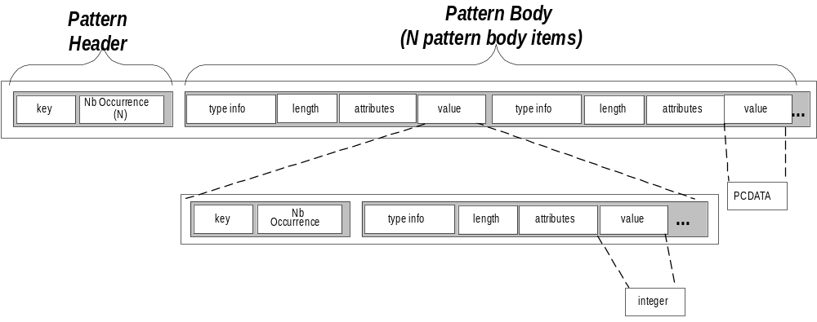
Figure 10 - The general binary coding format

Each one of these items is optional:
- The Key is not coded in the binary description if the element or the attribute is mandatory,
- The NumberOfOccurence is not coded if the number of occurrence is fixed in the schema,
- If the mode is a partial coded mode, the type info is always coded. In other case the type info is not coded if the type can’t be subclassed or if it is not an union type,
- attributes values are not coded if the type can't have attributes (e.g. simple type),
- The length is coded only if the fast access feature is desired and only in front of elements,
- The value is not coded if the element is empty (length and polymorphism doesn’t appear either in this case).

General process (generating keys)
The process relies on a prior schema analysis phase. This schema “compilation” aims at generating finite state automata. These automata represent the binary format. Notice that automata are considered here as a formalization tools, but implementation can diverge.

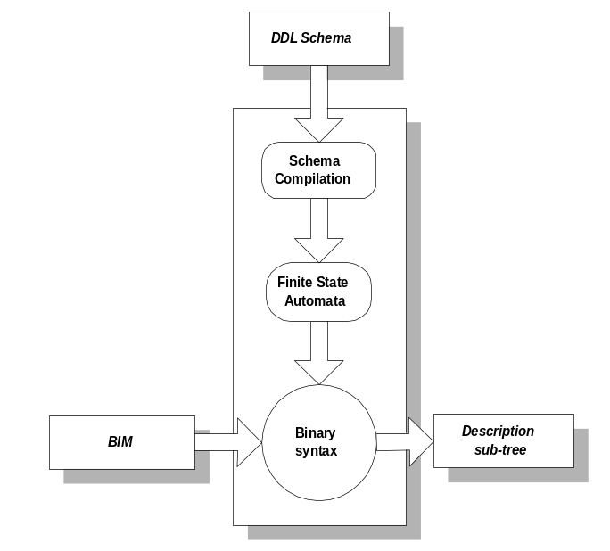
Figure 11 - The decoding process

More precisely, the process generates a finite state automaton for every "complexType" of the schema. These finite state automata express complexType coding rules.
The decoding of a binary stream is done by the propagation of a token through these automata. Its propagation is guided by the binary stream. When the token faces different possible paths, it reads the bit stream to find the right way to go. When a token enters certain kind of states, it triggers another decoder.

Schema compilation and structure code
This part presents the process which will generate these automata. The process is composed of 4 phases.
Phase 1 – Schema realization  This phase flattens types inheritances and solves namespaces support. It realizes group references, element references, substitution group and possible polymorphism.  Phase 2 – Syntax trees generation  This phase produces syntax trees for every complex type. These trees are transformed in order to ease binary encoding and improve compression ratio.  Phase 3 – Syntax Trees Normalization  This phase normalizes the syntax trees in order to produce a signature for every tree node. These signatures are used in phase 4 to unambiguously generate header keys.  Phase 4 – Finite State Automata generation  This final phase produces the finite state automata used by the coding/encoding process. | 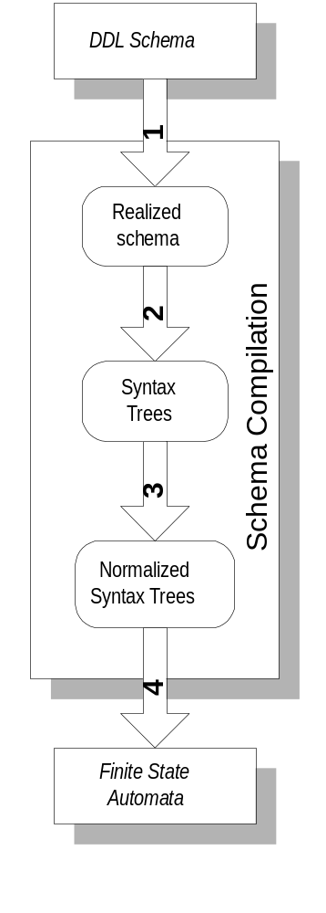
Figure 12 - The schema compilation

Character string comparison
Many phases of the general process rely on a string comparison method. This method is based on the Unicode value of each character in the strings. The following defines the notion of lexicographic ordering:
If two strings are different, then either they have different characters at some index that is a valid index for both strings, or their lengths are different, or both.
- If they have different characters at one or more index positions, let k be the smallest such index; then the string whose character at position k has the smaller value, as determined by using the < operator, lexicographically precedes the other string.
- If there is no index position at which they differ, then the shorter string lexicographically precedes the longer string.

Phase 1 - Schema realization
During this phase, the schema is analyzed in order to produce a realized schema. A realized schema is a compiled version of the schema where inclusion of other schemes, element references, attributes references, attribute group references, group references, complex type inheritances, simple type inheritances, substitution groups, and namespaces support are realized.
A realized schema is generated by :
- The realization of namespaces
- For each element, attribute, type, group, the qualified name is used as defined in XML Namespace [8].

- The generation of realized complexTypes is done by
- Appending super type definition in the case of an extension. The content models of the type hierarchy are appended as defined by the DDL.
- Redefining type definition in a case of a restriction. The content model of a sub-type replaces the type of its super type.
- Replacing element references by their referenced definition
- Realizing substitution groups. If an element can be substituted by other elements (they are in the same substitution group), the element is replaced by a choice node containing every possible elements that are not abstract (itself included).

- The generation of realized simpleTypes is done by
- Merging its facets and the facets of its supertypes. In case of two identical facets the most constrained one is kept.

Phase 2 - Syntax tree generation
A syntax tree is then generated for every realized complex types.
Syntax trees are composed of item nodes, group nodes and occurrence nodes. Item nodes associate an element name to its type. Group nodes define composition group (sequence, choice or all). Occurrence nodes define occurrence information.
Syntax tree transformations

In specific cases syntax trees are reduced to improve the compactness of the resulting binary format. These transformations aim at simplifying complex type definition in a non destructive way. In the following figures, occurrence nodes are represented by “[minOccurs, maxOccurs]”, composition groups by the keywords “SEQ”, “CHOICE” or “ALL” and item nodes by the name of the element they describe possibly followed by its type between brackets.
a) Group simplification rule

This rule applies on every group that contains only one item (element or other group) whose minOccurs is equal to 0 or 1.
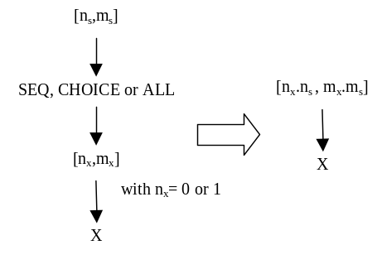

b) Empty choice simplification

This rule applies on a choice when it contains at least one item (group or element) whose minOccurs equals 0. The minOccurs of the item is replaced by 1 and the minOccurs of the choice by 0.
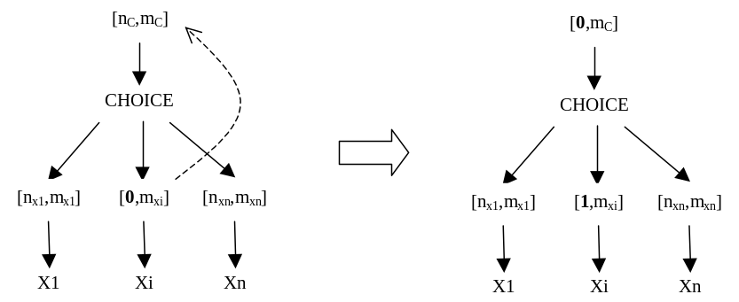

c) Choice Simplification rule

This rule applies when a choice contains an other choice whose occurrence is strictly equals to 1.
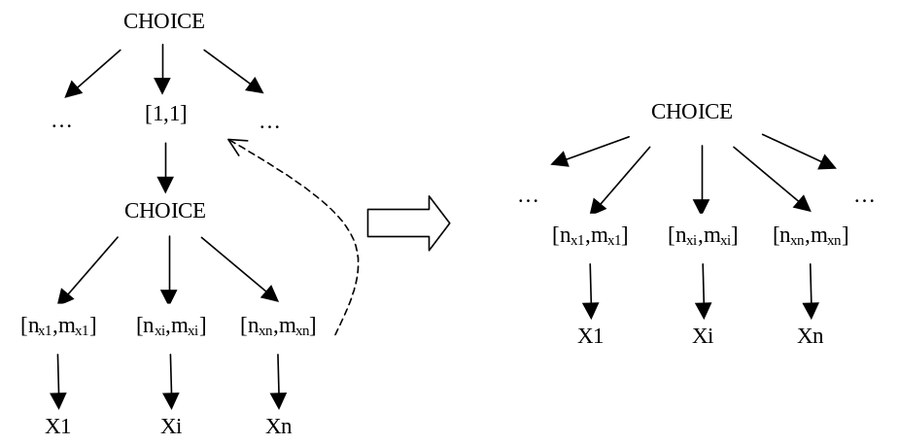

Phase 3 - Syntax tree normalization
Syntax tree normalization aims at giving unique name to every group node in the syntax tree. It allows to order the nodes and finally give a key to them. This key will be needed during the automata construction phase.
A signature is generated for every element or group of elements (seq, choice, etc..). Every node signature is generated by the concatenation of its child nodes signatures. In case of a “choice” or a “all”, the children signatures are alphabetically sorted (c.f. 7.2.4.3.1) and then appended. In case of a “sequence”, the child signatures are appended in their order of definition in the schema. The Item node signatures are equal to their element name.

Phase 4 - Finite state automata generation
A complexType automaton is recursively defined by the following rules :
- Every node of the syntax tree produces an automaton,
- A complex Type automaton is the automaton produced by its root node,
- Every node automaton is generated by the merging of its child automata. The nature of the merging is dependent of the nature of the node.
At the end of the process, automata are “realized” in order to produce their transitions coding key.

Phase 4.a - Automata construction

Item Node automata
Definitions :
- Element transitions: Element transitions are crossed when an element is present in the description,
- Type states: Type states trigger specific type decoders when activated. The triggered decoder can be a specific datatype decoder in the case of a simpleType and a generic or a specific one in the case of a complexType,
Automata generation :
An item node automaton is composed of two states and a transition between them. The transition is an “element transition”. The target state is a “type state”.

Occurrence Node automata
Definitions :
- Loop start transitions: When crossed, they decode a number of occurrence (N) from the stream,
- Loop transitions: A loop transition is crossed N times (where N is the number decoded by the last loop start transition),
- Loop end transitions: The transition is crossed when the desired number of occurrence is obtained,
- Key transitions : Key transitions are used to read a key from the stream. This key will raise decoding ambiguity. During the automata construction, a signature is associated to its key transition. Its signature comes from the signatures generated during the syntax tree normalization phase,
- Shunt transitions : Shunt transitions are a special kind of key transitions. Their coding value is always equal to 0.
Automata generation :
An occurrence node automaton is generated by adding transitions and states to its child automaton. The shape of the resulting automaton depends on the minOccurs and maxOccurs values :
- case a: if minOccurs = 1, maxOccurs = 1
- no change to the child automaton
- case b: if minOccurs = 0, maxOccurs = 1
- two states are added to the automaton : a new start state and a new final state.
- a “Shunt” transition is added between the new start state and the new final state,
- a “Key” transition is added between the new start state and the old one, its signature is equal to the signature of the child node of this occurrence node.
- a simple transition is added between the old final state and the new one.
- case c: if maxOccurs > 1
- two states are added to the automaton : a new start state and a new final state.
- a “Key/Loop start” transition is added between the new start state and the old one, the key signature is equal to the signature of the child node of this occurrence node
- a “Loop end” transition is added between the old final state and the new one,
- a “Loop” transition is added between the old final state and the old start state.
- case c-2: if minOccurs = 0
- a “Shunt” transition is added between the start state and the final state,

Occurrence coding length
Occurrence automata add loops to the final automaton. Each loop is used to decode n similar consecutive patterns. When crossed, “Loop start” transitions read an integer from the stream. The integer coding length (in bits) is computed with the following formula :
- if maxOccurs-minOccurs <= 65535 :
- (NumberOfOccurrences-minOccurs) is coded with ⎡(log₂(maxOccurs-minOccurs+1)⎤ bits
- if maxOccurs-minOccurs > 65535 or maxOccurs = unbounded :
- (NumberOfOccurrences-minOccurs) is coded using unsigned infinite integer coding as described in 7.2.4.7.3

Sequence automata
A sequence automaton is constructed by a serial merging of its child automata.

Choice automata
A choice automaton is built by the parallel merging of its child automata:
- Two new states are created : a new start state and a new final state,
- Key transitions are added between the new start state and every start states of its child automata. The key signatures are equal to the signature of their corresponding child node,
- Simple transitions are added between every final state of its children and its new final state,

All automata
The All automaton is slightly different from other automata because it can only combine item node automata (because of XML Schema restrictions).
The All automaton is recursively constructed. It forms a tree of choices. Every level of this tree is used to choose an other element among those that are still possible.

Phase 4.b – Key realization
This final phase transforms the key transitions signatures into coding values. The coding value of a key transition is equal to its position in the ordered list of key signatures starting from the same state. If there exist a shunt transition, this shunt transition is always the first transition in this list. Their coding length (in bits) is equals to ⎡log₂(number of key transitions)⎤.

Specific case of attributes
In order to improve the coding, attributes are reordered during the encoding phase. This operation is conformant with the XML canonical form [10]. Apart this specificity, attributes encoding is similar to element encoding.
Attributes are encoded as a set of consecutive patterns. These patterns are composed of two components:
- the attribute key, which aims at clarifying any potential ambiguity (presence or absence of an optional attribute),
- the attribute value.

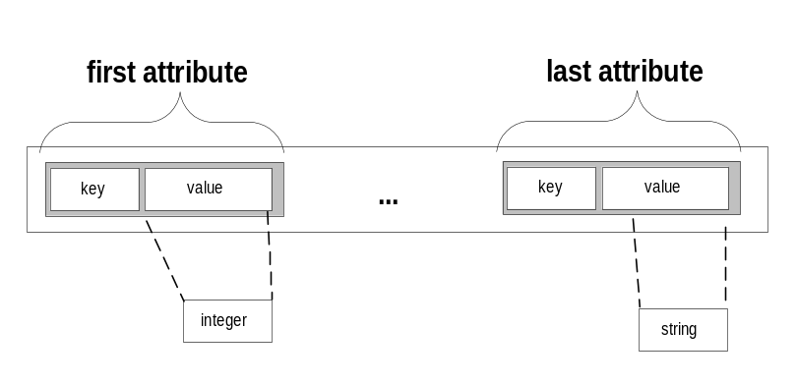
Figure 13 - Attributes coding format

The key for each attribute is either 0 or 1 for optional attributes. It is not coded for mandatory attributes.
Attribute coding rules :
- During the schema compilation, all the attributes are collected from the super types of the complex type.
- During the syntax tree normalization:
- all the attribute nodes defined as FIXED in the schema are suppressed,
- the attribute nodes are lexicographically sorted, as defined in 7.2.4.3.1
- During the automaton generation phase, the produced automaton is a sequence automaton.

Uncoded type, polymorphism and union
The MPEG-7 Description Definition Language allows an element or an attribute to have different possible types:
- in case of element polymorphism (xsi:type),
- in case of the union simpleType.

Moreover, elements cannot be coded at all :
- in case of a partial instantiation,
- in case of a nullable element.

For that purpose a type info is defined. It is composed of two parts:
- a flag [1 bit]
- 0 if there no type identifier
- 1 if there is a type identifier
- a type identifier
- the key of the entry in the ordered set of possible types coded with ⎡log₂(size(set))⎤ bits.

In case of complete instantiation mode (allows_partial_instantiation = 0) and allowed polymorphism (allows_subtyping = 1), the type info is not coded if the type of the element is not an union or if there is no sub-type defined for the type of the element.

Element Polymorphism
Polymorphism potential candidate elements are the elements in the schema whose type has subtypes.
The type choice is built with all the possible subtypes alphabetically sorted (see 7.2.4.3.1). In case of partial instantiation, the first object of the type choice is the specific uncoded type (see 7.2.4.5.4).

Union type
The type choice is built with all the simple types sorted using their order of definition in the schema.

Nullable type
To specify that a type can be null, we add the specific type nullable at the first place of the set of possible types (if the uncoded type is not present) or at the second place (in other cases).

Partial instantiation
To specify that a type can be null, in the type choice, we add the specific type uncoded at the first place of the set of possible types.

Fast Access
Length information allows a fast skipping of undesired elements. It encodes the number of bits that should be skipped in order to reach the sibling element.

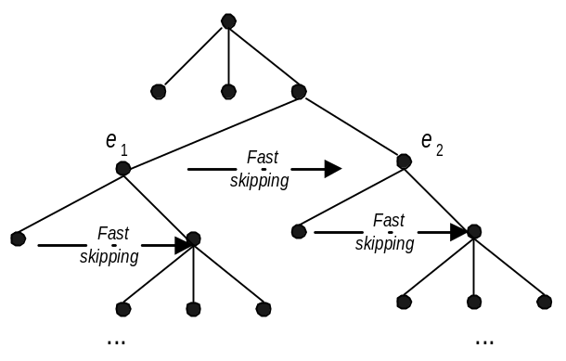
Figure 14 - Fast access feature
If the allows_skipping flag is set to 10, the length information is coded using the infinite unsigned integer coding defined in 7.2.4.7.3.
If the allows_skipping flag is set to 01 the length is preceded by a bit. If this bit is equal to 1, the length is coded using the infinite unsigned integer coding, otherwise it is not coded.

Datatypes Coding
BiM encodes data with dedicated encoders. This section describes the datatypes coding format.

DDL Primitive datatype
- string : is encoded in UTF-8 [11],
- boolean : one bit, 0 = true, 1 = false,
- float : encoded as a IEEE 754 floating-point "single precision" [12],
- double : encoded as a IEEE 754 floating-point "double precision" [12],
- decimal : is encoded in UTF-8,
- timeDuration : is encoded in UTF-8,
- recurringDuration : is encoded in UTF-8,
- uriReference : is encoded in UTF-8,
- ID : is encoded in UTF-8,
- IDREF : is encoded in UTF-8.

Optimized datatype encoding

Integers
Constrained integers are coded using a dedicated datatype encoder. This encoder uses minExclusive, maxExclusive, minInclusive and maxInclusive facets to deduce the minimum coding length of the integer :
if the integer is constrained both for its minimum and maximum value :
compute the following values
min = minInclusive or minExclusive+1
max = maxInclusive or maxExclusive-1
and test them
if max-min <= 65535
(value – min) is coded with ⎡log₂(max-min+1)⎤ bits
if max-min > 65535
(value – min) is coded using unsigned infinite integer (c.f. 7.2.4.7.3)
else the integer is coded by :
one bit to indicate the sign (0 : positive, 1 : negative)
abs(value) is coded using unsigned infinite integer (c.f. 7.2.4.7.3)

Enumeration
Every enumerated datatype generates a sorted dictionary of the enumeration values. The coded value is the key of the value in this dictionary. The coded value length (in bits) is equal to ⎡log₂(size(dictionary))⎤.

Lists
Each item of a list is encoded using its datatype encoder. The length of the list is placed at the beginning and is coded with the following rules:
if maxLength-minLength <= 65535 :
(length-minLength) is coded with ⎡log₂(maxLength-minLength+1)⎤ bits
if maxLength-minLength > 65535 or maxLength not constrained:
(length-minLength) is coded using unsigned infinite integer coding (c.f. 7.2.4.7.3)

Infinite unsigned integer coding
Infinite unsigned integers are encoded by an infinite set of integer chunks. Each chunk is composed of 5 bits. The first bit specifies if an other chunk follows the current one. The last 4 bits of the chunk encode the integer.
Annex A
(informative)
Bibliography
- MPEG Requirements Group, ”MPEG-7: Context, Objectives and Technical Roadmap”, Doc. ISO/MPEG N2861, MPEG Vancouver Meeting, July 1999
- MPEG Requirements Group, ”MPEG-7 Overview Document V.3.0”, Doc. ISO/MPEG W3444, MPEG Geneva Meeting, June 2000
- MPEG Requirements Group, ”MPEG-7 Requirements Document V.11”, Doc. ISO/MPEG W3446, MPEG Geneva Meeting, June 2000
- XML Schema Part 0: Primer, W3C Working Draft, 22 September 2000, http://www.w3.org/TR/xmlschema-0/
- XML Schema Part 1: Structures, W3C Working Draft, 22 September 2000, http://www.w3.org/TR/xmlschema-1/
- XML Schema Part 2: Datatypes, W3C Working Draft, 22 September 2000, http://www.w3.org/TR/xmlschema-2/
- Extensible Markup Language (XML) 1.0 (Second Edition), W3C recommendation, 6 October 2000, http://www.w3.org/TR/REC-xml/
- Namespaces in XML, W3C Recommendation, 14 January 1999, http://www.w3.org/T R/REC-xml-names/
- XML Path Language (Xpath) Version 1.0, W3C Recommendation, 16 November 1999, http://www.w3.org/TR/xpath.html
- Canonical XML - Version 1.0, W3C Candidate Recommendation, 26 October 2000, http://www.w3.org/TR/xml-c14n
- UTF-8, a transformation format of ISO 10646, IETF RFC 2279. F. Yergeau. January 1998, http://www.ietf.org/rfc/rfc2279.txt.
- IEEE Standard for Binary Floating-Point Arithmetic, Std 754-1985 Reaffirmed1990, http://standards.ieee.org/reading/ieee/std_public/description/busarch/754-1985_desc.html
Annex B
(informative)
Patent statements
The user's attention is called to the possibility that, for some of the processes specified in this part of ISO/IEC 15938, conformance with this specification may require use of an invention covered by patent rights.
By publication of this part of ISO/IEC 15938, no position is taken with respect to the validity of this claim or of any patent rights in connection therewith. Information regarding such patents can be obtained from the following organisations.
The table summarises the formal patent statements received and indicates the parts of the standard to which the statement applies. The list includes all organisations that have submitted informal patent statements. However, if no "X" is present, no formal patent statement has yet been received from that organisation.
Annex C
(informative)
MPEG-7 meta data flow
Figure 15 - MPEG-7 Metadata shows the flow of Metadata and Essence through the Content creation and delivery lifecycle. The stages in the life cycle are as follows:
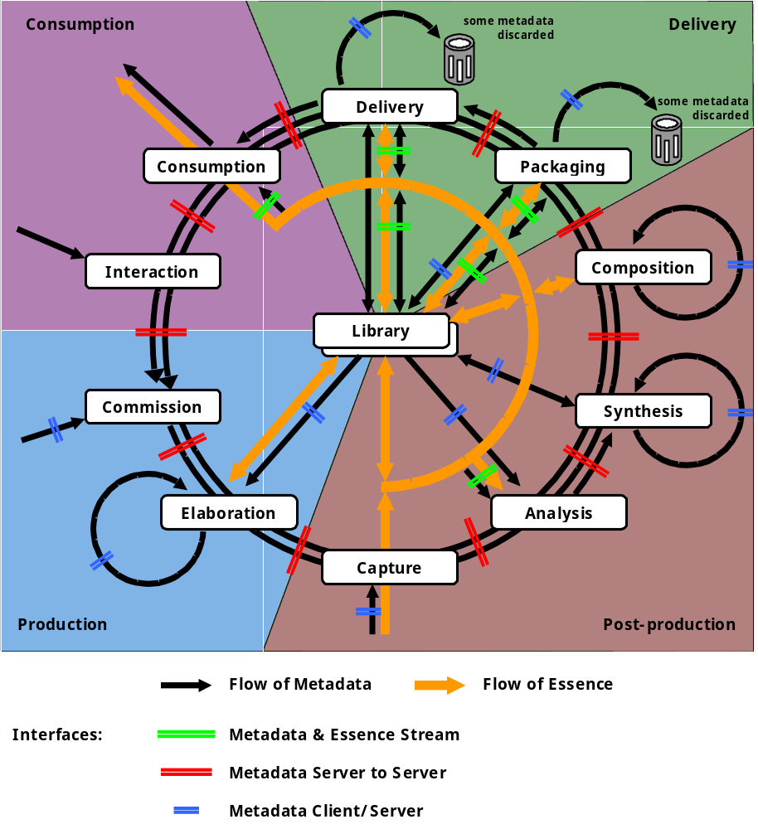
Figure 15 - MPEG-7 Metadata Flow

Commission
The Commissioning of the Content by the producer begins the Content creation cycle. At this stage the Content is wholly built up of Metadata representing original input, or consumer requirements derived from analysis of interaction (see below).
The output from Commissioning is Metadata describing the concept of the new Content.

Elaboration
Elaboration of the Content Concept is performed during pre-production. This stage may include script-writing, storyboarding, and research into archives. During Elaboration, the Content Concept is augmented with Metadata described the Content at a high level of abstraction, perhaps dealing with scenes and shots, continuity, location, cast, script and so on.
Elaboration is an iterative process.
The output from Elaboration is a greatly expanded description of the intended Content, in a number of DSes [TBD].

Capture
Capture of the raw Content is performed next. Capture includes shooting, graphic origination, archive research and acquisition. During Capture, the raw Essence is first brought into the Content database. Metadata is retrieved from Archive or is captured at the time of shoot or recording or is a manual input at this stage.
Note that Content may exist prior to either Commission or Elaboration.
Output from Capture consists of a Content database including unedited Essence and a further expanded repertoire of Metadata describing the unedited Essence, in a number of “Logging DS”es [TBD].

Analysis
Analysis of the raw Essence is performed next. Analysis includes the processes of feature extraction, motion analysis, and content analysis. Analysis may involve further reference to archived information.
Output from Analysis is a further expanded set of Metadata described in a number of different DSes [TBD] (c.f. various MDS outputs).

Synthesis
Synthesis is an iterative process in which extracted descriptions are merged with each other and with Content Plot Ds to synthesize useful descriptions of the raw Essence. These synthesized descriptions will be used in Composition (or Editing) and will be archived for future re-use.
Synthesis is an iterative process.
The total amount of Metadata associated with the Content may not increase substantially from the Synthesis phase.
Output of Synthesis is a new set of Metadata describing the raw Essence, in a number of “Multimedia DS”es [TBD]

Composition
Composition is the first phase of editing or cutting down the raw Essence to form the intended Content. This phase includes “Off-Line Editing” and many other creation and composition steps, which often include incorporation of additional archive material. It is an iterative process.
Composition uses the metadata derived from all earlier phases.
The output of Composition is a reduced collection of Essence in the Content Database plus a new set of Metadata which forms the Pull Lists and Edit Decision Lists plus additional description of composition steps.

Packaging
Packaging is the phase of building the final version of the Content to be distributed.
Packaging includes the creation of new Metadata describing the finished Content.

Delivery
The Delivery phase includes the transfer of Content from the production form to the delivery vehicle – content server, web server, packaged media, or broadcast.
At this stage additonal forms of description Metadata are needed, to describe content availability, access restrictions, etc.

Consumption
Consumption is the phase of viewing or receiving the Content.
Additional Metadata in this phase includes schedules, transient location information, decryption description etc.

Interaction
Interaction is the phase in which the cosumer interacts with the Content, perhaps following hyperlinks, exploring the coordinate space, placing additional information requests, purchase decisions etc.

Library
Library functions are used throughout the Content Creation process. It includes both deep Archive also known as long term storage and retrieval (with an emphasis on cataloguing Metadata) and Library access (where the emphasis is on search and retrieval).
Annex D
(informative)
Informative Educational Examples for the MPEG-7 BiM

Example for general structure
One of the main advantages of the BiM structure is to offer a high level of flexibility through the use of navigation commands with absolute and relative paths while using an optimized encoding of sub-trees. The instance tree is thus first divided into sub-trees with a flexible granularity. The encoder has the freedom to define points in the instance structure that will be located globally (or relatively for sake of compactness) in order to allow fast access to this given nodes and possible re-synchronisation. This allows the BiM stream to be scalable in the sense that the sub-trees can be transmitted or stored in any order, easing the access to the most important information in a given application context. 3 use case scenarios are described below as different examples to illustrate the need for different levels of fast access granularity.

- Maximum compression:
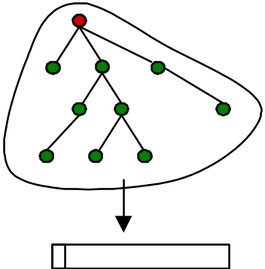

- Maximum flexibility:
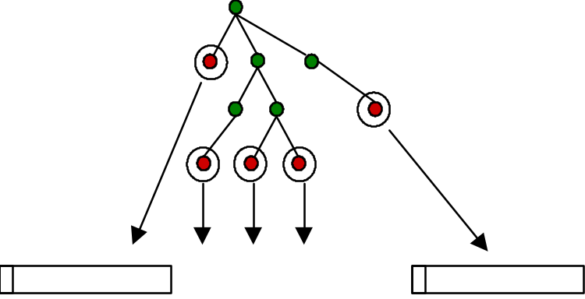

- Application-specific choices:
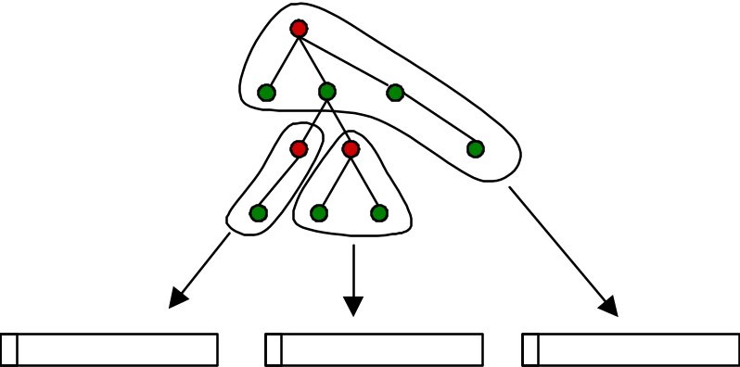

Example for decoding of sub-trees

General Example
Given the following schema,
<element name=”e1”>
<complexType>
<sequence>
<element ref=”my:e2” maxOccurs=”unbounded”/>
<element name=”e3” type=”string”/>
</sequence>
</complexType>
</element>

<element name=” e2” type=”unsigned8”/>

and the following description :
<e1>
<e2>14</e2>
<e2>12</e2>
<e3>bon</e3>
</e1>

BiM generates the following binary format where Key_{xx} represents the Key of description item xx, NbO_{xx} is its number of occurrences, and V_{xx} their values :

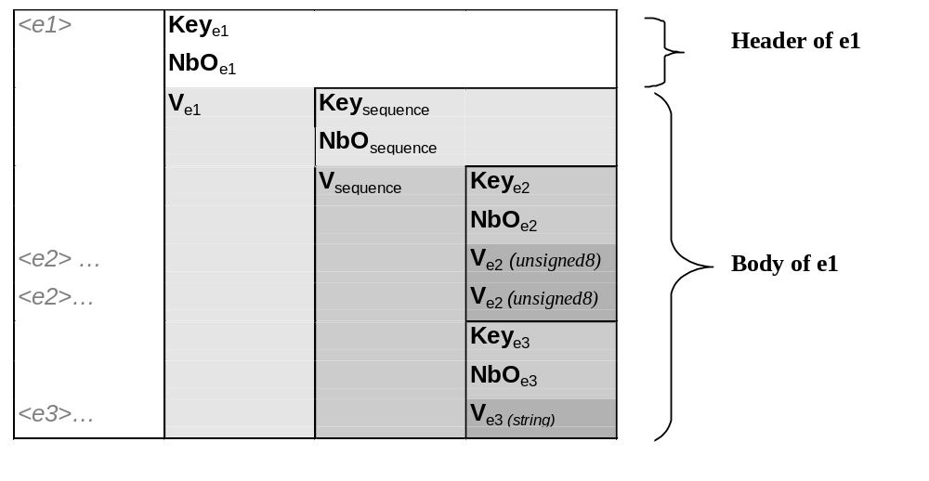
The DDL schema defined in example 1 produces the automaton of e1, which models the possible encodings of any valid instance of e1.
Figure 16 - A complexType automaton
A decoding scenario
In the example, the token starts at the “root” state. It has two possible paths, left or right. The token reads one bits to decide which path to take (only one bit is necessary to encode two possibilities), the given value will send it to the left state. When the token enters the left state, it triggers the automata of e1. The token then starts on state 0. It crosses the sequence transition (no bits). It crosses the e2 transition (no bits), decodes the occurrence number of e2 (infinite integer coding c.f. later). On state 2, it triggers the decoding of e2 (usigned8 = 8 bits) then moves to state 3. In state 3, it moves back to state 1 (no bits) because of the number of occurrence decoded during transition e2 crossing, etc..
The final result
The resulting binary format is (levels of gray express nesting, crossed boxes express an information which is not coded) :
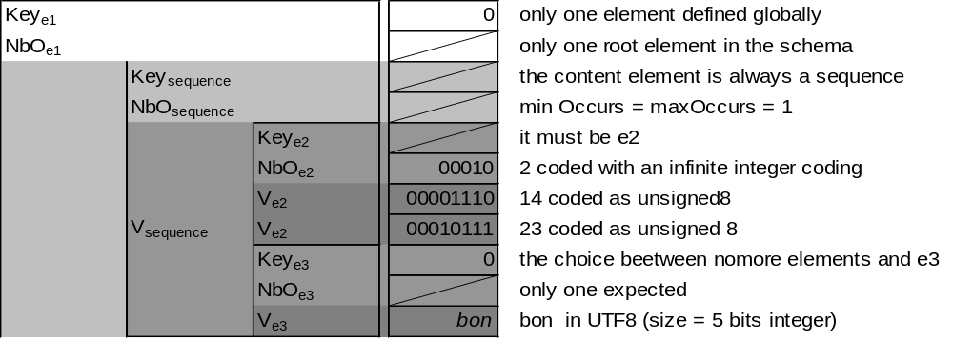
The resulting binary encoding of the example is :
0 00010 00001110 00010111 0 00011_{size} %b₈ %o₈ %n₈

=> 50 bits

Substitution group realization
The following schema:
<element name="e" type="a"/>

<element name="e1" type="a" substitutionGroup="e"/>
<element name="e2" type="a" substitutionGroup="e"/>

<element name="e3" >
<complexType>
<element name="e" maxOccurs="0" minOccurs="*"/>
</complexType>
</element>

is realized in:
<element name="e3" >
<complexType>
<choice maxOccurs="0" minOccurs="*">
<element name="e"/>
<element name="e1"/>
<element name="e2"/>
</choice>
</complexType>
</element>

Syntax tree generation
In the syntax tree figures, occurrence nodes are represented by “[minOccurs, maxOccurs]”, composition groups by the keywords “SEQ”, “CHOICE” or “ALL” and item nodes by the name of the element it describes possibly followed by its type between brackets.
The schema
<complexType name="CoordinateMapping">
<sequence maxOccurs="unbounded">
<element name="pixel" type="mds:IntegerVectorType"/>
<choice>
<element name="coordPoint" type="mds:FloatVectorType"/>
<element name="srcpixel" type="mds:IntegerVectorType"/>
</choice>
</sequence>
<element name="mappingFunct" type="mappingFunct" minOccurs="0"
maxOccurs="unbounded"/>
</complexType>

The syntax tree

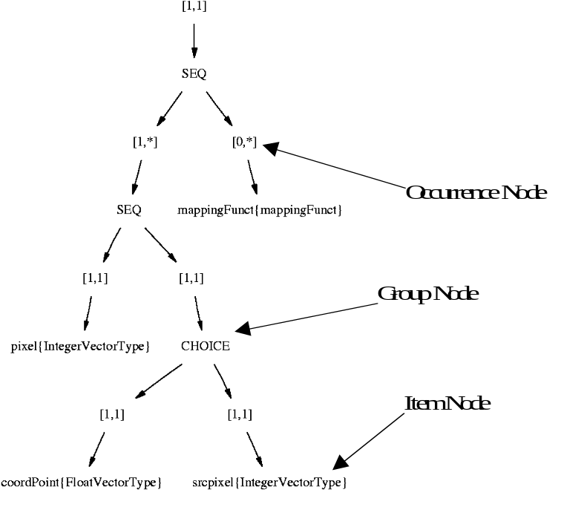
Figure 17 - The syntax tree of coordinate mapping

The syntax tree node signatures
- The signature of the choice is choicecoordPointsrcpixel,
(concatenation of alphabetically ordered signatures)
- The signature of the lower sequence is seqpixelchoicecoorPointsrcpixel
(concatenation of signatures in their order of definition)
- The signature of the upper sequence is seqseqpixelchoicecoorPointsrcpixelmappingFunct
(concatenation of signatures in their order of definition)

Syntax tree simplification
The following anonymous complex type :
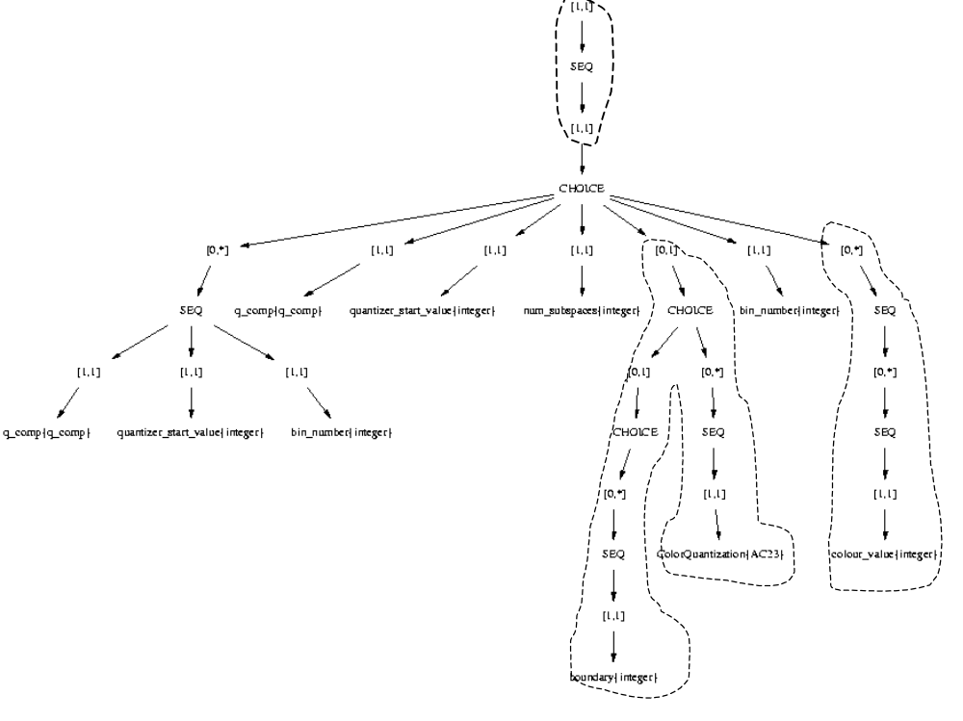
Figure 18 - A complex syntax tree

Becomes after simplification :

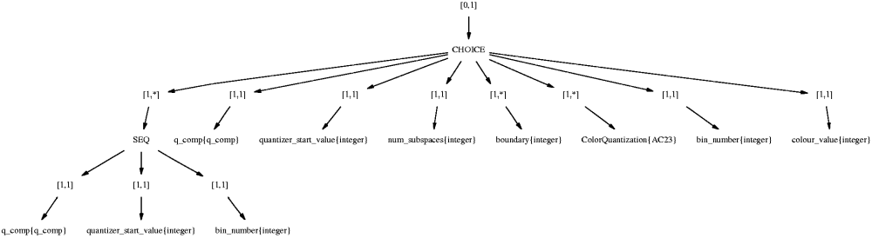
Figure 19 - A reduced syntax tree

Attributes coding

The following complexType :
<element name=”A” type=”attributeExample”/>

<complexType name="attributeExample">
<attribute name="a2" type="unsigned3"/>
<attribute name="a1" type="string" type="required"/>
<attribute name="a3" type="string" type="required"/>
<attribute name="a5" type="string" type="required"/>
<attribute name="a4" type="string" use="fixed" value="word"/>
</complexType>

will generate the following automata:
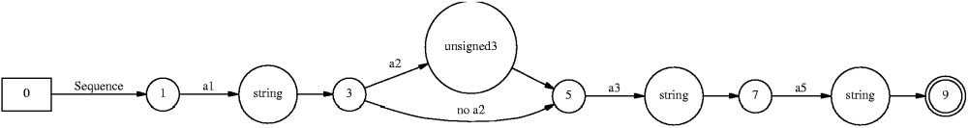
Figure 20 - Attributes automata

Therefore, the following element:
<A a1="v1" a2="2" a3="v3" a5="v5"

is coded:
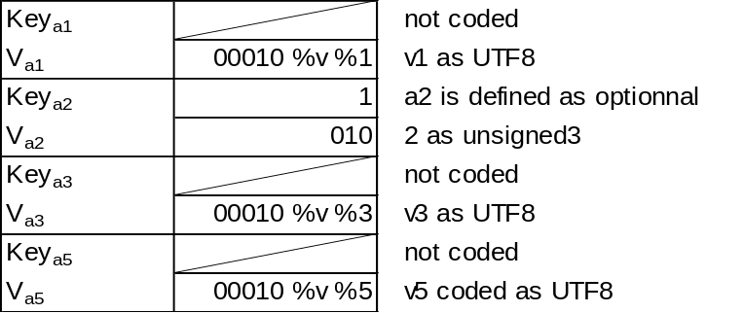

Decoding automata
In the following figures, “start states” are represented by boxes and “final states” by double circles.

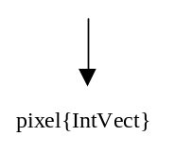 |  | 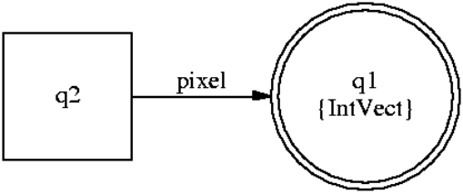
Figure 21 - An item automaton

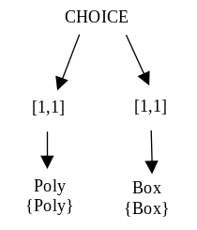 |  | 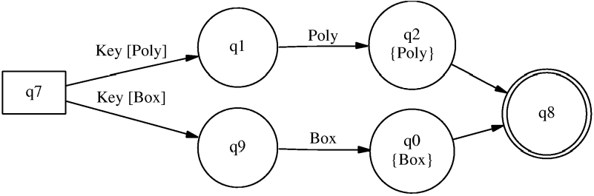
Figure 22 - A choice automaton

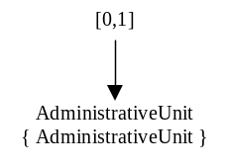 |  | 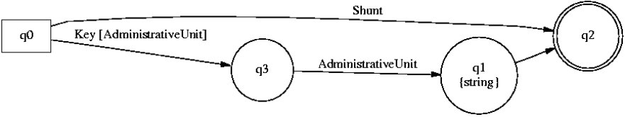
Figure 23 - An occurrence automaton

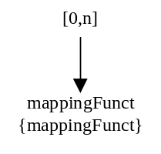 |  | 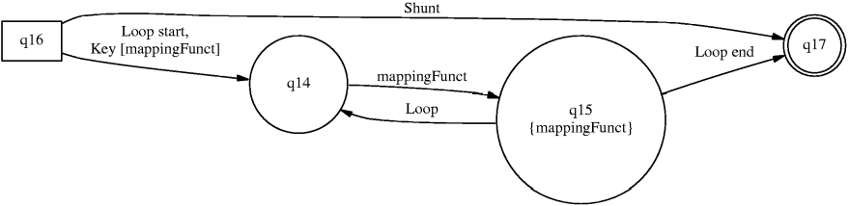
Figure 24 - An other occurrence automaton

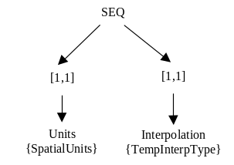 |  | 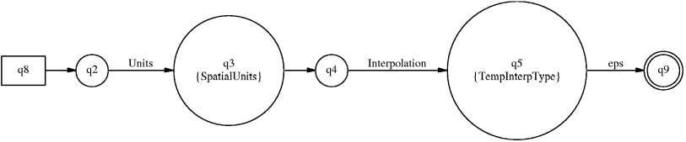
Figure 25 - A sequence automaton

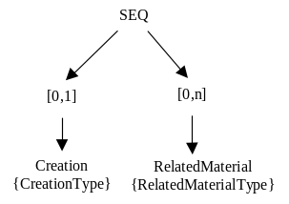 |  | 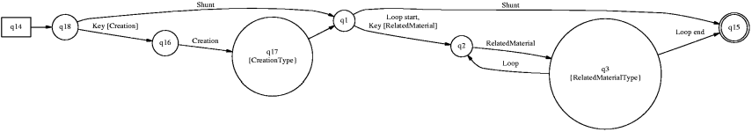
Figure 26 - An other sequence automaton

Realized automaton
In this example, the keys are coded on a single bit. The value of the “box key” is equal to 0, the value of the “Poly key” is equal to 1.

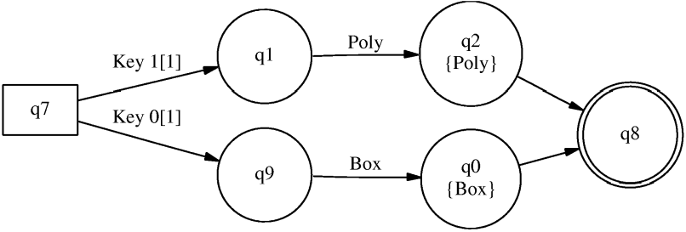
Figure 27 - Automaton with key realized

Infinite unsigned integer coding
The integer “570” is coded :
0000 0010 0011 1010₍₅₇₀₎ => 1 0010 1 0011 0 1010

Polymorphism coding
Given the following schema :
<complexType name="b">
<complexContent>
<extension base="a">
...
</extension>
</complexContent>
</complexType>

<complexType name="c">
<complexContent>
<extension base="a">
...
</extension>
</complexContent>
</complexType>

<complexType name="d">
<complexContent>
<extension base="c">
...
</extension>
</complexContent>
</complexType>

<element name="ea" type="a"/>

and the following element:
<ea xsi:type="c" ...> ...

In the body components, the polymorphism part will be equal to:
1 01

