

International Features in Microsoft SQL Server 2000
Michael Kaplan, Trigeminal Software, Inc.
Abstract: This document introduces Microsoft® SQL Server™ developers to the international features of SQL Server 2000. Topics covered include an explanation of Unicode, SQL Server international data types, and key issues regarding implementation.

The information contained in this document represents the current view of Microsoft Corporation on the issues discussed as of the date of publication. Because Microsoft must respond to changing market conditions, it should not be interpreted to be a commitment on the part of Microsoft, and Microsoft cannot guarantee the accuracy of any information presented after the date of publication.
This white paper is for informational purposes only. MICROSOFT MAKES NO WARRANTIES, EXPRESS OR IMPLIED, AS TO THE INFORMATION IN THIS DOCUMENT.
Complying with all applicable copyright laws is the responsibility of the user. Without limiting the rights under copyright, no part of this document may be reproduced, stored in or introduced into a retrieval system, or transmitted in any form or by any means (electronic, mechanical, photocopying, recording, or otherwise), or for any purpose, without the express written permission of Microsoft Corporation.
Microsoft may have patents, patent applications, trademarks, copyrights, or other intellectual property rights covering subject matter in this document. Except as expressly provided in any written license agreement from Microsoft, the furnishing of this document does not give you any license to these patents, trademarks, copyrights, or other intellectual property.
© 2001 Microsoft Corporation. All rights reserved.
Microsoft, ActiveX, Visual Basic, Windows, and Windows NT are either registered trademarks or trademarks of Microsoft Corporation in the United States and/or other countries.
The names of actual companies and products mentioned herein may be the trademarks of their respective owners.
Table of Contents
International Features in Microsoft SQL Server 2000 1
Introduction 6
What Is Unicode and How Can It Be Used? 6
Encodings 6
UCS-2 7
UTF-16 7
UTF-8 8
What Are Surrogates? 8
Data Types in SQL Server 2000 9
Non-Unicode Text Types: char, varchar, text 9
Unicode Text Types: nchar, nvarchar, ntext 10
Date/Time Types: datetime, smalldatetime 10
Performance and Storage Space 13
Storage Space Issues 13
Speed Issues 13
Metadata Information in System Tables 14
Collation 14
Collation in SQL Server 6.5 and Earlier 15
Collation in SQL Server 7.0 15
Collation in SQL Server 2000 17
How Collations Specify the Sorting of Data 20
Collations Specified at Multiple Levels 21
Collation Specified at the Server Level 21
Collations at the Database Level 21
Collations Specified at the Column Level 24
Collations Specified in Expressions 26
The COLLATE Keyword 26
The Rules of Precedence for Collations 27
Limitations of the COLLATE Keyword 29
Returning Less than a Full List of Collations 29
Issues with Defining Collation at the Column Level 29
LCIDs and Collations 30
ISO Strings and Collations 30
How Are Custom Collations Defined? 30
Communication Between Server and Client (code page and collation issues) 31
Unicode Server and Client 31
Unicode Server and One or More Non-Unicode Clients 31
Non-Unicode Server and Unicode Client 34
Non-Unicode Server and Client 34
Conversion of Multilingual Data from Earlier Versions of SQL Server 34
Using the Access 2000 New ADP Format 35
Multilingual Data in the User Interface 35
General UI Changes (Unicode Support) 35
Multilingual Information in the Grid and SQL Panes of SQL Query Analyzer 37
Format Issues in the Query Designer 37
Sort Order 38
Double-Byte (DBCS) Characters 38
Getting to SQL Server Data (Data Access Methods) 38
OLE DB 38
ADO 38
ODBC 39
DB-Library 39
SQL-DMO 39
Multilingual Transact-SQL 39
Encoding of String Literals in an SQL Statement 39
SQL String Encoding 40
String-Handling Functions 40
Locale Support in SQL Server 2000 40
Language Settings 41
Messages 45
Date/Time 45
First Day of Week 45
Currency and Currency Symbols 46
Month/Day Names and Abbreviated Month Names 46
Dealing with COM's Locale Interference 47
Data Transformation Services 47
Summary of DTS Conversion Issues 51
Using the bcp Utility with Multilingual Data 52
The Microsoft Search Service and FTS 54
Dealing with OLAP/Hierarchical Data 55
Using XML Support in SQL Server 2000 with Multilingual Data 56
Interacting with Other Database Products 57
Conclusion 57
Acknowledgments 58
About the Author 59

Introduction
Microsoft® SQL Server™ 2000 includes powerful features to support international operations and environments. Extensive multilingual features make SQL Server 2000 a compelling database product and applications platform. This white paper provides a complete overview of how to use these features in a global context. This white paper is not limited to a list of features but also will explain how international/multilingual requirements can affect many aspects of a project.
Note: This paper uses the following international fonts: Arial Unicode MS, Latha, Mangal, PmingLiu, Gulim, SimSun, MS-Mincho to provide examples of some international characters. Not having these fonts installed will not seriously affect usability of this paper.

What Is Unicode and How Can It Be Used?
Unicode support is the foundation of the multilingual support of SQL Server 2000. Unicode is a standard that is designed to support all of the world's scripts. Unicode supplies a unique code point for every character, regardless of platform, program, or language. A program that supports Unicode can handle data in any language. Unicode 3.0 can handle up to 1,114,112 characters.
Unicode is an industry standard managed by the Unicode Consortium, an organization that recognizes the importance of having a single character set for all languages. Microsoft is a member of the Unicode Consortium. Most companies joined for many of the same reasons that Microsoft did: in creating global software solutions, the importance of being able to represent multilingual data is obvious. Many other companies and individuals join to understand the issues and techniques for handling multilingual data.
The Unicode Standard, now at version 3.01, is identical to ISO-10646, an international standard that matches all of the code points in Unicode since just after Unicode 1.1 was released. The effective combination of both an industry and international standard helps to keep any individual interest from subverting the goal of both standards: one character set for everyone!
For more information, go to the Unicode Consortium Web site at http://www.unicode.org.

Encodings
Unicode maps code points to characters, but does not actually specify how the data will be represented in memory, in a database, or on a Web page. This is where the actual encoding of Unicode data comes into play. There are many different encodings for Unicode. This section describes these common encodings:
- UCS-2
- UTF-16
- UTF-8
The information about encoding is presented here to help you better understand Unicode and some of the many ways in which it can be stored. Most of the time you can simply choose a Unicode data type and not worry about these details; however, it is important to understand the encoding any time you:
- Are dealing with an application that may encode Unicode differently.
- Must send data to other platforms (non-Microsoft Windows®) or Web servers.
- Must manage the importation of data from or exportation of data to other encodings.

UCS-2
UCS-2 is the main Unicode encoding used by Microsoft Windows NT® 4.0, Microsoft SQL Server version 7.0, and Microsoft SQL Server 2000. UCS-2 allows for encoding of 65,536 different code points. All information that is stored in Unicode in SQL Server 2000 is stored in this encoding, which uses 2 bytes for every character, regardless of the character being used. Therefore the Latin letter "A" is treated the same way as the Cyrillic letter Sha (Ш), the Hebrew letter Lamed (ל), the Tamil letter Rra (ற), or the Japanese Hiragana letter E (え). Each one has a unique code point (for these letters, the code points are U+0041, U+0248, U+05DC, U+0BB1, and U+3048, respectively, where each four-digit hexadecimal number represents the 2 bytes that UCS-2 uses).
The ordering of bytes can be crucially important at the operating-system level. Because SQL Server runs on the Windows platform, it uses a Little Endian encoding system (meaning "little end in"). Therefore, a hexadecimal word such as 0x1234 is stored in memory as 0x34 0x12.

UTF-16
UTF-16 is the primary Unicode encoding used by Microsoft Windows 2000. Even before Unicode 2.0 was released, it became clear that the goal of Unicode (to support a single code point for every character in every language) could not be achieved by using only 65,536 characters. Some languages, such as Chinese, require that many characters to encode just the rarely used characters. Thus, support was added for a surrogate range to handle an additional 1,048,576 characters. UTF-16 is the encoding that fully supports this extension to the original standard. For information about the surrogate range, see the topic "What Are Surrogates?" that follows.
In UTF-16, the same standard of 2 bytes per code point is followed; however, with UTF-16 certain code points use another code point right after them to define the character.
Like UCS-2, UTF-16 is stored in a Little Endian manner, as is everything on Windows, by default. One important point is: Although UCS-2 is not aware of surrogates, it will not corrupt the actual data in a database that contains them; it will treat them as two separate (undefined) characters. Although SQL Server 7.0 and SQL Server 2000 can store surrogate pairs losslessly, they will treat the surrogate pairs as two undefined Unicode characters rather than as a single character. Such applications are usually referred to as surrogate "neutral" or surrogate "safe" (where safe is referring to the ability to store the data even if there is no intrinsic ability to interact with it). Surrogate "aware" applications are rare at this time, because currently there are no surrogate characters officially defined. Microsoft Word 2000, Microsoft Windows 2000, and Microsoft Internet Explorer version 5.0 and later are a few surrogate-aware applications.

UTF-8
Many ASCII and other byte-oriented systems that require 8-bit encodings (such as mail servers) must span a vast array of computers that use different encodings, different byte orders, and different languages. UTF-8 is an encoding scheme that is designed to treat Unicode data in a way that is independent of the byte ordering on the computer. Although SQL Server 2000 does not store data in UTF-8 format, it supports UTF-8 in at least one crucial scenario: its support of the Extensible Markup Language (XML). For more information, see "Using XML Support in SQL Server 2000 with Multilingual Data" later in this paper.
Many other database systems (such as Oracle and Sybase SQL Server) support Unicode using UTF-8 storage. Depending on a server's implementation, this can be technically easier for a database engine to implement (all of the existing text management code on the server that is designed to deal with data 1 byte at a time does not require major changes). In the Windows environment, UTF-8 storage has these disadvantages:
- The Component Object Model (COM) supports only UTF-16/UCS-2 in its APIs and interfaces, which would require constant conversion if data were stored in UTF-8 format (this issue only applies when COM is used; SQL Server database engine does not typically call COM interfaces).
- The Windows NT and Windows 2000 kernels are both Unicode and use UCS-2 and UTF-16, respectively. Once again, a UTF-8 storage format would require many extra conversions (as with the previous note on COM, this would not result in a conversion hit in the SQL Server database engine, but would potentially affect many client-side operations).
- UTF-8 can be slower for many string operations. Sorting, comparing, and virtually any string operation can be slowed by the fact that characters do not have a fixed width.
- UTF-8 will often need more than 2 bytes, and the increased size can make for a larger footprint on disk and in memory.
Because XML is (among other things) a very important standard for communication over the Internet (which has a strong byte-oriented bias), its defaulting to UTF-8 is something that can make a lot of sense.

What Are Surrogates?
The surrogates' area is a range in Unicode from U+D800 to U+DFFF that contains 1024 low surrogate values and 1024 high surrogate values. A high surrogate and a low surrogate can be combined to give access to over a million possible characters. It is not considered valid to have only one-half of a surrogate pair; to be valid, there must always be a high surrogate followed by a low surrogate. This makes checking for a surrogate an easy matter of range checking compared to the rather complex rules that are required to detect DBCS (double-byte character system) characters.
There were no surrogates when SQL Server 7.0 was released. When SQL Server 2000 was released, the only surrogate characters were those relating to language tags in plain text.
Important As mentioned previously, surrogates can be stored without any danger of data loss, but you should be very careful in trying to use the SQL Server string manipulation functions with such data. In addition, Windows 2000, at this time, supports only code-point sorting for surrogate characters.
After SQL Server 2000 released, through the efforts of the ISO and Unicode standard group, more characters were added to the surrogate range including about 40,000 CJKV (Chinese, Japanese, Korean, and Vietnamese) ideographs. These characters are used primarily for historical and classical literary documents to help with the encoding of the rich CJKV literary heritage.

Data Types in SQL Server 2000
The central task of a database is obviously the storage of data. This section covers some issued involved in using SQL Server 2000 data types for storing international data.

Non-Unicode Text Types: char, varchar, text
When you deal with text data that is stored in the char, varchar, or text data types, the most important limitation to consider is that only information from a single code page can be stored. The exact code page depends on the collation of the column (if there is no column-level collation then the collation of the database is used). To determine the code page that is used for a given column, you can use the COLLATIONPROPERTY function, as shown in the following examples:
SELECT COLLATIONPROPERTY('Chinese_PRC_Stroke_CI_AI_KS_WS', 'CodePage')
936

SELECT COLLATIONPROPERTY('Latin1_General_CI_AI', 'CodePage')
1252

SELECT COLLATIONPROPERTY('Hindi_CI_AI_WS', 'CodePage')
0

In the last example, Hindi was added to point out the fact that many locales (such as Georgian and Hindi) do not have code pages, as they are "Unicode only" collations. Those collations are not appropriate for these data types.
Any time Unicode data must be inserted into these columns, the columns will be internally converted from Unicode using the WideCharToMultiByte API and the code page associated with the collation. Any time a character cannot be represented on the given code page, it will be replaced by a question mark (?); this makes random question marks a good indication of data that has been corrupted due to this conversion. It also is a good indication that you really needed a Unicode data type. If you use a string literal of a non-Unicode type, it will be converted first using the database's default code page (derived from its collation).
You might encounter another problem if you try to store data when not all of the characters you wish to support are contained in the code page. One of the best examples of this is the Arabic script: it supports a wide array of languages, including Baluchi, Berber, Farsi, Kashmiri, Kazakh, Kirghiz, Kurdish, Pashto, Sindhi, Uighur, Urdu, and more. All of these languages have additional characters beyond those in the Arabic language, which is the basis for Windows code page 1256. These extra characters are thus converted into question marks if they are stored in a non-Unicode column with the Arabic collation. This problem occurs because, in many cases, Windows will consider a particular code page to be a "best fit" code page, which means there is no guarantee that you will be able to rely on the code page to handle all text, but it is the best one available.

Unicode Text Types: nchar, nvarchar, ntext
The SQL-92 specification defines these "N" (stands for national) data types but does not specifically require them to be used for Unicode; the actual definition of these data types is left to the database platform or developer. In SQL Server 7.0 and SQL Server 2000, these data types are defined as being equivalent to UCS-2/UTF-16 Unicode. It is important to keep in mind that this is specific to Microsoft SQL Server. When you work with other database servers (such as Sybase SQL Server), its important to know that the "N" data types do not specifically mean Unicode.
For the storage of complex scripts, such as Hindi and Tamil, it is important to note that the data is expected to be in the proper ordering. Many languages such as Tamil will actually specify that certain letters must be reordered when the text is rendered, thus making the logical order of text as it is stored in memory different from the visual order that will be seen in a user interface. Data should always be stored in the proper logical order for any complex script language, which includes all of the Indic languages, Arabic, Farsi, Hebrew, and many others. The actual rendering of such data is a separate issue (see "Multilingual Data in the User Interface" later in this paper).
Although the "N" columns can indeed support data of any language or combination of languages, the actual sorting of this data can only be in a single collation (the meaning and consequences of this issue are discussed further in the section on collation). None of the code page limitations that were mentioned previously in this paper apply to Unicode columns.

Date/Time Types: datetime, smalldatetime
The actual data types have no actual international meaning; they represent a date/time value with the following definitions:
datetime
Date and time data in the Gregorian calendar from January 1, 1753 through December 31, 9999, to an accuracy of one three-hundredth of a second (equivalent to 3.33 milliseconds or 0.00333 seconds).
smalldatetime
Date and time data in the Gregorian calendar from January 1, 1900, through June 6, 2079, with accuracy to the minute. smalldatetime values with 29.998 seconds or lower are rounded down to the nearest minute; values with 29.999 seconds or higher are rounded up to the nearest minute.
Microsoft SQL Server rejects data that falls outside of these ranges. The actual data is stored internally as two integers (4-byte integers for datetime, and 2-byte integers for smalldatetime) that represent the date and time in question. Because the actual value has no actual connotations in regard to locale-specific formatting, it is up to the developer to define such conversions as needed.
SQL Server 2000 supports many different locale-specific conversions that can be performed at the server instead of relying on custom solutions from developers. These date styles can be accessed through the CONVERT function, which takes a data type, an expression, and an optional style, as shown in the following table (Figure 1).
W/century | w/o century | Standard | Input (converting to datetime)  Output (converting to text)
0 or 100 | - | Default | mon dd yyyy hh:miAM (or PM)
101 | 1 | USA | mm/dd/yy
102 | 2 | ANSI | yy.mm.dd
103 | 3 | British/French | dd/mm/yy
104 | 4 | German | dd.mm.yy
105 | 5 | Italian | dd-mm-yy
106 | 6 | - | dd mon yy
107 | 7 | - | Mon dd, yy
108 | 8 | - | hh:mm:ss
9 or 109 | - | Default + milliseconds | mon dd yyyy hh:mi:ss:mmmAM (or PM)
110 | 10 | USA | mm-dd-yy
111 | 11 | JAPAN | yy/mm/dd
112 | 12 | ISO | yymmdd
13 or 113 | - | Europe default + milliseconds | dd mon yyyy hh:mm:ss:mmm(24h)
114 | 14 | - | hh:mi:ss:mmm(24h)
20 or 120 | - | ODBC canonical | yyyy-mm-dd hh:mi:ss(24h)
21 or 121 | - | ODBC canonical + milliseconds | yyyy-mm-dd hh:mi:ss.mmm(24h)
126 | - | ISO8601 (no spaces) | yyyy-mm-dd Thh:mm:ss:mmm
130 | - | Kuwaiti (Hijri) | dd mon yyyy hh:mi:ss:mmmAM
131 | - | Kuwaiti (Hijri) | dd/mm/yy hh:mi:ss:mmmAM
Figure 1: Date and Time Conversions
The following example shows how the CONVERT function is used:
SELECT CONVERT(char, GETDATE(), 100) AS [100]
Aug 16 2000 11:50AM

You can then convert the data from a string to a date value in much the same manner:
SELECT CONVERT(datetime, 'Aug 16 2000 11:50AM', 100) AS [100]

It is worth noting that when you convert such dates with Style 130 (Kuwaiti or Hijri), converting to the char data type may result in the data corruption if the collation is not one of the Arabic collations that uses code page 1256 for its Unicode conversions. The following illustration (Figure 2) shows this issue.
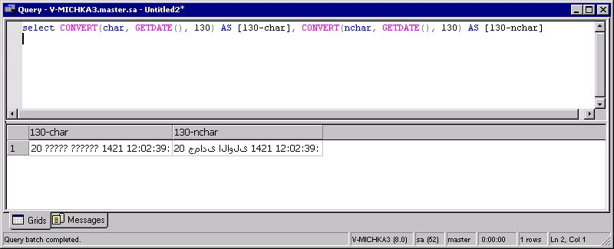
Figure 2: Convert date/time Transact-SQL
Note that on a U.S. client computer, attempting to use the char data type results in the Arabic characters being converted into question marks, and the nchar data type renders Arabic characters. This particular string is one that is still not properly formatted (as it would be on an Arabic) client computer due to limitations in the SQL grid in SQL Query Analyzer. The following illustration (Figure 3) shows how the actual Hijri date string should appear.

Figure 3: Hijri date string
This is because complex scripts, such as Arabic, have shaping rules that must be complied with so that the data can be rendered properly. In the case of bidirectional (BIDI) languages such as Hebrew, it will cause all data to be reversed; in the case of Arabic the effect is more marked, because the actual shapes of letters can change, depending on the surrounding letters. This problem does not happen in Windows 2000 or in any earlier, Arabic-enabled versions of Windows.
Additionally, the date string that is returned can itself cause problems in the bidirectional cases where it is needed, because the rules for the layout of bidirectional text used by an application, such as Internet Explorer or Windows 2000, causes the date to appear as shown in the following illustration (Figure 4).

Figure 4: Bi-directional date string example
This visual order (dd hh:mi:ss yyyy mon :) is obviously not the order that would be expected; the problem can be considered a general limitation of the 130 style in the CONVERT function, although you can work around it easily enough by adding the proper Unicode control character in front of the string, as shown in the following query:
SELECT NCHAR(8207) + CONVERT(nchar, GETDATE(), 130)

The NCHAR function returns a character based upon the passed-in Unicode code point; 8207 or hexadecimal 0x200F is the Right-to-Left Marker (RLM), and it causes the string to be displayed properly.

Performance and Storage Space
Ideally, every column is defined with one of the Unicode data types; however, doing so when you do not need to support multilingual data can create issues relating to storage space and speed.

Storage Space Issues
The actual amount of space required for the Unicode data types is 2 bytes per character, and the amount of space for the non-Unicode data types is 1 byte for all non-DBCS text and 2 bytes for Asian languages that use DBCS. Therefore, unless your data is on one of the Asian code pages, you will be using twice as much space to store the data. This must be considered when you upgrade existing databases or when you are deciding on the proper data types of new projects. If you are storing data only in a column that is on a single (non-Asian) code page, you might prefer to not use Unicode so you can save the space on disk and in memory.

Speed Issues
The speed issue is a complicated one. Here are some of the issues:
- If you are running on Windows NT or Windows 2000, the kernel is expecting Unicode data, and thus non-Unicode columns will have to be converted in many cases, such as when you display data or use the operating system services.
- There is the additional time needed to load the larger amount of data that must also be considered when you are dealing with DBCS data.
- If you are dealing with a Windows 95 or Windows 98 client or server, much of the information can also face conversions from Unicode when operating-system services, such as data display, are needed.
- If you are working between servers (see "Communication Between Server and Client" later in this paper), database server products, or other products, the number of conversions can also play a great role in the performance battle.
- If you are dealing with Asian languages, Unicode will actually be faster than using the language-specific DBCS code page. This is because DBCS data does not have fixed width; it is a mixture of double-byte and single-byte characters.
- If you are dealing with non-Asian languages, sorting Unicode data can be up to 30-percent slower than non-Unicode data. This can be considered one cost of being able to represent global data.
Important: To realistically evaluate a performance issue, you must test to get conclusive data about the situation.

Metadata Information in System Tables
The system tables in SQL Server 2000 store all the data they contain as Unicode. This minimizes the problems that can occur with different collations between databases and columns. There is no other way to deal with the fact that different databases on the same server can have any mix of Unicode and non-Unicode column names. Even if you are supporting only a single language, SQL Server must be ready to support any language you might choose to support.
When you are converting databases and servers from SQL Server 6.5 or earlier, it easy to become concerned because metadata is being converted; however, there is no need to worry. The conversion to Unicode is straightforward because these earlier versions of SQL Server are only in one code page/collation, defined at the server level.
One important issue involves using identifiers for objects in the system tables. SQL Server 2000 uses the Unicode 2.0 character property definition to create the list of valid characters in identifiers (Unicode 3.0 was not released when SQL Server 2000 development was completed). To avoid running into issues with international characters that are not defined in the Unicode 2.0 character property definition, you should limit your identifiers with brackets ([]) or double quotation marks ("). This prevents the server from checking for valid characters.

Collation
One of the things that everyone takes for granted is sorted data; after all, what could be more basic than the alphabet? Some of us may acknowledge languages that use different sets of letters such as Greek, Russian, Thai, or Japanese. But at least in the United States everyone seems to feel like if they can count on anything, it’s the alphabet.
The problem is that they are wrong! Whether or not you choose to understand why users who know Spanish might expect the letter combination "ch" to sort as a single character after the letter "h", you cannot deny it because it is true. In general, one of the most effective ways to alienate end users of an application is to get a task such as basic sorting wrong.
The way this works is through collations, or sort orders, and a technique known as string normalization. This is a different meaning of the word normalization than database developers are used to, as it is a not a design issue; when you refer to string normalization, you are considering how to compare two strings so that they can be sorted. This can be optimized through the creation of indexes.
For non-Unicode columns, collation has a second meaning that is very important: Collation specifies the code page for the data and, thus, what characters can be represented. Data can be moved between Unicode columns seamlessly; while data moved between non-Unicode columns cannot.

Collation in SQL Server 6.5 and Earlier
In SQL Server version 6.5 and earlier, collation was also relied on to specify the code page to use for language in general. There are some limitations related to different sort orders (for example in various Latin languages); you could only support Western European languages if you used Latin-1, for example. Because of this, the number of different locales (meaning language used in a specific region) you could represent in information on a single instance of SQL Server was limited. The basic issues also apply to the collation of non-Unicode fields in later versions of SQL Server. In addition, the issue about languages that have a "best fit" code page, such as Farsi, (mentioned previously in "Non-Unicode Text Types: char, varchar, text") can apply here.

Collation in SQL Server 7.0
SQL Server 7.0 has one Unicode and one non-Unicode collation per server. The non-Unicode collations are made up of the decision for code page and sort order ID, because each code page can support more than one sort (for example Latin languages will usually allow both case sensitive and case insensitive sorts, and Simplified Chinese will allow sorts both by stroke count and phonetic sorts). In the Unicode collation, any character of any language can be included in the column, so the individual collations that are available are there to make sure any collation-specific differences are properly handled. This is the proper solution to the "best fit" problem, because, for example, sorting Farsi data with the general Unicode collation gives users the data they expect. A Unicode collation consists of a locale and several comparison styles. Locales are usually named after countries or cultural regions. They sort characters according to the standard in that area. The Unicode collation still provides a sort order for all characters in the Unicode standard, but precedence is given to the locale specified. The following table lists the supported, unique Unicode collations in SQL Server 7.0. Any locale not on the list (Figure 5) should use the General Unicode Collation.
Locale ID (LCID) | Description
1033 | General Unicode
33280 | Binary Order
1027 | Catalan
197636 | Chinese Bopomofo (Taiwan)
2052 | Chinese Punctuation
133124 | Chinese Stroke Count
1028 | Chinese Stroke Count (Taiwan)
1050 | Croatian
1029 | Czech
1043 | Dutch
1061 | Estonian
1036 | French
66615 | Georgian Modern
1031 | German
66567 | German Phone Book
1038 | Hungarian
66574 | Hungarian Technical
1039 | Icelandic
1040 | Italian
1041 | Japanese
66577 | Japanese Unicode
1042 | Korean
66578 | Korean Unicode
1062 | Latvian
1063 | Lithuanian
1071 | FYRO Macedonian
1044 | Norwegian/Danish
1045 | Polish
1046 | Portuguese
1048 | Romanian
1051 | Slovak
1060 | Slovenian
1034 | Spanish Traditional
3082 | Spanish Modern
1053 | Swedish/Finnish
1054 | Thai
2057 | UK English
1058 | Ukrainian
1066 | Vietnamese

Figure 5: LCID conversions map
As you can see by this list, not all languages are included, but this is okay, as not all of them have to be. For example, the general Unicode sort order properly handles not only the data but also the sorting of Afrikaans, Albanian, Arabic, Basque, Belarusian, Bulgarian, English, Faeroese, Farsi, Georgian (Traditional), Greek, Hebrew, Hindi, Indonesian, Malay, Russian, Serbian, Swahili, and Urdu. The other languages listed in the table, however, have one or more differences from the general Unicode collation.
It should be emphasized that the developers of SQL Server are not "political" people and there really is no desire to offend any one country by asking them to "use another country's sort order." Thus, someone living in the Serbian region of Yugoslavia may not have to worry about using the Croatian sort order; because both the Croatian and Serbian languages use the same collation, the name is arbitrary. In working with customers in other countries, just use the numbers because the names are really arbitrary descriptions. What is most important is that you can choose a collation that will allow your data to be handled appropriately.
One very important change in SQL Server 7.0 was the provision of an operating system–independent model for string comparison, so that the collations between all operating systems from Windows 95 through Windows 2000 would be consistent. . This code, based on the same code that Windows 2000 uses for its own string normalization, is encapsulated to be the same on all computers. With this change, SQL Server is no longer reliant on the operating system for its international functionality -- from the smallest MSDE installation to the largest SQL Server Enterprise Edition.

Collation in SQL Server 2000
In SQL Server 2000, the collation model has been changed because:
- The requirement for two different collations was confusing.
- A more flexible model was needed to handle all of the new places for which a collation could be specified.
- In SQL Server 2000, collations are also used to handle the code page of non-Unicode columns; therefore, more collations were required.
A single, consistent model was designed to handle both Unicode and non-Unicode sorts. This model supports the languages listed in the following table (Figure 6):
Albanian | German_PhoneBook | Lithuanian_Classic
Arabic | Greek | FYRO Macedonian
Chinese_PRC | Hebrew | Modern_Spanish
Chinese_PRC_Stroke | Hindi | Polish
Chinese_Taiwan_Bopomofo | Hungarian | Romanian
Chinese_Taiwan_Stroke | Hungarian_Technical | Slovak
Cyrillic_General | Icelandic | Slovenian
Croatian | Japanese | Thai
Czech | Japanese_Unicode | Traditional_Spanish
Danish_Norwegian | Korean_Wansung | Turkish
Estonian | Korean_Wansung_Unicode | Ukrainian
Finnish_Swedish | Latin1_General | Vietnamese
French | Latvian
Georgian_Modern_sort | Lithuanian

Figure 6: Collation in SQL Server 2000
Each of these collations is combined with a series of suffixes that help define whether there is case, accent, width, or kana sensitivity. The exact suffixes that are possible are shown in the following table. Each of the 40 languages in the previous table supports the 17 suffixes (Figure 7), for a total of 680 Windows collations.
Suffix | Meaning
_BIN | binary sort
_CI_AI | case-insensitive, accent-insensitive, kanatype-insensitive, width-insensitive
_CI_AI_WS | case-insensitive, accent-insensitive, kanatype-insensitive, width-sensitive
_CI_AI_KS | case-insensitive, accent-insensitive, kanatype-sensitive, width-insensitive
_CI_AI_KS_WS | case-insensitive, accent-insensitive, kanatype-sensitive, width-sensitive
_CI_AS | case-insensitive, accent-sensitive, kanatype-insensitive, width-insensitive
_CI_AS_WS | case-insensitive, accent-sensitive, kanatype-insensitive, width-sensitive
_CI_AS_KS | case-insensitive, accent-sensitive, kanatype-sensitive, width-insensitive
_CI_AS_KS_WS | case-insensitive, accent-sensitive, kanatype-sensitive, width-sensitive
_CS_AI | case-sensitive, accent-insensitive, kanatype-insensitive, width-insensitive
_CS_AI_WS | case-sensitive, accent-insensitive, kanatype-insensitive, width-sensitive
_CS_AI_KS | case-sensitive, accent-insensitive, kanatype-sensitive, width-insensitive
_CS_AI_KS_WS | case-sensitive, accent-insensitive, kanatype-sensitive, width-sensitive
_CS_AS | case-sensitive, accent-sensitive, kanatype-insensitive, width-insensitive
_CS_AS_WS | case-sensitive, accent-sensitive, kanatype-insensitive, width-sensitive
_CS_AS_KS | case-sensitive, accent-sensitive, kanatype-sensitive, width-insensitive
_CS_AS_KS_WS | case-sensitive, accent-sensitive, kanatype-sensitive, width-sensitive

Figure 7: 17 Suffixes for collation
These language names are arbitrary and were chosen to properly represent each unique supported code page for non-Unicode data and sort order for all data. In the many cases where a language can be completely represented on another code page, or when a sort order that one language needs is covered by another, the language was "removed" from the list because it is adequately covered. Note that the default setting of kana sensitivity and width sensitivity is set to insensitive.
To ensure that code pages from earlier versions of SQL Server are properly supported, many backward-compatible, SQL-specific sort orders are also included in SQL Server 2000. These SQL-specific sort orders are shown in the following table (Figure 8). Many of these support some of the various parts of the suffixes described previously, but not all of the suffixes are supported.
SQL_1xCompat_CP850 | SQL_Estonian_CP1257 | SQL_Latin1_General_Pref_CP437
SQL_AltDiction_CP1253 | SQL_Hungarian_CP1250 | SQL_Latin1_General_Pref_CP850
SQL_AltDiction_CP850 | SQL_Icelandic_Pref_CP1 | SQL_Latvian_CP1257
SQL_AltDiction_Pref_CP850 | SQL_Latin1_General_CP1 | SQL_Lithuanian_CP1257
SQL_Croatian_CP1250 | SQL_Latin1_General_CP1250 | SQL_MixDiction_CP1253
SQL_Czech_CP1250 | SQL_Latin1_General_CP1251 | SQL_Polish_CP1250
SQL_Danish_Pref_CP1 | SQL_Latin1_General_CP1253 | SQL_Romanian_CP1250
SQL_EBCDIC037_CP1 | SQL_Latin1_General_CP1254 | SQL_Scandinavian_CP850
SQL_EBCDIC273_CP1 | SQL_Latin1_General_CP1255 | SQL_Scandinavian_Pref_CP850
SQL_EBCDIC277_CP1 | SQL_Latin1_General_CP1256 | SQL_Slovak_CP1250
SQL_EBCDIC278_CP1 | SQL_Latin1_General_CP1257 | SQL_Slovenian_CP1250
SQL_EBCDIC280_CP1 | SQL_Latin1_General_CP437 | SQL_SwedishPhone_Pref_CP1
SQL_EBCDIC284_CP1 | SQL_Latin1_General_CP850 | SQL_SwedishStd_Pref_CP1
SQL_EBCDIC285_CP1 | SQL_Latin1_General_Pref_CP1 | SQL_Ukrainian_CP1251
SQL_AltDiction_CP1253 | SQL_Hungarian_CP1250 | SQL_Latin1_General_Pref_CP850

Figure 8: SQL-specific sort orders
The actual information about collations can be retrieved by using the COLLATIONPROPERTY function. In addition to the CodePage value used earlier, you can also pass other information types, such as LCID, which returns the Windows Locale ID (returns Null for SQL collations). You can also specify Windows ComparisonStyle (returns Null for both Binary and SQL collations). This information can be used to verify that there is indeed an equivalence between string normalization in Windows 2000 and SQL Server 2000 for all of the Windows collations.
All of the available collations can be returned by using the fn_helpcollations() function, for example:
SELECT * FROM ::fn_helpcollations()

This query returns 753 rows in SQL Server 2000. Additional collations cannot be added, unless they are added in service packs or future versions.

How Collations Specify the Sorting of Data
It is important to briefly explain how collations actually operate on Unicode data. As a general rule that has no exception, every single defined collation in SQL Server on a Unicode column will sort all defined Unicode characters. There are many different collations because there are many differences in how the data can be sorted. A good example of this is the Georgian modern sort. Although the traditional sorting of Georgian text places all of the characters in a specific order, it is common for modern usage to place certain rarely used characters at the end. These characters are HE (), HEI (), WE (), and HAR (). Thus, there are two ways to sort the Georgian alphabet:
- Traditional (Figure 9):
- Modern(Figure 10):
This does not stop any other Unicode data from being sorted according to the same sort as is provided in the Latin1_General collation. All collations, in fact, sort Georgian in the traditional form, with the sole exception of the Georgian_Modern_Sort collations. The same rule applies to all other collations; only the exceptions change between collations.

Collations Specified at Multiple Levels
In SQL Server 2000, collations can be specified:
- At the server level.
- At the database level.
- At the column level.
- In an expression.

Collation Specified at the Server Level
The server level is where the collation always used to be, and in many cases is the only collation you ever need to set. This collation acts as the default for all collations in all databases on the server when they are created, if you do not explicitly set the collation at the database level. Because a database is always given a collation, the server-level collation is never really consulted except when the database is created.
You can change this collation without rerunning Setup by using the Rebuild Master utility (RebuildM.exe), which is located in Program Files\Microsoft SQL Server\80\Tools\BINN directory. For more information, see the topic "Rebuild master Utility," in SQL Server Books Online for SQL Server 2000.
You can also query the server for the collation with the Transact-SQL SERVERPROPERTY function, for example:
SELECT CONVERT(char, SERVERPROPERTY('collation'))

Collations at the Database Level
Every database can have a unique collation, with the sort order being set at the database level. The following illustration (Figure 11) shows how the collation is set using SQL Server Enterprise Manager.
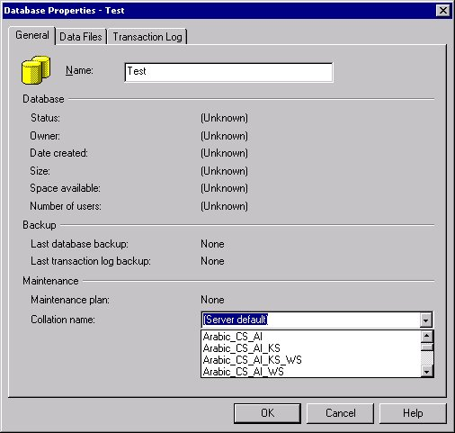
Figure 11: Setting Collation using the Enterprise Manager
You can set the collation order with Transact-SQL, as well. For example, to create a new database in Czech sort order, case and accent sensitive, use a statement such as:
USE master
GO
CREATE DATABASE Products
ON
( NAME = products_dat,
FILENAME = 'c:\program files\microsoft sql server\mssql\data\products.mdf' )
COLLATE Czech_CS_AS
GO

Interestingly, you can even change the collation of an existing database using the ALTER DATABASE statement (this is not available using SQL Server Enterprise Manager). For example, the following statement changes the collation of the Products database from Czech_CS_AS to Czech_CI_AI (case and accent sensitive to case and accent insensitive):
ALTER DATABASE Products
COLLATE Czech_CI_AI

Considerations Before Changing the Collation of a Database
To change the collation of a database, all of the following must be true:
- No one else can be using the database.
- No schema-bound object can be dependent on the database collation. Schema bound objects that qualify include any of the following:
- User-defined functions and views created with SCHEMABINDING
- Computed columns
- CHECK constraints
- Table-valued functions that return tables with character columns with collations inherited from the default database collation.
- The act of trying to change the collation of the database does not result in duplicates among any of the system names. This is very easy to imagine, for example, in the case of trying to change the collation from French_CI_AS to French_CS_AS (case insensitive to case sensitive). With the collation in earlier versions of SQL Server, it is possible to have two tables named Table1 and TABLE1; whereas, in the collation in SQL Server 2000, this causes duplicates. Objects that can potentially cause such duplications include:
- Object names (such as procedure, table, trigger, or view).
- Schema names (such as group, role, or user).
- Scalar-type names (such as system and user-defined types).
- Full-text catalog names.
- Column or parameter names within an object.
- Index names within a table.
None of these restrictions is unrealistic, and they keep you from doing things that can corrupt your data or your database. In fact, some might think the rules are not strict enough! If you have data in a text, varchar, or char fields and there is no explicit collation on the column, changing the collation of the database alters the way that the data's encoding is interpreted, resulting in a form of corruption of any characters beyond the ASCII range (which is contained by all code pages). Rather than tempting fate in this way, you should really avoid changing the collation of any database that contains text data columns that are not one of the Unicode types, unless those columns have their own explicit collations set (see "Collations Specified at the Column Level" that follows).
You can also use the Transact-SQL DATABASEPROPERTYEX function to find out the collation of a database, for example:
SELECT CONVERT(char, DATABASEPROPERTYEX('pubs', 'collation'))

Collations Specified at the Column Level
In SQL Server 2000, you can change the collation of text in a particular column. This can be very useful, for example, in a circumstance when you might need to force case sensitivity for a password column. Different language columns would be useful in other scenarios: for example, a customer name might need to be in Unicode using Latin1_General for the broadest appropriate sorting, and a product line might always be in Greek, and for this a Greek collation might make sense. The following illustration (Figure 12) shows specifying a collation during table design, using SQL Server Enterprise Manager.
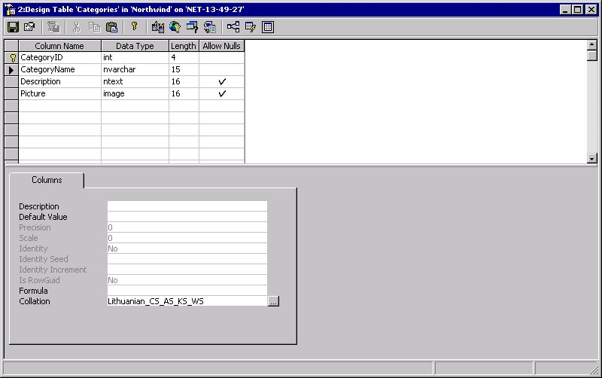
Figure 12: Specifying Collation during table design using the Enterprise Manager
When you click on the ... button, the dialog box shown in the following illustration appears. In this dialog box (Figure 13), you can choose a collation.
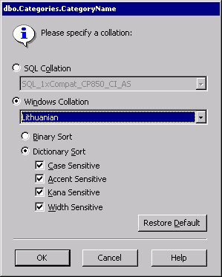
Figure 13: Collation dialog box
You can also set column-level collations using Transact-SQL. In the CREATE TABLE statement, simply add a COLLATE clause to the column definition. In the following example, the job description has a collation set for Arabic (case and accent insensitive, kanatype insensitive).
CREATE TABLE jobs
(
job_id smallint
IDENTITY(1,1)
PRIMARY KEY CLUSTERED,
job_desc varchar(50)
COLLATE Arabic_CI_AI_KS
NOT NULL
DEFAULT 'New Position - title not formalized yet',
)

You can use the ALTER TABLE statement to change the collation at the column level (except for an ntext or text column) with a new data type. However, you can change the collation on an ntext column using SQL Server Enterprise Manager. This is because SQL Server Enterprise Manager creates a temp table, moves data to the new temp table, drops the old table, creates a new table with the new collation, and then copies the data back to the new table.

Collations Specified in Expressions
There may be many instances when you need to display data to people in different countries and want locale-appropriate sorting. With SQL Server 2000, you can specify collations in expressions. This powerful new feature allows you to sort in a particular manner so that the ORDER BY clause can be language-specific.
For example, the following query sorts the Customers table by last name and first name, (using the Lithuanian sort order provides a good example of collation differences because the rules about how the letter Y sorts after the letter are so striking and noticeable).
SELECT
*
FROM
tblCustomers
ORDER BY
LastName COLLATE Lithuanian_AI_CI,
FirstName COLLATE Lithuanian_AI_CI

You can also refer to the examples in SQL Server Books Online for SQL Server 2000 that relate to regular comparisons, such as:
SELECT
*
FROM
Table1
WHERE
Field1 = Field2 COLLATE Turkish_ci_ai

Assuming that Table1 has no explicit column-level collations, both columns are compared with the Turkish sort order. For a more complete explanation on why this is the case, see "The Rules of Precedence for Collations" later in this paper.

The COLLATE Keyword
This is the syntax for using the COLLATE keyword is:
COLLATE [<Windows_Collation_name>|<SQL_Collation_Name]

The choice of collation name can be a difficult one to make. The keyword can be specified at the database level, the column level, or in expressions. As a rule, any time the field is not a Unicode one (ntext, nvarchar, or nchar) the earlier process in which the collation is converted into a code page is used.
There are two types of collations:
Windows collations
These are defined by Windows. You have full options to specify case, accent, kana, and width sensitivity, as well as being able to define binary sorts.
SQL collations
These collations are defined by SQL Server for legacy reasons. You do not have full options to configure these sorts.
Generally, you should try to use the Windows collations whenever you can. The following illustration (Figure 14) presents a simple example showing how sorting rules can change. In this example the pubs database is used. Whether or not Y comes between I and J, or between X and Z, depends on whether or not a Lithuanian collation is used, which clearly affects the way items in the query are ordered.
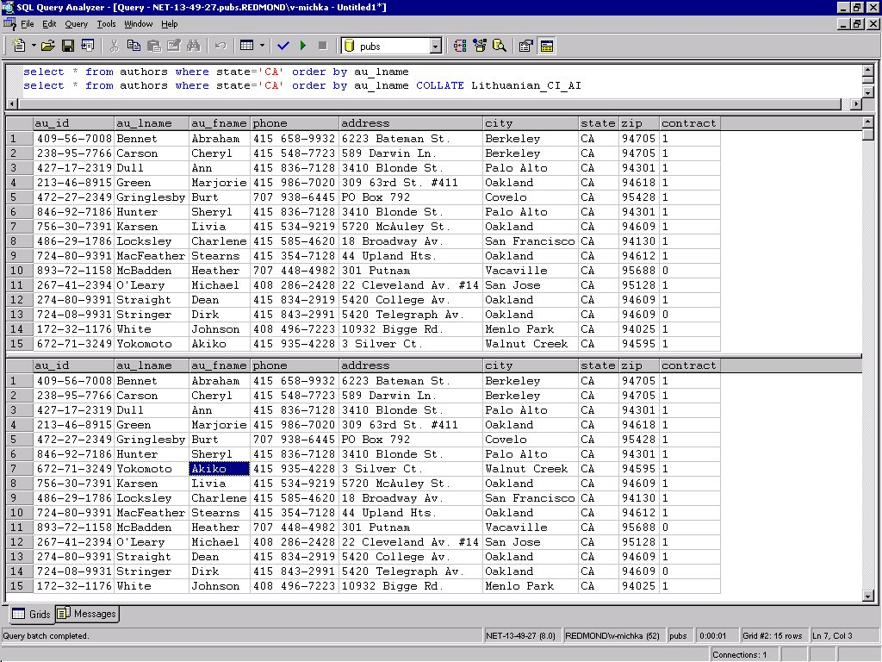
Figure 14: Example of collations effect on sorting.

The Rules of Precedence for Collations
In SQL Server 2000, you can specify a collation: at the server, in the database, in the column, and in an expression. How do these interact?
The interaction works by some straightforward rules which may seem confusing at first, but are needed. The following table (Figure 15) shows an interaction in which A and B act as the two different parts of the comparison.
 | Explicit B | Implicit B | Default | No Collation
Explicit A | Run-time Error | Explicit A | Explicit A | Explicit A
Implicit A | Explicit B | No Collation | Implicit A | No Collation
Default | Explicit B | Implicit B | Default | No Collation
No Collation | Explicit B | No Collation | No Collation | No Collation
Figure 15 Interaction of collations table
Here is an explanation of all the terms in this table:
Explicit A/Explicit B
A collation is explicitly defined for a given expression.
Implicit A/Implicit B
A collation has been defined at the column level.
Default
The database-level collation is being used.
No Collation
There is a conflict between the two operators, and the expression will be handled with no collation.
As you can see, the only time that SQL Server cannot handle an expression is when you explicitly define two different, conflicting collations, or when you try to compare two items and no common ground for the comparison can be found. These are not really blocking limitations; they are understandable rules. SQL Server simply needs you to provide some basis for comparison!
For example, consider the following Transact-SQL statement for creating a table:
CREATE TABLE TestTab (
id int,
GreekCol nvarchar(10) COLLATE greek_ci_as,
LatinCol nvarchar(10) COLLATE latin1_general_cs_as
)
INSERT TestTab VALUES (1, N'A', N'a')
GO

This statement creates a table with one column using a case-insensitive, accent sensitive Greek collation and the other using a case-sensitive, accent sensitive General Latin1 collation.
You could attempt to use a query to explicitly compare the two:
SELECT *
FROM TestTab
WHERE GreekCol = LatinCol

However, this returns an error:
Msg 446, Level 16, State 9, Server V-MICHKA3, Line 1
Cannot resolve collation conflict for equal to operation.

This occurs because the server cannot compare the two segments of text with different collations. If, however, you use the COLLATE keyword to explicitly create an expression that allows them to be compatible, the query will work, for example:
SELECT *
FROM TestTab
WHERE GreekCol = LatinCol COLLATE greek_ci_as

You will also want to note that although LatinCol usually has a case-sensitive collation, the case-insensitive collation of the expression overrides this and allows the uppercase and lowercase 'A' to be treated as being equal.

Limitations of the COLLATE Keyword
The COLLATE keyword and all of its related features are pretty incredible and this author believes they are without compare among contemporary enterprise database products; however, there are some limitations. These limitations are listed below. Note these limitations all have workarounds. The limitations are described here to help you understand what you can do directly and what requires a little extra work.

Returning Less than a Full List of Collations
The fn_helpcollations function (see the illustration in "Collations Specified at the Column Level" earlier in this paper) returns a full list of collations. However, as shown by the dialog box presented in "Collations at the Database Level" earlier in this paper, SQL Server clearly can list one locale (such as Albanian) and provide the rest of the flags as options, returning the full string in the end. If you want to provide a user interface for this functionality, you must do a little extra work yourself.

Issues with Defining Collation at the Column Level
How often would you have a database that needs one sort order (for example Latin1_General) and a column that needs a different one (for example Greek)? Sometimes, this may be crucial, but in other cases if the data in your database does not use a single collation, then it is probably multilingual data that may need to be sorted according to more than one collation. Being able to define multiple collations, each of which can be indexed, allows you to access the Greek data by specifying the Greek collation, and to have this query be an indexed search.
That last clause "and to have this be an indexed search" is the crux of the matter. In the example provided earlier, using a COLLATE expression in the ORDER BY clause of a query gives you the functionality; however, this will not be an indexed ordering, so it will be slower for large datasets. As it stands, column-level collation makes sense only if you do not have monolingual data in a column, or if you denormalize your database to store different languages in different columns.

LCIDs and Collations
Windows use the locale ID (LCID) to define sorts. If you are doing work to format your results, you will probably already have the LCID on hand (or you can use the default LCID by specifying 1024 or using Microsoft Visual Basic® formatting functions to do your work). In fact, if you are doing this work in a Web-based ASP application, you can use the SetLocale function in Microsoft Visual Basic Scripting Edition (VBScript) to change the formatting to use the date/time, number, and currency formatting preferences of any locale. Unfortunately, there is no way to map the two: You can get an LCID from a collation, but you cannot get a collation from an LCID due to many to 1 mapping from LCID to collation.
Why is this inconvenient? Well, imagine a case where you have a multilingual Web site, with people visiting from different countries and examining product information. You may already be mapping their browsers’ HTTP_ACCEPT_LANGUAGE variables to LCIDs for formatting date and currency values using the Session.LCID property, and you decide that sorting using their locale is a sensible option for the sake of usability.
To help build your own mapping function to work around this issue, see the conversion table in the topic "Windows Collation Designators," in SQL Server Books Online for SQL Server 2000.

ISO Strings and Collations
You can obtain the HTTP_ACCEPT_LANGUAGE variable in VBScript with a script such as:
Dim stLang

stLang = Request.ServerVariables("HTTP_ACCEPT_LANGUAGE")

Recognizing that this value is the only value many Web developers will have when it comes to locale information, the VBScript SetLocale function was designed to not only take LCID values but to accept this value directly. This means you do not have to go through the intermediate step of mapping the value to an LCID. Because SQL Server2000 does not accept a string such as "en-us" (English-United States) and properly map that to a Latin1_General collation, or "vi" (Vietnamese) and map that to a Vietnamese collation, you have to map all of them yourself.

How Are Custom Collations Defined?
One commonly asked question that many developers have after seeing the myriad of collation options is how they can define their own. The answer is that they cannot. Unless a collation is added to Windows 2000, it cannot be added to SQL Server 2000 (because all of the new SQL Server collations are derived from information in Windows—this is why they are referred to as Windows Collations). The reason for this is that a collation is literally designed to define the method for sorting every defined character in the Unicode standard, and there is no user interface designed to allow for creating such a thing.

Communication Between Server and Client (code page and collation issues)
In a very small number of cases, everything that you do with a SQL Server will happen on the same computer on which the server resides and only the SQL Server tools such as SQL Query Analyzer or SQL Server Enterprise Manager will be used. In most cases, however, the server will be interacting with other servers or clients, and might be using one or more data access standards. You will want to be aware of how such issues are handled by SQL Server 2000. In this context, anyone who talks to SQL Server is a client, and there are basically two types of clients:
- Unicode clients: OLE DB, and ODBC versions 3.7 and later
- Non-Unicode clients: ODBC version 3.7 and earlier, and DB-Library
One important issue that comes into play with non-Unicode data is the way that the data is translated between code pages or to and from Unicode when ODBC is used. There are two possible settings of the SQL_COPT_SS_TRANSLATE attribute when sent to SQLSetConnectAttr:
- SQL_XL_OFF
The driver does not translate characters from one code page to another in character data exchanged between the client and the server.
- SQL_XL_ON
The driver translates characters from one code page to another in character data exchanged between the client and the server. The driver automatically configures the character translation, determining the code page installed on the server and that in use by the client.
By default, SQL_XL_ON is the attribute that is used. You can also set it using the SQL-DMO TranslateChar method off the SQLServer object. Usually, this default provides the desired behavior (which is to turn auto_translate on) any time you are dealing with non-Unicode data.
The possible scenarios of client and server connections, with some of their issues, are presented in the topics that follow.

Unicode Server and Client
This is the ideal type of configuration. By keeping data in Unicode throughout the process, you can guarantee the best performance and protection from corruption of retrieved data. This is the case with ADO and OLE DB.

Unicode Server and One or More Non-Unicode Clients
In this type of configuration, you may not have any problems storing data, but there is obviously a serious limitation when it comes to bringing the data to the client and using it. The client code page must be used to convert the Unicode data at some point.
An example of this at the data layer would be when you are connecting to a SQL Server 2000 database from a computer that is using DB-Library. DB-Library is a Call Level Interface that allows C applications to access SQL Server. DB-Library has not been upgraded significantly since SQL Server 6.5, and for our purposes this explicitly spells out the limitations that any client using DB-Library will face. Data can be based on only one code page, the default OEM code page for the system. You can also choose whether locale information will be based on the locale settings of the client system or not. As shown in the following illustration, in the DB-Library Options tab of the SQL Server Client Network Utility, you can choose between two options for how DB-Library converts information. Both of these options are selected by default (Figure 16).
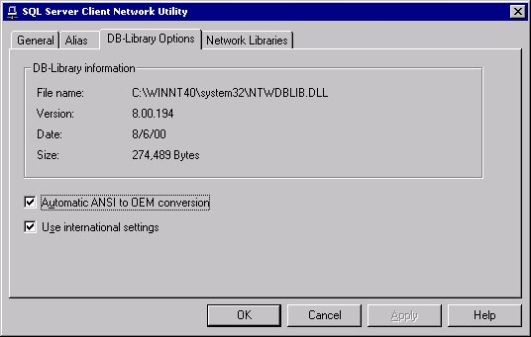
Figure 16: Default DB-LibraryOptions
Because you cannot handle data on other code pages, the only time DB-Library really makes sense as a data layer is in a legacy system that only needs to deal with a subset of data from SQL Server. Although it is clearly technology that is only there so developers already using it are not forced to rewrite their applications, it may well be worth considering such a rewrite if you need to support multilingual data.
Another case of a non-Unicode client would be programs that are not Unicode enabled, such as Microsoft Access 97. While an Access database can be linked to a SQL Server 2000 database, there are some limitations you should be aware of. If you connect to a database that, for example, has Japanese table names from a US English computer, you may see a dialog box like that shown in the following illustration (Figure 17), one in which the table names have been converted to question marks.
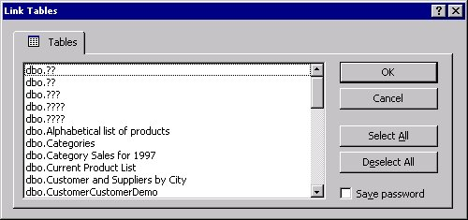
Figure 17: Illustration of table names converted to question marks in Access 97.
The cause of this problem is easy to understand; Access 97 is using a version of ODBC earlier than 3.7, and, thus, the data is being converted from Unicode to ANSI using the default system code page. Even if you install a later version of ODBC, Jet 3.5 in Access 97 will do the same conversion. Because Japanese characters are not on code page 1252 of the US English computer, they are replaced by question marks.
It is not possible to connect to these tables; connection attempts will result in the error message seen in Figure 18.
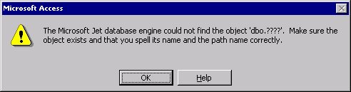
Figure 18: Microsoft Access error message illustration
This too, is easy to understand. Once data has been converted to the wrong code page and been replaced by question marks, there is no way for it to ever be converted back. This causes Jet and ODBC to literally try to connect to a table named dbo.????, which will obviously fail because it does not exist. This will occur with any data not in that code page.
A similar problem will occur in data in the tables themselves. For example, as shown in the following illustration, in a table that contains Korean data, you will see the data show up in a non-Unicode client (such as Access) as all question marks replacing the Korean data as seen in Figure 19.
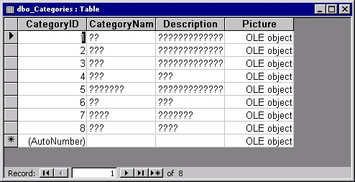
Figure 19: Example of questions marks in non-Unicode client database
In all three of these clients (DB-Library, ODBC, and Jet 3.5), a component that simply does not understand Unicode, except for how to convert it to the default system code page, will not be able to handle this type of multilingual data. Such a client will be limited to using data that is containable on its default system code page.

Non-Unicode Server and Unicode Client
This is not an ideal configuration for multilingual data, because you will not be able to keep such data on the server, but at the very least you can be sure that the data will show up properly. This configuration has all the limitations of the previous case, without the risk of data corruption of received data due to invalid conversions. An example of this would be when a SQL Server 2000 database defines a linked server to a SQL Server 6.5 database. All information that is received from the server running SQL Server 6.5 will be valid, but do not try to insert any off code page data!

Non-Unicode Server and Client
This is the most limiting configuration, because you are basically restricted to a single code page at all times.

Conversion of Multilingual Data from Earlier Versions of SQL Server
Not all users could wait for the Unicode features included in SQL Server 7.0 and SQL Server 2000 to handle their multilingual data; as a result, some users have created custom encoding schemes to store such data. If you were thinking ahead in such a way, then you will need to use the bulk copy utility (bcp) to save the data out as binary (which means no conversion), and then bulk copy back in using the appropriate code page using the -C command line parameter. For more information about the bcp utility, see "Using the bcp Utility with Multilingual Data" later in this paper.

Using the Access 2000 New ADP Format
Microsoft Access 2000 adds a new file format option that is not a Jet database, but is an Access Data Project (ADP). These files can act directly as a front end to SQL Server.
The capabilities of ADPs are beyond the scope of this paper, but two important issues to point out are:
- Access 2000 does not support SQL Server 2000 unless the SQL Server 2000 client tools are installed.
- In all of the entry points to SQL Server data within Access (forms, data access pages, table datasheet view, ADO), there is one layer that sits between Access and SQL Server: COM. This can affect the input of date/time values, numbers, and currency values, because the regional settings of the client (in this case the computer on which the ADP is sitting) are used to interpret the meaning of the data. This is important to keep in mind when you are using Access, because SQL Server's rules are less restrictive in some cases. For more information, see "Dealing with COM's Locale Interference" later in this paper.

Multilingual Data in the User Interface
Although SQL Server is first and foremost a server, it has many administration and management tools. These tools have been updated in SQL Server 2000 to support multilingual data as needed.

General UI Changes (Unicode Support)
SQL Server Enterprise Manager does a fairly good job of handling table names that are on the current default code page or server code page, but can also take advantage of some of the font linking technologies in Windows to "borrow" characters from other fonts when needed, as shown in the following illustration (Figure 20).
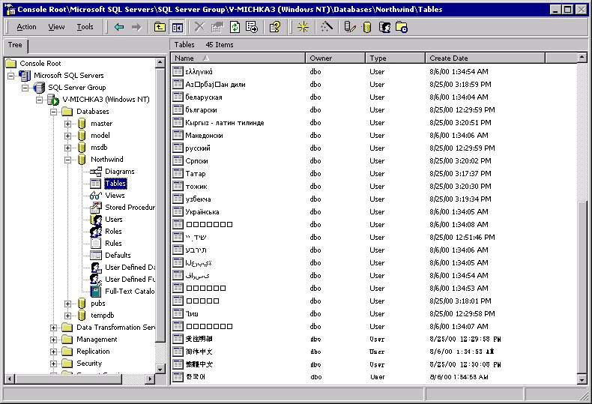
Figure 20: Font Linking technology example
As shown, font linking cannot do 100 percent of the job. There are many languages (such as Armenian, Sylfaen, Georgian, and Hindi) about which Windows has no advanced font linking information. Also, when a language uses characters that are not as commonly used within a script (such as Azeri – Cyrillic, also shown Fig. 19), most of the string will be displayed, but a few characters might not be.
There are three interesting things to note:
- Any time the name is not supported within the font and font linking cannot be done, you will not see characters corrupted; instead, you will see the boxes shown above, which is your indication that there is a character that could not be displayed.
- Because the SQL Server 2000 client tools do not use the Uniscribe technology for rendering complex scripts, unless you are using Windows 2000, the bidirectional languages (such as Hebrew, Yiddish, Arabic, and Farsi shown in the previous illustration) will have their characters displayed backwards. On Windows 2000 and BIDI-enabled platforms, however, these characters will display properly. Other complex script rendering issues such as Thai word breaking can see the same limitations (although not on Windows 2000).
- The "base" font used by SQL Server Enterprise Manager is the one defined in the desktop display settings of the computer and cannot be overridden.

Multilingual Information in the Grid and SQL Panes of SQL Query Analyzer
In SQL Server Enterprise Manager, you cannot make font changes; however, in SQL Query Analyzer, in the Fonts tab in the Options dialog box (Figure 21), you can explicitly change the font for many parts of the user interface.
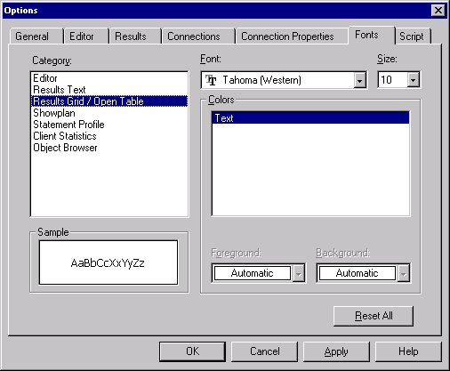
Figure 21:SQL Server 2000 Query Analyzer font dialog box
The reason for this may not at first be apparent, because font linking seems to allow most strings to be displayed. However, there is more to proper display of a string than simply finding a font that can represent the characters; often, the font choice can make a difference—therefore, this functionality can be important for properly representing multilingual data. In cases in which font linking does not seem to work, this feature will enable you to see the string instead of boxes.

Format Issues in the Query Designer
In the Query Designer, for the most part you can enter information in the grid pane that matches the default regional settings of the computer, or you can explicitly use the CONVERT function to cause a string in an arbitrary format to be handled.
There are a few design limitations in regard to this method of using the regional settings that you should be aware of:
- Long data formats are not supported.
- Currency symbols should not be entered in the grid pane, although the US dollar sign ($) can optionally be used. Either way, the currency symbol retrieved from the regional settings will be used in the Results pane.
- Unary minus always appears on the left side without parentheses, regardless of the regional settings. Thus, -1 should be represented as -1 instead of 1- or (1) or any other valid variation that may be specified in the Regional Options dialog box.
These limitations are necessary to allow a certain amount of worldwide support in the Query Designer, and are not actually something that will block most efforts to use locale-specific data.
Note that any information entered in the Grid pane will be translated to a locale-independent format in the SQL pane, thus "03.09.65" on a Standard German computer will be translated to { ts ' 1965-09-03 00:00:00 }. All data entered directly into the SQL pane should be in this format or otherwise include an explicit CONVERT call.

Sort Order
The sorting of data displayed in the Results pane is not influenced by the Regional Settings; instead, the collation rules (presented in "Collation in SQL Server 2000" earlier in this paper) control how an ORDER BY clause is interpreted.

Double-Byte (DBCS) Characters
You can enter DBCS characters for literals and database object names, aliases, parameter names, and parameter marker characters. However, you cannot use DBCS characters for SQL language elements such as function names or SQL keywords. Thus, you should use the keyword SELECT instead of the Japanese Fullwidth "ＳＥＬＥＣＴ".

Getting to SQL Server Data (Data Access Methods)
How you access data in SQL Server can be crucial. There are many different data access methods, and the rules for how each handles multilingual text can be very important. The sections that follow describe several of these data access methods.

OLE DB
OLE DB is the central component of the Microsoft Data Access Components (MDAC), which is MDAC version 2.1 in SQL Server 7.0 and MDAC version 2.6 in SQL Server 2000. OLE DB is based on COM, and thus all of the strings are Unicode BSTRs (UTF-16 on Windows 2000, and UCS-2 on all other operating systems). For SQL Server, the provider is the Microsoft OLE DB Provider for SQL Server (SQLOLEDB). Data is converted to Unicode as needed, using the collation of the actual data. The most optimized case would require you to keep the data as Unicode throughout the process.

ADO
Microsoft ActiveX® Data Objects is a Visual Basic and scripting friendly interface that acts as a wrapper around OLE DB. It is also a COM component and thus has the same support for Unicode. There is no way to decouple ADO and OLE DB in a way that would ever allow conversions to happen between the two, so when problems do exist they will always be at the OLE DB layer.

ODBC
Whether ODBC is a Unicode layer dependents on the version of ODBC that is being used. For the rules that apply to the use of ODBC, see "Communication Between Server and Client" earlier in this paper.

DB-Library
There is no later Unicode version of DB-Library. For more information, see "Communication Between Server and Client" earlier in this paper.

SQL-DMO
SQL Distributed Management Objects (SQL-DMO) is a COM layer that encapsulates SQL Server 2000 database and replication management. Because it is COM, the same rules that applied to ADO and OLE DB apply to SQL-DMO. SQL-DMO also has properties that can be used for features mentioned earlier, such as the Collation property on the SQLServer2, Database2, Column2, SystemDateType2, and UserDefinedDataType2 objects.

Multilingual Transact-SQL
When you send an SQL statement to the server that contains multilingual data, the two primary issues that will affect whether the data makes it to the server properly are the:
- Encoding of the SQL statement itself.
- Encoding of string literals inside the statement.

Encoding of String Literals in an SQL Statement
After the SQL string itself is encoded, a technique for handling string literals must also be employed. Essentially, the only choices here are a string in the computer's default code page or a Unicode string: the latter is designated by placing an "n" (for National) prefix in front of the string, as in:
SELECT n'हिन्दी'

This string (the Hindi word for the Hindi language) would be converted to ?????? if the "n" prefix is not placed there. This would also happen with data that does have a code page but one that does not match the system defaults.
Warning: Remember that the use of the "n" prefix both in string literals and in data types (nchar, nvarchar, and ntext) to represent Unicode data is specific to SQL Server. The ANSI-92 SQL specification does define the National character data types but does not specify them as having to be Unicode. The ANSI-99 SQL specification (which was not complete when SQL Server 2000 was released and will likely be discussed and modified from its present status in regards to Unicode support) does discuss using a set of Unicode types with a "u" prefix (for example, utext, uchar, and uvarchar). These data types are not available in SQL Server 2000.This is not true for some other server database products. For more information, see "Interacting with Other Database Products" later in this paper.

SQL String Encoding
If the SQL string uses Unicode (as would any SQL string using ADO, for example), you can encode any type of character. If the string does not use Unicode (such as a string in a non-Unicode batch file or .SQL file), the conversion will have to be made at some point, and usually this will be done with the default system code page of the computer on which the conversion is done. This can be very problematic, if not planned properly, in a multilingual application.
If a string literal is not in Unicode (marked with the N prefix), it will be converted to Unicode using the database's default code page. With multilingual data it is best to use a Unicode data type and Unicode string literals.

String-Handling Functions
Transact-SQL has built-in string-handling functions that have important multilingual considerations:
ASCII
Returns the code point of the first character in a string using the current default system code page. If the character is not on that code page, a 63 is returned (the code point for a question mark). This is similar to the Asc() function in Visual Basic and VBScript.
CHAR
Returns a character given the ANSI code point; essentially the inverse operation of the ASCII function, it is similar to the Chr() function in Visual Basic and VBScript. If the code point is not in the 0-255 range, it returns Null.
NCHAR
Is the Unicode equivalent of the CHAR function. It returns a character given its Unicode code point. It is similar to the ChrW() function in Visual Basic and VBScript.
UNICODE
Is the Unicode equivalent to the ASCII function, and it returns the Unicode code point of the first character in a string. It is similar to the AscW() function in Visual Basic and VBScript.
Note that the NCHAR function was used in an example earlier in this paper (see "Date/Time Types: datetime, smalldatetime") to add the RLM (right to left mark) in front of a Hijri date to allow it to be formatted in the expected manner.

Locale Support in SQL Server 2000
SQL Server 2000 includes some specific locale support for 33 different languages. This is not the full locale support that is available in the NLS database in Windows, but it does provide many basic functions. The following table (Figure 22) shows the languages that are supported (in both English and in the native language).
English (us_english) | Slovak (slovenčina)
German (Deutsch) | Slovenian (slovenski)
French (Français) | Greek (ελληνικά)
Japanese (日本語) | Bulgarian (български)
Danish (Dansk) | Russian (русский)
Spanish (Español) | Turkish (Türkçe)
Italian (Italiano) | British English (British)
Dutch (Nederlands) | Estonian (eesti)
Norwegian (Norsk) | Latvian (latviešu)
Portuguese (Português) | Lithuanian (lietuvių)
Finnish (Suomi) | Brazilian (Português - Brasil)
Swedish (Svenska) | Traditional Chinese (繁體中文)
Czech (čeština) | Korean (한국어)
Hungarian (magyar) | Simplified Chinese (简体中文)
Polish (polski) | Arabic (Arabic)
Romanian (română) | Thai (ไทย)
Croatian (hrvatski)
Figure 22: Table of Locales supported in Windows 2000
You can enumerate these languages and information about them using the sp_helplanguage stored procedure. Note that although every version of SQL Server will store full information about many of the items listed below, you will not get translated system messages for all locales unless you have installed a localized version of the product.
The information on languages is stored in the syslanguages table, except for messages, which are stored in sysmessages.

Language Settings
Every SQL Server must have a default language that it uses to handle items such as date formats and messages. This information is stored for each login to the server that is created. Although this is initially set during setup, it can be overridden at the server level in the Server Settings tab in the SQL Server Properties dialog box, as shown in Figure 23.
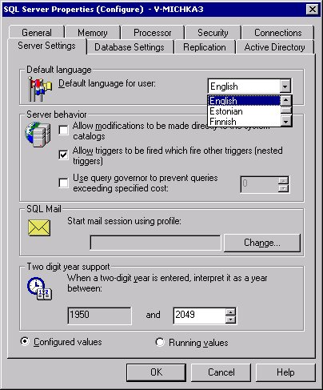
Figure 23: SQL Server language settings dialog box
You can also use the sp_configure stored procedure, as in a call such as the following to change the default language to Italian:
sp_configure "language", 6

The following table (Figure 24) shows the language IDs (langids) that are available (and that can be queried using a query from the syslanguages table).
langid | Language name
0 | English
1 | German
2 | French
3 | Japanese
4 | Danish
5 | Spanish
6 | Italian
7 | Dutch
8 | Norwegian
9 | Portuguese
10 | Finnish
11 | Swedish
12 | Czech
13 | Hungarian
14 | Polish
15 | Romanian
16 | Croatian
17 | Slovak
18 | Slovenian
19 | Greek
20 | Bulgarian
21 | Russian
22 | Turkish
23 | British English
24 | Estonian
25 | Latvian
26 | Lithuanian
27 | Brazilian
28 | Traditional Chinese
29 | Korean
30 | Simplified Chinese
31 | Arabic
32 | Thai

Figure 24: Language Ids from syslanguages table
The default language setting can be overridden on a per-login basis using the sp_addlogin stored procedure or by using the Login Properties dialog box shown in Figure 25.
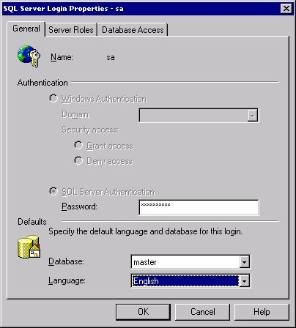
Figure 25: Login Properties dialog box
Finally, the language can be overridden at the session level, using the SET LANGUAGE statement, as shown in the following examples:
SET LANGUAGE French
SET LANGUAGE čeština
SET LANGUAGE 한국어
SET LANGUAGE N'日本語'

You should use the N prefix in front of strings to make sure they are passed as Unicode. This can help avoid the unintended problems with conversions using the default system code page of the server.
Individual data access methods provide their own methods of specifying the language setting outside of a SET LANGUAGE call:
- ADO supports a provider-specific language keyword in the ConnectionString.
- OLE DB can set the provider-specific SSPROP_INIT_CURRENTLANGUAGE property.
- ODBC can specify a language in the data source definition or in a LANGUAGE keyword in the connect string.
- DB-Library can use dblogin to allocate a LOGINREC, and then DBSETNATLANG to specify a language setting.
The language settings (whether specified at the server, login, or session level) affect these items:
- Messages
- Date/Time
- First Day of Week
- Currency and currency symbols
- Month/day names and abbreviated month names

Messages
SQL Server 2000 supports having multiple, language-specific copies of system error strings and messages. These messages are stored in the sysmessages table of the master database. When you install a localized version of SQL Server 2000 these system messages are translated for that language version you are installing. You also get by default the US English set of these messages. You can use Set Language to specify the language of the server session. By default it is the language of the installed version. When SQL Server sends a message to a connection, it uses the localized message if the language ID Set matches one of the language IDs found in the msglangid column of the sysmessages table. These IDs are in decimal format and represent the locale ID (LCID) of the message. If there is no message in the sysmessages table with the same LCID, the US English messages are sent. You can add a language-specific user-defined message to the sysmessages table by using @lang parameter of the sp_addmessage system stored procedure. (Error numbers should be greater then 50,000) @lang is the language (Named Alias that maps to the LCID) for the message. Because multiple language-specific, system-error strings and messages can be installed on the server, the value of language specifies the language in which the messages should be written to the sysmessages table. When language is omitted, the language is the default language of the server session. The supported language definitions are stored in the master.dbo.syslanguages. If you must install multiple language versions of sysmessages, contact your Product Support Services (PSS) representative.

Date/Time
The basic change that can be made is whether the short date format is mdy, dmy, or ymd. You can override this at the connection level by using the SET DATEFORMAT setting, but each language has an appropriate default. The default can be retrieved by using the sp_helplanguage stored procedure. The value is stored in the dateformat column.

First Day of Week
The first day of the week varies among different locales; among the 33 languages in the syslanguages table, it varies between 1 (Monday) and 7 (Sunday). This information can be retrieved by using the sp_helplanguage stored procedure. The value is stored in the datefirst column.

Currency and Currency Symbols
Any column of money or smallmoney type can include a currency symbol. The symbol does not have to be the one specified in the Regional Options dialog box, and can be any of the characters shown in figure 26.
Currency symbol | Currency name | Unicode (hexadecimal) value
$ | Dollar sign (USA) | 0024
£ | Pound sign (UK) | 00A3
¤ | (Universal) Currency sign | 00A4
¥ | Yen sign | 00A5
৲ | Bengali Rupee mark | 09F2
৳ | Bengali Rupee sign | 09F3
฿ | Thai Baht symbol | 03EF
₡ | Colon sign | 20A1
₢ | Cruzeiro sign | 20A2
₣ | French Franc sign | 20A3
₤ | Lira sign | 20A4
₦ | Naira sign | 20A6
₧ | Peseta sign | 20A7
₨ | Rupee sign | 20A8
₩ | Won sign | 20A9
₪ | New Sheqel sign | 20AA
₫ | Dong sign | 20AB
€ | Euro sign | 20AC

Figure 26:Table of currency symbols
You will probably want to note that the SQL Server 2000 Books Online incorrectly lists the Euro sign as having a hexadecimal value of 20A0; the real value is 20AC. The character represented by 20A0 is ₠, the Euro-Currency (ECU) sign. This is not the Euro and should not be used as such; attempting to use ₠ in a money value will result in an error.

Month/Day Names and Abbreviated Month Names
The names of the months and days are included in the syslanguages table. They can be retrieved using the sp_helplanguage stored procedure, using the following columns:
months
A comma-delimited list of month names, January through December.
shortmonths
A comma-delimited list of abbreviated month names, January through December.
days
A comma-delimited list of the days of the week, Monday through Sunday.

Dealing with COM's Locale Interference
Although SQL Server has some very powerful features when it comes to handling date/time and currency values, if you are using any COM service such as ADO to access the server, you must for its intervention. For example, you can have problems getting Visual Basic to recognize that a number value prefaced by any of the currency symbols (shown in the preceding table) is a currency value. You can also have serious problems getting COM to properly use date/time values stored in strings.
To properly deal with this situation, you must understand when your application is converting a string to a date/time or currency value. Once you know whether it is happening on the client or the server, you can decide which rules apply.
The Access 2000 ADP is an example of such a client (see "Using the Access 2000 New ADP Format" earlier in this paper). Because Access is working through OLE DB, all operations from Access 2000 will be governed by the COM rules that use the client computer's regional settings.
Note that OLE DB providers such as the Microsoft OLE DB Provider for SQL Server will properly convert a valid COM date to and from a SQL Server date. It is best to not rely on date formats in strings when you can avoid it, because this is the type of functionality that can break as you move the client side between different locales.

Data Transformation Services
When dealing with multilingual data, there are some issues in the user interface of the DTS Import/Export Wizard, shown in Figure 27.
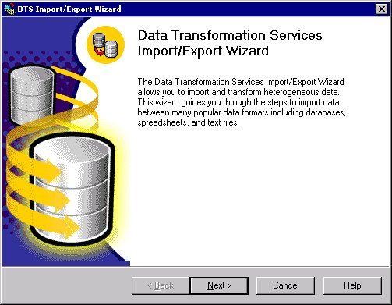
Figure 27: DTS Wizard dialog box
The wizard provides an interface for working with heterogeneous data. There are a few dialog boxes for showing the data that are not as fully Unicode enabled as SQL Server Enterprise Manager and SQL Query Analyzer (see "Multilingual Data in the User Interface" earlier in this paper). Because of this, you may encounter situations in which the data may not look right in the wizard, but it will transfer properly. The reliability and stability of DTS operations are not affected by these UI limitations! In most cases, you simply will not be able to see the data because it will be replaced by boxes, as shown in Figure 28.
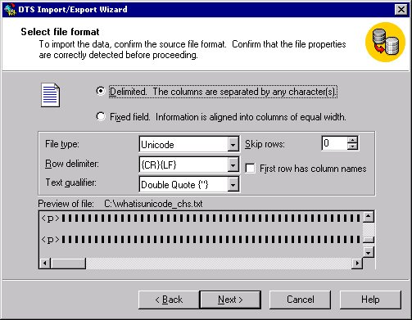
Figure 28: DTS wizard illustration
This is a Unicode text file with Simplified Chinese data in it. Once imported, the data will be properly handled, whether it is imported into a Unicode text column or a Simplified Chinese text column.
However, if you have a text file that uses a particular code page that does not match the system default, the wizard does not have the proper context to read it, as shown in Figure 29. Note that this is not an uncommon limitation; many programs, including Notepad and WordPad, do not have the capability to understand files that are not in the expected code page.
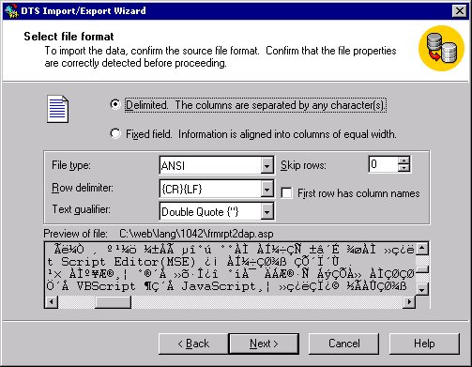
Figure 29: Illustration of a file that will not import properly using DTS Wizard
This Korean file will not import properly on a U.S. computer, and the wizard does not allow means to specify a code page for the import process (this is why the data will neither display nor import properly). As in many other cases, the rules are very clear: If you want to use multilingual data, you should use Unicode.
There are three rules you can use for encoding information during DTS transformations: you can choose to "use src," "use dest," or "use collation." The third option is the one that is most likely to give you the results that you want. It is actually the default in both SQL-DMO and in the DTS Designer (it is not the default in the DTS wizard but it is easy enough to set). The option to use collation only works when both source and destination are SQL Server 2000 databases, but it will use the collation information of the respective columns to best determine how to do the transfer.
The other two transformation options are not quite so flexible and require you to use either the source or destination code pages of the server to determine how the transform should be done. Unfortunately, these settings are quite literal in their adherence to the code page settings of the server. Although they will respect the collation of a particular multiple-instance server, they will not support a database collation that is different from the server.
The other feature that exists in DTS Transformation operations is a very powerful ability to convert strings and other non-datetime data, using the NLS information of the instance of SQL Server. For formats that have date/time data stored as strings, this crucial functionality can allow the import to proceed as the user would expect it to. This can be very important because not all formats have the large number of data formats SQL Server 2000 does, and DTS is the important bridge between these limited formats and the server's capabilities.
Other problems with DTS can occur when moving data between non-Unicode columns with a SQL Server 7.0 source and a SQL Server 2000 destination, when the collation of the SQL Server 2000 column is not one that is easily represented in SQL Server 7.0 (conversely, a SQL Server 2000 source and SQL Server 7.0 destination can also cause the same problem). The default of using the server code page on the SQL Server 7.0 end is what will be used in these cases. Once again, using Unicode data types prevents such problems from occurring.
When you perform a copy operation with DTS rather than a transform, there are three possibilities:
- OLE DB provider column
This choice just copies the raw data, which obviously will have problems if the two columns do not contain data on the same code pages. It is a very fast option when the source and destination use the same code page, but the copy will not be effective for copying between columns with data that uses two different code pages.
- NCHAR to CHAR
DTS will automatically use the code page of the server to do conversions from Unicode.
- CHAR to NCHAR
DTS will automatically use the code page of the source server to do conversions to Unicode.

Summary of DTS Conversion Issues
To start, Unicode source and target will always work. This fact cannot be stressed strongly enough. The issues occur only with non-Unicode data in specific circumstances, which I will summarize here.
When you are creating a destination table:
- Translation fails when the source is SQL Server 7.0 and the SQL Server 2000 destination server code page does not match the destination database code page.
- Translation fails when the source is SQL Server 2000, the destination is SQL Server 7.0, and the source column collation does not match the source server code page.
- When the source and destination is SQL Server 2000, translation fails if Use Collation is not selected; otherwise, no data is lost.
When the destination table already exists:
- Translation fails when the source is SQL Server 7.0 and the SQL Server 2000 destination server code page does not match the destination column code page.
- Translation fails when the source is SQL Server 2000, the destination is SQL Server 7.0, and the source column collation does not match the source server code page.
- When the source and destination are SQL Server 2000, translation succeeds if either of these exist:
- The source and destination column code pages match and Use Collation is selected.
- The destination column code page matches destination server code page and Use Collation is not selected.
If Use Collation is true, data transfer is raw. If false, data is cast into the source server code page and then translated into the destination column code page.
For the copy column transform:
- char to char is a raw transform. Translation fails if the source and destination column code pages do not match.
- char to Unicode casts source data into the computer code page and translates to Unicode, but fails if the source data does not appear in that code page.
- Unicode to char casts translates data into the computer code page, regardless of destination code page. As such it will fail if the destination column code page does not match the computer's code page.
As in the other cases, Unicode to Unicode will work properly with no conversions that could fail or corrupt data, and is preferred for use with multilingual data.

Using the bcp Utility with Multilingual Data
When you want to import data from or export data to a particular code page, you can still use the bcp utility, which supports the flags (Figure 30) for lossless conversion of data.
Flag | Meaning | Explanation and notes
-C xxx | Code page specifier | xxx can specify a code page, ANSI, OEM, or RAW (for direct copy with no conversion—the fastest option).
-N | Use Unicode native format | Uses native (database) data types for all noncharacter data, and Unicode character format for all character data.
-w | Use Unicode character format | Uses the Unicode character data format for all columns.

Figure 30: bcp utility file format flags
You can also use format files and specify collations at the column level (if you do not specify -C, -N, or -w, bcp will actually query for each column, the collation, and code page information prior to performing the import/export). You will then be prompted to save a format file, as shown in the following example (refers to the authors table in the pubs database):
8.0
9
1 SQLCHAR 0 11 ""1 au_id Latin1_General_CI_AI
2 SQLCHAR 0 40 "" 2 au_lname Latin1_General_CI_AI
3 SQLCHAR 0 20 "" 3 au_fname Latin1_General_CI_AI
4 SQLCHAR 0 12 "" 4 phone Latin1_General_CI_AI
5 SQLCHAR 0 40 "" 5 address Latin1_General_CI_AI
6 SQLCHAR 0 20 "" 6 city Latin1_General_CI_AI
7 SQLCHAR 0 2 "" 7 state Latin1_General_CI_AI
8 SQLCHAR 0 5 "" 8 zip Latin1_General_CI_AI
9 SQLBIT 0 1 "" 9 contract ""

The allowable data types are shown in the following table (Figure 31) The collation is the default one specified for the column, which may have been inherited from the database or the server.
Type | Full name
c | Char
T | Text
i | Int
s | Smallint
t | Tinyint
f | Float
m | Money
b | Bit
d | Datetime
x | Binary
I | Image
D | Smalldatetime
r | Real
M | Smallmoney
n | Numeric
e | Decimal
w | Nchar
W | Ntext
u | Uniqueidentifier

Figure 31: Allowable data types used with bcp utility
Note that the varchar and nvarchar data types are not listed in the table. For the bcp utility, the char and nchar types should be used in their place, respectively.
Finally, bcp supports the -R flag for "Regional Enable". This flag has the same effect as the ODBC "use regional settings" option (see "Communication Between Server and Client" earlier in this paper) and can relate to the way that date/time, number, and currency data that is being stored in nontext fields is interpreted.

The Microsoft Search Service and FTS
Many Microsoft products use the Microsoft Search service; the service itself is used in both SQL Server 2000 and Exchange 2000. The engine is the same one used in Index Server, and many other products will likely include its capabilities in the future. Its most important capability is its ability to provide stemming (verb conjugation) and word breaking functionality that are language-specific; for example, allowing you to properly index words such as l'unique in French. The languages supported by Microsoft Search service are:
- Dutch
- English (UK)
- English (US)
- French
- German
- Italian
- Japanese
- Korean
- Simplified Chinese
- Spanish (Modern)
- Swedish
- Traditional Chinese
- Thai
In addition to these language-specific stemmers/word breakers, a neutral one is also provided for use in other languages. There are specific cases where you may be more pleased with the results of using a specific language rather than neutral (for example you may wish to use the Spanish language for Catalan, or Dutch for Afrikaans), but the official recommendation for such cases is to use the neutral choice. Therefore, testing it out on your data rather than just assuming that "similar" languages will provide good results is recommended. The language support is very sophisticated, and this can potentially be a bad thing if you try to provide data that is not specifically in that language.
The actual implementation details of the various providers that use the Microsoft Search service and related components are for the most part based on your need: If you are indexing data in an Exchange store, the Exchange implementation would be preferred. But if you are using the file system, Index Server would be preferred. Obviously, if you are using SQL Server 2000, then Full-Text Search in SQL Server 2000 is the best choice.
Microsoft Search service can allow clients to "tag" areas of text with a particular language to allow for multilingual indexing on a single set of data, but because SQL Server 2000 does not expose a way to "tag" data in this way, languages should be specified at the column level. You can, however, create multiple indexes for a single column, and this might provide a good workaround if you have multilingual data in a single column and you think you might want to do some language-specific searching. You can specify the language to use with the @language parameter of the sp_fulltext_column stored procedure.
You can also specify a default language to use for Full-Text Search by using the default full-text language option to the sp_configure stored procedure, which you can call as follows:
sp_configure 'show advanced options', 1
GO
RECONFIGURE
GO
sp_configure 'default full-text language', 1041
GO
RECONFIGURE
GO

If you are using the default language, you do not need to specify a language in the call to sp_fulltext_column.
Commonly, users ask how they can add support for their own languages in Full-Text Search. Unfortunately, at this point there is no way to do this.
Surrogate pairs (see "What Are Surrogates?" earlier in this paper) are not supported in FTS or Microsoft Search service, and you cannot reliably perform searches based on these values, or, for that matter, on any characters that SQL Server 2000 considers to be undefined.

Dealing with OLAP/Hierarchical Data
In general, all of the rules about multilingual text in Unicode fields that apply to relational use of SQL Server 2000 apply equally to the Online Analytical Processing Capabilities (OLAP) included in the Analysis Services component of SQL Server 2000. Analysis Services can handle any character that SQL Server 2000 itself can support. There are a few cases in the user interface for OLAP and its wizards where such data will be displayed as question marks if it is not on the client system's default code page. However, this does not affect the actual data and is purely a display issue in the UI.
One feature that is not supported in SQL Server 2000 for OLAP is the ability to have different collations in different parts of hierarchical data structures that make up a Data Warehouse. Although not generally useful in the analysis of data, there are cases such as partitioning of data alphabetically (for analysis) that can be impacted. In such cases, you would need to come up with another way to partition the data that defines the ordering and partitions explicitly and does not assume letter order. This would also be very useful in the display of hierarchical data. If you need such functionality, you will have to do sorting on the subset of the data returned from the OLAP source.

Using XML Support in SQL Server 2000 with Multilingual Data
The rich XML support in SQL Server 2000 provides the ability to support multilingual data, based on the fact that XML itself has a default encoding of Unicode using UTF-8 and in many cases SQL Server will use UCS-2 encoding in the XML it creates. Here are several ways you can specify an encoding in XML:
- If you are formatting data as XML in a ADO Stream object and then persisting the stream, you can specify an output encoding and the proper encoding will be marked in the XML-formatted data.
- You can specify an output encoding in a URL.
- XML templates can specify an encoding.
Even if you do not use any of these methods, by default Unicode is supported and will work properly.
One important issue that must be kept in mind is that the characters allowed in names in XML are a lot more restricted than those that are allowed as identifiers in SQL Server. To fully support SQL Server identifiers, the identifier characters that are not supported in XML are replaced by a special form: _x005F_x0000_ is the form, where 0000 would be replaced by the Unicode code point number. SQL Server will properly recognize these characters and return them correctly. Note, Updategrams interpret the encoding either way; however, using them is necessary only if you do not have a mapping schema.
For example, the following Transact-SQL statement can be used to create an XML file in UCS-2 encoding:
USE Northwind
GO

SELECT TOP 1 * FROM "Order Details" FOR XML AUTO

DECLARE @h int

EXEC sp_xml_preparedocument @h output,
N'<?xml version="1.0" encoding="ucs-2"?>
<root test_x0020_2="foo">українською</root>'

SELECT * FROM OPENXML(@h,'/root') WITH("test 2" varchar(200) )

EXEC sp_xml_removedocument @h

This bit of script creates an XML document that encodes the Cyrillic string українською, which happens to be a word for the language name Ukranian.
Annotated schemas shipped with XPath support in SQL Server 2000. Updategrams are currently in beta release on the Web and are planned for final release to the Web in early 2001. Both features are designed to work well with multilingual text and support methods for specifying encoding; they also support the syntax mentioned earlier for the use of identifiers.

Interacting with Other Database Products
When working with other database systems, your most important task is simply a matter of determining the code page and similar rules of that system. The majority of the recommend data access methods on the SQL Server side involve COM, and thus use Unicode data. Therefore, how well the other database products support Unicode is the main piece of information you need to determine how well an international application will run between them.
For example, other database products such as Oracle and Sybase SQL Server support Unicode using the UTF-8 encoding. Usually this will not affect you because the data must be converted to UTF-16 using ADO/OLE DB before you ever see the information. But you should be aware of the difference if you try to interact with data in such products directly.
Another major issue that you must allow for is the fact that products such as Sybase SQL Server do support the National character data types but do not treat them as Unicode data types. For them, nchar and nvarchar are fields that you could use (for example) to store Japanese data in an otherwise US English database. When you run queries against another product, it is very important that you know how information is being handled in the other database so that using commands such as OPENROWSET will properly handle international text. The use of the National character data types for specifying Unicode text is a Microsoft SQL Server–specific use, in order to properly handle this encoding that supports all languages.

Conclusion
Microsoft SQL Server 2000 includes a variety of very powerful international features. By building on SQL Server 7.0, the first truly multilingual-capable version of SQL Server, SQL Server 2000 has added a compelling set of features that allows the creation of truly global applications. With the importance of the Internet and the World Wide Web, it is crucial that applications and databases are able to meet this need, and the ever-increasing needs of e-commerce and global communication require a database product that can support them. SQL Server 2000 is the database of choice for global organizations.

Acknowledgments
This paper would have been impossible without the hard work of many people, and I would be remiss if I did not mention them.
Michael Kung, in his role as a Program Manager for SQL Server with a focus on globalization, provided not only invaluable review material for many different parts of the paper, but he also helped point me to the right people for all of the questions that came up in areas of the product with which I was less familiar. His broad knowledge of many different areas has always been a great resource even beyond this white paper, and I was very happy for his help in this project.
Peter Carlin, a Development Manager whose responsibilities include the SQL Server relational engine, was not only able to find the time to provide more feedback than any other person I was in contact with, but he also crafted an e-mail that contained a lot of the important information regarding Unicode support in SQL Server. This e-mail was actually the direct inspiration for this white paper that exploded into a document almost 25 times the size!
Fernando Caro, a lead international program manager, was not only able to help take me through the OLAP features of SQL Server, but he was also able to help change the discussion on localized system messages from a curt "sorry, not supported" to the helpful pointer to the appropriate resources. I am grateful that this white paper gave me the opportunity to point out the problem, but even more grateful that Fernando and Peter decided it was important to solve it. It is widely due to people like them who always want to help users in any (reasonable) way possible that SQL Server is such a great product.
I also would like to thank several program mangers and testers for their assistance. Without their help, many of the features that are scattered throughout the full SQL Server product would not have had their international features and issues discussed here. These people include: Michael Rys, Euan Garden, Fadi Fakhouri, and James Howey. I also would like to thank Margaret Li for the insight she gave me into how the Microsoft Search service that sits underneath SQL Server's Full-Text Search does its work.
Many of the hard working people on the Windows 2000 team were also very helpful, both for providing information on how basic issues such as collation and locale support are supposed to work and of course for providing the original data on which SQL Server 7.0 and 2000's collation support is based. I would especially like to thank Julie Bennett, Cathy Wissink, and John McConnell for being around to answer questions and provide encouragement for getting the word out!

Of course, the full list of people who were involved in the planning, developing, and testing of SQL Server's international and multilingual features would probably be almost as long as the list of people who worked on the product, because these features are clearly not an "add-on" but are a core part of SQL Server 2000. Therefore, I would like to thank everyone involved for producing a great product that is so globally useful!

About the Author
Michael Kaplan is the president and lead developer of Trigeminal Software, Inc., a software development and consulting company that specializes in the internationalization and localizability of Microsoft Visual Basic, Microsoft SQL Server, Microsoft Access, and ASP applications. He is the author of the book Internationalization with Visual Basic from Sams Publishing, and his next book, Internationalization with SQL Server, is due out in the middle of 2001. He has also written many articles and spoken on international development. His e-mail address is michka@trigeminal.com, and the Web site for Trigeminal Software, Inc. is http://www.trigeminal.com/.

