THANJAVUR REGION
NAME OF SCHEME:- KNMT 2021-22 JAYANKONDAM MUNICIPALITY
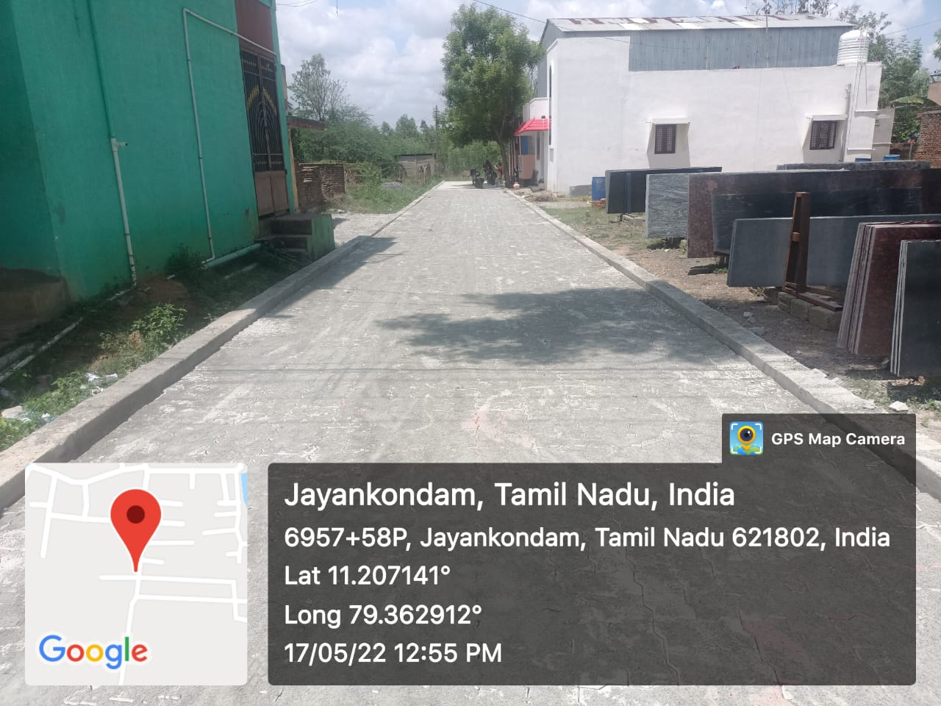
- NAME OF WORK :- PROVIDING PAVER BLOCK ROAD AT WARD NO:02 Unicode No. O91 002 R025 IN KEELAKUDIERUPPU ROTTU STREET 4TH CROSS.
- PACKAGE NO :- 1 ESTIMATE AMOUNT : 298.32 LAKHS.
- STAGE OF WORK : COMPLETED

THANJAVUR REGION
NAME OF SCHEME:- KNMT 2021-22 JAYANKONDAM MUNICIPALITY
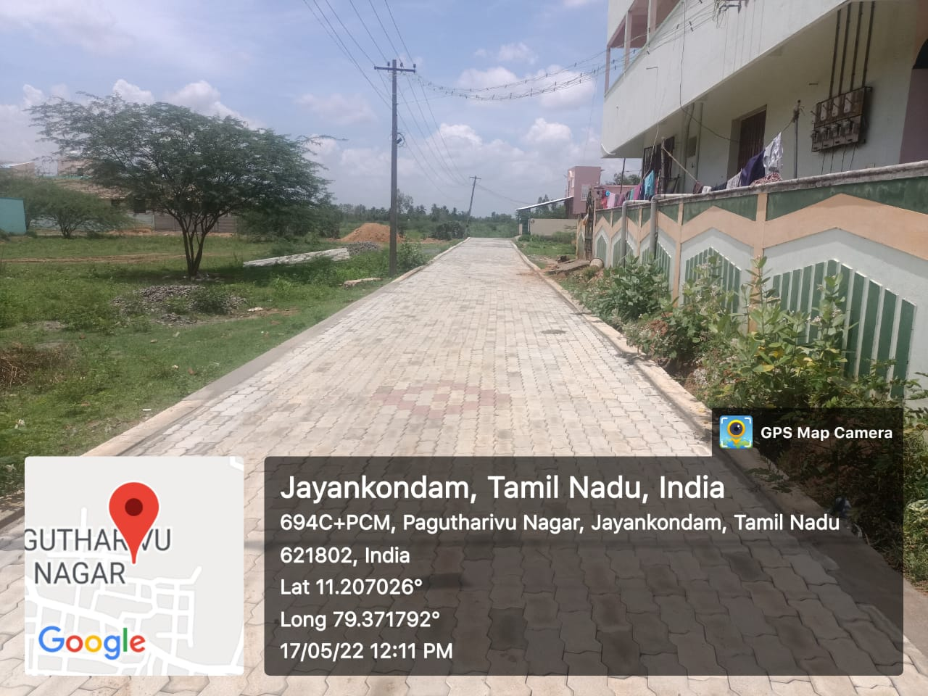
- NAME OF WORK :- PROVIDING PAVER BLOCK ROAD AT WARD NO:02 Unicode No. O91 017 R356 IN PAGUTHARIVU NAGAR
2.PACKAGE NO :- 1 ESTIMATE AMOUNT : 298.32 LAKHS.
3.STAGE OF WORK : COMPLETED
THANJAVUR REGION
NAME OF SCHEME:- KNMT 2021-22 JAYANKONDAM MUNICIPALITY
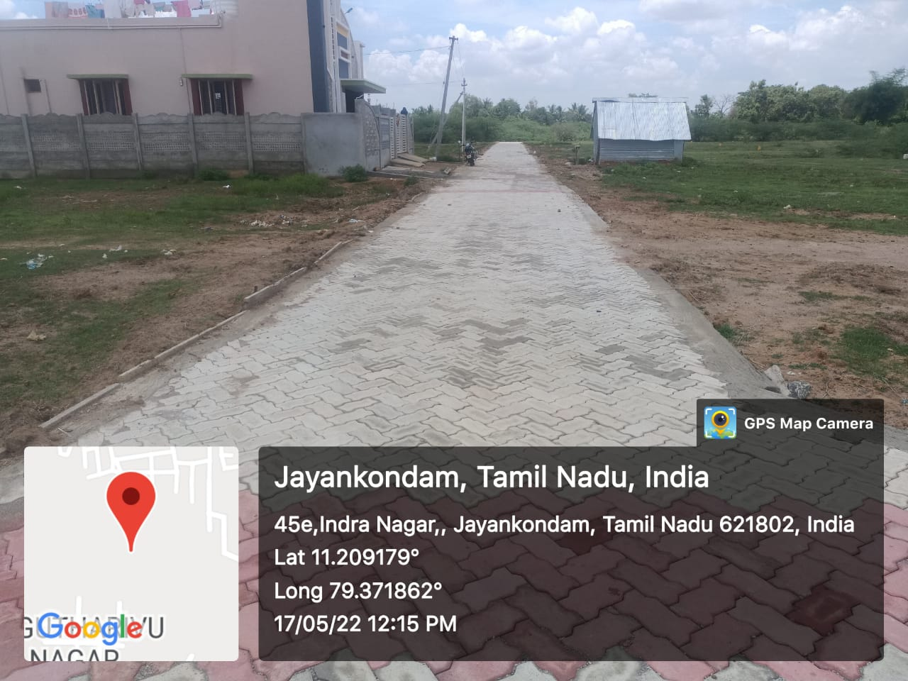
- NAME OF WORK :- PROVIDING PAVER BLOCK ROAD AT WARD NO:02 Unicode No. O91 017 R357 IN PAGUTHARIVU NAGAR
2.PACKAGE NO :- 1 ESTIMATE AMOUNT : 298.32 LAKHS.
3.STAGE OF WORK : PARTLY COMPLETED
THANJAVUR REGION
NAME OF SCHEME:- KNMT 2021-22 JAYANKONDAM MUNICIPALITY
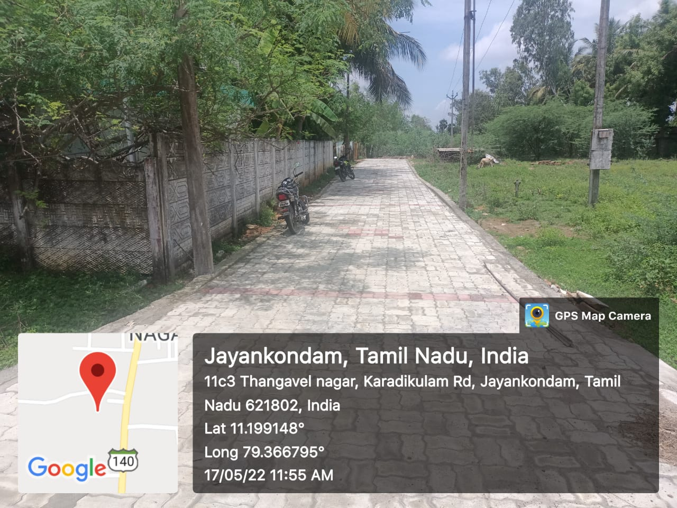
- NAME OF WORK :- PROVIDING PAVER BLOCK ROAD AT WARD NO:02 Unicode No. O91 018 R359 IN KARADIKULAM MAIN ROAD 1ST CROSS
2.PACKAGE NO :- 1 ESTIMATE AMOUNT : 298.32 LAKHS.
3.STAGE OF WORK : COMPLETED
THANJAVUR REGION
NAME OF SCHEME:- KNMT 2021-22 JAYANKONDAM MUNICIPALITY
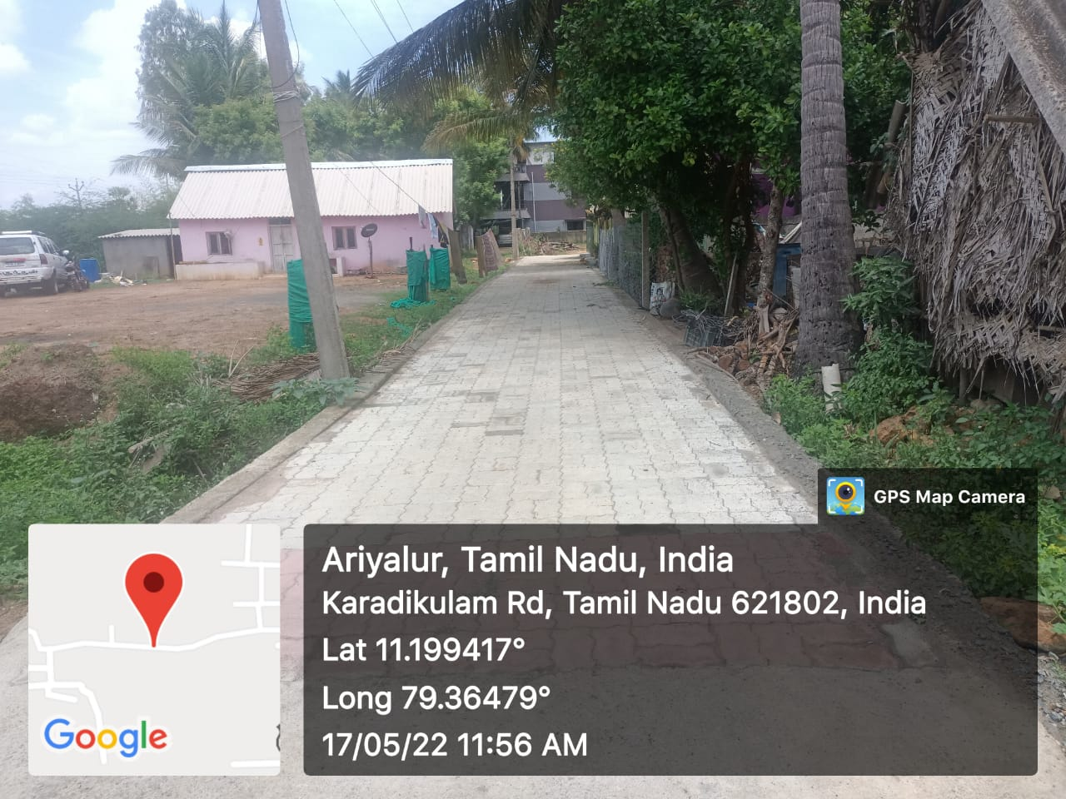
- NAME OF WORK :- PROVIDING PAVER BLOCK ROAD AT WARD NO:02 Unicode No. O91 018 R360 IN KARADIKULAM MAIN ROAD 2ND CROSS
2.PACKAGE NO :- 1 ESTIMATE AMOUNT : 298.32 LAKHS.
3.STAGE OF WORK : COMPLETED
THANJAVUR REGION
NAME OF SCHEME:- KNMT 2021-22 JAYANKONDAM MUNICIPALITY
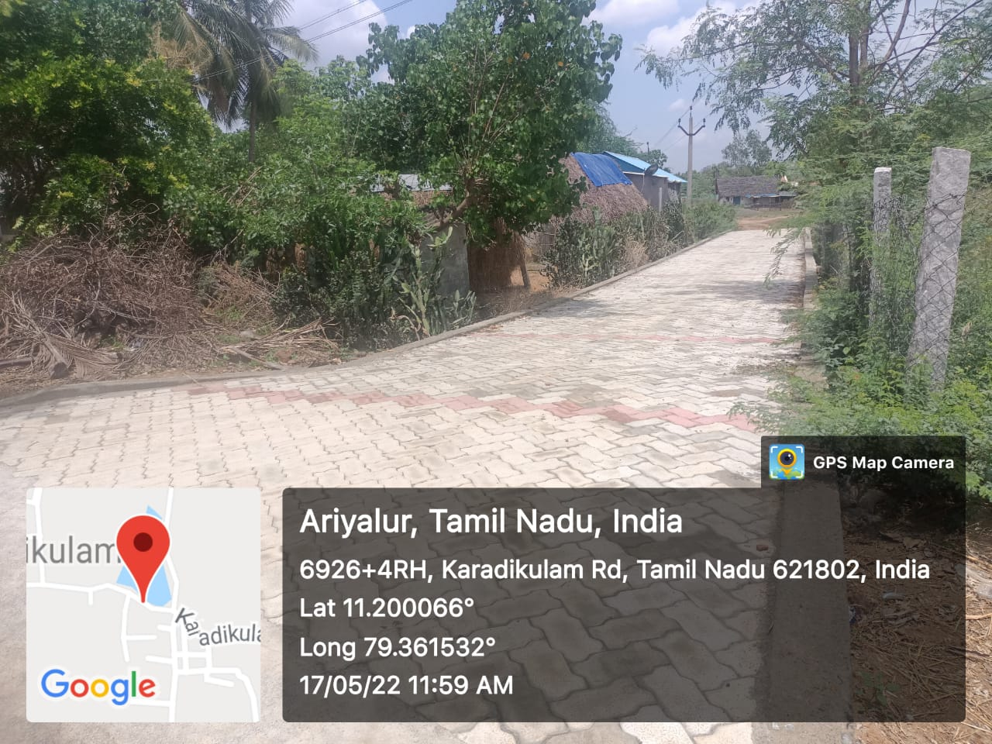
- NAME OF WORK :- PROVIDING PAVER BLOCK ROAD AT WARD NO:02 Unicode No. O91 018 R361 IN KARADIKULAM MAIN ROAD 3RD CROSS
2.PACKAGE NO :- 1 ESTIMATE AMOUNT : 298.32 LAKHS.
3.STAGE OF WORK : COMPLETED
THANJAVUR REGION
NAME OF SCHEME:- KNMT 2021-22 JAYANKONDAM MUNICIPALITY
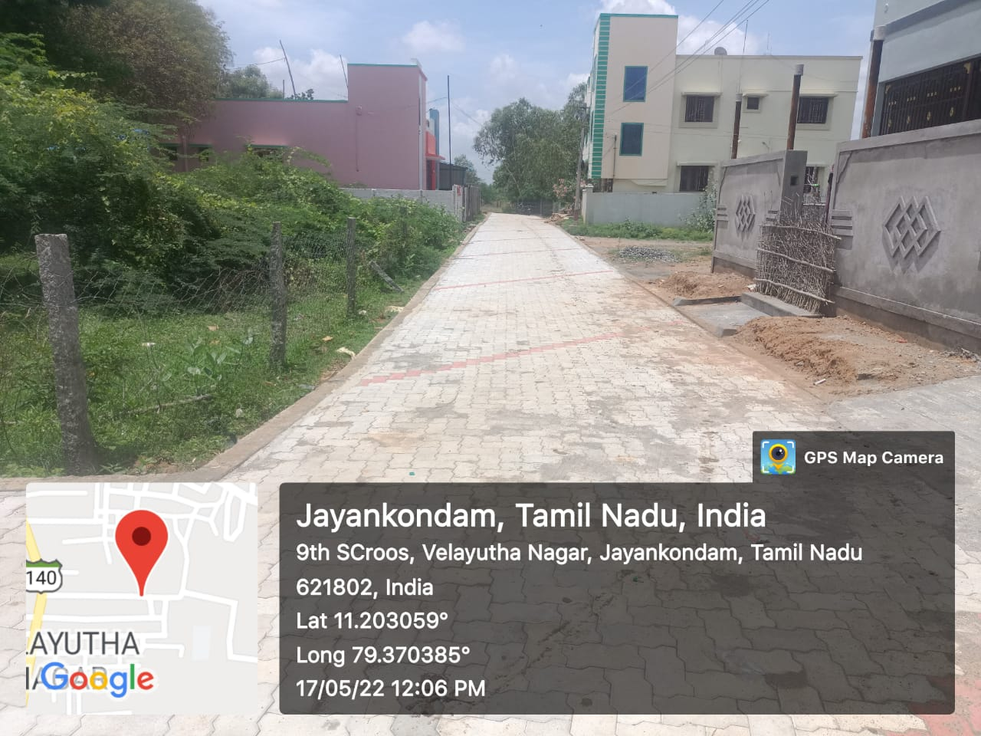
- NAME OF WORK :- PROVIDING PAVER BLOCK ROAD AT WARD NO:02 Unicode No. O91 017 R339 IN VELAYUTHA NAGAR 7th CROSS
2.PACKAGE NO :- 1 ESTIMATE AMOUNT : 298.32 LAKHS.
3.STAGE OF WORK : COMPLETED
THANJAVUR REGION
NAME OF SCHEME:- KNMT 2021-22 JAYANKONDAM MUNICIPALITY
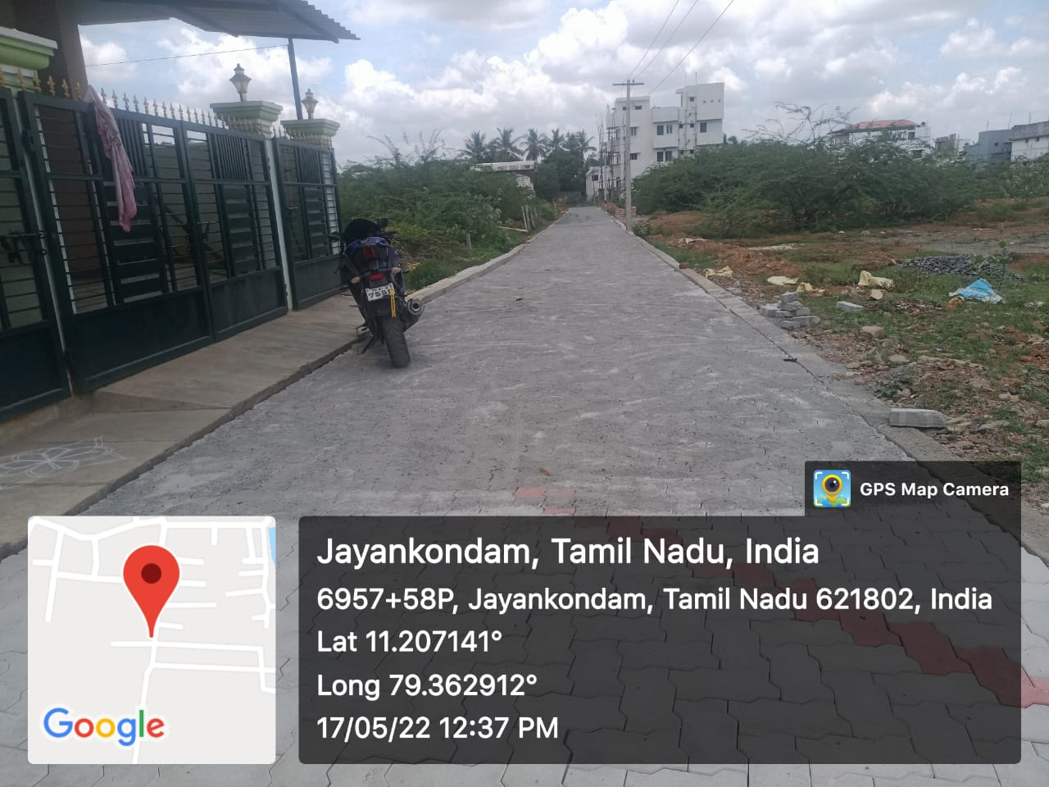
- NAME OF WORK :- PROVIDING PAVER BLOCK ROAD AT WARD NO:02 Unicode No. O91 015 R291 IN GANAPATHY NAGAR (L/S-4)
2.PACKAGE NO :- 1 ESTIMATE AMOUNT : 298.32 LAKHS.
3.STAGE OF WORK : COMPLETED

THANJAVUR REGION
NAME OF SCHEME:- KNMT 2021-22 JAYANKONDAM MUNICIPALITY
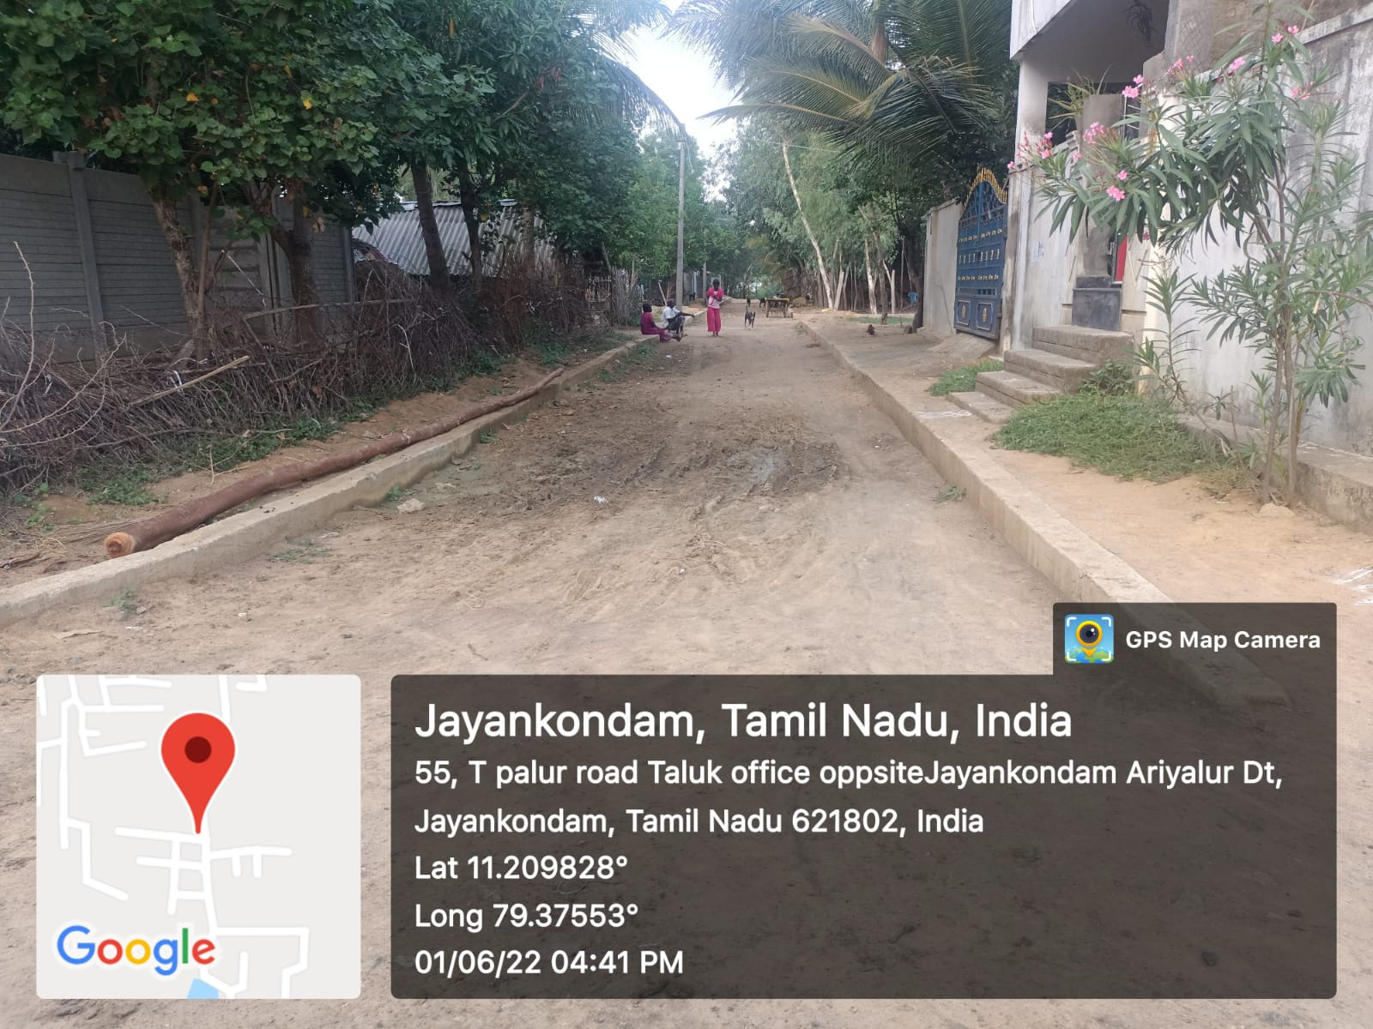
- NAME OF WORK :- PROVIDING PAVER BLOCK ROAD AT WARD NO:02 Unicode No. O91 006 R143 IN BALAJI NAGAR
2.PACKAGE NO :- 1 ESTIMATE AMOUNT : 298.32 LAKHS.
3.STAGE OF WORK : KERB WALL COMPLETED

THANJAVUR REGION
NAME OF SCHEME:- KNMT 2021-22 JAYANKONDAM MUNICIPALITY
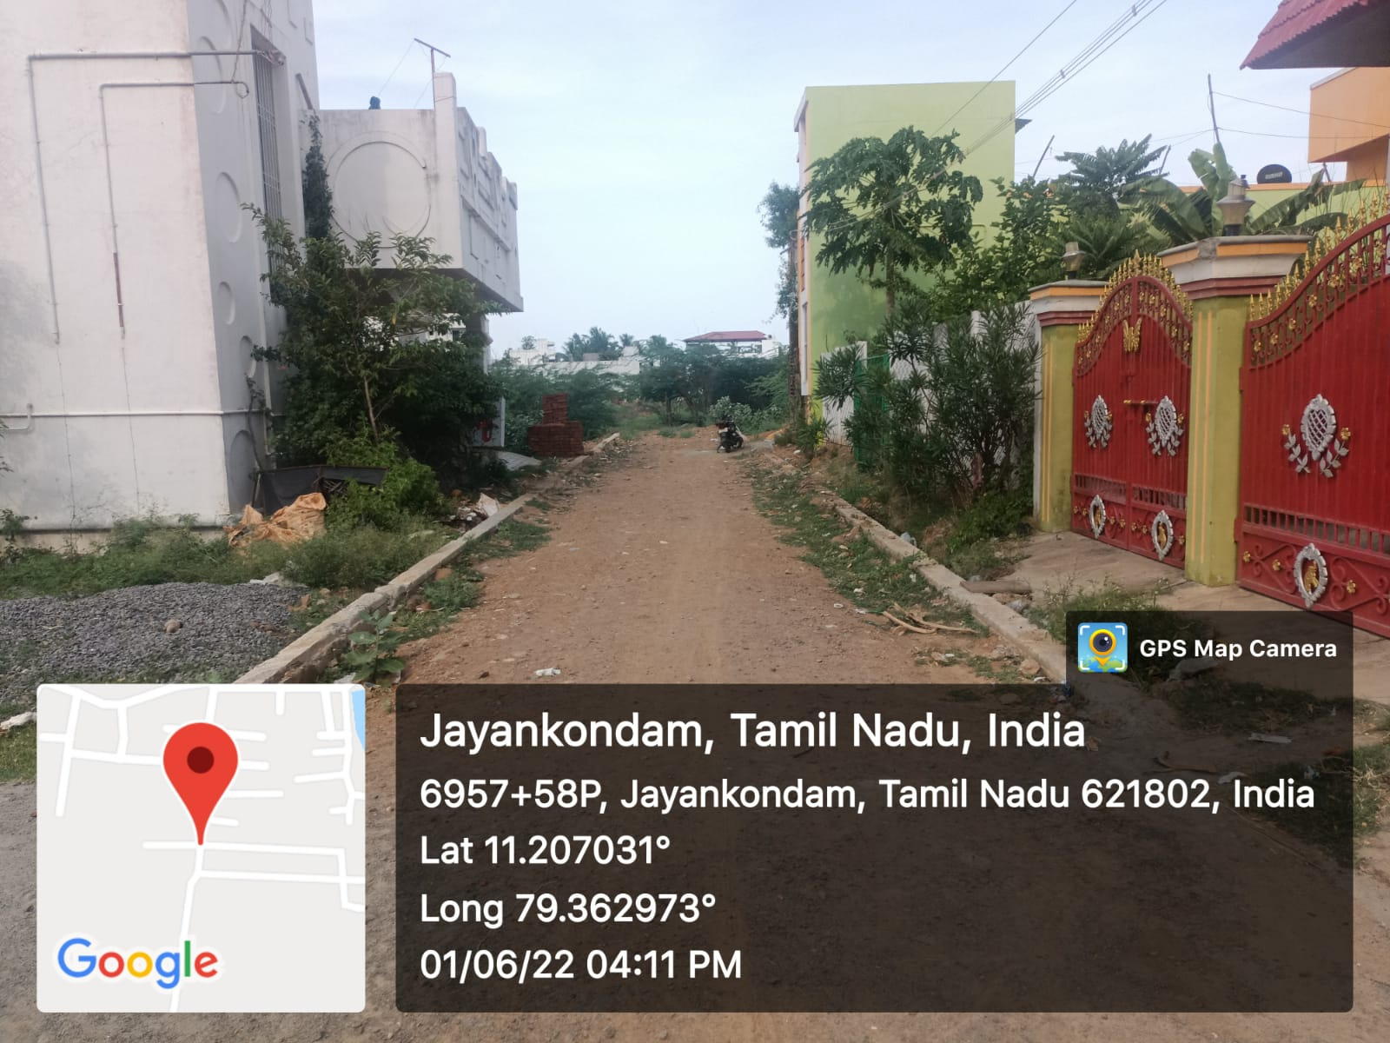
- NAME OF WORK :- PROVIDING PAVER BLOCK ROAD AT WARD NO:02 Unicode No. O91 015 R296 IN GANAPATHY NAGAR (L/S-5)
2.PACKAGE NO :- 1 ESTIMATE AMOUNT : 298.32 LAKHS.
3.STAGE OF WORK : KERB WALL COMPLETED
THANJAVUR REGION
NAME OF SCHEME:- KNMT 2021-22 JAYANKONDAM MUNICIPALITY
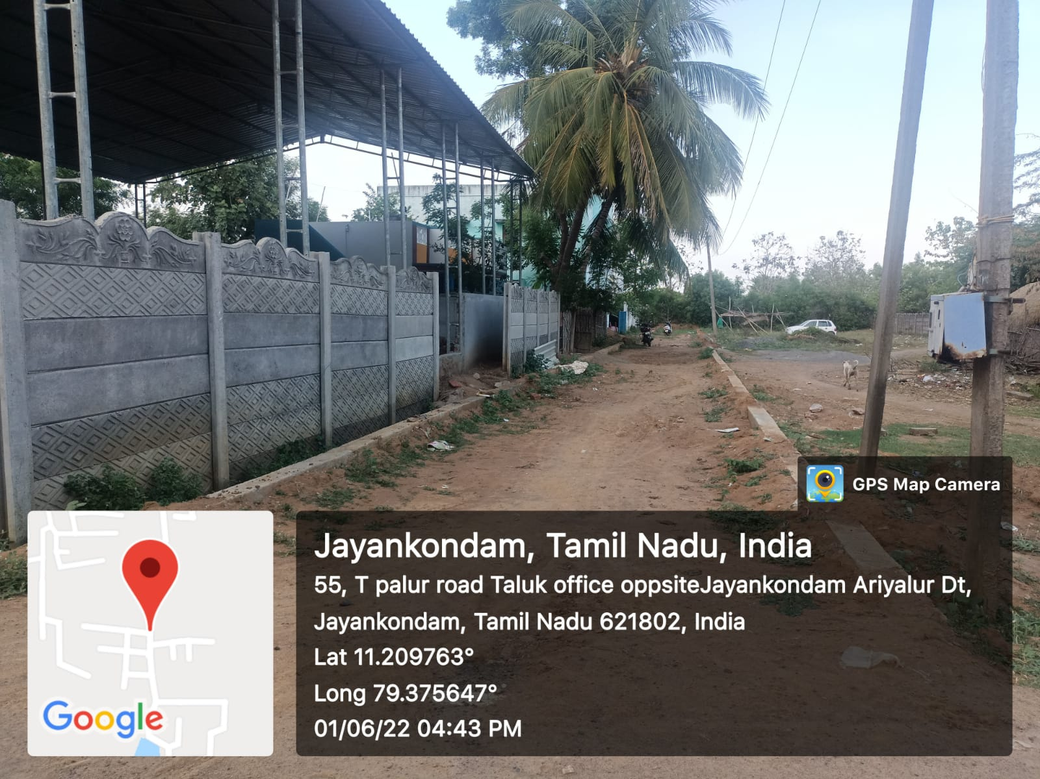
- NAME OF WORK :- PROVIDING PAVER BLOCK ROAD AT WARD NO:02 Unicode No. O91 006 R114 IN KEELA STREET MAIN ROAD
2.PACKAGE NO :- 1 ESTIMATE AMOUNT : 298.32 LAKHS.
3.STAGE OF WORK : KERB WALL COMPLETED

THANJAVUR REGION
NAME OF SCHEME:- KNMT 2021-22 JAYANKONDAM MUNICIPALITY
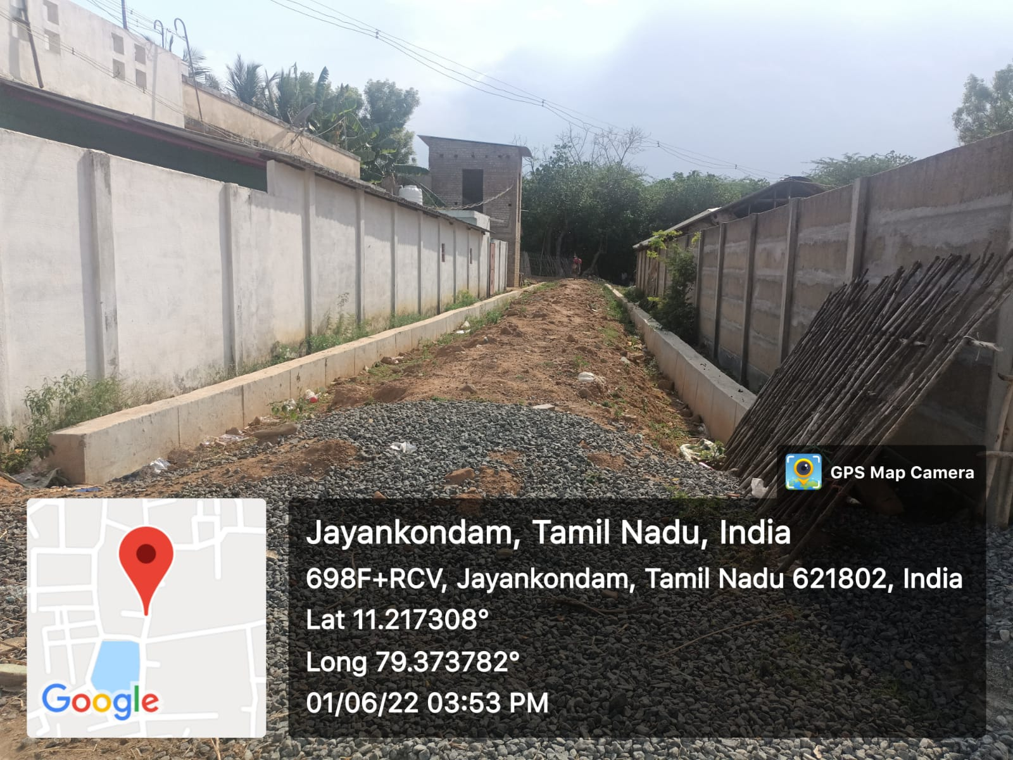
- NAME OF WORK :- PROVIDING PAVER BLOCK ROAD AT WARD NO:02 Unicode No. O91 003 R057 IN MALAGANKUDIYERUPPU KUDIYANA STREET 2ND CROSS
2.PACKAGE NO :- 1 ESTIMATE AMOUNT : 298.32 LAKHS.
3.STAGE OF WORK : KERB WALL COMPLETED
THANJAVUR REGION
NAME OF SCHEME:- KNMT 2021-22 JAYANKONDAM MUNICIPALITY
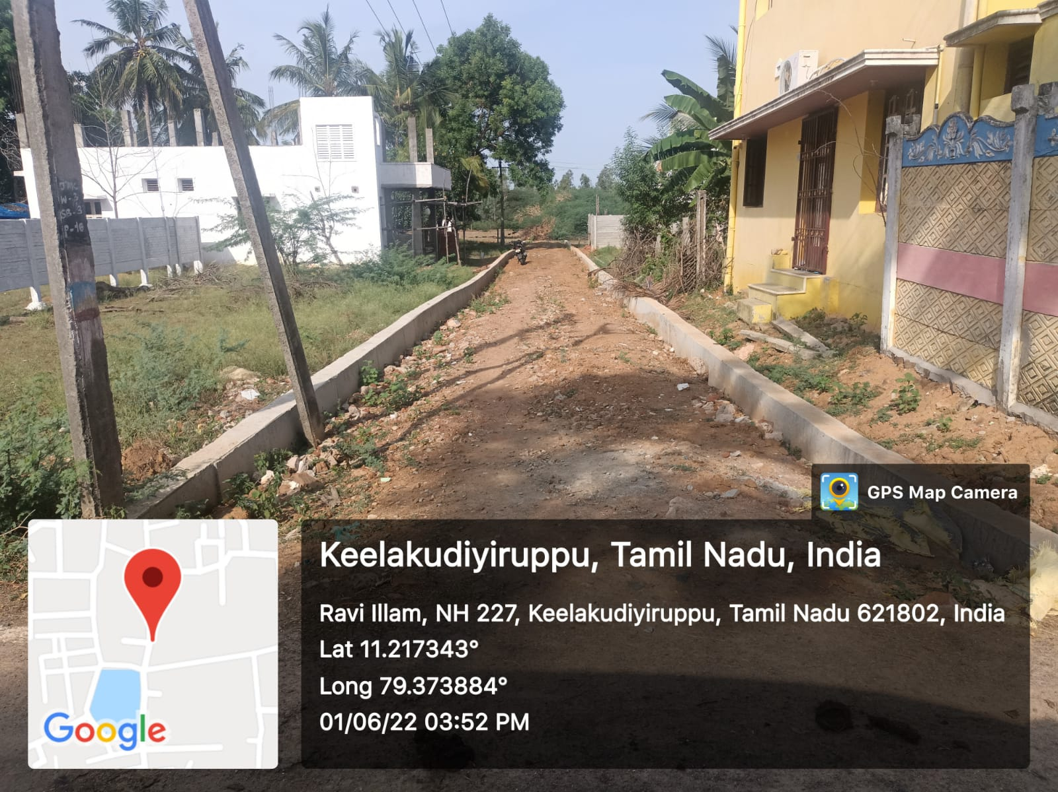
- NAME OF WORK :- PROVIDING PAVER BLOCK ROAD AT WARD NO:02 Unicode No. O91 003 R0578 IN MALAGANKUDIYERUPPU KUDIYANA STREET 3RD CROSS
2.PACKAGE NO :- 1 ESTIMATE AMOUNT : 298.32 LAKHS.
3.STAGE OF WORK : KERB WALL COMPLETED

THANJAVUR REGION
NAME OF SCHEME:- KNMT 2021-22 JAYANKONDAM MUNICIPALITY
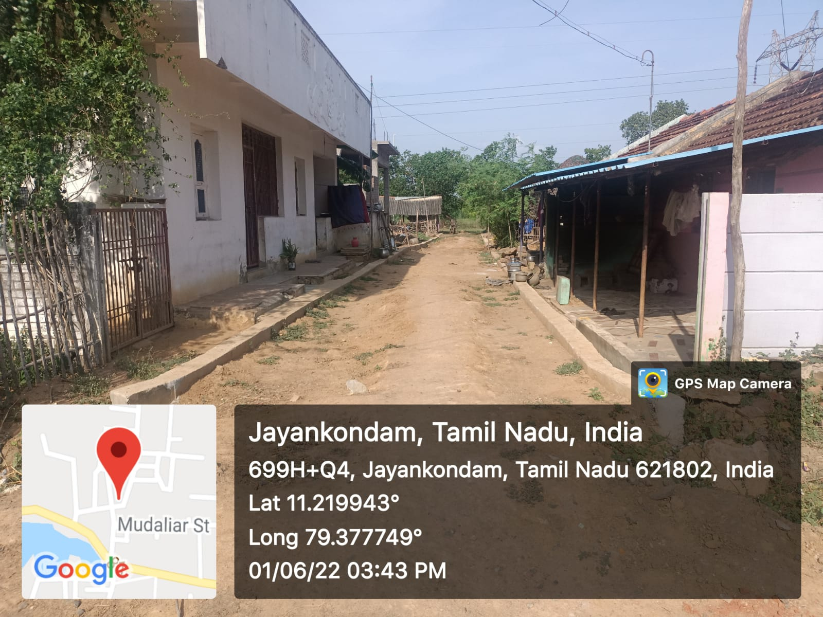
- NAME OF WORK :- PROVIDING PAVER BLOCK ROAD AT WARD NO:02 Unicode No. O91 003 S013 IN MALAGANKUDIYERUPPU KUDIYANA STREET 14TH CROSS
2.PACKAGE NO :- 1 ESTIMATE AMOUNT : 298.32 LAKHS.
3.STAGE OF WORK : KERB WALL COMPLETED
THANJAVUR REGION
NAME OF SCHEME:- KNMT 2021-22 JAYANKONDAM MUNICIPALITY
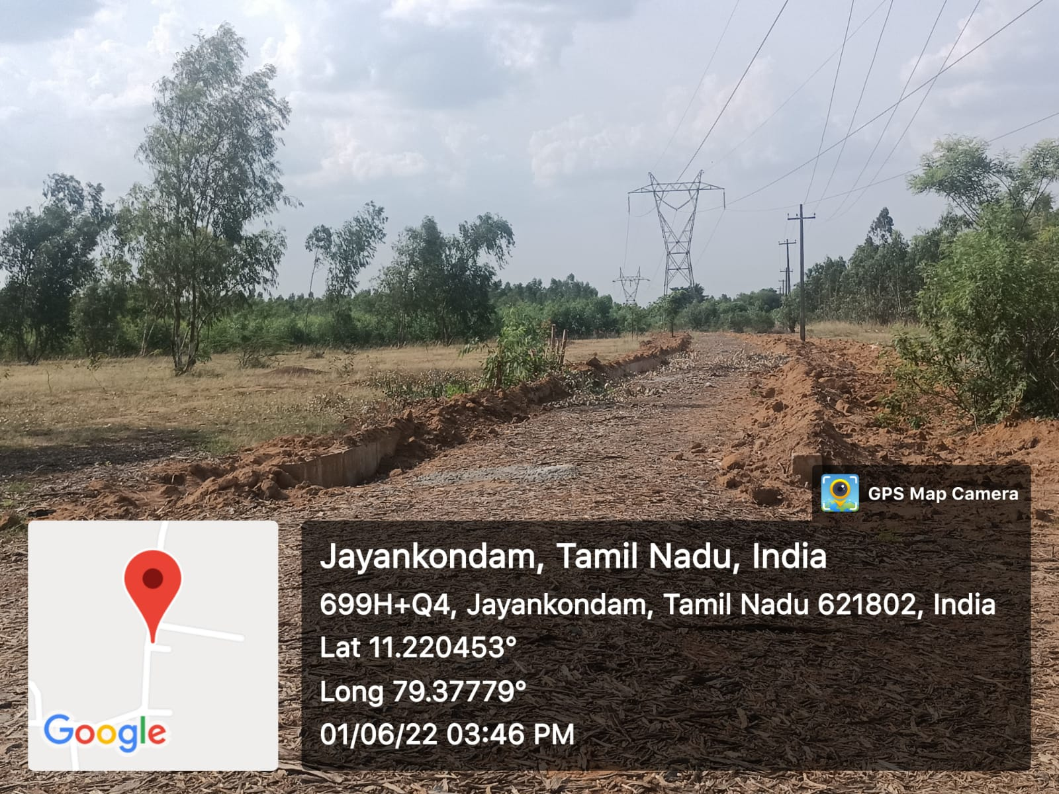
- NAME OF WORK :- PROVIDING PAVER BLOCK ROAD AT WARD NO:02 Unicode No. O91 003 R071 IN MALAGANKUDIYERUPPU IRULAR STREET
2.PACKAGE NO :- 1 ESTIMATE AMOUNT : 298.32 LAKHS.
3.STAGE OF WORK : KERB WALL COMPLETED

THANJAVUR REGION
NAME OF SCHEME:- KNMT 2021-22 JAYANKONDAM MUNICIPALITY
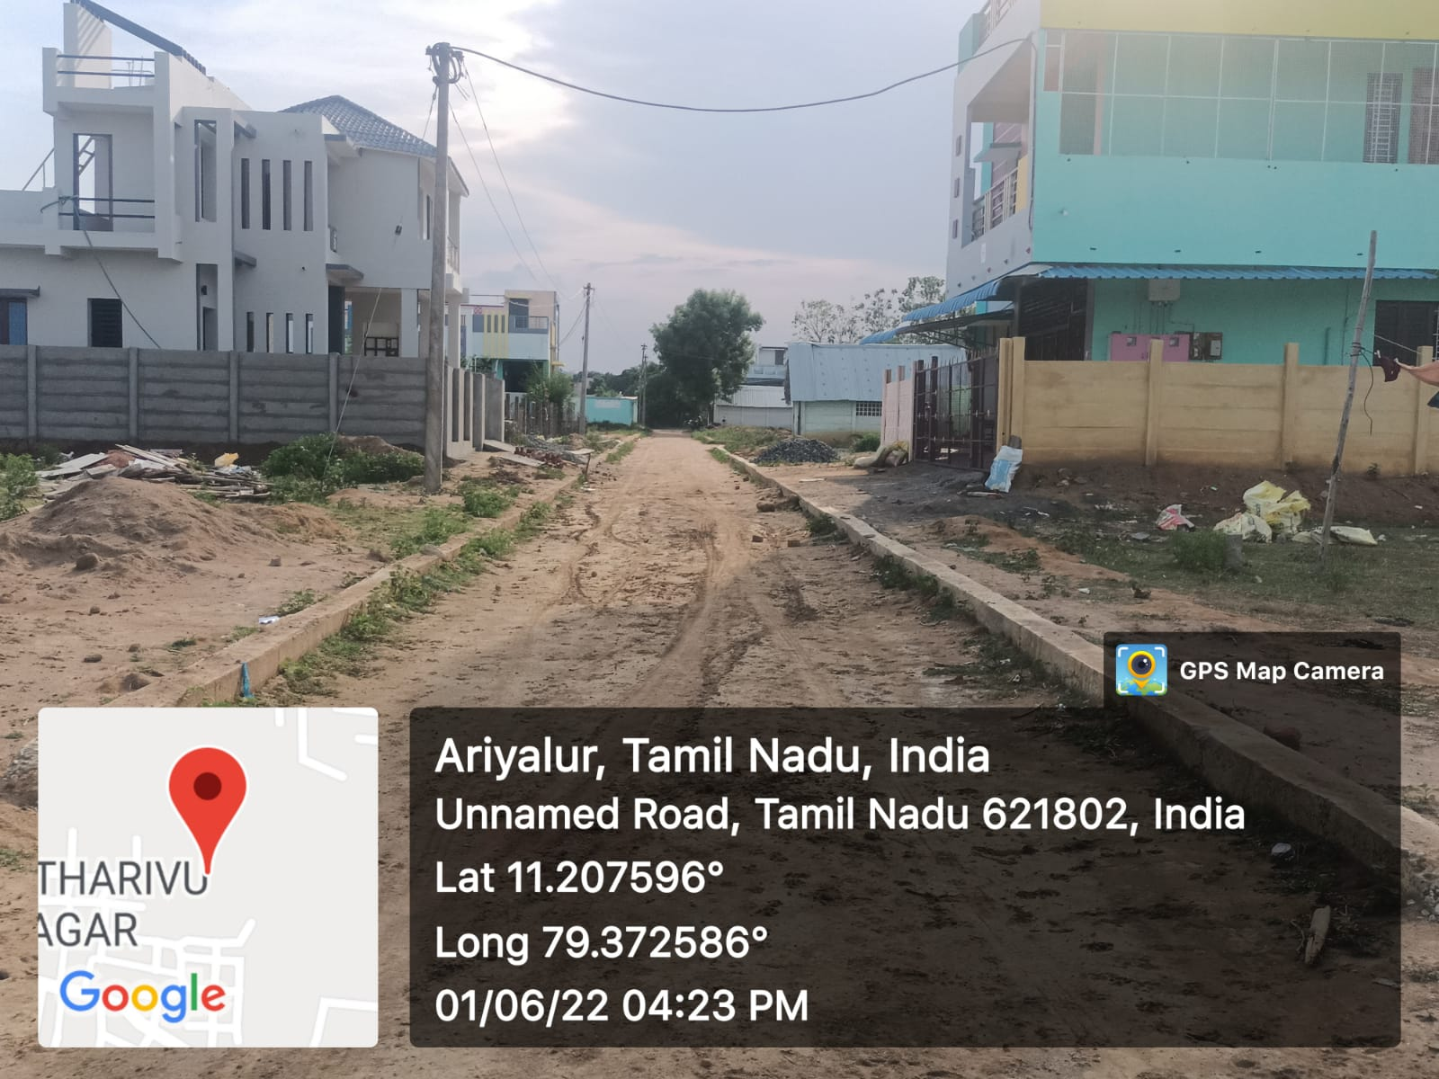
- NAME OF WORK :- PROVIDING PAVER BLOCK ROAD AT WARD NO:02 Unicode No. O91 017 R357 IN PAGUTHARIVU NAGAR MAIN ROAD
2.PACKAGE NO :- 1 ESTIMATE AMOUNT : 298.32 LAKHS.
3.STAGE OF WORK : KERB WALL COMPLETED
THANJAVUR REGION
NAME OF SCHEME:- KNMT 2021-22 JAYANKONDAM MUNICIPALITY
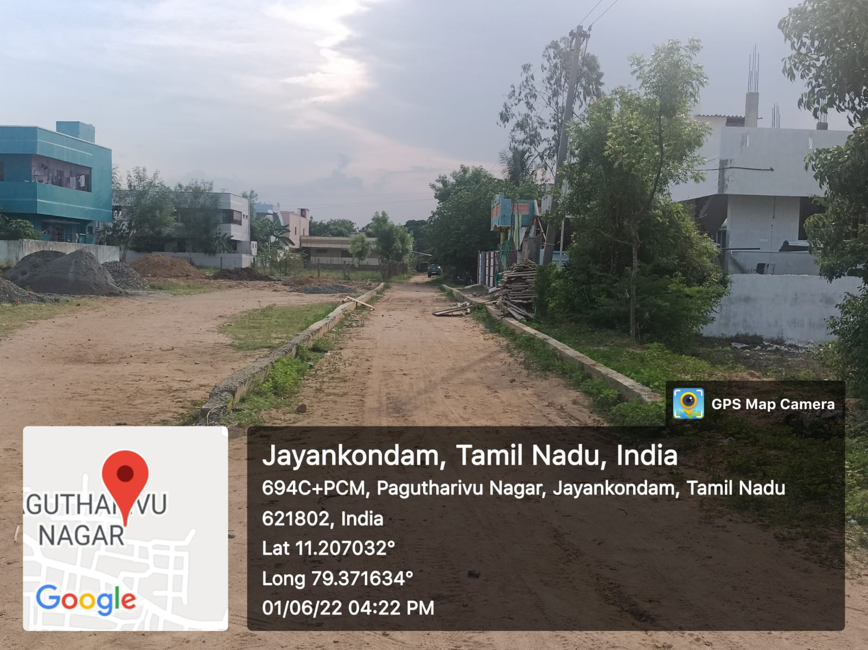
- NAME OF WORK :- PROVIDING PAVER BLOCK ROAD AT WARD NO:02 Unicode No. O91 017 R357 IN PAGUTHARIVU NAGAR MAIN ROAD
2.PACKAGE NO :- 1 ESTIMATE AMOUNT : 298.32 LAKHS.
3.STAGE OF WORK : KERB WALL COMPLETED

