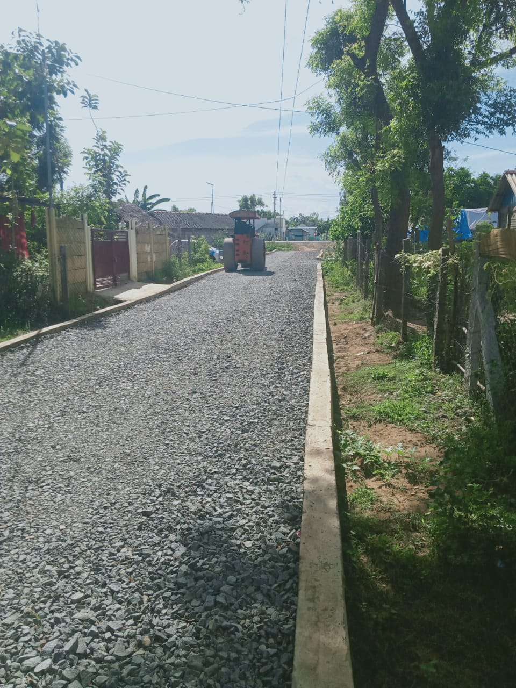

**ARIYALUR DISTIRCT-UDAYARPALAYAM TOWN PANCHAYAT**

Kalaingar Nagarpura Mempattu Thittam (KNMT) 2021 – 2022

Estimate Rs.106.88 Lakh